REFLECTIVE PORTFOLIO

Name: Malika Ali
Student Number: 2026355
Module Code: BMSW4006
Assignment Title: Reflective Portfolio
Lecturer: Olubukola Adegbite

Contents
Introduction 1
Task 1: Personal Development Plan 2
SWOT Analysis 3
Task 2: Learning and Development Plan 4
Kolb’s Experimental Learning Cycle 5
Honey and Mumford Learning Styles 6
Task 3: Reflective Model 7
Conclusion 10
Reference list 10

Introduction
This is assignment details my journey through this module and how it helped amass a variety of skills which helped in the development of my personal development plan. It also helps me analyze how as a manager I can apply different theories to assess the performance of my employees and better the productivity of my company. And finally, the third task helped me reflect on how this module helped me hone my professional skills and took me on a journey of reflection based on the different models we had studied.

Task 1: Personal Development Plan
Goals | Action plan in order to attain goal | Resources I will use | Time scale of completion of target
Short term  Get a degree in Health and Social Care | I will accomplish this registering in a university that offers this degree and complete the degree. | I will attend the lectures, do every assignment, and study for all the quizzes and exams. | For 3 years
Short term  Improve my Management and Organization Skills | - Self organization and management by using plans, frameworks and actively recording activities and goals  - Volunteer and organize activities for colleagues and friends  -Take courses/training in the discipline | I will use online courses and look at different people’s plans and frameworks. I will also utilize the resources and courses provided by the university. | For 3 years
Medium term goal  Get job in the field for more experience. | - Build interview skills  -Make a good CV  -Have the required expertise for the job | I will take help from my seniors in the field regarding how to prepare for my interview and how to improve my CV. | For 4 years
Long Term  I plan to open my own business for adult healthcare. | -Take courses/training in for entrepreneurship  -Get training and certification in the field  -Connect with people of the field  -Find investors | -I will utilize the resources and courses provided by the university.  - I will make use of government funding if possible  -My connections with people in the field will also be a valuable resource that I will use. | In the next 7 years.

SWOT Analysis
My career goal is to be a successful entrepreneur. I plan on opening my own business for adult healthcare. By analyzing my strengths, weaknesses, the opportunities I have, and the threats I would face as an entrepreneur, I was able to understand the likelihood of me achieving my career goal successfully.
Strengths:  - I have good communication skills.  - I have experience working in healthcare.  - I have achieved Intermediate level in adult care.  - I have good management skills. | Weakness:  - Time limitation- it takes time to learn the required skills.  - I find it hard to keep a healthy work life and family life balance.  - My leadership skills require work.  - I lack professional knowledge of the Social Work sector.
Opportunity:  - Courses offered by the university.  - Many job opportunities in the sector.  - The training provided by workplace.  - Funding from government. | Threats:  - Lack initial investment for a startup.  - Many skillful competitors.  - Changes in laws and legislations.

Task 2: Learning and Development Plan
As the manager at an adult care service, it is my top priority to make sure my employees are learning effectively. It is important to evaluate and assess the learning and developmental training of your employees, since this training directly benefits employee skills and performance which affects the organization as well. For me, my employees are my investments, so I train my employees, to better their productivity and performance so that the organization's performance gets better as well. For organizations, it is important to measure and assess the learning and development training of the staff so that an organization can understand whether the employees need more attention in training or not (Asgarova, 2019). One my employees are trained successfully there would be a rise in the productivity, sales, and profits of the organization as well. As the manager of my organization, I invested a lot of time, money, and energy into training their employees and it is important to track whether these training programs are working since organizations that invest in their employees have been shown to do better in profits (Bhat, 2019). Learning and training effectiveness can be measured by different theories and methods. The models that I will use as a manager in order to assess the learning and development training of my staff are:
- Kolb’s Experimental Learning Cycle
- Honey and Mumford learning styles

Kolb’s Experimental Learning Cycle
Kolb has described four stages as an integrated learning process, where each process is dependent on the last, thus creating a circle of learning stages. According to Kolb, effective learning can only occur when an individual goes through all four stages of the learning cycle (Sarabdeen, 2013). The four stages are:
- Concrete Experience
- Reflective Observation
- Abstract Conceptualization
- Active Experimentation
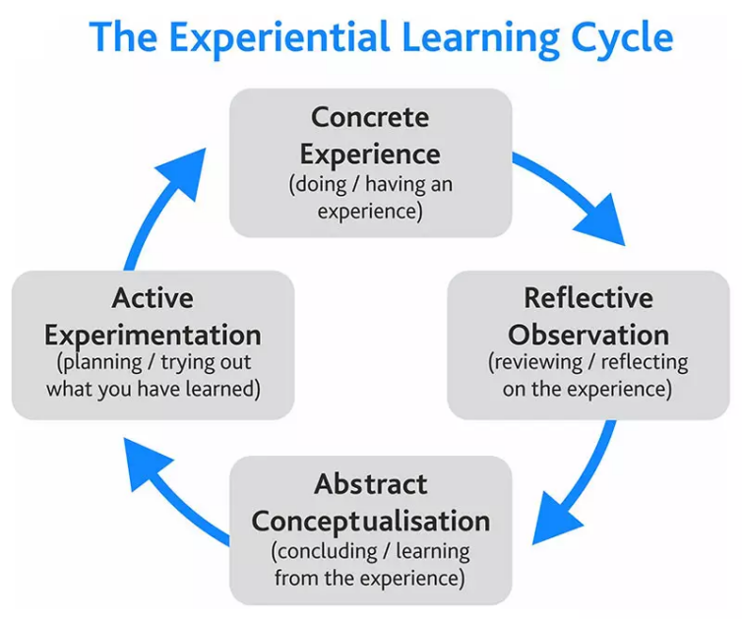
(McPheat, 2019)
In light of Kolb's experiential learning style theory, I will evaluate the learning of my staff which can be represented by a four-stage learning cycle as specified by Kolb (Wain, 2017). In the first stage, concrete experience, the learning process begins with a concrete experience. So, when my employees start their learning and development training, they will be able to reinterpret their own experiences in lights of the new information they would be learning. After undergoing a new experience, the employees will relearn how to perform the tasks and refresh their own learning. This would allow them to reflect on their new experience. This step of the cycle is known as reflective observation. In abstract conceptualization, the employees will try to make sense of their learning and development training. They will attempt to make conclusion based on their experience after reflecting on their past knowledge. The employees will also discuss what they experienced and learnt with each other to have a better understanding. By analyzing these experiences, the employees’ reflections and notes will allow them to modify their behavior according to the experiences gained during the training in order to make up for any inconsistencies they will have observed. These newly modified concepts will be further applied to their future performance. This process of applying modified concepts to experiences is known as Active Experimentation, as termed by Kolb.

Honey and Mumford Learning Styles
Another theory that I will use is Honey and Mumford learning styles. The theory states that people learn in four different styles: activist, pragmatist, theorist, and reflector.
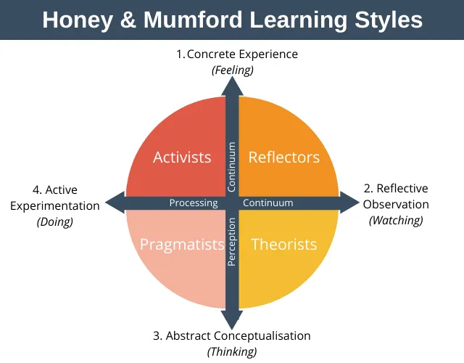
(Expertprogrammanagement.com, 2022)
An individual is categorized as activist if he/she learns by doing tasks. The nature of these tasks is short and concrete. Theorists are individuals are that learn effectively once they understand the theory behind the idea. These individuals require concepts, facts, and models to learn their best. An individual that learns effectively when they are able to see how the new ideas can be applied in the real world. Reflectors are individuals that learn effectively by reviewing, listening, looking back, and reflecting on what they have learnt. As the manager of an adult care service, I will pick the activist learning style. The reason for my selection is that in an adult care service company, I require individuals that thrive in hands on experience and learn best when they are actively participating. Many aspects of the learning and development training will require active participation; therefore, I will need people who learn by doing tasks.

Task 3: Reflective Model
It is important to understand and assess your progress at different stages of your learning through self-observation and self-evaluation. It is important to continuously analyze and refine your actions and learning to develop their learning further. The goal of self-reflection is not only to address a question or problem, but it also helps in observing and refining one’s practice. In this report, I will apply Gibbs’s reflective cycle to assess and reflect on what I learnt from this module.
This module has allowed me to hone my interview skills and by observing my learning in light of Gibbs’s reflective cycle, I had to role play an interview process, where I use the framework of this reflective cycle to understand the relevance of my quiet skill with the job application. Considering the feelings part of the cycle, playing the part of the individual being interviewed was nerve wracking but since I had performed an in-depth analysis of my acquired skills and my learning, I was able to present a structured view of my past work evidence add my learning. When evaluating my interview, I can say that it was a good experience where it was a professional and realistic interview which helped me prepare for future interviews. There were competency-based questions within the interview, which in my opinion I handled well since I answered them based on my own professional experience and The academic skills I had acquired during this module. when analyzing this exercise, I feel as if the role play of sitting in an interview contributed very positively to my work ethic and allowed me to conduct sufficient research to ensure that my answer is aligned with the questions that The interviewer had structured. as an interviewee I took careful consideration when answering to make sure that my expressions, the pacing of my answers and my posture were professional and understandable, and my body language came off as open and knowledgeable. I took great care to show that my answers were structured in such a way that they did not only focus on the usual theoretical language but also drew up on real life examples. The formality of the interview helped me maintain an emotional balance and keep a level head while answering. I found it helpful to maintain a conversational tone while answering so that my interpersonal skills would help the process go smoother. For an action plan I have decided that I will set up a personal plan which will help in practicing and assessing my progression so that I may develop my technical and software skills such as behavioral competencies so that I will find it easier to manage tougher circumstances within an interview. I have decided to employ CAR or STAR techniques in my future interviews in order to articulate myself more clearly, I'm not fumble over my answers. using the Gibbs reflective cycle has helped me in enhancing my interview skills so that the process is far less stressful, and I can understand the situation better. I have become more aware of my actions during the interview so that I may structure my approach in the future in such a way that it can help me give better interviews and handle the common interview questions that employers often ask.
I evaluated my learning with the open book assessment with the help of Gibbs’s reflective cycle. For the Gibbs cycle, I reflected on how I felt about the incident, and what is the good part of the experience and what is the bad part. There are six stages in the Gibbs’s reflective cycle: description, feelings, evaluation, analysis, conclusion, and action plan (The University of Edinburgh, 2020). For the description stage, I described to myself the details about the open assessment. Then, I recalled how I was feeling and what I was thinking during it. For example, I was feeling extremely anxious before it started, and I was relieved and satisfied when it ended. The next step was evaluation, in which I objectively evaluated what areas of the open assessment were good and what areas could be considered unsatisfactory. In the next step, I analyzed myself and dug deeper into the event to understand it. According to my evaluation and analysis, I felt that I performed to a seventy percent of my abilities. After exploring my experience, I drew conclusions about how to improve my performance in the future and how I might do it. In the last stage, I devised an action plan about what I would do differently and how I planned on doing it. For my action plan I understood that in the future I would analyze the case study thoroughly and make important notes so that it would help me when answering the questions presented during the case study.
It is important to analyze your learning experience to understand what can be learned from it. Gibb’s cycle has allowed me to evaluate my experiences during this module, experiences such as the open book assessment, UK employment legislation, mock interview and so on, where the theory allowed the transference of theoretical knowledge into the practical world under deflection on this and reflecting on this can help provide variety of depths to the experience. The UK employment legislation start legal framework that regulates the relationship that exists between employers and employees. It made me more aware of the laws that helped build employment contracts call Bob add other details such as data protection and anti-discrimination laws and policies that exist for the protection of individuals. Studying the UK employee legislation help me understand the responsibility that a business or a company has towards it employees and how it regulates the relations between workers and how different employment status affects the employment rights of an individual and how it affects the responsibilities that an individual employer has towards its employees. By reviewing myself with the Gibbs’ cycle, I was able to pinpoint where I went wrong in this module and how I can improve my performance in the future. For example, during the mock interview I was extremely nervous which caused me to underperform. As I was able to identify the cause behind the lag in my performance, in the future, I can avoid such mistakes.

Conclusion
This is assignment details my journey through this module and how it helped a mass a variety of skills which helped in the development of my personal development plan. By using the theories discussed in the learning and development training, I will be able to guide others how to learn to the best of their abilities. Whereas, by reviewing myself with the help of the theories discussed in task 3, I was able to pinpoint where I went wrong in this module and how I can improve my performance in the future.

Reference list
Adeani, I.S., Febriani, R.B. and Syafryadin, S. (2020). USING GIBBS’ REFLECTIVE CYCLE IN MAKING REFLECTIONS OF LITERARY ANALYSIS. Indonesian EFL Journal, [online] 6(2), p.139. Available at: https://journal.uniku.ac.id/index.php/IEFLJ/article/view/3382/2034.
Ahmed, A.M. (2019). Students’ reflective journaling: an impactful strategy that informs instructional practices in an EFL writing university context in Qatar. Reflective Practice, 20(4), pp.1–18.
Anderson, T. (2011). Toward a Theory of Online Learning. 5th ed. Marquis Book Printing.
Asgarova, A. (2019). Impact of Employee Training on Employee Job Satisfaction and Achievement: A Case of Turkish Manufacturing Industry. SSRN Electronic Journal.
Brown, N. (2001). Dr Nicole Brown. [online] Dr Nicole Brown. Available at: https://www.nicole-brown.co.uk/reflective-model-according-to-rolfe/.
Bhat, A.A. (2019). Training and Development and its Impact on Employees Performance and Productivity "A case Study of district Anantnag Private Sector companies located in the District Anantnag Jammu and Kashmir. Archives of Business Research, 7(9), pp.121–133.
Bhattarai, A. (2017). Action Research: A Reflective Cycle. Journal of NELTA, 10(1).
Expertprogrammanagement.com. (2022). [online] Available at: https://expertprogrammanagement.com/wp-content/uploads/2020/10/Honey-and-Mumford-Learning-Styles.png?ezimgfmt=ng:webp/ngcb2.
Gibbon, B. (2002). Critical Reflection for Nursing and the Helping Professions. A User’s Guide Critical Reflection for Nursing and the Helping Professions. A User’s Guide. Nursing Standard, 16(20), pp.29–29.
Kanaslan, E.K. and Iyem, C. (2016). Is 360 Degree Feedback Appraisal an Effective Way of Performance Evaluation? International Journal of Academic Research in Business and Social Sciences, 6(5).
Markkanen, P., Välimäki, M., Anttila, M. and Kuuskorpi, M. (2020). A reflective cycle: Understanding challenging situations in a school setting. Educational Research, [online] 62(1), pp.46–62. Available at: https://www.tandfonline.com/doi/abs/10.1080/00131881.2020.1711790.
McPheat, S. (2019). What Are KOLB’s Learning Styles And What Do They Mean? - Skillshub.com. [online] Skillshub.com. Available at: https://www.skillshub.com/what-are-kolbs-learning-styles/.
Moore, J. (2017). Setting SMART objectives. Headteacher Update, 2017(6), pp.14–14.
Sarabdeen, J. (2013). Learning Styles and Training Methods. Communications of the IBIMA, [online] pp.1–9. Available at: http://ro.uow.edu.au/cgi/viewcontent.cgi?article=1476&context=dubaipapers.
The University of Edinburgh (2020). Gibbs’ Reflective Cycle. [online] The University of Edinburgh. Available at: https://www.ed.ac.uk/reflection/reflectors-toolkit/reflecting-on-experience/gibbs-reflective-cycle.
Wain, A. (2017). Learning through reflection. British Journal of Midwifery, [online] 25(10), pp.662–666. Available at: https://www.magonlinelibrary.com/doi/abs/10.12968/bjom.2017.25.10.662.

