In this assignment, I will be reflecting critically on an intervention designed to support the learning and development of a pupil, focusing specifically on a year 3 pupil named Charlie. Charlie is a 7-year-old boy working at a progression step 2 level and is currently on track for his age according to (Welsh Government, 2025). For context as stated in Appendix 1, Charlie is currently struggling vastly with regulating his emotions, along with uncontrollable outbursts. It is important to mention Charlie's parents have recently gone through a distressing divorce which may indicate the behavior change. Due to protection reasons, I have named this child Charlie under the act of (British Educational Research Association), expressing how any changes to a child's anonymity should be carefully assessed to protect the confidentiality of others involved. When planning and implementing any intervention, it is crucial to ensure that children's development and needs are consistently addressed. The Social Services and Well-Being (Wales) Act 2014 emphasizes the importance of prioritizing children's emotional and physical well-being as a central focus of all interventions. Further supporting this is (Welsh Government, 2014), who express how Children are entitled to feel happy, healthy, and safe, with appropriate services in place to support their needs.
To support Charlie, I have chosen ELSA (Emotional Literacy Support Assistance) intervention. ELSAs are trained staff members who work within their schools to assist children in identifying, understanding, and managing their emotions to improve their overall success. They design and implement personalized support programs for individual students or small groups. ELSAs undergo training and receive ongoing supervision from educational psychologists to ensure the effectiveness of their support (Educational Endowment Foundation, no date) (Educational Psychology Service,2021). I selected the ELSA intervention because it provides a focused approach to addressing a child's emotional needs and explores how these emotions can influence children's overall development. For pupils like Charlie, this intervention can target their resilience and increase self-awareness. According to (Estyn,2020) Schools that excel at fostering resilience in their students are those that prioritize emotional well-being and provide strong mental health support for all learners. This supports why ELSA could be beneficial to Charlie. This viewpoint is reinforced by (Elsa Network, 2017) clarifying that children perform better and feel more content in school when their emotional needs are met. As part of my critical reflection, I will also explore the challenges associated with the ELSA intervention, such as limited funding, time constraints, and insufficient resources, all of which can hinder its effectiveness. Additionally, I will discuss the issue of “receiving limited research attention” (Nicholson-Roberts, p.n., 55, no date), which can contribute to a lack of robust evidence supporting the intervention’s long-term impact. These barriers may affect the scalability of the ELSA program, making it difficult to fully assess its potential and implement it consistently across various settings.
Child development and well-being play a central role within the Welsh curriculum, emphasizing the importance of nurturing both academic and emotional growth to support holistic learning. (Welsh Government,2025.) The primary objective of the curriculum is to support and enhance the learning experience of its students. (Welsh Government,2022). Graham Donaldson, a Welsh educational specialist, changed the way the Welsh curriculum is run by preparing students for the future, creating a more personalized, skills-based curriculum. A more flexible curriculum will include more critical thinking and emotional well-being embedded in learners and teachers. (Donaldson, G. 2015). Building on this point, the four purposes outlined in the Welsh Framework emphasize that these objectives should serve as the foundation for a school’s curriculum design, underlining their essential role in fostering children's development. Learners will be supported in building the confidence, motivation, physical skills, knowledge, and understanding necessary to adopt healthy and active lifestyles that foster good physical health and overall well-being (Welsh Government, 2022). This evidence from the curriculum may align with the 2023 Estyn Annual Report that highlights how the Curriculum for Wales supports primary students by nurturing the skills and attributes defined in its four purposes. Estyn notes that many schools are starting to focus on developing these skills in their pupils moving forward which could lead to positive outcomes overall (Estyn,2023).
Children's emotional and social development is crucial for their overall growth, influencing their ability to interact with peers, regulate their emotions, and navigate various social situations. Emotional development begins at an early age and is shaped by interactions with caregivers, teachers, and peers this is mentioned in the Social Services and Well-being (Wales) Act 2014 encourages children to have positive relationships with peers and family, recognizing that strong social connections are essential for a child’s emotional development (Welsh Government, 2014) Positive relationships foster a sense of security, which in turn helps children learn to express their emotions appropriately and manage difficult feelings like frustration or sadness (Child Development Institute, 2020). John Bowlby's attachment theory further reinforces this, emphasizing the significance of secure attachments for emotional regulation and future emotional stability (Bowlby, 1988). Bowlby (1969) argues that the quality of early bonds forms the foundation of a child's emotional well-being. This was then reinforced by development psychologist Mary Ainsworth who concluded that when children experience positive relationships with their parents or caregivers, they are more likely to develop confidence, self-regulation, and the ability to cope with stress. In contrast, children who lack these secure attachments may develop negative attachment patterns, such as avoidant attachment, which can lead to difficulties in forming relationships and coping with challenges later in life (Ainsworth, 1978orming relationships and coping with challenges later in life (Ainsworth, 1978) (The Attachment Project,2024).
Estyn emphasizes the crucial role of emotional and social support in the development and well-being of Key Stage 2 pupils. A 2022 Estyn report on mental health in schools indicates that 60% of Key Stage 2 pupils demonstrate a positive self-regard as learners, underscoring the importance of fostering self-esteem and emotional well-being through targeted support strategies (Estyn, 2022). According to Erik Erikson's psychosocial stages of development, emotional well-being develops through key stages in early childhood, with children facing challenges that foster resilience and confidence throughout their lives (Erikson, 1963). By successfully overcoming challenges at each stage, children build resilience, which is essential for handling future obstacles. Erikson’s theory emphasizes that emotional well-being is not static; rather, it evolves as children face age-appropriate challenges that shape their self-esteem and social competence, setting the stage for positive emotional health throughout their lives. Through this, children can “explore new roles and identities: Engage in pretend play to try out different roles and develop a sense of purpose and initiative” (Erikson, 1950). Maslow’s Hierarchy of Needs suggests that emotional and social development is linked to fulfilling basic needs, starting from survival to self-fulfillment. As each lower-level need is met, children can build self-esteem, form relationships, and develop emotional resilience. For Charlie, this progression would help him build confidence, social connections, and emotional well-being, supporting his growth in a positive environment (Maslow & Borgeaud, 2013).
Directing to Charlie's profile (as seen in Appendix 1), Charlie is on track with his cognitive and physical development but struggles with social and emotional skills. An ELSA intervention could help address these needs and improve his social interactions in the classroom. In agreement with this opinion is (Harris, 2010a; Harris, 2010b) who states that The ELSA program was consistently recognized as a valuable resource in schools, contributing to numerous positive outcomes at the whole-school level, such as improving emotional literacy awareness, attendance, behavior, emotional well-being, relationships, and academic performance. This viewpoint is further supported by Portsmouth City Council (2025), which highlights how the ELSA programme can help children develop crucial skills such as managing anxiety, improving self-esteem, regulating emotions, and enhancing social skills, among other key areas of social and emotional development. This correlates with ELSA’s aim to enhance emotional well-being by helping children develop emotional awareness and self-regulation, improving behavior and engagement in learning through personalized support. This approach may support children’s overall well-being by fostering emotional intelligence and resilience (Educational Endowment Foundation, 2019). However, on the other hand, Fairall (2020) identified several barriers to the successful implementation of the ELSA program, including a lack of overall school understanding and support for its main goals, confusion between ELSA and other social, emotional, and mental health (SEMH) services, as well as challenges in defining role boundaries and managing pupils' excessive reliance on the program.

Charlie excels in cognitive and physical tasks but struggles emotionally and socially. He has difficulty connecting with peers, often feeling isolated and frustrated during group activities. His anxiety impacts his participation in discussions and school events, affecting his self-esteem and sense of belonging. These emotional and social challenges highlight the need for interventions to help him develop essential skills for emotional well-being and academic success. The ELSA intervention would be conducted by a member of staff who is a trained ELSA within the school. The intervention would begin with background research on the child and completion of the relevant ELSA form to ensure it is the most suitable option. Parental consent would be obtained before proceeding. The intervention would take place in a designated room in school which is key to the intervention. Supporting this point, Jane Smith (2021) emphasizes the importance of having a safe, sensory space with privacy to prevent interruptions. She further states, "A dedicated ELSA room is sure to be a valuable resource for your school" (Smith, J., 2021).
The benefits of ELSA intervention can be highlighted as a positive and valuable tool as suggested by Sayer (2,011), who explained the impact of ELSA. The study on the ELSA program in schools found that children who took part in ELSA interventions showed progress in emotional literacy and social interactions. It highlighted that the success of the program relied on continuous support and a well-defined structure, which helped children improve emotional regulation and build better peer relationships. Similarly, the 2023 Estyn Annual Report highlights the positive impact of interventions like ELSA on children's emotional and social development. It states that such interventions improve emotional well-being and foster healthier relationships, which in turn enhance learning outcomes. For instance, children who receive emotional support are more likely to engage positively in class, leading to better academic performance and social growth (Estyn, 2023). Furthermore, in an investigation created by Dodds J and Blake e R. 2015), two teaching assistants asked ELSA workers around Plymouth what they thought of the method and if it was genuinely helping students develop. As seen in Appendix 2, 68% of ELSA workers agreed there was a positive impact from the intervention, suggesting it may conclusively impact children's development. Supporting this point further is the Education Endowment Foundation, which discussed how social and emotional interventions can provide better academic outcomes. It gives an emotional intervention to provide better academic outcomes. They report that when children have strong emotional and social skills, they are more likely to engage in the lessons while managing to stay on task and focus effectively.

However, we may have reason to be cautious of the ELSA intervention, (Laquea, K.2025) explained the overall negative side to interventions in primary school stating Inconsistent implementation such as variations in resources, training, and expertise can lead to students receiving unequal levels of quality intervention. ELSA has faced criticism regarding the amount of time children spend outside the classroom. Alston (2022) explains that this separation from their teachers and peers can lead to a sense of disconnection, reducing both their social engagement and understanding of classroom learning. Their educational experience can become fragmented and disrupted as they shift between different groups. Another barrier affecting interventions like ELSA is insufficient resources. Effective programs often require financial investment, particularly for trained professionals and appropriate materials. When schools struggle to provide these resources adequately, the impact of the intervention may be limited, resulting in outcomes that fall short of expectations. This can also have negative consequences for staff, who may feel responsible for the intervention's reduced effectiveness (March et al., 2022). Estyn advocates a similar point when it comes to funding interventions in the report on how Early Years Pupil Development Grant (EYPDG) is unevenly distributed across Wales. Local authorities with higher levels of deprivation often receive insufficient funding, which reduces the effectiveness of the interventions. This may limit schools to address the needs of the children. This point can be further expanded upon when Estyn highlights the issue of inaccurate data, which makes it challenging for schools to assess students effectively. As a result, some children may miss out on the necessary support they require, potentially affecting their progress and development (Estyn, 2024). Complementing support is put forward by the Education Endowment Foundation, who show that efficient evidencing recommended authorities with higher levels of deprivation often receive insufficient funding, which reduces the effectiveness of the interventions. This may limit schools to address the needs of the children. This point may be extended further when Estyn continue by discussing the lack of accurate data, which makes it difficult for schools to create resources. As a result, some children may not receive the support they need. (Estyn, 2024). Complementing support is put forward by the Education Endowment Foundation, who show there is a lack of efficient evidence regarding emotional support and resilience. The main aim of the ELSA program is to help students build the skills needed to regulate their emotions and interact positively with others. However, if students become too dependent on the support, they may find it difficult to manage on their own, which can undermine the long-term effectiveness of the intervention. (Fairall, H.2020).
For a childlike Charlie who struggles to work with others or express emotions, having the appropriate training and effective resources could be crucial to the intervention having a positive impact. Reflecting on my own experience observing ELSA sessions in my PTE2, the ELSA session began with the question, “What has been your favorite part of your day?” Through my research, this was a key part of the intervention as it allowed children to open in a space, they felt to be safe. It was explained that there was no right or wrong answer, and the child did not have to share feelings if they did not want to. Meanwhile, the main sections of the intervention did require resources such as Lego, paper, which required funding from the school. Another point I observed was the school did not have a designated ELSA/intervention room, therefore, there were inaccuracies about where the intervention was held. As mentioned prior the importance of having a specific ELSA intervention room, this could have negatively impacted the session as music and singing lessons were taking place in the next room. As a result, the session became interrupted and Charlie along with other children, would get frustrated or distracted, taking away vital time from the intervention. This could contradict a view made earlier by Smith J (2025) who stressed the importance of a private designated space that will not be disturbed. Reflecting on Charlie's home and family situation, which is less than ideal, may provide insight into why his social and emotional skills are underdeveloped compared to other areas. Research suggests that family involvement plays a crucial role in the success of interventions. However, challenges such as scheduling conflicts or low participation levels can hinder this involvement, potentially limiting the effectiveness of the program. When families are actively engaged, the chances of achieving desired outcomes for the child's development increase significantly (Betts et al., 2009). My recommendation if I were to provide Charlie with an ELSA session, would be to ask him to create his own ‘emotional toolbox’ filled with strategies and activities to self-regulate or use when Charlie is feeling overwhelmed. The toolbox may include calming activities, visual charts or personal comfort items. This research was supported by (Child Mind Institute 2022) which expresses that the emotional toolbox can allow children to enhance their coping skills while building resilience outside of the ELSA intervention.
To draw this critical evaluation together, it is evident that the ELSA intervention has significant potential to support children while addressing challenges they may face in their everyday lives. However, to reach that end goal, there are serval steps that must be put in place and considered for everyone involved in the intervention process. In my opinion, it is vital to regularly assess the outcome of the situation and how to properly draw the intervention to a close. Children's emotional and social skills should be regularly monitored to provide a clear outcome. As stated earlier, there is not enough tracked research to understand how effective ELSA is in the long term. However, I believe that with more studying and focus, ELSA interventions could be a stepping-stone for children. When it comes to providing support to staff who are training to be ELSA support workers, I think there should be regular continuous training to discover new techniques, methods and activities to provide children with the best outcome possible. I believe that parental involvement could be key to also improving this intervention with regularly open workshops where the parents can learn more about what they could do to assist: for example, techniques to develop further at home. A suggestion I would provide to schools undergoing ELSA intervention would be to create fundraisers to raise money for the intervention to overcome the barrier of resources and training. I believe this could make a vast improvement to how the intervention is run. This can be reinforced by a report in 2024 that discussed the importance of stronger support when it comes to interventions such as ELSA. It suggests that sufficient funding is crucial to addressing the impact of poverty on children, particularly focusing on their language development, social skills and emotional well-being. This implies that interventions to support children can be improved with a bigger budget (Estyn,2024).

References

Abraham Harold Maslow, and Emily Borgeaud. A Theory of Human Motivation. Psychological Review. Paris, Eyrolles, Dl , Cop, 2013. Accessed 4 Mar. 2025.

Ainsworth, Mary. PATTERNS of ATTACHMENT. 2015. Accessed 7 Mar. 2025.

Alston, Sara. “Outventions: When Interventions Turn into Exclusion Pupil Premium Teaching Lesson Planning Pedagogy.” Headteacher Update, 29 Nov. 2022,
www.headteacher-update.com/content/best-practice/outventions-when-interventions-turn-into-exclusion/. Accessed 5 Mar. 2025.

Betts, Joseph, et al. “An Investigation of the Psychometric Evidence of CBM-R Passage Equivalence: Utility of Readability Statistics and Equating for Alternate Forms.” Journal of School Psychology, vol. 47, no. 1, Feb. 2009, pp. 1–17, https://doi.org/10.1016/j.jsp.2008.09.001. Accessed 5 Mar. 2025.

British Educational Research Association. “Ethical Guidelines for Educational Research, Fifth Edition (2024).” Www.bera.ac.uk, 10 Apr. 2024, www.bera.ac.uk/publication/ethical-guidelines-for-educational-research-fifth-edition-2024. Accessed 5 Mar. 2025.

Brodie, Kathy. “The 7 Areas of Learning in the Early Years Foundation Stage (EYFS).” Early Years TV, 7 May 2024, www.earlyyears.tv/erik-erikson-psychosocial-development/#. Accessed 4 Mar. 2025.
“Child Development Advice and Parenting Help for Parents.” Child Development Institute, 2020, childdevelopmentinfo.com. Accessed 5 Mar. 2025

Child Mind Institute. “Healthy Coping Skills - Child Mind Institute.” Child Mind Institute, 21 Oct. 2022, childmind.org/give/newsletters/healthy-coping-skills/. Accessed 7 Mar. 2025.

Dodds, Jessica, and Rachel Blake. Investigation into the Effectiveness of Emotional Literacy Support Assistants (ELSAs) in Schools (May 2015) ELSA Room at Woodfield Primary School. May 2015. Accessed 4 Mar. 2025

Donaldson, Graham. Successful Futures Looking at the Curriculum and Assessment Arrangements in Wales. 2015. Accessed 5 Mar. 2025

Education Endowment Foundation. Guidance Report IMPROVING SOCIAL and EMOTIONAL LEARNING in PRIMARY SCHOOLS. 2025. Accessed 6 Mar. 2025.

Educational Endowment Foundation . PUTTING EVIDENCE to WORK: A SCHOOL’S GUIDE to IMPLEMENTATION. Accessed 5 Mar. 2025

Educational Psychology Service. No Limits on Learning. 2021.
EEF. “EEF -.” Educationendowmentfoundation.org.uk, 2019, educationendowmentfoundation.org.uk. Accessed 5 Mar. 2025.

ELSA Network. Y Rhaglen ELSA the ELSA Programme Ar Waith Yng Ngwynedd a Môn in Action in Gwynedd and Ynys Môn. Accessed 4 Mar. 2025.

Elsa Network. “About ELSA.” ELSA Network, 14 Dec. 2017, www.elsanetwork.org/about/. Accessed 6 Mar. 2025.

Erikson, E H. “Erikson, E. H. (1963). Childhood and Society (2nd Ed.). New York Norton. - References - Scientific Research Publishing.” Www.scirp.org, 1963, www.scirp.org/reference/ReferencesPapers?ReferenceID=254848. Accessed 5 Mar. 2025.

Estyn. “Estyn Report Highlights the Significant Contribution of Early Years Providers in Communities and the Need for Stronger Support to Address the Impact of Poverty on Young Children’s Development - Estyn.” Estyn, 26 Nov. 2024, estyn.gov.wales/news/estyn-report-highlights-the-significant-contribution-of-early-years-providers-in-communities-and-the-need-for-stronger-support-to-address-the-impact-of-poverty-on-young-childrens-development/. Accessed 7 Mar. 2025.

---. Learner Resilience -Building Resilience in Primary Schools, Secondary Schools and Pupil Referral Units. 2020. Accessed 4 Mar. 2025.

---. “Supporting the Mental Health of the School “Community” - Estyn.” Estyn, 6 Sept. 2024, estyn.gov.wales/improvement-resources/supporting-the-mental-health-of-the-school-community/?utm_source=chatgpt.com. Accessed 6 Mar. 2025.

---. “Thematic Report: Impact of Poverty on Educational Attainment, Support, Provision and Transition for Early Education - Estyn.” Estyn, 19 Nov. 2024, estyn.gov.wales/improvement-resources/thematic-report-impact-of-poverty-on-educational-attainment-support-provision-and-transition-for-early-education/. Accessed 6 Mar. 2025.

---. “Welcome to Estyn | Estyn.” Www.estyn.gov.wales, 22 Feb. 2024, https://estyn.gov.wales.
Fairall, Hannah. Child and Adolescent Psychology the ELSA Project in Two Primary Schools: Reflections from Key Stakeholders on the Factors That Influence Implementation. 2020. Accessed 6 Mar. 2025.

Harris, L. “ELSA Network.” ELSA Network, 2010, www.elsanetwork.org. Accessed 4 Mar. 2025.

Hills, Rebecca. “An Evaluation of the Emotional Literacy Support Assistant (ELSA) Project from the Perspectives of Primary School Children.” Educational and Child Psychology, vol. 33, no. 4, Dec. 2016, pp. 50–65, https://doi.org/10.53841/bpsecp.2016.33.4.50. Accessed 4 Mar. 2025.

Laquea, Kaley. “What Is Response to Intervention? | ACE Blog.” American College of Education, 9 Jan. 2025, ace.edu/blog/what-is-response-to-intervention/. Accessed 7 Mar. 2025.

March, Anna, et al. “Barriers and Facilitators to Sustaining School-Based Mental Health and Wellbeing Interventions: A Systematic Review.” International Journal of Environmental Research and Public Health, vol. 19, no. 6, 17 Mar. 2022, p. 3587, www.ncbi.nlm.nih.gov/pmc/articles/PMC8949982/, https://doi.org/10.3390/ijerph19063587. Accessed 6 Mar. 2025.

Nicholson-Roberts, Bryony-Rose . “Institute of Education.” Accessed 5 Mar. 2025.

Portsmouth City Council. “ELSA - Emotional Literacy Support Assistants - Meeting Children’s Wellbeing Needs > Portsmouth Local Offer.” Portsmouth Local Offer, 2025, portsmouthlocaloffer.org/information/emotional-literacy-support-assistants-meeting-childrens-wellbeing-needs/. Accessed 5 Mar. 2025.

Smith, Jane. “HOW to SET up an ELSA ROOM in YOUR SCHOOL.” Vertisbuildings.com, 2021, www.vertisbuildings.com/blog/set-up-elsa-room-school?utm_source=chatgpt.com. Accessed 7 Mar. 2025.

The Attachment Project. “Mary Ainsworth: Attachment Theory and the Strange Situation.” Attachment Project, 2024, www.attachmentproject.com/attachment-theory/mary-ainsworth/. Accessed 4 Mar. 2025.

Welsh Government . “Curriculum for Wales: Annual Report 2024 [HTML] | GOV.WALES.” GOV.WALES, 4 July 2024, www.gov.wales/curriculum-wales-annual-report-2024-html?utm_source=chatgpt.com. Accessed 6 Mar. 2025.

---. “Curriculum for Wales: Framework | GOV.WALES.” GOV.WALES, 2024, www.gov.wales/curriculum-wales-framework. Accessed 5 Mar. 2025.

---. “Developing a Vision for Curriculum Design - Hwb.” Hwb.gov.wales, 28 Jan. 2022, hwb.gov.wales/curriculum-for-wales/designing-your-curriculum/developing-a-vision-for-curriculum-design. Accessed 3 Mar. 2025.
---. “Health and Well-Being: Statements of What Matters - Hwb.” Hwb.gov.wales, 10 Jan. 2022, hwb.gov.wales/curriculum-for-wales/health-and-well-being/statements-of-what-matters. Accessed 4 Mar. 2025.

---. “Search - Hwb.” Gov.wales, 2025,
hwb.gov.wales/search?query=progression+steps&sort=relevance&strict=1. Accessed 5 Mar. 2025.
---. Social Services and Well-Being (Wales) Act 2014. 2014. Accessed 4 Mar. 2025.

Appendix 1
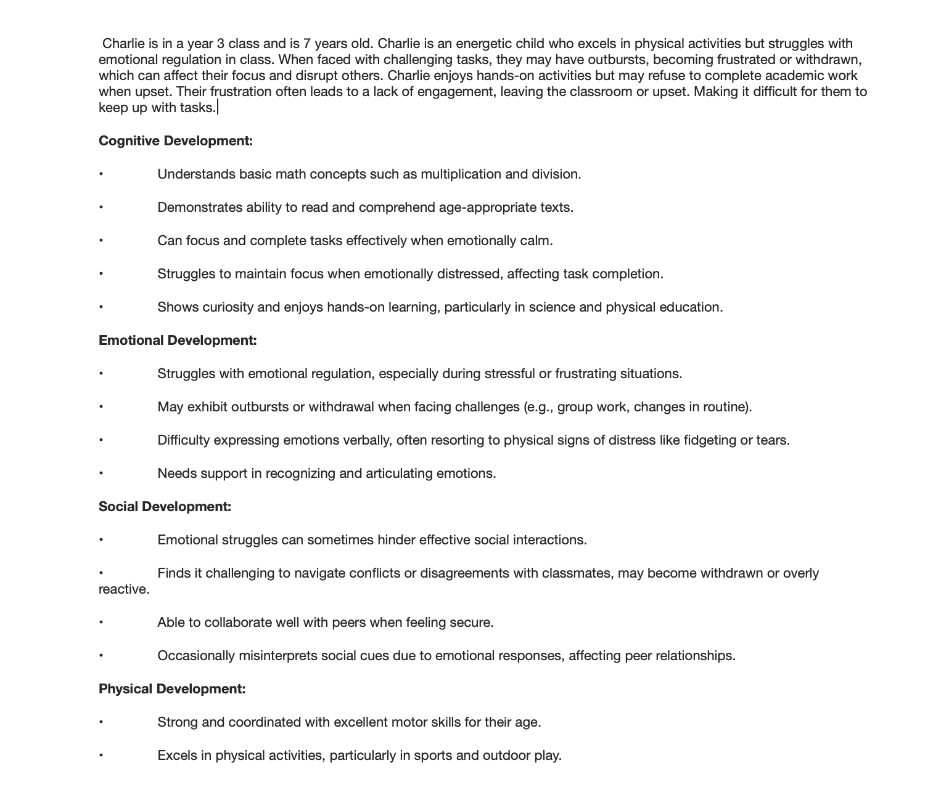
Appendix 2


