Combustion and Emissions Study: Modelling Fuels and NOx
Powertrain and Sustainability (M6X01206)

University of Wales Trinity Saint David, School of Engineering
BEng Motorcycle Engineering (4 Year Course)
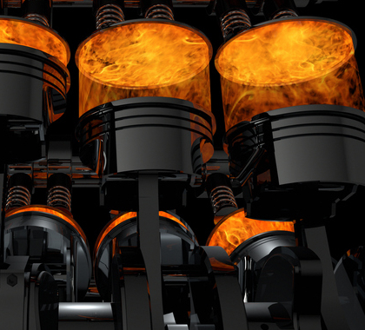
Table of Contents
1 Task 1: Methanol:Iso-Octane Blended Fuel 1
1.1 Mass Percentages 1
1.2 Air:Fuel Mass Ratio for Stoichiometric Combustion 1
1.2.1 Balancing the Individual fuel Stoichiometric Combustion Equations 1
1.2.2 Balancing the “multi-part fuel” Stoichiometric Combustion Equations 2
1.2.3 Air Fuel Mass Ratio 2
1.3 Lower Heating Value of Blended Fuel 2
1.4 Enthalpy of Formation 3
1.5 Heating Values and the differentiation between them 3
1.6 CO₂ Production per Kilogram of Combusted Products 3
1.7 An Ideal Fuel 3
2 Task 2: NOx Production Modelling using the Simple Zeldovich Model 4
2.1 NO_{x} Production in “Leaner” than Stoichiometric conditions 4
A Brief Explanation of Hess’ Law 4
2.2 Methodology for input values of basic NO_{x} estimation model (Zeldovich model) 4
2.2.1 Components of Combusted products 5
2.2.2 Net Enthalpy from Flame Temperature 5
A Brief Explanation of Excels Goal Seek Function 7
2.2.3 Concentrations of O₂ and N₂ 8
2.3 The Zeldovich model 9
2.4 Exhaust Gas Recirculation 10
2.4.1 Components of combusted products 10
2.4.2 Repeat prior steps 10
2.4.3 Reduction in NOx production with EGR 10
3 Results 11
3.1 Overview 12
3.2 Major Assumptions Seen 13
4 References 13

Task 1: Methanol:Iso-Octane Blended Fuel

Mass Percentages
The Mass percentage of each fuel in the blend was calculated using the following equations/method:
$$Total mass of 2kmol of 50:50 blend= Molar Mass of Iso-Octane+Molar Mass of Methanol$$
$$Mass percentage of each fuel in 50:50 blend= \frac{Molar Mass of Individual Fuel}{Total Molar Mass of 50:50 Blend}$$
Using the following values this method returned the results shown for the mass percentage of each fuel:
$$Molar Masses: Iso-Octane=114.23\frac{kg}{kmol} Methanol=32.04\frac{kg}{kmol}$$
$$Total Molar Mass of 50:50 Blend=\frac{114.23}{2}+\frac{32.04}{2}=73.135\frac{kg}{kmol}$$
$$Iso-Octane Molar Mass Percentage=\frac{57.115}{73.135}=0.781=78.1\%$$
$$Methanol Molar Mass Percentage=\frac{16.02}{73.135}=0.219=21.9\%$$

Air:Fuel Mass Ratio for Stoichiometric Combustion
The Air:Fuel Mass Ratio for stoichiometric combustion of fuel in the blend was calculated using the following method found in “Fundamentals of Combustion Processes” Chapter 2: 2.2 Page 18,19 for the balancing of stoichiometry equations relating to multi-component fuel blends (McAllister S, 2011):

Balancing the Individual fuel Stoichiometric Combustion Equations
$$Iso-Octane :C_{8}H_{18}+x\left(O_{2}+3.76N_{2}\right)→n_{1}CO_{2}+{n_{2}H}_{2}O+n_{3}N_{2}$$
$$n_{1}=8 n_{2}=\frac{18}{2}=9 n_{3}=x×3.76 ∴2x=2n_{1}+n_{2} so if x=12.5 n_{3}=47$$
$$∴Iso-Octane: C_{8}H_{18}+12.5\left(O_{2}+3.76N_{2}\right)→8CO_{2}+9H_{2}O+47N_{2}$$
___________
$$Methanol:CH_{4}O+x\left(O_{2}+3.76N_{2}\right)→n_{1}CO_{2}+n_{2}H_{2}O+n_{3}N_{2}$$
$$n_{1}=1 n_{2}=2 n_{3}=x×3.76 ∴2x=2n_{1}+n_{2} so if x=1.5 n_{3}=5.64$$
$$Methanol:CH_{4}O+x\left(O_{2}+3.76N_{2}\right)→CO_{2}+2H_{2}O+5.64N_{2}$$

Balancing the “multi-part fuel” Stoichiometric Combustion Equations
$$Iso-Octane :0.5(C_{8}H_{18}+12.5(O_{2}+3.76N_{2})→8CO_{2}+{18H}_{2}O+47N_{2})$$
$$Methanol: 0.5\left(CH_{4}O+1.5\left(O_{2}+3.76N_{2}\right)→CO_{2}+2H_{2}O+5.64N_{2}\right)$$
$$Combined :0.5C_{8}H_{18}+0.5CH_{4}O+x\left(O_{2}+3.76N_{2}\right)→n_{1}CO_{2}+n_{2}H_{2}O+n_{3}N_{2}$$
$$n_{1}=4+0.5=4.5 n_{2}=\frac{11}{2}=5.5 n_{3}=x×3.76 ∴2x=2n_{1}+n_{2} so if x=7.25 n_{3}=27.26$$
$$Combined :0.5C_{8}H_{18}+0.5CH_{4}O+7.25\left(O_{2}+3.76N_{2}\right)→4.5CO_{2}+5.5H_{2}O+27.26N_{2}$$

Air Fuel Mass Ratio
Conventional Atomic weights (Wieser M, 2010):
$$A_{r convetional } :Oxygen=15.999 Nitrogen=14.007 Carbon=12.011 Hydrogen=1.008$$
$$AFR Mass Ratio= \frac{7.25(2×15.999+3.76×2×14.007)}{4.5×12.011+5.5×1.008}=16.707$$

Lower Heating Value of Blended Fuel
The ‘Lower Heating Value’ of the stoichiometric combustion of fuel in the blend was calculated using the following equations/method:
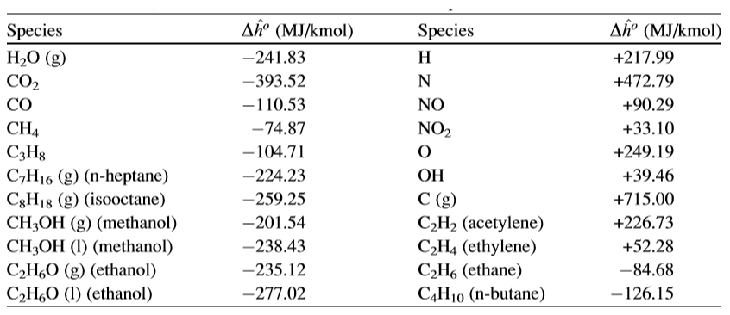
Figure 1:Table of Enthalpies of Formation of Common Combustion Species
$$Enthalpies of formation input to the balanced stoicometry equation:$$
$$0.5C_{8}H_{18}+0.5CH_{3}OH+7.5\left(O_{2}+3.76N_{2}\right)→4.5CO_{2}+5.5H_{2}O+27.26N_{2}$$
$$\frac{259.25}{2}+\frac{201.54}{2}+0+0→4.5×393.52+5.5×241.83+0$$
$$Total Enthalpies of Reactants and Products: 230.37→3100.905$$
$$Total Enthalpy for Combustion for Blended Fuel: 3100.905-230.37=2870.535\frac{MJ}{kmol}$$
$$Lower Heating Value or Enthalpy of Combustion =\frac{2870.535}{73.115}=39.250\frac{MJ}{kg}$$

Enthalpy of Formation
The enthalpy of formation of a substance is the amount of energy required to produce that substance from its individual constituent elements at standard temperature and pressure conditions (denoted by STP) of 25°C and 1atm (298K & 101325Pa). It then therefore it follows that the Enthalpy of Formation value of a substance is the equivalent of the chemical bond energy required to form that substance.

Heating Values and the differentiation between them
In simple terms, the heating value of a fuel is the total amount of heat energy that can be released by complete, idealised combustion with air (at STP conditions). Heating values are commonly grouped into either “Lower Heating Values” (LHV) (also known as “Enthalpy of Combustion”) or “Higher Heating Values” (HHV). The distinction between these values is due to the nature of the state in which the H₂O in the combusted products of the reaction lies; if H₂O exists in its gaseous form in the products then the value is considered to be LHV and if the H₂O exists in its liquid form the value is considered to be the HHV, this is due to the additional energy found in the substance when it is in a liquid state, this additional energy is equivalent to the “latent heat of vaporization” which is a substances energy requirement to change state from liquid to vapor (or substances gas phase below its critical temperature).

CO₂ Production per Kilogram of Combusted Products
At stoichiometric, complete, combustion conditions the amount of CO₂ produce can be estimated using the method below
$$1 kmol of fuel→4.5kmol of CO_{2}$$
$$≡6×10^{26}→4.5(6×10^{26})$$
$$4.5\left(12.011+31.998\right)=198.0405\frac{kg}{kmol}$$
$$\frac{198.0405}{73.115}=2.709kg of CO_{2} per kg fuel burned$$

An Ideal Fuel
An Ideal fuel will possess a set of characteristics allowing for; the fastest possible (within parameters determined by the application), most complete, cleanest, least harmful combustion (to both the environment and the general public/operator) whilst being readily available, easily stored simple to synthesise/produce. To produce these characteristics the fuel should have the highest possible calorific value per kilogram to give the greatest possible power density per unit volume. The fuel should also have the lowest possible ignition temperature (within reason in relation to the application and not below ambient conditions of storage or transport ideally) whilst providing the greatest possible work energy from combustion, the lower the combustion temperature the less NO_{x} production will be seen.

Task 2: NOx Production Modelling using the Simple Zeldovich Model

NO_{x} Production in “Leaner” than Stoichiometric conditions
When air is subjected to the temperatures seen in the combustion chamber (generally considered to be greater than 1600°C) during ignition it will, due to the nature of chemical disassociation of diatomic molecules, begin to form its own reaction products without the need for external input species. This phenomenon can be observed when a fuel is burned in a “lean” condition producing a group of products we group together called NO_{x}. NO_{x} simply indicates a family of products (Nitrogen Oxides) that are the combination of Nitrogen (N) and a number of “Oxygens” (O_{x}) such as NO, NO₂, NO₃…etc. The work shown here only demonstrates the most basic form of NO_{x} production and (when using the Simple Zeldovich Model) only considers two reactions:

A Brief Explanation of Hess’ Law
In a nutshell, Hess’ law states that during a reaction, no matter the number or complexity of stages of reaction, the total enthalpy change of the reaction as a whole must be equal to the sum of the individual enthalpy changes seen during each of the stages of the reaction. Therefore, if we know the enthalpy change seen at each stage of the reaction, we can surmise the overall enthalpy change of the reaction in its entirety. This relationship is used throughout many NO_{x} modelling techniques.

$$O+ N_{2}=NO+N and N+O_{2}=NO+O$$
Obviously, there is a multiplicity of secondary (secondary with regards to the conversion of C_{x}H_{x} translation to CO₂ and H₂O) reactions that can take place due during combustion not just solely between N₂ and O₂ in the methods shown above. Beyond the work shown here (also in the attached Excel lies the “Extended Zeldovich Model” incorporating the reaction of Hydroxides, further Thermal NO_{x} which, using a Dissociation Model interprets forward and reverse reactions seen in NO_{x} production as when the reactants begin to cool the reaction can being to take place in the opposite direction reducing the NO_{x} production seen at the exhaust outlet in relation to the NO_{x} production seen in the combustion chamber. Further again than this there are “Prompt” and “Fuel” NO_{x} models, exploring the reactions of atmospheric nitrogen with the CH radical created during oxidation of the fuel and fuel-bound nitrogen due to the organic compounds that make up a great variety of common fuels and can contribute to the overall NO_{x} produced during combustion.

Methodology for input values of basic NO_{x} estimation model (Zeldovich model)
Overleaf, and in the accompanying Excel workbook, can be found the work done on “lean” NO_{x} production, unlike the first chapter of this report it was felt that an “on-paper” approach would be too complex as there was a large amount of “what-if” (know as a “Goal Seek” function in Excel) style analysis. This type of methodology considers a single-zone model, idealised/adiabatic conditions and only provides a basic over-assumption of produced NO_{x} as it doesn’t consider the further models in 2.1.

Components of Combusted products
This task was undertaken in the same manner as seen in 1.2.1, this method was then applied through a set of fuel equivalence ratios ranging from 1-0.9 in steps of 0.01 and further from 0.9 to 0.6 in steps of 0.05.
$$Calculation of parts of individual combusted component=Stoiciometric number of parts of component produced ×Fuel Equivalence ratio$$
$$e.g. CO_{2}=8 parts produced at stoiciometric ×Fuel Equivalence Ratio of φ0.97=7.76CO_{2}$$

Net Enthalpy from Flame Temperature
This method essentially sets up a feedback loop driven from an initial incorrect flame temp that then feeds back through a “what-if” style analysis to produce the correct flame temp value by changing a set of calculations, the loop follows this pathway:

Figure 2: Feedback Cycle used to calculate Net Enthalpy for Flame Temperature

Whereby each of the titles seen prior pertain to the following sequence:
$$Incorrect input flame temp \left(Flame Temp\right)$$
$$Interpolation for component enthalpies using flame temp\left(Interpolation\right)$$
$$Multiplication of interpolated enthalpies by number of parts in combusted products \left(Individual Enthalpies\right)$$
$$Sum of component enthalpy values at fuel equivalence ratio(Net Enthalpy)$$
$$"What if" analysis to determine at what flame temp the individual enthalpies sum to match the "\text{Ideal Enthalpy}\text{" }(Flame Temp)$$

“Ideal” Net Enthalpy
This is an intermediary step taken to allow the use of a specific function that allows for the calculation of flame temperatures seen during combustion that will be used to calculate NO_{x} Parts Per Million later in this model. The “Ideal” Enthalpy is calculated using the following equation :
$\text{Ideal }Net enthalpy=Input Enthalpy from fuel-\left(Enthalpy of CO_{2} in combusted products+Enthalpy in H_{2}O in combusted products\right)$

Polynomial Interpolation of Enthalpy Values
This was undertaken by importing tables of the style shown below to Excel and then taking a 6th order polynomial interpolation of the enthalpy values (denoted by ĥ-ĥ⁰) at the required flame temperature:
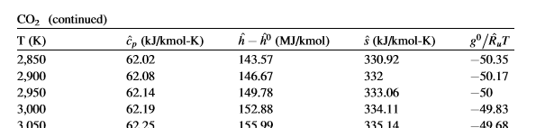
Figure 3: Example section of table showing enthalpy values at varying temperatures

Individual Enthalpies
Each enthalpy value for each individual component found during the polynomial interpolation then is multiplied by the number of each individual component seen in the combusted products to provide a total enthalpy value for that component, for example here is the Individual Enthalpy calculation taken from the Excel workbook for CO₂ at φ1.00:
$$Polynomially interpolated enthalpy value of CO_{2} at specific flame temperature ×Parts of CO_{2} seen in combusted products=Total Individual Enthalpy of CO_{2} in combusted products$$
$$115.175247MJ @2390.303K ×8.00=921.402MJ$$

Net Enthalpy
The Net Enthalpy value is then simply the sum of all the Individual Enthalpies seen in the prior section (2.2.2.3), again, from the Excel workbook at φ1.00:
$$CO_{2}+H_{2}O+O_{2}+N_{2}=Net Enthalpy$$
$$921.402+838.918+0+3304.681=5065MJ$$

What-if analysis (Goal Seek)
This final step in the calculation of net enthalpy via flame temperatures is the key to correcting all other previous steps and giving workable data for the calculation of NOx further in the model.
Due, to the nature of Excels Goal Seek function the value that is to be the goal has to be input manually, due to this it can be a very laborious process to “seek” large ranges of data using this tool, to this end a “Macro” was used to modify the base VBA code of the Goal Seek function to allow for larger ranges of data to be selected to speed up the process of correcting the flame temperatures thus the Individual Enthalpies/Net Enthalpy needed for further calculations in the model.

A Brief Explanation of Excels Goal Seek Function
The “Goal Seek” function uses a what-if style analysis to set a value of a cell to a specified value by changing a cell that drives the calculation of the original cell. So, in the case of the calculations found here the function changes the “Net Enthalpy” to the value of “Ideal Enthalpy” by changing “Flame Temperature”.
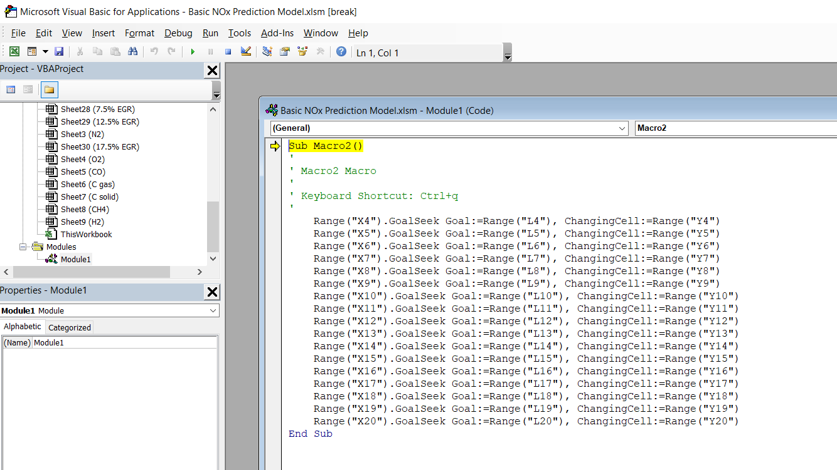
Figure 4: VBA code used to modify the Goal Seek function to accommodate faster processing of data through the Fuel Equivalence Ratio range
Essentially, what this code does is changes the need to input the value into the Goal Seek function tool and, if the correct format is followed, simply pressing [Ctrl] and the [q] key will carry out the what-if analysis for all of the values through the fuel equivalence range.

Concentrations of O₂ and N₂
To calculate the overall NOx produced the concentrations of O₂ and N₂ must first be known. To find these values the starting point is to find the overall amount of substance involved in the reaction this value is known as the alpha value (α), this value represents the number of kilo-moles in the mixture. To calculate this value the following equation must be used:

Swallowing Capacity
Firstly the total amount swallowed by each intake (kmol), denoted as “n” must be found and can be described by the Ideal Gas Equation:
$$n=\frac{PV}{RT}$$
$$P=Ambient Pressure in Pascals$$
$V=Volume of combustion area \left(Clearance or Head Volume ×Volumetric efficieny of the motor\right) in cubic centimeters$
$$R=Universal Gas Constant$$
$$T=Ambient Temperature in Kelvin$$

Alpha Value (α)
The “alpha” variable provides a multiplier that can ensure that the total number of kmols in the reaction remains balanced throughout the change in fuel equivalence ratio this is better explained by the equation shown below:
$$α(φC_{8}H_{18}+12.5\left(O_{2}+3.76N_{2}\right)→α(n_{1}CO_{2}+n_{2}CO+n_{3}H_{2}O+n_{4}N_{2})$$
If either side of the reaction must be equal to the total swallowing capacity of the system ($n$), it can be rearranged to show the value of alpha:
$$α=\frac{n}{φ+12.5\left(1+3.76\right)}$$
As can be seen here, the value of alpha will change with fuel equivalence ratio and thus changing the equations relating to it relative to the reduction of fuel in the reaction.

Concentrations
Now the coefficients representing the respective concentrations can be calculated using the following equation:
$$Concentration Coefficient= \frac{Parts of component in combusted product×α}{Clearance or Head Volume}$$
These Concentration Coefficients (O₂ or N₂) are the final step needed to begin actually applying the Zeldovich Model.

The Zeldovich model
Once all the prior steps have been undertaken the application of the Zeldovich model can be undertaken. The equation used for this basic iteration of the Zeldovich model is thus:
$$NO_{x}Production= Gas Kinetic Collison Rate ×Concentration Coeff. N_{2}×Concentration Coeff. {O_{2}}^{0.5}×\exp\left(\frac{Energy required for reaction}{R×T}\right)$$
To provide a reasonable estimation of NOx production the model will uses the assumption of a pressure increase of 2 bar per degree from 10bar to 40bar over a 15-degree crank angle rotation event from combustion start. As the equation above will output a value in relation to kmols/m³/second, volume and time components must be added to produce data in the desired format.
The revised equation appears as so:
$$NO_{x}Production per degree of crank rotation=\left(\frac{NO_{x}Production}{Time per degree of crank rotation}\right)×Clearance or Head Volume$$
The only remaining unknown is the burn zone temperature value at a given crank angle during combustion (T) and, through rearrangement of the Adiabatic, Ideal Gas, Expansion equation this value can be determined like so:
$$T_{2}=\left(\frac{P_{2}^{γ-1}}{P_{1}^{γ-1}}\right)×{{(T}_{1}^{γ})}^{\frac{1}{γ}}$$
This allows the calculation of NOx per degree at each individual fuel equivalence ratio. If the sum of the NOx per degree is then calculated over the combustion event for each fuel equivalence ratio (NOx per cycle) there is only one final step in calculating the NOx Parts Per Million in combusted products and that is that the total amount of combusted product must be calculated to allow calculation of the content of NOx.
The equation to calculate the total combusted products is simply:
$$\left(Parts of CO_{2}+Parts of H_{2}O+Parts of O_{2}+Parts of N_{2}\right)×α=Total combusted products$$
This then coupled with the sum of NOx per each degree of combustion event at each fuel equivalence ratio will provide the NOx PPM value at each fuel equivalence ratio as so:
$$\frac{NOx per cycle}{Total combusted products}=NOx parts per million$$

Exhaust Gas Recirculation
The primary reason for recirculating exhaust gasses back into the combustion chamber each cycle is to reduce in-cylinder temperature to reduce the overall NOx produced per cycle, as can be seen by the results in the accompanying Excel workbook the greater volume of EGR the lower the flame temperatures seen and thus the lower the PPM of NOx produced.
The methodology used for calculating this EGR effect on combustion is as follows:

Components of combusted products
Much the same as 2.2.1 the parts of the individual combusted components must be calculated:$$Calculation of parts of individual combusted component=Stoiciometric number of parts of component produced ×Fuel Equivalence ratio$$
Once this has been done the result must be multiplied by the level of EGR being applied like so:
$$Calculation of parts of individual combusted component incliuding EGR=Calculated parts of individual combusted component×(EGR percentage+1)$$

Repeat prior steps
Once the number of combusted components with respect to EGR has be determined the steps seen in sections 2.2 and 2.3 can be carried out in the same manner, being careful to remember to re-calculate flame temperature and net enthalpies.
A point of note here is that for the purposes of this work the “alpha” has been left the same as with zero EGR, this is using the assumption that the additional products can fit into the working of combustion to allow an increase in the O₂ and N₂ concentrations inline with the EGR addition.

Reduction in NOx production with EGR
This simple calculation allows for the percentage improvement/reduction comparison over 0%EGR in NOx that EGR displays:
$$\frac{Average NOx PPM @ 0\% EGR-Average Nox PPM @ x\% EGR}{Average NOx PPM @ 0\% EGR} ×100$$
A table of the values calculated can be seen in the excel workbook in sheet “EGR NOx PPM Comparison”.

Results
The following graphs provide the overview of results found during this model:

Figure 5: Graph of NOx Production at differing fuel equivalence ratios against EGR fraction in lean burn conditions

Figure 6: Graph displaying the relationship between EGR and NOx production

Overview
The graphs prior re-affirm the points made throughout the methodology that:
- Increased EGR reduced NOx production significantly, in the case of the cases shown, up to +90%.
- At lower fuel equivalence ratios where flame temperatures are lower the level of NOx production is reduced. An interesting caveat to this rule is that as the fuel equivalence ratio is reduced there is a higher concentration of O₂ to bond with the Nitrogen in the reaction but due to the lower temperatures there is less energy in the system create these bonds, there is a “cross-over” point in these two counter-acting situations at φ0.97 where the “sweet-spot” for maximum NOx production can be seen as there is the greatest possible “free” O₂ in the highest possible temperature to provide energy to allow the creation of NOx, any higher temp and the O₂ level is decreased further, and lower the fuel equivalence ratio (and therefore the O₂ concentration) the less energy in the system to form the bonds.
- When compared to graphs found in Fundamentals of Combustion Processes (McAllister S, 2011) the overall trend is relatively similar (the assumptions made, and further modelling considerations should correct the results seen here more in line with the graph seen below):
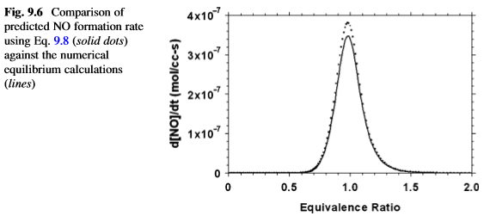
Figure 7: Graph displaying the trend of NOx production at differing equivalence ratios

Major Assumptions Seen
Some of the assumptions made during this work that hinder full analysis or create inaccuracies:
- This method only works in “lean” burn conditions.
- Further NOx production methods not explored.
- “Reverse Reactions” not considered.
- Idealised conditions: Dry air, ambient conditions assumed, “perfect” values for percentage of EGR and Fuel Equivalence Ratio etc.
- Single-zone style of model.
- Values taken from other methods that have conflicting magnitudes across the field, Merker for Activation Energy etc.

References
McAllister S, C. J.-Y. F.-P. A., 2011. Combustion Stoiciometry. In: L. F, ed. Fundamentals of Combustion Processes. Berkeley, CA: Springer Science+Business Media, pp. 17-19.
McAllister S, C. J.-Y. F.-P. A., 2011. Fundamentals of Combustion Processes. 1st ed. Berkeley, CA: Springer Science+Business Media.
Wieser M, C. T., 2010. Atomic weights of the elements 2009. Pure Appl. Chem., 83(2), pp. 359-396.

Figures
Figure 1:Table of Enthalpies of Formation of Common Combustion Species 2
Figure 2: Feedback Cycle used to calculate Net Enthalpy for Flame Temperature 5
Figure 3: Example section of table showing enthalpy values at varying temperatures 6
Figure 4: VBA code used to modify the Goal Seek function to accommodate faster processing of data through the Fuel Equivalence Ratio range 7
Figure 5: Graph of NOx Production at differing fuel equivalence ratios against EGR fraction in lean burn conditions 11
Figure 6: Graph displaying the relationship between EGR and NOx production 11
Figure 7: Graph displaying the trend of NOx production at differing equivalence ratios 12

Enthalpies of Formation for common products and reactants taken from “Fundamentals of Combustion Processes” (McAllister S, 2011).
Species in their most stable form have enthalpies of formation of zero, as seen in the equation above with O₂ and N₂ being represented by an enthalpy of 0 MJ/kmol.
As can be seen in the work undertaken in 2 Task 2: NO_{x} Production Modelling using the Simple Zeldovich Model.
Where a greater volume of air (with respect to fuel) is present during combustion resulting in complete combustion of the fuel without complete use of the air supplied to the reaction.
A further understanding, as this basic work still lies within the field of Thermal NOx production, just in its simplest, most assumptive form.
A “Fuel Equivalence Ratio” value pertains to the volume of fuel in relation to air in the system in relation to stoichiometry. So, in the case of Iso-Octane a fuel equivalence ratio (φ) of 1 would be equal to the fuels stoichiometric Air-Fuel Ratio which is 15.1 parts air to 1 part fuel, therefore it follows that a φ of 0.99 would mean that there is 1% more air than stoichiometric value required as there is the equivalent of 99% of stoichiometric fuel value in the system. This condition of excess air is our “lean” combustion condition.
This value can be totally random as it just allows a “jumping-off” point for the calculation loop to start from.
At each φ value the individual enthalpies must be multiplied by the φ value to provide an accurate “Ideal” Net Enthalpy value.
The curve fit method for this made use of the LINEST and INDEX tools in Excel rather than the inefficient method of plotting graphs to differentiate the curve equation values used for interpolation.
As the work carried out only considers a single kilo-mole of substance the values for enthalpy are shown in MJ only.
The method of calulating “No. of components in combusted product” is shown during 2.2.1.
Here the Polytropic index value of the process is represented by gamma (γ).
The “+1” seen in this equation is just to convert a percentage of EGR into a coefficient for addition of EGR e.g. 5% EGR is 0.05 so to get an addition of 5% a value of 1.05 is required.

