

Health and Functional Fitness Report

For
Wyn Griffiths

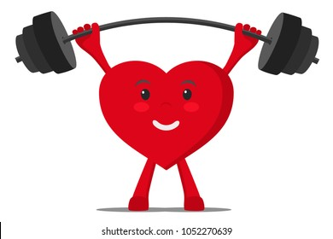

Introduction:

Worldwide, people are living longer, and the World Health Organisation (WHO) predict that by 2050 the number of people aged over 80 will triple. Though we are living longer because of improvements in health care and chronic disease treatment, the ageing process is still associated with some large risks. This report firstly aims to explain what ageing is, how it can affect your daily life and how exercise, along wish a healthy diet, can improve ageing symptoms.
This report will then demonstrate your results in the functional health tests we conducted before and after your 8 week training intervention. This report will give you guidance on how to maintain your current improvements and more importantly, work on the areas that need more attention reducing your risk of early mortality. These results in your tests and the information you provided from your food diary is what have been used to create my recommendations and your goals.

Your health and well-being:
As you age, your health and well-being requirements change. For a healthy and active life in old age, your body must maintain its strength and endurance through physical activity, a healthy diet and good lifestyle behaviours. Your health is comprised of your physical, cognitive, functional, and social performance. Your wellbeing is how happy you are and strongly linked to your life satisfaction. As you age it is harder to maintain the same life as you did before with long trips and days out with the family requiring more thought and planning than before. This can lead to a very secluded life resulting in high levels of loneliness negatively affecting your mental health and wellbeing.
Fortunately, mental and physical health can be improved even in later life through regular physical activity, social interactions and a healthy diet. The risk of developing comorbidities associated with ageing such as diabetes, dementia and cardiovascular disease drop significantly following exercise too.
Following the governments recommended guidelines for nutrition, exercise and sleep will ensure both your physical and cognitive health maintain and even improve. The following section explains what ageing is, how it can affect everyday life and how exercise can (in some cases) reverse to symptoms.

Ageing:
Ageing is considered a chronic disease and is a natural process that effects every part of your life from your metabolism to your muscle’s performance. At the age of 69, you are in early old age, where the effect of ageing is more pronounced than they used to be. To better tackle ageing, a deeper understanding of it will help you understand how regular exercise will benefit you.
What this means for you:
Ageing can affect every part of bodily function. On a cellular level, the membranes and organelles of cells deteriorate resulting is tissue dysfunction. In muscles, this can result in atrophy (the loss of muscle fibres) and increase the rate at which this lost muscle fibre is replaced by fat or fibrous tissue. This loss of muscle fibre, strength and function is known as Sarcopenia. Ageing also influences the bodies balance due to the loss of proprioception from fewer muscle fibres increasing the likelihood of a fall due to being unsteady with poor balance. Your reaction time and bodies reflexes are much slower with age which also has an influence on your ability to regain balance. Ageing also affects the skeletal system as bone tissue tends to lose more calcium than it replaces making the bones more brittle and prone to fractures from even mild trauma. This makes balance even more important as a small fall could result in a broken bone rather than a bruise in later life. The extensive use of weight baring joints such as the knees and hips cause an inevitable erosion of articular cartilage resulting in pain and loss of mobility in those areas.
Ageing unfortunately influences the function of the heart as there is a greater likelihood of atherosclerosis which is the formation of cholesterol on the inside walls of the arteries the older you are. This ultimately decreases the blood flow around the body and increases the blood pressure which strongly increases the risk of cardiovascular disease and other chronic diseases. Your maximum heart rate lowers as you age along with cardiac output making strenuous exercise more difficult and even more simple activities such as walking with shopping bags or climbing stairs can become more problematic.
Functionally, therefore, ageing can have some drastic effects on your quality of life as these ageing symptoms make everyday activities and movements much more difficult than they used to be. For example, driving, getting out of a chair, using stairs, and even standing for long periods of time will start to become too difficult if the correct precautions are not taken.

How does exercise help?
The combination of these ageing symptoms makes every movement less efficient or as easy as they used to be. As mentioned, walking upstairs, reaching for items low or high and walking for a sustained period are common issues faced by the ageing population. Fortunately, regular exercise can help combat all these symptoms of ageing.
By exercising regularly, your muscular system will adapt, and hypertrophy will occur, adding more muscle fibre to your body. This has a wide range of positive associations such as improved strength, speed of movement, proprioception, and balance. These combined, will allow your body to lift itself upstairs more easily, carry more shopping and reduce the risk of falling or other injuries ultimately improving your quality of life. The skeletal system will benefit hugely from resistance training and walking with calcium being added to bones to increase their strength reducing the risk of fractures.
Regular exercise has not only been proven to enhance physical function, but also cognitive function with those who regularly participate in exercise and cognitive stimulation having a much slower decline in cognitive function. This does suggest however, that exercise is not the only answer. Regularly stimulating your brain by reading, learning, or doing cross words alongside exercise will best maintain your brain’s function. As little as one long walk per week (~60 minutes) has been shown to reduce anger, depression and confusion in the ageing population and improve self-esteem reducing the risk of isolation.
The following section demonstrates how the 8 weeks of training you completed improved your strength and functional movements.
Test data:
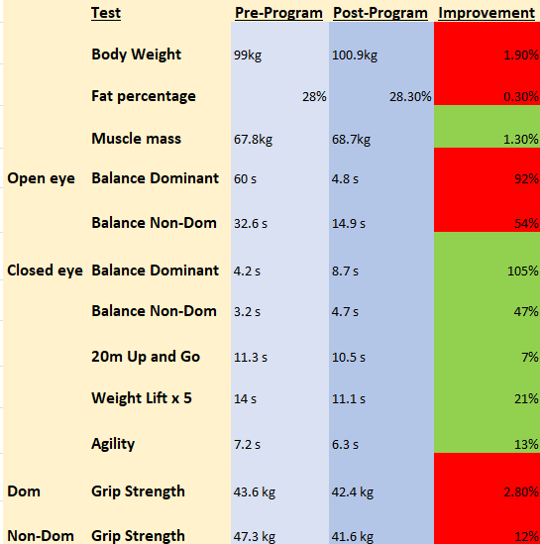
This table shows all the test data we gathered from the tests you completed. Anything highlighted green shows an improvement and anything red shows no improvement.
Results:

The table above shows your test data from the beginning of the 8-week programme, results at the end and how much they changed. These tests were chosen as they replicate common movements for somebody your age such as getting in and out of a chair, walking and lifting items on or off high shelves.
As the table shows, you improved in many of the tests, most notably the functional assessments of the 20m up and go, weight lift x 5 and agility. This is evidence that the 8-week programme you completed did improve your functional capacity and shows you can improve your quality of life through exercise despite the ageing process. The muscle you gained improved your speed and power to move yourself with greater coordination and speed.

AGILITY AND BALANCE

Your balance with closed eyes improved in both legs which is brilliant however, your open eye balance strangely got worse. It is unlikely that your balance with open eyes reduced by that much and the reason for this big drop is most likely poor measurement. We only allowed 1 attempt at the balance, but you were not settled before you started possibly due to the time pressures of the final session. I am sure if you were to retake the balance test, you would score much higher if you were not rushed within a group. Your balance was good at the beginning of the programme, achieving the full 60 seconds on your dominant leg, but you should still focus on maintaining your balance to reduce the risk of falling or tripping especially on your weaker, non-dominant side. Single leg strength work and incorporating one leg balance exercises into your daily routine will improve this without taking too much time out of your day. As I mentioned during the programme, practicing your one-legged balance while waiting for the kettle to boil or microwave to ping will benefit you enormously. The improvements come from your greater leg strength and more muscle fibres improving your bodies proprioception and control.

GRIP STRENGTH

Despite your absolute grip strength lowering, the balance between your dominant and non-dominant hands has improved. Your scores after the programme are still above average for your age group and very close to being considered ‘strong’ (44kg). this shows that your strength is not something you need to worry about as in every resistance machine you were lifting heavy weights and as the programme continued, these weights did increase for each exercise. The balance between your dominant and non-dominant sides is important as one side of your body may be weaker and more prone to injuries such as muscle strains. Having imbalanced muscles could also influence your walking gait by unconsciously favouring one side of the body by leaning or over striding which can cause more issues further down the line. Lowering the weight on machines and doing single leg or arm work will avoid you favouring one side of your body during a movement at the gym and improve both sides of the body at the same rate.

BODY COMPOSITION

This is where you wanted to see improvements and what I think you should tailor your training toward. The body composition results show that most of the weight gained over the 8-week period was muscle mass which is further evidence that you got stronger. However, when the goal is total weight loss, this becomes less of a positive. A body fat increase of 0.3% is only small and a body fat percentage of 28.3% still puts you in the overweight category. Therefore, focusing your training on cardiorespiratory work, walking, and cycling more often and limiting your resistance raining to twice per week will target weight loss much more than your current training while still maintaining your strength. Obesity is associated with a higher mortality rate, diabetes, back problems, and mental health issues making it a high priority issue for you but with your motivation to exercise and the right goals, it will be easy for you to start losing fat mass.

Lifestyle and behaviours:

You live an active lifestyle and with your weekend long walks and weekly gym routine, you are meeting American College of Sports Medicine’s (ACSM) guidelines for your age group for strength training (2 resistance training sessions per week and 150-300 minutes of moderate intensity exercise). However, due to the time of year when we were training, getting outdoors to walk or cycle was understandably not something you were doing too often. Because of this, your training was more resistance based with minimal aerobic exercise suggesting you may not be meeting the guidelines for moderate exercise. Your body fat percentage was 28% when we met which is considered ‘poor’ by ACSM so starting to hit your ambitions of walking and cycling more often will greatly improve your body fat percentage. With summer fast approaching, these outdoor activities will become more appealing again, however, in the colder, wetter months you still need to avoid a sedentary lifestyle. Using the bikes at the gym, as you do, is a great way to maintain your fitness and lose weight while avoiding the colder weather.
You have good lifestyle behaviours and you expressed an ambition to lose weight and improve your flexibility. As you will be aware, to lose weight, a combination of a healthy diet and regular exercise will offer the greatest benefits. The following section offers guidance on your diet based on the typical food week diary you filled out.

Diet:

As you will be aware, your diet can affect you both positively and negatively. A healthy diet can improve your physical appearance and mental health but without the correct choices, you are at a greater risk of developing chronic diseases such as cardiovascular disease, type 2 diabetes, cancers and even depression. Over three quarters of the 65-74 years population are overweight or obese showing that the physical activity and diets of this population is generally poor. Public Health England found that the over 65 population were exceeding daily recommendations of saturated fat, sugars and salt but not meeting the requirements of fibre or protein. For a clear guide on portion sizes and what a healthy diet should look like for someone between the ages of 65 and 74, visit the Gov website and find their dietary recommendations booklet. You can follow this link:
https://assets.publishing.service.gov.uk/government/uploads/system/uploads/attachment_data/file/618167/government_dietary_recommendations.pdf
You typically eat a balanced diet however there are areas for improvement. You tend to eat more red meat, butter, bread, and cheese than is advised and some of your meat portion sizes could be reduced. Red meat, butter and cheese are all high in saturated fat which will be stored in the body and increase your risk of early mortality. Bread is very high in carbohydrates and if you are consuming more calories per day than you are burning, you will gain weight. Considering one of your goals is to lose weight, making small changes to these aspects of your diet will help you greatly.
On the other hand, you do have good habits such as avoiding eating any luncheon meats such as salami, cakes and pastries and sugary soft drinks. Avoiding these high fat and sugar products is key if you want to continue to lose weight. Your fruit and vegetable intake are good, but you are not meeting the 5 a day recommendation much like most people your age. This is an issue as ageing causes the digestive system to become less efficient and slow down the process. Fruits tend to be high in fibre and contain vitamins and minerals such as vitamin C and potassium that both promote digestion.
Your alcohol intake of 10 units is within the guidelines (14 units per week) but it is advised that you should keep alcohol free days. Even an average 4% beer contains around 180 calories which is about the same as one slice of pizza. If you do not exercise, these calories will be stored as fat.
Here is a copy of the Eatwell guide that clearly demonstrates the advised portion sizes and food that should be eaten. Just being aware of this guide will help you plan meals that provide you with sufficient vitamins and minerals but do not contain too much fat or sugar.
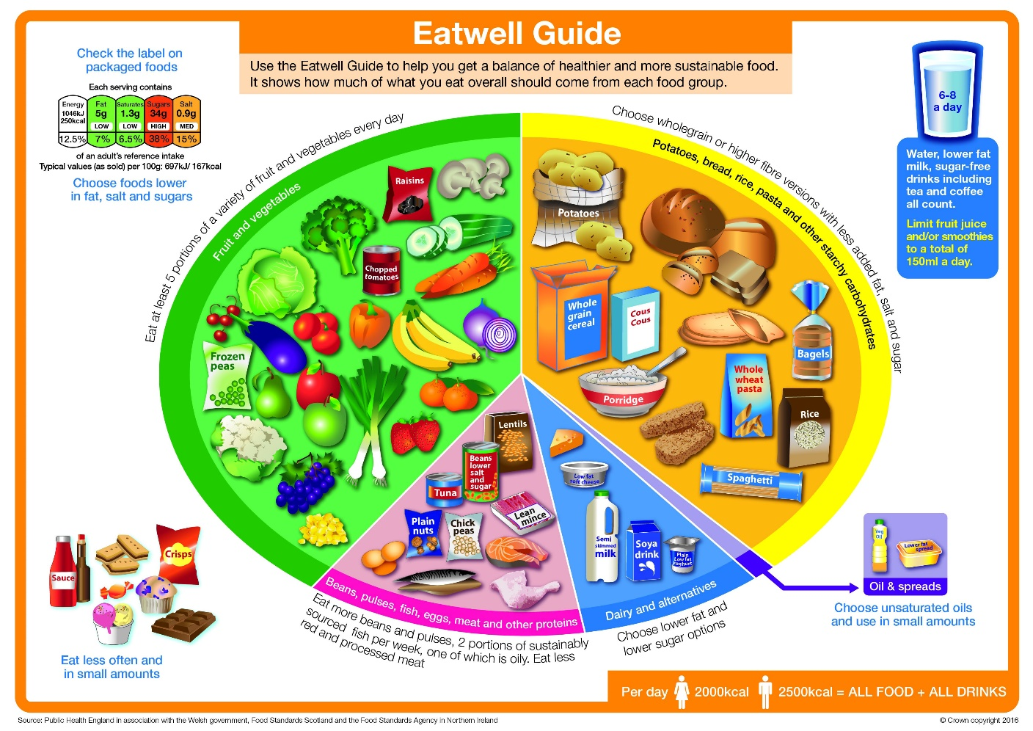

Future recommendations and goals

Overall, these results show you only need to make small lifestyle changes that will make a big difference to your health and wellbeing. In terms of exercise, no more than 2 resistance training sessions per week is enough to maintain and even improve your strength without building too much muscle mass, preventing weight gain. More of your weekly exercise should be aerobically orientated, exercising by walking or cycling. As little as one long walk per week (~60 minutes) has been shown to reduce anger, depression and confusion in the ageing population and improve self-esteem reducing the risk of isolation. You may even want to consider purchasing a pedometer to measure your steps with a goal to eventually reach 10000 steps per day.
Goals like these are important to maintain your motivation and minimise the risk of setting unachievable goals. I would recommend your biggest goal will be to reduce your body fat percentage down to 25% as this will greatly reduce the risks associated with being overweight and place in the ‘fair’ category for body fat percentage. Simple changes at home such as using the time it takes for the kettle to boil and the microwave to ping to productively work on your balance and using the toilet on a separate floor at home (if possible) are great ways to increase your steps per day and reduce your risk of falling. However, you need to be both training regularly and eating healthily to best combat ageing.
You expressed great ambition with your diet saying you are sure you can limit fast food, bacon and sausages, salad dressing servings and sweet items like biscuits and doughnuts. Acting on these ambitions is a great way of reducing your fat intake and aiding your weight loss. As mentioned before, reducing your butter, bread, cheese, and red meat intakes will also improve your diet.
Organisations such as “Walking for Health Wales” provide free weekly walks all around the UK to help motivate the elderly to leave their homes and continue to be social and active. Find their website here if you are interested: https://www.walkingforhealth.org.uk/get-walking/walk-us/health-walks-wales-and-scotland

