
By
Steph Challenger
2115980

Lecturer: Katie Gardner

23 January 2023

Learning support report -ALN and Inclusive practice
Contents
Part 1 3
Part 2 6
Megan’s Support Statement 6
Dafydd’s Support Statement 7
Alys’ Support Statement 9
References 10

Learning Support Report

Part 1
The Equality and Diversity policy at my placement in Neath Port Talbot college states that following this policy helps the college accomplish its ongoing progress of becoming an inclusive college that provides appropriate assistance to fulfil all students’ needs (Dunbar and Elms, 2021, p.3). ‘Demonstrate commitment to learners, their learning, safety and well-being’ professional standard links in here by ensuring learners are fully supported and taking appropriate action where required using relevant policies and guidance (Welsh Government, 2017). In compliance with its duties under the Equality Act 2010 (Equality Act 2010), the college will support all of the protected characteristics (Dunbar and Elms, 2021, p.6), these include ‘age, disability, gender identity, marriage and civil partnership, pregnancy and maternity, race, religion or belief, sex and sexual orientation.’ This links in with the professional standard of ‘Value and promote diversity, equality of opportunity and inclusion’ as it is promoting diversity and opportunity and treating all learners and colleagues equally and fairly (Welsh Government, 2017). The disability conditions can include hearing, visual and physical impairment, learning disability and mental health (Dunbar and Elms, 2021, p.12). The college’s aim for this is to make sure that everyone is treated with equity, regardless of whether they have, or are believed to have, any of the protected characteristics (Dunbar and Elms, 2021, p.3), linking in with ‘Demonstrate dignity, courtesy and respect towards others’ professional standard as colleagues are to behave professionally at all times and ensure everyone has an equal opportunity (Welsh Government, 2017). It also links in with the professional standard, ‘Build positive and collaborative relationships’ by ensuring appropriate communication and working to build and maintain relationships (Welsh Government, 2017). The policy declares that any indication of non-compliance will be handled through the college’s disciplinary process and can lead to dismissal for employees (Dunbar and Elms, 2021, p.4). This policy was reviewed in 2021 and scheduled for its next review in 2023, which ties in with most of the professional standards because the policy is checked every two years and updated if necessary to ensure that ALL learners’ needs are fulfilled as different circumstances may change over time. Also, ‘Know how to use evidence and research to improve my practice’ links in because this policy complies with the Equality Act 2010 (Equality Act 2010), and is researched every time this policy is reviewed, along with the professional standard, ‘Critically reflecting to improve learning’ as the college is keeping abreast of the changes where applicable to provide effective support (Welsh Government, 2017).
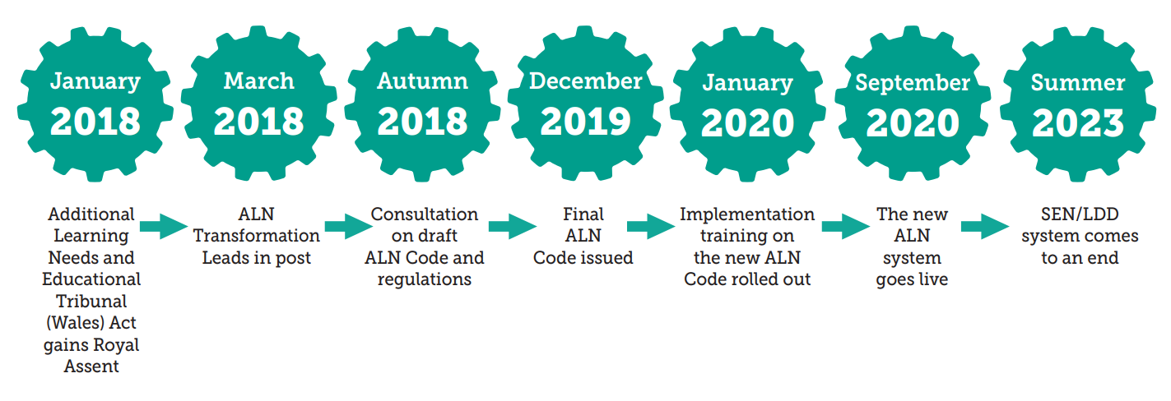
Neath Port Talbot college also follow the Additional Learning Needs Transformation Programme policy provided by the Welsh Government (Welsh Government, 2018). This supports learners from 0 to 25 years old with Additional Learning Needs (ALN). The aim of this is to make sure that all learners with ALN receive the help they need in overcoming learning barriers and reaching their full potential which links in with the professional standards of ‘Demonstrate commitment’ by removing any learning barriers and supporting their needs, ‘Value and promote diversity, equality of opportunity and inclusion’ and ‘Demonstrate dignity, courtesy and respect towards others’ by treating the ALN learners equally and fairly and providing them with opportunities along with listening to and responding positively to them. It also links in with ‘Build positive and collaborative relationships’ and ‘Plan and deliver effective learning, teaching and assessment’ by taking an active role to support the learner and making use of different teaching and learning platforms to support their needs (Welsh Government, 2017). This programme policy creates the legislative framework from the ‘Additional Learning Needs and Educational Tribunal (Wales) Act 2018’ (Welsh Government, 2018). The legislation and statutory guidance of this programme’s policy has eleven aims; the majority of them relate to the IDP (Individual Development Plan) previously known as a ‘statement’, to enable greater learner participation. It also contains the ALN code, providing a set of legally enforced regulations, and a bilingual system that provides ALN learners with the option of learning in either English or Welsh (Welsh Government, 2018). Promoting and supporting this, aligns with the professional standard ‘Understand the importance of the Welsh culture and language as a bilingual nation’ (Welsh Government, 2017).

(Welsh Government, 2018)
The diagram above shows the ALN implementation timeline. This was meant to end in 2021 but due to the Covid-19 pandemic interrupting this, the SEN/LDD system now comes to an end in 2023. The additional learning needs transformation programme policy states that those who work with ALN people are to continue to comply with the Education Act 1996 (Education Act 1996) and the SEN Code of Practice for Wales 2004 (Welsh Assembly Government, 2004) until this programme’s implementation is fully rolled out (Welsh Government, 2018).
The UN Convention on the Rights of Persons with Disabilities 2006 states people with disabilities have a right to an education without discrimination. This Act aims to promote lifelong learning and an equal educational environment as a result of their progress to reach their fullest potential (United Nations General Assembly, 2006). In line with the objective of full inclusion, the Act also makes sure that effective, tailored assistance measures are offered in settings to enhance academic and social development. Similar to the equality and diversity policy at Neath Port Talbot college where they provide appropriate assistance to fulfil all students’ needs. The Act mandates that ‘disability awareness, the use of suitable augmentative and alternative modes, methods, and formats of communication,’ as well as educational strategies and resources to help individuals who have a disability shall be incorporated into teacher training (United Nations General Assembly, 2006). This Act links in with all of the professional standards, some examples are ‘Demonstrate commitment to learners, their learning, safety and well-being’ by supporting the learners’ individual needs and reducing and removing any barriers to learning, ‘Value and promote diversity, equality of opportunity and inclusion’ by providing the learner with an equal and fair opportunity to learn, ‘Demonstrate dignity, courtesy and respect towards others’ by listening to what the learner needs and responding positively to their view, ‘Plan and deliver effective learning, teaching and assessment’ along with ‘Build positive and collaborative relationships’ by creating and planning an effective learning environment to meet the individuals’ specific needs, by doing this builds a positive relationship with the individual and ensures appropriate communication (Welsh Government, 2017).
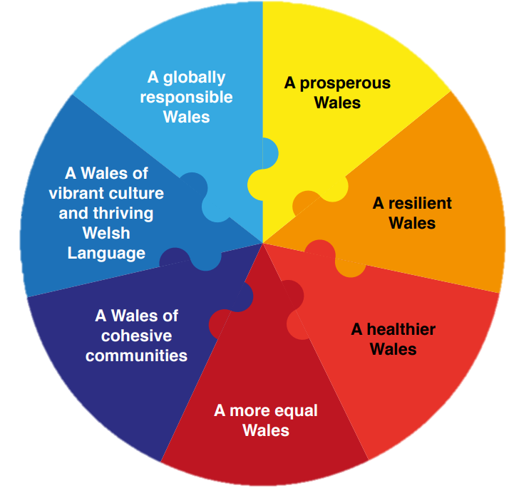
The Well-Being of Future Generations Wales Act 2015 (WBFGA) is to enhance Wales ‘social, economic, environmental and cultural well-being’ to work towards building a Wales that everyone wants to live in, both today and in the future. This Act was introduced since Wales is struggling with some challenges right now, such as social and other issues mentioned above. This Act's goal is to provide a high quality of life for both the present and the next generation (Welsh Government, 2015). Seven well-being objectives are set forth by the Act to ensure that everyone is striving towards the same goal:

(Welsh Government, 2015)
This Act links in with the main professional standards listed in the UN Convention on the Rights of Persons with Disabilities 2006 Act for the same reasons as well as the professional standards of ‘Use evidence and research to improve practice’ as the Act have noted that Wales are struggling with some challenges and therefore the aim of this Act is to improve them and ‘Reflect on values, knowledge and skills to improve learning’ which is exactly what this Act is trying to do, improve things to provide a better future (Welsh Government, 2017).

Part 2
As a PCET practitioner, I will be involved in teaching and supporting students who have ALN, therefore I need to make sure I keep up to date with my understanding of the various types of ALN by reviewing the information, guidance, and resources created by the Welsh Government and the FEI I am currently on my placement with.

Megan’s Support Statement
Education setting: Further education at Neath Port Talbot College
Course: Computing Level 1 – Year 1
Due to previous tutors mentioning Megan may have dyslexia, the FEI’s (Further Education Institution) responsibilities will be to distinguish any ALN and meet Megan’s needs, create an IDP (Individual Development Plan) and obtain the ALP (Additional Learning Provision) (Welsh Government, 2021). This may also identify if Megan has ADHD (Attention Deficit Hyperactivity Disorder) as she has mentioned that she finds it hard to concentrate in class and is unable to maintain attention on the information being taught. If any Additional Learning Needs are identified, as a PCET teacher I would follow the ALN policies and code, as well as the college’s Equality & Diversity policy. Additionally, what support is needed and what can be done to give Megan that support should all be noted in Megan’s IDP along with a description of her ALN/s. The FEI may look at providing an ALNCo (ALN Coordinator), whose job it is to organise ‘planning and interventions around ALN,’ the additional learning needs and education tribunal Wales Act 2018 states (Welsh Government, 2018). As for Megan declaring mental health, the Mental Health Act 1983 states ‘anxiety could lead to harm to self or others,’ therefore, as a PCET teacher, I would be alert to early signs of escalating risk and try to prevent further escalation (Bennett, 2015), also, ‘a risk assessment of personal safety due to increased vulnerability’ is also advised under the Mental Health Act 1983 (Welsh Government, 2016). Megan will be referred to the student services department and the well-being department within the college to help with her mental health.
Whilst in class, I can assist Megan in achieving her full potential during the next academic year, by following her IDP produced by the ALN department in Neath Port Talbot College as well as providing the following support:
Mental health support needs
An open-door policy for students to raise any problems to bring comfort to them in knowing that we are there to try and help as well as listen to them (Barden and Caleb, 2019).
Provide a positive, supportive and secure class environment to enhance belonging and connectedness (Student Support, 2015).
Dyslexia
Incorporate the three learning styles by using visual, auditory and kinesthetic (Reid, 2016). Greater intensity of instruction, checking for understanding regularly and providing extra time for any exams (Welsh Government, 2012 p.38).
The ALN code for Wales 2021 states information should be made accessible. This can be done by using straightforward Welsh or English and removing any jargon, and by creating other versions with an easy-reading font and a different background colour if needed (Welsh Government, 2021 p.62).
Difficult mixing with new people
Set teamwork activities putting Megan in a group with other quiet students at first to help build friendships (Race and Pickford, 2010).
Hard to concentrate
Break up the taught sessions with activities and assessments, breaking things down into smaller tasks to feel more manageable (Welsh Government, 2019).
Create an organised classroom with minimal distractions to help Megan feel focused without adding unnecessary structure and change the classroom seating to ensure Megan is sat at the front of the class, also provide help to organise her work (Welsh Government, 2019).

Dafydd’s Support Statement
Education setting: Further education at Neath Port Talbot College
Course: Computing Level 1 – Year 1
Due to Dafydd having cerebral palsy and partially sighted, the FEI’s responsibilities will be to create an IDP and obtain the ALP (Welsh Government, 2021). The FEI is dedicated to fostering an environment that encourages inclusivity and equality for all students so that they can achieve their fullest potential in their chosen course (Dunbar and Elms, 2021). They should take all reasonable measures to detect and remove learning barriers for students with a disability (Welsh Government, 2018). The FEI also have a responsibility to adapt what they do or were about to do to make appropriate changes to prevent any disadvantages for a young person with a disability. Working out what support is needed and what we can do to give Dafydd that support will be noted in his IDP produced by the ALN department within Neath Port Talbot College. Instead of being removed and separated from the class because of his cerebral palsy, Dafydd would be accompanied by an ALNCo (Welsh Government, 2018). As a PCET teacher, it will be my responsibility to be prepared for medical emergencies by making a plan in advance on what I would need to do and who I would call (Hirsch, 2021).
Along with an ALNCo being provided for Dafydd, as a PCET teacher, I can assist him in achieving his full potential during the next academic year by following his IDP as well as providing the following support within the class:
Cerebral palsy
Provide Dafydd with extra time and support to complete assignments (Flint Rehab, 2020).
Prepare a plan for any missed lessons due to doctor appointments (Hirsch, 2021).
Speak to the head of department about removing the physical barrier of lessons being upstairs due to Dafydd using crutches and getting tired easily, therefore, all Dafydd’s lessons can be taught in a classroom on the bottom floor (Race and Pickford, 2010).
Partially sighted
Dafydd to sit at the front of the class and to ensure lighting is suitable and change background colours on teaching materials if necessary (Welsh Government, 2019).
‘Explore the use of assistive technologies,’ such as a magnifier or a screen reader, or even have the screen zoomed in (Race and Pickford, 2010).
Slow typing speed for note taking and struggles with use of left arm sometimes
‘Explore the use of assistive technologies’ (Race and Pickford, 2010), such as Speech-to-text software (Welsh Government, 2015).
Provide Dafydd with extra time and support to complete activities and assignments (Flint Rehab, 2020).
Change the format of activities and assignments, for example, taking a written test verbally (Flint Rehab, 2020).

Alys’ Support Statement
Education setting: Further education at University of Wales Trinity Saint David (UWTSD)
Course: Computing Level 2 – Year 2
Due to Alys discovering she is pregnant and wants to continue with her studies, the UWTSD’s responsibilities will be to create an IDP and obtain the ALP (Welsh Government, 2021). Inclusivity and equality should be encouraged for all students so that they can achieve their fullest potential in their chosen course (Equality Act 2010). Pregnancy is a protected characteristic under the Equality Act 2010. The University believes that having a child or being pregnant should not stop a student from achieving academic success. The University provides as much flexibility to support students’ achievements, ensuring that no student is affected while maintaining academic standards (UWTSD, 2021). Alys will meet with a faculty member from the academic discipline department in UWTSD to talk about how the pregnancy could affect her studies. Depending on the baby’s due date, a study break may be required. A decision will need to be made if a break is necessary and how long of a break will be needed. A student who is expecting a baby around the time of exams may need medical clearance to take the test (UWTSD, 2021). Alys will require regular meetings with a faculty member from the academic discipline department to evaluate the efficacy of any support measures put in place are not compromised. Additional changes can be made as needed. Also, extenuating circumstances can be applied for if Alys’ performance has been affected (UWTSD, 2021). ‘A risk assessment will also be completed by the academic discipline department’ (UWTSD, 2021).
Alys can be referred to the student services department and the well-being department within UWTSD if necessary for support and advice but whilst in class, I can assist Alys by providing the following support:
Pregnant
Be accommodating for doctor/ante-natal appointments (UWTSD, 2021).
Prepare a plan to catch up on work for any missed lessons due to doctor/ante-natal appointments (UWTSD, 2021).
Review any adjustments and make required changes to arrangements if required, for example, a more supportive chair or rest breaks (UWTSD, 2021).
Rearrange exams if necessary (UWTSD, 2021).
‘Ensure Alys is not treated less favourably than any other student on the basis of her circumstances’ (UWTSD, 2021).

References
Dunbar, M. and Elms, C. (2021) Equality & Diversity Policy. NPTC Group of Colleges.
Welsh Government (2017) Professional standards for further education teachers and work-based learning practitioners in Wales. Available at: https://hwb.gov.wales/api/storage/460a740a-7bf1-4c7b-b4ae-348ae380879b/professional-standards-further-education-teachers-work-based-learning-practitioners-wales.pdf (Accessed: December 27, 2022).
Equality Act 2010, c.1 Available at: https://www.legislation.gov.uk/ukpga/2010/15/part/2/chapter/1 (Accessed: December 27, 2022).
Welsh Government (2018) Additional learning needs (ALN) transformation programme. Available at: https://www.gov.wales/sites/default/files/publications/2018-09/additional-learning-needs-aln-transformation-programme-v2.pdf (Accessed: December 27, 2022).
Welsh Government (2018) Additional learning needs and education tribunal Wales Act 2018. Available at: https://gov.wales/sites/default/files/publications/2018-02/additional-learning-needs-and-education-tribunal-wales-act-2018-explanatory-notes.pdf (Accessed: December 27, 2022).
Education act 1996, c.1 Available at: https://www.legislation.gov.uk/ukpga/1996/56/contents (Accessed: December 27, 2022).
Welsh Assembly Government (2004) Special educational needs code of practice for Wales. Available at: https://www.gov.wales/sites/default/files/publications/2018-03/special-educational-needs-code-of-practice-for-wales.pdf (Accessed: December 27, 2022).
United Nations General Assembly (2006) United Nations Convention on the Rights of Persons with Disabilities. Available at: https://www.un.org/development/desa/disabilities/convention-on-the-rights-of-persons-with-disabilities/article-24-education.html (Accessed December 31, 2022).
Welsh Government (2015) Well-being of Future Generations (Wales) Act 2015 Available at: https://www.futuregenerations.wales/wp-content/uploads/2017/02/150623-guide-to-the-fg-act-en.pdf (Accessed: December 31, 2022).
Welsh Government (2021) The Additional Learning Needs Code for Wales 2021. Available at: https://www.gov.wales/sites/default/files/publications/2021-03/the-additional-learning-needs-code-for-wales-2021.pdf (Accessed: January 7, 2023).
Welsh Government (2016) Mental Health Act 1983 - Code of Practice for Wales. Available at: https://www.gov.wales/sites/default/files/publications/2019-03/mental-health-act-1983-code-of-practice-mental-health-act-1983-for-wales-review-revised-2016.pdf (Accessed: January 7, 2023).
Bennett, D. (2015) Fitness to Study Policy. NPTC Group of Colleges.
Barden, N. and Caleb, R. (2019) Student Mental Health & Wellbeing in higher education: A practical guide. Los Angeles: Sage.
Student Support (2015) Safeguarding Children and Vulnerable Adults Policy and Procedure. NPTC Group of Colleges.
Reid, G. (2016) Dyslexia: A practitioner's handbook. 5th edn. Chichester: Wiley-Blackwell.
Welsh Government (2012) Current literacy and dyslexia provision in Wales. Available at: https://www.gov.wales/sites/default/files/statistics-and-research/2019-08/120824-current-literacy-dyslexia-provision-en.pdf (Accessed: January 9, 2023).
Race, P. and Pickford, R. (2010) Making teaching work: "teaching smarter" in post-compulsory education. London: Sage.
Welsh Government (2019) Support for children and young people with Attention Deficit Hyperactivity Disorder (ADHD) in educational settings. Available at: https://www.gov.wales/sites/default/files/publications/2019-01/ways-of-supporting-learners-with-attention-deficit-hyperactivity-disorder-adhd.pdf (Accessed: January 9, 2023).
Hirsch, L. (2021) Cerebral Palsy Factsheet (for Schools). Available at: https://kidshealth.org/en/parents/cp-factsheet.html (Accessed: January 13, 2023).
Flint Rehab (2020) Cerebral palsy in the classroom: How to promote success. Available at: https://www.flintrehab.com/cerebral-palsy-in-the-classroom/ (Accessed: January 13, 2023).
Welsh Government (2019) Support for children and young people with vision impairment in educational settings. Available at: https://www.gov.wales/sites/default/files/publications/2019-12/191209-support-for-children-and-young-people-with-vision-impairment-in-educational-settings.pdf (Accessed: January 13, 2023).
Welsh Government (2015) Assistive technology. Available at: https://www.gov.wales/sites/default/files/publications/2018-03/assistive-technology-guidance-for-teaching-practitioners-to-support-learners-with-specific-learning-difficulties.pdf (Accessed: January 13, 2023).
Welsh Statutory (2021) The Additional Learning Needs (Wales) regulations 2021. Available at: https://www.gov.wales/sites/default/files/publications/2021-03/210329-the-additional-learning-needs-wales-regulations.pdf (Accessed: January 13, 2023).
University of Wales Trinity Saint David (2021) Student Pregnancy, Maternity, Paternity and Adoption Leave Policy. University of Wales Trinity Saint David.

