[Title Here, up to 12 Words, on One to Two Lines]
Ieuan Jones

Contents
[Heading 1] 2
[Heading 2] 2
[Heading 3]. 2
References 4
Appendices 6

Task 1
See Figure 1 for the PowerBi file
For task 1 see Figure 2-3:
Task 1 has asked me to import all the data into PowerBi and remove any extra columns in the Aircraft Type query, As shown in the figures.

Task 2
For Task 2 see figures 4-5
Task 2 has asked me to firstly make the first row a header in the Airline query. As shown in the PowerBi file. It then asked me to replace all the Null values with 0 which I did by doing the replace command and replacing Blank with 0 in the order cost query. I also was able to change the datatype to a Fixed Decimal Number which was asked of me. The airline column has been split.

Task 3
See Figure 6:
Task 3 has asked me to inspect the relationships and shown in Figure 6, there is a relationship between the airline query and aircraft type query to the OrderCost query.

Task 4
See Figure 7-10
Task 4 has asked me to create a bar chart to analyze orders by aircraft types which I have shown, the airbuses have the most orders. I’ve also done a stacked area chart which shows the total cost of various airlines. The American airline incurred the highest cost. I’ve done a yearly trend for the freight in information for different airlines. I made a card visual, and the total number of orders is 9.19k orders.

Task 5
See figure 11.
In task 5 it’s asked for a slicer with a select all option. The slicer can be used to find information based on specific areas you want to find.

Task 6
See figure 12
Task 6 has asked me to find the top 5 Airlines by total cost. I have done this by using a tree map, I had to sort the airlines against the total cost and filter it by Top N and set the number to 5.

Task 7
See figure 13
Task 7 has asked me to create a map visual to show the number of airlines for different countries. This is most likely to help with finding places without many airlines to potentially make one there and get more customers.

Task 8
See figure 14
I have made a matrix visual to show Total Ins and Total Outs for different ports. I’ve also added a %GT to find out which airlines take up what percentage of Total in and outs. This would be useful to find popular airlines.

Task 9
See figure 15
Task 9 has asked me to make a measure to get the variance of freight out. I done this by clicking quick measure and variance then input the freight out data. Then I made a gauge chart.

Task 10
Task 10 has asked me to layout the report as it is shown on the task and make a title which I was able to do.

Appendices
Figure 1:
https://gowercollegeswanseaacuk-my.sharepoint.com/:u:/g/personal/jon20857791_stu_gcs_ac_uk/ETPMdGWdLEFHjwW2yxyWfPkBHyU-qKJKaNT69RSxOhrmBg?email=Catherine.Wilkes%40gowercollegeswansea.ac.uk&e=a4Deb

Figure 2
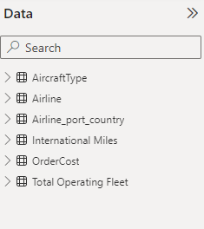

Figure 3:
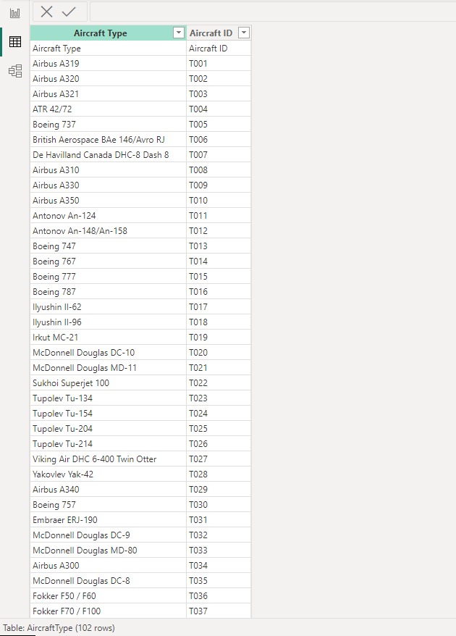
Figure 4:
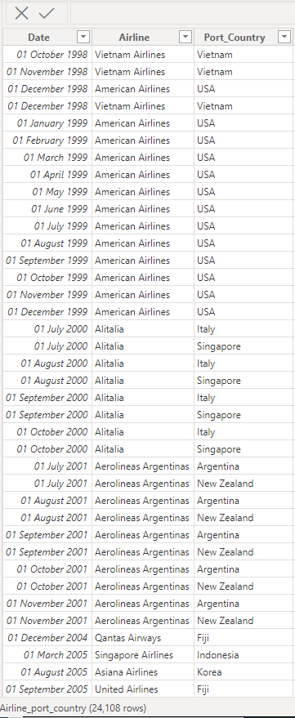

Figure 5:

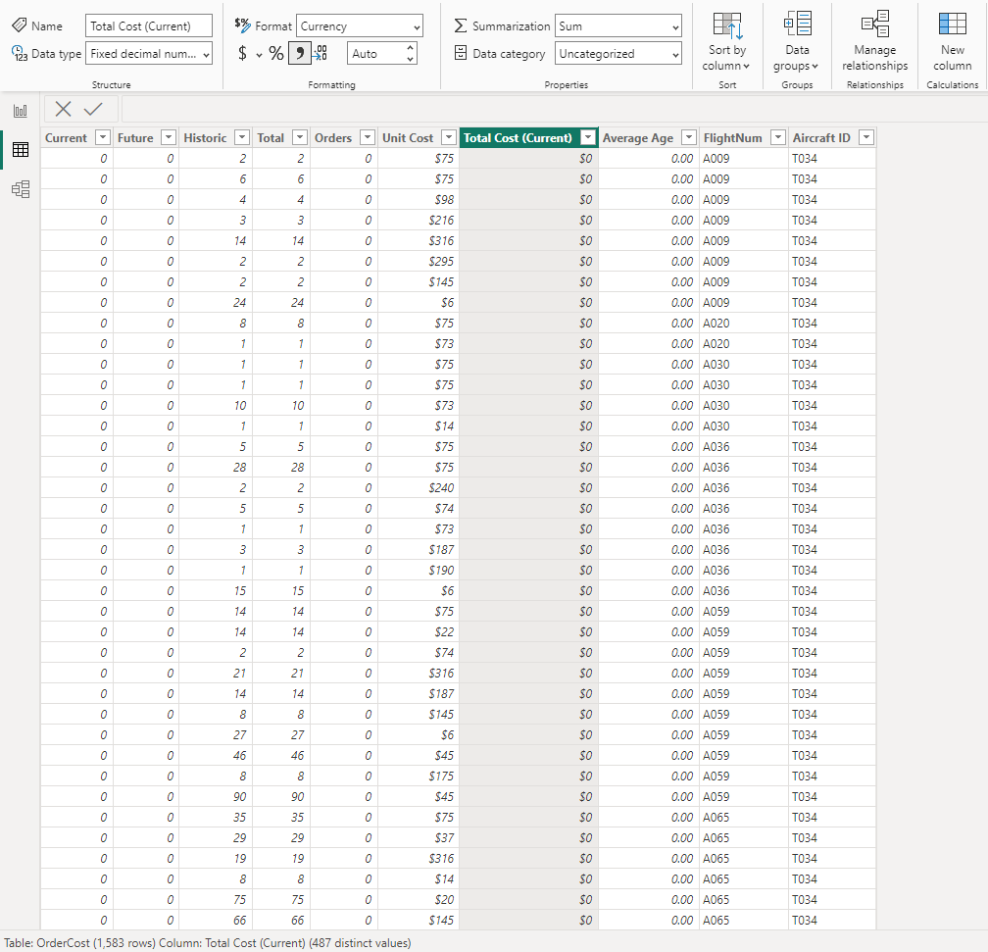

Figure 6:
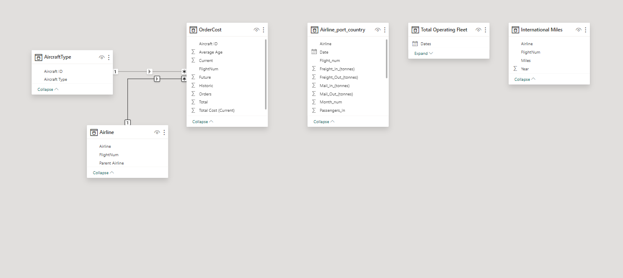
Figure 7: 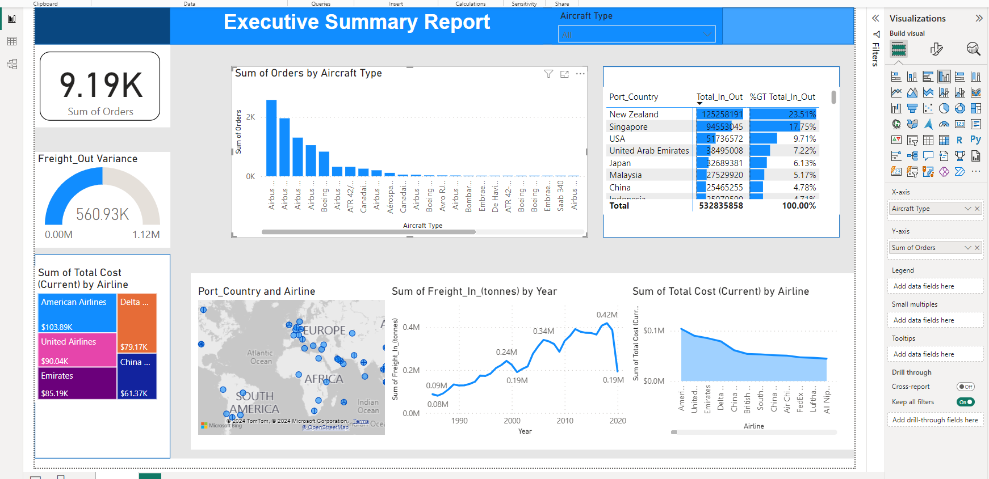
Figure 8:
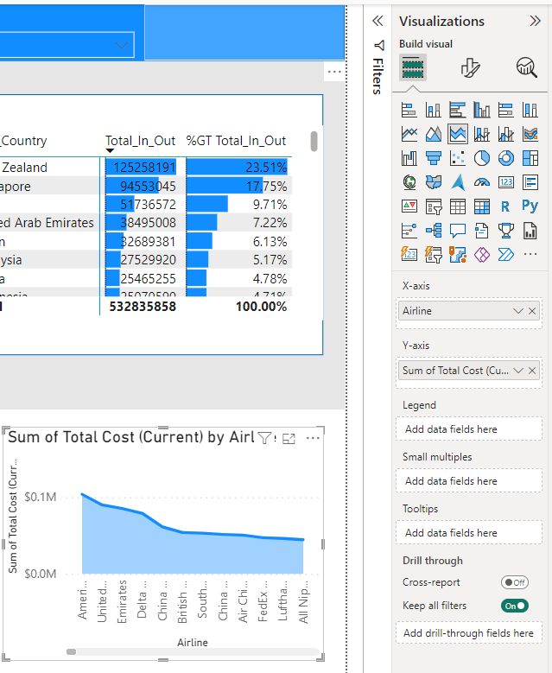

Figure 9:
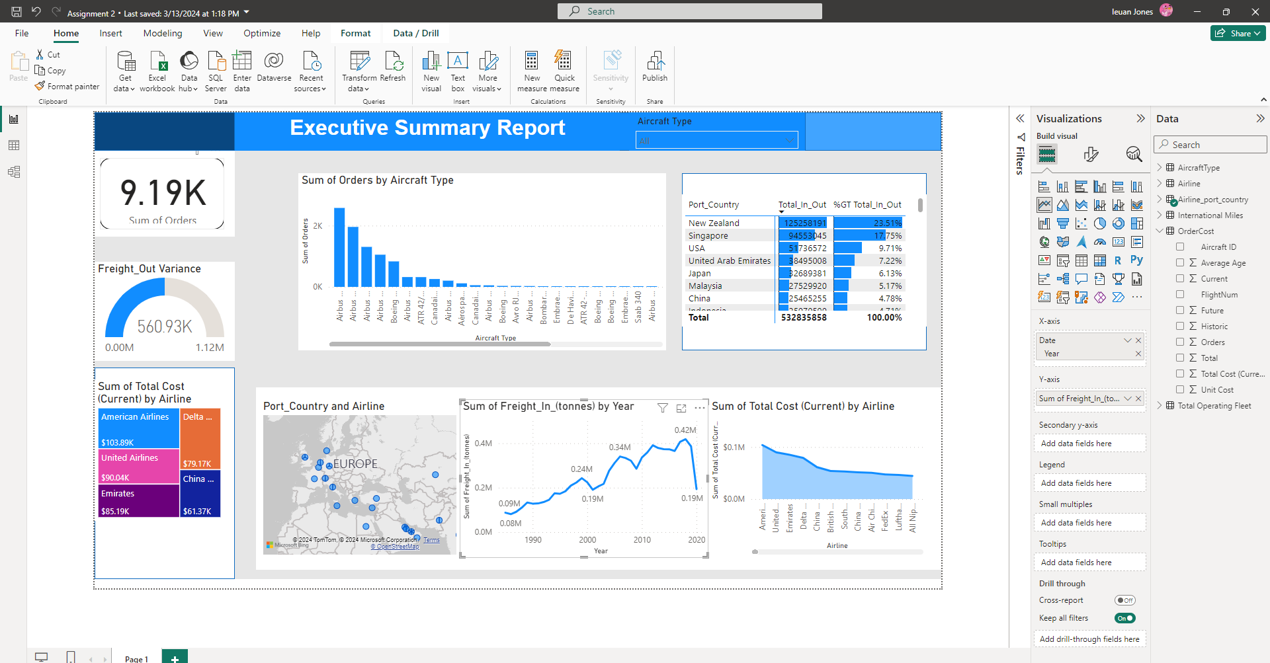
Figure 10:
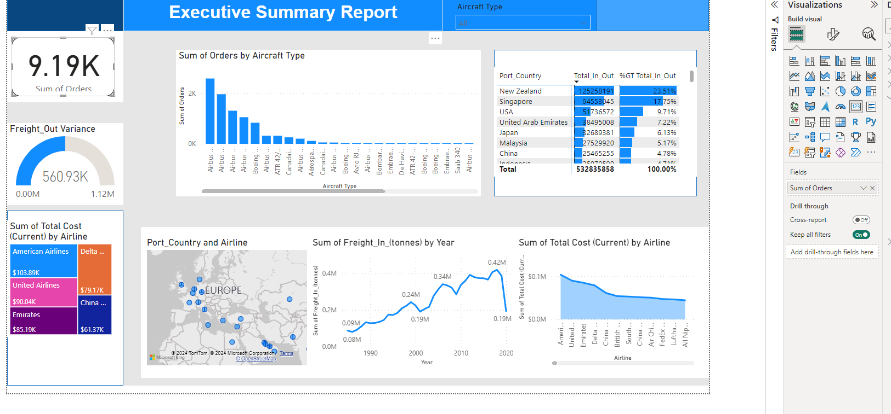

Figure 11:
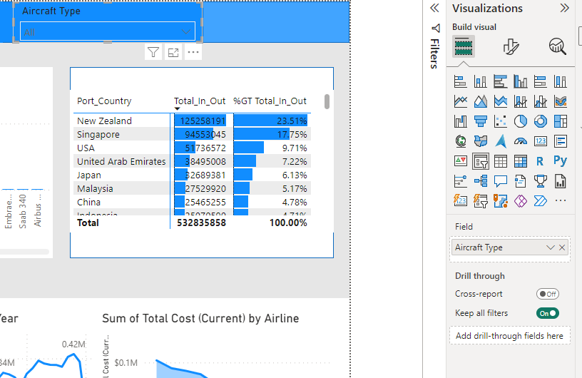
Figure 12:

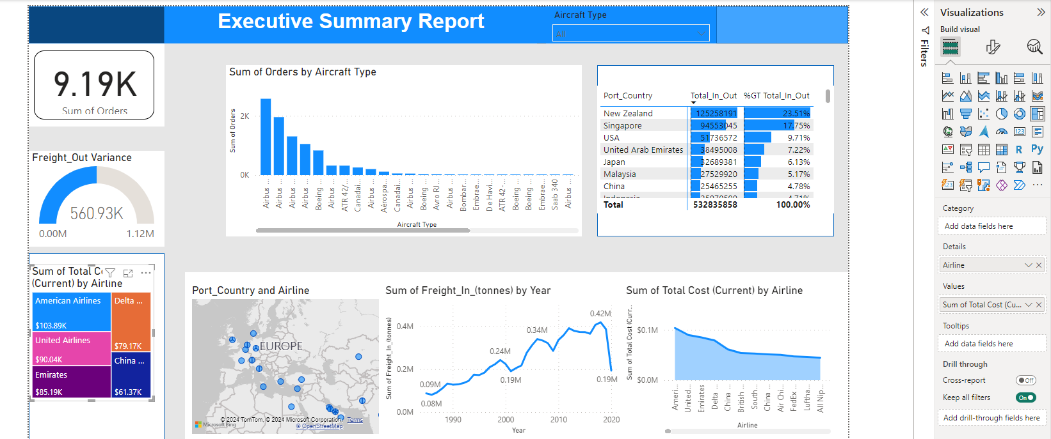

Figure 13:

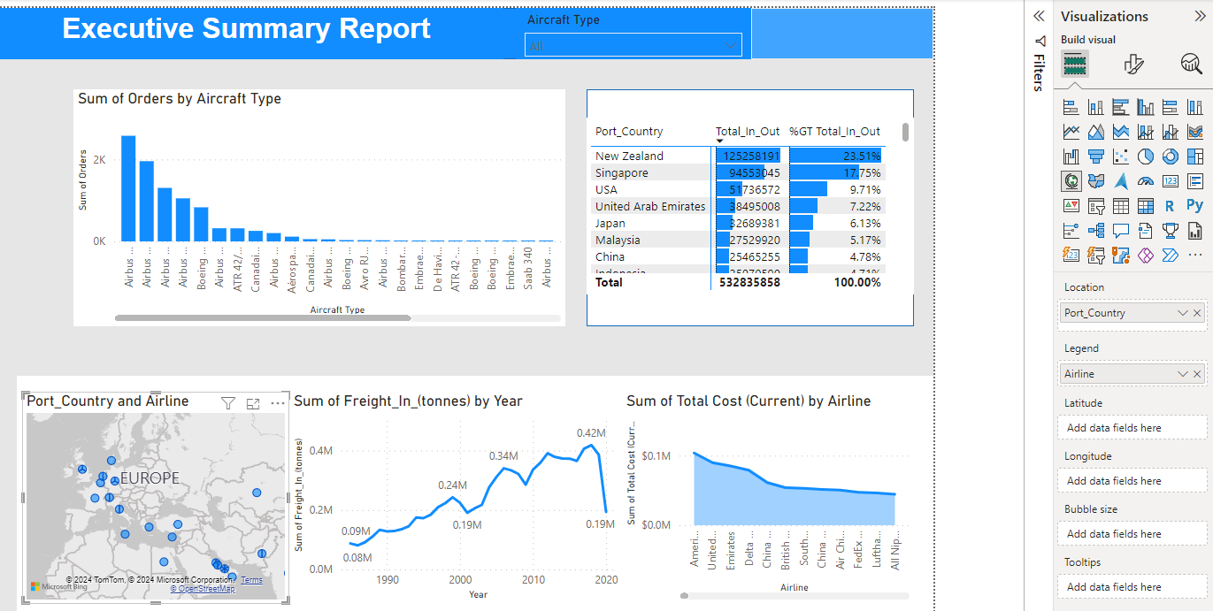

Figure 14:

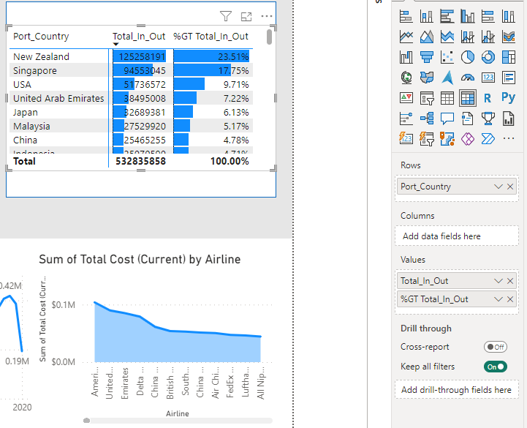

Figure 15:


