Sustainable Practices in the Hotel & Hospitality Industry

Traian Cristian Roibulescu
Student ID : 2215953
Lecturer : Lisa-Marie Bassler
Module : Sustainale Hospitality & Tourism Management BMIH5006
Word count – 2147

Executive Summary: Sustainable Practices in the Hotel & Hospitality Industry

The hotel and hospitality industry is undergoing a significant transformation, prioritizing sustainability in response to growing environmental concerns. Achieving sustainable accreditation, such as the Green Key certificate, has become a marker of a hotel's commitment to environmental stewardship. Key requirements for accreditation encompass energy efficiency, water conservation, waste management, sustainable procurement, and guest education.
Integration of sustainable practices in daily hotel operations yields numerous benefits. Energy-efficient systems, renewable energy sources, and water-saving measures contribute to resource conservation, cost savings, and pollution reduction. Enhanced operational efficiency ensures guest satisfaction and strengthens brand reputation.
Despite these benefits, hotels encounter challenges in integrating sustainability. High initial costs, operational disruptions, staff training, and guest participation pose significant hurdles. However, overcoming these challenges is essential for long-term success and competitiveness.
Looking ahead, the future of sustainability in the hotel industry will be shaped by advancements in green technology, increasing regulatory pressure, and rising consumer demand for eco-friendly practices. Collaboration within the industry and adherence to industry standards will be crucial for driving collective progress towards a sustainable future.

Contents

Sustainable Practices in the Hotel & Hospitality Industry 1
Executive Summary: Sustainable Practices in the Hotel & Hospitality Industry 2
Introduction 4
Key requirements: 5
Challenges of Integrating Sustainability into Daily Operations 12
Initial Costs and Investment 12
Operational Disruption 12
Staff Training and Engagement 13
Guest Perception and Participation 13
The Future of Sustainability in the Hotel & Hospitality Industry 13
Advancements in Green Technology 14
Consumer Demand for Eco-Friendly Practices 14
Integration of Sustainable Practices into Core Business Strategy 15
Collaboration and Industry Standards 15
Conclusion 15
References 16

Sustainable Practices in the Hotel & Hospitality Industry

Introduction
With the growing global focus on environmental issues, the hotel industry prioritizes sustainable practices. Eco-friendly measures are essential for modern hospitality operations, aiming to conserve resources, reduce pollution, and enhance operational efficiency, ultimately improving guest satisfaction and brand reputation. (Melissen et al., 2016). Achieving sustainable accreditation, such as the Green Key certificate, signifies a hotel commitment to environmental stewardship (Rodríguez-García et al., 2023).


Key requirements:
- Energy Efficiency: Installation of energy-efficient lighting and appliances (Pereira-Moliner et al., 2021)
- Implementation of renewable energy sources, such as solar panels (Dos Santos et al., 2017). Use of energy management systems to monitor and reduce consumption (Griffin and DeLacey, 2012).
- Water Conservation: Installation of low-flow faucets, showerheads, and toilets (Font, 2002). Implementation of greywater recycling systems (Dos Santos et al., 2017). Regular maintenance to prevent leaks and optimize water use (Pereira-Moliner et al., 2021).
- Waste Management: Comprehensive recycling programs (Pereira-Moliner et al., 2021).
- Composting organic waste (Dos Santos et al., 2017).
- Reduction of single-use plastics through alternatives like glass or biodegradable materials (Griffin and DeLacey, 2012).
- Sustainable Procurement: Sourcing locally-produced and organic food and beverages (Pereira-Moliner et al., 2021).
- Using eco-friendly cleaning products and toiletries (Dos Santos et al., 2017).
- Opting for sustainably sourced building materials and furniture (Griffin and DeLacey, 2012).
- Guest Education and Involvement: Informing guests about the hotel’s sustainability
- initiatives (Pereira-Moliner et al., 2021).
- Encouraging guests to participate in water and energy conservation efforts (Dos Santos et al., 2017).
- Providing options for guests to opt-out of daily linen and towel changes (Griffin and DeLacey, 2012).

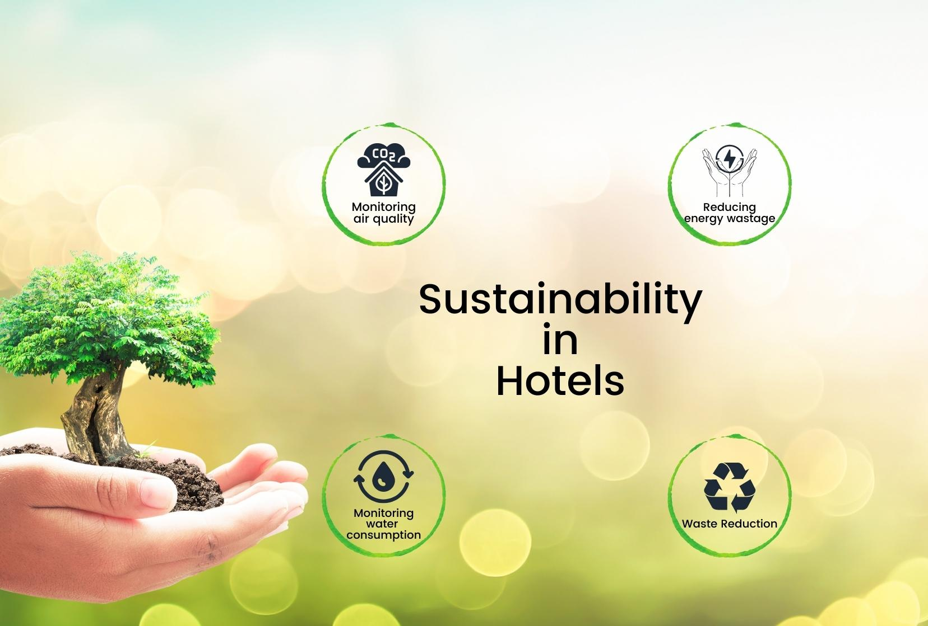

Compliance with Regulations and Standards Hotels seeking sustainable accreditation must comply with relevant environmental regulations and standards.
This compliance ensures that hotels meet the minimum requirements for
environmental performance and often involves:

Environmental Management Systems (EMS): Developing and implementing an
EMS based on ISO 14001 standards (Rodríguez-García et al., 2023). Regular
audits and reviews to ensure continuous improvement (Dos Santos et al., 2017).
Legal Compliance: Adhering to local, national, and international environmental laws
and regulations (Pereira-Moliner et al., 2021). Ensuring proper handling and
disposal of hazardous materials (Griffin and DeLacey, 2012).

Certification Criteria: Meeting specific criteria set by accrediting bodies such as
Green Key, LEED, or EarthCheck (Rodríguez-García et al., 2023). Regular
reporting and verification processes to maintain certification status (Dos Santos et
al., 2017).
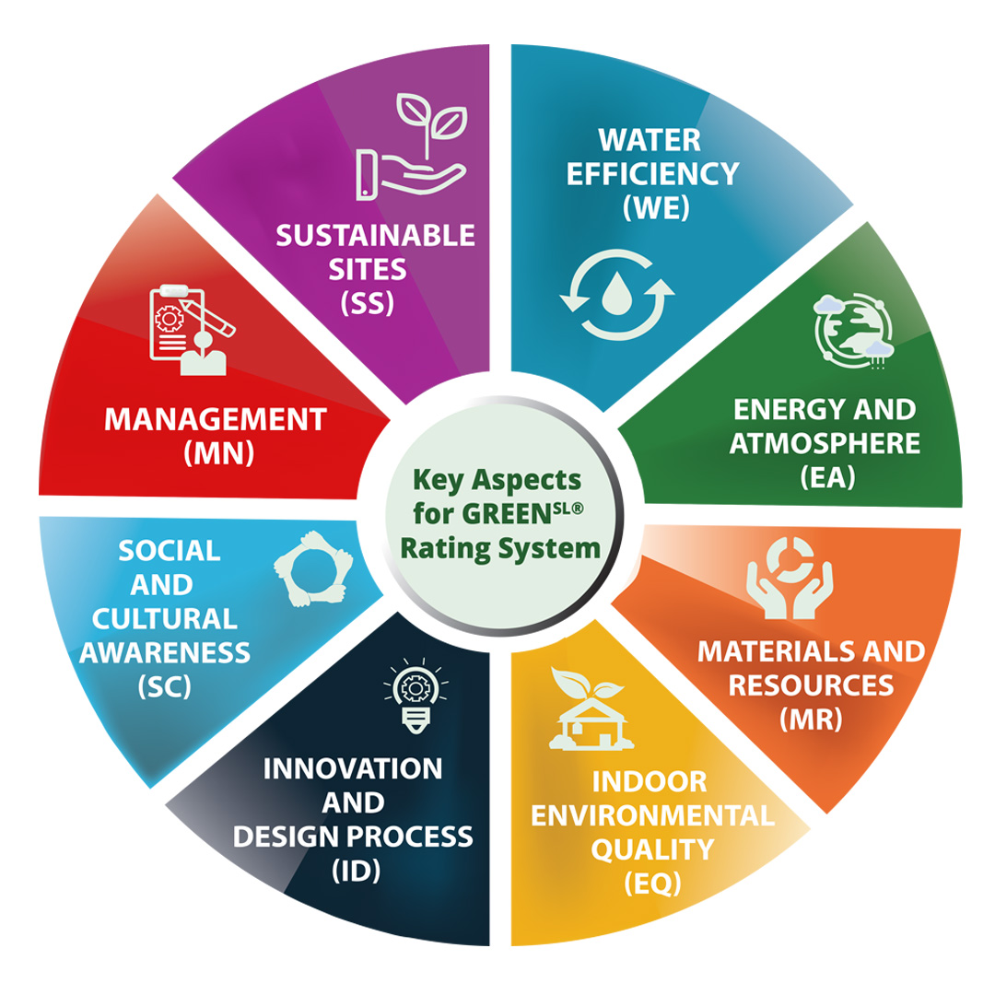
Integrating sustainability in hotel operations conserves resources and saves costs. Energy-efficient systems like LED lighting and advanced HVAC controls reduce electricity use, while renewable sources like solar panels cut reliance on non-renewable energy. (Pereira-Moliner et al., 2021). Water-saving measures, including low-flow fixtures and greywater recycling, drastically cut water usage (Dos Santos et al., 2017). Sustainable procurement, involving eco-friendly products and locally sourced materials, lessens the strain on natural resources (Griffin and DeLacey, 2012).
Eco-friendly practices in hotels reduce pollution and resource depletion while saving costs. Waste management and recycling programs minimize landfill waste and emissions, promoting sustainability. (Dos Santos et al., 2017).
Implementing renewable energy sources, such as solar panels and wind turbines,
allows hotels to generate clean energy and decrease reliance on fossil fuels. This
transition significantly lowers greenhouse gas emissions, which are major
contributors to global warming (Pereira-Moliner et al., 2021). Additionally, using
energy-efficient appliances, including LED lighting and high-efficiency HVAC
systems, further reduces energy consumption and associated emissions (Griffin and
DeLacey, 2012).
Sustainable procurement practices involve sourcing eco-friendly products and
materials. For example, hotels can choose biodegradable cleaning supplies instead
of those with harsh chemicals that pollute water sources (Dos Santos et al., 2017).
Opting for sustainably sourced building materials and minimizing packaging waste
also reduce the overall environmental impact (Pereira-Moliner et al., 2021). By
sourcing locally produced and organic food, hotels support local economies and
lower the carbon footprint associated with long-distance transportation (Griffin and
DeLacey, 2012).
Sustainability initiatives significantly improve hotel operational efficiency. Energy management systems optimize heating, cooling, and lighting based on occupancy and need, ensuring efficient energy use. (Pereira-Moliner et al., 2021). This not only reduces energy waste but also leads to substantial savings on utility bills (Dos Santos et al., 2017).
Water-saving technologies further enhance efficiency by reducing water consumption. The installation of low-flow faucets, showerheads, and toilets helps minimize water use without compromising guest comfort (Griffin and DeLacey, 2012).
Advanced irrigation systems, which adjust water usage based on soil moisture and
weather conditions, also contribute to water conservation (Dos Santos et al., 2017).
Additionally, greywater recycling systems let hotels reuse water from sinks, showers, and laundry for irrigation and toilet flushing, reducing water bills and the overall water footprint. (Pereira-Moliner et al., 2021).
Efficient waste management systems streamline operations by handling waste effectively. Recycling programs separate recyclable materials, reducing landfill waste. (Dos Santos et al., 2017). Composting programs for organic waste convert
food scraps and yard waste into valuable compost for landscaping (Pereira-Moliner
et al., 2021). These practices not only reduce waste disposal costs but can also
generate revenue by selling recyclable materials like paper, plastic, and metal to
recycling companies (Griffin and DeLacey, 2012).
Sustainability initiatives often improve operations, enhancing the guest experience. Energy-efficient HVAC systems ensure comfortable temperatures, while water-saving fixtures maintain adequate flow. (Pereira-Moliner et al., 2021). These enhancements
contribute to higher guest satisfaction, leading to increased repeat business and
positive reviews (Dos Santos et al., 2017).
Enhanced Brand Reputation and Guest Satisfaction Prioritizing sustainability boosts a hotel's reputation in an eco-conscious market. Guests increasingly seek accommodations that align with their values and ethics. (Melissen et al., 2016). Hotels that demonstrate a genuine commitment to sustainable practices not only attract environmentally conscious guests but also foster loyalty among existing clientele (Pereira-Moliner et al., 2021).
Sustainable practices contribute to positive guest experiences, which often translate into favourable reviews and recommendations. Guests appreciate hotels that prioritize sustainability, recognizing their efforts to minimize environmental impact (Dos Santos et al., 2017). Positive reviews not only attract new guests but also reinforce the hotel reputation as a socially responsible establishment (Griffin and DeLacey, 2012).
Increased guest loyalty is another significant advantage of prioritizing sustainability.

Guests who value sustainability are more likely to return to a hotel that shares their environmental ethos (Pereira-Moliner et al., 2021
By consistently delivering exceptional experiences and demonstrating sustainability commitment, hotels can foster long-term guest relationships, driving repeat business and positive word-of-mouth. (Dos Santos et al., 2017).
Sustainability initiatives can differentiate a hotel from competitors, attracting environmentally conscious travelers and strengthening its market position. (Melissen et al., 2016). Hotels that prioritize sustainability can position themselves as leaders in eco-friendly hospitality, appealing to a growing segment of environmentally conscious consumers (Pereira-Moliner et al., 2021).
Corporate clients increasingly prefer eco-friendly accommodations for events and travel. They prioritize sustainability and favour hotels that share their values. (Dos
Santos et al., 2017). By offering eco-friendly amenities and services, hotels can
attract corporate clients and secure lucrative contracts for meetings, conferences,
and events (Griffin and DeLacey, 2012). This not only expands the hotel’s customer
base but also generates revenue opportunities in the corporate sector (Pereira-
Moliner et al., 2021).
Implementing sustainability practices in hotels presents challenges, notably the upfront investment needed for energy-efficient systems, recycling programs, and sustainable materials. (Melissen et al., 2016). While these investments lead to long-term cost savings, they can be a barrier for hotels with limited budgets (Pereira-Moliner et al., 2021).
Another challenge is changing the mindset and behavior of staff and guests. Hotels
must educate employees on new sustainability procedures and encourage them to
take an active role in conservation efforts (Dos Santos et al., 2017). Similarly, hotels
must communicate their sustainability initiatives to guests and encourage participation in practices like recycling and water conservation (Griffin and DeLacey, 2012).
Additionally, hotels may face challenges in measuring and tracking their sustainability performance. Establishing key performance indicators (KPIs) and conducting regular audits are crucial for assessing progress and identifying areas for improvement (Pereira-Moliner et al., 2021). However, this requires specialized knowledge and tools, which can be a challenge for smaller hotels or those with limited resources (Dos Santos et al., 2017).
Finally, hotels must navigate the complex landscape of sustainability certifications
and standards. With numerous accrediting bodies and sets of criteria, choosing the
right certification path can be overwhelming (Rodríguez-García et al., 2023).
Additionally, the process of achieving and maintaining certification can be time-
consuming and costly (Melissen et al., 2016).
Future of Sustainability in the Hotel and Hospitality Industry As environmental concerns continue to grow, sustainability will remain a top priority for the hotel and hospitality industry. Hotels that embrace eco-friendly practices and commit to continuous improvement will be well-positioned for success in the future (Kim et al., 2019).
A growing trend in sustainability is the emphasis on energy efficiency and renewable sources like solar panels and wind turbines in hotels, reducing reliance on fossil fuels and cutting greenhouse gas emissions. (Pereira-Moliner et al., 2021). Energy management systems will also play a crucial role in optimizing energy use and minimizing waste (Dos Santos et al., 2017).
Water conservation is becoming increasingly important in the hotel industry due to growing water scarcity concerns. Hotels are implementing advanced measures like greywater recycling systems and low-flow fixtures to reduce water usage. (Griffin and DeLacey, 2012). Sustainable procurement practices will also become more prevalent, with hotels sourcing more locally produced and organic food, and opting for eco-friendly products and materials (Pereira-Moliner et al., 2021).
Waste management will also be a key focus, with hotels implementing comprehensive recycling programs and composting initiatives to minimize waste sent to landfills (Dos Santos et al., 2017). The reduction of single-use plastics will be a major priority, with hotels replacing plastic straws, bags, and bottles with biodegradable alternatives (Griffin and DeLacey, 2012).
Guest education and involvement will remain crucial, with hotels providing more information about their sustainability initiatives and encouraging guests to participate
in conservation efforts (Pereira-Moliner et al., 2021). Hotels will also need to stay abreast of changing guest expectations and preferences, as travelers become more
environmentally conscious and seek out sustainable accommodations (Melissen et
al., 2016).
Finally, technology will play an increasingly important role in hotel sustainability. From energy management systems to waste tracking software, technology will enable hotels to monitor their sustainability performance more effectively, identify areas for improvement, and make data-driven decisions (Dos Santos et al., 2017).
Innovations like smart buildings and the Internet of Things (IoT) will also enhance operational efficiency and reduce environmental impact (Pereira-Moliner et al., 2021).

Challenges of Integrating Sustainability into Daily Operations

Initial Costs and Investment
One key challenge in sustainability integration is the high initial cost. Implementing energy-efficient systems, water-saving tech, and waste management requires significant upfront investment. This can pose a barrier, especially for smaller hotels with limited budgets. (Melissen et al., 2016).

Operational Disruption
Transitioning to sustainable practices disrupts daily operations. Installing new systems, training staff, and adjusting procedures takes time and may affect service delivery temporarily. Smooth transition requires careful planning and management while maintaining guest service standards. (Pereira-Moliner et al., 2021).

Staff Training and Engagement
Implementing sustainable practices requires thorough staff training and engagement. Employees need to grasp sustainability's importance, learn new procedures, and stay motivated. Consistent engagement is vital, especially in high-turnover industries like hospitality. (Dos Santos et al., 2017).


Guest Perception and Participation
While some guests appreciate sustainability, not all participate. Some see eco-friendly practices like reduced towel changes as inconvenient. Hotels must communicate benefits and encourage participation without compromising comfort and service. (Griffin and DeLacey, 2012).

The Future of Sustainability in the Hotel & Hospitality Industry
Increased environmental awareness will lead to more regulatory pressure on the hospitality industry. Governments may enact stricter regulations, making compliance mandatory. Hotels must stay proactive, improving sustainability practices and investing in green tech to stay ahead. (Rodríguez-García et al., 2023).

Advancements in Green Technology
Green technology advancements will shape sustainability in hotels. Innovations in renewable energy, water conservation, waste management, and sustainable building materials offer new tools. Embracing these is crucial for competitiveness and meeting regulatory and consumer demands. (Pereira-Moliner et al., 2021).

Consumer Demand for Eco-Friendly Practices
Consumer demand for eco-friendly practices is rising. Travelers prefer hotels committed to environmental stewardship. Hotels not adapting risk losing market share to greener competitors. (Melissen et al., 2016).
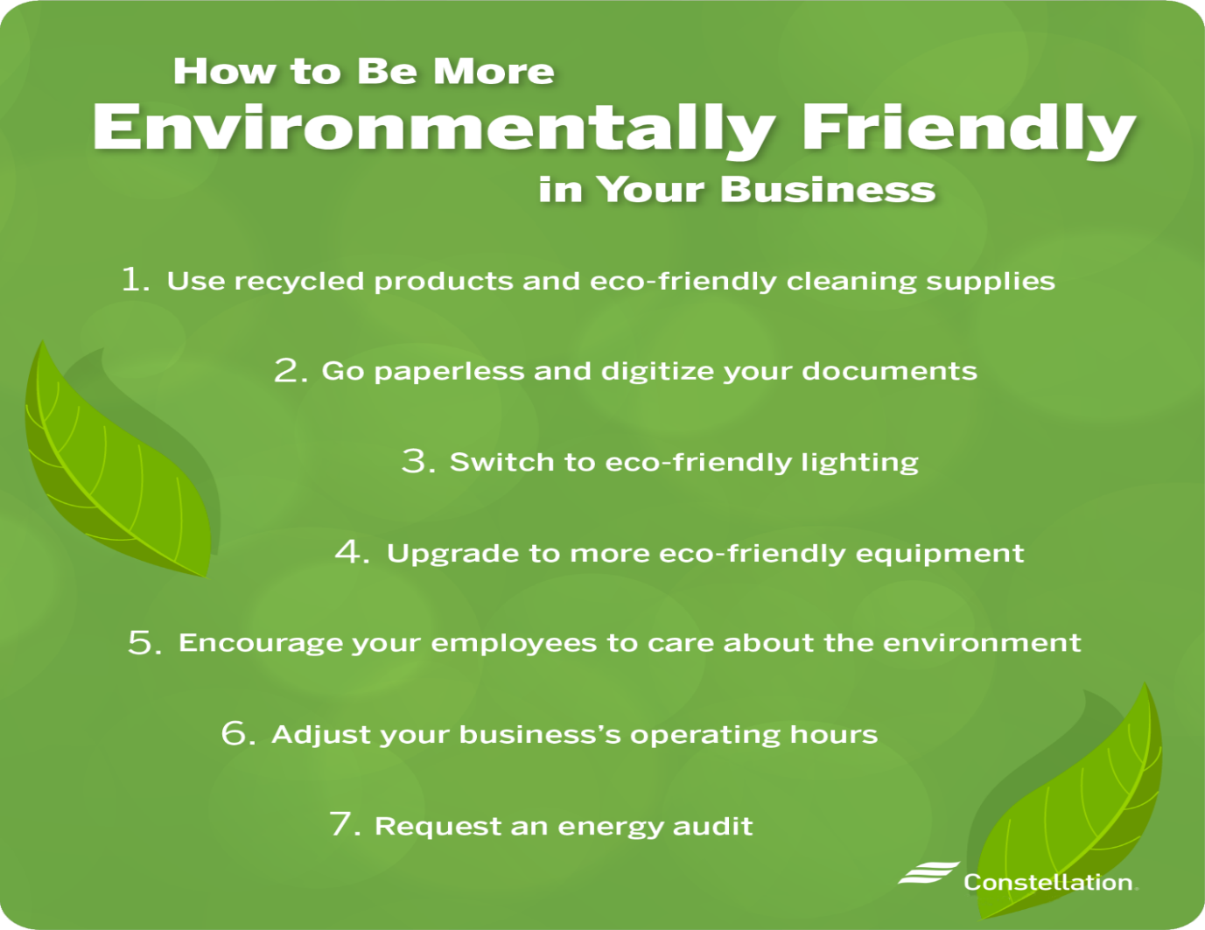

Integration of Sustainable Practices into Core Business Strategy
In the future, sustainability will be integral to hotels' core business strategy, requiring operational and strategic shifts. Sustainability must be ingrained in their corporate ethos, ensuring every operation reflects environmental responsibility. (Dos Santos et al., 2017).

Collaboration and Industry Standards
Collaboration and industry standards are vital for sustainability. Hotels benefit from sharing best practices and supporting initiatives for sustainable tourism. Standards set benchmarks, driving collective progress towards a sustainable future. (Rodríguez-García et al., 2023).

Conclusion
Sustainability is now a core aspect of hotel operations. To gain accreditation and benefits, hotels must adopt eco-friendly practices, comply with regulations, and innovate. Challenges like costs and disruptions exist, but long-term benefits include resource conservation, pollution reduction, efficiency improvement, and enhanced brand reputation. (Melissen et al., 2016).
The hotel industry's future hinges on regulation, tech progress, and eco-demand. Sustainable practices are key to thriving, benefiting customers, shareholders, and the environment. Collaboration and industry standards drive progress towards a sustainable future in travel and tourism, enriching lives while safeguarding the planet. (Pereira-Moliner et al., 2021).

References

Bruns-Smith, A., Choy, V., Chong, H. and Verma, R., (2015) Environmental
sustainability in the hospitality industry: Best practices, guest participation, and
customer satisfaction Available at: https://ecommons.cornell.edu/handle/1813/71174 (Accessed: 29 May 2024)

Dos Santos, R.A., Méxas, M.P. and Meiriño, M.J. (2017) Sustainability and hotel
business: criteria for holistic, integrated and participative development. Journal of
Cleaner Production, 162, pp.S54-S68 Available at: https://arquivos.ufrrj.br/arquivos/2018014228446320461094acd48ea8ac6ac/Publica
oFinal-_Artigo_JCP.pdf (Accessed: 29 May 2024)

Font, X. (2002) Environmental certification in tourism and hospitality: progress,
process and prospects. Tourism Management, 23(9), pp.197-205 Available
at: https://www.academia.edu/download/51294930/s0261-5177_2801_2900084-
x20170110-15693-1c3yhbd.pdf (Accessed: 29 May 2024)

Griffin, T. and DeLacey, T. (2012) Green Globe: Sustainability accreditation for
tourism. In: R. Sharpley and P. Stone, eds. Tourism, Development and Environment:
Beyond Sustainability. New York: Routledge, pp.143-154 Available at:
https://research.cbs.dk/files/66439967/adam_lindgreen_et_al_a_club_perspective_of
_sustainability_certification_schemes_acceptedversion.pdf (Accessed: 29 May
2024)

Jurigová, Z., Tučková, Z. and Kuncová, M. (2016) Economic sustainability as a future
phenomenon: moving towards a sustainable hotel industry. Journal of Security and
Sustainability Issues, 6(1), pp.5-18 Available at:
https://publikace.k.utb.cz/bitstream/handle/10563/1007977/Fulltext_1007977.pdf?se
quence=1 (Accessed: 29 May 2024)

Khairat, S. and Maher, A. (2012) Integrating sustainability into tour operator
business: An innovative approach in sustainable tourism. Tourismos, 7(2), pp.265-
282 Available at: https://tourismosjournal.aegean.gr/article/download/265/232 (Accessed: 29 May 2024)

Kim, Y.H., Barber, N. and Kim, D.K. (2019) Sustainability research in the hotel
industry: Past, present, and future. International Journal of Contemporary Hospitality
Management, 41(10), pp.4156-4174 Available at: https://www.tandfonline.com/doi/abs/10.1080/19368623.2019.1533907 (Accessed: 29 May 2024)

Melissen, F., Cavagnaro, E., Damen, M. and Duweke, E. (2016) Is the hotel industry
prepared to face the challenge of sustainable development? Journal of Vacation
Marketing, 22(1), pp.35-46 Available at: https://www.academia.edu/download/66894043/Melissen_Cavagnaro_Damen_Duwe
ke_2015_JVM.pdf (Accessed: 29 May 2024)

Pereira-Moliner, J., López-Gamero, M.D., Font, X., Perles-Ribes, J. and Dobon-
Suárez, R. (2021) Sustainability, competitive advantages and performance in the
hotel industry: A synergistic relationship. Journal of Tourism and Sports
Management, 27, pp.35-48 Available at: https://www.jots.cz/index.php/JoTS/article/download/282/112 (Accessed: 29 May 2024)

B. and Raymond, L. (2013) Sustainable development practices in the hospitality industry: An empirical study of their impact on customer satisfaction and
intentions. International Journal of Hospitality Management, 34, pp.258-268
Available at: https://www.sciencedirect.com/science/article/pii/S0278431913000285
(Accessed: 29 May 2024)

Rodríguez-García, R., Ferrero-Ferrero, I., Kumar, V. and García-Martínez, A. (2023)
Analysis of integration of sustainability in sustainability certifications in the hotel
industry. Frontiers in Sustainability, 4, pp.1-13 Available at:
https://www.frontiersin.org/articles/10.3389/frsus.2023.1116359/full (Accessed 29
May 2024)

Sakshi, S., Shashi, S., Cerchione, R. and Demertzi, M. (2020) Measuring the impact
of sustainability policy and practices in tourism and hospitality industry. Business
Strategy and the Environment, 29(2), pp.393-406 Available at:
https://onlinelibrary.wiley.com/doi/abs/10.1002/bse.2420 (Accessed: 29 May
2024)

van Rheede, A. and Blomme, R.J. (2012) Sustainability in hospitality: A research
framework. Advances in Hospitality and Leisure, 8, pp.1-19 Available at:
https://www.emerald.com/insight/content/doi/10.1108/S1745-
3542(2012)0000008018/full/html (Accessed: 29 May 2024)

What is Sustainability Available at : https://www.bing.com/images/search?view=detailV2&ccid=0WGYg7gv&id=276615CDAF7AE86EF98D2C17007463EEEAA215E2&thid=OIP.0WGYg7gvcbyZIVYCztLiHQHaE8&mediaurl=https%3a%2f%2fwww.charteredaccountants.ie%2fsf_images%2fdefault-source%2fsustainability-centre-images%2fbubble-sustainable-min.jpeg%3fsfvrsn%3d25dea27c_2&cdnurl=https%3a%2f%2fth.bing.com%2fth%2fid%2fR.d1619883b82f71bc99215602ced2e21d%3frik%3d4hWi6u5jdAAXLA%26pid%3dImgRaw%26r%3d0&exph=1203&expw=1800&q=sustainability&simid=608052140182808547&FORM=IRPRST&ck=3BC3A33A40962563F067A8F51BAD0D9D&selectedIndex=2&itb=0&ajaxhist=0&ajaxserp=0 (Accessed: 29 May 2024)
How is Hotel Industry Adopting IoT Based on Sustainable Development Available at: https://www.bing.com/images/search?view=detailV2&ccid=FxGWgGtx&id=4C9AF81810615061852D3D757F9D11A576AE978F&thid=OIP.FxGWgGtxPMdYKft--ZyKugHaFA&mediaurl=https%3a%2f%2fwww.zenatix.com%2fwp-content%2fuploads%2fSustainability-in-hotels.jpg&cdnurl=https%3a%2f%2fth.bing.com%2fth%2fid%2fR.171196806b713cc75829fb7ef99c8aba%3frik%3dj5eudqURnX91PQ%26pid%3dImgRaw%26r%3d0&exph=1119&expw=1656&q=energy+efficiency+in+hospitality+industry&simid=608003413807485806&FORM=IRPRST&ck=2BFE18D6CCAC9391A35FF5A213636116&selectedIndex=4&itb=0&ajaxhist=0&ajaxserp=0 (Accessed 30 May 2024)

Green Rating System for Built Environment Available at : https://www.bing.com/images/search?view=detailV2&ccid=jp2pOlqD&id=47491D5FC9EEEF369C788F3EEE531864ED0571BE&thid=OIP.jp2pOlqDmJAZ64A5oV-4ZwHaHa&mediaurl=https%3a%2f%2fwww.srilankagbc.org%2fwp-content%2fuploads%2f2022%2f08%2frating_2.jpg&cdnurl=https%3a%2f%2fth.bing.com%2fth%2fid%2fR.8e9da93a5a83989019eb8039a15fb867%3frik%3dvnEF7WQYU%252b4%252bjw%26pid%3dImgRaw%26r%3d0&exph=1080&expw=1080&q=Certification+Criteria%3a+Meeting+specific+criteria+set+by+accrediting+bodies+such+as+Green+Key%2c+LEED%2c+or+EarthCheck&simid=607987324857698036&FORM=IRPRST&ck=0C1424832692FFE1AB5D29EFDB658C9C&selectedIndex=5&itb=0&ajaxhist=0&ajaxserp=0 (Accessed: 30 May 2024)
How to communicate to improve employee engagement Available at :https://www.bing.com/images/search?view=detailV2&ccid=U4peEaKm&id=D7A3A084FCE3F24098B1F8AE6E95BB348BA0E58B&thid=OIP.U4peEaKmQGGAaB0SPhkGyAHaEL&mediaurl=https%3a%2f%2fcuttingedgepr.com%2fwp-content%2fuploads%2f2015%2f02%2fEmployee-engagement.-Components-written-on-blackboard-2-Shutterstock-274499819-1536x867.jpg&cdnurl=https%3a%2f%2fth.bing.com%2fth%2fid%2fR.538a5e11a2a6406180681d123e1906c8%3frik%3di%252bWgizS7lW6u%252bA%26pid%3dImgRaw%26r%3d0&exph=867&expw=1536&q=Staff+Training+and+Engagement&simid=608021688885911279&FORM=IRPRST&ck=1A08EA6EE1BA362E0F09F765EA53BAD0&selectedIndex=1&itb=0&ajaxhist=0&ajaxserp=0 (Accessed 30 May 2024)

7 Environmentally Friendly Work Practices Available at:
https://www.bing.com/images/search?view=detailV2&ccid=9mXLejqe&id=514CCDD3E96FC4AEFBDAC5AC21CF0FA70709A63C&thid=OIP.9mXLejqesv6MpydL2oABzgHaHz&mediaurl=https%3a%2f%2fblog.constellation.com%2fwp-content%2fuploads%2f2021%2f04%2fenvironmentally-friendly-methods-for-businesses-1458x1536-1.png&cdnurl=https%3a%2f%2fth.bing.com%2fth%2fid%2fR.f665cb7a3a9eb2fe8ca7274bda8001ce%3frik%3dPKYJB6cPzyGsxQ%26pid%3dImgRaw%26r%3d0&exph=1536&expw=1458&q=Consumer+Demand+for+Eco-Friendly+Practices+in+hospitality+industry&simid=607989910419351502&FORM=IRPRST&ck=AF39F893F60D921F462E20F619F459E0&selectedIndex=8&itb=0&ajaxhist=0&ajaxserp=0 (Accessed 30 May 2024)

