CORONAVIRUS
------------------------------------------------------------------------------------------------------------------------------------------------
Are you suffering from the following signs and symptoms?

- High temperature
- New continuous cough
- Loss of taste or smell
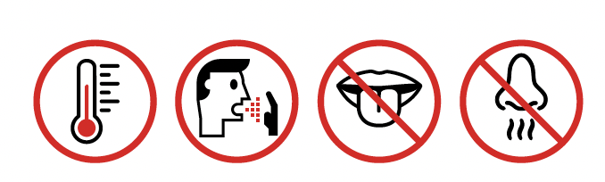

No one in your household should leave home if any one person has symptoms. Find out how to get a test, and how long to isolate, at nhs.uk/coronavirus

As soon as possible contact your Employer for guidance.

Do not enter this building
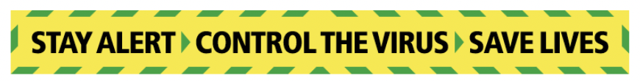

CORONAVIRUS
------------------------------------------------------------------------------------------------------------------------------------------------
Wash your hands

more often for

20 seconds

Use soap and water or a hand sanitiser when you:

- Get home or into work
- Blow your nose, sneeze or cough
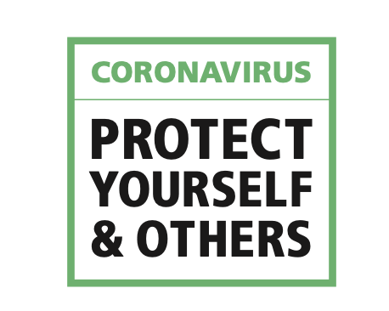
- Eat or handle food

CORONAVIRUS
------------------------------------------------------------------------------------------------------------------------------------------------

Wash your hands with soap and water more often for 20 seconds
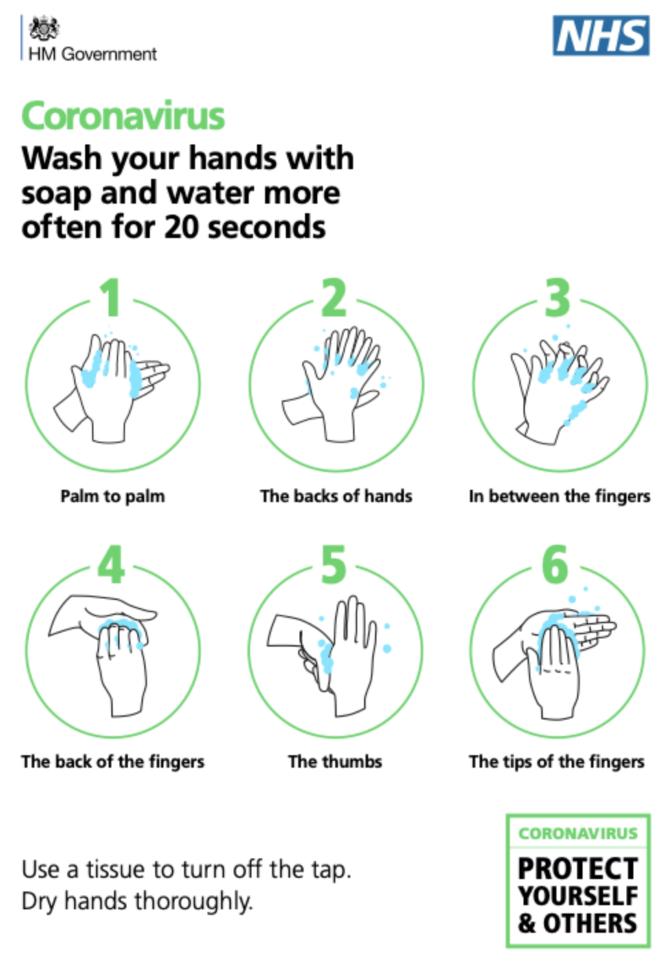

Palm to palm The backs of hands In between the fingers

The back of the fingers The thumbs The tips of the fingers

Use a tissue to turn off the tap. Dry hands thoroughly.

Poster layout and content developed from the NHS.

