
Integrating Project
Small fast-food business


Student nume : Valentin Stefan Mirica
Student ID : 2211628
Module : Integration Project
Lecturer : Divya Chidambaram

Table of Contents
Assessment 1 3
Problem Statement 3
Research Background 3
Project Topic 4
Research Aim 4
Research Objectives 4
Research Questions 4
Literature Review 5
Research Methodology 7
Conclusion 9
Recommendations to improve the small fast-food business 10
References 12
Assessment Component 2: Practical Component 14
Problem Statement 14
Research Background 15
Research Aim and objectives 15
Literature Review 16
Research Methodology 18
Summary/Conclusion 19

Assessment 1

Problem Statement
The problem statement reflects the lack of employee motivation can increase the employee turnover rate in the UK-based small fast-food business. Employee motivation plays a crucial role in triggering organisational productivity. Moreover, a high employee turnover rate is a cost to the company. Furthermore, the high employee turnover rate is financially challenging for small businesses. Small businesses in the UK are having limited financial budgets. Moreover, the lack of strategic planning in integrating the operational process through emerging technologies can be spotted in the SMEs of the UK. The owners of the SMEs are encountering skill shortages to overcome productivity in the post-pandemic period. During the COVID-19 pandemic, UK-based SMEs have faced severe impacts on their revenue. In a report, it has been spotted that 85% of UK-based SMEs have reported a decline in their business revenues [1]. The changes in the external business environment and the inability of the SMEs to implement effective strategic plan has also increased the high employee turnover rates. Hence, the project will investigate the role of employee motivation towards employee turnover rates by considering primary research.

Research Background
As per the Government report, there are 5.5 million UK-based small businesses within the year 2021. The total small business population is around 99% in the UK. In accordance with the report, 50% of UK-based small businesses are experiencing skill shortages. The ONS report has claimed that official vacancies in small businesses have reported around 1.2m by the year-end 2021 [2]. Small businesses in the UK are encountering challenges to fill vacancies. The skill shortages are mainly due to the lack of employee motivation. The high number of resignations can lead to a loss of balance in the workforce. Moreover, the issues in work allocation at the workplace are due to a lack of employee motivation. The outcomes of low employee motivation include high absenteeism, high employee turnover, and limited productivity in the workplace. Employee motivation underlines intrinsic and internal drive by focusing on the necessary effort and action toward specific action [3]. Employee motivation is the level of commitment and creativity that the employee delivers in the workplace. Moreover, highly motivated employee is dedicated to delivering discretionary effort in the workplace. However, less motivated employees are not committed to their job responsibilities. The lack of motivation is impactful on organisational productivity. On the contrary, high employee turnover rates focus on the number of employees that are leaving the organisation due to ineffective management and leadership [4]. The approaches and ways to enhance employee motivation require thorough analysis. Furthermore, the reasons for low employee motivation require face-to-face examination through primary research. Hence, the research project will diagnose the role of employee motivation level towards high employee turnover rates in small businesses.

Project Topic
Investigating the lack of employee motivation towards high employee turnover rate in the UK-based small fast-food business.

Research Aim
The project will investigate the extent to which employee motivation can influence employee turnover rate in a UK-based small fast-food business.

Research Objectives
The research objectives are as follows:
- To explore the theoretical frameworks and views regarding employee motivation, strategic human resource management, and employee turnover rates.
- To investigate the role of motivation in reducing employee turnover rates in the small business
- To evaluate the interrelationship between the role of employee motivation and employee turnover
- To recommend the measures regarding the enhancement of the employee motivation

Research Questions
The research questions of the following topic are as follows:
- What is the theoretical framework of employee motivation and strategic human resource management?
- What is the impact of employee motivation on high employee turnover rates?
- What is the interrelationship between employee motivation and employee turnover?
- What are the proposed measures to enhance employee motivation?

Literature Review
Employee Motivation in the workplace
As per Baesu (4), Employee motivation focuses on the intrinsic and internal drive by focusing on the necessary effort and action towards a specific action. Employee motivation is the level of commitment and creativity that the employee delivers in the workplace. Moreover, highly motivated employee is dedicated to delivering discretionary effort in the workplace [5]. Motivation is a critical element in a successful workplace as it pushes employees to excel. The energy, commitment, and effort of the employees enhance the potential of the workplace. Motivation from the organisational perspective can take place in different forms. Moreover, a clear understanding of the types of motivation supports employers to enhance the motivation level of employees [6]. The managers of business organisations must categorise motivation into two forms intrinsic and extrinsic.
Different forms of employee motivation
According to Brooks (6), intrinsic motivation comes from the individual or inner self. However, extrinsic motivation comes from external sources. Some individuals remain motivated by achieving the desired target. The personal satisfaction of the individual is a part of intrinsic motivation [3]. Therefore, employers can provide challenging tasks and roles to drive the intrinsic motivation of the employees. The role of the ‘learning motivation’ is an intrinsic motivation that relates to the need of the individual to feel competent through achieving the desired target. Certain employees feel competent and energetic in achieving the desired goals. Hence, education and knowledge sharing through a ‘training programme’ is important as an organisational effort. At the workplace, undertaking training and development programmes for the staff can ensure the value and importance given to the employees [7]. Business organisations provide opportunities to employees that are competence-motivated by promoting highly skilled employees that seek learning opportunities. On the contrary, Extrinsic motivation reflects the external sources of motivation for an individual. The external sources can be rewards, recognition, affiliation, monetary benefits, etc. From an organisational perspective, rewards, and a hike in the pay scale of the employees create positivity in their minds and help them to remain motivated [4]. The energy and commitment of the employees are raised through external sources of motivation. Daley (7), opined that extrinsic motivation involves the ‘achievement-motivation’ that helps to reach a specific goal. Achievement motivation is a part of extrinsic motivation that calls for external sources by providing a sense of accomplishment.
The interrelationship between employee motivation and employee turnover rates
Mullins (9), argued that less motivated employees are not committed to their job responsibilities and tend to quit their job frequently. The lack of motivation is impactful on organisational productivity [8]. Motivation is vivacious in accelerating or reducing the performance of the employees irrespective of the private and public sector organisations. The performance of the employees is dependent on their motivation level. The vastly motivated employees will deliver good performance and have fewer turnover intentions due to their job satisfaction. Shahzadi (10), briefed that employee happiness is the factor that requires in the form of input against the intended output. Satisfied employees are loyal employees and also result in high-performance levels. Hence, motivated employees have no reason to switch to another organisation. The motivation develops a sense of satisfaction at a certain point and eventually supports the organisation to meet the productivity benchmark [9]. Motivation encompasses the psychosomatic mechanisms of the individual and accordingly develops personality differences among the individual. The low employee motivation in the workplace reveals the lack of obligation and commitment among the employees. Hence, extremely motivated employees are innovative, have strong minds, and are resourceful for the organisation. Schuler (12), claimed that poor motivation in the organisation leads to higher employee turnover, lack of engagement, and poor communication.
Theoretical frameworks of Motivation
Job motivation is the foundation of employee inventiveness and performance. The Componential theory of organisational creativity demonstrates the individual having elevated job motivation used to get pleasure from their current employment and have the propensity to produce artistic outcomes [10]. Organisations used to organise their effort to increase employee motivation to get a difference in their productivity. Moreover, employee motivation has a constrictive relation with employee performance. Udechukwu (11), opined that a motivated employee responds to the organisational goals seriously and supports the organisation to achieve a competitive advantage. In accordance with Maslow’s Hierarchy of Needs theory, the five phases of human needs stimulate the motivation of individuals. The theory depicted the hierarchical levels of human needs and also helps to analyse the motives for human behaviour. The different levels of needs (basic needs, safety needs, psychological needs, self-esteem needs, and self-actualization needs) are designed by focusing on the motivations of a pyramid [11]. Firstly, the basic needs of people require food, shelter, clothing, etc. In the second hierarchical order, the people used to focus on safety needs that include employment and job security. Thirdly, psychological needs encompass the requirement of the individual in the form of friendship and social groups. At the fourth layer, self-esteem needs to manifest the desires of the people in receiving rewards, recognition, and freedom. Lastly, the fifth layer of needs in the form of creativity and spirituality of the people can be observed in Maslow’s Hierarchy of Needs theory.
Application of Strategic human resource management
According to Schuler (12), Strategic Human Resource Management is an integrated process of managing the workforce of the organisation in alignment with the overall organisational goal. Strategic human resource management provides a clear framework that links people management activities with the development practices for achieving the long-term business vision. The components of strategic human resource management are performance management, training and development, recruitment, and selection process [7]. Moreover, the purpose of strategic human resource management is to retain a productive workforce and enhances the flexibility among the employees to attain a competitive advantage [12]. Hence, optimal work performance can be enhanced for achieving the business mission and vision.

Research Methodology
Research Methodology is the combination of methods, approaches, and techniques that are used to analyse the research problem [13]. The current research will investigate the role of employee motivation towards employee turnover rates in a small business by considering primary research. Therefore, the research approaches, strategies, and methods that will be used to interpret the research topic are as follows:
- Research Approach: The research approach is the logical approach for tracking progress in consideration of general ideas and a valid conclusion [14]. The ‘Deductive Approach’ will be focused on in the current research project as it will help to fetch a valid conclusion from general ideas. The initial form of investigation is to collect ideas and insights to form a general conclusion. Moreover, the deductive approach includes a scientific investigation. Therefore, the current research project will collect information about employee motivation from the workplace to analyse the negative impact of high employee turnover rates. Hence, the Primary Research will be focused to collect the ideas and insights of the employees. The primary research considers the collection and utilisation of raw and unedited information [13]. Moreover, primary research establishes the reliability of the study due to the inclusion of real-time information.
- Research Strategy: The Research strategy is the foundation of the data collection process and analysis. The current research piece will consider the ‘experimental research’ strategy to test the research problem for fetching a valid conclusion of the study. The experimental research strategy is effective to derive meaningful insights regarding the research problem [15]. Moreover, the experimental research strategy is conducted in a controlled environment like the workplace. Hence, the opinions and views of the employees regarding the role of motivation in controlling employee turnover rates can be analysed through the experimental research strategy.
- Research method: The research method reflects the techniques used in data collection and analysis for uncovering new information for better understanding. The current research study will consider the ‘Quantitative Research method’ to collect the numerical information that helps to measure the responses. Quantitative research is effective to generate reliable insights due to the application of numerical analysis [14]. More specifically, the research instruments like the ‘Questionnaire Survey’ will be designed to collect quantitative information from the selected respondents. The Questionnaire Survey is a widely utilised research instrument by researchers for collecting quantitative information. Sampling is the process of selecting the subset of the population in the research study [16]. The current research study will consider ‘non-probability sampling’ by focusing non-random method. The non-probability sampling does not require a complete survey frame and an inexpensive way to collect data. The total sample size will be 10 employees working in the small food joint. Lastly, the Data Analysis is the interpretation process to fetch a valid conclusion of the study. The Quantitative information collected from the questionnaire survey will be analysed by using the statistical tool Mode method followed by Ms. Excel charts. The Mode method demonstrates the maximum occurrence in the data set. Therefore, the perspectives of the employees regarding employee motivation in the workplace can be analysed efficiently with the Mode Method under the Data Analysis phase of the research methodology.
- Research Ethics: Research Ethics consists of the fundamental ethical principle that includes the research design and research implementation [17]. The current research will utilise the resources by avoiding scientific misconduct. The data collected from the respondents will be stored in a secure system by respecting confidentiality and privacy. Furthermore, informed-consent ethics will be priortised before collecting the responses of the employees by briefing the respondents about the purpose of the study.

Conclusion
To conclude, the research report will investigate the role of employee motivation towards employee turnover rates by considering primary research. Employee motivation is the intrinsic and internal drive by focusing on the necessary effort and action toward a specific action. Employee motivation is the level of commitment and creativity that the employee delivers in the workplace. Moreover, highly motivated employee is dedicated to delivering discretionary effort in the workplace. However, less motivated employees are not committed to their job responsibilities and the possible outcomes in the workplace like high employee turnover rates can be spotted. Therefore, the research report will collect and analyse the views of the employees working in a small business food joint.

Recommendations to improve the small fast-food business.
The lack of employee motivation that has raised employee turnover rates in the small fast-food business can be controlled and managed through the implementation of strategic human resource management. The businesses irrespective of size must organise their effort to increase employee motivation to get a difference in their productivity. Moreover, employee motivation has a constrictive relation with employee performance. It has been observed from the reserach that a motivated employee responds to the organisational goals seriously and supports the organisation to achieve a competitive advantage. The employee motivation is a critical factor that can enhance organisational productivity through job satisfaction among the people. Employee motivation reflects the commitment level and creativity that the employee exerts in the workplace. Moreover, a highly motivated employee is dedicated in delivering discretionary effort in the workplace. Motivation is a critical element in a workplace as it pushes employees to excel and contribute significantly to the organisational goal. The energy, commitment, and effort of the employees enhances the potential of the workplace. Motivation from the organisational perspective can take place in different forms like extrinsic and intrinsic. Hence, the small business owner needs to analyse the factors determining the employee motivation for retaining the productive staffs and to reduce the employee turnover cost. Therefore, determining the employee motivation for retaining the talented staffs of the business is imperative in the small businesses. The small businesses are exposed to diverse challenges like staff retention, fund shortages, and lack of strategic planning are observed. The strategic human resource planning is an effective measure to retain the human resources in the businesses. Furthermore, strategic human resource planning reduces the operational cost related to high employee turnover rates. Strategic Human Resource Management is an integrated process of managing the workforce of the organisation in alignment with the overall organisational goal. Strategic human resource management provides a clear framework that links people management activities with the development practices for achieving the long-term business vision. The components of strategic human resource management are performance management, training and development, recruitment, and selection process. The business owner can attempt ‘strategic alliance’ with the recruitment agencies to mitigate the risks of high employee turnover rates. The strategic alliance is an effective business model that help to share resources for achieving the common business objectives. Moreover, with the strategic alliance, the business owner can share the responsibilities to attain desired productivity. Apart from the strategic alliance business model, the people-centric approach is imperative for managing the issues related to human resource management. The people-centric approach encourages employee engagement and help to address the issues in the workplace. The employee engagement allows the employees to share their views and feedbacks. Therefore, open communication in the workplace is ideal for driving employee engagement. The requirement of sound leadership to boost the mind set of the employees can be effective for the small businesses. The leadership ability can unite the teams to enhance their functionality and effectiveness in the workplace. The motivated employees can create difference in the organisation and support the business to attain the desired competitive advantage.

References

[1] | R. C. M. a. L. W. Calabrese, “Understanding the dynamics of UK Covid‐19 SME financing,” British Journal of Management, vol. 33, no. 2, pp. 657-677, 2021.
[2] | B. a. A. U. Bularafa, “Effect of COVID-19 pandemic on SME Performance,” Advanced International Journal of Business, Entrepreneurship and SMEs, vol. 3, no. 1, pp. 75-92, 2021.
[3] | M. a. R. E. e. Butler, Introduction to organisational behaviour, London : Kogan Page Publishers, 2015.
[4] | L. G. T. B. S. a. S. M. Eisele, “Employee motivation for personal development plan effectiveness,” European Journal of Training and Development., vol. 23, no. 4, pp. 222-225, 2017.
[5] | C. a. B. R. Baesu, “Leadership approaches regarding organisational change,” The USV Annals of economics and public administration, vol. 13, no. 4, pp. 146-152, 2017.
[6] | I. Brooks, Organisational behaviour: individuals, groups and organisation, London : Pearson Education, 2018.
[7] | D. Daley, “Strategic human resources management,” Public personnel management, vol. 1, pp. 120-125, 2019.
[8] | V. Ganta, “Motivation in the workplace to improve the employee performance.and Applied Sciences,” International Journal of Engineering Technology and Management , vol. 22, no. 1, pp. 221-230, 2019.
[9] | L. J. a. C. G. Mullins, Management & organisational behaviour, Eleventh edn ed., Harlow, England: Pearson, 2018.
[10] | I. Shahzadi, “Impact of employee motivation on employee performance,” European Journal of Business and Management, vol. 23, no. 2, pp. 159-166, 2018.
[11] | I. Udechukwu, “Maslow's needs hierarchy and Herzberg's motivation theory,” Public Personnel Management, vol. 39, no. 6, pp. 69-82, 2016.
[12] | R. Schuler, Strategic human resource management, London: John Wiley & Sons, 2019.
[13] | U. a. B. R. Sekaran, Research methods for business: A skill building approach, John Wiley & Sons, 2019.
[14] | Y. Singh, Fundamental of research methodology and statistics, New Age International, 2017.
[15] | M. L. P. a. T. A. Saunders, Research methods for business students, London : Pearson education, 2019.
[16] | K. Peffers, “A design science research methodology for information systems research,” Journal of management information systems, vol. 25, no. 6, pp. 45-77, 2018.
[17] | U. Flick, Introducing research methodology: A beginner's guide to doing a research project, London : Sage, 2015.

Assessment Component 2: Practical Component


Problem Statement
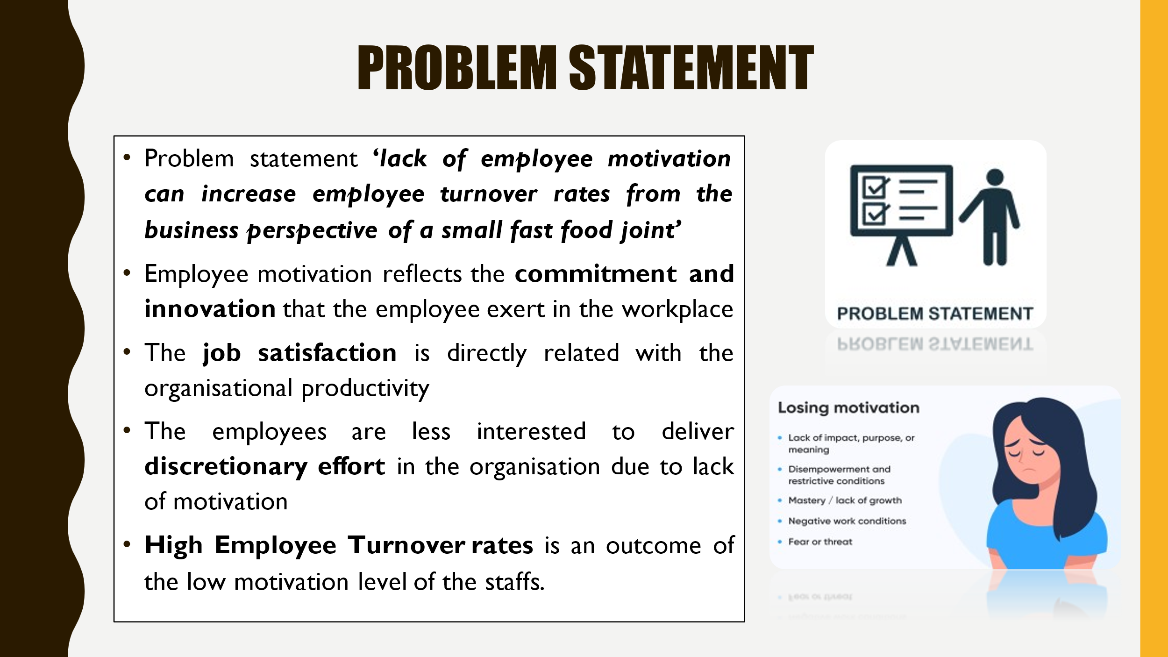
The problem statement reflects the lack of employee motivation can increase the employee turnover rate in the UK-based small fast-food business. Employee motivation plays a crucial role in triggering organisational productivity.

Research Background
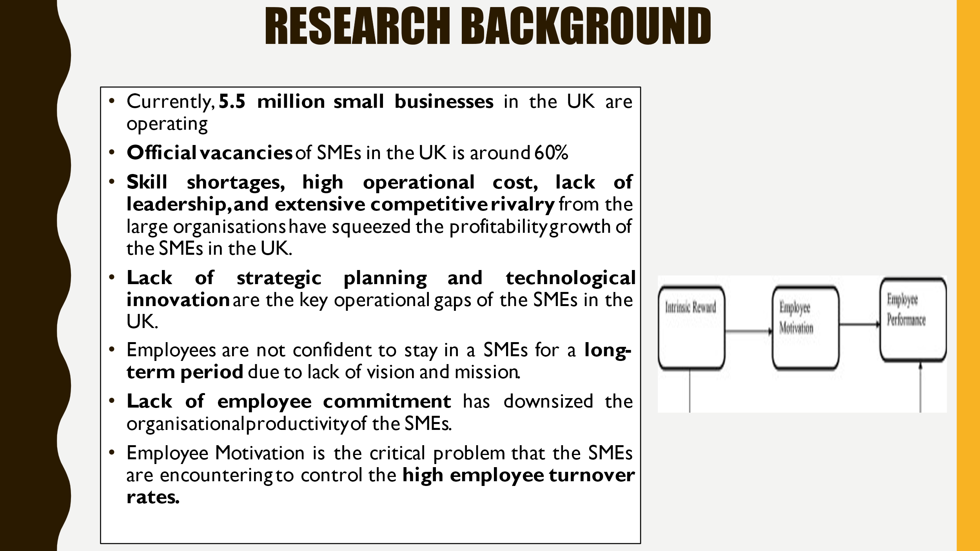
The ONS report has claimed that official vacancies in small businesses have reported around 1.2m by the year-end 2021. Small businesses in the UK are encountering challenges to fill vacancies. The skill shortages are mainly due to the lack of employee motivation. The high number of resignations can lead to a loss of balance in the workforce. Employee motivation underlines intrinsic and internal drive by focusing on the necessary effort and action toward specific action The outcomes of low employee motivation include high absenteeism, high employee turnover, and limited productivity in the workplace. On the contrary, high employee turnover rates focus on the number of employees that are leaving the organisation due to ineffective management and leadership.

Research Aim and objectives
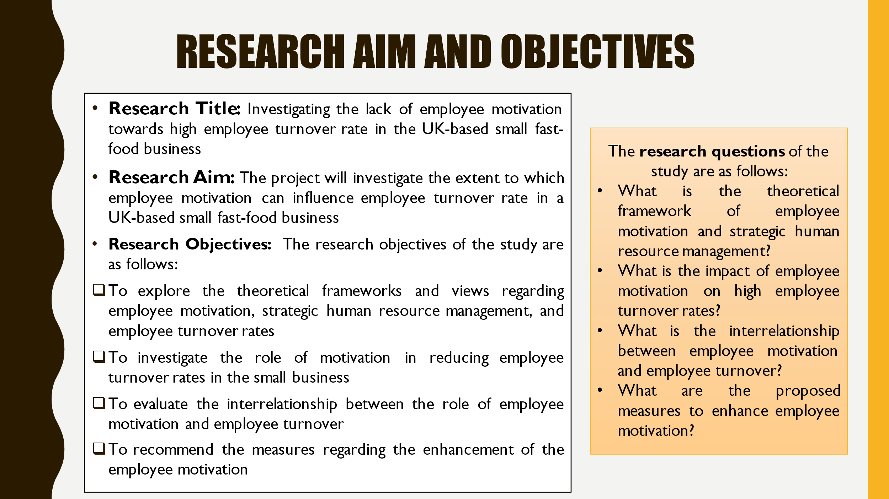
The research aim and objectives are presented by focusing on the research topic.

Literature Review
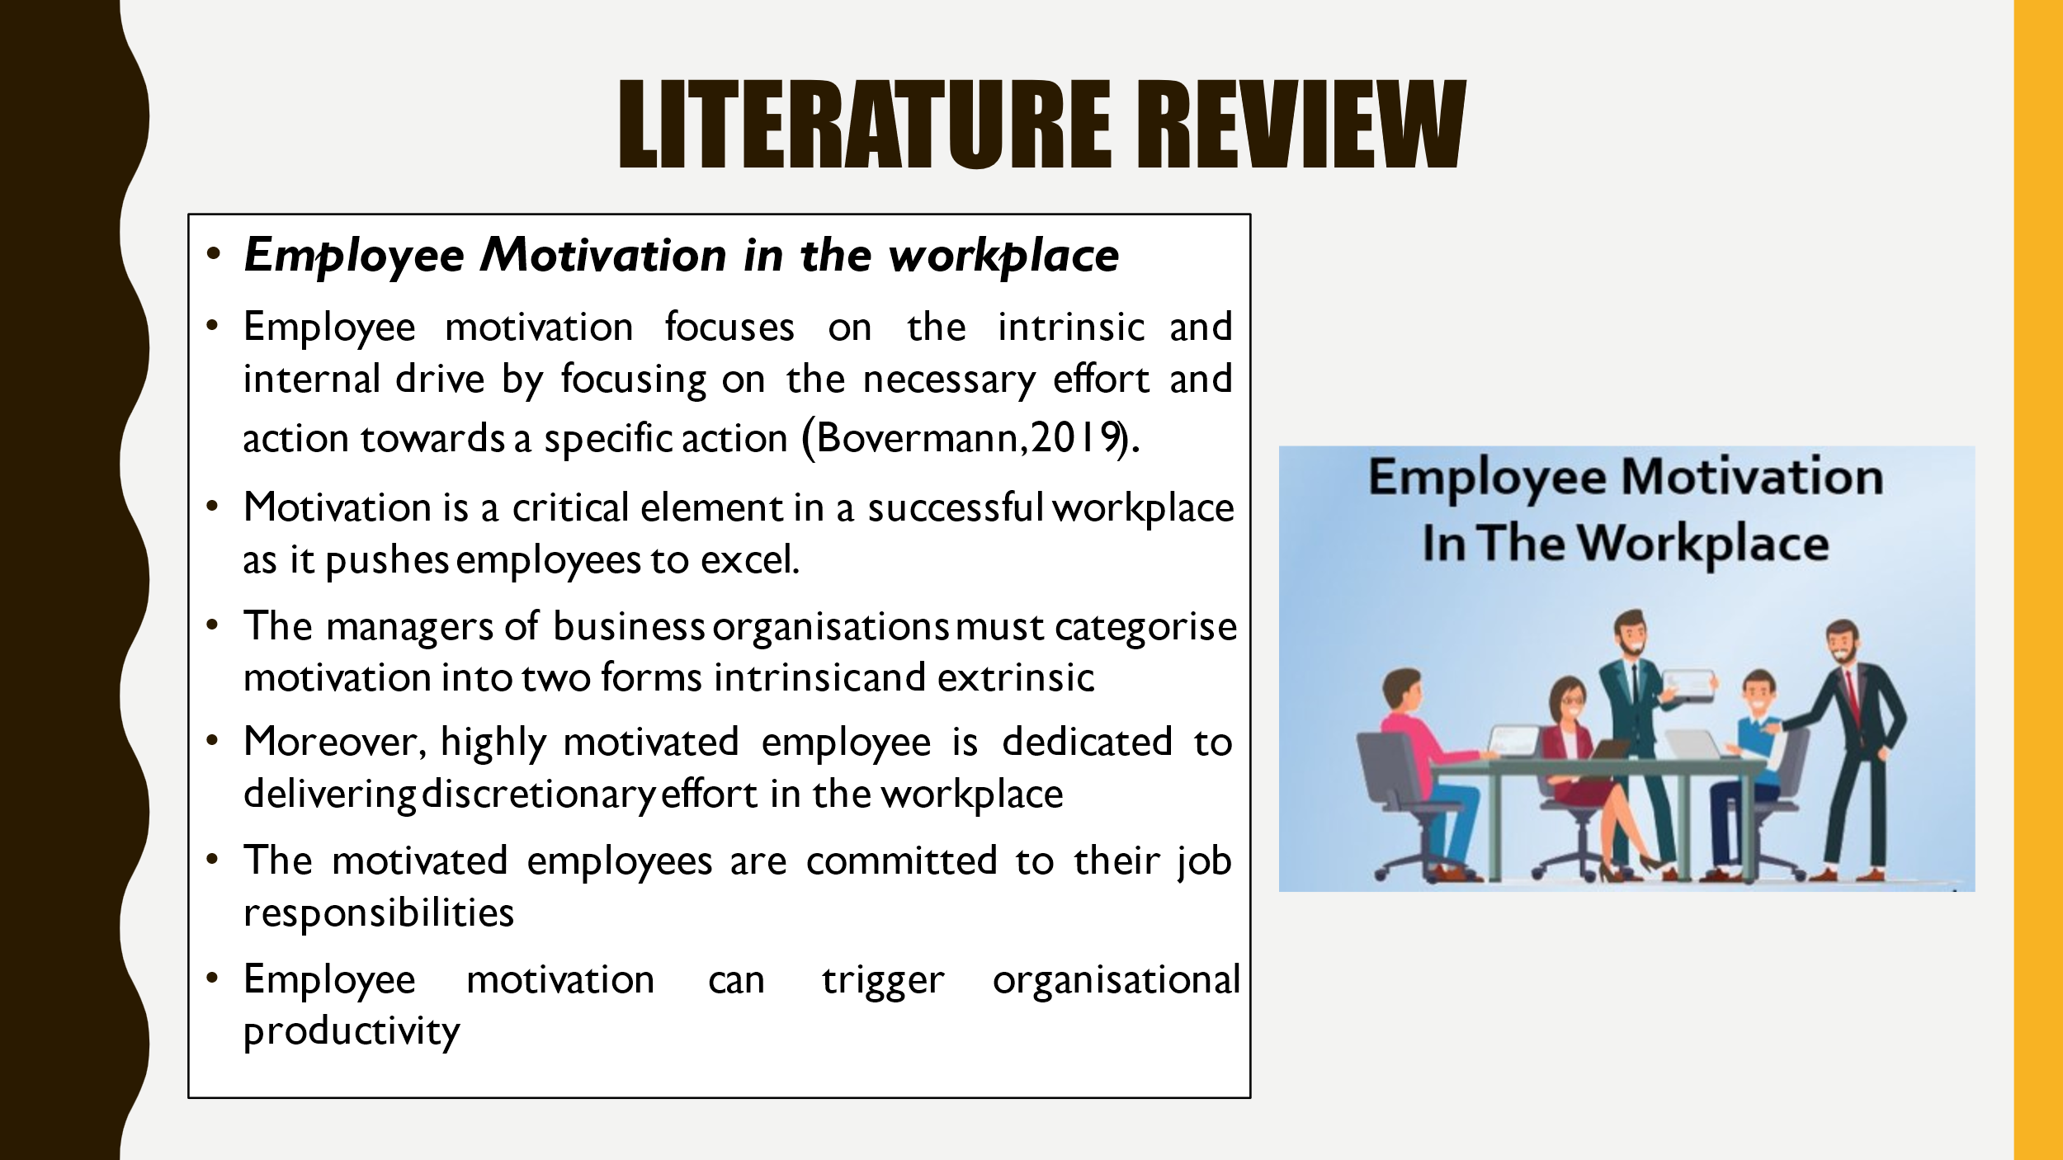
The Literature Review is a part of research project that critically analyses the knowledge and understanding of the research topic.
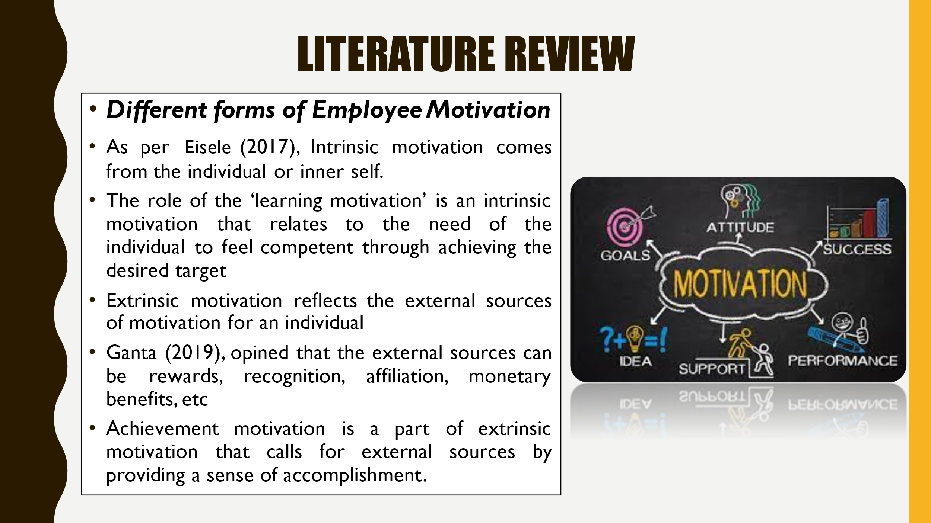
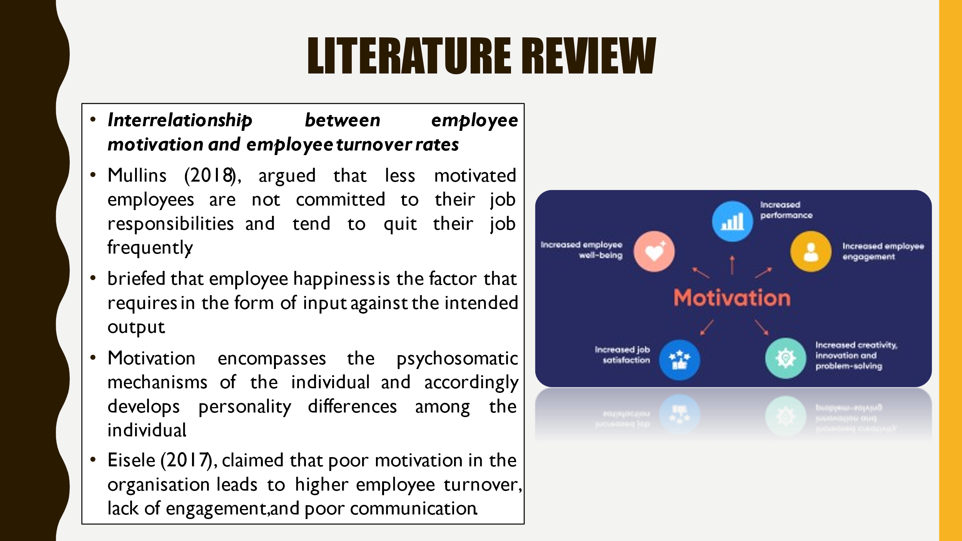

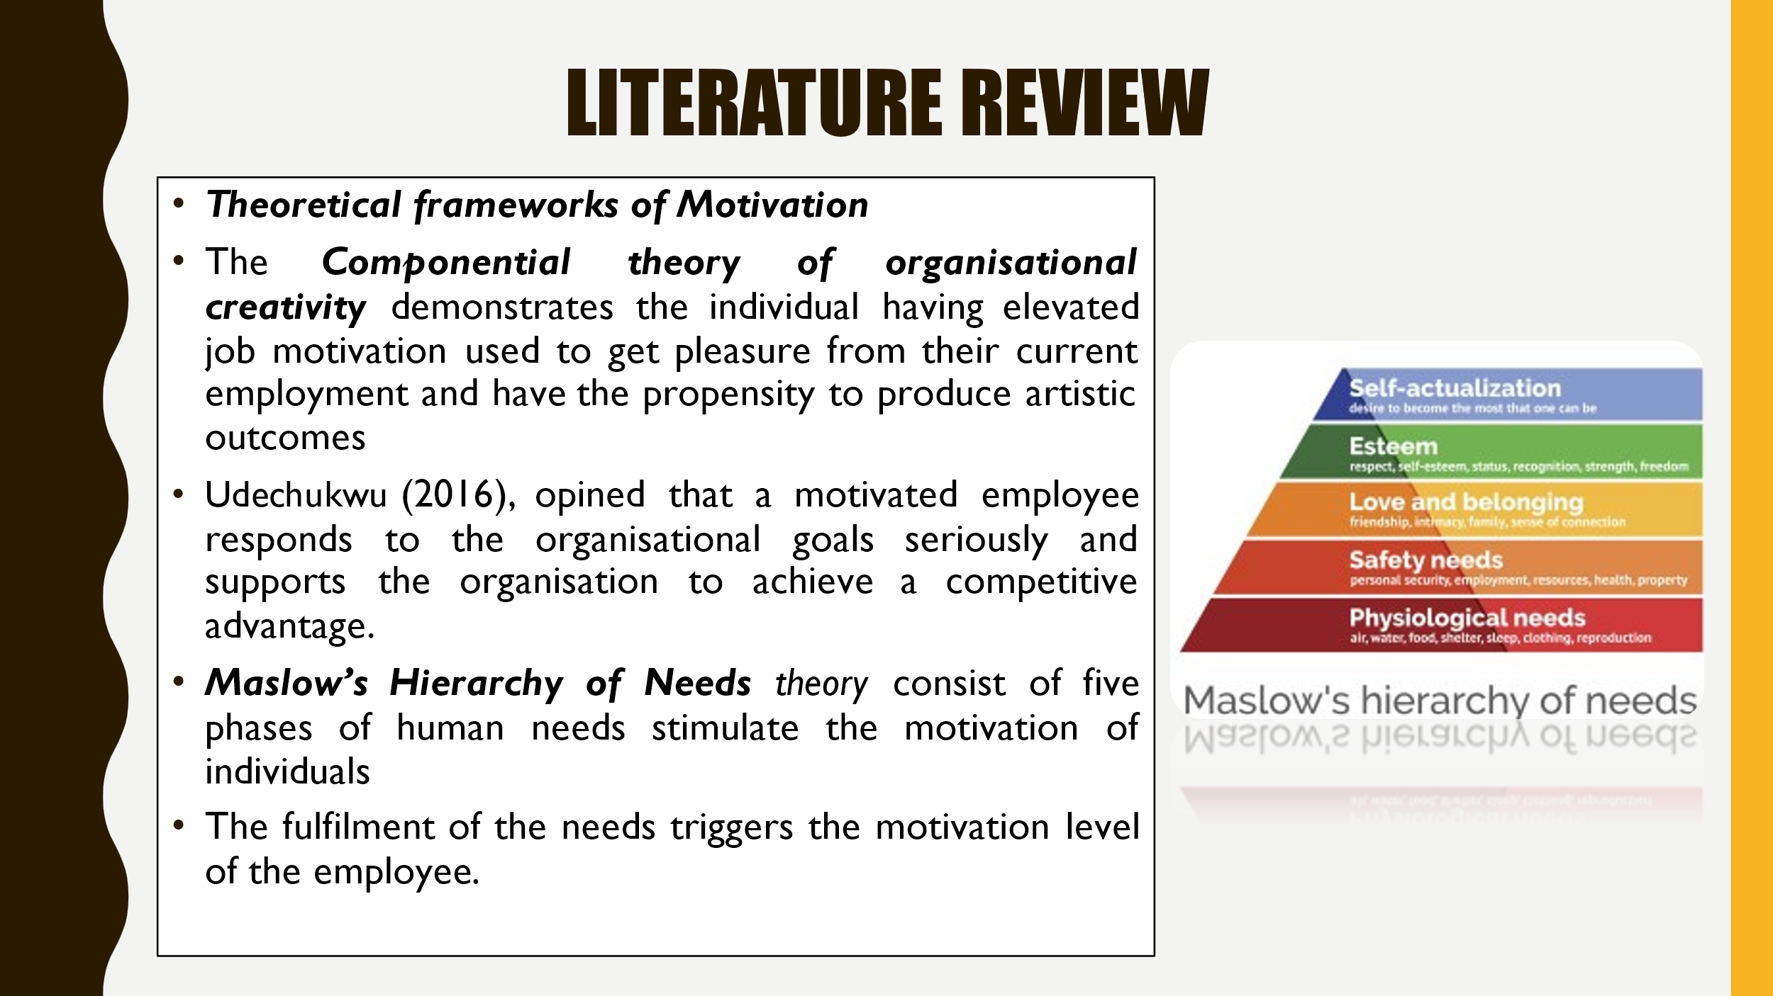
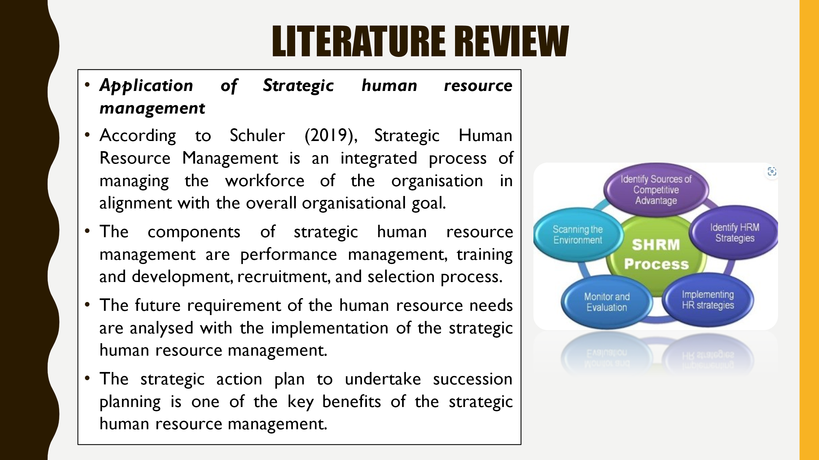

Research Methodology
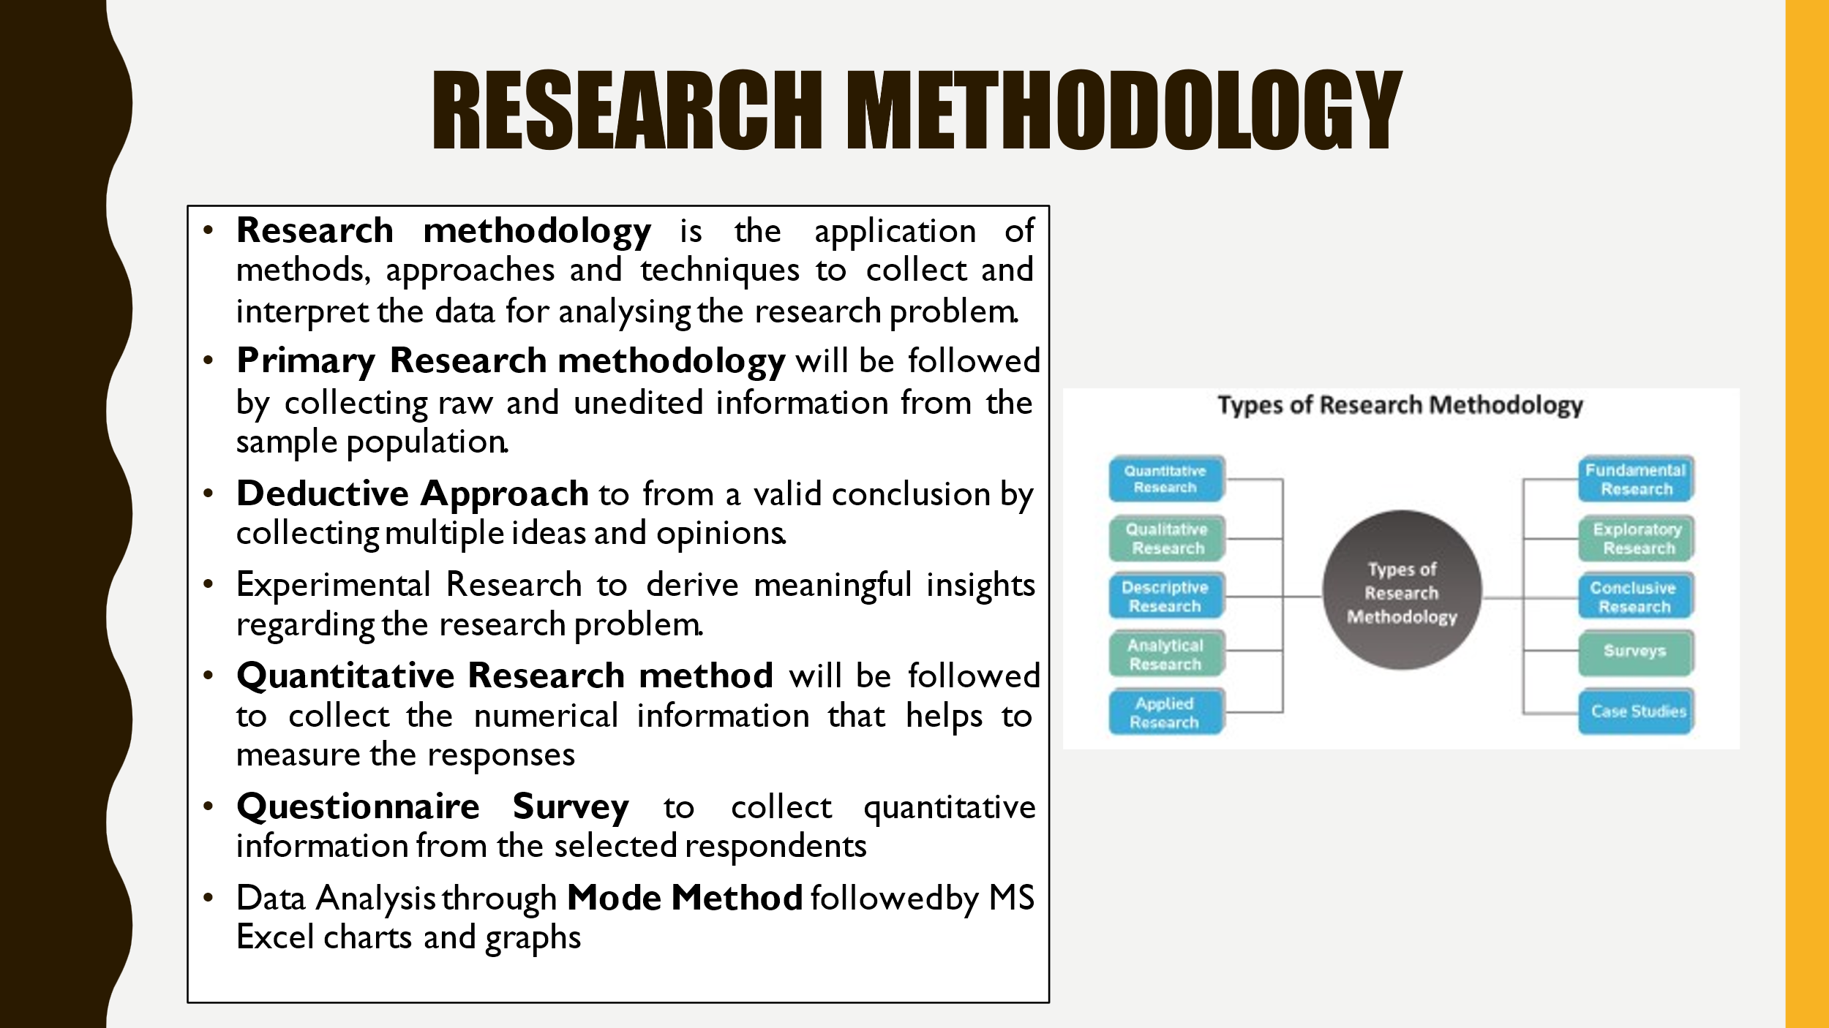
Research Methodology is the combination of methods, approaches, and techniques that are used to analyse the research problem. The current research project will collect information about employee motivation from the workplace to analyse the negative impact of high employee turnover rates. The ‘Deductive Approach’ will be focused on in the current research project as it will help to fetch a valid conclusion from general ideas. The Primary Research considers the collection and utilisation of raw and unedited information. The current research piece will consider the ‘experimental research’ strategy to test the research problem for fetching a valid conclusion of the study. Moreover, the experimental research strategy is effective to derive meaningful insights regarding the research problem. The current research study will consider the ‘Quantitative Research method’ to collect the numerical information that helps to measure the responses. The research instruments like the ‘Questionnaire Survey’ will be designed to collect quantitative information from the selected respondents. Furthermore, the Quantitative information collected from the questionnaire survey will be analysed by using the statistical tool Mode method followed by Ms. Excel charts.

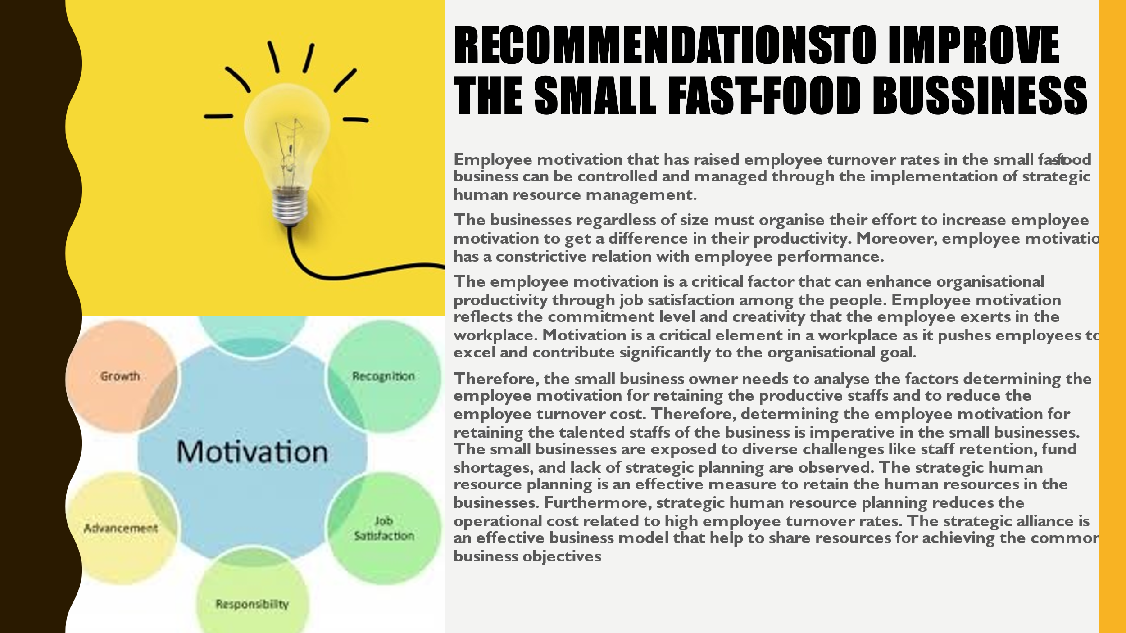

Summary/Conclusion
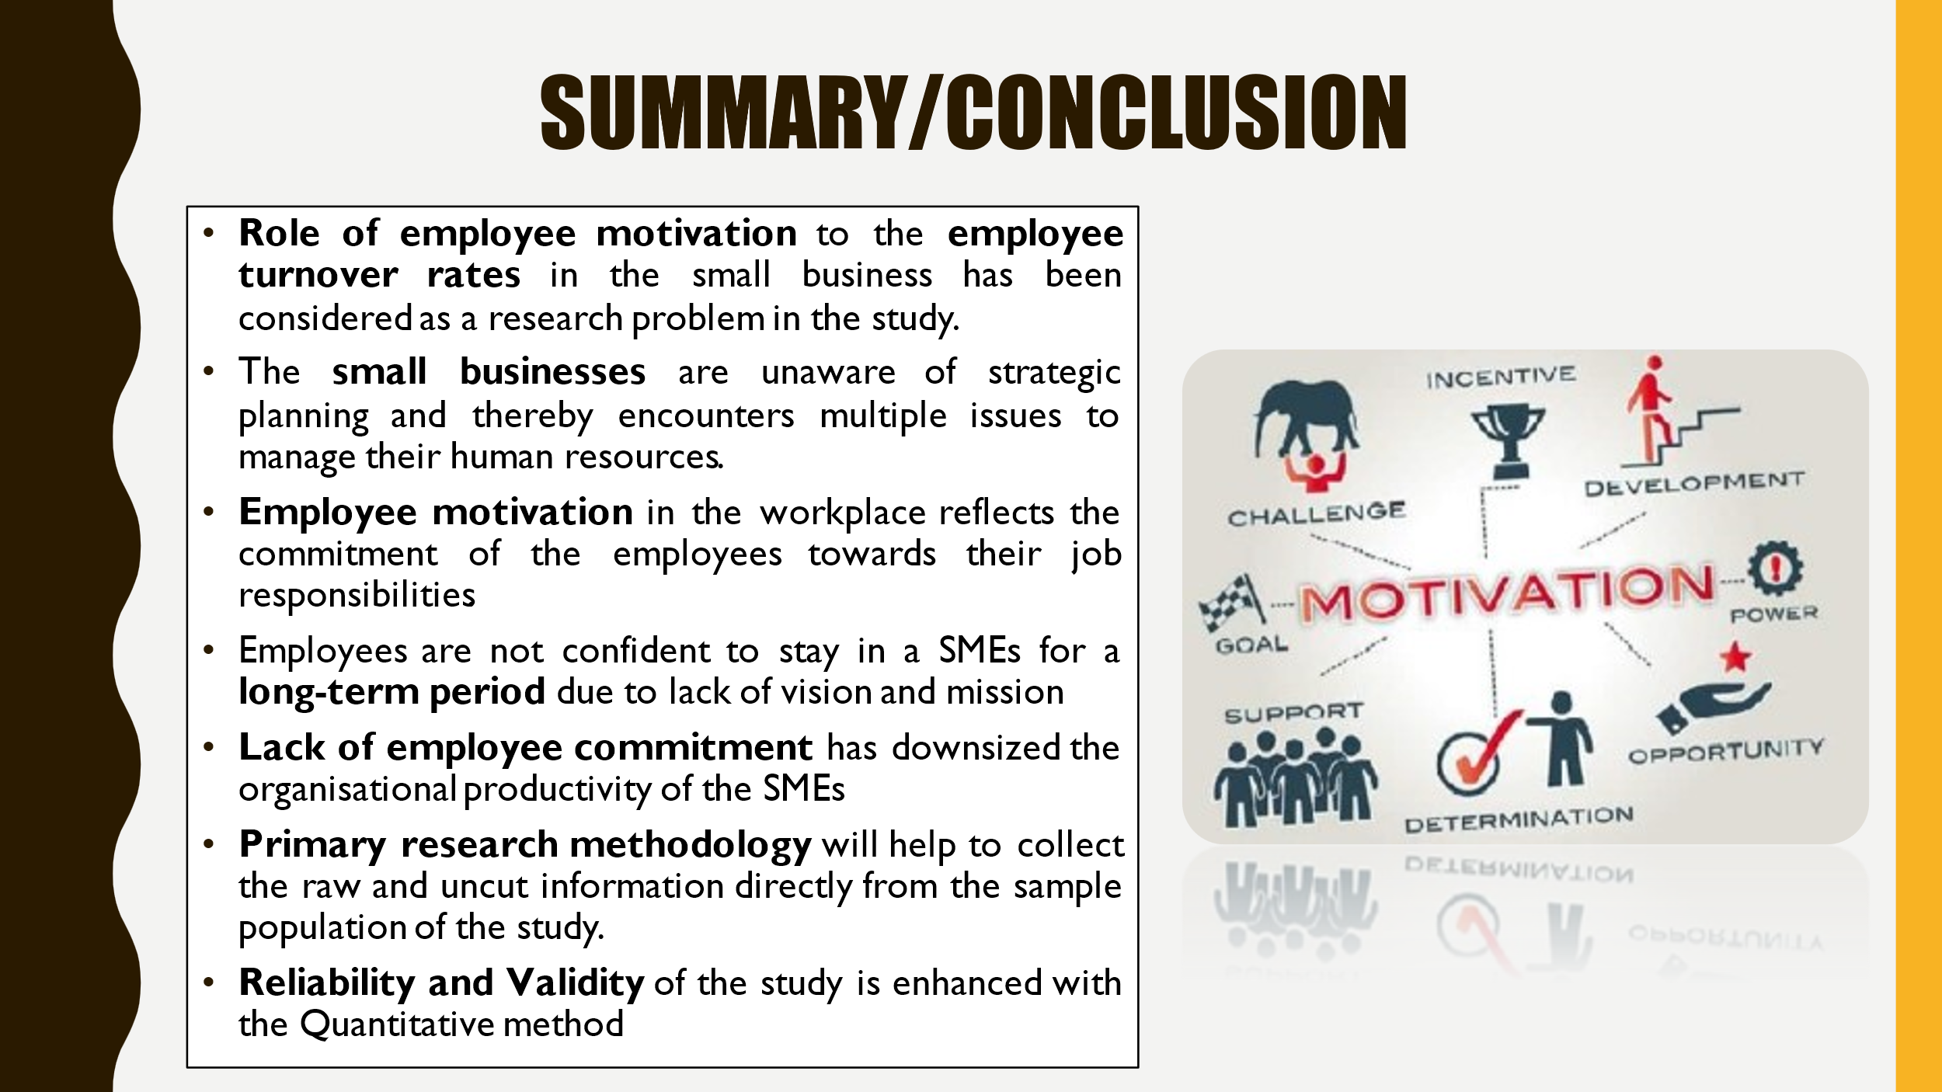
To conclude, the research report will investigate the role of employee motivation towards employee turnover rates by considering primary research. Employee motivation is the intrinsic and internal drive by focusing on the necessary effort and action toward a specific action. Employee motivation is the level of commitment and creativity that the employee delivers in the workplace. Moreover, highly motivated employee is dedicated to delivering discretionary effort in the workplace. Hence, Primary research methodology will help to collect the raw and uncut information directly from the sample population of the study.


