Qualification: CIPD Diploma in Applied Human Resources

Research Title: Using a Research Approach in Human Resources

Word Count: 2015

Student Name: Stephanie Rayner
Student Number: 1907192
CIPD Membership Number: 55478507

By signing below, I confirm that the work/evidence presented is my own, unaided work. I understand the regulations pertaining to candidate malpractice and the action that may be taken as a result.

Signed:

Date: 29th August 2020

Executive summary
This report aims to contribute to the effectiveness of wellbeing initiatives within the Authority and determine whether early intervention would be beneficial to employees improving performance and reducing sickness absence.

Due to the COVID-19 situation, there were limitations in relation to collecting Primary data however; the methodology included the gathering of secondary data from both Swansea Council, Office of National Statistics and reliable sources, which has been analysed throughout the report.

It is clear from data within Swansea Council and the literature review that there continues to be an increase in sickness absence. However, the flexible working pilot which has been led by the Corporate Management Team has proven to be successful, resulting in a reduction in sickness absence and could benefit other departments across the Authority contributing to the overall reduction of sickness within the Organisation.

Whilst it is beneficial for an organisation to promote and encourage wellbeing, there is also a legal obligation to ensure employees are treated in a fair and reasonable manner. As Swansea Council are a local government organisation there is an expectation to go over and above legal requirements However due to budget savings, resources are limited within the Occupational Health Department and therefore, to enable the Authority to provide a high level of support, there is a reliance on volunteers who assist in providing support to employees.

Cost implications have been considered and due to the COVID-19 situation, these are reduced as the Authority have been required to fast track a number of changes which were being considered i.e. IT equipment to enable agile working.

It has been recognised that Swansea Council have introduced a number of wellbeing initiatives providing support to employees, and it is clear that employees are aware of how they can access such initiatives however, the increased awareness is as a result of COVID-19 and therefore it would beneficial to employees if this was continued.

It is encouraging that Swansea Council have a wellbeing strategy outlining the importance of wellbeing however, due to the challenging times being faced by employees, this should be reviewed to ensure the focus is based on the present time.

Table of Contents

Content | Page Number
Executive Summary | 2
- Introduction | 4
- Literature Review  - What is Wellbeing?  - Strategic Approach to Wellbeing  - Management Support  - Summary of Literature Review | 4  4  5  5  5
- Methodology | 6
- Findings | 7
- Conclusions | 8
- Recommendations | 9
- Limitations | 9
References | 10

Wellbeing Initiatives influencing Employee Engagement and Sickness Absence

- Introduction
An Aim of Swansea Council within the next 12 months is to reduce sickness absence which in turn will contribute to the overall budget savings.
This report is an evaluation of the wellbeing initiatives accessible to employees within Swansea Council focusing on whether they are the right initiatives and whether there is sufficient awareness to all employees. The report considers whether early intervention and improved wellbeing engagement would reduce stress related absences.

Identified Stakeholders are:
- Corporate Management Team
- Employees
- Trade Unions
- Occupational Health Department

Having analysed the absence data within Swansea Council for the period 2019/2020, it is evident that stress is the highest reason for sickness, resulting in an increase in both Long Term and Short Term absences.
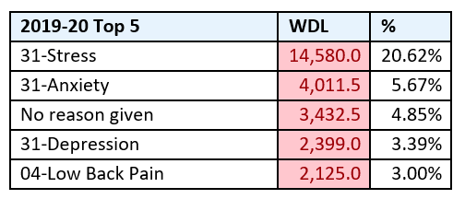
Aim
The aim of this research is to critically analyse wellbeing initiatives to determine whether wellbeing engagement/early intervention will effect sickness absence.

Objectives
- To identify and critically analyse the benefit of wellbeing initiatives within the workplace
- To critically analyse whether wellbeing initiatives improve employee engagement
- To make recommendations to improve Wellbeing Engagement

- Literature Review
Through the process of researching Wellbeing Engagement, whilst there is evidence that it would be beneficial for Organisations to promote wellbeing initiatives, there is also a legal obligation in line with the Equality Act 2010, for employers to consider reasonable adjustments to remove disadvantages felt by staff as a result of a physical or mental illness.

2.1 What is wellbeing?
Wellbeing doesn’t have one defined meaning but may be used to describe the way people feel, how they are coping with day-to-day life, (Mind, 2020). The Department of Health expand further stating ‘Wellbeing is about feeling good and functioning well and comprises an individual’s experience of their life; and a comparison of life circumstances with social norms and values’ (Department of Health, 2014).

The figure below helps describe and defines what is meant by well-being
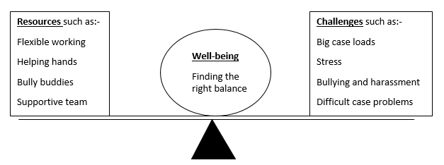
As described in the ‘seesaw’ well-being is a fine balance of understanding what challenges employees may be facing and ensuring the right resources are in place manage these. This approach is based on the research by Michaelson, Mahony, & Schifferes (2012), and Dodge, Daly, Huyton, and Sanders (2012).

2.2 Strategic approach to Wellbeing
Employee health and wellbeing initiatives should be fundamental to an organisation, having a collaborative approach benefiting the overall success of an organisation. To achieve this, (CIPD, 2020) recommend employers to raise awareness at a strategic level. Similarly as stated by (People Management, 2019), in order for any new wellbeing initiatives to succeed, there has to be ‘top level buy in’. Another viewpoint by (Simple Health, 2017), as cited in (Personnel Today) employers can empower employees to maintain their everyday health and wellbeing by providing them with the right wellbeing initiatives.

2.3 Management Support
The (CIPD, 2020), suggests for employers to provide managers with the relevant ‘softer skills’ to enable them to support employees and conduct difficult conversations. (People Management, 2019) recognises that early intervention can minimise the effect on mental health and it is crucial for managers to recognise signs that individuals may be struggling. Again ensuring they are equipped with the ‘softer skills’ to enable them to support employees. A key factor when requesting management ’buy in’ is to ensure that the information presented clearly details the issues sickness absence is creating within the Organisation, (PersonnelToday 2017).

2.4 Summary of literature review
In summary, the key findings from the literature review are very similar in that all articles make reference to the positive impact on employee engagement and the Organisation as a whole should the appropriate wellbeing policies and procedures be in place and have ‘buy in’ from a strategic level.

3 Methodology
(Gov.uk, 2019) has been chosen as a reliable, replicable and valid source of data, which meets the criteria according to Bryman and Bell (2015), as cited in Perkins and Woodhams (2016). The Government collect data to meet legislative requirements and as such is relied upon when making policy decisions.
The report provides a summary of quantitative survey data collected in June 2018 based on 2,564 telephone interviews with employers in Great Britain exploring employer’s behaviours and attitudes in relation to sickness absence and health in the workplace.
Over half of the employers (55%) encountered health concerns that affected their staff with the main reason being stress (29%).

As detailed within the table below, there is evidence that larger organisations take a pro-active approach to wellbeing and are more likely to collect sickness absence data.
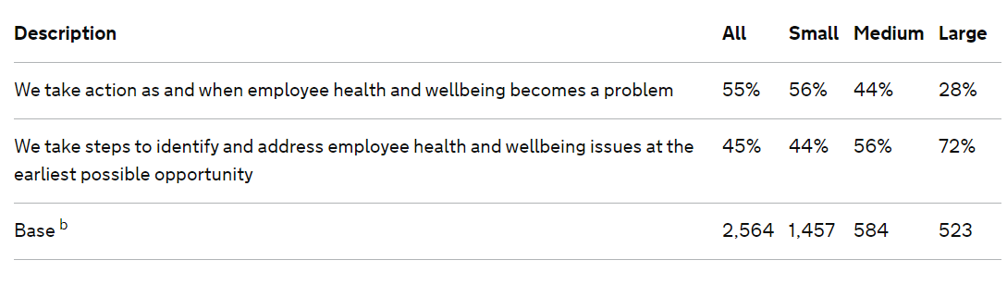
Swansea Council are one of the largest employers within Swansea employing approximately 11,000 employees with an internal Occupational Department providing a number of both informal and formal wellbeing initiatives, full details available via (Swansea Council, 2020).

The top reason for sickness in 2019-2020 was stress with 577 referrals received by the Stress Management Service. This year has seen a large increase with the total number of referrals to day being 1,077. The assumption is that the increase reflects the challenges faced by employees as a direct result of COVID-19. (CIPD, 2019) suggest that the pandemic will have a significant impact upon the mental health of employees.

Whilst the Stress Management Service has seen an increase in referrals, the resources within the Department are limited resulting in signposting to alternative support and implementation of a RAG system to prioritise referrals. It is therefore important for employees to receive early intervention support raising awareness of the wellbeing initiatives available, which may avoid a period of sickness absence.

Swansea Council has recently conducted a survey in relation to Employee Wellbeing and Working from Home arrangements due to COVID-19 with 1600 responses, findings of the survey can be found via the website (Swansea Council, 2020). 90% of employees rated positive about their wellbeing since the onset of the pandemic and most were very clear on where and how to access well-being support from the Council. This may be as a result of specific signposting and regular communications to employee regarding wellbeing during the pandemic, (Swansea Council, 2020).

Prior to the COVID-19 pandemic, Swansea Council introduced a flexible working pilot across a number of departments including the Service Centre and HR&OD allowing employees to have a flexible approach to work managing their own time with the emphasis being on work output. The data below evidences that the pilot has reduced sickness absence within both service areas.

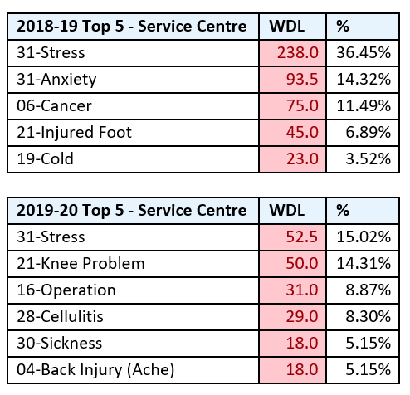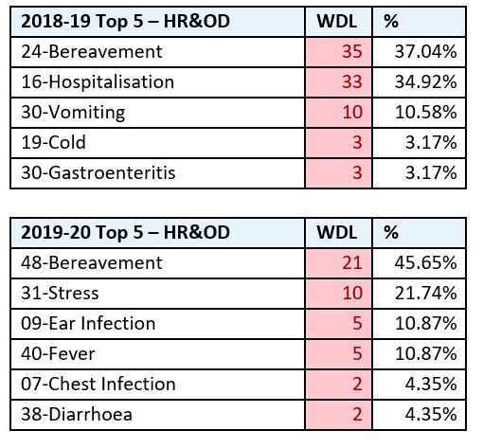

The positive benefits of flexible working is evidenced within a survey conducted by (People Management, 2019) which confirms that employees felt flexible working improved their mental health and helped them maintain a work life balance. However, it also reflected the difficulties in managing flexible working as it requires a trusting working relationship and individuals may have different perceptions.

Whilst Anderson (2013) as cited in Perkins and Woodhams (2016) describes the importance of qualitative data, due to the stigma around mental health it is difficult to determine whether true responses would be provided when conducting interviews/questionnaire and as such, Swansea Council gather quantitative data to identify trends and determine whether early intervention is required.

Due to the sensitive nature of the subject matter in relation to stress, ethical consideration was given to the data collected to ensure the safeguarding of all confidential, commercially sensitive and personal data as set out by the CIPD Code of Conduct (CIPD, 2020). Going forward, if there is capacity to collect qualitative data, there would be a requirement to gain consent of participants prior to presenting the findings or alternatively undertake an anonymous survey.

4. Findings
From the data illustrated below, it is clear that there continues to be an increase in sickness absence within Swansea Council.
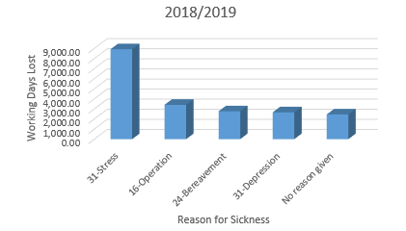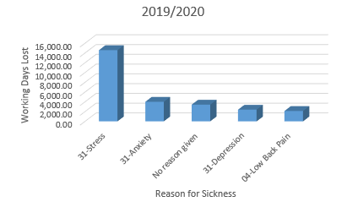

This is also evidenced within figures published by the Office for National Statistics which revealed the total number of days lost due to sickness increased by 7% between 2017 and 2018, (PersonnelToday, 2019).

The absence data below evidences that the introduction of the flexible working pilot has resulted in a reduction to sickness, which suggests that a flexible approach to work provides employees with an improved work life balance and increased productivity, which in turn contributes to the priorities within the Authority. According to (HR Review, 2020) ‘Businesses that believe they have an emotional duty of care to their employees, see flexible working as the most popular way to support staff’. However, there remains to be a significant number of employers who do not believe in supporting the wellbeing of their employees.

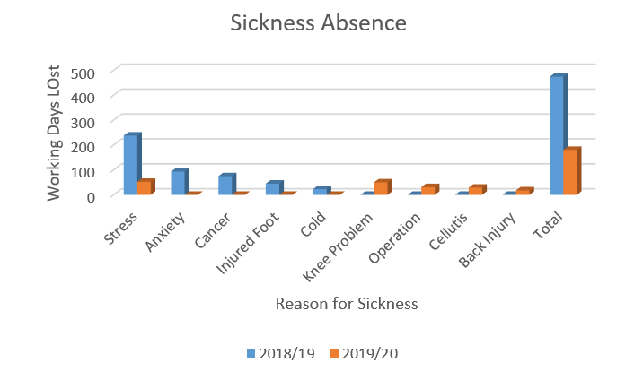

Whilst is it clear that there has been an increase in the number of referrals to the Stress Management Team, this evidences the view of (CIPD, 2020) in relation to mental health during the pandemic. However, the outcome of the staff survey confirmed that employees are aware of the wellbeing initiatives available which in my view is due to the regular communication to employees during the pandemic clearly identifying the support available. As referenced within (HR Review, 2020), awareness of the wellbeing support available for employers and employees is vital.

5. Conclusions
The aim and objective of this report was to critically analyse wellbeing inititatives to determine whether wellbeing engagement/early intervention will effect stress related sickness absence.

Following a literature review, it is clear that wellbeing initiatives benefit both employees and the organisation as a whole. The (CIPD, 2020) refer to wellbeing as a ‘core enabler of employee engagement and organisational performance’.

It is clear that since the pandemic, Swansea Council has recognised the challenging times for employees and as such taken a proactive approach in promoting wellbeing initiatives providing reassurance to employees regarding the support available during unprecedented times. This is evidenced within the outcome of the staff survey whereby 90% of the responses related positive about their wellbeing (Swansea Council, 2020).

It is clear from the analysis of the quantitative data that sickness absence continues to increase however, the introduction of a flexible working pilot as resulted in a reduction of sickness within both departments who have chosen to engage with the pilot.

There are various wellbeing initiatives accessible to employees, and it would be beneficial for future research to determine what initiatives employees have accessed and whether early intervention enabled employees to remain within the workplace.

6. Recommendations for change
Based on the significant increase in Stress Referrals, it is recommended for the Corporate Management Team to consider additional resources within the Occupational Health Department, which will enable the Service to have a proactive approach allowing earlier intervention and engagement with employees. Whilst this would result in increased costs, it would in turn reduce sickness absence contributing to the overall budgets savings to the Authority.

There is evidence to determine that the flexible working pilot has resulted in a reduction of sickness absence within the two pilot areas. Prior to COVID-19, there were restrictions and cost implications in relation to IT equipment, Software requirements etc. however, on the basis that employees have been provided with the relevant equipment to enable them have a flexible approach to work, the recommendation is to review the flexible working policy and implement the working practice across the Authority where reasonable practical.

There is evidence to show that employees have become aware of the wellbeing initiatives available during the pandemic and as such, it is recommended for regular communication and awareness to continue. It would be beneficial to undertake a further survey during the winter period and whether they feel the initiatives have been beneficial to their wellbeing.

Whilst there is a wellbeing strategy policy within the Council, due to the COVID-19 pandemic and the challenges faced by both employees and the organisation, there is a recommendation to review the wellbeing strategy to ensure consideration is taken regarding changes to working practices, working arrangements and the challenges employees have faced during such difficult times.

Limitations
Due to the COVID-19 pandemic, there were restrictions in collecting Primary Data i.e. conducting interviews/questionnaires and as such, the report makes reference to Secondary Data specific to the subject matter.

In addition, as stated by (Mind, 2017)), due to the stigma attached to mental health, the qualitative data available is limited.

References

CIPD (2020) ‘Code of Professional Conduct’. Available at: https://www.cipd.co.uk/Images/code-of-professional-conduct-april-2020_tcm18-14510.pdf (Accessed 21st August 2020).

CIPD (2020) ‘Coronavirus (COVID-19): Mental health and returning to the workplace’. Available at: https://www.cipd.co.uk/knowledge/culture/well-being/supporting-mental-health-workplace-return (Accessed 20th August 2020)

CIPD (2020) ‘Employee Health and Wellbeing’. Available at: https://www.cipd.co.uk/news-views/viewpoint/employee-health-well-being. (Accessed 4th August 2020)

CIPD (2020). ‘Well-being at work’. Available at: https://www.cipd.co.uk/knowledge/culture/well-being/factsheet (Accessed 29th August 2020)

Department of Health (2014) ‘Wellbeing, Why it matters to Health policy’. Available at: https://assets.publishing.service.gov.uk/government/uploads/system/uploads/attachment_data/file/277566/Narrative__January_2014_.pdf (Accessed 29th July 2020).

Gov.uk (2019) ‘Sickness absence and health in the workplace understanding employer behaviour and practice – an interim summary’. Available at: https://www.gov.uk/government/publications/sickness-absence-and-health-employer-behaviour-and-practice/sickness-absence-and-health-in-the-workplace-understanding-employer-behaviour-and-practice-an-interim-summary (Accessed 20th August 2020)

HR Review (2020) ‘Flexible working is most popular way to deliver emotional wellbeing’. Available at: https://www.hrreview.co.uk/hr-news/wellbeing-news/flexible-working-is-most-popular-way-to-deliver-emotional-wellbeing/124129 (Accessed 26th August 2020)

Legislation.gov.uk ‘The Equality Act 2010’. Available at https://www.legislation.gov.uk/ukpga/2010/15/contents (Accessed 29th July 2020)

Mind (2017) ‘Mental health problem, an introduction’. Available at: https://www.mind.org.uk/information-support/types-of-mental-health-problems/mental-health-problems-introduction/stigma-misconceptions/ (Accessed 20th August 2020)

Mind (2020) ‘How to improve your mental wellbeing’. Available at https://www.mind.org.uk/information-support/tips-for-everyday-living/wellbeing/wellbeing/ (Accessed 4th August 2020)

People Management (2019) ‘Flexible work improves mental health’. Available at: https://www.peoplemanagement.co.uk/news/articles/flexible-work-improves-mental-health (Accessed 21st August 2020).

People Management (2019) ‘What’s HR’s responsibility for workplace mental health’. Available at: https://www.peoplemanagement.co.uk/experts/legal/what-is-hr-responsibility-workplace-mental-health (Accessed 29th July 2020)

Perkins, G Woodhams, C. (2016) ‘Using Information in Human Resources’, in Taylor S, Woodhams C. (ed) Studying Human Resource Management, 2nd Edition, London:CIPD.
Personnel Today (2019) ‘Sickness absence increases to 4.4 day per worker’. Available at: https://www.personneltoday.com/hr/sickness-absence-2018-increase/ (Accessed 21st August 2020).

Personnel Today (2020) ‘Maintain employee wellbeing to reduce absence’. Available at: https://www.personneltoday.com/hr/maintain-employee-wellbeing-reduce-absence/ (Accessed 4th August 2020)

SeeSaw ‘What wellbeing means at SeeSaw’. Available at https://www.seesawconsulting.co.uk/useful-information (Accessed 4th August 2020)

Swansea Council (2020) ‘Chief Exec’s Blog’. Available at: http://ceblog.ccos.me.uk/2020/08/21/interesting-results-from-staff/ (Accessed 21st August 2020)

Swansea Council (2020) ‘Employee Mental Health and Wellbeing – Coronavirus’. Available at: http://www.swansea.gov.uk/staffnet/coronavirusstaffmentalhealth (Accessed 21st August 2020)

Swansea Council (2020). ‘Stress management and counselling service’. Available at: http://www.swansea.gov.uk/staffnet/stressmanagement (Accessed 29th August 2020)

