

Bruno jeronimo

Module Name: Introduction to Web and Database Concepts
Module Code: ACCA4023

Student Name: Bruno Jeronimo
Student ID:2442240
Group:1

Introduction to Web and Database Concepts

Table of Contents
Introduction 3
Task 1: Implementation Guide: 5
Scenario Analysis 5
Entity-Relationship Diagram (ERD) 6
6
Data structure Development 7
Normalization Compliance 8
Sample Data Population 8
Query Development 9
Average Maintenance Cost by Bike Type 9
Bike Returns Mismatched with Current Location 9
Validation and Testing 10
Conclusion 10
References 11
Appendices 12
Appendix 1: Draft work 12

Introduction

In this task I will describe The Eco-Ride Database Project and explain what I was designed to do. I will show the main parts of the database, how it was created and why it is useful for the company. I will also talk about how the database works and what it helps Eco-Ride achieve. [1] [2]

Task 1: Implementation Guide:

Scenario Analysis
Entities | Attributes | Relationships
Rider | RidersID  Name  Email  Phone  IDNumber | Single rider can make many rentals
Bike | BikeID  Model  Type  PurchaseDate  Status | A single bike can be rented many times
Station | StationID  Name  Address  Phone  RiderID | A station can hold many bikes
Staff | StaffID  Name  Role  Email  Phone | A staff member can perform many maintenance tasks
Rental Transactions | RentalID  RiderID  BikeID  RentalDate  ReturnDate  TotalCost | A station can be pick-up location many rentals
Bike Maintenance | MaintenanceID  BikeID  ServiceDate  Description  Cost | A single bike can have many records

Entity-Relationship Diagram (ERD)

This Screenshot shows the ERD for the Eco-Ride database. It displays all the tables and how they are linked using primary Keys and foreign keys.

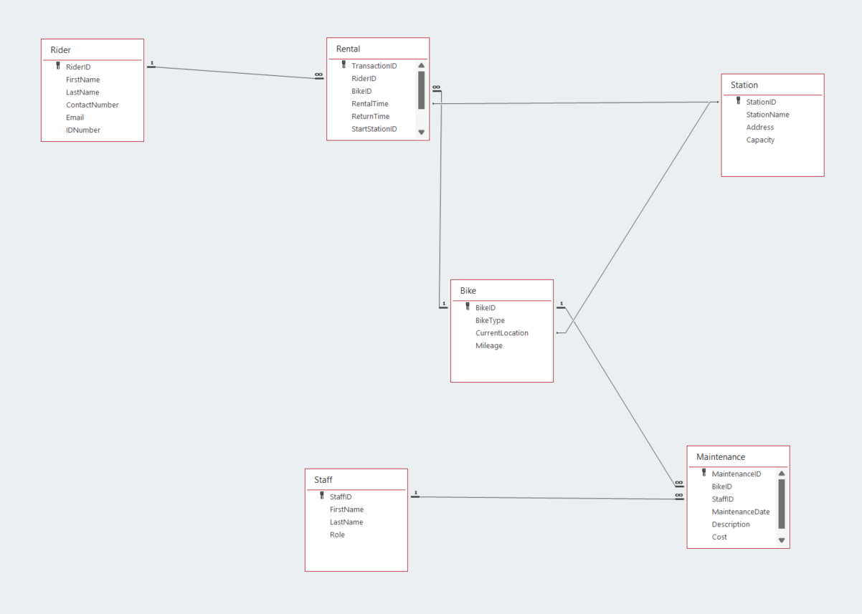

Data structure Development
This Screenshot shows the tables created for the database. Each table has fields that store important information, such Rider details, Bike details and Rental information.
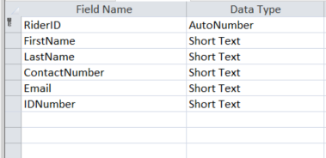
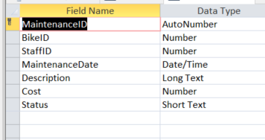
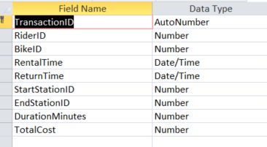
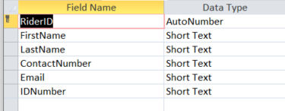
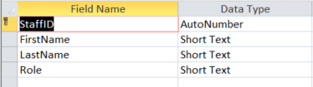
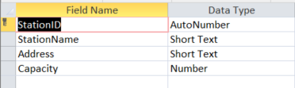

Normalization Compliance
Normalization ensures data quality. To meet Third Normal Form (3NF), we eliminate transitive dependency. For example we don’t store a Station’s address in the BIKE table, we only store the StationID (Codd, 1970. This avoids updating the same address on multiple bike records, minimizing redundancy. [3]

Sample Data Population
This Screenshot shows sample data added to the tables. This data is used to test how database works.

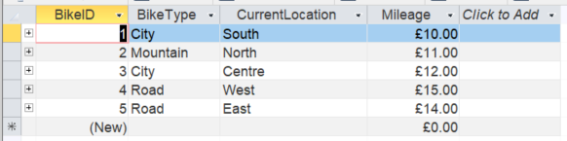
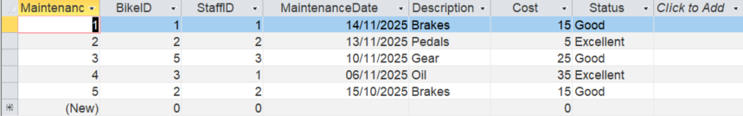
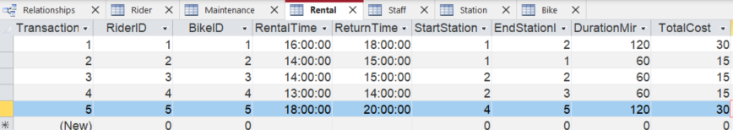
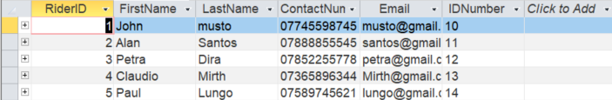
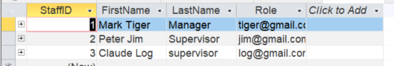
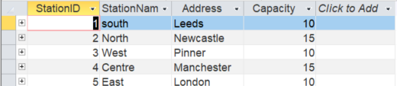

Query Development

Average Maintenance Cost by Bike Type
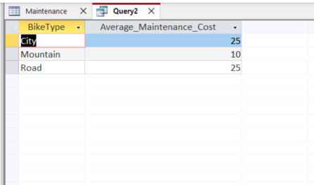
This query joins BIKE and Maintenance tables to group maintenance by bike the bike’s category (BikeType)

Bike Returns Mismatched with Current Location

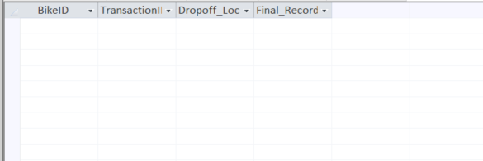
This query compares the final-drop-off location (EndStationID) from the transaction record with the bike’s current station recorded in the Bike table, identifying discrepancies that need investigation.

Validation and Testing
Table Testing
- I checked that each table had the right fields and data type
- I tested entering sample data to make sure the fields only accept the correct type ( numbers, Text, Dates)
- Primary keys were tested to confirm they do not allow duplicates

Relationship Testing
- I tested the foreign keys between tables such as RiderID, StationID and StaffID
- I tried adding a rental with the RiderID that not exist and the system blocked it
- I checked that the database does not allow deleting records if they are linked to another table
Sample Data Testing
- I entered sample Rider, Bikes, Rentals, Stations, Staff and Maintenance records
- All valid data was stored correctly
- Incorrect data was rejected

Query Testing
- Average Maintenance Cost by Bike Type
- The query correctly calculated the average cost fir each based on sample data
- Bike Returns Mismatched with Current Location
- The query showed bikes returned to the wrong station which matched the test data

I compared the database with the project requirements:

- Register Riders Pass
- Store Bike information Pass
- Record Rentals Pass
- Track Maintenance Pass
- Run Queries Pass

The testing shows that the Eco-Ride database works correctly, keeps data organized, prevents mistakes and procedures accurate query results. The system meets all needs of the Eco-Ride project.

Conclusion

The Eco-Ride project successfully developed a structured digital database to replace inefficient manual processes. The solution is build around six core entities (Rider, Bike, Station, Staff Rental and Maintenance) which separate data logical to achieve Third Normal Form (3NF). This organization is critical because it eliminates data redundancy and prevents errors like repeating the same address information across thousands of bike records. The system uses Primary Keys and Foreign Keys to link these tables, creating a robust framework that enforces Referential Integrity, ensuring data accuracy and solving the original problem of inaccurate operational tracking and double-bookings.
I Learned the smart way to organize data so we never write the same information twice. Also found that the computer program we used ( Microsoft Access) has very tricky rules for the data base language (SQL) which caused problems.
The main problem was not having enough time for such a complex job. Because of the limed time I had to spend a lot of effort search for solutions and answers to get a final job.

References

[1] | F. C. E, “A relational model of data for large shared data banks,” https://dl.acm.org/doi/10.1145/362384.362685, pp. 377-387, 1970.
[2] | W3Schools, “SQL Tutorial,” November 2025. [Online]. Available: https://www.w3schools.com/sql/.
[3] | Oracle, “Database Design and Data Modelling Concepts,” Oracle, [Online]. Available: https://docs.oracle.com/en/database/. [Accessed November 2025].

