Abigail Poulson
P1702468
Independent Inquiry
BA Photography in the Arts
Tutor – Dr Hamish Gane

In contemporary society, it seems that the gallery continues to reflect a wider social injustice. Even if this is an unintended, subconscious behaviour, should it not be challenged to confront and encourage cultural democracy, and how do curators develop strategies to change this?

Submitted in partial fulfilment of the requirements for the degree of BA (Hons) Photography in the Arts University of Wales Trinity Saint David, Swansea, 11th of December 2019.

Total Word Count - 5878

Table of Contents

List of Illustrations 2

Summary of Topic 4

Introduction 5

Chapter 1 -
A Meeting with a Curator 8

Chapter 2 -
What is Curatorial Activism, and should we be a curatorial activist? 16

Chapter 3 -
The Artist and the Curator 23

Conclusion 33

Bibliography 35

List of Illustrations

Fig. 1: Boghiguian A (2018) A Meteor Fell from the Sky [installation].
Available at: https://www.studiointernational.com/index.php/anna-boghiguian-video-interview-artes-mundi-8 (Accessed 3 November 2019).

Fig. 2: Author Unknown (2019) Swansea Stories [Poster].
Available at: https://www.swansea.gov.uk/article/52703/Swansea-Stories (Accessed 3 November 2019)

Fig. 3: Hayward Gallery (2019). Installation view of Diane Arbus: in the beginning at Hayward Gallery.. [image]
Available at: https://www.southbankcentre.co.uk/blog/diane-arbus-interview-jeff-rosenheim-karan-rinaldo-hayward-gallery [Accessed 3 Dec. 2019].

Fig. 4: Pussy Galore (2015). The Guerrilla Girls’ 1986 Report Card Alongside Pussy Galore’s 2015 Report Card. [image]
Available at: http://hyperallergic.com/wp-content/uploads/2015/02/GG-PG-genderstats.jpg [Accessed 3 Dec. 2019].

Fig. 5: The White Pube (2018). The White Pube. [image]
Available at: https://dazedimg-dazedgroup.netdna-ssl.com/531/azure/dazed-prod/1240/0/1240547.jpg [Accessed 3 Dec. 2019].

Fig. 6: A Poulson (2019) What Will Remain of Usr. [image].

Fig: 7: Suarez, K. (2019). The Poisons We Breathe. [image]
Available at: https://www.instagram.com/p/ByyRmooBtH6/ [Accessed 3 Dec. 2019].

Fig. 8: Haywood, A. (2019). All The Sneezes I've Sold. [video]
Available at: https://vimeo.com/340888088 [Accessed 3 Dec. 2019].

Fig. 9: This Morning (2019). Art Student Makes Hundreds From Videoing Herself Sneezing. [video] Available at: https://www.youtube.com/watch?v=SAirrc7sQqU [Accessed 3 Dec. 2019].

Summary of Topic:
Despite art and culture becoming more accessible to all, evidence and statistics show that social inequality still exists within galleries. Whether it be through gallery exhibitions, collections, outreach programmes or through awards and prizes. The debate of who or what is being shown, and what is not, and why, is crucial today. From the perspective of a young woman artist and aspiring curator from Wales, this inquiry focuses on ways in which we can challenge and confront this injustice, and encourage culture democracy to create a more equal inclusive art world.

Introduction
Former Prime Minister of the Labour party, Tony Blair made a triumphant promise to the public of Britain in 2007 and pledged that art would be made a central core of British culture, by the abolishment of all entry fees to national collections in museums. This meant that collections in museums such as the National Gallery, Natural History Museum and Tate Britain were made free and accessible to all.
When people on low incomes can visit museums free of charge, and see great works of art, they take something of the inspiration with them. A nation that cares about art will not just be a better nation ... Because art, more than any programmes of government, worthy and necessary though those are, can make people consider, see things differently, understand where the other comes from. (Blair, 2007)

Blair’s speech was a great step forward for cultural democracy, “the desire for every culture to be respected equally without hierarchy.” (LANG, 2017) and art and culture became more accessible to all, across the UK. However, evidence and statistics show that social inequality still exists within galleries. Whether it be through gallery exhibitions, collections, outreach programmes or through awards and prizes. The debate of who or what is being shown, and what is not, and why, is crucial today.

Until recently, I naively viewed the art world as a warm, friendly and collaborative place where artists worked extremely hard to stay a part of it. My first time visiting the Tate Modern in London during my foundation studies in Art and Design blew me away. I had never felt so much joy in a gallery, and for me the first experience of visiting a national gallery confirmed that I wanted to be an artist. Three years later, and I still want to be part of the art world, and feel strongly dedicated to my practice. However, the innocence of this ambition has been replaced by a sense of unease. I have come to realise that women have never been treated equally in the art world, and today we remain dramatically underrepresented in galleries, museums and even auction houses. This underrepresentation applies not only to women. Artists of colour, of marginalised communities and LGBTQ+ artists are also represented in minority. Nevertheless, I have begun to understand that this is a problem that is being addressed by individuals who are taking revolutionist and activist approaches to create a more inclusive art world, and that these are strategies that I, myself could employ and be aware of within my own practice, both as an artist and as an aspiring curator.

For this inquiry, I have decided to research and identify ways in which we can tackle male white privilege and western centrism and create a more inclusive art world towards women artists, artists of colour and LGBTQ+. Employing an auto ethnographic approach in writing, this essay will use self-reflection to connect personal experience to wider cultural, political and social meanings and understandings. It is important to mention that the selection of exhibitions, artists and curators I have chosen to discuss have been informed by my identity as a young white woman from Wales, who most often sees exhibitions between Wales, the United Kingdom and sometimes Europe.

To begin my research, I will explore my encounters with Karen Mackinnon, current curator of Glynn Vivian Art Gallery in Swansea and previous director of international art prize, Artes Mundi, and how her socially engaged practice inspires a new way of thinking. For Chapter 2, I will focus on the reading of Maura Reilly’s book Curatorial Activism and whether all curators should take on a curatorial activists’ approach, and the advantages and the disadvantage of this. In response to the previous research, taking the previous chapters into account, Chapter 3 will then focus on my experience as a curator, and how my research has been implemented to create new strategies within my practice.

Chapter 1
A Meeting with a Curator

On a rainy Swansea Friday afternoon, 18th of October 2019, myself and another young artist and curator made our way to meet Karen Mackinnon at Glynn Vivian Art Gallery, where she is now head curator. Mackinnon was previously the director of Artes Mundi and curator at Chapter Arts Centre. She was also recently made an MBE at the 2019 Queen’s birthday honours for her services to the arts and for bringing high profile artists, exhibitions and events to Wales. Freedom of expression is at the heart of her curatorial philosophy which is fuelled by socially engaged practice.

My first encounter with Mackinnon was attending a talk she gave last November, during which she not only discussed Artes Mundi, an international art prize, and her role as director, but also acknowledged the award’s importance and how core themes within the show often connect to the outside world. As she discussed the show’s themes and spoke about the works by the artists, she also began to answer questions about criticism she’d received about the exhibition, criticism that was perhaps unfair or biased. It was during this talk that I began to realise and recognise the problems existing within the art world. When reflecting on the experience I had in that lecture hall, I made a pledge to myself that this social and cultural inequality is totally unjust and that I want to make change and integrate this within my practice.

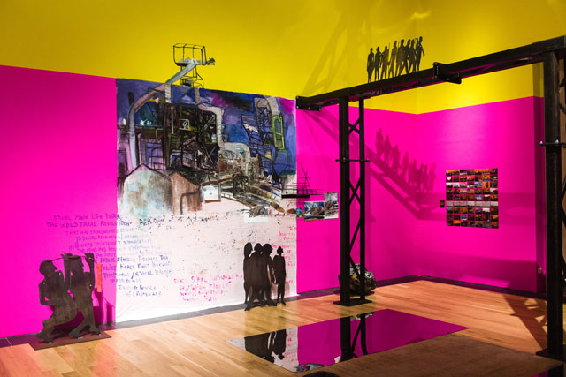

Figure 1: A Meteor Fell from The Sky.

Artes Mundi, Latin for ‘Arts of the Worlds’, focuses internationally “to bring exceptional and challenging international art to Wales and to generate unique opportunities for individuals and local communities to engage creatively with the urgent issues of our time”. (Artesmundi.org, 2019) The 2019 shortlist for Artes Mundi 8 was selected from over four hundred and fifty nominations spanned across eighty-six countries. Surveys have shown that Artes Mundi has been recognised as a prize that represents the most diversity through their selection process. When asked how this happens, Mackinnon replied that it was simply something they do that they felt was crucial, “If we’re selecting and there’s too many men, or there’s not enough diversity then we change it.” (Mackinnon. 2019)
British art critic, Jonathon Jones wrote a slightly negative review of Artes Mundi 8 for The Guardian newspaper, which remains uncomfortable to read even today. Titled ‘Artes Mundi 8 review – engrossing works blunted by limp liberal agenda,’ he criticises the show and questions “what has happened to rewarding artistic quality? Or is that now synonymous with expressing the correct worldview?” (Jones, 2019) Jones’ view goes against Mackinnon’s values in freedoms of expression and appears to push art back into a closed box. This negative review highlighted issues between gender, discrimination and the denial of diversity and inclusivity, and the challenges that are faced when trying to create global impact through curatorial and artistic practice.

During her talk, Mackinnon stated that public galleries are all we have, and we should be supporting them. These spaces should have the freedom to be open and political as they are supported by the public, and are for the public. It is the private galleries that we should be challenging, as they do not allow the same kind of relationship with artists or the public. Works are restricted, and rather than reflecting the world we live in and connecting to the people, they act separately, following their own values and motives. To fight for a new culture, we must take risks and see the gallery as a part of our practice, rather than the end goal.

As a young artist and curator from South Wales, I felt somewhat reassured that there were people like Mackinnon in such places of power within the art world. Her decision making and approach within her curatorial practice is crucial part of the art scene in Wales, both formerly within Artes mundi and currently through her role at the Glynn Vivian. It felt evident that she was forging a path forward in the art world for the next generations of artists, and inspiring and supporting radical practices which, encourage change and new ways of thinking.

The coffee machine whistled busily in the cafe as we sat around cups of coffee and got out our notebooks. Mackinnon sat down with a bowl of soup, and we were ready to begin our conversation. We focused on urgent, necessary questions relating not only to the gallery we were sat in, but also wider institutions. The conversation almost stemmed into a curator’s ‘to-do list’, focusing on existing problems within galleries, and what positive strategies are currently being employed at the Glynn Vivian.

Glynn Vivian Art Gallery is a publicly funded gallery and has experienced major redevelopment since its opening in 1911. As well as exhibiting a dynamic range of works from Welsh and global artists such as Shimabuku and Bedwyr Williams, the gallery also holds a vision to engage more meaningfully within the community and to create new, inspiring and exciting experiences between their exhibitions, collections and learning programmes. The aim is to engage with the widest audiences possible, offsite and onsite, to contribute to social wellbeing and support the future regeneration of the city of Swansea.
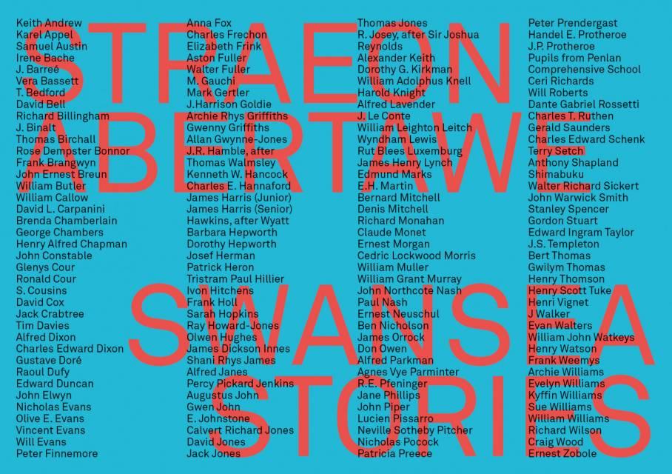

Figure 2: Swansea Stories.

Swansea Stories, Glynn Vivian’s current major exhibition explores the gallery’s collection of art works, presenting the largest selection of the permanent collection to ever be displayed. This includes artworks bought and collected by Glynn Vivian himself and the gallery, celebrating Swansea’s 50th anniversary as a city. The exhibition exists in two large rooms, and displays works from the 18th century to modern day, presenting an eclectic and unique portrait of the city, from the city centre to the beautiful coastlines. It is an exhibition for the people of Swansea, curated loosely into two categories, Swansea people and Swansea places, allowing the public eye to create their own narrative.

Despite the exhibition being a positive outreach to the community and creating opportunity for the public to discover parts of the collection which had never been seen before, there is a problem with what exists within the collection and what does not. In the collection, there are very few Women artists, LGBTQ+ artists and artists of colour, the works are predominantly made by white men. Despite the show being successful and engaging with the public’s interest, an exhibition like this fails to offer representation to the diversity of the artists that have existed within the gallery, Swansea and Wales. Many artists have been excluded from the canon due to a history of male and white privilege. This problem exists in collections around the world, not only in Glynn Vivian.

For example, when Tate Modern reopened in 2016, out of the 300 artists represented in the rehang of its permanent collection, less than a third were women. Fewer still were artists of colour. This was researched by East London Fawcett, (ELF) who are a London based charity campaigning for gender equality and women’s rights, both at home and in public life. Statistics also show that out of the 134 galleries in London, less than a third of the artists they represent are women.

In 2013, less than a third of artists represented by commercial galleries in the United States are women, even though between 65%-80% of US art students are not men. (Nmwa.org, 2019) To make change we must identify and be honest about problems that do exist within the collections in our galleries, as currently they only represent a minority of artists and do not act inclusively.

In response to this issue, it is announced that Glynn Vivian will be holding a group of LGBTQ+ themed shows at the beginning of 2020 which will exhibit both international and local artists. During these shows, Mackinnon and the team at the gallery hope to research the history of LGBTQ+ artists in Swansea, both historically and contemporary with the plan to add these works to the gallery’s collection. Other plans include opening the gallery’s decision making to the public, and allowing for members of their community groups to participate in the gallery’s decisions. Another plan Mackinnon hopes to set up allows the opportunity for anyone to be able to curate an exhibition of any topic, regardless of academic or artistic background.

When I asked if Mackinnon regarded herself as a curatorial activist, she replied that she describes herself more as a socially engaged curator who sees importance in diversity, community, and the future of museums and that they should exist and support the community and the wider world.

Chapter 2
What is Curatorial Activism, and should we be a curatorial activist?

Curatorial Activism is used to describe the practise of organising art exhibitions with the principle aim of ensuring that certain kinds of artists are no longer ghettoized or excluded from the narratives of art. It is a practice that commits to giving voice to those who have been historically silenced or have been forgotten altogether, and focuses predominantly on work produced by women, artists of colour, non-euro- Americans and queer artists. Curatorial Activism: Towards an Ethics of Curating by Maura Reilly creates an operative assumption that the art system, its history, institutions, market and press is an economy that privileges white male creativity, and excludes all other artists. It also emphasises that this white western male viewpoint has been unconsciously accepted as the universal viewpoint on which we favour and prioritise art. The book questions how curators operating within the art world can be encouraged to think about gender, race and sexuality, and to understand that these are concerns that require action, and more importantly, ensuring that the art world can become more inclusive.

“Do you see art as a man’s world? Yes, it is a world where men and women are continually trying to satisfy the power of men.”
Louise Bourgeois (Reilly, 2018)

Linda Nochlin’s landmark essay, “Why have there been no great women artists?” shows that women have come a long way since the 1970s. (Nochlin, 1971) Since then, curators have gained greater interest in involving women fully in major group exhibitions. For example, just under half of the artist exhibited in this year’s Venice Biennale, organised by Ralph Rugoff, are women. Female solo shows and retrospective themed exhibitions have also become increasingly popular since the 2000s.

At the beginning of the year, the Hayward Gallery, London, hosted Diane Arbus’ most recent retrospective show titled In the Beginning. The show aimed to give a clearer insight into the photographer’s early career and was a revision of her former retrospective exhibition which was held in 1972. In the previous show, many of her early photographs were not included or published in the catalogue. The recent exhibition at the Hayward Gallery presents most of her works, and enacted as a ‘Volume One’ of her works. Her works were hung onto standing columns within the space, allowing the spectator to walk and find their own way to discover the pieces, allowing them to create their own connections and dialogues. Its former 1972 exhibition now acts as a ‘Volume 2’ exhibition due to the way it silenced and suppressed her works and excluded them from the canon.
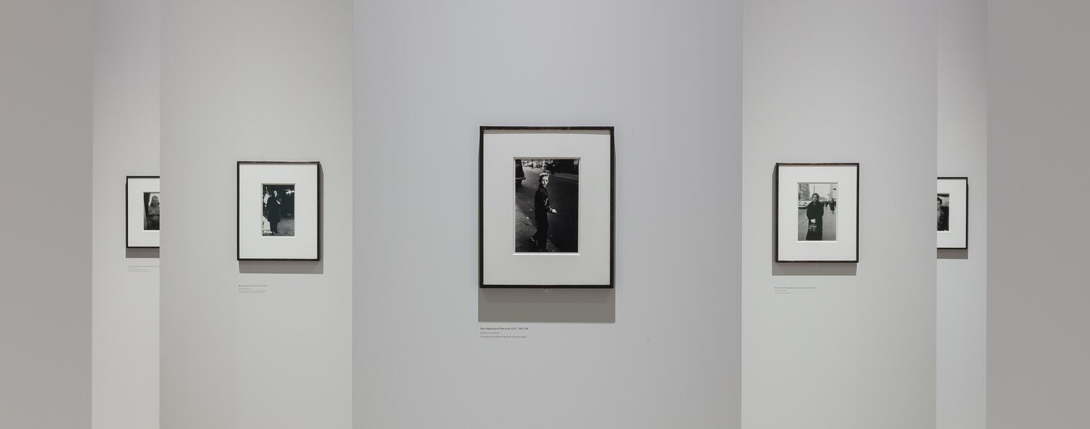

Figure 3: Hayward Gallery (2019).

On researching the book Curatorial Activism, I realised that this Arbus exhibition was an example of a revisionist strategy, where artists are reclaimed from history, and the canon is rewritten. A revisionist approach rediscovers what the canon has supressed, and looks for the “sins and errors” of the past. (Showalter, 1981) This strategy enables curators to present a wider selection of artists and works relating to subject.

In ethical curating, other strategies are also used to resist masculinism and sexism. Area Studies creates new canons through centralising work that is based on either racial, geographical, gendered or sexual orientation. This strategy encourages and dedicates space to exhibitions that spotlight Women Artists, African American Art, Middle Eastern Art or LGBTQ+. While this creates opportunity for the artists to be included in the canon, it does not integrate the artists within the system. It instead keeps them separate, and they exist as separate entities.

Another strategy that can be employed to resist masculinism and sexism is Relational Studies. This is described as the most efficient way to debunk the Euro-US-Centrism that exists. A relational approach:

presents art as if it were a polysemic site of contradictory positions and contested practices. The focus goes beyond a mere description of discrete regions and cultures, it transcends the “additive” approach, collapses the destructive centre-periphery binary, and is essentially postmodern in nature: it is textual, dialogic and “writerly” (Reilly, 2018)

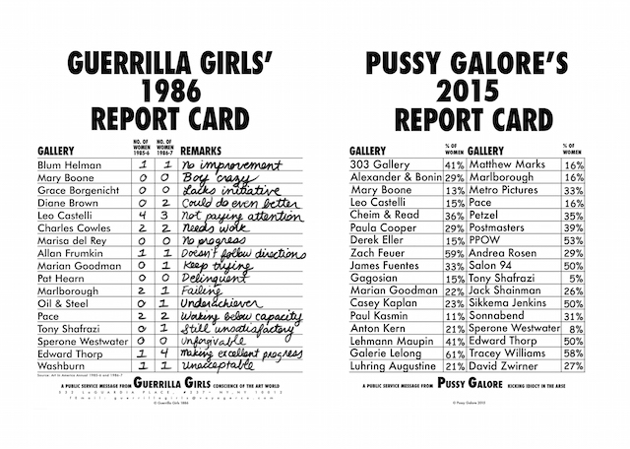

Fig. 4: Pussy Galore.

The Pussy Galore are an international feminist art collective of artists, curators, critics, collectors, educators, and writers who are dedicated to eradicating sexism within the art world through a series of antagonistic tactics of artworks, actions / performances, exhibitions, purchases, articles, classes and books. Like the Guerrilla Girls, the Pussy Galore keep their identities anonymous. This modern reproduction of the former Guerrilla Girls’ 1986 report card shows that, almost 30 years later, sexism still exists within the art world.

Tate Modern’s first female director, Frances Morris, pledged in 2016, that more women will be shown within the gallery’s programme. “It isn’t like we are celebrating women for six months and then all the chaps come back,” she reported in The Guardian. “There is a commitment now to show the real history of art and the contribution made by many women who have been overlooked for many reasons.” (Morris, 2016) Changes to the programming and exhibition lists within the Tate Modern are yet to be seen, as previously mentioned, of the three hundred artists displayed in the 2016 rehang of the permanent collection, less than a third are women.

Despite history, “[The art world] is one of the last bastions of white supremacy by exclusion” (Wilson,1987) and is still invested in promoting legacies of patriarchal western art history. Despite the artist’ conception of producing new and original ideas, certain artists are still favoured over others. The concept of talented artists being rewarded for the exceptional work they produce is a misconception. Many individuals work to tackle and confront white privilege and western centrism and to create equal opportunities within the arts, for example The White Pube.
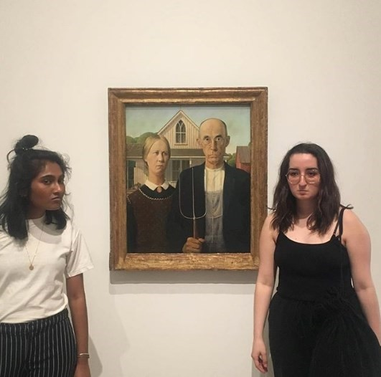

Figure 5: The White Pube.

The White Pube, their name playing with the title of the international commercial gallery, the White Cube, is the online identity of Gabrielle de la Puenty and Zarina Muhammad. Through writing and criticism, they challenge the art world after feeling that art critique had become boring, overly academic, male and white privileged. In contrast, The White Pube wish to take more of an ‘embodied’ approach, creating personal reviews of exhibitions where they record their encounters and reflect on personal reactions almost immediately.

So many critics presume that they have the authority to predict your response [to an artwork],” says Muhammad. “It’s all outdated. Art critics are either trying to canonise artworks for the market or actively make contemporary art history. The White Pube, by contrast, is about the immediate encounter we have with the art. (Muhammad Goh, 2019)

The White Pube make every effort to keep an honest approach towards critiquing art despite traditional criticism still being a valuable judgement on art, rating things as good or bad. The White Pube value the kind of reviews you would give a friend, by word of mouth or through messaging more than what The Evening Standard might have written, for example. This approach is a core within their writing, but is also used for boycotting institutions for poor treatment in the arts, and they take advantage of their online presence to call out and expose situations that neglect artists within the art world.

As The White Pube have become increasingly popular, they have been invited to attend and have visited many exhibitions, organisations and events across Europe. However, as their popularity has grown, their thoughts and posts can often be quite attacking towards artists’ directors, curators and institutions, sometimes making false presumptions and false accusations without all the knowledge and facts.

In 1931 Walter Benjamin used the term Left-Wing Melancholy to characterise dominant forms of political art of the time, such as activism. For Benjamin, the political incentive of these positions is fixed on showing inequality, and using moralistic position for reaction, rather than constructing alternative actions (Traverso, 2016). Both The White Pube and The Guerilla Girls demonstrate this activist approach to cause reaction, but where are the strategies? When so many are shouting at once it’s impossible to hear what everyone is saying. Contemporary philosopher and left wing political activist, Srecko Horvat speaks about how to fight capitalism within a capitalist society, we must use the system to subvert the system, rather than fight against it. (Bown, 2017)

Curatorial Activism, The Pussy Galore and The White Pube all demonstrate direct strategies that work towards creating an art world that is more inclusive towards more inclusive towards gender, race and sexuality. However, Horvat’s view on subverting the system provokes the question, how effective are these strategies, and as we make every effort to stay politically activist, are we making progress and how do we know? Or, are we simply in an infinite loop of repetitively fighting the system? Should one adopt the direct strategies of a curatorial activist, such as organising exhibitions with positive discrimination in favour of the previously marginalised, or follow Mackinnon’s example and work strategically within the system as a ‘socially engaged curator’?
Chapter 3
The Artist and the Curator
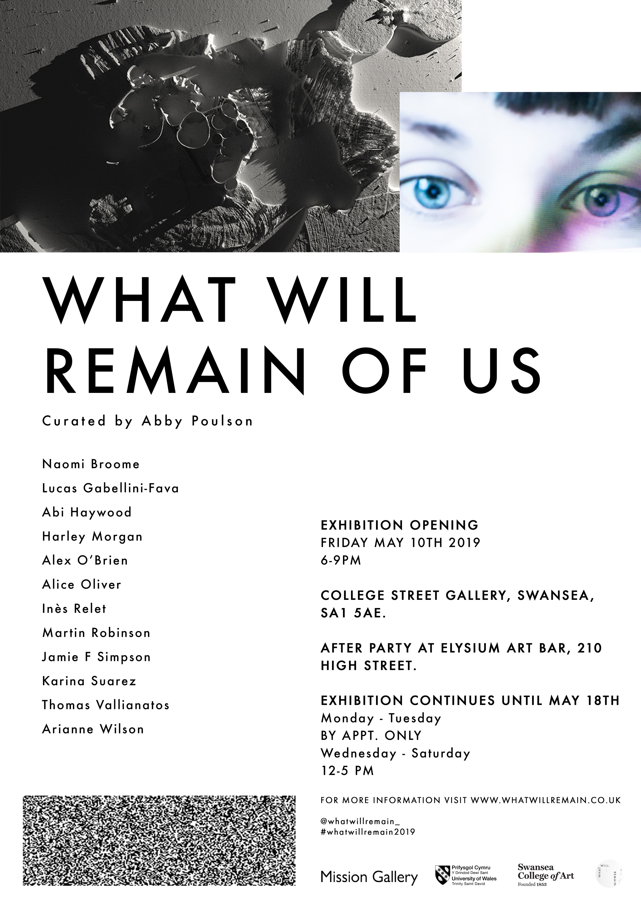

Figure 6: What Will Remain of Us.

At the beginning of the year, there was a call-out for proposals for a commission to curate an exhibition in Swansea with a budget of £1,000. I responded, proposing a group exhibition that reflected the contemporary human condition, exploring the concept of what it means to be human in a fast-changing geological period, and how we navigate the ever-expanding digital network culture. Having presented my ideas to the commissioning panel, the proposal was accepted and the final exhibition, What Will Remain of Us, included works from 12 artists who explored these themes in a variety of ways.

The exhibition will always be very important as it was my first opportunity to apply curatorial and artist research and to explore ideas from texts such as Curatorial Activism. It was essential to curate ethically, and to curate in a way that would bring many dialogues into the space from various contexts, in the hope to engage and challenge the audience and create a reaction, whilst attempting to avoid a very direct, loud approach.

To find artists and works to exhibit I created an open call, hoping to discover a diverse range of perspectives and to avoid those that may be biased to my location and network. I had recently been researching French Sociologist, Pierre Bordieu and his concepts of ‘habitus’ and how it is physically embodied in cultural capital. Bordieu thought that capital formed the foundations of social life and imposed on one’s position within social order. He argued that the more capital one has, the more powerful a position one involves themselves in within social life. This idea explored capitalism beyond economics and more into the symbolic realm of culture. It refers to the collection of symbolic elements such as posture, clothing, skills, tastes and material belongings that one acquires through being part of a distinctive social class. It is pointed out that cultural capital is a major source of social inequality as certain types of culture are valued more than others, and can aid or damage one’s social mobility as well as income or wealth. Bordieu explains that cultural capital comes in three forms, embodied, objectified and institutionalised. An example of embodied cultural capital could be one’s accent or dialect. A luxury car or record collection forms the examples of cultural capital in an objectified state, and within an institutionalised form culture capital refers to qualifications or credentials such as degrees or titles that symbolise authority and cultural competence.

Habitus explores the physical embodiment of cultural capital to the deeply ingrained habits, skills, and dispositions that we possess due to life experience. An individual’s habitus allows them to successfully navigate social environments. It also extends to our preference for cultural objects such as food, art and clothing.

A recent case study used Bordieu’s constructs to explore the responses of 38 older people to contemporary visual art through the results of a 28-month study. In the study, it was researched how cultural capital, habitus and class influenced their response to contemporary visual art. Five groups of older people from diverse backgrounds were taken to galleries and their responses were recorded, transcribed and analysed. It was concluded that the participant’s responses are influenced by their cultural capital, habitus and class, which in turn are affected by their life course experiences. Within the habitus, many of the participants had embedded ways in which they classified and understood art.
When those embedded ways did not allow them to make sense of the contemporary art that was offered to them, then their obvious retort was to classify what they saw in the exhibitions as not art. Evidence indicated that group dynamics and social class are important to the way individuals recognise their field and interpret art, for example many did not view contemporary art as “art”. (Newman, Goulding and Whitehead, 2013)

Aware of these implications, I decided to be socially engaged and aware of how my taste and habitus could influence decision making within the exhibition. I decided to send my open call through as many networks possible, through well-established networks such as the Artist’s Newsletter and Art Rabbit, and through emerging networks like the Revolv collective. I also shared the open call with local institutions and networks I was already connected with in Swansea and Wales, and established an online presence from the beginning of the project which gave context to the themes of project through still and moving image and encouraged people to submit their works.

After a month of pushing the open call into the public, I had received over a hundred submissions from artists both local and international, many of which I had not heard of before. This was then shortlisted to 30 artists, and finally narrowed down to 12 artists who exhibited in the show. When selecting the artists that were to be exhibited I decided to focus primarily on the show’s concept and themes and how well the work represented the themes, and made sure that there was a diverse dialogue of works included. Nothing else mattered except for the work.
During the process of receiving submissions, selecting and organising the exhibition, certain pressures were noticed. It was interesting to see others thoughts and feelings during the development process of the exhibition. Although I was open to responses and suggestions, I also had to remain conscious of the values and goals that were set by myself. One Swansea based gallery director suggested that I should invite an established local artist to exhibit in the show to boost its popularity. To put an already established artist at the centre of the exhibition felt unfair and unequal towards the other artists submitting. I also recall receiving some sarcastic comments during the period of receiving submissions about the uncertainty and risk of receiving poor submissions. This would’ve been better controlled if I were to have invited artists to exhibit instead. I also felt pressure from my peers, as I received from fellow young artists whom I had met and studied with, and friends who had submitted work to the call because they knew me, and not because their work responded to the themes of the show.

I realised that these pressures needed to be challenged. Choosing to ignore advice from professional creatives with more experience than I felt wrong. Rejecting artists with the same or more experience than myself also felt unjust. However, I was aware that every decision made during the process of curating the exhibition had to be questioned, and the outcome had to remain true to my values and strategies.

One artist who I selected through the open call was Argentinian photographic artist, Karina Suarez whose work explores contemporary human condition and political themes through photomontage. Although Suarez’ work was powerful and moving, I realised that there was difficulty in communicating through English. Many questions were asked about the open call prior to her submitting. Despite explaining what was needed, her submission was without titles and descriptions. When sending submissions, it has been made clear to me that sending a submission without following the submission guidelines often means that your submission will not get acknowledgement as it is regarded as a failure to follow instructions. However, I did not want to fully adopt this approach and attempted to communicate with her.

When Suarez discovered that she was selected she was very pleased, and contacted me to let me know that she wanted to apply for a visa to come to the UK and visit the show, and believed it was a major exhibition. I had to explain that it was in fact a tiny show curated by a student in a small welsh city and that it may not be worth travelling for. We have kept in touch and hope to meet each other someday. I feel that the exhibition meant a great deal to her, and the visual impact of her work was highly regarded in the exhibition.
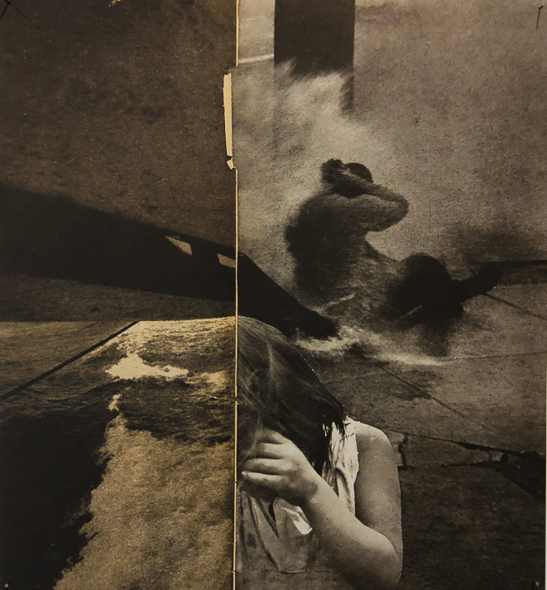

Figure 7: The Poisons We Breathe.

Another artist selected and exhibited in What Will Remain of Us was created by young working class artist Abi Haywood, who presented herself with her fictional persona, Snotty B*tch.
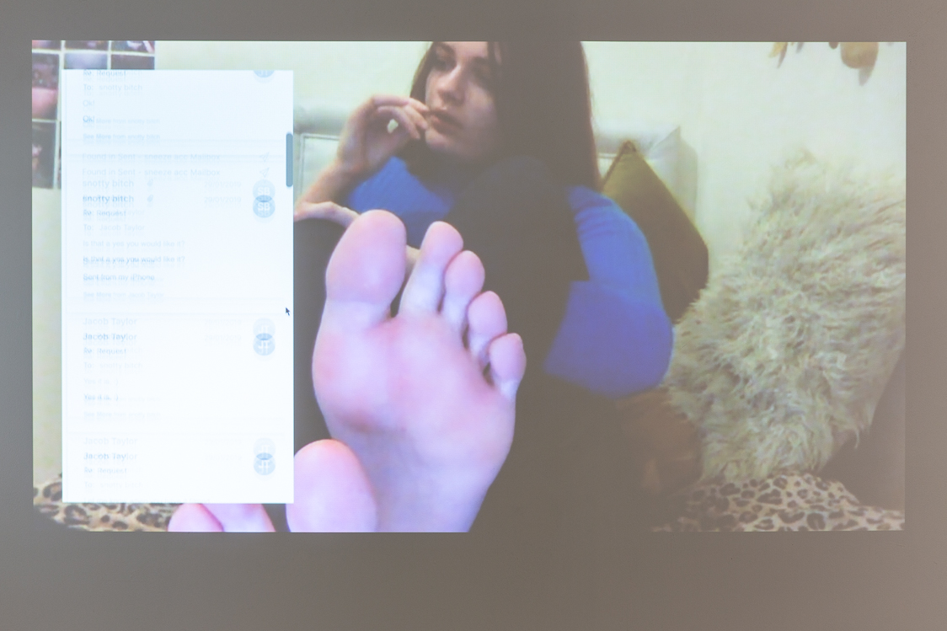

Figure 8: All the Sneezes I’ve Sold.

Haywood was studying art and design on a Foundation Course, when she innocently uploaded a video of herself in the studio on to YouTube as part of her coursework submission. During the video, whilst drawing, she accidentally sneezed, and before long realised that the video had gone viral, seemingly very popular with a niche fetish community.

With the persona of Snotty B*tch, Haywood decided to quit her job and fund her foundation year through selling videos of herself online to sneeze fetishists. For one video, Haywood decided to record herself sneezing in a bathroom at the Henry Moore Institute, Leeds, as an institutional critique of the art world. Ironically, the artist managed to sell her work at the gallery. This then developed into a major body of work where Haywood began to keep record of all the conversations and recordings she had sold to clients, drawing a parallel between the transactional nature of selling art and the selling of pornography.

Poor arts funding makes for an exclusive and inaccessible industry. Through selling her work as pornography the artist earns more than she would be likely to earn by selling it as art. On May 17th, Snotty B*tch made her accounts public and displayed her works both in Swansea and Leeds. News outlets were also released publicly and the story went viral. Haywood even appeared on ITV’s This Morning to speak about her videos and practice as a young working class artist.
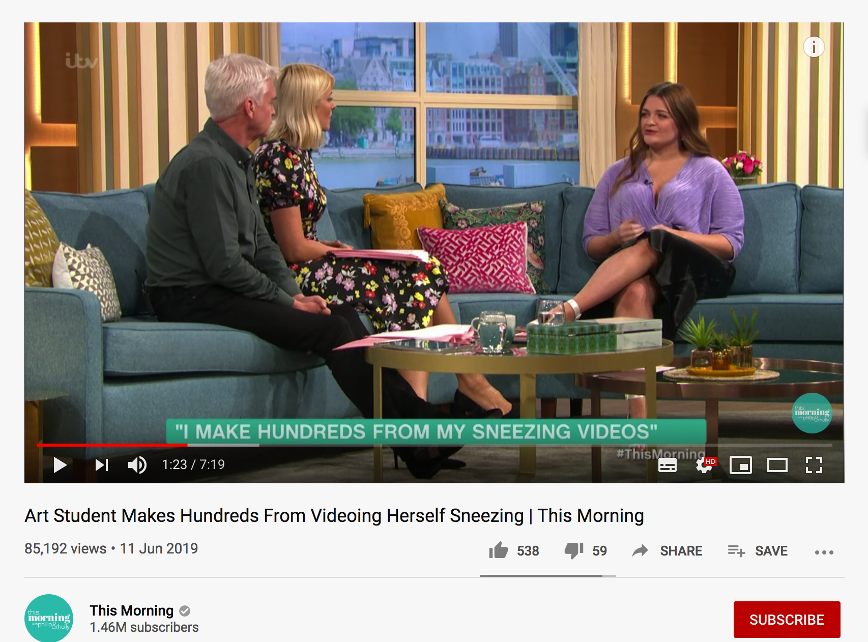
Fig. 9: This Morning (2019).

Haywood is also part of the Working-Class Artists Network (WANK) who are a collective of artists from traditional working class upbringings. Each artist within the collective has experienced first-hand the inequality between working class artists within the creative industries, and have joined to exhibit their art work as an active pledge for change. Recently they exhibited 28 working class artists in safe houses at Peckham, using both the context of the location and the artists as a bid to tackle white privilege and resist western centrism.

Curating What Will Remain of Us emphasised to me the importance of the artist’s voice, and the curator’s role of ensuring that voice is protected. When communicating with Suarez I didn’t want language or her geographic location to be a barrier, and enjoyed communicating with her. Rather than being a curator and she the artist, I felt like we’d become friends. I also admired the honesty in Haywood’s practice and as a fellow young artist I could relate to the issues she highlighted. Ultimately, every artist wants their part in the art world, we must find our way into the system.

Conclusion

As illustrated, artists and professional creatives work passionately to develop strategies that obstruct silencing and underrepresentation and prevent the erasure of many artists throughout the world. However, the art world remains dominated by ‘The Man’ and their legacy of authority and privilege still exists. Despite the challenges within the art world, these individuals take great strides in challenging hierarchies and circulating new knowledge. However, despite evidence showing positive change, the art world remains dominated by ‘The Man’ and their legacy of authority and privilege still exists.

As Horvat expresses, to subvert systems, we must use the system rather than fight against it. (Bown, 2017) The practices of socially engaged curators like Mackinnon demonstrate this, and working with the artists and the public to create dynamic and inclusive shows is of great importance. The recent announcement of the four 2019 Turner Prize winners who asked to be judged as a collective, publicly demonstrates solidarity amongst artists. An attitude which is crucial amongst members of the art world in contemporary society. Curators and other creative professionals must unite and work with artists who challenge to subvert the system, and remain equal to them, and abandon outdated attitudes that are instilled in western supremacy and hierarchies.
Ethical curating is the act of taking back control. Curators must be encouraged to develop on the historiography of activist exhibitions, and attempt to assure that the practice of non-white, non-male, non-heterosexual artists are accessible to gallerists, curators and scholars to revise the canon.

Speaking is not solely an expression of creative power; it is an act of resistance, a political gesture that challenges politics of domination that would render us
nameless and voiceless. (Genova, 2018)

To talk back as a curator means to fight against the rules established in history by Western and male-dominated institutions. We must be proactive and not wait for change. We must call out institutions, critics, curators, gallerists and collectors for their sexist and racially unbalanced practices and statistics should be made public so that individuals will be under greater pressure to be aware of who they are supporting, promoting and publishing.

As feminist critic and philosopher Gayatri Spivak constantly reminds us,
We must always acknowledge not only who we are, but where we are, that is where we are positioned in relation to hierarchies, and to questions of authority and privilege. (Shohat, 2001)
Bibliography
Books

Harvey, E. (2012). Ventriloquized Voices. Milton: Taylor & Francis, p.18.

Bown, A. (2017). Advancing Conversations Srecko Horvat - Subversion! Zero Books, p 6-37.

Lang, C. (2006). Responsive Museum. GARLAND Science.

Reilly, M. (2018.). Curatorial Activism. London: Thames & Hudson, pp.7-15.

Shohat, E. (1998). Talking visions. Cambridge, Mass.: MIT.

Showalter, E. (1981). Feminist Criticism in the Wilderness. Critical Enquiry, Vol 8. p.179-205.

Traverso, E. (2016). Left-wing melancholia. New York Columbia University Press.

Articles

Genova, A. (2018). Redressing the Art-World Gender Imbalance - ELEPHANT. [online]
Available at: https://elephant.art/curatorial-activism/ [Accessed 10 October 2019].

Higgins, C. (2019). 'It's about solidarity': the artists who hijacked the Turner prize speak out. [online] The Guardian. Available at: https://www.theguardian.com/artanddesign/2019/dec/04/its-about-solidarity-the-artists-who-hijacked-the-turner-prize-speak-out [Accessed 10 Dec. 2019].

Southbank Centre. (2019). Diane Arbus: An interview with Jeff L. Rosenheim.
Available at: https://www.southbankcentre.co.uk/blog/diane-arbus-interview-jeff-rosenheim-karan-rinaldo-hayward-gallery [Accessed 10 October 2019]

Jones, J. (2019). Artes Mundi 8 review – engrossing works blunted by limp liberal agenda. [online] the Guardian. Available at: https://www.theguardian.com/artanddesign/2018/oct/25/artes-mundi-8-review [Accessed 29 Oct. 2019].

Journals

Goulding, A, Newman, A, Anna, G & Christopher, W 2013, How cultural capital, habitus and class influence the responses of older adults to the field of contemporary visual art, Poetics, Vol. 41, no. 4, pp. 456-480. Available at: https://doi.org/doi:10.1016/j.poetic.2013.07.001 [Accessed 3 December. 2019]

Websites

Artesmundi.org. (2019). Artes Mundi - About Us. [online] Available at: http://www.artesmundi.org/about-us [Accessed 29 Oct. 2019].

Artsy.net. (2019). Anna Boghiguian - Art, Bio, Insights - Artsy. [online] Available at: https://www.artsy.net/artist/anna-boghiguian [Accessed 29 Oct. 2019].

Nmwa.org. (2019). Get the Facts | National Museum of Women in the Arts. [online] Available at: https://nmwa.org/advocate/get-facts [Accessed 6 May 2019].

