Module Code: BMSW4002
Module Title: Effective Team Working and Communication
Student Name: Nabeel Raja
Student ID: 1818476
Tutor: Navami Sudarsan

Table of Contents

Introduction 3

Effective communication in the Workplace 4

Communication Model 5

Written Communication 6

Verbal Communication in the Workplace 6

Communication skills 6

Communication skills in a group 7

Suggestion to improve Communication 9

Conclusion 10

Reference 11

Appendix: 12

Introduction
As a door supervisor in a large department store, I need to communicate with many types of people like with my subordinary, my employer even some time with the customer. The activities of door supervisor are very challenging as sometimes I need to work as a receptionist for my employer. All that I do in my workplace is communicating with others. So, with good communication skills, I need to know the use of modern communication technology like Walkie Talkie, radio and so on. The efficiency of my job greatly depends on effective communication and teamwork. So, I am very much concern about the skills and competency related to communication activities.

Effective communication in the Workplace
As a door supervisor, I need to manage effective communication with many people for which I need to concentrate on effective communication. I think effective communication has some Influences and Implications for which as a communicator I need to perform some responsibility in my workplace (Maund, Schriek and Tinkler, 2017).
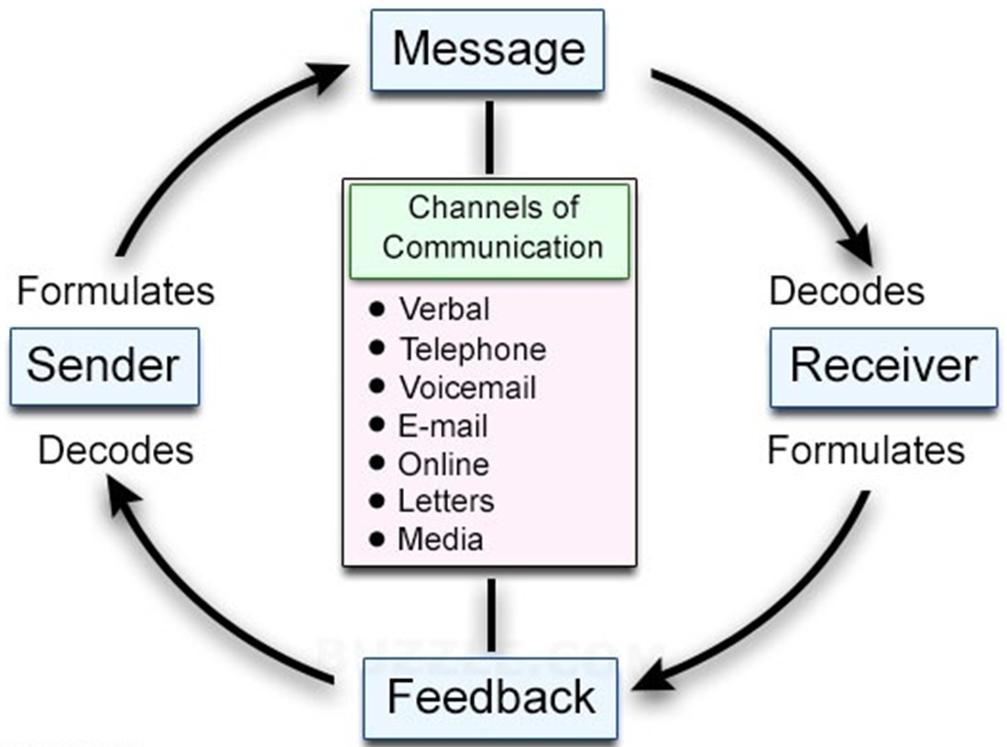
Source Effects: Like the effectiveness of communication depends on how I am presenting the information to communicate. So, I need to ensure good eyes contract to increase the attractiveness.
Encoding Effects: Like for example while presenting any information in front of my subordinate I need to know the capabilities of them so that they can get the message of mine. Like while communication with my subordinate from China I concentrate on the culture and language.
Media/Channel Issues: In many cases, the channel plays a vital rule in communication in the workplace. Like in most of the cases we use verbal communication but while using non-verbal communication we need to concentrate on the culture.
Receiver Effects: Like while communication as a door supervisor it is the responsibility of mine to represent the communication so that all my receiver can interpret what I am saying. If the message is not sent relating with the Age, Lifestyle, esteem level the receiver may fail to properly understand the message.
Decoding Effects: The message sent need to be dramatic so that all the people understand the message. So, besides the use of a good communication channel, I try to use cognitive resources for better communication.

Communication Model
Transactional Model of Communication: This model was proposed by Barnlund in 1970 where the sender and receiver of the messages directly engage to individual and exchanges their opinions simultaneously. According to this model, all the information from the sender travels to the receiver individually. It is a dynamic and creative process rather than a discrete exchange of data in this communication model. The procedure of this communication model is encoding the message-transmitting-decoding-receiving. Sometimes this creates problem to identify the actual meaning of the message if there is any fault in the communication tool. I have also observed the effectiveness of transactional model in my communication while working as a supervisor.
Linear Model of Communication: Linear model is a one-way channel of communicating with individuals where the sender encodes the information and send it to the receiver. The receiver decodes the messages and collects the information. There is no way t to respond in a linear model work in single channel. Shannon & Weaver introduced this communication model in 1949 when technology was not modern enough to ensure multi-channel communication. In present workplace, this module sometime found in the advertising sector where the messages from the sender travel from start to an endpoint. Most of the electronic mail work according to this model where the sender sends the mail and receiver need to start a new mail to respond.

Written Communication
Although in most of the time in my workplace I need to depend on nonwritten communication, I sometimes need to engage in written communication. Written communication is formal communication. In my office like for example, we sent letters to the staff like with new job responsibilities (Maund and Tinkler, (2017).
Letters: Like for example, in my workplace, we sent letters to the team who were responsible for a certain job. For writing letter, I chose words which are easy to understand by the receiver. Like for example, while sending a letter to the people of India I use small sentence with easy word. Otherwise, the receiver will not be able to understand the message of mine.
Memos: This is formal paper used to show daily cost in my workplace as this is a written format of the paper there is a little chance of making any bad communication.
Reports: Like for example, in my workplace, I need to write report frequently so, this is almost my regular job. While writing the report I need to use easy to understand the word and small sentence as the reader can be not so much skilled.

Verbal Communication in the Workplace
Verbal communication means using voice, sound, physical gesture to facilitate communication among different parties within a workplace. This communication is mostly used for casual sharing rather than any formal structure and verbal communication is vastly used in general meeting. The sender of verbal information is directly linked with the receiver while sharing opinions. I have seen the effectiveness of verbal communication in my workplace and the benefits of this communication are unlimited except some poor manner such as irrelevant word choice and physical disabilities.

Communication skills
In each working day, I need to communicate with many people for which I need to have good communication skills. But many factors of the communication are not dependable only with the skills of mine but I think I need to have good skills to reduce the negative effect of the other elements of the communication. I always want to reflect the Berol’s model of communication so I think I need to have some sills which are like…
Listener: First of all I need to understand the message of the sender. Like for example, suppose a customer asked me a question about the product of my store. So, first of all, I need to understand the message of the customer.
Asking the Questions: It may happen that I may fail to understand the message of the sender so in those case, I need to ask questions. If I am not able to clear about the message I will fail to satisfie the message sender (Greenberg and Baron, 2017).
Being clear and succinct: I need to represent my feeling wit clearly like for example if I fail to present the message that receiver may fail to interoperate what in means, in this case, the communication will not be effective.
Feedback: I need to ask feedback from the customer or even from my subordinate to reduce my error in the communication. So, while communication I need to care about the previous errors by this I will be able to be an effective communicator (Morgan, 2016).
Developing trust: To be a good leader I need to develop trust among my subordinate and even this is also important for teamwork, Without trust, the effectiveness of the communication will be reduced greatly.
Being present: To be a good communication I need to accept and listen to the opinions of the others and this will help me to increase my skills and knowledge. For this, I need to be a good listener and empathetic also.

Communication skills in a group
Group are form to work collaboratively so that in the workplace complex business problem can be solved. So, in my workplace, we form a group to shared ownership, responsibility and issues related to confidentiality. In most of the cases we see that group working is a good tool for negotiating and developing ideas, especially on shared objectives. In my workplace, all the work of the team is effectively done with the help of Belbin team rules (Adair, 2009).
Action-oriented roles
This role enables the team to keep the regular wok ongoing. In this type of roles, them people plan and implement the strategy. And all the team member wants to finish the work of the team like for example, for this role in the team I participate in teamwork and take part in making strategy and implementation of those.

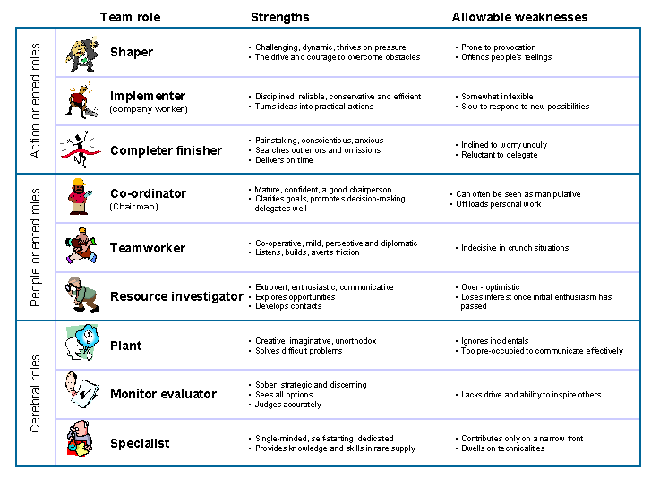
People-Oriented roles
People-oriented roles enable me to ensure a cooperative work environment in the team so that all the member can concentrate on finding all the available resources to make the team more productive and effective. As a resources investor, I also want to find out new ideas and opportunities (Driskell, James E., et al., 2016).
Cerebral Roles
This role enables me to use my impartial judgements to indenting the use of the ideas and plan generated by the team. As a specialist I need to participate in the formation of the problem-solving model and also need to help while applying the model on the core business activities.
Inter-personal communication
Communication in the group is complex and different from the normal communication in my workplace. Like for example, in the team of my subordinate, there are people from a different culture. One of my staff from USA is from individualism society so, he wants to work individually. And introverted people are less agreed to share their information also with high context culture. So, in my workplace, while communication with my subordinate I need to concentrate on the culture there are from. The way of communication on the High-Context and Low-Context Culture is different in most of the cases (Cherrington, 2014).
Working collaboratively
For working collaboratively, we need to identify and understand the culture of the people. Like for example, we can say the culture of most of the North American countries is individualistic so they are not too much like to work in a team. On the other hand, the people of the UK are collaboratively so they of these people are most effective to work in a collaborative environment. Besides this team of the extroverted people are more effective and productive than them of the introverted people (Farrell, 2016).

Suggestion to improve Communication
In every business organisation, effective communication is needed even for my own workplace. For improving internal and external communication in my business I think the management of the organisation needs to concentrate on the communication medium. So, some of the instrument used in the communication purpose need to replace with modern communication medium like automated reporting. The organisation can use modern technology and online tools to communicate with its stakeholder where the data and information will be archived and can be used for future needs. Besides this in this organisation, as almost all the communication is done on verbal communication problem may arise. So, I think we need to concentrate on formal written communication activities to avoid any communication conflicts in the future.

Conclusion
All the business organisation wants to have an effective and most productive team but because of the lack of communication among the team member, they fail in most of the cases. But effective communication among the team member can increase the efficiency of the team. So, all the business organisation needs to ensure that they allocate all the resources so that all the team member can communicate effectively. Otherwise, there will be lack of coordination which in the end will reduce the productivity of the organisation.

Reference
- Adair, J.E. (2009). Effective Teambuilding: How to make a winning team. London: Pan Books
- Cherrington, D.J. (2014). Organizational Behavior. Boston: Allyn and Bacon,
- Driskell, James E., et al. (2016). “What Makes a Good Team Player? Personality and Team Effectiveness.” Group Dynamics: Theory, Research, and Practice 10, no. 4: 249–271.
- Farrell, M. (2016). Collegiality in the workplace. Journal of Library Administration, 56(2), 171-179.
- Frey, L.R., and S. Wolf (2014). “The Symbolic & Interpretive Perspective on Group Dynamics.” Small-Group Research 35, no. 3:277–316.
- Greenberg, J., and R.A. Baron. (2017). Behaviour in Organizations. 7th ed. Upper Saddle River, NJ: Prentice Hall,
- Hellriegel, D., and J.W. Slocum. (2018). Organizational Behavior. 10th ed. Mason, OH: Thomson South-Western.
- Maund, A. Schriek, M. and Tinkler, P. (2017). Certificate in Higher Education: Skills for the Workplace Student Yearbook. Sage Publications
- Morgan, P. (2016). The Business Student’s Guide to Study and Employability. Sage Publications
- Walumbwa, F. O., & Christensen, A. L. (2016). The importance of social capital in the workplace and how individuals and organizations can support their development. The fulfilling workplace (pp. 125-138). Routledge.

Appendix:


