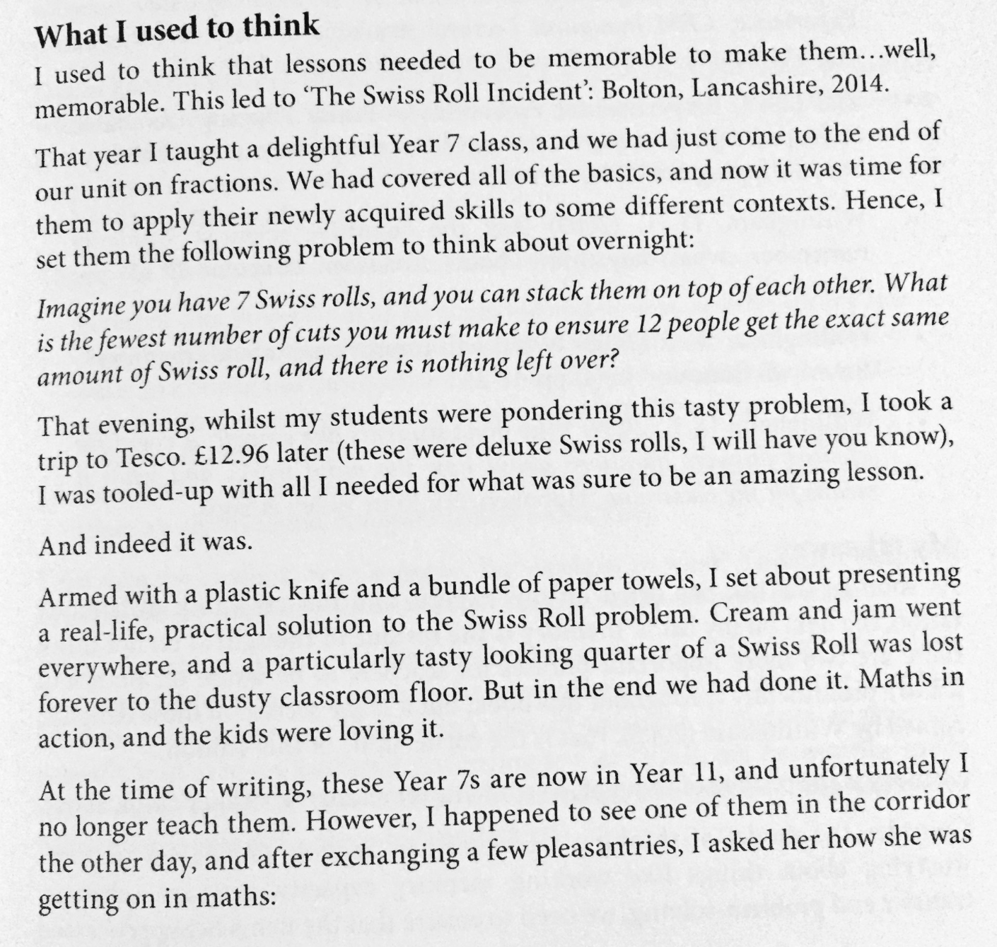
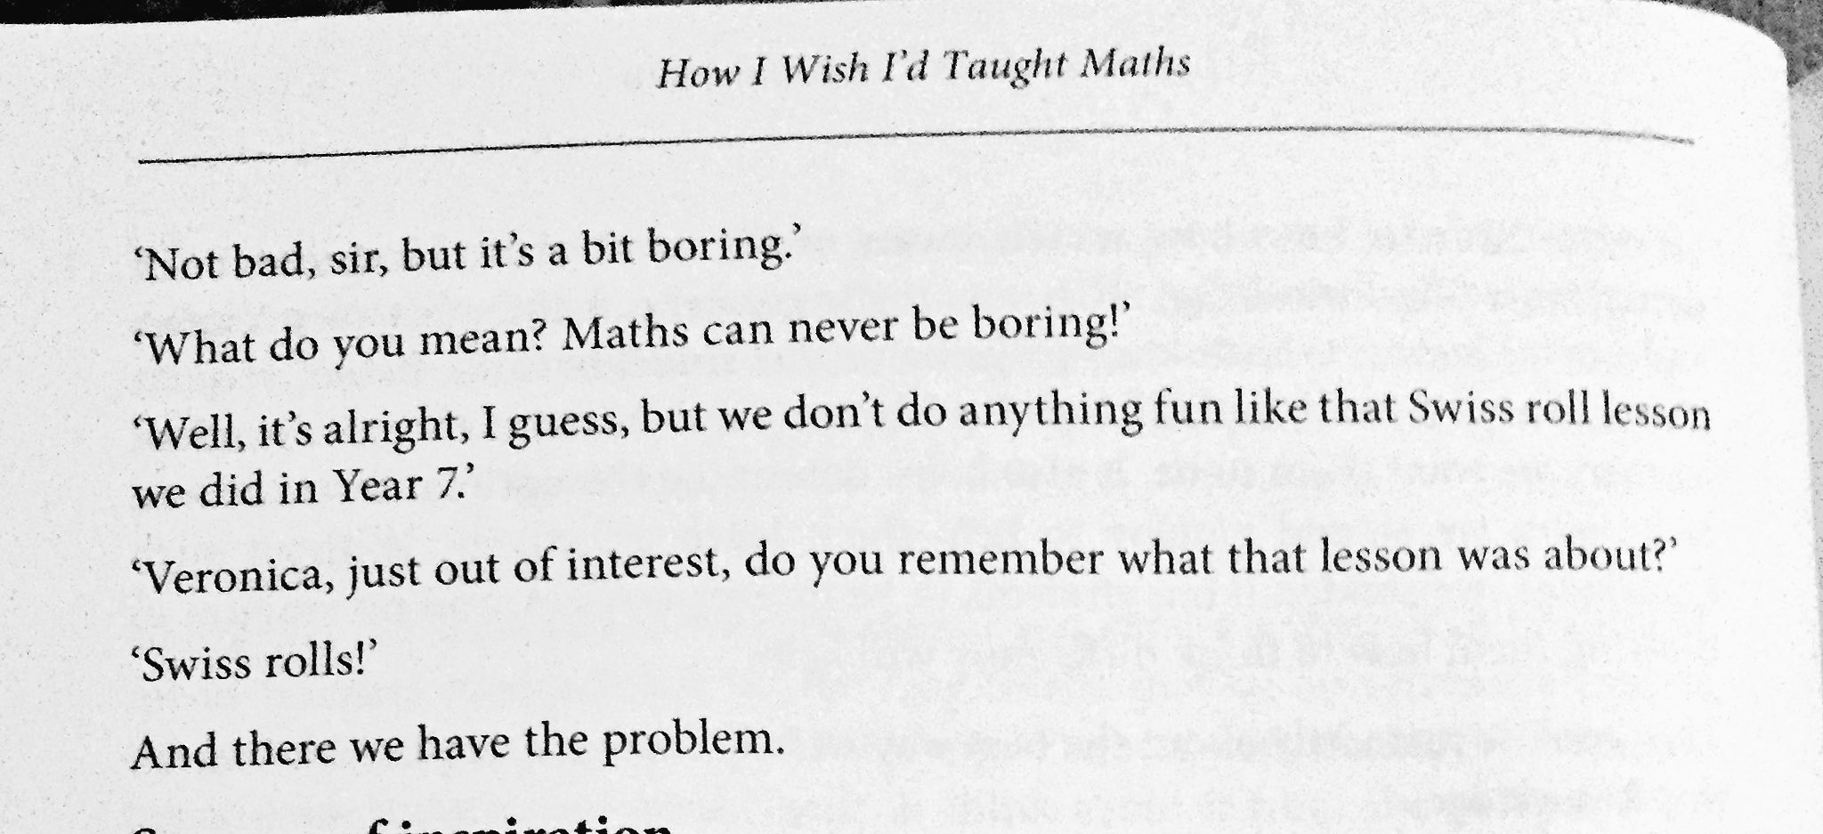

Taken from: C. BARTON – HOW I WISH I’D TAUGHT MATHS

