Student name | Shekinah mala Biasala
Student number | 1914922
Module NO | BMSW4001
Module title | Effective team working and communication

Effective team working and communication
Table of Contents
Introduction: 2
Body: 2
Ways communication skills can be made more effective in business organisation: 2
In-class activities: 3
Communication skills discussed in class: 4
Analyse communication within the own or friend's workplace: 5
Improving communication skills and teamwork: 7
Conclusion: 8
References 10

Introduction:
Communication is the act by which meanings are conveyed from one group to another by means of symbols, signs and semiotic rules that are mutually understandable (Maund, et al., 2017). Effective communication is a process by which the communication done by an individual creates an impression on another individual or to the entire group (Morgan, 2016). Teamwork is the effect of effective communication within a group because every group member collaborates and cooperates with one another, and it also helps the group members share ideas within themselves (Belbin, 2012). Any business group fostering teamwork and right communication procures success in the market.
The paper focuses the ways by which communication skills can become more effective in the context of business, the activities that are performed within the class, discussing the communication skills in class, analysing the communication skills within the own or friend's workplace, and also, methods for improving teamwork and communication skills.

Body:

Ways communication skills can be made more effective in business organisation:
Effective communication skills are important for business organisations because it leads to faster decision-making, stronger employee relationships and increase of productivity (Blanchard, et al., 2000). The communication skills are made to be more effective within the context of a business organisation by means of regular meetings within the workplace (Bovée & Thill, 2016). The official meetings become a channel of communication where the management discuss the business plans with employees, and also, take their opinions on a regular basis, which is important for the development of business. It has also been found that meeting also helps in knowing the personality of every employee within a group.
The provision of feedback is also an important factor for improving communication skills. The business takes regular feedback from the employees, which helps in knowing the expectations of employees, and lets them know the business expectations (Hänninen & Karjaluoto, 2017). For example, there must be a system for providing anonymous feedback in the organisational software where an employee can provide feedback against other people anonymously, which helps in understanding the conflicts and the overall problems of communication that are taking place (Lindner & Connell, 2015). The social intranet software is also a method for improving the communication skills in a business where the training is provided by the help of a video to those people who have joined the organisation newly (Nah & Yamamoto, 2015). The organisation can also improve communication skills by creating a social media group on Facebook or WhatsApp where people can regularly discuss ideas and opinions, which make the employees come closer to one another.
It has also been found that the communication skills of the employees within a business organisation are improved by means of training (Taskov & Mitreva, 2015). There are many employees who are introverts, and they cannot speak more than what is required or try to make an impression on others (Valos & Habibi, 2016). For example, during the process of training, the skills of telephone etiquette or the etiquettes of speaking with other persons are trained by the managers within the workplace. The managers and leaders of the company train those people who are introverts so that they can come forward, which is important for the sake of improving communication development in the business.

In-class activities:
The in-class activities that are performed for the sake of improving communication are group discussion, direct interaction with the tutor, and the feedback session (Bovée & Thill, 2016). Also, the game of communication 'Never have I ever' is played in the class for improving communication skills. The group discussion is done by placing a topic, which is either strategy for improving the business, or the rules of budgeting. The sharing of ideas and opinions has helped in developing of communication skills as well as the teacher had strictly instructed during the group discussion that coming to a conclusion is essential as a part of the group discussion.
The direct interaction with the tutor had helped in understanding our faults during the overall process of communication (Belbin, 2012). Not all the people in our class had English as their native language, and hence, the tutor had also pointed out grammatical errors of a few students. Other than that, our tutor had also pointed out the lack of politeness in the speech of some individual like lack of smile, or not using basic etiquettes like 'please' or 'thank you' between statements, which had helped every class member to improve communication skills.
The in-class activities that are done in the class consist of the feedback session where every individual has been asked to provide feedback to others (Blanchard, et al., 2000). The feedback session has helped in finding out the difficulties of communication within various individuals. In order to increase bonding within the team, the game of 'Never have I ever' was played where people have shared their experiences where they had lacked confidence or the things that they had not done in their life. On the other hand, in the game, the team members have understood not to consider any kind of rumour seriously in an organisation unless something is declared by the management.

Communication skills discussed in class:
The main communication skills that are discussed in the class consist of the verbal skills, non-verbal skills, written skills and the visual skills of communication. The verbal skills are mostly related to the individual's pronunciation, accent and vocabulary used during the speaking (Hänninen & Karjaluoto, 2017). The tutor within the class has discussed that verbal communication skills can improve by means of increasing confidence in the voice; increase the capacity of active listening, and avoiding more filler in the speech (Maund, et al., 2017). The non-verbal communication skills as discussed by our teacher are equally important for establishing a good relationship within the teammates, and it constitutes the understanding of body language and using the techniques of public relations and etiquettes to become closer to the people as a whole. The non-verbal communication also consists of understanding the emotions of people by looking at the facial expression and using the exact kind of body language required. It has also been found that the written skills are also equally important because the e-mails and other business messages sent to the concerned employees in an organisation also helps in maintaining a proper relationship with employees.
The visual skills help an individual to design a video, or graphics that help the other individuals to understand a particular aspect in a better manner (Maund, et al., 2017). It also says that most of the methods for visual communication help in the development of graphics that are used for the sake of overall progress of communication, and the type of graphics or colour that helps the other people to get the most influenced.

Analyse communication within the own or friend's workplace:
Workplace communication mainly involves collaboration, teamwork, and free sharing of ideas, which are important for professional decision-making in business (Bovée & Thill, 2016). The methods of workplace communication occur within the own or a friend's workplace by resolving the conflict within the team members. Conflicts generally occur within a workplace due to the high skill levels of all employees, and also, due to the differences of opinion. The resolution of conflicts increases effective communication and leads to the development of collaboration within the team.
The Berlo’s model of communication states that the mode of communication mainly depends on the development of communication processes like source, message, channel and receiver. It is given below:-
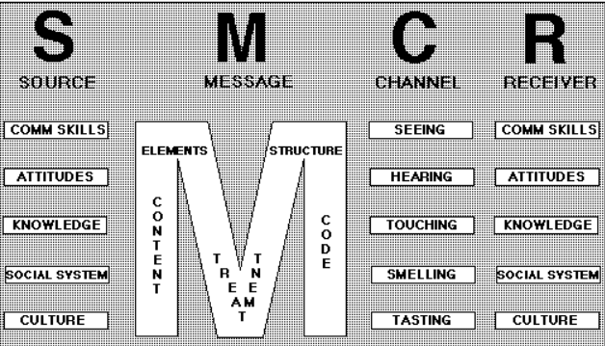
Figure 1: Berlo's model of communication Source: (Bovée & Thill, 2016)
It says that communication goes through four distinct stages called the source stage, the message stage, the channel stage and the receiver stage. The effectiveness of communication depends on the source, where the communication skills of the person, the attitudes, the knowledge, and the cultural understanding play a role (Lindner & Connell, 2015). The message is dependent on the content, the treatment, the code, and the structure embedded within it. For example, when the message is verbally communicated, the pattern and the strength of the message is different than a written message because it is more direct, and stored in the form of a document.
The channel also plays a role in the transformation of the message like the communication of the message by seeing, tasting, hearing or by the sensory organs that are affected by the message processing (Nah & Yamamoto, 2015). Also, it has been found that the communication skills, active listening power, culture and the role of the social system help in the improvement of the communication process. Thus, an individual or an organisation is required to improve the attitude, cultural awareness, and beliefs of individuals in order to make the communication process better.
Another way of resolving conflict in the team is by the help of making every individual team member take responsibility in the workplace, which is done by the help of Belbin's team roles as given below:-
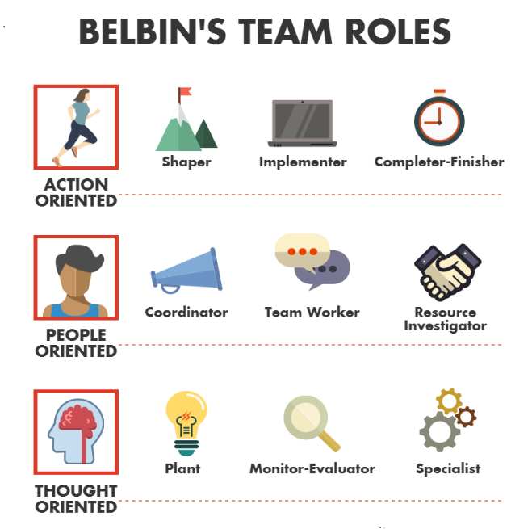
Figure 1: Belbin's team roles Source: (Belbin, 2012)
The Belbin's team roles are of nine types where the action-oriented people are shaper, implementer and fisher. The people-oriented members are coordinator, team worker and resource investigator (Belbin, 2012). The thought oriented members are the planter, monitor and specialist. The team is divided into all the specific types of work position so that every team member get respect for their specific position, and nobody is considered as a subordinate (Bovée & Thill, 2016). The communication skills are improved by the help of differentiating the team into their specific roles based on their personality, which helps in sharing of opinions and take faster decision-making.

Improving communication skills and teamwork:
The teamwork and communication skills are improved by means of conversation, sharing of opinions and taking of feedback in the management. It has been found that the communication skills are improved by training, group discussion and sharing of feedback (Lindner & Connell, 2015). On the other hand, the teamwork is improved by means of proper leadership skills according to the expectations of the employees. Generally, democratic or transformational leadership improves the teamwork in a proper way. Conversation in a team occurs when there is spare time for continuous communication among teammates.
It is seen that sharing of opinions in a team is improved by means of developing the methods of communication, which are group discussion. Group discussion is called an official meeting where every individual is allowed to share their opinions in front of others, and also, openly share strategies for improving the business (Taskov & Mitreva, 2015). On the other hand, the sharing of anonymous feedback within the workplace improves the understanding of management about the communication process in the whole company. It has also been found that the communication process is improved by training where the managers and specific trainers give training on etiquettes and public relations for influencing others.
The teamwork of a group within a professional context is improved by the help of leadership skills of the management. The transformational leaders, therefore, chose to follow contingency leadership for improving the communication process, and for developing teamwork within an organisation (Nah & Yamamoto, 2015). The contingency leadership means understanding when to use the democratic leadership, and when to use the autocratic leadership according to the situation within the organisation, and the business pressure.
Leadership skills are democratic, autocratic or laissez-faire, where democratic leadership tends to improve the performance of an organisation. Democratic leadership allows employees to work according to their own way of working, and it is also related to allowing freedom to employees to have their own liberty to share their opinions (Valos & Habibi, 2016). However, democratic leadership is not suitable when the employees work under pressure, and then, the autocratic leadership becomes more efficient.

Conclusion:
The report concludes that communication is an important process of business, which ensures collaboration among professionals and help in improving performance and revenue. It has also been found that effective communication is the main essence of teamwork, which is possible to be improved in an organisation by means of sharing feedback, doing group discussion and training. It has been seen from Tuckman's theory that it is possible to improve teamwork by communication development. The Belbin's team role has shown how dividing a team on the basis of roles help the team to become more collaborative for success. It has also been found that contingency leadership, which is a mix of democratic and autocratic, helps in maintaining collaboration and monitoring of employees at the same time for business success.

References
Belbin, M., 2012. Team roles at work. 3 ed. London: Oxford University Press, ISBN: 68197162462.
Blanchard, K., Hersey, P. & Johnson, D., 2000. Management of organizational behavior: Leading human resources. 5 ed. London: Prentice Hall, ISBN: 489179981475.
Bovée, C. & Thill, J., 2016. Business communication today. 4 ed. London: Pearson Education India, ISBN: 1108594417.
Hänninen, N. & Karjaluoto, H., 2017. The effect of marketing communication on business relationship loyalty. Marketing Intelligence & Planning, 12(5), pp. 105-107, DOI: 10.1108/MIP-01-2016-0006.
Lindner, A. & Connell, E., 2015. Professional journalists in ‘citizen’journalism. Information, Communication & Society, 16(5), pp. 553-568, DOI: 10.1080/1369118X.2015.1012530.
Maund, A., Schriek, M. & Tinkler, P., 2017. Certificate in Higher Education: Skills for the Workplace Student Yearbook. 3 ed. London: Sage Publications, ISBN: 985641126323.
Morgan, P., 2016. The Business Student’s Guide to Study. 3 ed. London: Sage Publications, ISBN: 68419876246.
Nah, S. & Yamamoto, M., 2015. Modeling the adoption and use of citizen journalism by online newspapers. Journalism & Mass Communication Quarterly, 19(7), pp. 399-420, DOI: 10.1177/1077699015574483.
Taskov, N. & Mitreva, E., 2015. The motivation and the efficient communication both are the essential pillar within the building of the TQM (total quality management) system within the Macedonian Higher Education Institutions. Procedia-Social and Behavioral Sciences, 18(6), pp. 227-234, DOI: 10.1016/j.sbspro.2015.02.109.
Valos, M. & Habibi, F., 2016. Exploring the integration of social media within integrated marketing communication frameworks. Marketing Intelligence & Planning, 15(7), pp. 105-110, DOI: 10.1108/MIP-09-2014-0169.

