DS 1 Template

My Screenshots/Photos
- Please add 4–6 screenshots or photos of your digital life.
- You can use your phone or laptop.
- For each screenshot, write one or two sentences explaining what it shows.

Screenshot/Photo 1
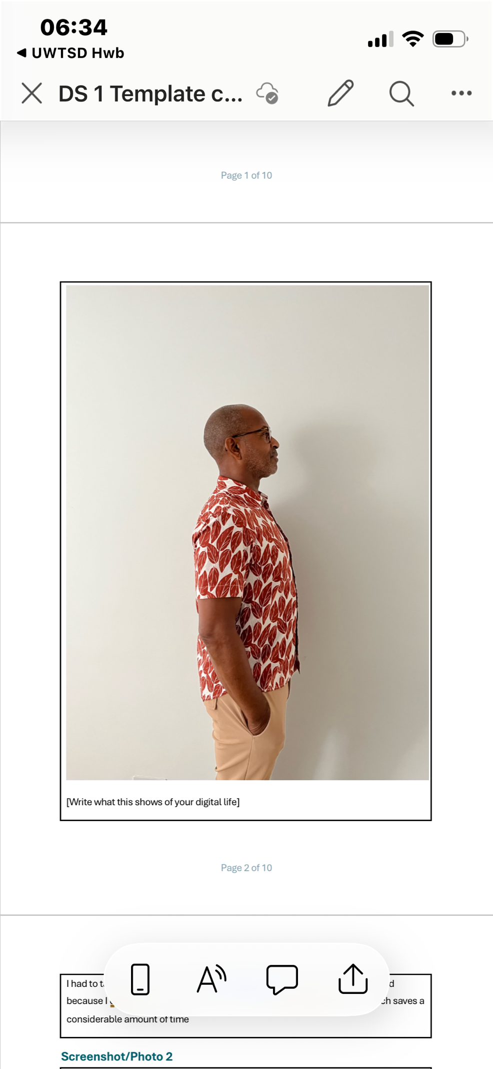
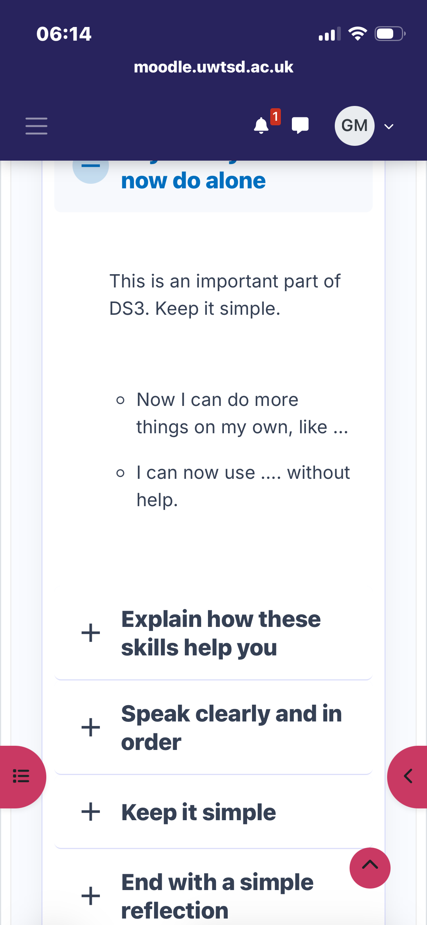
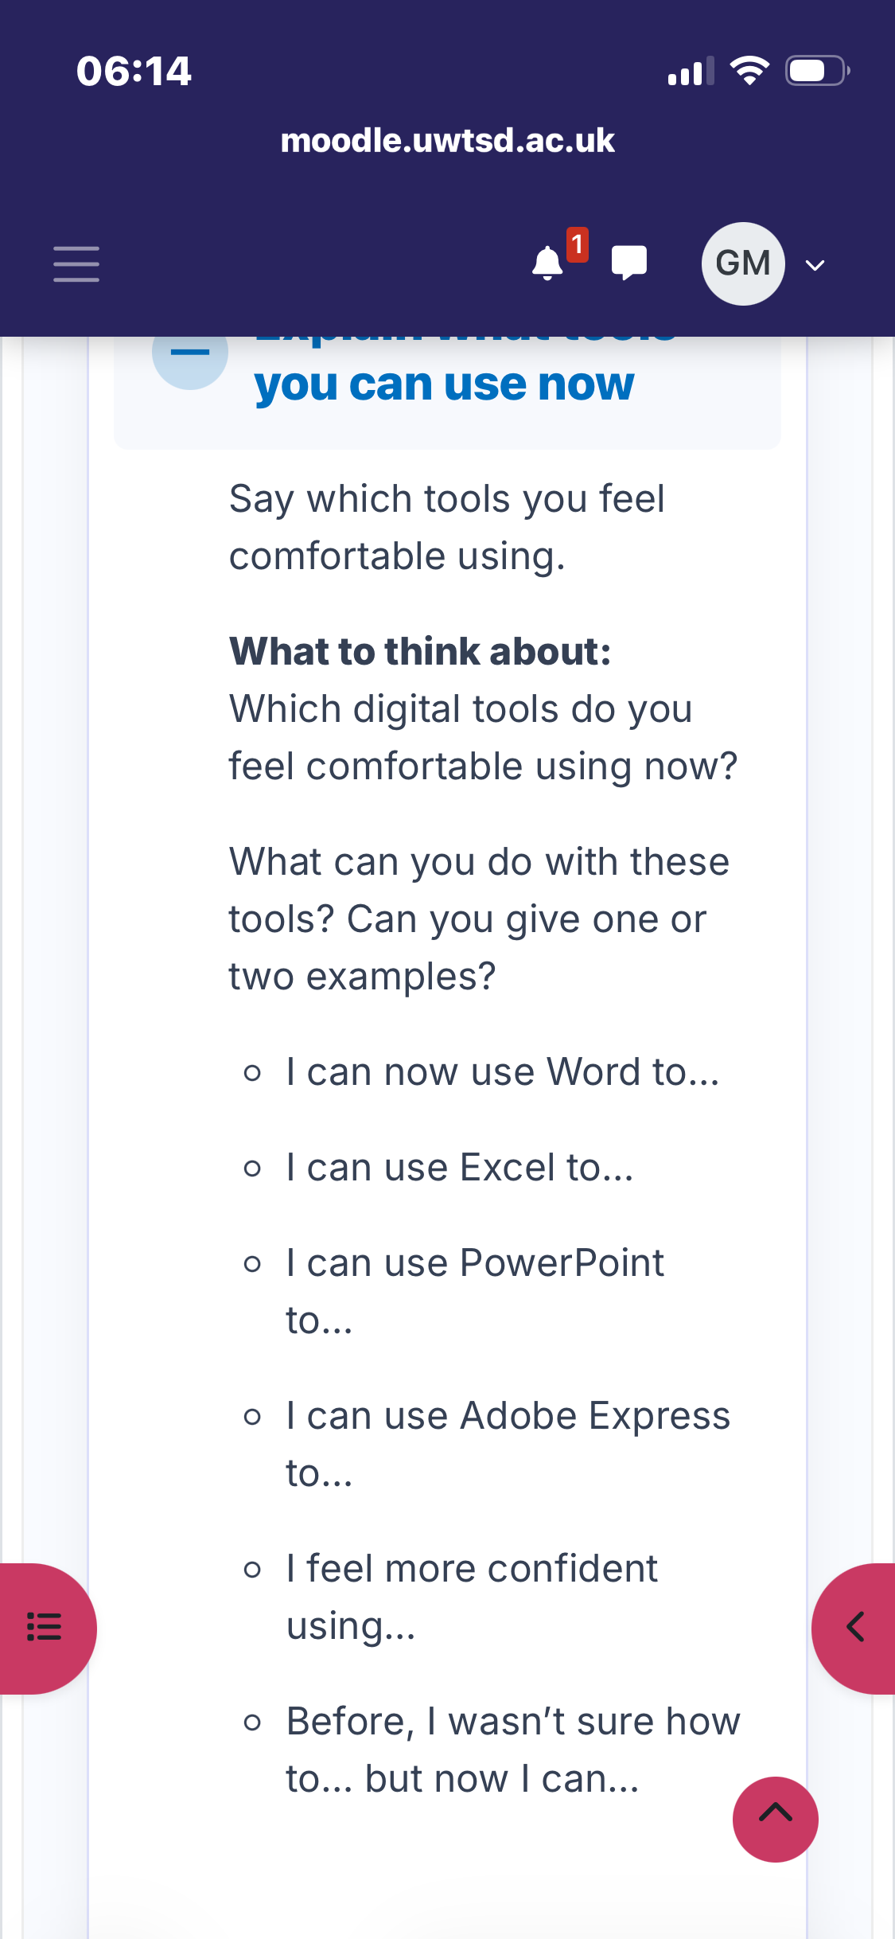
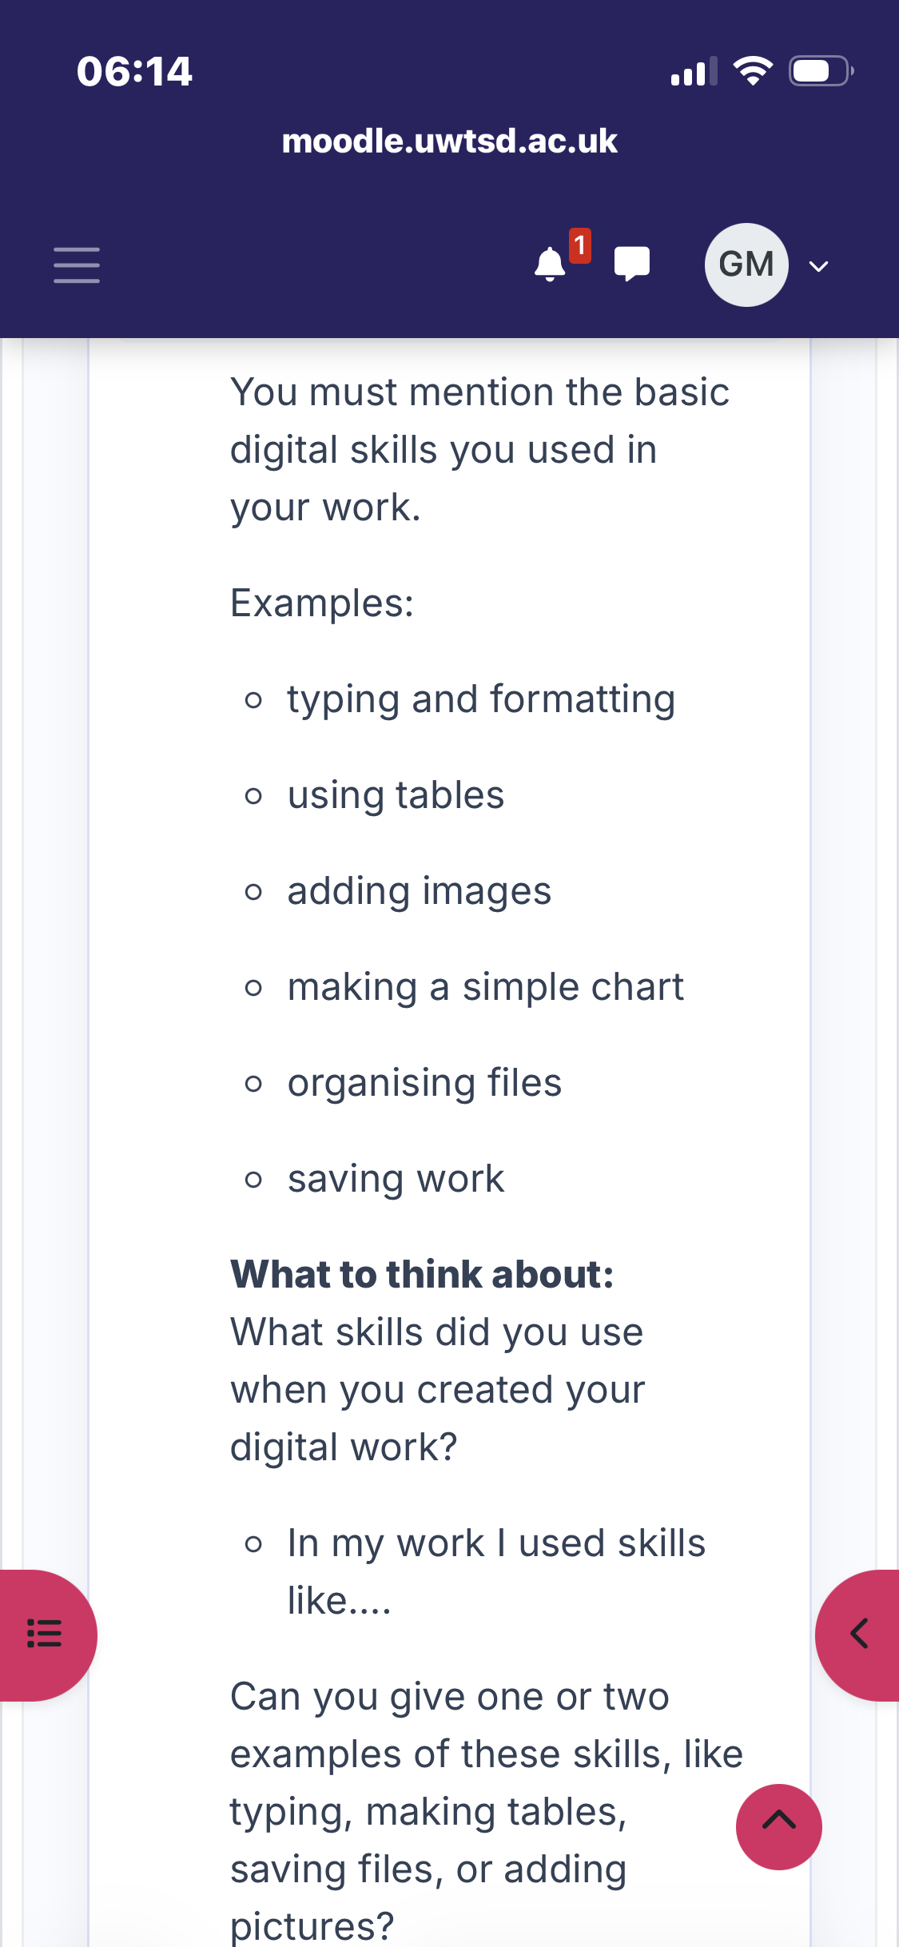
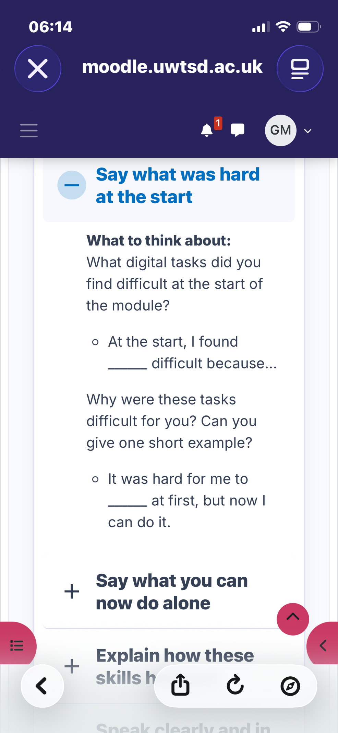
[Insert Photo/Screenshot below]
I took this picture and found that sending it to Casting Collective was quite difficult until I understood the format of how to upload. I’m not very good with technology and it takes me quite awhile to work something out once I have found my way it becomes quite easy to perform uploading and sending images
[Write what this shows of your digital life]

Screenshot/Photo 2
[Insert Photo/Screenshot below]
I found it working in construction the Roofing industry to communicate with Site managers and clients showing them the works that have been done. I had to take pictures and upload and send. I found this quite easy after understanding how to Upload and post two different email addresses i.e. Outlook, Gmail, yahoo. Palmer stress that every time I go to send, I still feel nervous that I’m doing the right thing and sending it to the right person
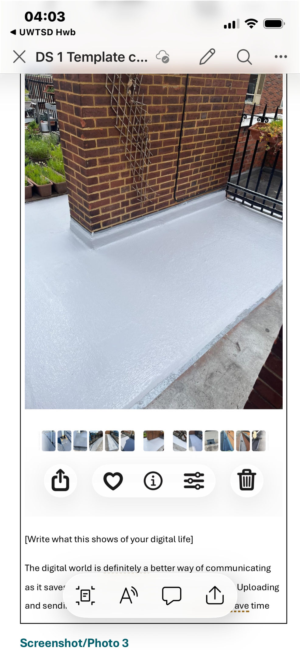
[Write what this shows of your digital life]

Screenshot/Photo 3
[Insert Photo/Screenshot below]
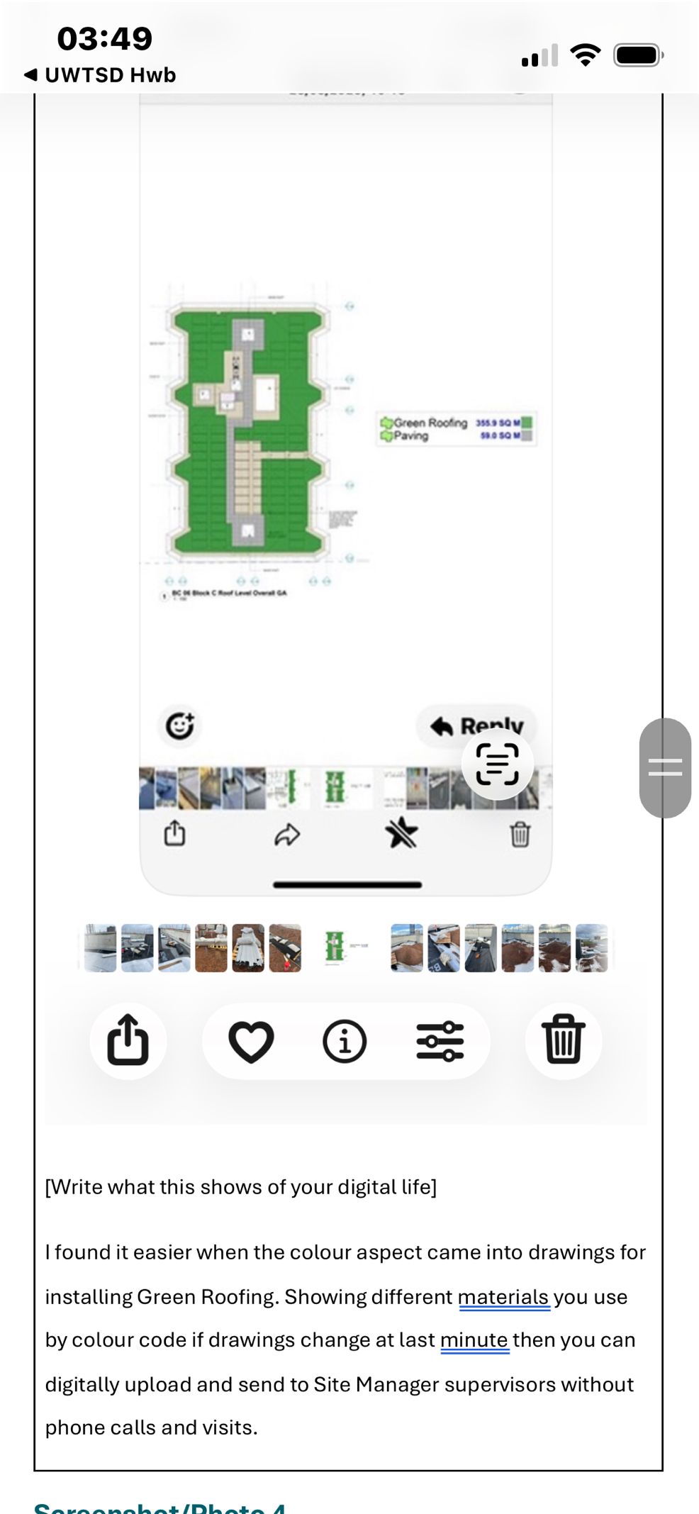
[Write what this shows of your digital life]
In the screenshot I had to work out how the drawings relate to practical work on top of the roof doing green gardens installation, what I found was that following drawings of how the installation should be carried out was much easier as everything was colour-coded digitally, in all drawings it was all black-and-white on paper.

Screenshot/Photo 4
[Insert Photo/Screenshot below]
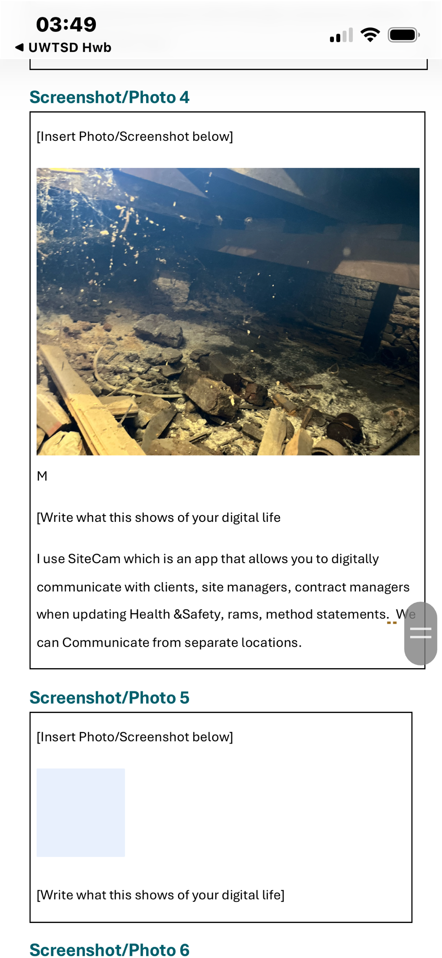
[Write what this shows of your digital life]

Screenshot/Photo 5
[Insert Photo/Screenshot below]
[Write what this shows of your digital life]

Screenshot/Photo 6
[Insert Photo/Screenshot below]
[Write what this shows of your digital life]

My Short Reflection
- Write 5–8 simple sentences about your digital life.
- You can use the sentence starters below if helpful.
When I first started to use my hand device, I found it very hard to understand how the apps worked, especially when it came to sending emails, photos, and understanding how to use the digital system altogether. I have Recently gathered understanding of how to use my phone till it’s full capacity, and iPad. Although saying that I still have to grow in confidence with using devices so that I can feel comfortable, Downloading material i.e. application forms, paying Bill, And purchasing. I have been struggling with this assessment a little bit because I’ve been very unwell and I’m now just starting to recover.

Sentence starters
- I use digital tools to …
- I feel confident when I …
- I want to improve …
- I often use these tools: …
- I sometimes feel nervous about …
- I hope this module will help me …
- Digital skills are important for me because …
You can write more if you want.

Submission Checklist
Before you submit, please check:
​​​ ☒ I added 4–6 screenshots
☒ I wrote short sentences for each screenshot
☒ I wrote my short reflection
☒ My work is my own
☒ My file opens correctly
​​☒ My file opens correctly

