
APPENDIX GA36d

LEVEL 7 ASSESSMENT SPECIFICATION

Student name: | LUI KA MAN | Student ID number: | 2133986
Programme: | MBA
Module: | Finance for Business Managers
Module code: | HKBM7008 | Contribution to Overall Module Assessment (%): | 100%
Lecturer: | Dr Katherine Mo | Internal Verifier: | Dr Arion Wong
Assignment Title: | Assignment 1 | Word count (or equivalent): | 5,000 words  ± 10%
Submission deadline: | 5 September 2022 | Return date of provisional marks & written feedback: | Within 10 days after submission
Submission method: | All written assessments, where practical and possible, must be submitted via Turnitin unless otherwise instructed by the Lecturer. (Please DO NOT put this assessment specification into Turnitin or it will match many similarities with other students’ submissions.)  Alternative submission method (if applicable):  Late submission of the assessment will result in a late penalty mark. Penalties for late submission: Up to one week late, maximum mark of 50%. Over one week late, 0%. Only the Extenuating Circumstances Panel may approve a change to submission dates.
Academic honesty / referencing: | Academic honesty is required. In the main body of your submission you must give credit to authors on whose research and ideas your work is based. Append to your submission a reference list that indicates the books, articles, etc. that you have used, cited or quoted in order to complete this assessment.

Table of content
1. Introduction 2
1.1 Company’s background 2
1.2 Business situation 2
1.3 Company structure 4
1.4 Comparison company in the research 4
2 Luk Fook’s financial analysis 5
2.1 Z-score analysis 5
2.2 Financial structure 6
2.3 Debt-paying ability 7
2.4 Operational ability 8
2.5 Profitability 10
2.6 Growth ability 11
2.7 Stock Market Prospect Analysis 12
3 Luk Fook’s Corporate Governance assessment 12
3.1. Luk Fook’s current corporate governance 13
3.2 Emerging risks and suggestions 15
4 Investment project assessment 16
4.2 Project information 16
4.2 Computing sales and profits 18
4.3 Cash Flow Calculation 18
4.4 ARR and NPV calculation 19
4.5 Payback period and IRR 19
4.6 Investment appraisal and analysis 20
5 Financing and capital management 20
6 Recommendations and Audit Plan 22
7 Conclusion 24
8 References 25
9 Appendix 28

Introduction

1.1 Company’s background
Luk Fook Holdings (International) Limited is a jewellery retailer in Hong Kong. It was established in 1991 and is headquartered in Sha Tin, Hong Kong. It expanded its business in 10 countries and regions and have over 1800 retail stores. Luk Fook involves in business areas including sourcing, designing, wholesaling, trademark licensing and retailing of gold, platinum and gem-set jewellery products (Luk Fook Holdings Limited, 2021).

In 1997, Luk Fook (0590.HK) listed the company on the Main Board of The Stock of Exchange of Hong Kong Limited. Upon the listing, it raised HK$95 million of net proceeds (Luk Fook Holdings Limited, 1998). Luk Fook’s first IPO issued 114 million shares of HK$1.0 each to the public and the cash amounting to HKD$114 million. After listing, it expanded more retail outlets and registered the trademark of “Lukfook” in both Hong Kong and mainland China. It helped Luk Fook to capture the potential business opportunity in mainland’s gold market at the time of growing economy. Current value of Luk Fook (as of 31 Mar 2021) is 581 million shares at HKD$21.4 (Yahoo Finance, 2021).

The corporate vision is to be “Brand of Hong Kong, Sparkling the World”. It has the goal of becoming globally recognized and desired brand. The mission of Luk Fook is providing finest jewellery and establish the reputation in the international market. Therefore, it continuously provides innovative and attractive products with fashionable and creative styles. Luk Fook promoted its tradename and builds their brand awareness and loyalty through different kinds of marketing and the ambassador of the year (Luk Fook Holdings Limited, 2021).

Business situation
Luk Fook’s business model is brick-and-mortar. It offers a large variety of jewellery and watches to the customers. The target customer is mass marketing. It targets to make profits through shop expansion and reach as much customers as possible. The value proposition is brand building and develop good reputation.

With the impact of COVID-19 pandemic, Luk Fook was facing great business challenge since 2019. The total revenue for 2021 has fell by 21.1% over the corresponding period of 2020 to HKD$8861 million ( 2020: HKD$11,233 million). In Hong Kong, part of the Luk Fook’s business relies on the sales from tourists which mainly came from mainland China. As travel restriction and social distancing policy are still active for a long period of time, Luk Fook switched its focus to expand mainland China’s market by adding 224 shops there in order to catch up the business during the economic growth under effective control of pandemic.

Figure 1.1 : Luk Fook’s revenue from 2017 to 2021
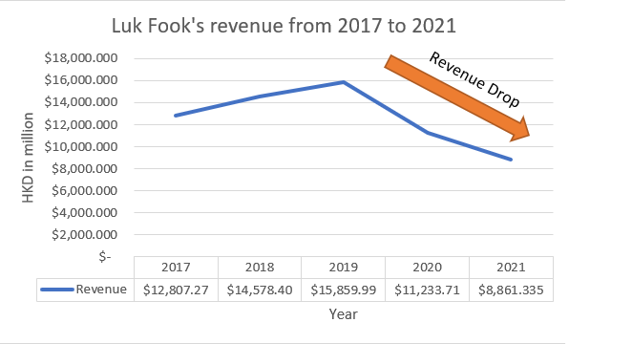
Source: Constructed by author

The source of Luk Fook’s revenue and segment profits came from retailing, wholesaling and licensing. Retailing and wholesaling contributed the greatest part revenue while licensing contributed the largest part of segment profit (Luk Fook’s Holdings Limited, 2021). This is because of the 224 licensed shops added and drove the wholesaling revenue by 14.2% and licensing income by 18.2%. Gold and Platinum, and fixed price jewellery equally contributed to the sales of Luk Fook but fixed price jewellery occupied Luk Fook’s gross profit slightly more than Gold and platinum.

1.3 Company structure
Luk Fook’s company structure is composed of 6 divisions. They are Manufacture and Wholesale, PRC Business, Retail, Finance, Authentication and Portal Business. In the risk management framework, the top management is Board of Directors, and then followed by Audit Committee, Risk Management Committee and Departments and Management.

1.4 Comparison company in the research
King Fook Holdings Limited (00280.HK) and Chow Sang Sang Holdings International Limited (00160.HK) are used as comparison companies. Three of the companies share the same business nature of jewellery retail. In terms of the business scale, Luk Fook has the largest scale, and Chow Sang Sang has the middle scale while King Fook has the smallest scale. They can help to analyze the financial management of Luk Fook.

Table: Comparison company in the research
Company name  (Stock Number) | Luk Fook  (00590.HK) | King Fook  (00280.HK) | Chow Sang Sang  (00116.HK)
Business Nature | Jewellery Retail
Market Value (HKD)  (As of 29 July 2022) | $11.249 billion  (Stock price at $19.16) | $360.006 million  (Stock price at $0.395) | $5.949 billion  (Stock price at $8.110)
PE Ratio  (As of 29 July 2022) | 8.08 | 5.64 | 7.37
Market Area | Self-operated shops in 8 different countries; licensed shop in 3 countries. | Hong Kong | Mainland China, Hong Kong and Macau, and Taiwan
Number of stores | 2,366  (Luk Fook Holdings Limited, 2021) | 7  (King Fook Holdings Limited, 2021) | 872  (Chow Sang Sang Holdings Limited, 2021)
Source: Constructed by author

Luk Fook’s financial analysis
Financial Analysis is a tool to help the company understanding its financial features and performance so that it can predict business crisis (Salmi and Martikainen,1994).

2.1 Z-score analysis

Z-score model helps to predict bankruptcy and other firm’s distress and indicates the failure risk of a company (Altman et al. 2017). For Luk Fook’s setting of public-manufacturer, a z-score lower than 1.81 means high probability of bankruptcy; a z-score between 1.81 and 2.99 is a grey area; a z-score greater than 2.99 means a low probability of bankruptcy. The calculation of z-score is 1.2*(Net working capital/Total assets) +1.4*(Accumulated retained earnings/Total assets) +3.3*(EBIT/Total assets) +0.6*(Market value of equity/Total Liabilities) + 0.999*(Sales/Total Assets).

Table 2.1: Z-score analysis of Luk Fook, Chow Sang Sang and King Fook.
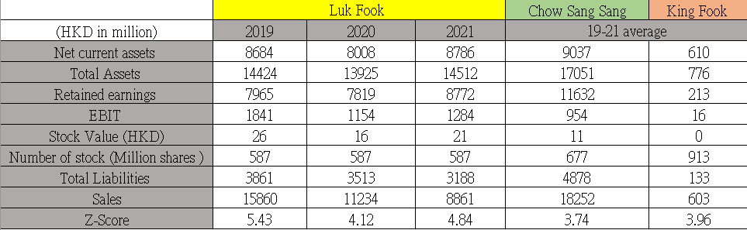
Source: Constructer by author
By looking at Table 2.1, the sales of Luk Fook dropped year by year between 2019 to 2021, and the EBIT has dropped by 30% in 2021 compared to 2019. However, it shows that Luk Fook kept a relatively smaller total liabilities while its scale of business is a lot larger that Chow Sang Sang and King Fook. With the above reason, Luk Fook’s z-score is greater than 2.99 in all three years so it has lower probability to go bankruptcy and in safe business.

2.2 Financial structure
The analysis of financial structure shows how the company operate its finance through the mix of debt and equity (Scott, 1972). Every company has different mix due to different business needs, expenses and demand of investors.

Table2.2: Financial structure analysis
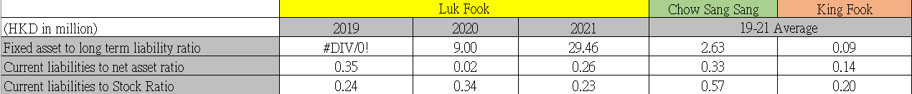
Source: Constructed by author

The fixed asset to long term liability ratio indicates a company’s debt coverage capabilities and the extent of long-term liabilities can be covered with fixed assets (Holz, 2002). If the rate is higher, the source of funds will be more stable. However, Luk Fook had a high ratio of 29.46 (Table 2.2) and a lot higher than the industry. This means it has lower chance of financial crisis.

The current liabilities to net asset ratio is a solvency ratio that examine a company’s net assets are made of current liabilities (Chiu and Li, 2006). Luk Fook has a relatively low ratio of 0.23 in 2021 (Table 2.2) and lower than the industry which means it has a low pressure on the future cash flows.

The current liabilities to stock ratio means how much of a company’s stocks are made of current liabilities (Bookstaber and Gold, 2015). It suggests that if the ratio is high, it means there is over-reliance on unsold goods to finance operations. Luk Fook has a lower rate (i.e. 0.23 in 2021) than the industry so it has maintained a healthy stock.

In the financial structure analysis, Luk Fook maintains a fair position to operate its finance but it has little worries on its long-term liabilities that may affect its future finance.

2.3 Debt-paying ability
There are a few accounting ratios that help to measure a company’s ability to meet debt paying ability. This provides a good indicator for management, lenders and future investors to make business decisions (Byrd and Mizruchi, 2005).

Table 2.3: Paying debt ability of Luk Fook, Chow Sang Sang and King Fook.
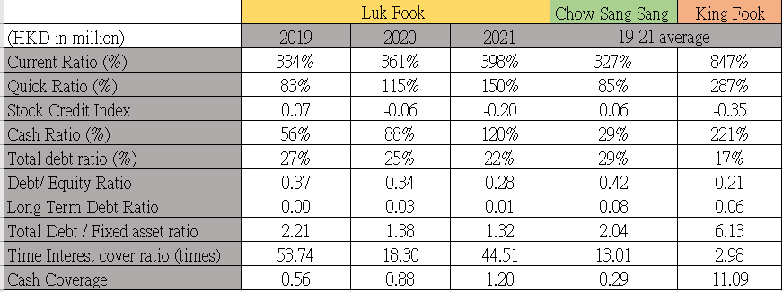
Source: Constructed by author

The current ratio is a liquidity ratio that examine whether a company is capable of paying off all of its current liabilities with its current assets (Tumanggor, 2020). On the other hand, the quick ratio is another liquidity ratio to determine how efficient a company paying off its current liabilities using its current assets. Luk Fook maintained sufficient amount of cash in all 3 years so it had a healthy cash flow. Despite it had a quick ratio of 83% and cash ratio of 56% in 2019 (Table 2.3), it quickly went back to a healthy status in 2020 and 2021.

Luk Fook’s current liabilities mainly came from bank borrowings and trade payables but the amount was relatively lower, therefore the stock credit index is -0.06 and -0.20 in 2020 and 2021 (Table 2.3) which were good sign. Total debt ratio shows the proportion of a company’s assets that are financed by debt (Yuan and Motohashi, 2008). Luk Fook maintained a low total debt ratio, debt-to-equity ratio and long term debt ratio among the industry. By looking into the total debt-to-fixed asset ratio, it would show that Luk Fook’s fixed assets such as property, plant and equipment were more financed by the debt but it might not raise any big concern as it was similar to the industry.

Time interest cover ratio evaluates a company on how well it can cover its debt obligations (Setiany, 2021). Luk Fook was outperformed among the industry with a higher interest earned ratio of 54 times and 45 times in 2019 and 2021 (Table 2.3). It has stronger performance and is less risky.

Through the dept-paying analysis, it shows that Luk Fook managed to handle well its business debts so it can attract future investors and get the good credit from its lenders.

2.4 Operational ability
Operational ability is the functional skill, capability and capacity of a company to perform its duties, tasks and obligations (Bawa and Basu, 2020). By looking into the sales performance, Luk Fook did not successfully help its business to recover from the pandemic. It generated decreasing sales from $15,860 million in 2019 to $8,861 million in 2021, which was dropped by 44% (Figure 2.1). In fact, Luk Fook has the largest scale of business among the other 2 companies but the sales did not reflect. On the other hand, Chow Sang Sang which has the medium size of business has reported a steep increase of sales in 2021 and with the positive growth of 24% compared to 2019. One of the success factor of Chow Sang Sang is their robust e-commerce, well-developed personalized jewellery service and omni-channel retail networks (Chow Sang Sang, 2021).

Figure 2.1: Sales performance of Luk Fook, Chow Sang Sang and King Fook from 2019 to 2021.
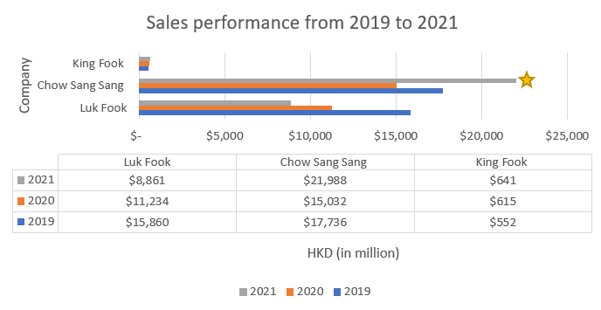
Source: Constructed by author

Operating expense is an expense generated from a company’s normal business operation. Luk Fook’s expenses included some main activities like employee costs, depreciation and amortization and rental expense. Table 2.4 has utilized the total turnover as the based amount for analysis for each of the company and showed the proportion of each type of expense.

Table 2.4: Proportion of operating expenses of Luk Fook, Chow Sang Sang and King Fook.
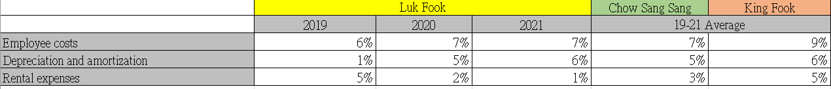
Source: Constructed by author
Luk Fook managed a good control in overall operational expenses. Especially looking at the rental expense, Luk Fook has a clever strategy of closing down self-operated shops from 181 shops in 2020 to 146 shops in 2021 (Luk Fook, 2021), while its licensed shops have increased from 1881 shops in 2020 to 2138 shops in 2021. This can help Luk Fook shared operating expenses with the investors and made a better financial report.

Table 2.5: Efficiency in generating revenue of Luk Fook, Chow Sang Sang and King Fook
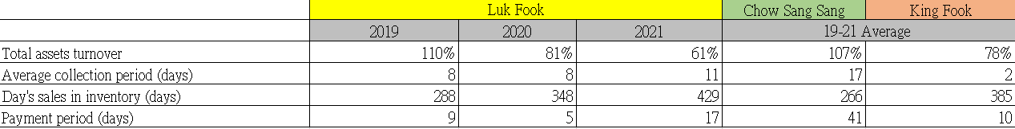
Source: Constructed by author

The total assets turnover measures the ability of a company to efficiently produce sales (Nariswari and Nugraha, 2020). Luk Fook’s total assets turnover was in a high rate of 110% in 2019 but it dropped to 61% in 2021 (Table 2.5), which is lower than its peer average level. Average collection period is around 8-11 days which means it took quite a short time to receive payment owed by clients. As Luk Fook’s product nature is luxury, the day’s sales in inventory tends to be longer. However, it has a quite long inventory period of 429 days in 2021. This is a lot longer than the peer average time which means Luk Fook’s product took longer time to become sales. In addition, payment period of Luk Fook has lengthened from 5 days in 2020 to 17 days in 2021 which has increased a lot but still at a reasonable time when compared to peer average.

By analyzing the operating capacity of Luk Fook, it shows that it has a slowdown in business growth and weaker than its peer average. In addition, it has lack of efficiency of generating sales. Nevertheless, it controlled well about its operating expenses. To conclude, there is room of improvement here.

2.5 Profitability
Profitability is a measurement of a company’s profit relative to its expense. It can help to assess a company’s ability to generate income (Lesakova, 2007).

Table 2.6 Net profit of Luk Fook, Chow Sang Sang and King Fook.
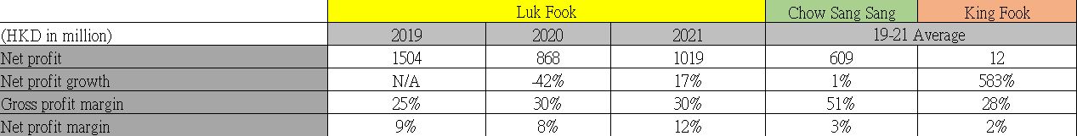
Source: Constructed by author

The net profit margin of Luk Fook is 12% in 2021 (Table 2.6) and was way more than its peer average. This means that for each dollar sales, Luk Fook was generating more profits. In the general rule of thumb, a 20% of net margin is considered as good, so Luk Fook was actually performing in average level. The gross profit margin indicates the profit remaining after cost of goods sold. In all 3 years, Luk Fook achieved over 20% of gross profit margin which is considered as high, although Chow Sang Sang performed even more outstanding and achieved 51% in average.

Table 2.7: ROA and ROE of Luk Fook, Chow Sang Sang and King Fook.
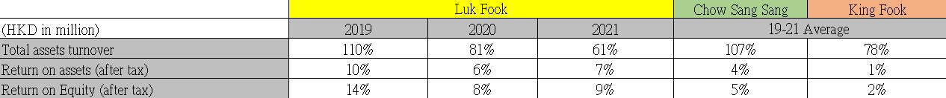
Source: Constructed by author

Return on equity (ROE) and return on assets (ROA) are two important measurement of profitability of a company. They indicate how much equity or asset is required to generate certain amount of net income (Heikal, Khaddafi and Ummah, 2014). ROA of Luk Fook dropped year by year from 10% in 2019 to 7% in 2021 (Table 2.7); while ROE also showed the same phenomenon and dropped from 14% in 2019 to 9% in 2021. This means it did not make a good usage of the assets or shareholder's equity to generate revenue growth. The good side is that Luk Fook still performed better than peer average.

2.6 Growth ability
A company’s growth ability allows it to expand its business and enables long-term survival of a business.

Table 2.8: Growth ability of Luk Fook, Chow Sang Sang and King Fook.
Source: Constructed by author
The retained earning ratio (Retention ratio) is the proportion of earnings that a company keeping back in the business (Singh, 2021). Luk Fook kept a fair amount of earnings for internal use and plowing the money back into its operation. It can help to increase their stock price. Luk Fook was probably reserve the money for future investment opportunities. The sustainable growth rate (SGR) shows the ability that a company can grow with using internal revenue and without outside source. Luk Fook’s SGR is quite high with 77% in 2021 (Table 2.8). Therefore, it is a resourceful company to main business growth in the future.

2.7 Stock Market Prospect Analysis
A stock market prospect is a company’s potential future performance in a competitive marketplace.

Table 2.9:
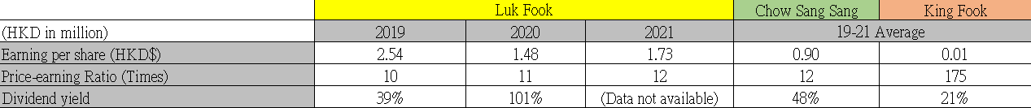

The price-earning ratio (P/E Ratio) measures share price relative to the annual net income earned per share. It shows investors how much a company is worth (Easton, 2004). Luk Fook’s P/E value was low in all 3 years so it might mean that the stock is undervalued, while King Fook was relatively high that was up to 175 times earnings in average (Table 2.8). The earning per share of Luk Fook was relatively high among the peer average. The dividend yield of Luk Fook was also high so it shows that its stakeholders can expect to receive a good money per dollar they have invested. Therefore, its stock is at a reasonable level.

Luk Fook’s Corporate Governance assessment
Corporate governance provides the systems of rule, practices and processes that a company is directed and controlled. All business decisions are determined by some part of the system of corporate governance. A good corporate governance requires a complex system of checks and balance (Monks and Minow, 2011).

3.1. Luk Fook’s current corporate governance
The Board of the Company of Luk Fook provides transparent and independent corporate governance report in its annual reports every year.

Figure 3.1: Corporate governance framework of Luk Fook.
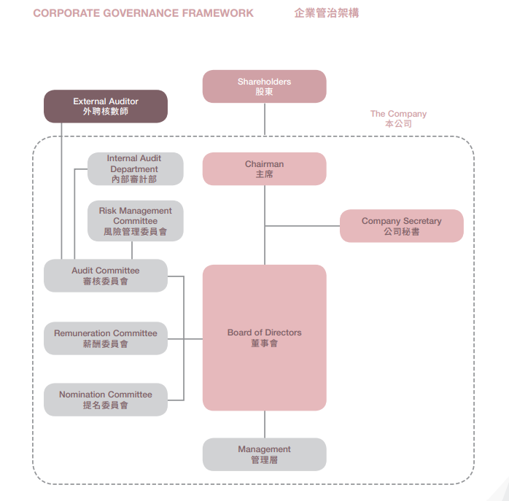
Source: Luk Fook, 2021

Luk Fook applied the principles and complied with the practices of the Corporate Governance Code and Corporate Governance Report (the “CG Code”), and the Rules Governing the Listing of Securities (the “Listing Rules”) on Stock Exchange (Luk Fook, 2021, p.106). The responsibilities for the management of the Board are clearly divided from the day-to-day management of the business (Table 3.1). It helps to balance the power and authority. It also adopts the Model Code for Securities Transactions. This is a code of conduct regarding to directors’ securities transactions.

There are different responsibilities and delegation. The board provides the leadership of the company, set the strategic aims, values and standards, while the management level do the operation works. In addition, all the directors seek independent professional advice in appropriate circumstances at the Company’s expense in carrying out their functions. It arranged a liability insurance to indemnify the directors for their liabilities arising out of corporate activities. There is also audit committee to review the consolidated financial statements of the group in order to making sure it complies with the accounting standard and the listing rules and sufficient disclosure.

Figure 3.2: Risk Management Framework of Luk Fook.
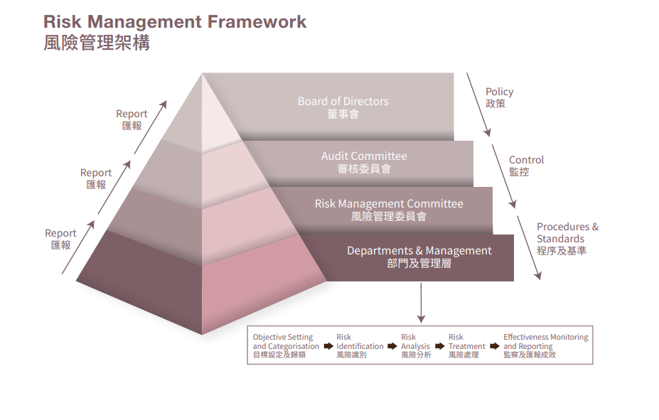
Source: Luk Fook, 2021
For the risk management (Table 3.2), Luk Fook has a framework that is aligned with the Committee of Sponsoring Organizations of the Treadway Commission (“COSO”) integrated framework. It comprises 5 components which are Control Environment, Risk Assessment, Control Activities, Information and Communication and Monitoring Activities. All departments and management are risk owners to take direct risk management responsibilities and reports to the Risk Management Committee.

3.2 Emerging risks and suggestions
1. Oversight issue on Luk Fook’s licensed shop
Luk Fook has shifted its strategy to close down existing self-operating shops and opening more licensed shops (mainly in mainland China market) to drive the business growth. The licensed shop in mainland has drastically increased from 1,614 shops in 2019 (Luk Fook, 2019) to 2,135 shops in 2021 (Luk Fook, 2021), which had 32% growth. However, there was lack of oversight on the licensed shops in mainland market so Luk Fook had a scandal of selling counterfeits on a popular mainland online shopping platform called Tmall (天貓) (Sina, 2019). The mainland consumers complained that Luk Fook online shops did not provide after-sale maintenance and the quality assurance as promised.

To improve the situation, Luk Fook can develop a dedicated team to monitor licensed shop’s quality of operation in order re-build the reputation in mainland’s market. A clear timeline of reports and regular audits should be made to the licensed shops. In addition, Luk Fook can make use of its official webpage to disclose all the licensed shops details and the after-sale contacts so that consumers can have the trust in the brand.

2. Accountability issue
As there are growing licensed shops around the world, it is important to maintain the accountability from top management to low-tier employees in the system of checks and balance (Brennan and Solomon, 2008). Consumer tends to believe that all Luk Fook’s shop should be providing the same service and good quality of products. Whenever consumer buys defective product, there should be the same standard to exchange of products and report back to the main office. As Luk Fook has not clearly stated the accountability of the works, it might cause consumers feel confused and disappointed if they could not find the accountable department.

To improve accountability issue, Luk Fook should provide a clear instruction to its licensed shops to maintain the good quality of services and the quality assurance of the products. Licensed shops should follow a standard procedure that is provided by Luk Fook’s headquarter office to allow all consumers to have a standard after-sales service. It may also centralize to a dedicated team or outsourced party to follow up the service within the guaranteed service time. When the services provided by licensed shops does not meet the criteria, there is always a hotline or customer service center to receive complaints and follow up. This refined system can help to monitor the service quality of licensed shops and make the management in licensed shop accountable to the product or service problems. Thus, it can help to re-build the brand reputation.

Investment project assessment

Project information
Luk Fook can capture new business opportunity through e-commerce. Luk Fook has suffered from negative sales growth for 2 years (2020 and 2021) and it has to learn from Chow Sang Sang’s success in e-commerce which it first started in 2014 (Money.udn.com, 2022). The target yearly sales growth rate of Luk Fook is 9% (Luk Fook, 2019) in the upcoming 6-year project.

Table 4.1 : Project information
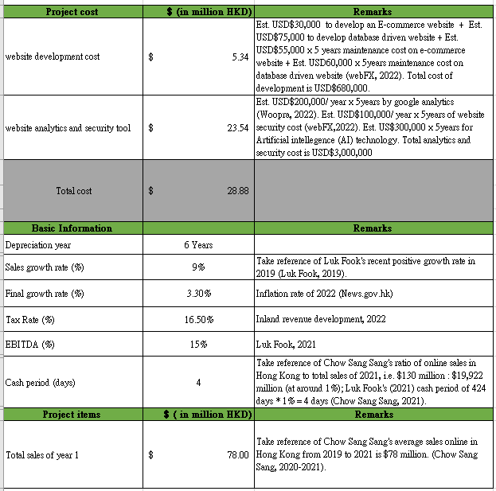
Source: Constructed by author

The project is to develop online shop for Luk Fook in Hong Kong as a pilot program. The project duration is 6 years. Besides the development of the comprehensive e-commerce system for Luk Fook, artificial intelligence (A.I.) will be implemented to in the online system to provide a “A.I. salesperson” to serve the customers. It can help to identify the suitable items to the online customers based on their browsing history. Potentially, it will increase the content reach rate, the click rate and the sales conversion rate of the online customers (Akerkar, 2019).

Luk Fook can thus capture both online and offline business so that it can boost its sales and achieve positive sales growth in the coming 6 years. The project cost is $28.88 million (Table 4.1) for the website development and website analytics and security tool.

4.2 Computing sales and profits
Table 4.2 : Computing sales and profits of the project.
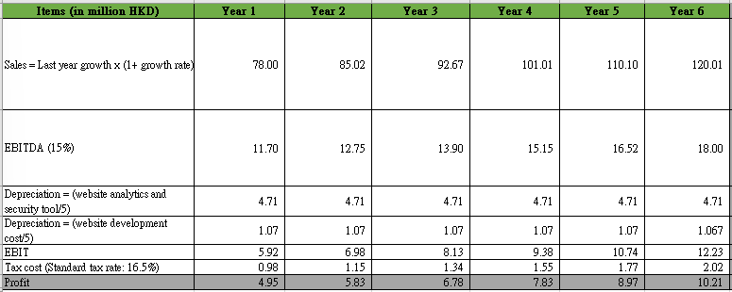
Source: Constructed by author

The sales of first year is calculated to be $78 million (Table 4.2). It takes reference of Chow Sang Sang's average sales that were driven from 2019 to 2021 which is $78 million in Hong Kong region. Sales increase by 9% each year. The profit for the 1st year is $4.95 million.

4.3 Cash Flow Calculation
Table 4.3 : Cash Flow of the project
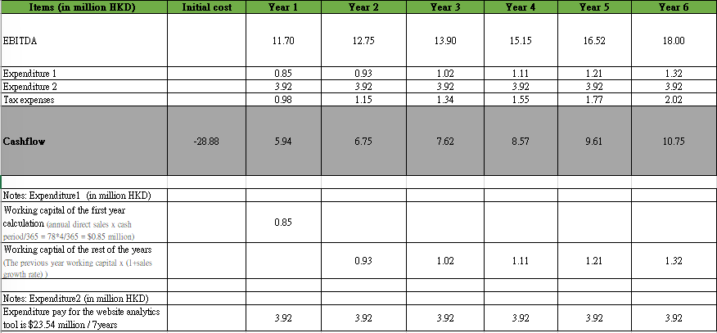
Source: Constructed by author

With the calculation of the expenditure from the depreciation of the e-commerce website and the analytics and security tools, and the tax expenses of 16.5% (Inland revenue development, 2022), the project still maintains positive cashflow every year (Table 4.3).

4.4 ARR and NPV calculation
Table 4.4 : ARR and NPV of the project
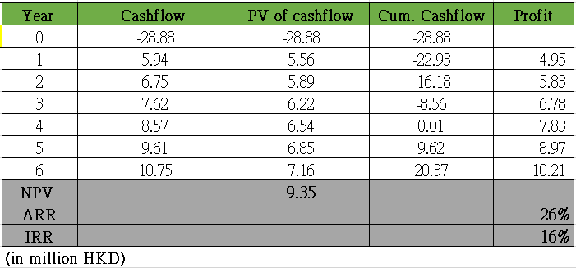
Source: Constructed by author
Accounting rate of return (ARR) is a tool to compare multiple projects and provides the expected rate of return of the project (Brief and Lawson, 2014). In the 6-year project, Luk Fook will have a ARR of 26% (Table 4.4). It means the project is expected to earn 26 cents for every dollar invested per years which is good. Internal rate of return (IRR) is used to compare to a company’s cost of capital and a project is considered as good investment when IRR is greater than or equal to the cost of capital (Hartman and Schafrick, 2004). IRR is 16% (Table 4.4) and is larger than the return of asset (ROA) of 7% (Luk Fook, 2021) so it is considered as a good investment. Net present value (NPV) is the analysis shows the intrinsic value of the future cash flows in order to determine the value of a business (Ross,1995). NPV is $9.35 million (Table 4.4) which is larger than 0 and is considered as good.

4.5 Payback period and IRR
Payback period shows the required time to recover the original cash investment (Weingartner, 1969). The 6-year project is going to need 4 years payback period which means it has sufficient net revenue to recover the cost.

4.6 Investment appraisal and analysis
Capital investment appraisal (CIA) helps the company to make organizational management decisions about what projects to invest in and the ways to finance in order to achieve corporate goals (Harris and El-Massri, 2011).

From profit-based analysis, the 6-year project will generate a ARR rate of 26% (Table 4.4) which is higher than Luk Fook’s current ROA of 7%. It reflects a good long-term return of this project.

From cash-flow based analysis, it also reflects a positive return. The payback period is 4 years which is fairly good for a 6-year project. Additionally, it is important to consider the time value which is a better indicator to evaluate a project. The NPV is $9.35 million which is a positive value and considered that it has a high intrinsic value of the future net cash flow. Also, the IRR is 16% which exceeds the required return and the cost of capital so the project is preferable.

It is crucial to make sure the operating activities generate enough cash to stay liquid. Luk Fook online shop generates $28.88 million cash outflow in year 0 of the project, compared to Luk Fook’s total of $2445 million net cash flow in 2021 (Luk Fook, 2021) which is at around 1.18%. Therefore, Luk Fook has sufficient internal resources to meet the liquidity requirement.

Therefore, the investment appraisal is positive and the project should be carried out.

Financing and capital management
The 6-year project of Luk Fook initiates additional cash of $28.88 million (Table 4.3). Compared to the total asset of Luk Fook in 2021 which is $14,512 million, it is at 0.20% of it. The below is to analyze different financing program of Luk Fook’s capital management through exploring each of the pros and cons.

  - Financing method analysis
Table 5.1 : Financing method analysis
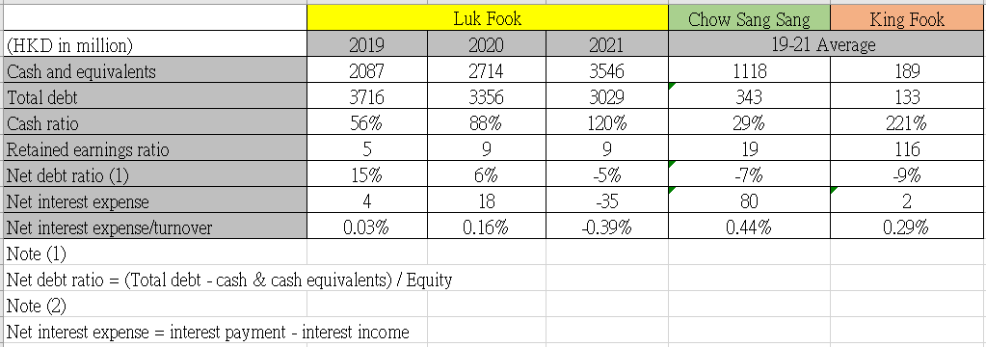
Source: Constructed by author
- Use of retained profits
It means using internal retained earnings or cash as the source of funding. Luk Fook maintained an increasing net cash flow in the past few years. The net debt ratio is 6% (Table 5.1) in average from 2019 to 2021 which means healthy status. The cash ratio is 88% (Table 5.1) in average which means Luk Fook can easily pay off its debt. Retained earning ratio is also at high level which means Luk Fook keeps a high amount of reserve for reinvestment in the future. However, it may affect the overall perception of the financial report as the equity of the company will be lowered after the reinvestment.

- Apply for bank Loan
Luk Fook’s current interest at floating rate for its bank loan is 0.63% - 2.78% (Luk Fook, 2021). Take 2.78% for the estimation, the net interest expense over turnover will change from -0.39% (Table 5.1) to -0.38%, which is a small impact to the company. This will still perform the best among the industry average. Bank Loan provides a good flexibility on how Luk Fook spend the money and enable Luk Fook maintain the control of its equity. However, obtaining a bank loan is time consuming and sometime may take several months to qualify the obtain the capital.

- Issue shares
Issuing and selling shares of stock to raise money by attracting more investors to provide the capital to the company for investment. The advantage of raising funds by issuing shares is the absence of fixed liability as the company does not guarantee the dividend rate on equity share. However, issuing share involves cost such as audit fee, legal fee, security and exchange commission registration fee. Also, Luk Fook has a sound financial position, so they have to pay dividends at higher rates even when loans are at lower rate in the market.

  - Financing method proposed

With the above analysis, the proposed method of financing is to use the retained profits for investment project.

Table 5.2: Financing method proposed
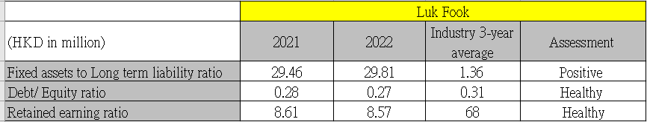
Source: Constructed by author
Luk Fook has maintained a good cash flow and retained earnings in the past few year, and the 6-year project proposed does not cause major impact to the financial performance. The debt to equity ratio is only slightly change from 0.28 to 0.27 (Table 5.2) which is healthy. The retained earning ratio is slightly affected by changing from 8.61 to 8.57 (Table 5.2) but still this is a healthy status. While the fixed assets to long term liability ratio increases from 29.46 to 29.81 which is a positive sign. The use of retained earnings for investment is a preferred financing method.

Recommendations and Audit Plan
To maintain a good financial report, an annual operational audit quarterly plan in the coming 12 months has been drafted based on the financial impact.

Table 6.1: Gantt Chart for the first 12 months of the 6-year project.
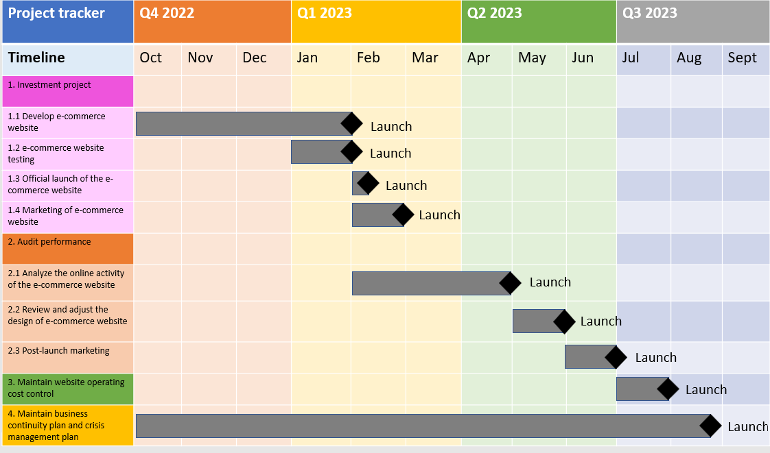
Source: Constructed by author

The 12-month audit plan (Table 6.1) has shown the main 4 problematic areas.
- Investment project
The initial development of the e-commerce website requires designing, testing, launching and marketing works to do. The special characteristic is “artificial intelligence salesperson” in the e-commerce website, so it is important to do a proper testing in order to ensure the good service quality provided by AI to interact with the online customers and drive the online sales. Along with the launch of website, there should be marketing campaign for this website so that the potential customer aware of the new online shop provided.

- Audit performance
Once the e-commerce website has launched, every online activity will be tracked by the website analytics tool that is installed in the beginning. This is important for the back-end staff to analyze effectiveness of the website promotion and usage volume. The sales from website can improve the sales ratio, profit margin, and the rate of return. If problem occurs after the review, the design adjustment of the website can be made. A post-launch marketing after 3 months of first marketing can capture another batch of customers through peer influence (Bapna and Umyarov, 2015).

- Maintain website operating cost control
Operating cost to turnover ratio should be maintained at a reasonable rate. The major operation expenses are quite standard for website management, such as online customer service, after-sales service and technical supporting staff cost. The fluctuating expense will be the product delivery cost when the order has drastically increased or decreased. The operating cost review should be done in the end of the 12-month audit plan.

- Maintain business continuity plan and crisis management plan
Luk Fook needs to comply with good governance code and the laws and regulations. In this 6-year project, it should take care of the expectation of online customers. Online customers expect the same good quality assurance of the products and the standardized service should be provided during the customer journey. When problems occur, a standard of procedure should be provided to customers and the physical stores should also take accountability for the problems derived from online shops. All front-line staff should be well trained to face any kind of crisis. This can help to build reputation for its online shop.

Conclusion
Luk Fook has a healthy financial report and performed well among the industry average in different aspects. It has well developed the corporate governance code and clearly disclose all of the operation details to its stakeholders. Although it has suffered from negative sales growth for the past 2 years, a 6-year project is proposed with a comprehensive analysis and should be implemented in the upcoming years. It is believed that Luk Fook can catch up the sales growth and grow the business through the investment.

References
Academic reference:
- Akerkar, R. (2019) Artificial intelligence for business. Springer.
- Altman, E. I. et al. (2017) Financial distress prediction in an international context: A review and empirical analysis of Altman's Z‐score model. Journal of International Financial Management & Accounting, 28(2), pp. 131-171.
- Bawa, J. K. and Basu, S. (2020) Restructuring assets reform, 2013: Impact of operational ability, liquidity, bank capital, profitability and capital on bank credit risk. IIMB Management Review, 32(3), pp. 267-279.
- Bapna, R. and Umyarov, A. (2015) Do your online friends make you pay? A randomized field experiment on peer influence in online social networks. Management Science, 61(8), pp.1902-1920.
- Brief, R. P. and Lawson, R. A. (2014) The role of the accounting rate of return in financial statement analysis. In The Continuing Debate Over Depreciation, Capital and Income, pp. 235-250.
- Brennan, N. M. and Solomon, J. (2008) Corporate governance, accountability and mechanisms of accountability: an overview. Accounting, Auditing & Accountability Journal, 21(7), pp. 885-906.
- Bookstaber, R. and Gold, J. (2015) In search of the liability asset. Financial Analysts Journal, 71(1), pp.18-28.
- Byrd, D. T. and Mizruchi, M. S. (2005) Bankers on the board and the debt ratio of firms. Journal of corporate finance, 11(1-2), pp.129-173.
- Chiu, M. C. and Li, D. (2006) Asset and liability management under a continuous-time mean–variance optimization framework. Insurance: Mathematics and Economics, 39(3), pp. 330-355.
- Easton, P. D. (2004) PE ratios, PEG ratios, and estimating the implied expected rate of return on equity capital. The accounting review, 79(1), pp.73-95.
- Harris, E. P. and El-Massri, M. (2011) Capital investment appraisal. In Review of management accounting research, pp. 343-377.
- Hartman, J. C. and Schafrick, I. C. (2004) The relevant internal rate of return. The Engineering Economist, 49(2), pp.139-158.
- Heikal, M. and Khaddafi, M. and Ummah, A. (2014) Influence analysis of return on assets (ROA), return on equity (ROE), net profit margin (NPM), debt to equity ratio (DER), and current ratio (CR), against corporate profit growth in automotive in Indonesia Stock Exchange. International Journal of Academic Research in Business and Social Sciences, 4(12), p.101.
- Holz, C. A. (2002) The impact of the liability–asset ratio on profitability in China's industrial state-owned enterprises. China Economic Review, 13(1), pp.1-26.
- Lesakova, L. (2007) Uses and limitations of profitability ratio analysis in managerial practice. In International Conference on Management, Enterprise and Benchmarking, pp. 1-2.
- Monks, R. A. and Minow, N. (2011) Corporate governance. John Wiley & Sons.
- Nariswari, T. N. and Nugraha, N. M. (2020) Profit growth: impact of net profit margin, gross profit margin and total assets turnover. International Journal of Finance & Banking Studies (2147-4486), 9(4), pp. 87-96.
- Ross, S. A. (1995) Uses, abuses, and alternatives to the net-present-value rule. Financial management, 24(3), pp.96-102.
- Salmi, T. and Martikainen, T. (1994) A review of the theoretical and empirical basis of financial ratio analysis. News Group.
- Scott, D. F. (1972) Evidence on the importance of financial structure. Financial Management, pp. 45-50.
- Setiany, E. (2021) The Effect of Investment, Free Cash Flow, Earnings Management, and Interest Coverage Ratio on Financial Distress. Journal of Sosial Science, 2(1), pp. 64-69.
- Singh, U. (2021) Modeling of dividend payout, retention, yield, capital gains and irrelevance and its impact on value of the firm. Journal of Contemporary Issues in Business and Government, 27(2), pp.5166-5178.
- Tumanggor, M. (2020) The Influence of Current Ratio, Quick Ratio and Net Profit Margin on Return on Assets at PT. Hero Supermarket Tbk. PINISI Discretion Review, 1(1), pp.137-146.
- Weingartner, H. M. (1969) Some new views on the payback period and capital budgeting decisions. Management Science, 15(12).
- Yuan, Y. and Motohashi, K. (2008) Impact of the Debt Ratio on Firm Investment: A case study of listed companies in China. Research Inst. of Economy, Trade and Industry.

Non-academic reference:
- Chow Sang Sang (2019) Annual Report 2019. Available at: https://www1.hkexnews.hk/listedco/listconews/sehk/2020/0423/2020042301464.pdf (Accessed: 27 July 2022).
- Chow Sang Sang (2020) Annual Report 2020. Available at: https://www1.hkexnews.hk/listedco/listconews/sehk/2021/0422/2021042201415.pdf (Accessed: 27 July 2022).
- Chow Sang Sang (2021) Annual Report 2021. Available at: https://www1.hkexnews.hk/listedco/listconews/sehk/2022/0421/2022042101798.pdf (Accessed: 27 July 2022).
- Inland revenue development (2022) Profit tax rate. Available at: - (Accessed: 31 Aug 2022).
- King Fook (2019) Annual Report 2019. Available at: https://www1.hkexnews.hk/listedco/listconews/sehk/2019/0718/ltn20190718177.pdf (Accessed: 27 July 2022).
- King Fook (2020) Annual Report 2020. Available at: https://www1.hkexnews.hk/listedco/listconews/sehk/2020/0723/2020072300426.pdf (Accessed: 27 July 2022).
- King Fook (2021) Annual Report 2021. Available at: https://www1.hkexnews.hk/listedco/listconews/sehk/2021/0722/2021072200382.pdf (Accessed: 27 July 2022).
- Luk Fook (1998) Annual Report 1998. Available at: https://www.lukfook.com/content/uploads/2012/01/5e1e995e5bd26.pdf (Accessed: 27 July 2022).
- Luk Fook (2019) Annual Report 2019. Available at: https://www1.hkexnews.hk/listedco/listconews/sehk/2019/0719/ltn20190719187.pdf (Accessed: 27 July 2022).
- Luk Fook (2020) Annual Report 2020. Available at: https://www1.hkexnews.hk/listedco/listconews/sehk/2020/0717/2020071700529.pdf (Accessed: 27 July 2022).
- Luk Fook Holdings Limited (2021) Annual Report 2021. Available at: https://www1.hkexnews.hk/listedco/listconews/sehk/2021/0719/2021071900332.pdf (Accessed: 27 July 2022).
- Money.udn.com (2022) Appier虛擬 AI 銷售員為周生生珠寶衝刺線上業績. Available at: https://money.udn.com/money/story/12987/6345522 (Accessed: 31 Aug 2022).
- Sina (2019) 六福珠宝遭消费者投诉 期待品牌积极解决问题. Available at: https://blog.omnichat.ai/2022/04/lukfook-success-story/ (Accessed: 20 Aug 2022).
- webFX (2022) How much should a website cost in 2022? Available at: https://www.webfx.com/web-design/pricing/website-costs/ (Accessed: 20 Aug 2022).
- webFX (2022) Website Security Analysis Pricing: How Much Does It Cost? Available at: https://www.webfx.com/web-development/pricing/website-security-analysis/ (Accessed: 28 Aug, 2022).
- Woopra (2022) How Much Does Web Analytics Cost in 2022? Available at: https://www.woopra.com/blog/how-much-does-web-analytics-cost (Accessed: 28 Aug, 2022).
- Yahoo Finance (2021) Luk Fook Holdings (International) Limited (0590.HK). Available at: https://finance.yahoo.com/quote/0590.HK/history?period1=1583020800&period2=1617235200&interval=1d&filter=history&frequency=1d&includeAdjustedClose=true (Accessed: 30 July 2022).

Appendix
- Luk Fook’s value on 29 March 2019
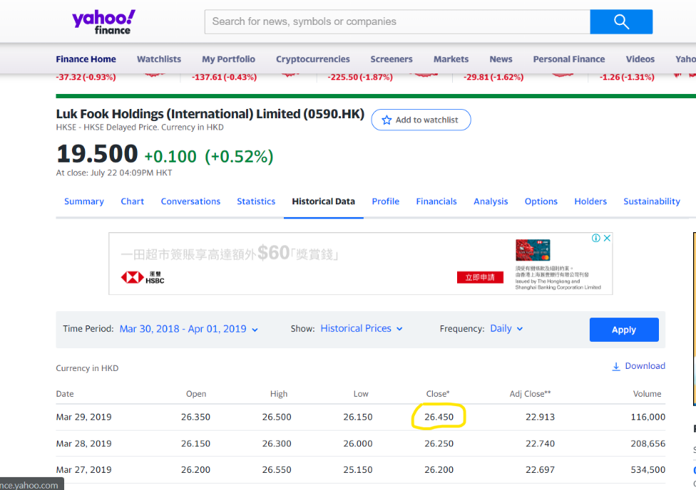

- Luk Fook’s value on 31 March 2020
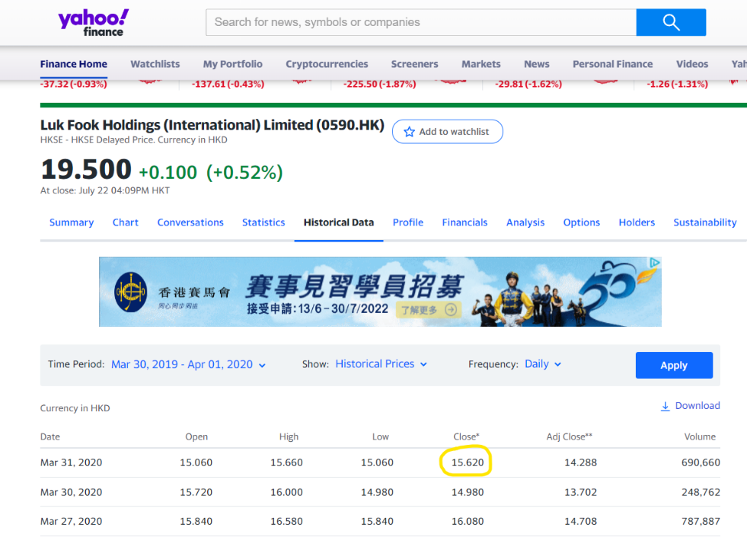

- Luk Fook’s value on 31 March 2021

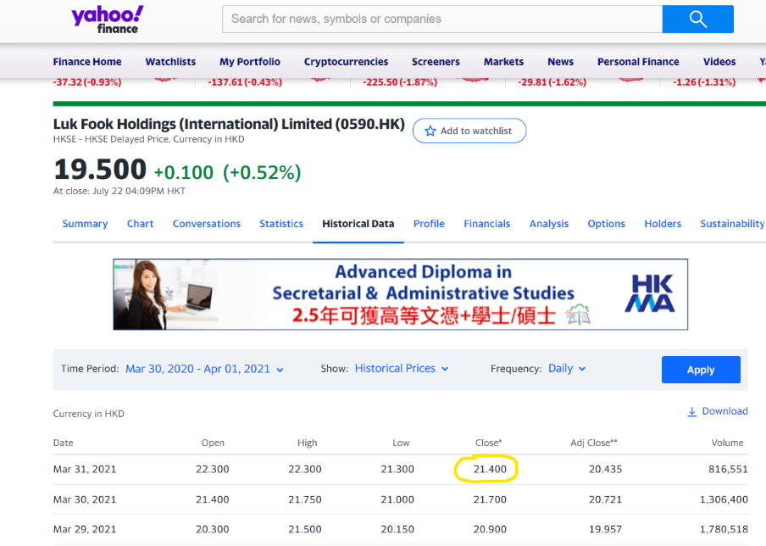

- Luk Fook’s Balance Sheet 2019
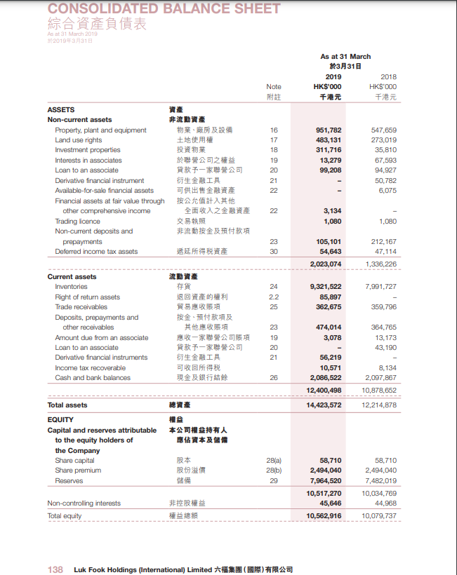
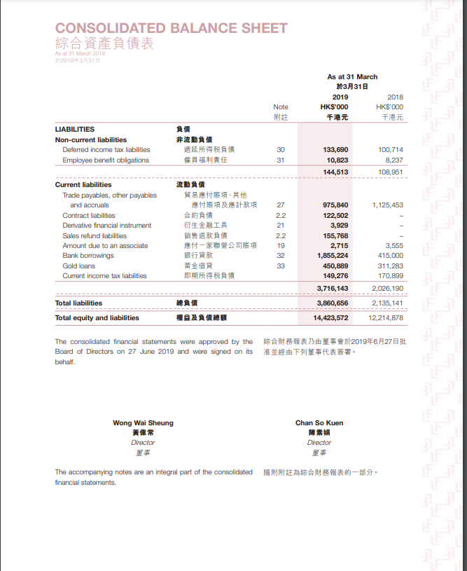

- Luk Fook’s Balance Sheet 2020
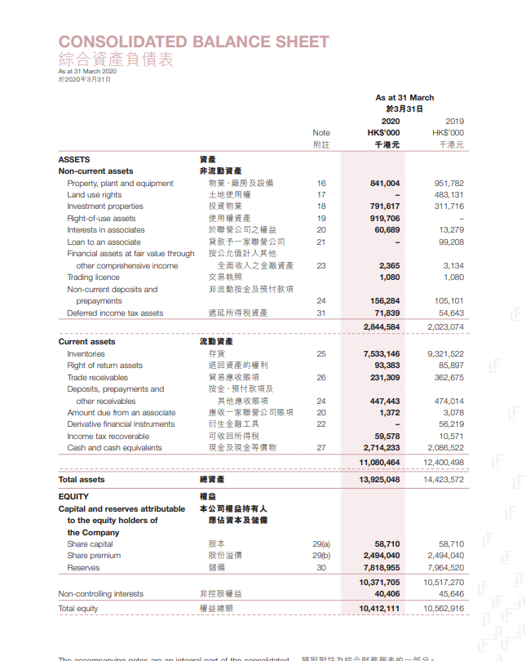
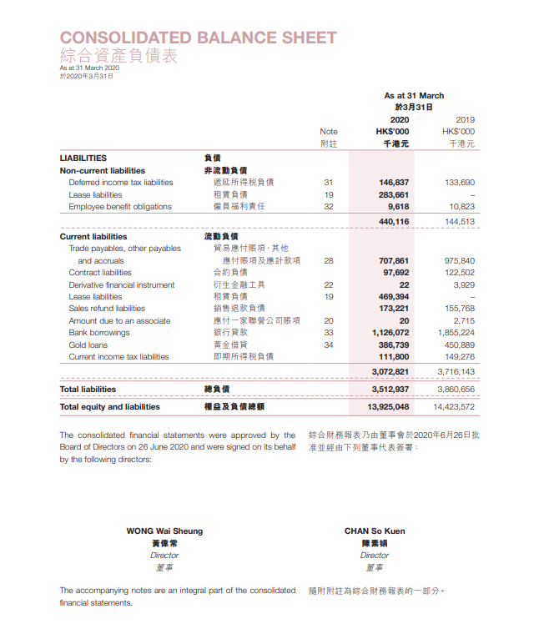

- Luk Fook’s Balance Sheet 2021
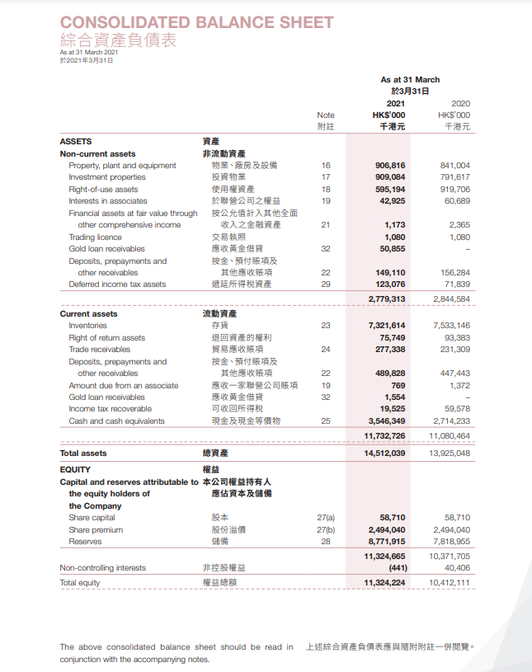
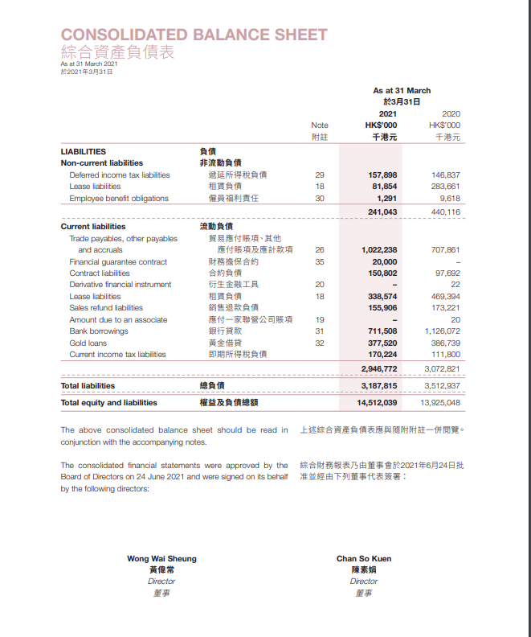

- Luk Fook’s Income Statement 2019
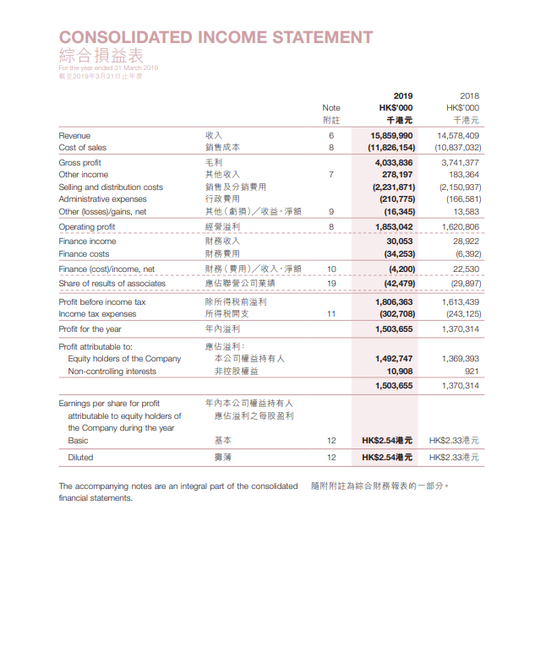
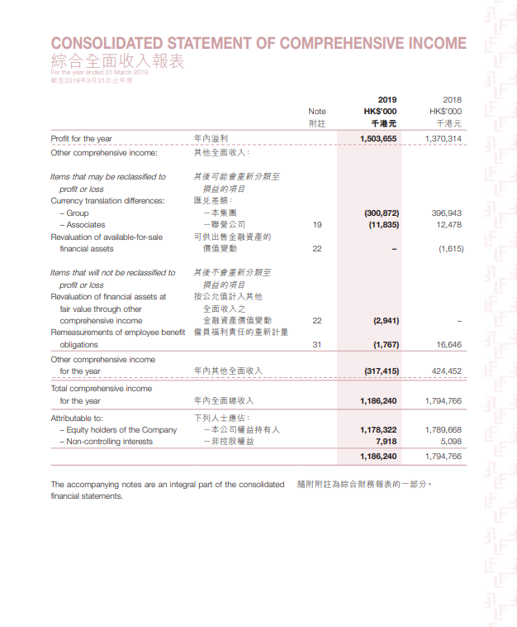

- Luk Fook’s Income Statement 2020
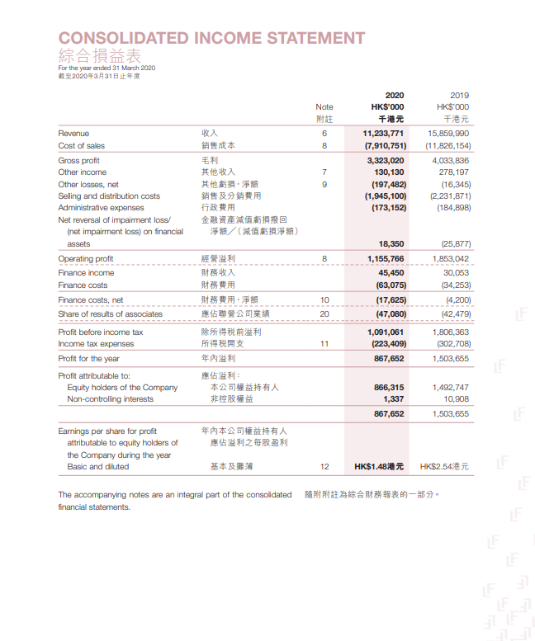
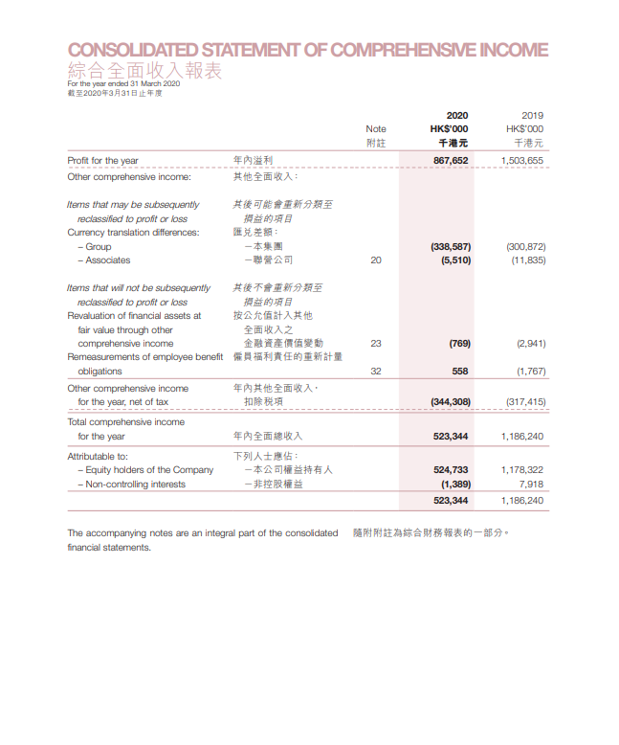

- Luk Fook’s Income Statement 2021


