ACCB6017
Usability Engineering – Component 1 Technical Report

Name: Sanam Asghar

BSc Applied Computing - ID:2220567

Module Tutor: Nassir Ibrahim

Table of Contents
1. Introduction 2
2. Four Detailed Personas & Associated Scenario 2
Persona 1: — International Postgraduate Student (Business School) 2
Persona 2: — A Student with Visual Impairment (Computing and IT) 2
Persona 3: — Neurodiverse Student (ADHD) 3
Persona 4: — Mature / Part-time Student 3
User Research and Requirement Gathering 4
MoSCoW Prioritization of User and Experience Requirements 5
3. Usability Issues to be Addressed 5
3.1 Navigation and Learnability 5
3.2 Accessibility and Inclusivity 5
3.3 Feedback and Error Prevention 6
3.4 Consistency and Aesthetic Design 6
4. Initial Wireframe Storyboards 6
4.1 Overview of Storyboard Structure 6
4.2 Screen-by-Screen Description 7
1. Home / Login Screen 7
2. Character Selection Screen 7
3. Tutorial / Onboarding Screen 7
4. Campus Map (Game Board) 8
5. Clue Interaction Screen 8
6. Evidence Notebook / Progress Screen 9
7. Settings / Accessibility Screen 9
8. Accusation & Result Screen 9
9. Game Summary / Feedback Screen 10
4.3 Visual Wireframe Mock-ups 11
Home / Login Screen 11
13
5. Feedback 13
6. Conclusion: 14
7. References: 15
Appendices 17
Appendix A – MoSCoW Prioritisation Table: 17
Appendix B – User Research Materials 18
B1. Google Form / Questionnaire Example 18
Appendix C – Feedback Evidence 19
C1. Google Form Survey Summary 19
Appendix C – Participant consent form……………………………………………………………..20

1. Introduction
The Cluedo board game is one of the classic mystery-solving games that allows people to think, collaborate and deduce critically. In this report, we have introduced a digital adaptation titled “Who Killed the Vice-Chancellor?” , set in the University of Wales Trinity Saint David. The players explore virtual locations, uncover different clues, and question suspects in order to solve the mystery. The prototype is shaped by usability engineering and user-centred design principles, focusing on making the experience accessible, easy to use, and genuinely engaging for all players [1],[3] .In this report, we explain how user personas were created, key usability challenges were identified, and wireframe storyboards were developed. It also explains how feedback was gathered that will guide future improvements for design.

2. Four Detailed Personas & Associated Scenario
The user research process has been specially designed to reflect the diversity of students and staff at the UWTSD Swansea Campus [8] .In order to create realistic representations, we have developed four personas which are based on informal interviews, observations, and short surveys. Each persona highlights a different kind of user in terms of age, background, ability, and confidence with technology [15]. This ensures that the prototype design remains inclusive and user-centred.

Persona 1: International Postgraduate Student (Business School)
Age: 26
Background: Persona1 is an MSc Digital Marketing student from Pakistan. They are comfortable in using digital tools but are still adapting to academic English and the local learning environment. They have a moderate technical skill level.
Motivations: They enjoy structure, goal-oriented games that help them unwind while still giving a feeling of productivity. They value clear instructions and opportunities to connect with other students through similar experiences.
Frustrations: They get frustrated with overly complex game instructions or unclear objectives makes them lose interest quickly.
Key UX Requirements:
- Use of clear, simple language without jargon
- Step-by-step onboarding tutorial
- Visual cues alongside text instructions
- Progress indicators to maintain motivation

Persona 2: A Student with Visual Impairment (Computing and IT)
Age: 22
Background: Persona 2 is a Computer Science student who is partially sighted. They prefer to make use of a screen reader in order to navigate through digital platforms. They are extremely skilled with technology and test systems for accessibility and advanced technical skill level.
Motivations: They are passionate about inclusive designs and want to make use of their experiences to make digital platforms more accessible and user-friendly for everyone.
Frustrations: They get frustrated with games that lack screen reader compatibility, text size adjustments or keyboard controls, which make it nearly impossible to play the game.
Key UX Requirements:
- Full screen reader and keyboard navigation support (ARIA labels)
- Adjustable text size and high-contrast mode
- Clear focus order for navigation
- Optional audio descriptions for key events
Persona 3: Neurodiverse Student (ADHD)
Age: 19
Background: Persona 3 is a first-year Psychology student diagnosed with ADHD. They enjoy interactive and fast-paced games but find it extremely difficult to stay engaged with interfaces that are text-heavy or unstructured. They have a moderate technical skill level.
Motivations: They prefer games that are visually stimulating, provide immediate feedback, and allow them to make progress in short bursts.
Frustrations: They get frustrated with extremely long explanations, unclear instructions, and cluttered screens, which make it hard for them to stay focused.
Key UX Requirements:
- Step-by-step guided flow
- Minimal text per screen
- Visible reward and progress tracking
- Consistent colour coding to reduce cognitive load

Persona 4: Mature / Part-time Student
Age: 36
Background: Persona 4 is a part-time Education Studies student who is balancing both work and parenting. They mainly use a tablet for studying and prefer short, easy-to-learn games that they can play casually. Their technical skill level is moderate.
Motivations: They value simplicity, relaxation, and flexibility in games that fit in their busy schedule.
Frustrations: They get frustrated with overly complicated and long gameplay sessions further discourage them from engaging.
Key UX Requirements:
- Simple navigation for tablet users
- Quick loading and short session options
- Pause/resume functionality
- Accessible colour contrast for clarity

User Research and Requirement Gathering
In order to develop the above personas, we carried out a small-scale user research process. This helped us understand how different members of the university community interact with digital tools and what they expect from a muster game that’s based on the campus.
- Informal Interviews and Conversations:
We conducted brief informal discussions with seven participants [8],[16], which included five students and two staff members. They talked about the gaming habits, preferred devices, and accessibility needs. A lot of them emphasized that they enjoyed playing games that were easy to learn, visually clear, and could fit in the small-time frames in between academic commitments.
- Online Questionnaire via Google Forms
Another thing that we did was that we created a short Google Form and shared it in the campus chat groups in order to reach a wider audience[11]. The form included 5–7 questions about device preference, familiarity with digital games, accessibility needs, and what makes digital experiences engaging. The details of the Google Form is provided in Appendix B.
Example questions
1.What type of device do you usually play games on: mobile, tablet, or laptop
2.How important are accessibility features (e.g., font size adjustment, screen reader support)?
3. What keeps you most engaged in a digital game?
- Observation of Digital Behaviour:
We conducted casual observations while working in shared spaces such as the Learning Lounge and Business School labs. By watching how students used different platforms like Moodle and Teams, we were able to identify common usability frustrations [9] , mainly with unclear navigation and hidden features. This suggested the need for simple, user-friendly and consistent Ui layouts.[12]
From these combined methods, several consistent user needs were identified:
- Users preferred simple, structured, and visually appealing layouts with minimal text.
- Comprehensive tutorials and guided onboarding were considered extremely important.
- Accessibility and inclusivity were considered non-negotiable for some users, particularly by visually impaired and neurodiverse users.
- Flexibility, such as pause, resume features, appealed the people with busy schedules.
- Some users also showed interest in competitive elements like leaderboards that allowed healthy competition.

MoSCoW Prioritization of User and Experience Requirements
After identifying user requirements from the above methods, they were categorized using the MoSCoW prioritization method. This prioritization allows us to distinguish the essential features from the optional ones. A detailed list of user and experience requirements, prioritized using the MoSCoW method, is provided in Appendix A.
This research helped us in providing a practical understanding of the diverse user base at the UWTSD Swansea Campus. The combination of informal interviews, short questionnaires, and observation provided us with meaningful insights that informed both persona creation and interface requirements. The MoSCoW classification helps to ensure that early design stages prioritize usability and accessibility [10] before secondary features such as competition or personalisation are implemented.

3. Usability Issues to be Addressed
In order to design the digital version of UWTSD Cluedo, we had to balance entertainment with usability and accessibility. The aim was to ensure that a diverse community could enjoy it without confusion and frustration. The following section summarizes the main usability challenges that we had identified research and the strategies used to address them.

3.1 Navigation and Learnability
One of the most common issues we noted from feedback was the need for clear, simple navigation. Many users felt overwhelmed by complicated menus in other systems. To address this, this prototype follows the Nielsen’s principles of consistency and visibility of system status [4], ensuring that every screen feels familiar and easy to use [5].We also included a step-by-step tutorial at the beginning of the game, which aligns with the Schnederman's rule of offering informative feedback and reducing memory load [7]. Icons were paired with short labels, and the screens were kept clean and uncluttered to support users who find it difficult to navigate through dense interfaces.

3.2 Accessibility and Inclusivity
Accessibility was identified as one of the most important issues. To address this, the prototype includes adjustable text sizes, high-contrast themes, and keyboard navigation options for users who have any sort of impairment. It also supports screen reads through ARIA labels.
This design approach aligns with the Web Content Accessibility Guidelines (WCAG 2.1) and ISO 9241 standards [3] that emphasize designing for a wide range of abilities [20] . By keeping accessibility in consideration, this design allows users to tailor the experience to their personal needs.

3.3 Feedback and Error Prevention
Another usability challenge was the lack of feedback during game. Users mentioned that they wanted an interface that provides constant feedback. For example, color changes, small sounds, and confirmation messages that let players know when something has been completed successfully. This design aligns with Nielsen’s heuristic of visibility of system status [4] and Schneiderman's principle of informative feedback [7]. These elements increase the user confidence and reduce anxiety [6], particularly for less experienced players.

3.4 Consistency and Aesthetic Design
Visual consistency is also critical for reducing errors and enabling users to predict system behaviour. Our prototype maintains uniform fonts, icon styles, and spacing throughout. This supports Nielsen’s heuristic of consistency and standards [14]. We have sparingly used colour to differentiate clues, progress, and alerts. By keeping a minimalist wireframe style [9] ,[13], we keep the focus on usability and layout.
By addressing all of these usability issues early in the design process, our prototype builds a strong foundation for an interface that is inclusive, efficient, and engaging. The next step will involve creating an interactive version of the game and collecting further feedback to refine and improve the design before full development.

4. Initial Wireframe Storyboards
In this section, we present the early wireframe design for the UWTSD Cluedo prototype game. The purpose of these storyboards is to visualize the entire journey of the users through the game. At this point, the main thing that we have focused on is the structure and usability rather than the visual style and color.
The wireframes follow the principles of Nielsen’s usability heuristics and Schneiderman's Eight Golden Rules [5], while clarity, intuitive feedback, accessibility, and ease of use a priority [7].

4.1 Overview of Storyboard Structure
The storyboard follows the player's journey from the start of the game to the completion:
- Home / Login
- Character Selection
- Tutorial / Onboarding
- Campus Map
- Clue Interaction
- Notebook / Progress
- Settings / Accessibility
- Accusation & Result
- Game Summary / Feedback
We have created each of the wireframes at mobile screens while using a minimal layout grid to support a responsive design.

4.2 Screen-by-Screen Description

1. Home / Login Screen
Purpose:
This is the main entry point for users. They will be able to log in using the ID or play as guests.
Key Elements:
- Game title at top
- Two buttons: Login with UWTSD ID and Play as Guest.
- An accessibility icon that will allow you to manage settings.
Usability Focus:
The layout is simple and welcoming. It helps reduce any initial cognitive load that users might face and allows an easy onboarding process

2. Character Selection Screen
Purpose:
This screen allows players to choose a character that represents them, personalizing the experience.
Key Elements:
- It has six illustrated avatar placeholders representing different player roles
- “Continue” button is placed centrally to proceed.
Usability Focus:
This screen promotes engagement through light personalization and also has minimal text for readability.

3. Tutorial / Onboarding Screen
Purpose:
This screen guides the first-time players through a short interactive tutorial explaining the key steps and rules of the game.
Key Elements:
- It has sequential instruction slides that explain how to navigate the map, inspect clues, and use the notebook.
- Progress indicators (1/3, 2/3, 3/3) at the bottom.
- “Skip Tutorial” and “Start Game” buttons.
Usability Focus:
It promotes learnability and efficiency of use for first-time players and also helps reduce any initial confusion, particularly for users who have limited gaming experience.

4. Campus Map (Game Board)
Purpose:
This is the main interactive interface representing the Swansea Campus
Key Elements:
- Simplified top-down map with tappable building icons.
- Status bar at top showing collected clues, time elapsed, and player progress.
- Bottom navigation bar with icons: Map, Notebook, Settings, and Exit.
Usability Focus:
It has a consistent layout and large tap areas for accessibility. It also follows Nielsen’s “visibility of system status” [5] and Schneiderman's “strive for consistency.”[7]

5. Clue Interaction Screen
Purpose:
This is the most interactive part of the game where players examine locations for evidence.
Key Elements:
- It has a text box describing a clue
- Buttons: Inspect, Collect, and Skip.
- A placeholder showing the clue.
- An audio icon for narration for accessibility.
Usability Focus:
It provides immediate feedback after an action by a confirmation message or sound.
It also has a screen-reader-compatible design
The interaction is also kept short and focused.

6. Evidence Notebook / Progress Screen
Purpose:
This screen allows players to review collected clues and track suspects or locations.
Key Elements:
- Sections with Tabs: Clues, Suspects, Locations.
- Checkbox or icon system to mark clues as “confirmed” or “discarded.”
- “Summary” area showing progress percentage.
Usability Focus:
It reduces memory load by making information external (Schneiderman's Rule 6) [7].
It also enables players to review data without exiting gameplay, allowing clarity.

7. Settings / Accessibility Screen
Purpose:
This screen gives players control over accessibility and game experience preferences.
Key Elements:
- Toggle switches for Text Size, High Contrast Mode, Sound Narration, and Keyboard Controls.
- “Save” and “Back” buttons for navigation.
- Accessibility preview panel to preview settings before applying.
Usability Focus:
It supports universal design principles and ISO 9241-210 guidelines. [3]
It also allows players with impairments to personalize the interface before or during play.

8. Accusation & Result Screen
Purpose:
This screen helps conclude the game when the player makes their final guess.
Key Elements:
- Dropdown or icon lists of suspects, weapons, and locations.
- “Submit Accusation” button with confirmation prompt.
- Result panel showing whether the player was correct and a short storyline ending.
Usability Focus:
It allows confirmation before submission, which prevents accidental errors.
It gives immediate feedback to support closure and satisfaction.

9. Game Summary / Feedback Screen
Purpose:
This provides post-game feedback and allows players to reflect on their performance.
Key Elements:
- Summary table with all statistics
- “Play Again” and “Exit” buttons.
Usability Focus:
It supports satisfaction and evaluation of results.
It also encourages user reflection and allows developers to gather qualitative feedback for future design improvements.

4.3 Visual Wireframe Mock-ups
The wireframes showing the entire layout and structure of the app are shown below:
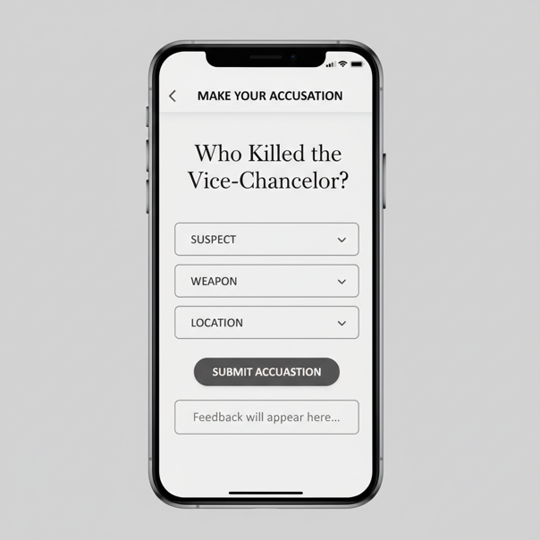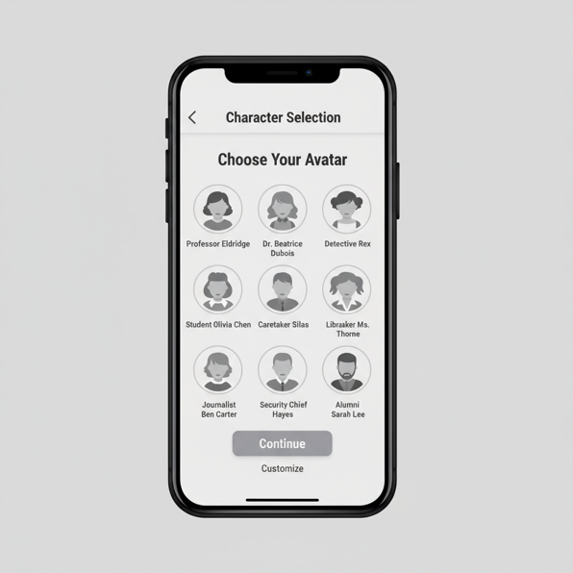

Home / Login Screen Character Selection Screen

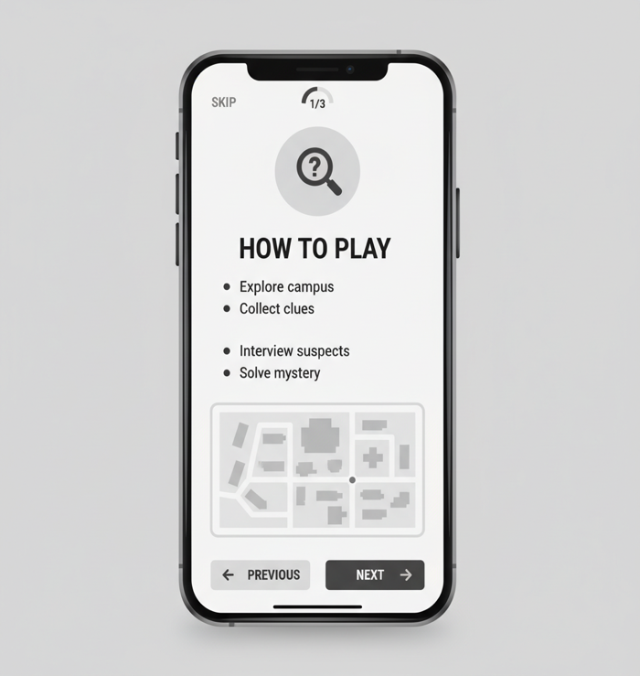

Tutorial Screen

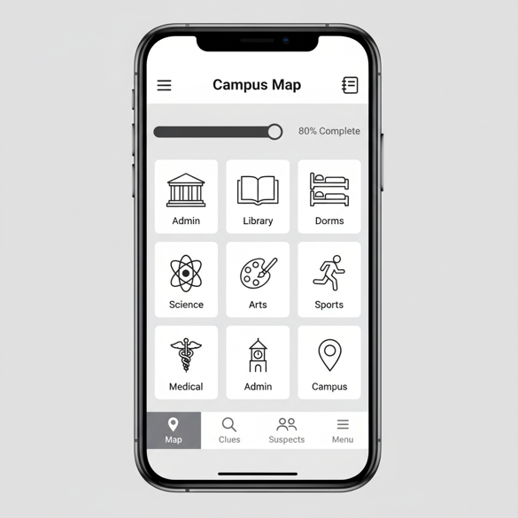

Campus Map Screen

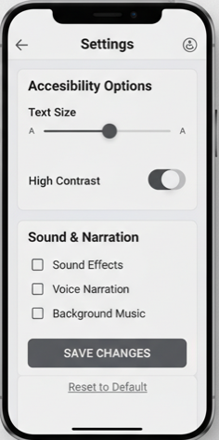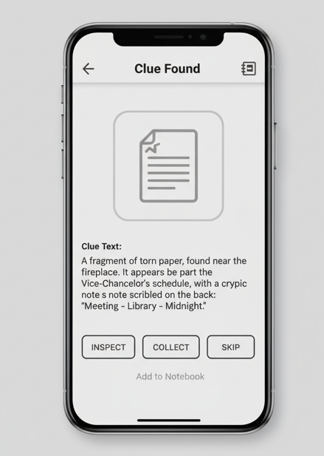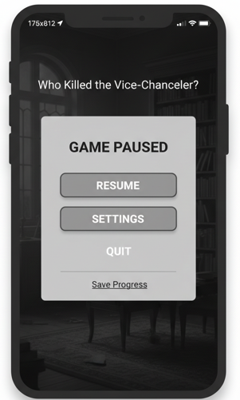

Settings Screen Clue Interaction Screen Pause/Menu Screen

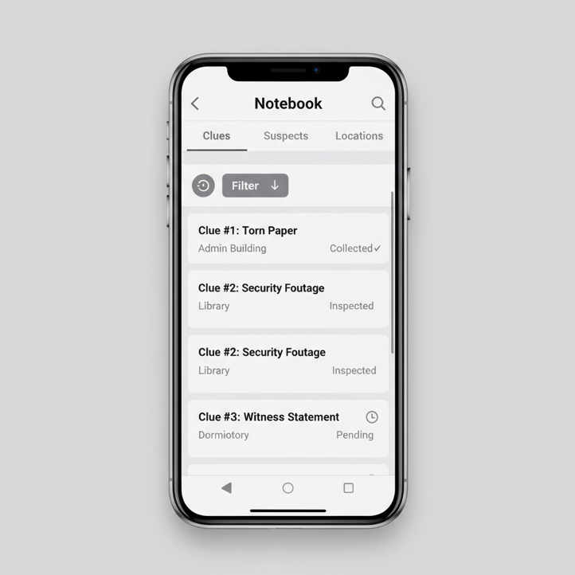

Notebook / Progress Screen
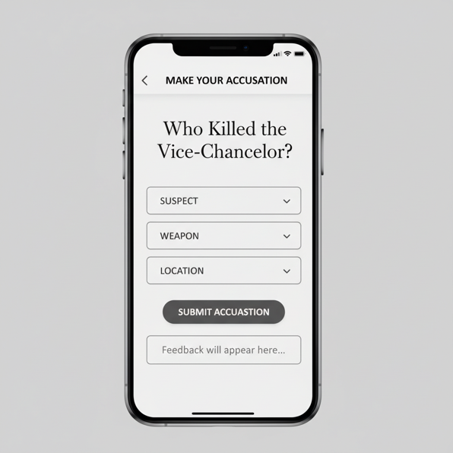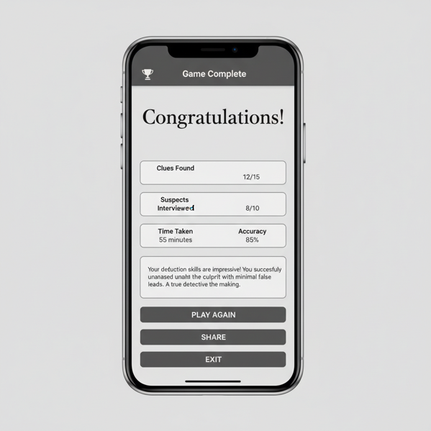

Accusation Screen Game Summary Screen

5. Feedback
Finally, to evaluate the effectiveness of the prototype “Who Killed the Vice-Chancellor?”, which we created, we collected feedback using a mixed-method approach [8] [16]. In this approach, we combined methods like informal usability testing, and a short Google Form Survey, and an observation session.
Five participants took part in it, and each of them represented the previously defined personas. an international postgraduate (Persona 1), a student with visual impairment (Persona 2), a neurodiverse undergraduate (Persona 3), and a mature part-time learner (Persona 4). During the session, they were shown on the wireframe storyboard screens and were asked to provide their feedback on them.
The overall feedback was pretty positive, and the participants were impressed by the clear navigation flow, logical progression between screens, and the strong alignment with accessibility principles. They also appreciated the inclusion of adjustable text and contrast modes and commented that the interface looks “simple but professional”. For Persona 2, the visually impaired student, the inclusion of screen-reader support and keyboard navigation felt particularly valuable. [19]
There were also some areas of improvement. The negative feedback included some comments about the limited visual variation between screens. Some participants also suggested that we should add clearer cues to increase interactivity.
The findings that we derived from the Google Form survey also reinforced these observations (see Appendix C). We saw that almost seventy-five percent of respondents said that the complicated navigation was their biggest frustration with digital games, and a similar percentage of people rated accessibility options such as adjustable font size and screen-reader support as “very important.” Almost half of the respondents said that they preferred sound or visual feedback to understand their progress. These results confirmed that the prototype’s focus on clarity, accessibility, and feedback directly addressed user priorities.[2] [6]

6. Conclusion
This project helped us demonstrate how a user-centred design and usability engineering principles can be applied, in order to create an inclusive and engaging app [1],[3]. Through research methods such as surveys, interviews, and observations, we were able to identify diverse user needs that helped us design the prototype[8],[10]. By making use of a framework, like the MoSCoW prioritization method, we made sure that accessibility, clarity, and feedback were treated as core features rather than optional ones [18]
The evaluation helped us capture a broad range of perspectives and responses across users. Most of the participants gave a positive review about the prototype, in which the. Moving forward, in the next phase, we will focus on developing an interactive prototype to test real-time behavior by adding audio narration for accessibility and incorporating more dynamic visual elements to enhance engagement [2],[6].

7. References
[1] Dix, A., Finlay, J., Abowd, G. and Beale, R. (2004) Human–Computer Interaction. 3rd edn. Harlow: Pearson Education.
[2] Hassenzahl, M. (2010) Experience Design: Technology for All the Right Reasons. San Rafael, CA: Morgan & Claypool.
[3] ISO 9241-210:2019. Ergonomics of human-system interaction – Human-centred design for interactive systems. Geneva: International Organization for Standardization.
[4] Nielsen, J. (1994) Usability Engineering. Boston: Academic Press.
[5] Nielsen, J. (1995) 10 Usability Heuristics for User Interface Design. Nielsen Norman Group. Available at: https://www.nngroup.com/articles/ten-usability-heuristics/
[6] Norman, D.A. (2013) The Design of Everyday Things. Revised and expanded edn. New York: Basic Books.
[7] Shneiderman, B., Plaisant, C., Cohen, M., Jacobs, S., Elmqvist, N. and Diakopoulos, N. (2016) Designing the User Interface: Strategies for Effective Human-Computer Interaction. 6th edn. Boston: Pearson.
[8] Lazar, J., Feng, J.H. and Hochheiser, H. (2017) Research Methods in Human-Computer Interaction. 2nd edn. Cambridge, MA: Morgan Kaufmann.
[9] Preece, J., Rogers, Y. and Sharp, H. (2019) Interaction Design: Beyond Human–Computer Interaction. 5th edn. Hoboken, NJ: Wiley.
[10] Sutcliffe, A. (2002) User-Centred Requirements Engineering. London: Springer.
[11] Tullis, T. and Albert, W. (2013) Measuring the User Experience: Collecting, Analyzing, and Presenting Usability Metrics.2nd edn. Waltham, MA: Morgan Kaufmann.
[12] Garrett, J.J. (2011) The Elements of User Experience: User-Centered Design for the Web and Beyond. 2nd edn. Berkeley, CA: New Riders.
[13] Sharp, H., Rogers, Y. and Preece, J. (2007) Interaction Design: Beyond Human-Computer Interaction. 2nd edn. Chichester: Wiley.
[14] Cooper, A., Reimann, R., Cronin, D. and Noessel, C. (2014) About Face: The Essentials of Interaction Design. 4th edn. Indianapolis: Wiley.
[15] Carroll, J.M. (2000) Making Use: Scenario-Based Design of Human-Computer Interactions. Cambridge, MA: MIT Press.
[16] Rubin, J. and Chisnell, D. (2008) Handbook of Usability Testing: How to Plan, Design, and Conduct Effective Tests. 2nd edn. Indianapolis: Wiley.
[17] Rogers, Y., Sharp, H. and Preece, J. (2011) Interaction Design: Beyond Human–Computer Interaction. 3rd edn. Chichester: Wiley.
[18] Bevan, N. (2009) ‘Extending quality in use to provide a framework for usability measurement.’ Human Centered Design, 5619, pp.13–22.
[19 Zimmerman, J., Forlizzi, J. and Evenson, S. (2007) ‘Research through design as a method for interaction design research in HCI.’ Proceedings of the SIGCHI Conference on Human Factors in Computing Systems, pp.493–502.
[20] World Wide Web Consortium (W3C) (2018) Web Content Accessibility Guidelines (WCAG) 2.1. Available at: https://www.w3.org/TR/WCAG21/

Appendices

Appendix A – MoSCoW Prioritization Table:

Category | User/Experience Requirement | Rationale (Linked Persona or Finding) | Priority
Usability & Navigation | Simple, clearly labelled menus and intuitive navigation | Needed for users with moderate digital literacy such as Persona 4 and Persona 1 to ensure clarity and ease of use. | Must Have
 | Step-by-step onboarding and rule explanation | Favored by Persona 1 and Persona 3, supports learnability and reduces confusion for new players. | Must Have
 | Fast, smooth interface responses | Enhances engagement and satisfaction for users such as Persona 3 who benefit from immediate feedback. | Should Have
Accessibility | High contrast and adjustable text size | Essential for visually impaired users like Persona 2 and beneficial for mature learners such as Persona 4. | Must Have
 | Keyboard and screen reader compatibility | Crucial for accessibility compliance and usability for Persona 2. | Must Have
 | Audio descriptions and sound cues for events | Supports multimodal interaction for Persona 2 and enhances engagement for Persona 3. | Should Have
Engagement & Motivation | Progress indicators and reward feedback | Keeps users like Persona 3 motivated and provides structure for Persona 1 during gameplay. | Should Have
 | Optional multiplayer or leaderboard | Adds competition and collaboration opportunities for socially motivated users like Persona 1. | Could Have
 | Extended storyline or campus lore | Provides narrative depth and replay ability but is not essential for usability. | Could Have
Device & Context | Mobile-first interface with optional desktop access | Reflects observed device preferences of UWTSD students and staff; supports Persona 4’s flexible learning style. | Must Have
 | Pause/resume option for short sessions | Important for part-time students like Persona 4 who may need to stop and continue later. | Should Have
 | Offline play mode | Convenient for users with inconsistent connectivity, though not critical for early prototypes. | Could Have
Aesthetics & Feedback | Consistent icons, colours, and visual hierarchy | Improves clarity and reduces cognitive load for all user types, particularly Persona 3. | Must Have
 | Clear feedback messages and pop-ups | Ensures transparency and user confidence, benefiting Persona 4 and Persona 1. | Must Have
 | Avatar or character personalization | Enhances enjoyment but is non-essential for functionality. | Won’t Have (Initial Release)

Appendix B – User Research Materials

B1. Google Form / Questionnaire Example

Google Form Questionnaire
Title: UWTSD Cluedo Prototype – User Experience Research Questionnaire
Purpose:
The questionnaire was designed to gather feedback from students and staff at the University of Wales Trinity Saint David (UWTSD) about their gaming habits, accessibility preferences, and expectations from a campus-based mystery game. The responses were used to inform the creation of realistic user personas and identify usability priorities for the prototype design.
Distribution:
The form was shared through university group chats and online study spaces to reach a diverse range of participants, including international students, mature learners, and individuals with accessibility needs.

Sample Questions:
- What device do you usually play games on? (Mobile / Tablet / Laptop / Console)
- How often do you play digital games? (Daily / Weekly / Rarely / Never)
- What makes a game engaging for you? (e.g., Storyline, Visuals, Rewards, Simplicity)
- How important are accessibility features such as adjustable text size or screen reader support? (1 = Not important, 5 = Very important)
- What frustrates you most in digital games? (e.g., Complicated menus, Poor feedback, No accessibility options)
- What type of feedback helps you stay motivated? (Sound / Visual / Text / None)
- Do you prefer short, structured tasks or long, exploratory gameplay? (Multiple choice)
Link: Click here to open the Google Form

Appendix C – Feedback Evidence

C1. Google Form Survey Summary
Responses:
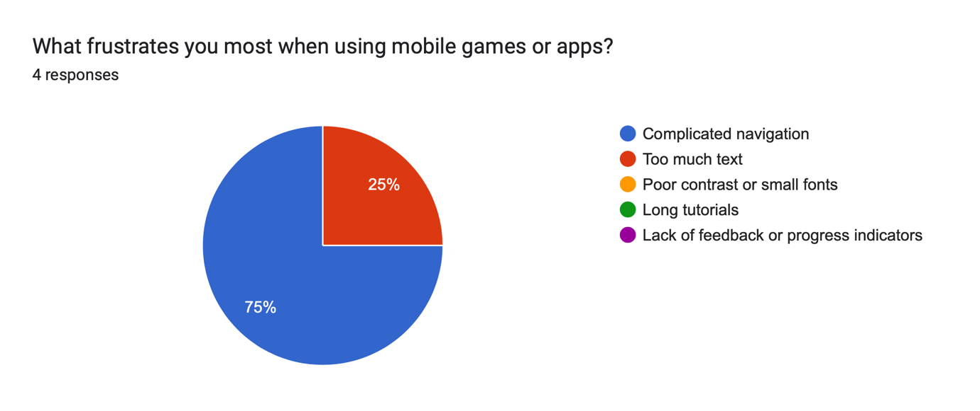
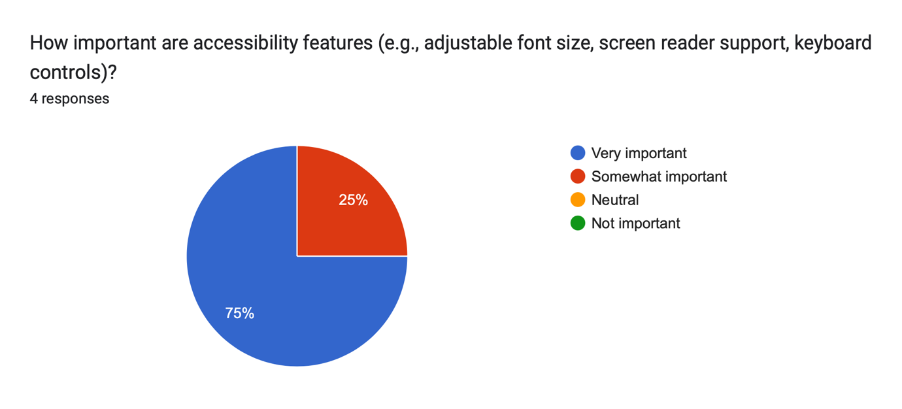
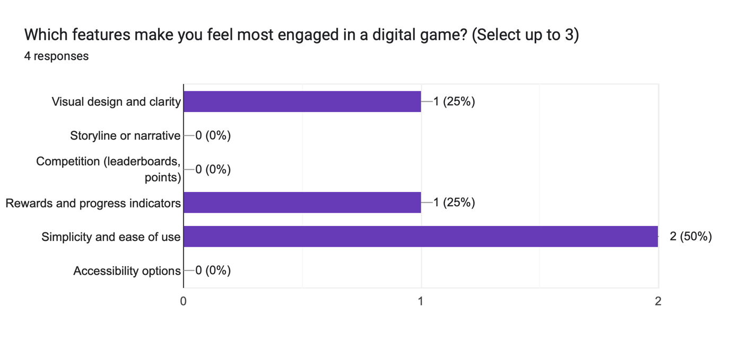
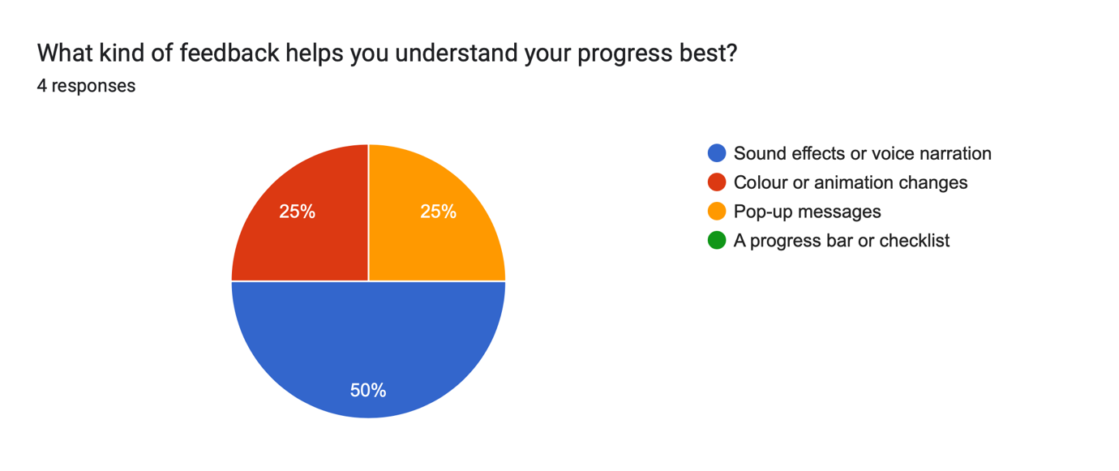
Appendix C – Participant Consent Form
University of Wales Trinity Saint David (UWTSD)
Participant Consent Form
Project Title: | Usability Engineering, User Requirements in the Cluedo Game – Mobile App Development
Researcher Name & ID: | Sanam Asghar - 2220567
Student Email: | 2220567@student.uwtsd.ac.uk
Course/Module: | BSc Applied Computing / Usability Engineering Module
Supervisor: | Nassir Ibrahim

The Study’s Goal
The purpose of this study is to determine and evaluate user needs for the creation of a mobile Cluedo Game Board application. The data gathered will only be utilized for academic purposes in order to enhance functionality recommendations and user experience design.

Statement of Participant Consent
Researcher’s Name: | Sanam Asghar
Signature: | __________________________
Date: | ___________________________
To indicate your agreement, please carefully read the following declarations and sign them:
- I certify that I have read and comprehended the study's information.
- I have received the chance to learn more about my involvement in the study and ask questions.
- I am aware that participation is completely voluntary and that I may stop at any moment before the data is anonymized, without penalty or explanation.
- I am aware that my answers will be kept private, anonymous, and used exclusively for scholarly study.
- I am aware that the information gathered might be used in publications, reports, or presentations, but that my identity will not be disclosed.
- I provide permission for the final project report and any associated appendices to use my anonymized data.
Name (please print): | _________________________________________
Signature: | _________________________________________
Date: | ___________________________
Researcher Declaration
I confirm that I have explained the purpose of the study, and the participants have freely given their consent.

Notice of Data Protection
All information gathered will be safely stored in compliance with the UK Data Protection Act (2018) and the University of Wales Trinity Saint David’s Data Protection Policy. The anonymized data will only be accessible to the supervisor and researcher.

