Table of Contents
1 Introduction 2
1.1 Rationale for research 2
1.2 Aims and Objectives 2
1.3 Background 2
2. Research methodology 4
2.1 Research philosophy 4
2.2 Research approaches 4
2.3 Research strategy 4
2.4 Research choices 5
2.5 Time horizons 5
2.6 Sample 5
2.7 Data collection and analysis 5
2.8 Limitations of research 5
2.8.1 Time management and sample 6
2.8.2 Ethical consideration 6
3. Reliability and validity 6
4. Resource planning 6
4.1 Gantt Chart 6
4. References. 6

INVESTIGATING THE INFLUENCE OF SOCIAL NETWORKING SITES ON TOURISTS’ DECISION TO TRAVEL RESPONSIBLY

1 Introduction
The purpose of this research proposal is to examine the power of social networking sites like Instagram and establish the influence upon people’s decision to travel responsibly. The word responsible is key to determine whether an individual’s conscious will have impact on travelling in a more responsible way. Consumers are influenced in their decision-making processes by many internal and external motivators and determents when they choose a product (Swarbrooke & Horner, 1999). Today, Social networking can be the leading factor of this process therefore gives purpose to investigate this issue further.

Rationale for research
While there have been numerous studies regarding social media as a travel motive to destinations around the world, there are none specific to Instagram and responsible travel combined. If answers can be found to the promotion of responsible travel through Instagram the whole tourism industry would benefit from findings in this study.

1.2 Aims and Objectives
This main aim of this study is to investigate traveller motivations and determine the influence social networking sites can have upon an individual’s decision to travel responsibly to a specific destination. Using Instagram as a case study will give current insight on this phenomenon.
- To determine whether social networking can encourage an individual’s decision to travel responsibly
The objectives created will assist answering the main aim by ensuring the research found is methodical and relevant.
- Explore responsible tourism further to gain better knowledge and understanding.
- Create primary research to understand tourist behaviour and reasoning behind the decision to travel responsibly.
- Examine the importance and power of social networking for responsible tourism purposes.

1.3 Background
Tourism is a complex industry which received a worldwide record of 1,323 million of international arrivals last year (UNWTO, 2017). While the rising economy growth is beneficial to the industry, immense strain is left upon the natural environment and its resources, where host communities tend to experience instantaneous inflation across society. Over recent years, tourism has led to cultural misunderstanding, destruction of natural milieus and overdevelopment. The industry now wants tourism to be more sustainable and encourages tourists to think more ethically whilst travelling.
Responsible tourism is simply taking responsibility associated with travel activities. (Goodwin, 2011) defines the ambition to “address the impacts of mainstream tourism to enhance the positive and reduce the negative”. This incorporates ethical concern in economic, socio – cultural and environmental issues. Members of the Italian association of responsible tourism state “responsible tourism actuates to foster a positive interaction between the tourist industry, the local communities and the travellers” (AITR, 2005). The United Nations asserted “Human beings are at the centre of concern for sustainable development” for thus the precise development needs to be fulfilled for the needs of present and future generations (Nations, 1992). The involvement of government and industry professionals to participate alongside locals and tourists to actively be aware of travel effects. It Is Imperative that the industry promotes and take action accordingly to develop and preserve diversity of the world. Often, ‘responsible tourism’ is a buzzword used by businesses whom exploit the term to boost financial gain.
The definition of motivation is “desire to do; interest or drive” (Anon., 2018). Application of this definition to travel concludes the driving force behind tourist behaviour as stated by (Crompton, 1979). Tourist behaviours are directly contributed to issues in tourism such as globalisation. Tourists are extremely concerned with own experiences and maximising each one. The majority of tourism academics base theoretical analysis on Maslow’s hierarchy of needs. Maslow states all human needs are categorised into 5 sections. Physiological needs, the needs of safety are followed by love and belonging, esteem and self-actualisation (Maslow, 1943). This theory, originally designed for psychology assessment is applicable to the tourism industry.
Travellers are becoming more mindful thanks to social networking platforms highlighting the importance of responsible tourism. (Beal, 2018) defines social networking as “any site that enables users to create public profiles and form relationships with other users”. Social networking is all about engagement with people joined by common interests. Such sites include Instagram, twitter and Facebook which have acted as a catalyst for traveller and local empowerment to interact across. “Instagram is a photo and video sharing social networking service” (Systrom & Krieger, 2018). After gaining instantaneous popularity since the launch in 2010, Instagram has over 500 million daily users. This platform is potentially the most influential component of the internet along with tourism and decision-making process of tourists. Modern travellers are more trusting of other traveller opinions often referred to as electronic word of mouth opposed to industry professional advisories. The rise of social sharing has resulted in social marketing holding significance in the decision making process. The sharing of experiences between users has created communities but also raised attention to vital social and environmental issues.

2. Research Methodology
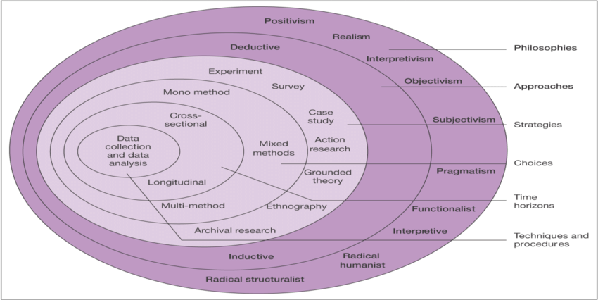
Research is a detailed investigation into a study to attain new information. Saunders et al state it as “something people undertake in order to find out things in a systematic way” in order to increase knowledge (Saunders, et al., 2009). Saunders believes this research process can be broken down into layers like an onion. The research onion model illustrates the steps covered when developing a research strategy (Saunders, et al., 2007). The steps will be discussed throughout based on figure 1.
Figure 1

2.1 Research Philosophy
The first step of research philosophy justifies the research needed to be undertaken. The positivism method emphasises that social reality is objective, and knowledge is based on natural wonders. The approach depends on scientific evidence to reveal how society operates often using existing theory to develop hypothesis during research process. (Collis & Hussey, 2009) believe that positivism is associated with quantitative methods of analysis.

2.2 Research Approaches
The next step will investigate deductive approaches where the three aims set will find an answer to the research question. From here the author will incorporate strategies of online surveys and paper questionnaires to generate rich and reliable statistical data.

2.3 Research Strategy
Sources of data collection can be classified into two categories; Primary and Secondary. Primary research will be obtained using an online questionnaire using survey monkey. A questionnaire is a useful instrument for collecting information from a wide source of people that is straightforward to analyse. To avoid bias the online questionnaire of 10 closed questions will be distributed to a variety of age groups across Instagram to my intended audience of social media users.
The distribution of paper questionnaires around university campus to students of Tourism management and Events faculties will compare against the online survey findings and ensure the number of respondents are met. Additional secondary data will come from information by government departments and further research previously collected before this study.

2.4 Research Choices
A monomethod research is where the study is grounded on a single research paradigm. In a quantitative study the data is in numerical form and generalises across groups of people to explain a phenomenon (Babbie, 2006).

2.5 Time Horizons
The time horizons are a framework intended for completion of the project. Cross sectional studies are designed to obtain research data in different contexts but over the same period. This measure can calculate behaviour of individuals and identify motive patterns between each traveller.

2.6 Sample
Sampling is a crucial element of research to retrieve stats from a smaller group of the total population. In a quantitative study, “the larger the sample, the better” (Cohen, et al., 2011). The author aims to measure findings obtained from the questionnaire by simple random sampling. The sample of 100 – 120 respondents minimum will act as a representation of the population which will provide greater reliability of adequate data return.

2.7 Data Collection and Analysis
Data collection is a process of gathering and measuring data collected in a systematic fashion. The data will be analysed through survey monkey software where data trends can provide insight of individual responses to the decision-making process of travellers.

2.8 Limitations of Research
All studies have limitations which can hinder the credibility of research found in terms of data collection. Therefore, the limitations identified in this study are deemed minor. Time constraints have been acknowledged as limited time may results in poor collection of data. Reliability of participants is key otherwise inadequate data will be collected from the questionnaires. There is possibility that online participants may distort opinions stated unlike face to face research. The sample can be weakened if participants decline to take part.

2.8.1 Time management and Sample
Time management is the ability to organise and manage work effectively. By using Microsoft excel to create a Gantt chart will allow scheduling of personal targets to be met throughout this project.

2.8.2 Ethical Consideration
It is imperative that ethical considerations are acknowledged in research through informed consent and voluntary participation. Upon releasing the questionnaire the participant will be aware that the right to withdraw at any time is acceptable and guaranteed confidentiality throughout. An ethics approval form will be completed and verified to ensure no potential harm or risks will be felt by the individual.

3. Reliability and Validity
Reliability is simply the consistency of a measure. (Cohen, et al., 2011) refers to this as a synonym for dependability, consistency and replicability. For research to be reliable it must demonstrate comparable results if it were to be carried out again by a similar group of respondents. Threats that can alter the results include error and bias from the respondent as well as the researcher.
Validity is a requirement for both quantitative and qualitative research. This concept is based on how accurately something is measured, which can be improved through careful sampling, suitable instrumentation and evading a range of threats to external validity. External validity is whether your sample is a true representative of the whole population.

4. Resource planning
The use of computer packages provided at the university library facilities and access to the online journal will help with resource planning. A range of secondary sources including governmental websites, travel statistics and information responsible tourism from tourist bodies i.e. Visit Britain and United Nations World Tourism Organisation and social networking statistical trends from Statista.com. The use of the Survey Monkey website will conduct primary research for results.

4.1 Gantt Chart
The use of a Gantt Chart provides a scheduled plan of this project whilst allocating a detailed timescale of a specified task and to track and update further progress. Using Microsoft excel allows ease when adjusting work tasks.
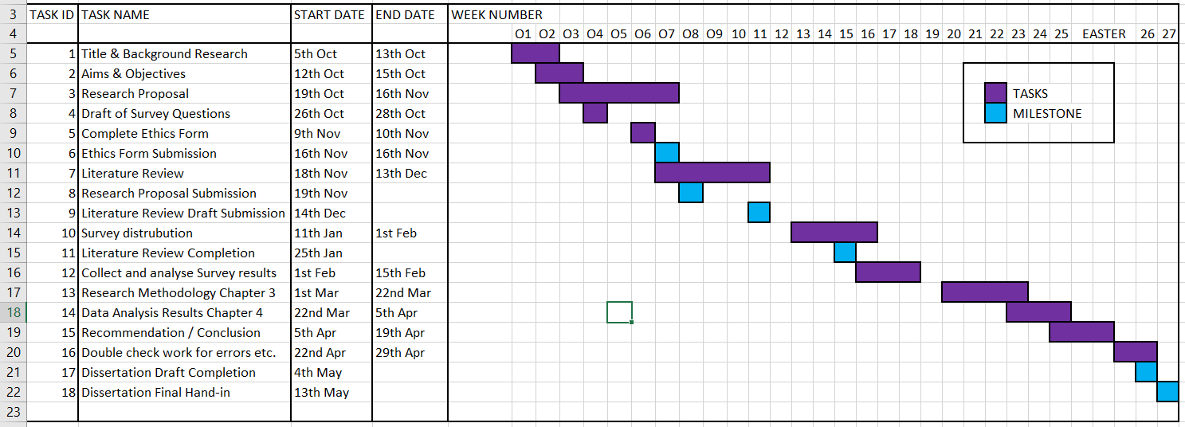

References.
Saunders, Lewis & Thornhill Research Methods for business students 4th edition 2007.
Saunders, Lewis & Thornhill Research Methods for business students 5th edition 2009
Swarbrooke and Horner Consumer behaviour in Tourism Butterworth-Heinemann 1999
Crompton, J Motivation for pleasure consumption 1972
Maslow, A A theory of human motivation 1943
Goodwin, H Taking responsibility for tourism good fellow publishers, Oxford UK 2011
Cohen, Manion & Morrison Research methods in education 7th edition 2011
Collis and Hussey Business research 3rd edition 2009
Babbie, E The practice of social research 12th edition 2006
UNWTO, 2017 United Nations world tourism organisation 2017 press release report accessed 22.10.2018 http://media.unwto.org/press-release/2018-01-15/2017-international-tourism-results-highest-seven-years
Nations, 1992 accessed 06.11.2018 http://www.unesco.org/education/pdf/RIO_E.PDF
AITR, 2005 accessed: 19.10.2018http://www.aitr.org/
Beal, 2018) Webopedia - Accessed 06.11.2018 https://www.webopedia.com/TERM/S/social_networking_site.html
Instagram, 2018 accessed: 06.11.2018 https://help.instagram.com/424737657584573
Collins, 2018 accessed 09.11.2018 https://www.collinsdictionary.com/dictionary/english/motivation

