Programme: | MSc Public Health and Social Care in Practice
Module: | Health Care System Organisation and Leadership
Module code: | LCHS7002
Assignment Title: | Case Study Analysis Report: Comparative report on COVID19 leadership responses
Lecturer: | Shephered Ziko
Student Name: | Mst. Sima Begum
Student ID: | 2433426


Executive Summary
Healthcare system architecture, leadership styles, and the balance between centralised and decentralised governance were the main areas of attention in this case study of Canada, South Korea, and Spain's COVID-19 solutions. Important personalities including South Korea's Prime Minister Chung Sye-kyun, Canada's Prime Minister Justin Trudeau, and Spain's Health Minister Salvador Illa exemplified striking variations in the nations' readiness, reaction time, and leadership styles. Despite a tardy reaction at first, Spain was able to attain high vaccine coverage in the end. Centralised crisis management was provided by South Korea's Korea Disease Control and Prevention Agency (KDCA), which excelled in testing and contact tracing. Although there were some initial hiccups with the vaccination introduction due to Canada's decentralised federal government, things eventually got better. This was because provincial and federal agencies had to work very closely together. South Korea's centralised system allowed for swift, coordinated action, but Canada's and Spain's decentralised systems depended on adaptive leadership to handle the complexity of jurisdictions. The study indicated that no singular governance model ensured success; instead, leadership adaptability, institutional preparedness, and the proficient utilisation of existing governance frameworks were essential in formulating successful pandemic responses.

Table of Contents
Executive Summary 2
1. Introduction 4
2. Critical Examination of Each Nation's Approach to the COVID-19 Pandemic 5
2.1 Spain 5
2.1.1 Spain's Healthcare System 5
2.1.2 COVID-19 Centralisation and Decentralisation Response in Spain 5
2.1.3 Advantages and Disadvantages of Spain's Response 7
2.2 South Korea 8
2.2.1 South Korea's Healthcare System 8
2.2.2 South Korea's COVID-19 Response 9
2.2.3 Advantages and Disadvantages of South Korea's Response 10
2.3 Canada 11
2.3.1 Canada's Healthcare System 11
2.3.2 Canada’s Decentralised Response to COVID-19 12
2.3.3 Advantages and Disadvantages of Canada's Response 14
3. Critical Analysis of the Leadership Styles Taken in Each Country 15
3.1 Leadership Styles in Spain 15
3.1.1 Initial Response and Leadership 15
3.1.2 Vaccination Program 16
3.1.3 Advantages and Disadvantages of Spain's Leadership Response 16
3.2 Leadership Style in South Korea 17
3.2.1 Proactive-transactional leadership 17
3.2.2. Advantages and Disadvantages of Leadership in South Korea 18
3.3 Leadership Style in Canada 19
3.3.1 Situational and Transformational leadership 19
3.3.2 Federated Challenges 20
3.3.3 Advantages and Disadvantages of Leadership in Canada 20
4. Conclusion 22
References 23

1. Introduction
There had never been a worldwide health crisis like the COVID-19 epidemic, which put a tremendous strain on healthcare institutions and governmental authorities alike. This study compared the health care systems and leadership styles of three countries: Canada, South Korea, and Spain, to see how they handled the problem. Different national reactions were shaped by different kinds of government, which might be either highly centralised or decentralised, and by the leadership styles of those in charge. The timing and efficacy of interventions were influenced by differences in institutional readiness, organisation, and political ideology.
Spain, under Health Minister Salvador Illa, achieved strong vaccination outcomes despite early delays and high infection rates. South Korea adopted a highly coordinated response through the KDCA, guided by Prime Minister Chung Sye-kyun, emphasising mass testing, digital contact tracing, and transparency. Canada, led by Prime Minister Justin Trudeau, managed the pandemic through a decentralised federal–provincial framework, requiring complex intergovernmental coordination.
The study highlights those centralised systems enable rapid, uniform decision-making, while decentralised systems support local flexibility but demand strong coordination mechanisms. Leadership approaches including transformational, transactional, and situational styles played a critical role in navigating uncertainty and aligning public health, social, and economic priorities. Overall, the analysis examines how healthcare system structures and leadership strategies influenced national crisis management capacity, identifying strengths and weaknesses in public health emergency governance.

2. Critical Examination of Each Nation's Approach to the COVID-19 Pandemic

2.1 Spain

2.1.1 Spain's Healthcare System
The Sistema Nacional de Salud (SNS) is Spain's national health system; it is almost universally covered, mostly supported by taxes, and most treatment is supplied by the public sector and is free of charge when delivered. Although people may purchase voluntary health insurance (VHI) on top of their public coverage, they cannot opt out of SNS coverage (European Observatory on Health Systems and Policies, 2024). 'Autonomous communities' are entrusted with health competencies, but the Ministry of Health oversees the SNS as a whole.
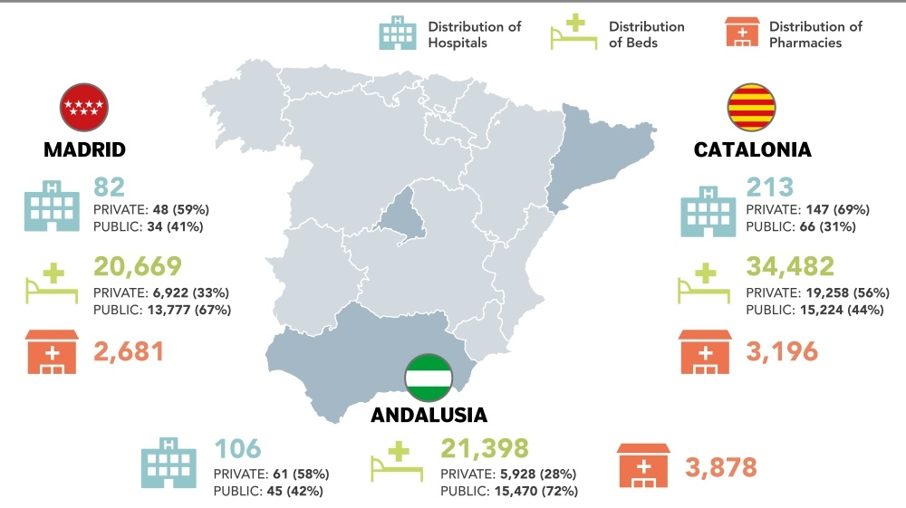
Figure 1: The Three Best Regional Healthcare Systems in Spain (Kun, 2021)
Public spending accounted for 71.7% of the overall health expenditure in 2021, continuing a trend of substantial increases in health expenditures relative to GDP that began with the 2020 COVID-19 pandemic (Júlia Spinardi et al., 2023).

2.1.2 COVID-19 Centralisation and Decentralisation Response in Spain
Managing the COVID-19 response in Spain required a delicate balancing act between decentralisation and centralisation, which was further emphasised by the four stages of the reaction. In the first phase, which lasted from January 2020 to March 13, 2020, responses were slow and disorganised. Despite being one of the first European nations struck, the Spanish government took its time to recognise the seriousness of the danger (Tuominen, Salminen and Halonen, 2022).
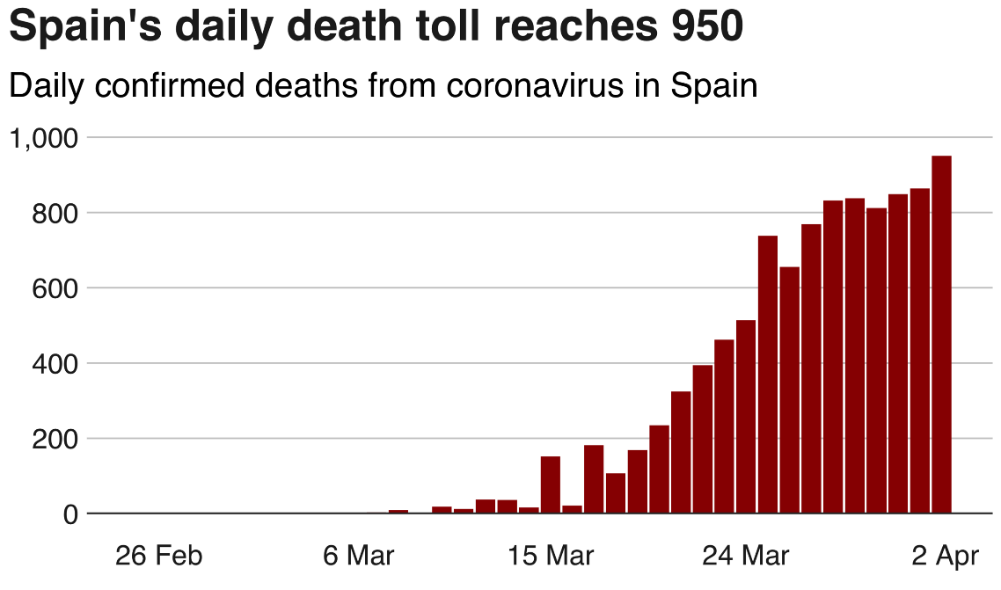
Figure 2: Spain’s Daily Death (BBC, 2020)
According to the health ministry, 950 more fatalities were recorded in the previous 24 hours, bringing the total number of deaths in Spain caused by the coronavirus, or COVID-19, to 10,033 (Tuominen, Salminen and Halonen, 2022). Consistent with earlier days, the number of confirmed cases increased from 102,136 on Wednesday to 110,238 an increase of 8% (García-Carretero et al., 2023).
"The system is ready to face this situation" was the first statement given by Health Minister Salvador Illa on January 30, however the administration failed to implement enough precautionary measures (Pool Moncloa, 2020). Officials' contradictory messages characterised the response. On February 28, Fernando Simón, director of the Centre for Coordination of Health Alerts, claimed that "in Spain there is no virus" (Erkoreka and Hernando‐Pérez, 2022), but as late as February 23, he recommended against social distancing measures. According to María Falcón et al. (2023), the government's lack of action was demonstrated when, despite deteriorating conditions in Italy throughout February, Spain took no measures to halt large-scale gatherings. On March 8, which was International Women's Day, over 120,000 people gathered for the mass protests in Madrid. Following the first state of alarm's deployment (on March 14, 2020), the second phase began, which established a command structure controlled by the central authority (Navarro Alonso and Limia Sánchez, 2022). Compared to the previous decentralised system, which abolished health sector autonomy for regions and handed Madrid control of important decisions, this was a huge shift. Up to June 20, 2020, a nationwide curfew, closed borders, and limitations on non-essential travel were all part of the lockdown state of panic.
Central and regional governments relinquished part of their authority related the pandemic management during the third stage, which took place from June 22, 2020, to October 24, 2020, and introduced a new normalcy and co-government model. This hybrid approach sought to integrate central planning with decentralised areas so that Autonomous Communities could gradually take back control of their own healthcare while still receiving support from the central government (Pool Moncloa, 2020). Beginning with the second wave of alarm (October 25, 2020–May 9, 2021), the fourth stage maintained a decentralised management paradigm. Unlike the first panic, this stage provided a legislative framework for enforcing restrictions like curfews and mobility restrictions while continuing to make choices on a local level (Prisa, 2022).

2.1.3 Advantages and Disadvantages of Spain's Response
Benefits
Decentralisation facilitated region-specific responses to viral dissemination and healthcare capability, its primary advantage. Certain Autonomous Communities exhibited superior performance compared to others, indicating that decentralised administration may be effective when adequately resourced and coordinated (Júlia Spinardi et al., 2023).
The adaptable approach enabled areas to address local epidemiological conditions and healthcare capabilities. For example, locations with fewer instances may maintain more lenient rules, while severely impacted areas such as Madrid may impose stricter measures (Dueñas et al., 2023).
Drawbacks
The flaws of Spain's decentralised plan were shown during the early phases of the pandemic. Crisis response was hindered due to a dilution of duties caused by a lack of collaboration between national and regional authorities (Héctor López-Mendoza et al., 2024). As a result of its twenty years of subordination to the Spanish government, the Ministry of Health was woefully unprepared to exercise centralised control when the time came.

2.2 South Korea

2.2.1 South Korea's Healthcare System
South Korea operates a universal single-payer National Health Insurance (NHI) system that provides coverage for all citizens.
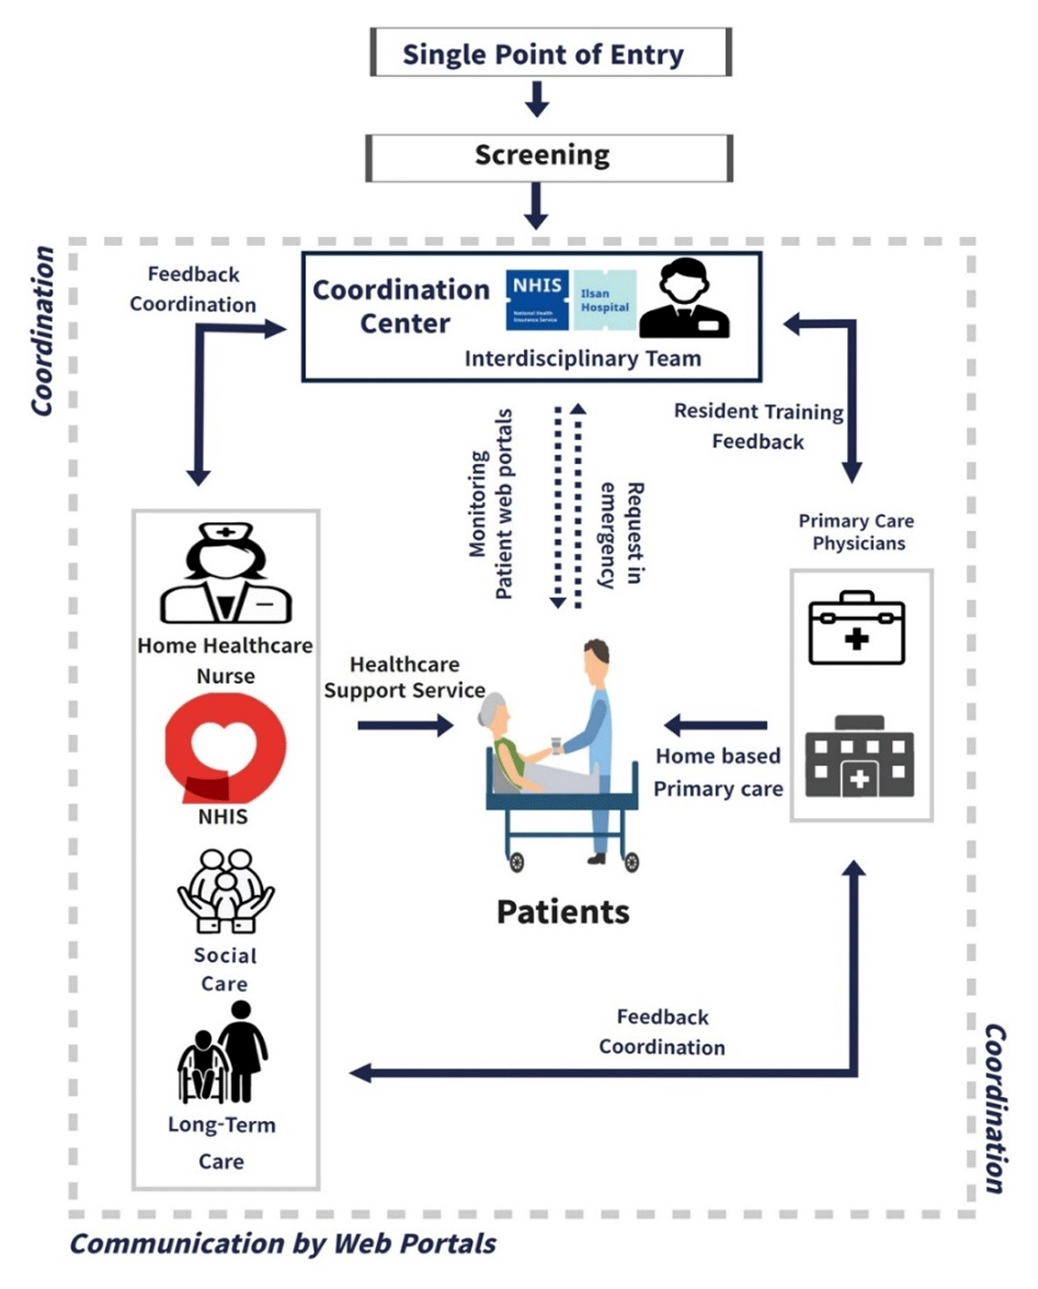
Figure 3: South Korean Patient-Centered Integrated Model of Home Health Care (Mun et al., 2023)
Established in 1989, the NHI ensures that all individuals, regardless of their income or employment status, have equal access to healthcare services by including all healthcare providers (Santoso et al., 2022). Significant central coordination and homogeneity characterise the system, in contrast to decentralised arrangements in other countries. In times of public health emergency, the KCDC (Korea Disease Control and Prevention Agency) keeps an eye on things. The KDCA was established in 2004 during the SARS pandemic and strengthened following the 2015 MERS pandemic. In 2020, during the COVID-19 pandemic, it became an independent government agency, indicating its increased responsibilities in national health security (Chu, 2025).

2.2.2 South Korea's COVID-19 Response
In contrast to the decentralised or federal systems seen in the West, the characteristic feature of Korean unitary politics, according to Kim (2020), is the concentration of authority at the federal level. Centralisation is the norm in Korea's public health system. Upon raising the COVID-19 crisis alert level to Level 4, Korea promptly established a centralised government entity in accordance with the IDCPA (Article 8.5) to manage the national crisis (June-Ho Kim, 2020).
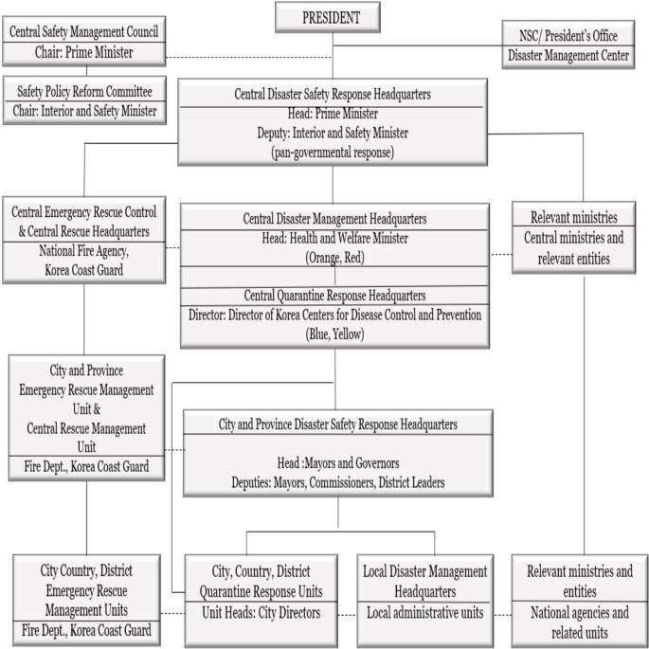
Figure 4: Crisis management and governance framework in Korea (Jennifer Mendoza, 2024)
It is the prime minister's responsibility to oversee the emergency management agency of the federal government. According to Shin Ae Hong (2024), the CDSHQ often met with national actors to discuss infectious disease control and prevention master plans and to provide suggestions for response methods. Some of the most important responsibilities highlighted by these response strategies are:
- Developing a system to improve the ability to respond quickly and accurately via epidemiological inquiry and monitoring (Ryu and Chung, 2021).
- Providing a groundwork for innovative studies in the treatment of infectious diseases.
- State and municipal governments should improve their testing opportunities and invest in cutting-edge diagnostic equipment.
After COVID-19 was identified as a highly infectious illness in Korea, the government instituted rigorous testing methods and conducted thorough contact tracing. As of April 9, it has effectively contained COVID-19 throughout the nation by testing 475,619 suspected cases; 17,858 of those cases (3.75%) were found to be positive (Ock Hyun-ju, 2020). Governments throughout the globe established COVID-19 surveillance systems that used digital technology including thermometers, smartwatches, contact monitoring software, and mobile phone geolocation (Lee and Choi, 2020). The Epidemic Investigation Support System reportedly collected and analysed massive amounts of COVID-19 data using the country's preexisting Smart City Data Hub urban monitoring systems (Shin Ae Hong, 2024).
Strong healthcare systems are able to manage the immediate crisis and provide critical medical services during a significant viral pandemic. Some 69 hospitals throughout the country will be converted into infectious disease centres with a budget of $31.6 million after a string of high-profile incidents (Kim, 2020). Cases were considered significant when individuals showed signs of dyspnoea, respiratory failure, or malfunction in many organs (Laura Bicker, 2021). Despite their apparent superiority in terms of diseases, South Korea lagged well behind in terms of vaccine procurement. The government initially depended on COVAX vaccine donations and signed contracts with vaccine makers later than other developed nations. Seijts et al. (2022) reports, however, that by taking cues from the strategies used by regional governments, the South Korean government managed to vaccinate over 80% of the population by the end of 2021.
The implementation of Korea's COVID-19 response was greatly enhanced by the active and strong involvement of the community. The efficient response to the pandemic was made possible by the generous contributions of many members of the community who selflessly shared their knowledge and fulfilled their duties (Steytler, 2022). The COVID-19 plan was made publicly available by the Korean government via online forums and public hearings (Kwon et al., 2020). The public's worries were addressed via community engagement and the development of new programs, such as the Public Mask App and Personal Safety Number.

2.2.3 Advantages and Disadvantages of South Korea's Response
Advantages
Rapid Decision-Making: According to Ohk Hyun-ju (2020), the KDCA was able to move quickly because to its central government authority, which let it to avoid bureaucratic hurdles. It instituted testing, tracking, and isolation procedures throughout the nation in a matter of weeks.
Communicating Effectively: After viewing the KDCA's frequent press conferences, people learnt to trust and follow their direction. There was no longer any room for confusion or speculation because of the emphasis on openness.
Technology-Based Streamlining: Centralised systems for tracking the spread of the pandemic and real-time data exchange meant that full countrywide lockdowns weren't necessary (Kim, 2020).
Disadvantages
Issues with Acquiring Vaccines: Compared to countries that pre-ordered vaccinations or engaged in decentralised negotiating, those with centralised control took longer to purchase vaccines (Kwon et al., 2020).
Concerns about Fairness: Despite the generally effective approach, the national plan failed to prevent some populations, such as undocumented migrants and rural residents, from undergoing testing or immunisation on time.

2.3 Canada

2.3.1 Canada's Healthcare System
The "13 different healthcare systems" of Canada symbolise the federal framework that allows provinces and territories to provide healthcare, making it one of the most decentralised healthcare systems in the world (Canada, 2020). While outlining national standards, the Canada Health Act gives provinces leeway in how they carry them out and oversee them.
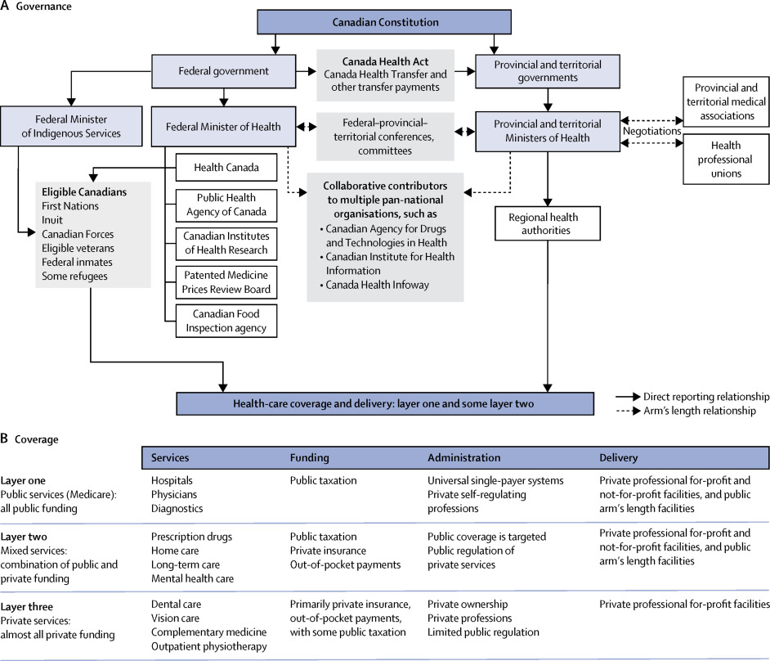
Figure 5: Overview of the Canadian health system (Martin et al., 2018)
Medicare is a collection of health insurance programs in Canada's provinces and territories that are subject to national standards. Every qualified Canadian may get free, essential medical and hospital care via these publicly supported, universal programs that are based on taxes (Government of Canada, 2020).
Medical care should be accessible to all Canadians based on their genuine medical requirements, not their ability to pay. This is a basic concept accepted by Canadians. This principle has endured despite the fact that it is bordered by the United States, which has the most expensive and uneven healthcare system among industrialised nations. Medicare is more than just a collection of public insurance plans (Desson et al., 2020) since over 90% of Canadians see it as an important source of national pride.

2.3.2 Canada’s Decentralised Response to COVID-19
The advantages and shortcomings of Canada's highly decentralised COVID-19 response were highlighted. Foreign borders and travel restrictions were given top priority by the federal government after the first case's detection in Toronto, Ontario on January 25, 2020. During the early stages of the outbreak, Prime Minister Justin Trudeau received daily reports from his house. Economic support programs like the Canada Emergency Response Benefit (CERB) were created by the federal government via the extraordinary use of its spending power, as pointed out by Detsky and Bogoch (2020).
The federal government-imposed travel restrictions, such as closing the borders to all but necessary travel and making all passengers undergo mandatory quarantine (Canada, 2017). When and how severe lockdowns, school closures, and mask requirements were eventually decided upon by provincial governments. British Columbia adopted a strategy centred on consistent messaging and low case numbers established by early science, but Quebec and Ontario saw bigger outbreaks due in part to delayed lockdowns and issues in long-term care institutions (Caricom, 2020).
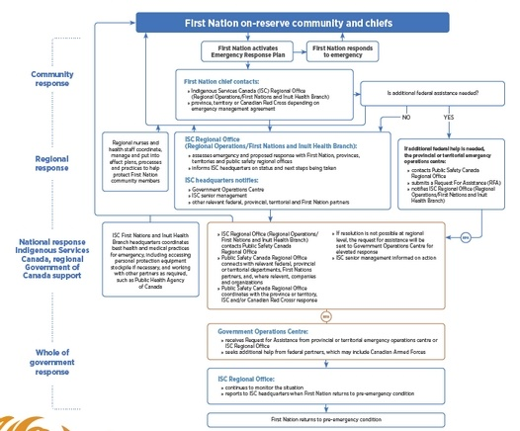
Figure 6: Covid-19 pandemic emergency response procedure (Government of Canada, 2020)
Due to their lack of centralisation, the nation's policies were all over the place. It was challenging to provide a cohesive national picture of the pandemic due to differences in data collecting and reporting and the fact that various provinces' Chief Medical Officers of Health presented distinct daily briefings (Combden et al., 2021). The federal government was tasked with procuring vaccinations via contracts with pharmaceutical businesses like Pfizer and Moderna. Each province received its allotment according to its population, and it was up to them to figure out how to normalise, roll out, and prioritise (Bigdeli et al., 2020). Alberta and Ontario predicated eligibility on age, whereas British Columbia's community-based strategy targets problem regions. Vaccine access became unequal during the early stages of the deployment due to these diverse tactics.
To aid provincial and territorial governments with policy, law, and regulation, PHAC published COVID-19 case descriptions and preliminary surveillance guidelines on February 10. This procedure included checking up on people's health, interviewing them at the provincial and territorial levels to see whether there were any links, and reporting instances to PHAC no later than 24 hours following national notice (Kun, 2021). Public health monitoring is only necessary on an as-needed basis for those in the high-risk group, whereas those in the lower-risk group were classified according to their exposure to risk. Over the first 100 administrations, which concluded on March 10, 11,023 tests were given in Canada, with a great deal of heterogeneity within the provinces and territories (Michelle Pratt, 2021).

2.3.3 Advantages and Disadvantages of Canada's Response
Advantages
The fundamental advantage of decentralisation was helping provinces adjust to local circumstances and preferences. Epidemiology, healthcare capability, and demographic factors may influence provincial responses (Desson et al., 2020).
Provincial "laboratories" for pandemic management techniques enabled policy innovation and learning. Other provinces might adopt successful policies, while failing ones could be adjusted or abandoned without impacting the country (Detsky and Bogoch, 2020). Other areas adopted Atlantic Canada's "bubble" model.
Disadvantages
The decentralised method in Canada has problems. The public was confused and public health initiatives may have suffered without national guidelines.
Complex jurisdictional structures impeded accountability and decision-making. During vaccine deployment delays, federal and provincial governments may conduct "blame games" instead of tackling issues (Canada, 2020).

3. Critical Analysis of the Leadership Styles Taken in Each Country
Low worker engagement, inadequate job satisfaction, and subpar service quality are common problems in the healthcare business. In spite of this, many healthcare service settings may greatly benefit from competent leadership.
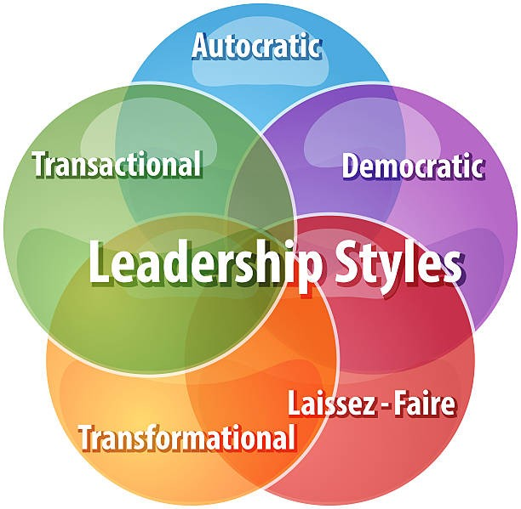
Figure 7: Leadership Framework (Alsarrani et al., 2021)
The start of the COVID-19 pandemic has made healthcare sector administration much more difficult.

3.1 Leadership Styles in Spain
An excellent example of leadership that changed in the face of adversity is Salvador Illa's work leading Spain's reaction to the COVID-19 pandemic. Based on his tenure as Spain's first health minister (January 2020–January 2021), Illa's leadership style was quite similar to that described in the theories of transformational and situational leadership (Seijts et al., 2022).

3.1.1 Initial Response and Leadership
Since Illa wanted people to believe in his authority, yet the system wasn't prepared to handle the problem, the leadership during the early stages of the pandemic may be described as reactive-transformational (Farhan, 2021). Preparation and system capability formed the basis of his opening comments, demonstrating how transformative leaders often project vision and promise preparation even when faced with uncertainty. Inadequate fundamental planning, however, led to Spain's delayed reaction and subsequent healthcare system overwhelmed, demonstrating the limits of inspiring message (Prisa, 2022). As the situation deteriorated for Illa, the shift to situational and adaptable leadership styles became apparent. He realised that the first attempts were inadequate, and that authorities reacted too slowly because they failed to see the enormity of the impending threat. This introspection exemplified the self-awareness and modesty that characterise good situational leaders, who adapt their leadership style in response to new information and shifting circumstances (Farid et al., 2024).
Typical of transactional leadership in times of crisis, Illa's style of leadership from March 2020 through June 2020 was marked by a heavy emphasis on directives (Jennifer Mendoza, 2024). The transactional concentration on defined responsibilities, expectations, and results also led to centralised decision-making, stringent lockdowns, and clear control chains. This was a necessary step in regaining control during the severe crisis, when strict adherence to public health regulations was essential.

3.1.2 Vaccination Program
The successful implementation of the vaccination campaign and the subsequent transition to co-governance in Spain demonstrated Illa's ability to utilise leadership concepts to transform the situation (Pool Moncloa, 2020). The aspect of transformational leaders concerned with inspiring their followers towards shared goals was on display in his emphasis on the cooperation of federal and state governments, streamlined communication, and a long-term view in rebuilding his nation following the pandemic (José Antonio Navarro-Alonso, 2025). To maximise efficiency, a hybrid model was developed, combining centralised decision-making with dispersed execution.
Illa shifted from an overconfident approach to communicating to one that was grounded on specific evidence-based statements. Secondly, in the framework of pandemic communication, his philosophical orientation which he personally associated with the formation of the principles of moderation, humility, self-control, and caution emerged (Navarro Alonso and Limia Sánchez, 2022). The situational leadership concept of adapting one's approach to the preparedness of one's followers and to emerging conditions (here, the population of the nation) was mirrored in this evolution (MIHAI, 2021).

3.1.3 Advantages and Disadvantages of Spain's Leadership Response
Advantages
As Illa demonstrated, adaptable leadership helped Spain accomplish its vaccine strategy. His capacity to learn from early errors, interact with local authorities, and rally support throughout recovery showed the effectiveness of situational leadership in long-term crisis management (Mun et al., 2023). Effective leadership adaptability to epidemic phases and needs helped Spain become a European vaccine leader (José Antonio Navarro-Alonso, 2025).
Disadvantages
Spain's tardy response and pandemic debacle showed its leadership flaws. Failure to synchronise leadership levels, cohabitation of official statements, and inability to incorporate countermeasures early suggested declining crisis readiness and leadership coordination (Héctor López-Mendoza et al., 2024). Transformational inspiration without operational preparedness failed to operate and resolve the initial problem.

3.2 Leadership Style in South Korea
As an example of proactive-transactional leadership with a high level of situational awareness and adaptive ability, Prime Minister Chung Sye-kyun led South Korea in reacting to COVID-19 (Bigdeli et al., 2020). Upon taking office in January 2020 roughly coinciding with the start of the pandemic Chung instituted a style of leadership that prioritised evidence-based decision-making, transparent communication, and process-oriented management (Ock Hyun-ju, 2020).

3.2.1 Proactive-transactional leadership
Practices demonstrated a significant emphasis on more systematic operations, clarity on expectations, and the extremely methodical reaction to the pandemic (Healey, 2017), suggesting that Chung's leadership style was really transactional in character. According to Mesu et al. (2015), the so-called "TTTIQ" strategy which stands for Testing, Tracing, Treatment, Isolation, and Quarantine was implemented as a result of transactional leadership, which emphasises detailed, sequential processes, performance objectives, and consequences for non-compliance. This methodical strategy provided defined criteria for evaluating response efficacy and enabled the application of the same solution on a national scale.
The prime minister's exceptional network managing skills, essential for crisis leadership, were on display in the way he coordinated and related with various government entities (Jennifer Mendoza, 2024). Chung demonstrated the collaborative character of his leadership style by establishing frequent connection with province administrations and organising online video sessions with local agencies. An advanced understanding of situational leadership was approaching in this blend of control and engagement. Since Chung identified openness, democracy, and transparency as the guiding principles for South Korea's prosperity, these concepts served as the basis for his communication strategy (Chu, 2025). Unlike the leaders of other nations, who communicated in a mixed bag, he consistently provided the public with evidence-based information in his daily briefings. According to Santoso et al. (2022), this approach demonstrated how transformational leadership shifted its emphasis to vision and inspire while maintaining the transactional base of clear expectations and feedback on performance.
Additionally, certain crisis occurrences, like as the Daegu epidemic in February-March 2020, are accompanied by adaptive situational leadership under the leadership of the Prime Minister. In response to the largest outbreak of its kind outside of China, the Chung government swiftly increased funding, imposed strict regulations, and coordinated efforts with local governments in an effort to contain the epidemic (Farid et al., 2024). This response demonstrated the situational leadership team's ability to accurately assess the situation and choose the most appropriate course of action.
Chung exhibited characteristics of transformational leadership by centring the pandemic response on continuous development and learning (Laura Bicker, 2021). He stressed again and again that the epidemic taught him humility and that adaptability was key to being an effective leader in the face of changing circumstances and evidence. With a focus on learning, South Korea was able to maintain its efficient response even as the epidemic developed and new challenges emerged.

3.2.2. Advantages and Disadvantages of Leadership in South Korea
Advantages
Chung's leadership paid off in South Korea's epidemic success. Systematic actions, efficient communication, and reactivity driven by flexibility helped the nation achieve low infection and fatality rates without large lockdowns across states (Lee and Choi, 2020). Mass testing, contact tracking, and healthcare system coordination are very difficult logistically, but the proactive-transactional strategy works well (Sreeramareddy and Sathyanarayana, 2013).
Crisis communications were also effective under Chung, who assured the public through unified, transparent messaging about problems and uncertainties and direct explanations of government actions and their rationale (Ryu and Chung, 2021). This communication method was crucial to ensuring societal health compliance without harsher enforcement.
Disadvantages
The centralised, process-oriented strategy has drawbacks such limited local adaptability and over-reliance on central decision-making. South Korea's small size and cultural homogeneity may have mitigated these difficulties, but bigger, more diversified nations needing higher local pandemic response variance may find the technique unsuitable (Shin Ae Hong, 2024).
Chung's leadership style worked because of his skills and South Korea's well-prepared public health system. Prior pandemic experience, response methods, and technical infrastructure helped competent leadership achieve extraordinary outcomes.

3.3 Leadership Style in Canada
Developing trustworthy connections with his colleagues is one way that the charismatic Prime Minister of Canada, Justin Trudeau, demonstrates his humanity. The Canadian federal government, which shares public health responsibilities with provincial administrations, created unique challenges for the pandemic response (Farhan, 2021). Through a combination of democratic and transformative leadership styles, Prime Minister Justin Trudeau deftly navigated these complexities. When the outbreak first broke out, Trudeau tried to assuage public anxiety and rebuild trust by taking a reassuring and calming attitude. He imposed a significant pressure on health experts and pushed for laws based on evidence, especially on Canada's Chief Public Health Officer, Dr. Theresa Tam.

3.3.1 Situational and Transformational leadership
There were many characteristics of situational leadership in Trudeau's style of leadership, as he adapted his strategy to meet the changing needs of his stakeholders and the evolving epidemic (Caricom, 2020). At the outset of the crisis, he acted with more assertiveness, closing international borders and coordinating federal emergency actions. As the pandemic progressed, he shifted to a more cooperative approach, prioritising collaboration between the federal government and provinces and ensuring that everyone was equally responsible for managing the outbreak (Marchildon et al., 2020).
In the early months of the epidemic, the prime minister's communication plan included holding daily briefings outside his mansion (Michelle Pratt, 2021). The ideas of transformational leadership were laid forth in these briefings, which included a future vision for Canada's recovery, a focus on helping others, and inspiring communication. His steadiness and composure in the face of uncertainty are the sources of the comfort and stability he brought to the Canadian people. The federal-provincial interactions that Trudeau oversaw helped the government deal with complex, multi-jurisdictional problems, demonstrating a great understanding of collective leadership knowledge (European Observatory on Health Systems and Policies, 2024). Instead, he tried to ensure that the provinces' reactions were more coordinated and that the federal government could provide assistance and resources as needed. This approach demonstrated an understanding of the need of leadership in decentralised systems relying on influence and collaboration rather than command and control.
Various crisis scenarios, such as the long-term care catastrophe and the issues with vaccine implementation, highlighted the Prime Minister's leadership style and its advantages and disadvantages (Combden et al., 2021). An example of situational leadership in action is the Trudeau government's use of federal resources, such as the backing of Canadian actors' forces, to alleviate strain on provincial institutions. The first vaccine distribution logistical challenges, however, revealed the organisational complexity of cross-jurisdictional operations over which actual implementation control was lacking (Desson et al., 2020).
The economic response to the epidemic by Trudeau demonstrated the power of transformational leadership to unite people in pursuit of common objectives. During the crisis, there was a vision for social solidarity and economic stability shown by the swift adoption of extraordinary economic assistance programs like CERB and salary subsidies (Detsky and Bogoch, 2020). These initiatives prioritised the common good above petty political manoeuvring and required substantial political capital to implement.

3.3.2 Federated Challenges
Running such a massive, decentralised federation has been difficult for Prime Minister Justin Trudeau, much like his country's response to the virus. The constitutional split between provincial and federal heads necessitated a careful balancing act between federal leadership and regional autonomy in healthcare (Steytler, 2022). Canada took its time to secure its borders, and there were initial issues getting vaccine doses.

3.3.3 Advantages and Disadvantages of Leadership in Canada
Advantages
Despite not having constitutional control over health problems, Trudeau was able to keep Canada together and coordinate solutions across varied provincial settings via his collaborative-situational strategy (Marchildon et al., 2020). He oversaw the federal pandemic response in a way that respected variety and authority at the provincial level.
Maintaining public confidence and complying with new public health requirements were both aided by Trudeau's communication abilities. Based on studies on pandemic leadership, Canadians had faith in him and thought he was successful because of his humility, transcendence, and integrity (Seijts et al., 2022). His ability to put himself in the people' shoes while keeping the group's objectives in mind was a hallmark of transformational leadership.
Disadvantages
The limitations of the collaborative strategy became obvious when prompt national action was required. The public was confused about their responsibilities and decision-making was delayed due to complex federal-provincial talks and coordination. Coordination problems and the shortcomings of influence-based leadership were on full display throughout the vaccination rollout, which may have benefited from direct authority (Michelle Pratt, 2021).
Pandemic accountability at the federal or provincial levels was a challenge for Trudeau's leadership because of Canada's fragmented structure. To maintain leadership's legitimacy while explaining jurisdictional obligations, complicated political communication was necessary (Farhan, 2021).

4. Conclusion
This comparative examination of the COVID-19 response in Canada, South Korea, and Spain highlights the need of adaptive leadership in pandemic management, namely the ability to capitalise on institutional strengths while addressing shortcomings. Leadership and system readiness are two factors that significantly impact the complex relationship between a healthcare organization's efficacy and competent leadership. Decentralised healthcare has both advantages and disadvantages, as shown in Spain. After initial coordination failed and unprepared leadership caused high rates of early mortality, vaccination in Spain showed promise of learning and adapting to the system. Salvador Illa's metamorphosis shows that changing leadership may promote the development of decentralised institutions. South Korea's experience shows that strong leadership can make centralised, well-prepared public health programs succeed. Quick reactions and voluntary obedience without lockdowns were made possible by Prime Minister Chung Sye-process Kyun's strategy to preventing COVID-19, which included well-developed infrastructure and open lines of communication. Pandemic experience and investments are difficult to replicate, but they were necessary for this accomplishment. Canadian Prime Minister Justin Trudeau's cooperative and flexible leadership helped manage issues in the country's highly decentralised structure. However, after early coordination issues that delayed some action, the federal economic assistance and the provincial innovation eventually formed a coordinated response.
Essential lessons include preparedness, adaptable leadership across many types, customised communication to cultivate trust, and the continuous growth of coordinating mechanisms. Prolonged crises necessitated continual learning and adaptability. Robust institutions and adaptable leadership are essential for applying governance concepts to unprecedented problems in pandemic management.

References
- Alsarrani, W.I., Jusoh, A., Alhaseri, A.A. and Almeharish, A. (2021). LITERATURE REVIEW STUDY OF THE RELATIONSHIP BETWEEN LEADERSHIP STYLE, LEADERSHIP BEHAVIOUR, AND LEADERSHIP TRAITS. Humanities & Social Sciences Reviews, [online] 9(4), pp.152–159. doi: https://doi.org/10.18510/hssr.2021.9422.
- BBC (2020). Coronavirus: More than 10,000 lives lost in Spain. [online] 2 Apr. Available at: https://www.bbc.com/news/world-europe-52131756.
- Bigdeli, M., Rouffy, B., Lane, B.D., Schmets, G. and Soucat, A. (2020). Health systems governance: the missing links. BMJ Global Health, 5(8), p.e002533. doi: https://doi.org/10.1136/bmjgh-2020-002533.
- Canada, G.A. (2017). Canada’s aid and development assistance in response to the COVID 19 pandemic. [online] GAC. Available at: https://www.international.gc.ca/world-monde/issues_development-enjeux_developpement/global_health-sante_mondiale/response_covid-19_reponse.aspx?lang=eng.
- Canada, P.H.A. of (2020). Government of Canada takes action on COVID-19. [online] aem. Available at: https://www.canada.ca/en/public-health/services/diseases/2019-novel-coronavirus-infection/canadas-reponse/government-canada-takes-action-covid-19.html.
- Caricom (2020). CARICOM Chair, PM Trudeau, discuss COVID-19 developments. [online] Caricom.org. Available at: https://caricom.org/caricom-chair-pm-trudeau-discuss-covid-19-developments/
- Chu, C. (2025). Effect of the establishment of the Korea Centers for Disease Control and Prevention/Korea Disease Control and Prevention Agency from the perspective of global health security. Global Health & Medicine. doi: https://doi.org/10.35772/ghm.2025.01015.
- Combden, S., Forward, A. and Sarkar, A. (2021). COVID‐19 Pandemic Responses of Canada and United States in First 6 months: a Comparative Analysis. The International Journal of Health Planning and Management, 37(1). doi: https://doi.org/10.1002/hpm.3323.
- Desson, Z., Weller, E., McMeekin, P. and Ammi, M. (2020). An analysis of the policy responses to the COVID-19 pandemic in France, Belgium, and Canada. Health Policy and Technology, [online] 9(4). doi: https://doi.org/10.1016/j.hlpt.2020.09.002.
- Detsky, A.S. and Bogoch, I.I. (2020). COVID-19 in Canada: Experience and Response. JAMA, [online] 324(8). doi: https://doi.org/10.1001/jama.2020.14033.
- Dueñas, A., Lucerón, C., Dueñas, A., Aurora, S., Cejudo, L., Conde, S., Gudino, E. and Pizarro, R. (2023). Lessons learnt from the vaccination strategy against covid-19 in spain. Population Medicine, 5(Supplement). doi: https://doi.org/10.18332/popmed/164349.
- Erkoreka, M. and Hernando‐Pérez, J. (2022). Decentralization: A handicap in fighting the COVID‐19 pandemic? The response of the regional governments in Spain. Public Administration and Development, 43(2). doi: https://doi.org/10.1002/pad.1988.
- European Observatory on Health Systems and Policies (2024). Spain: Health System Review 2024. [online] Who.int. Available at: https://eurohealthobservatory.who.int/publications/i/spain-health-system-review-2024.
- Farhan, B. (2021). A new strategic leadership model for surviving and coping: Lessons from Canada’s leadership approach to COVID-19. Cogent Business & Management, 8(1), p.1883221. doi: https://doi.org/10.1080/23311975.2021.1883221.
- Farid, A., Rahman, A., Islam, M.R. and Parvin, M. (2024). A study of the decentralised administrative arrangements between the central and local governments in Bangladesh during the COVID-19 pandemic crisis. Public Administration and Policy, 27(1), pp.58–72. doi: https://doi.org/10.1108/pap-08-2023-0108.
- Government of Canada (2020). Emergency response process during the COVID-19 pandemic. [online] Sac-isc.gc.ca. Available at: https://www.sac-isc.gc.ca/eng/1588704895842/1588705009996
- Healey, B. (2017). Principles of healthcare leadership. ACHE Learn.
- Héctor López-Mendoza, González-Álvarez, M.A. and Montañés, A. (2024). Assessing the effectiveness of international government responses to the COVID-19 pandemic. Economics & Human Biology, [online] 52, pp.101353–101353. doi: https://doi.org/10.1016/j.ehb.2024.101353.
- Jennifer Mendoza (2023). Topic: Coronavirus (COVID-19) in Spain. [online] Statista. Available at: https://www.statista.com/topics/6118/coronavirus-covid-19-outbreak-in-spain/#topicOverview.
- Jennifer Mendoza (2024). Spain: cumulative coronavirus cases, deaths and recoveries 2021. [online] Statista. Available at: https://www.statista.com/statistics/1109308/cumulative-coronavirus-cases-deaths-and-recoveries-in-spain/.
- José Antonio Navarro-Alonso (2025). Vaccination as a strategy to control SARS-CoV-2 pandemic. Vacunas (English Edition), [online] pp.500429–500429. doi: https://doi.org/10.1016/j.vacune.2025.500429.
- Júlia Spinardi, Carolina, A., Carballo, C., Thakkar, K., Nadine Al Akoury, Kyaw, M.H., Del, G., Srivastava, A. and Aurélio, M. (2023). Narrative Review of the Evolution of COVID-19 Vaccination Recommendations in Countries in Latin America, Africa and the Middle East, and Asia. Infectious Diseases and Therapy, 12(5), pp.1237–1264. doi: https://doi.org/10.1007/s40121-023-00804-2.
- June-Ho Kim (2020). South Korea. [online] exemplars.health. Available at: https://www.exemplars.health/emerging-topics/epidemic-preparedness-and-response/covid-19/south-korea.
- Kim, H. (2020). The sociopolitical context of the COVID-19 response in South Korea. BMJ Global Health, 5(5), p.e002714. doi: https://doi.org/10.1136/bmjgh-2020-002714.
- Kun, J. (2021). Spain’s Top Three Regional Healthcare Systems. [online] PharmaBoardroom. Available at: https://pharmaboardroom.com/articles/spains-top-three-regional-healthcare-systems/.
- Kwon, K.T., Ko, J.H., Shin, H., Sung, M. and Kim, J.Y. (2020). Drive-Through Screening Center for COVID-19: a Safe and Efficient Screening System against Massive Community Outbreak. Journal of Korean Medical Science, [online] 35(11), p.e123. doi: https://doi.org/10.3346/jkms.2020.35.e123.
- Laura Bicker (2021). South Korea coronavirus: PM aims for ‘herd immunity by autumn’. BBC News. [online] 23 Feb. Available at: https://www.bbc.com/news/world-asia-56156234.
- Lee, D. and Choi, B. (2020). Policies and innovations to battle Covid-19 – A Case study of South Korea. Health Policy and Technology, 9(4). doi: https://doi.org/10.1016/j.hlpt.2020.08.010.
- Marchildon, G.P., Allin, S. and Merkur, S. (2020). Canada: Health System Review. Health Systems in Transition, [online] 22(3), pp.1–194. Available at: https://www.researchgate.net/publication/345257495_Canada_Health_System_Review.
- María Falcón, Rodriguez-Blazquez, C., María Romay-Barja, Ayala, A., Burgos, A., de, J. and Maria João Forjaz (2023). COVID-19 vaccine hesitancy in Spain and associated factors. Frontiers in Public Health, 11. doi: https://doi.org/10.3389/fpubh.2023.1129079.
- Martin, D., Miller, A., Quesnel-Vallée, A., Caron, N., Vissandjée, B. and Marchildon, G. (2018). Canada’s universal health-care system: Achieving its potential. The Lancet, [online] 391(10131), pp.1718–1735. doi: https://doi.org/10.1016/S0140-6736(18)30181-8.
- Mesu, J., Sanders, K. and Riemsdijk, M. van (2015). Transformational leadership and organisational commitment in manufacturing and service small to medium-sized enterprises. Personnel Review, 44(6), pp.970–990. doi: https://doi.org/10.1108/pr-01-2014-0020.
- Michelle Pratt (2021). Perspective: COVID-19 vaccine distribution challenges in Canada and the United States. [online] HazNet. Available at: https://haznet.ca/perspective-covid-19-vaccine-distribution-challenges-canada-united-states/.
- MIHAI, L. (2021). Study Regarding the Leadership Styles Practiced in Catalan SMEs during the COVID-19 Pandemic. Journal of EU Research in Business, pp.1–24. doi: https://doi.org/10.5171/2021.414966.
- Mun, H., Cho, K., Lee, S., Choi, Y., Oh, S., Kim, Y.-S., Seo, M., Park, J.-Y. and Sung Bae Park (2023). Patient-Centered Integrated Model of Home Health Care Services in South Korea (PICS-K). International Journal of Integrated Care, [online] 23, pp.6–6. doi: https://doi.org/10.5334/ijic.6576.
- Navarro Alonso, J.A. and Limia Sánchez, A. (2022). Analysis of vaccination strategy against COVID-19 in Spain. The scientific basics (may 2022). Revista espanola de salud publica, [online] 96, p.e202209066. Available at: https://pubmed.ncbi.nlm.nih.gov/36073060/.
- Ock Hyun-ju (2020). Prime Minister Chung Sye-kyun gets tested for COVID-19 - The Korea Herald. [online] The Korea Herald. Available at: https://www.koreaherald.com/article/243085
- Pool Moncloa (2020). ‘The aim this week is to slow down COVID-19’, says Salvador Illa. [online] Lamoncloa.gob.es. Available at: https://www.lamoncloa.gob.es/lang/en/gobierno/news/Paginas/2020/20200406c19-slowdown.aspx.
- Prisa (2022). Spain’s health minister Salvador Illa and health experts meet to rethink post-COVID-19 healthcare | Prisa. [online] Prisa.com. Available at: https://www.prisa.com/en/noticias/noticias-1/spains-health-minister-salvador-illa-and-health-experts-meet-to-rethink-post-covid-19-healthcare.
- Ryu, S.-K. and Chung, S.-G. (2021). Korea’s Early COVID-19 Response: Findings and Implications. International Journal of Environmental Research and Public Health, 18(16), p.8316. doi: https://doi.org/10.3390/ijerph18168316.
- Santoso, N.R., Sulistyaningtyas, I.D. and Pratama, B.P. (2022). Transformational Leadership During the COVID-19 Pandemic: Strengthening Employee Engagement Through Internal Communication. Journal of Communication Inquiry, [online] 0(0), p.019685992210951. Available at: https://www.ncbi.nlm.nih.gov/pmc/articles/PMC9019500/.
- Seijts, G., de Clercy, C. and Miller, R. (2022). Character and Trust in Crisis Leadership: Probing the Relationships Among Character, Identification-Based Trust, and Perceptions of Effectiveness in Political Leadership During the COVID-19 Pandemic. The Journal of Applied Behavioral Science, 59(1), p.002188632211106. doi: https://doi.org/10.1177/00218863221110627.
- Shin Ae Hong (2024). Toward better pandemic governance and preparedness: South Korea’s whole-of-nation approach to COVID-19. BMC Public Health, [online] 24(1). doi: https://doi.org/10.1186/s12889-024-19655-8.
- Sreeramareddy, C.T. and Sathyanarayana, T. (2013). Decentralised versus centralised governance of health services. Cochrane Database of Systematic Reviews. doi: https://doi.org/10.1002/14651858.cd010830.
- Steytler, N.C. (2022). Comparative federalism and Covid-19: combating the pandemic. Abingdon, Oxon; New York, Ny: Routledge.
- Tuominen, T., Salminen, M. and Halonen, K.-M. (2022). The European Union’s responses to the COVID-19 crisis: How to fight a pandemic with the internal market. Maastricht Journal of European and Comparative Law, 29(4), pp.451–467. doi: https://doi.org/10.1177/1023263x221130182.

