ANALYSIS REPORT
COMMUNICATION & OPERATIONAL rEPORT

NAME:FLORIN CONSTANTIN NICA

STUDEN NUMBER:1815320

MODULE LECTURER’S NAME:JAHANZEEB QURASHI

2019

Part 2 A
The front office staff properly communicate with other departments of a hotel just like housekeeping, food and sales, marketing and sales, maintenance, human resources, and security departments. The front office is acting as a communicator in guest services because all guest who visits the hotel first communicate with the front office and also guest last communication point at the hotel is front office desk. Each department of the hotel has unique and different communication links with front office staff members. Department of hotels interacts with each other to perform daily tasks, to operate successfully communication is very important. Just like the market and sales department need help from the front office to get data on guest history, the front office desk provides detail concerning each guest's visit to the hotel. The front office gathers some information in zip code just like special needs, frequency of visit and reservation for sleeping room. It is the responsibility of the front office desk to make a good impression on the guest, provide detail to customers about hotel services and meet the needs and requests of hotel guests. The market and sales department get guest history from the front desk office, the guest's history information is valuable for the marketing and sales department they use this information for promotion of hotel, target market campaigns and to select specific advertising media.
The housekeeping department and front desk office communicate with each other to get information about housekeeping room status. The front office knows about the availability of room for urgent guest through this report. The housekeeping room status has different terms, just like if room available and ready then the room is ready to occupy. If occupied means the guests are already in the room. Stay over mean guest will not check out the room and not disturb guest on the current day. Dirty means the guest checking out the room but housekeeping staff did not release the room for other occupations. Out of order means the room is not ready for occupancy because of some mechanical default. So, the front office staff communicates with the housekeeping department to get room status report because of the front office reserve room for guests. The room status reporting is handled through face to face communication and not use PMS.
The front office communication with the food and beverage department is also very important. This communication gives accurate information on transfer, this information used to predict house count. It estimates the number of guests expecting based on previous activities information. This communication help food and beverage manager and hotel manager to meet the demand of the public. The supervisor of the food and beverage department relay on predicted house count information prepared by the front office manager, this information help food and beverage manager predicts sale and schedule employees of the hotel. The banquets department communicate with front office desk because this department relies on the front office for schedule event and bill payments. The banquet department combines the function of the food and beverage department and sale and marketing and sales department. That's why all departments of the hotel communicate with the front desk office because they rely on front office information to perform daily operations.

Communication Tools
Every industry has its way of communication and its own needs regarding internal and external communication. In the hospitality industry require more effective communication between the different department of a hotel to get the work completely done. The staff of the hotel needs communication tools that work perfectly inside and outside the hotel. There are many tools used in the hotel for communication these tools are listed below:

PMS
PMS stands for a property management system. It is a computerized system used in manufacturing, intellectual property, and hospitality accommodation management. hotel PMS is a comprehensive system that is used to cover objectives like front office operation, maintenance department, and sale department operations. It replaced the old manual system which is inefficient. With advanced cloud computing, the property management system expands its feature for hotel management just like the guest-facing feature. The system automates all operations of a hotel just like a point of sale, online reservation, food and beverage costing, front office operation and HR and Payroll, etc.
For Example
If any guest wants to reserve a room then guest easily reserve room online through this system because this system provides online reservations.

Radio Walkie-Talkie
The radio walkie-talkie has been used for many years in the hospitality industry and it still the most popular tool. It is a fast communication tool and communication is easy throughout radio walkie-talkie. Many users not switching to other communication tool but it is not so efficient because of a lack of functionality. It does not have good coverage of network so it uses limited coverage that's why it is nor effective.
For Example
If the desk office wants to communicate with the marketing and sale department then they easily use radio walkie-talkie because of its work efficiently within a hotel building.

Hotel Service Optimization System
The hotel service optimization system is a complete app that provides a complete package of communication to hotel staff. It not only works as a communication tool between hotel staff but it also provides the opportunity that hotel guest communicates with hotel staff. This app connects hotel guest with staff and improves the hotel services. It is a mobile-based device, the hotel staff can easily use this app on smartphones, there is no need for additional devices for this app.
For Example
Through this communication tool front desk office assign tasks to maintenance staff and house-keeping staff. Guests also communicate with staff if they have any issues in the hotel room.

Part 2 B

Operational Reports
Many reports included in the daily operation of hotel management. These reposts are generated by different departments of hotels. These reports include house-keeping repost, food and beverage report and reservation reports, etc. The communication between different department help in daily operational reports, because every department relies on front office desk for information. That's why communication is most important to generate accurate reports. Some of the hotel reports discuss below:

House-keeping Report
The house-keeping report includes front desk status, departure date, unit type, and housekeeping status. This report help housekeeping staff to know about which room is clean and available, which room is checkout and need to clean, change towel and bedsheets. This report enables the front office desk to know which room is available for reservation.
For Example
Here is an example of a house-keeping report:
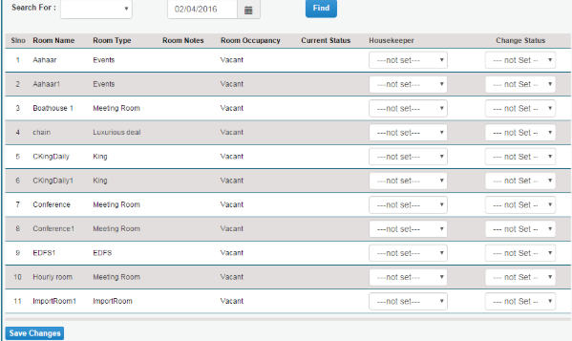

Reservation Report
The hotel reservation report shows all the detail of the guest who reserved the room. The report also includes the wait list and canceled reservation list along with arrival details. This report includes a record of a maximum of 31 days. This report creates in two ways by name or by reservation date. It includes guest name, reservation date, arrival date, departure date, room number and rate name, etc.
For Example
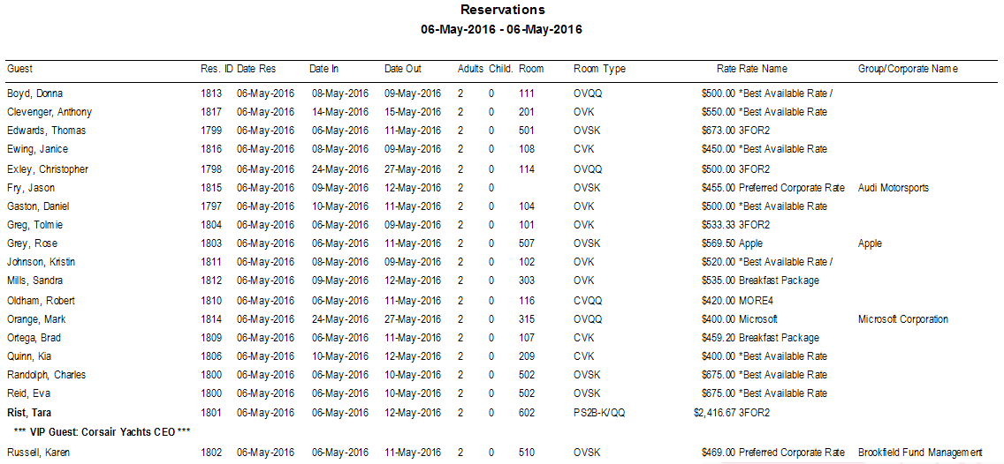

Departure Report
The departure report is about who leaves the hotel today and who will leave the next day. Every night the hotel manager should create two types of departure reports, the one report is for the present day and the second report is for the next day. The departure report of today shows the information of guests who supposed to check-out the hotel today. This report helps to identify guest who did not check out and this report also identify other issues just like overbooking. This report includes room assignment, reservation, guest name, departure date, arrival date, balance, and room status. The front office needs to communicate with the house-keeping staff to know about room status.
Example
Here is some example of departure Report of the hotel:
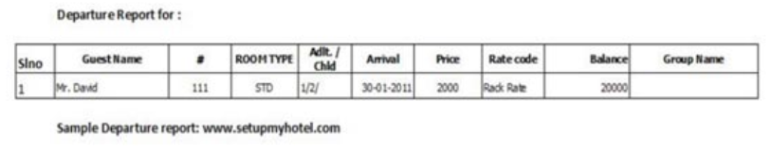

Forecasting/ Budgeting
Forecasting in the hotel starts with making a budget. The budget should be realistic, the budget some time change day by day. The budget is set for every room, and with time budget will be changed because the rate of rooms will be changed according to the price. The forecast reflects the expected short-term situation of about 1 to 3 months. The forecast of the hotel compared with the budget then new strategies will be applied to maximize the profit and revenue.
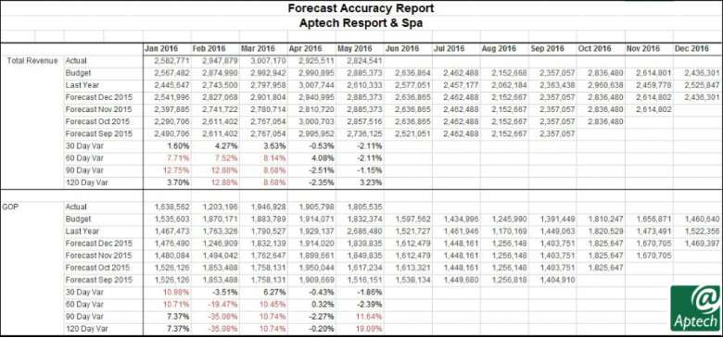

References
- Abernethy, M.A. and Lillis, A.M. (1995), The impact of manufacturing flexibility on management control system design, Accounting, Organizations and Society,.
- Adam, E. Jr and Swamidass, P. (1989), Assessing operations management from a strategic perspective, Journal of Management.
- Adler, P.S. (1988), Managing flexible automation, California Management Review,
- A Âlvarez Gil, M.J. (1994), Capital budgeting and flexible manufacturing, International Journal of Production Economics,
- Anderson, J.C., Cleveland, G. and Schroeder, R.G. (1989), Operations strategy: a literature review, Journal of Operations Management,
- https://www.cloudbeds.com/articles/6-reports-your-hotel-should-run-every-night/
- http://support.roomkeypms.com/m/57282/l/537661-reservations-report#!prettyPhoto

