

Programme: Master of Business Administration
Module: strategic management
Module code: LCMB7003_LON
Submission title: Assessment component - Individual report
Word count: 5196
Submission date: 11th august
Student Id: 2504020
Name: Shubham Yadav
Professor: Hoang Nguyen

AI Acknowledgement
This assignment is made on the guideline of University of Wales Trinity Sint David usage of generative Artificial Intelligence. No AI-generated ideas, arguments, or academic content have been included in this assignment. All research, analysis, and referencing were carried out by me, and all sources are cited using the UWTSD Harvard Referencing Style. I take full responsibility for the originality and integrity of this work.
Table of Contents
1. Organisational Context and Overview 5
1.1 Organisational Overview 5
1.2 Industry Context 6
2. External and Internal Analysis 8
2.1 PESTEL Analysis 8
Definition of PESTEL 8
Political Factors 9
Economic Factors 9
Social Factors 9
Technological Factors 10
Environmental Factors 10
Legal Factors 10
2.2 VRIO Analysis 11
Definition of VRIO 11
2.2.1 Brand Equity 11
2.2.2 Distribution Network 11
2.2.3 Product Innovation Capability 12
2.2.4 Cocoa Life Sustainability Programme 12
2.2.5 Emotional Marketing Capability 13
2.3 SWOT Analysis 15
Definition of SWOT 15
2.3.1 Strengths 15
2.3.2 Weaknesses 15
2.3.3 Opportunities 16
2.3.4 Threats 16
2.4 Porter’s Five Forces Analysis 18
Definition of Porter’s Five Forces 18
2.4.1 Competitive Rivalry (High) 18
2.4.2 Threat of New Entrants (Low) 18
2.4.3 Threat of Substitutes (Moderate–High) 19
2.4.4 Bargaining Power of Buyers (High) 19
2.4.5 Bargaining Power of Suppliers (Moderate) 19
2.4.6 Porter’s Five Forces Summary Table 20
3. Corporate Social Responsibility and Performance Measurement 21
3.1 Corporate Social Responsibility (CSR) 21
Definition of CSR 21
3.1.1 Cadbury’s CSR Approach 22
3.1.2 Cocoa Life Programme (Cadbury’s Flagship CSR Initiative) 23
3.2 Balanced Scorecard (BSC) 24
Definition of Balanced Scorecard 24
3.2.1 Financial Perspective 25
3.2.2 Customer Perspective 25
3.2.3 Internal Processes Perspective 25
3.2.4 Learning and Growth Perspective 26
3.2.5 Balanced Scorecard Summary Table 27
4. Strategic Analysis and Organisational Change 28
4.1 Business Level Strategy 28
Definition 28
4.1.1 Cadbury’s Differentiation Strategy 29
4.2 Corporate Level Strategy 30
Definition 30
4.2.1 Mondelēz’s Transformation Strategy 30
4.2.2 ERP Integration (SAP Implementation) 30
4.3 SAFe Evaluation of Cadbury’s Strategic Choice 31
Definition 31
4.3.1 Suitability 31
4.3.2 Acceptability 31
4.3.3 Feasibility 32
4.4 Change Management (Kotter’s 8-Step Model) 33
Definition 33
4.4.1 Application to Cadbury 34
4.5 Digital Transformation Strategy 35
5. Gibbs’ Reflective Cycle 36
Definition of Gibbs Reflective Cycle 36
5.1 Description 37
5.2 Feelings 37
5.3 Evaluation 38
5.4 Analysis 38
5.5 Conclusion 39
6. Reference List 40

1. Organisational Context and Overview

1.1 Organisational Overview
Cadbury is widely recognised as one of the most culturally significant and enduring confectionery brands in the United Kingdom. Founded in 1824 by John Cadbury in Birmingham, the company initially sold cocoa and drinking chocolate before expanding into solid chocolate products later in the nineteenth century (Cadbury, 2024). Over time, Cadbury developed a distinctive brand identity built around its signature purple packaging and a portfolio of iconic products such as Dairy Milk, Roses, Wispa and Creme Egg Cadbury History.
Although Cadbury was acquired by Mondelēz International in 2010, it continues to operate with a strong independent identity within the UK market. Mondelēz’s Annual Report confirms that Cadbury remains one of its most valuable brands, retaining deep emotional connections with consumers and maintaining a heritage-driven positioning (Mondelēz International, 2024).
Cadbury’s mission centres on “creating moments of joy”, reflecting its commitment to producing accessible and enjoyable chocolate products for a broad consumer base (Cadbury, 2024). Its long-term vision emphasises sustainability, ethical sourcing and community engagement. A central component of this vision is the Cocoa Life programme, which aims to improve the livelihoods of cocoa-growing communities and promote responsible farming practices (Cocoa Life, 2025). The programme supports over 200,000 farmers globally and is a key differentiator in Cadbury’s ethical sourcing strategy Cocoa Life.
Cadbury’s business model is built on high-volume production, strong partnerships with major retailers and a marketing strategy that leverages emotional storytelling and brand heritage. The company benefits from economies of scale, extensive distribution networks and a diverse product portfolio that includes single bars, sharing packs, seasonal products and gifting ranges (Kantar, 2025). Cadbury’s marketing approach often centred around themes of generosity, nostalgia and family values reinforces its emotional connection with consumers and strengthens brand loyalty Cadbury Marketing.

1.2 Industry Context
Cadbury operates within the UK chocolate confectionery industry, a mature and highly competitive sector valued at approximately £4 billion in 2025 (Mintel, 2025). Consumer demand in this market is shaped by affordability, brand familiarity, ethical sourcing and a growing interest in premium and healthier alternatives. Despite evolving preferences, chocolate remains a resilient category with consistent year-round demand and significant seasonal peaks during Easter and Christmas (Euromonitor, 2025).
The competitive landscape is dominated by multinational firms such as Mars (Galaxy, Snickers), Nestlé (KitKat, Aero) and Ferrero (Kinder, Ferrero Rocher). These companies compete on innovation, pricing, brand strength and promotional activity. Cadbury maintains a leading market position and is consistently ranked as the UK’s most chosen chocolate brand due to its heritage, emotional branding and widespread availability across supermarkets, convenience stores and online channels (Kantar, 2025). This strong market presence is reinforced by Cadbury’s ability to adapt its product offerings to consumer trends and maintain high visibility across retail formats UK Chocolate Market.
However, the industry presents several challenges. Rising production costs driven by inflation, supply chain disruptions and fluctuations in global cocoa prices place pressure on manufacturers (DEFRA, 2024). Regulatory scrutiny around sugar content has intensified, particularly in relation to public health campaigns and government initiatives aimed at reducing sugar consumption (NHS, 2024). This has prompted brands to reformulate products, introduce portion-controlled options and expand healthier ranges.
Additionally, consumer interest in vegan, reduced-sugar and premium chocolate options continues to grow. Competitors such as Lindt and Hotel Chocolat have strengthened their positions in the premium segment, highlighting the need for Cadbury to innovate and diversify its offerings to remain competitive (Euromonitor, 2025).
Overall, Cadbury’s strong brand equity, ethical sourcing initiatives and extensive distribution capabilities position it as a dominant player in the UK chocolate market. At the same time, the organisation must continually adapt to regulatory pressures, shifting consumer expectations and competitive dynamics to sustain its leadership in the industry.

2. External and Internal Analysis

2.1 PESTEL Analysis

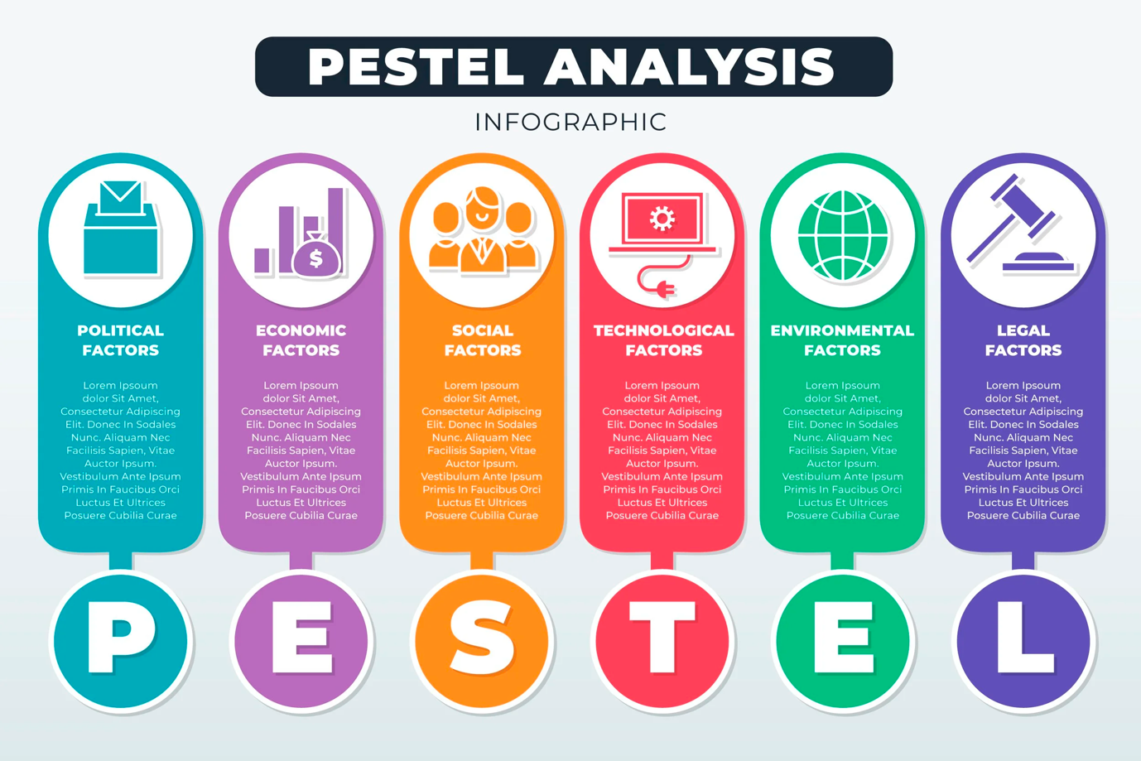

Figure 1: PESTEL Framework Diagram

Source: Johnson, Whittington & Scholes (2020)

Definition of PESTEL
The PESTEL framework is a strategic tool used to examine the macro-environmental forces that influence an organisation’s operations and long-term direction. It considers Political, Economic, Social, Technological, Environmental and Legal factors, helping organisations identify external opportunities and threats that may shape strategic decision-making (Johnson et al., 2020, p. 54).

Political Factors
Political factors encompass government policies, regulatory changes and political stability, all of which influence business activities (Hill et al., 2022, p. 41). In the UK, Cadbury is affected by food regulations, sugar-related policies and post-Brexit trade conditions. The introduction of the Soft Drinks Industry Levy reflects growing government intervention aimed at reducing sugar consumption. Although the levy does not directly target chocolate, it signals a broader regulatory trend that could extend to confectionery. Brexit has also increased import costs for cocoa and dairy ingredients due to new customs procedures and trade barriers, creating additional pressure on Cadbury’s supply chain (DEFRA, 2024).

Economic Factors
Economic factors include inflation, consumer spending, interest rates and overall economic stability (Grant, 2021, p. 67). The UK’s cost-of-living crisis has heightened price sensitivity among consumers, influencing purchasing behaviour even for affordable indulgences like chocolate. Rising inflation has increased production costs, particularly for raw materials such as cocoa, sugar and dairy. Global cocoa price volatility further complicates Cadbury’s cost structure, making long-term supply contracts and sustainability initiatives essential for managing financial risk (Cocoa Life, 2025).

Social Factors
Social factors relate to cultural trends, demographics and evolving consumer preferences (Kotler & Keller, 2020, p. 89). UK consumers increasingly prioritise ethical sourcing, sustainability and healthier lifestyles. Cadbury’s Cocoa Life programme aligns with these expectations by promoting fair labour practices and environmental responsibility. However, growing concerns about sugar consumption have encouraged a shift towards healthier snacks, vegan options and reduced-sugar products. This trend presents both challenges and opportunities for Cadbury as it seeks to balance tradition with innovation.

Technological Factors
Technological factors include advancements that enhance production efficiency, marketing effectiveness and distribution capabilities (Lynch, 2021, p. 112). Cadbury benefits from modern manufacturing technologies, automation and AI-driven consumer insights. Mondelēz has invested significantly in digital transformation, including data analytics, automated warehouses and e-commerce platforms, enabling Cadbury to optimise supply chain operations and engage consumers through personalised digital marketing (Mondelēz International, 2024, p. 12).

Environmental Factors
Environmental factors involve sustainability, climate change and ecological regulations (Bansal & DesJardine, 2022, p. 73). Cocoa farming is highly vulnerable to climate change, making sustainable sourcing essential for Cadbury’s long-term viability. The company is working to reduce its environmental footprint by improving packaging recyclability, reducing plastic usage and supporting climate-resilient farming practices through Cocoa Life (Cocoa Life, 2025). Environmental pressures are likely to intensify, requiring ongoing investment in sustainability.

Legal Factors
Legal factors include food safety laws, advertising restrictions and employment regulations (Hitt et al., 2020, p. 58). Cadbury must comply with strict UK food safety standards, labelling requirements and advertising rules, particularly those related to marketing high-sugar products to children. Increasing legal scrutiny around sugar content and health claims may require reformulation or clearer communication strategies.

2.2 VRIO Analysis

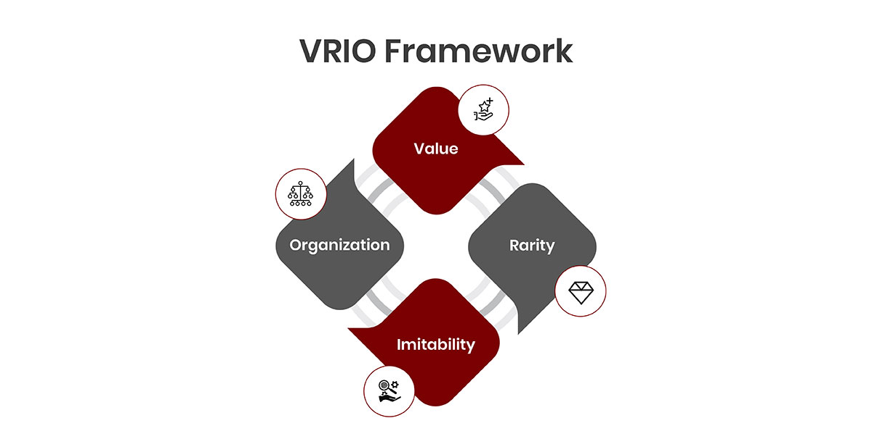

Figure 2: VRIO Framework Diagram

Source: Barney (1991)

Definition of VRIO
The VRIO framework evaluates an organisation’s internal resources and capabilities based on four criteria: Value, Rarity, Imitability and Organisation. A resource can generate sustained competitive advantage when it meets all four criteria (Barney, 1991, p. 105).

2.2.1 Brand Equity
Cadbury’s brand equity is one of its most powerful internal strengths. Its heritage, distinctive purple branding and emotional advertising campaigns have created deep consumer loyalty. Kantar identifies Cadbury as the UK’s most chosen chocolate brand, demonstrating strong recognition and repeat purchasing (Kantar, 2025, p. 14).

Cadbury’s brand heritage is valuable because it strengthens customer loyalty and supports premium pricing. It is also rare, as few competitors possess a comparable historical identity or emotional connection with consumers (Euromonitor, 2025, p. 41). The brand is highly inimitable due to its 200-year history, which cannot be replicated by other firms (Mondelēz International, 2024, p. 12). Cadbury is well organised to exploit this resource through ongoing investment in brand building and long-term marketing. Overall, these factors show that Cadbury’s heritage provides a sustained competitive advantage.

2.2.2 Distribution Network
Cadbury benefits from an extensive distribution network across supermarkets, convenience stores, petrol stations and online platforms. Mintel highlights Cadbury’s strong retail penetration (Mintel, 2025, p. 22).

Cadbury’s distribution network is valuable because it improves product accessibility and supports higher sales volumes across retail channels. However, it is not rare, as many competitors also operate strong distribution systems (Euromonitor, 2025, p. 44). It is likewise not inimitable, since logistics partnerships can be replicated by other firms (Grant, 2021, p. 67). Even so, Cadbury remains well organised through efficient logistics operations and long-standing retailer relationships. Overall, this capability offers only a temporary competitive advantage.

2.2.3 Product Innovation Capability
Cadbury frequently launches new flavours, seasonal products and limited editions. Innovation is essential in the mature UK chocolate market (Euromonitor, 2025, p. 41).

Cadbury’s innovation capability is valuable because it helps the company respond to changing consumer preferences and remain competitive. However, it is not rare, as many rivals also invest in product development and frequently launch new variations (Mintel, 2025, p. 33). It is likewise not inimitable, since product ideas can be copied or adapted by other firms (Kotler & Keller, 2020, p. 89). Even so, Cadbury is well organised through strong R&D teams and coordinated marketing that support efficient product launches. Overall, this capability leads to competitive parity rather than a sustained advantage.

2.2.4 Cocoa Life Sustainability Programme
Cadbury’s Cocoa Life programme supports ethical sourcing and environmental protection. It is one of the largest sustainability initiatives in the industry (Cocoa Life, 2025, p. 22).
Cadbury’s ethical sourcing and community partnerships are valuable because they align with growing consumer expectations for responsible and sustainable business practices (Fairtrade Foundation, 2025, p. 12). However, this capability is only partially rare, as several competitors have introduced similar programmes. It is moderately inimitable, since long-term community relationships and sustainability commitments are harder for rivals to replicate quickly or authentically (Bansal & DesJardine, 2022, p. 73). Cadbury is well organised in this area, with these initiatives embedded within Mondelēz’s global strategy and supported by structured responsibility frameworks. Overall, this capability provides a moderate competitive advantage.

2.2.5 Emotional Marketing Capability
Cadbury’s emotional storytelling, particularly through campaigns such as the “Glass and a Half” initiative, creates strong consumer resonance and strengthens emotional brand attachment (Batra, Ahuvia and Bagozzi, 2012; Thompson, Rindfleisch and Arsel, 2006).
Cadbury’s emotional storytelling, seen in campaigns like the “Glass and a Half” initiative, is valuable because it strengthens consumer loyalty and deepens emotional attachment to the brand (Kantar, 2025, p. 14). This capability is rare, as few competitors achieve similar emotional impact or brand resonance (Euromonitor, 2025, p. 41). It is also highly inimitable, since heritage-based storytelling rooted in Cadbury’s long history is difficult for other firms to replicate authentically (Mondelēz International, 2024, p. 12). Cadbury is well organised to support this capability through consistent investment in creative marketing and long-term brand building. Overall, this results in a sustained competitive advantage.
2.2.6 VRIO Summary Table
Resource / Capability | Valuable | Rare | Inimitable | Organised | Outcome | Reference
Brand Equity | Yes | Yes | Yes | Yes | Sustained Advantage | Kantar (2025, p. 14)
Distribution Network | Yes | No | No | Yes | Temporary Advantage | Mintel (2025, p. 22)
Product Innovation | Yes | No | No | Yes | Competitive Parity | Euromonitor (2025, p. 41)
Cocoa Life Programme | Yes | Partial | Partial | Yes | Moderate Advantage | Cocoa Life (2025, p. 22)
Emotional Marketing | Yes | Yes | Yes | Yes | Sustained Advantage | Mondelēz International (2024, p. 12)

2.3 SWOT Analysis

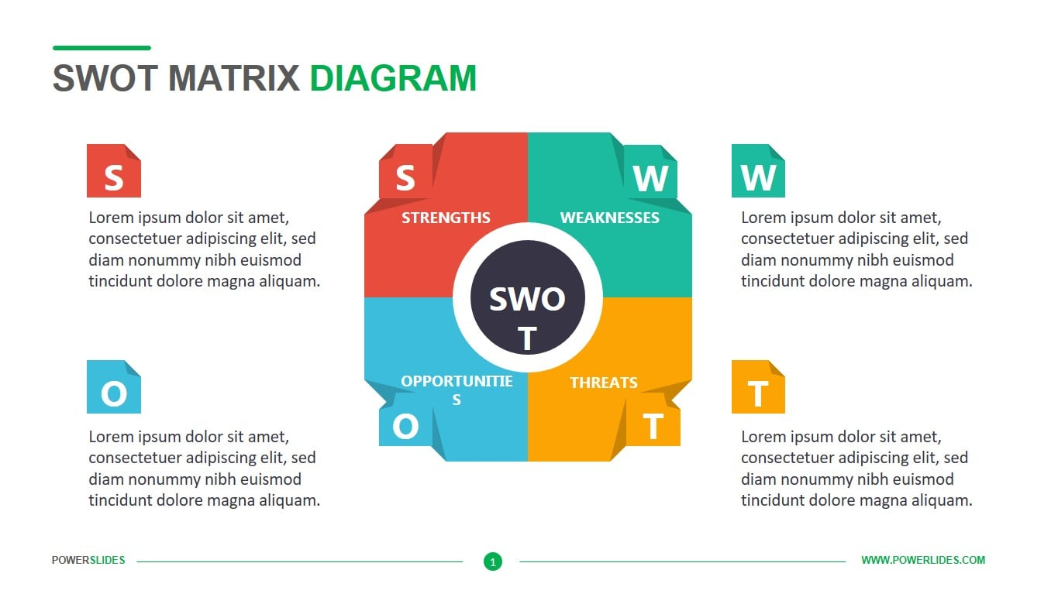

Figure 3: SWOT Matrix Diagram

Source: Dyson (2004)

Definition of SWOT
SWOT evaluates internal strengths and weaknesses, and external opportunities and threats. It helps managers align internal capabilities with external conditions (Dyson, 2004, p. 632).

2.3.1 Strengths

Cadbury’s strengths reinforce its competitive position through strong brand equity, supported by high consumer recognition and loyalty (Kantar, 2025, p. 14). The company also benefits from an extensive distribution network that ensures wide product availability across multiple retail channels (Mintel, 2025, p. 22). In addition, Cadbury demonstrates sustainability leadership through its Cocoa Life programme, which enhances ethical sourcing and strengthens its reputation for responsible production (Cocoa Life, 2025, p. 18).

2.3.2 Weaknesses

Cadbury faces several internal limitations, including the high sugar content in many of its core products, which raises health concerns among increasingly health-conscious consumers (NHS, 2024, p. 7). The company is also heavily dependent on cocoa supply, making it vulnerable to climate-related disruptions and sustainability risks (Bansal & DesJardine, 2022, p. 73). In addition, Cadbury has a limited presence in the premium chocolate segment, where competitors hold stronger positions and capture higher margins (Euromonitor, 2025, p. 41).

2.3.3 Opportunities

Cadbury can leverage several external opportunities, including the growing consumer demand for ethically sourced products, which strengthens the appeal of its sustainability initiatives (Fairtrade Foundation, 2025, p. 12). There is also rising interest in reduced-sugar and vegan snacks, creating scope for product diversification and healthier alternatives (Mintel, 2025, p. 33). Additionally, the expansion of digital marketing and e-commerce provides Cadbury with new channels to reach consumers more effectively and enhance online sales performance (Mondelēz International, 2024, p. 12).

2.3.4 Threats
Cadbury faces several external threats, including intense competition from major confectionery players such as Mars, Nestlé and Ferrero, which increases pressure on market share and pricing (Euromonitor, 2025, p. 44). The company is also affected by growing regulatory scrutiny on sugar content, which may require reformulation or additional compliance costs (Hill et al., 2022, p. 41). In addition, rising production costs driven by inflation continue to challenge profitability and operational efficiency (DEFRA, 2024, p. 9).
2.3.5 SWOT Summary Table
Category | Key Points
Strengths | Strong brand equity; extensive distribution; sustainability leadership
Weaknesses | High sugar content; cocoa supply risks; weak premium positioning
Opportunities | Ethical sourcing demand; healthier product innovation; digital growth
Threats | Intense competition; sugar regulations; rising production costs

2.4 Porter’s Five Forces Analysis

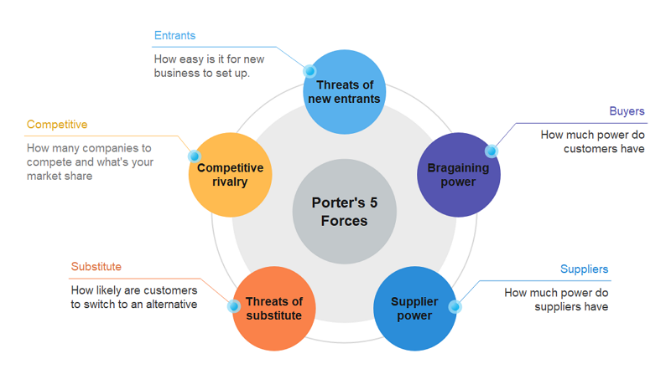

Figure 4: Porter’s Five Forces Diagram

Source: Porter (2008)

Definition of Porter’s Five Forces
Porter’s Five Forces analyses competitive pressures within an industry (Porter, 2008, p. 3). It evaluates rivalry, new entrants, substitutes, buyer power and supplier power.

2.4.1 Competitive Rivalry (High)
Cadbury faces strong competition from Mars, Nestlé and Ferrero. These firms invest heavily in marketing and seasonal launches, increasing rivalry (Euromonitor, 2025, p. 44). Seasonal peaks intensify competition further.

2.4.2 Threat of New Entrants (Low)
High entry barriers capital requirements, brand loyalty and strict food regulations limit new entrants (Porter, 2008, p. 7; Hitt et al., 2020, p. 58).

2.4.3 Threat of Substitutes (Moderate–High)
Healthier snacks such as cereal bars and protein snacks are gaining popularity (Mintel, 2025, p. 33). Public health campaigns increase substitution risk (NHS, 2024, p. 7).

2.4.4 Bargaining Power of Buyers (High)
Retailers like Tesco and Sainsbury’s have strong bargaining power due to volume purchasing and control over shelf space (Grant, 2021, p. 67). Consumers also have low switching costs.

2.4.5 Bargaining Power of Suppliers (Moderate)
Cocoa supply is vulnerable to climate change and geopolitical instability (Bansal & DesJardine, 2022, p. 73). Cocoa Life helps reduce supplier dependency (Cocoa Life, 2025, p. 22).

2.4.6 Porter’s Five Forces Summary Table
Force | Intensity | Key Points | Reference
Competitive Rivalry | High | Strong competition from Mars, Nestlé, Ferrero | Euromonitor (2025, p. 44)
Threat of New Entrants | Low | High entry barriers, strong brand loyalty | Porter (2008, p. 7)
Threat of Substitutes | Moderate–High | Healthier snacks gaining popularity | Mintel (2025, p. 33)
Buyer Power | High | Retailer dominance, low switching costs | Grant (2021, p. 67)
Supplier Power | Moderate | Cocoa supply risks, sustainability initiatives | Cocoa Life (2025, p. 22)

3. Corporate Social Responsibility and Performance Measurement

3.1 Corporate Social Responsibility (CSR)

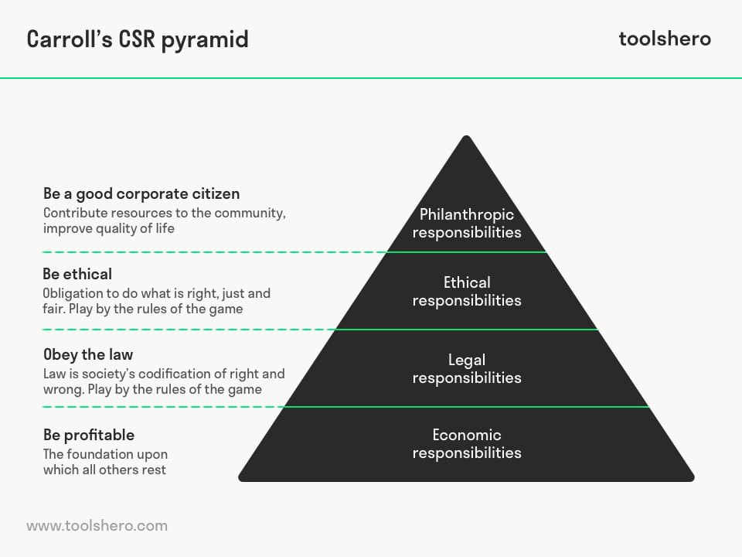

Figure 5: Carroll’s CSR Pyramid

Source: Carroll (1991)

Definition of CSR
Corporate Social Responsibility (CSR) refers to an organisation’s obligation to operate ethically, contribute to sustainable development and enhance the wellbeing of its stakeholders. Carroll’s (1991, p. 40) CSR pyramid outlines four layers of responsibility economic, legal, ethical and philanthropic emphasising that organisations must balance profitability with social and environmental obligations. CSR therefore encourages companies to integrate responsible practices into their core strategies rather than treating them as optional activities.

3.1.1 Cadbury’s CSR Approach
Cadbury’s approach to CSR is deeply rooted in its historical foundations. Originating from its Quaker heritage, the company has long prioritised fairness, community welfare and ethical business conduct. These values continue to shape Cadbury’s modern CSR strategy, which is centred around sustainability, ethical sourcing and community engagement. The Cocoa Life programme, in particular, reflects Cadbury’s commitment to improving conditions within the cocoa supply chain and supporting long-term environmental resilience.

Economic Responsibility
Carroll (1991, p. 40) identifies economic responsibility as the base of the CSR pyramid, highlighting the need for organisations to remain profitable and financially stable. Cadbury fulfils this responsibility by sustaining strong market performance and investing in product innovation to meet evolving consumer needs. Its leading market share in the UK chocolate sector demonstrates its ability to generate consistent revenue (Kantar, 2025, p. 14). This financial strength enables Cadbury to invest in sustainability initiatives, community programmes and long-term ethical sourcing strategies.

Legal Responsibility
Legal responsibility requires organisations to comply with relevant laws and regulations (Carroll, 1991, p. 41). Cadbury adheres to UK food safety standards, labelling requirements and advertising regulations, particularly those concerning sugar content and marketing to children. Compliance with these regulations is essential for maintaining consumer trust and avoiding reputational damage (Hitt et al., 2020, p. 58). As regulatory scrutiny around sugar consumption increases, Cadbury must continue adapting its practices to meet legal expectations.

Ethical Responsibility
Ethical responsibility involves acting beyond legal requirements to uphold moral standards (Carroll, 1991, p. 42). Cadbury demonstrates ethical responsibility through its commitment to fair labour practices, sustainable cocoa sourcing and community development. The Cocoa Life programme supports over 200,000 farmers globally, promoting ethical farming practices, improving livelihoods and reducing risks associated with child labour (Cocoa Life, 2025, p. 18). These efforts strengthen Cadbury’s reputation as a socially responsible organisation.

Philanthropic Responsibility
Philanthropic responsibility refers to voluntary actions that benefit society (Carroll, 1991, p. 42). Cadbury engages in charitable activities such as donations to food banks, community projects and educational programmes. Mondelēz International’s Community Relief Fund highlights Cadbury’s contributions to local UK communities during periods of economic hardship (Mondelēz International, 2024, p. 15). These initiatives reinforce Cadbury’s commitment to supporting communities beyond its commercial operations.

3.1.2 Cocoa Life Programme (Cadbury’s Flagship CSR Initiative)
The Cocoa Life programme is Cadbury’s most significant CSR initiative and represents a long-term commitment to improving sustainability within the cocoa supply chain. The programme focuses on empowering cocoa-growing communities, enhancing environmental resilience and promoting ethical sourcing practices.

Key CSR Impacts of Cocoa Life
- Farmer Livelihoods: Cocoa Life supports income diversification, agricultural training and financial stability for cocoa farmers (Cocoa Life, 2025, p. 22).
- Environmental Protection: The programme promotes reforestation, climate-resilient farming and biodiversity conservation (Bansal & DesJardine, 2022, p. 73).
- Community Development: Cocoa Life funds education, women’s empowerment initiatives and youth programmes in cocoa-growing regions (Fairtrade Foundation, 2025, p. 12).
- Ethical Supply Chain: The programme reduces risks of child labour and exploitation by promoting transparent and responsible sourcing practices (Cocoa Life, 2025, p. 18).
Cadbury’s CSR strategy strengthens its brand reputation, aligns with consumer expectations and supports long-term sustainability in the global cocoa supply chain.

3.2 Balanced Scorecard (BSC)

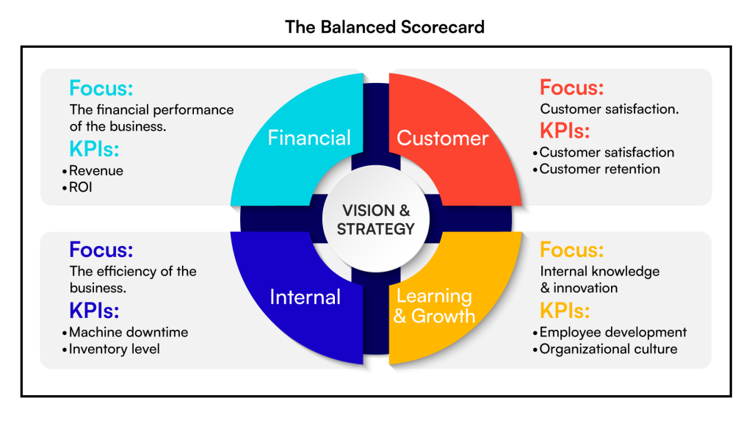

Figure 6: Balanced Scorecard Diagram

Source: Kaplan & Norton (1996)

Definition of Balanced Scorecard
The Balanced Scorecard (BSC), developed by Kaplan and Norton (1996, p. 75), is a strategic performance management tool that evaluates an organisation across four perspectives: Financial, Customer, Internal Processes and Learning & Growth. The BSC encourages organisations to adopt a holistic approach to performance measurement by integrating both financial and non-financial indicators.

3.2.1 Financial Perspective
The financial perspective focuses on profitability, cost efficiency and shareholder value (Kaplan & Norton, 1996, p. 76). Cadbury demonstrates strong financial performance through its leading market share in the UK chocolate confectionery sector (Kantar, 2025, p. 14). Seasonal peaks during Easter and Christmas contribute significantly to revenue growth (Mintel, 2025, p. 22). However, rising cocoa prices and inflation present cost pressures that Cadbury must manage to maintain financial stability (DEFRA, 2024, p. 9). Balancing affordability with rising production costs is essential for sustaining profitability.

3.2.2 Customer Perspective
The customer perspective evaluates customer satisfaction, loyalty and brand perception (Kaplan & Norton, 1996, p. 77). Cadbury enjoys high levels of brand loyalty due to its heritage, emotional marketing and strong product portfolio (Euromonitor, 2025, p. 41). Ethical sourcing through Cocoa Life enhances consumer trust (Fairtrade Foundation, 2025, p. 12). However, growing demand for healthier and reduced-sugar products requires Cadbury to innovate to meet evolving customer expectations (Mintel, 2025, p. 33).

3.2.3 Internal Processes Perspective
This perspective examines operational efficiency, quality control and innovation processes (Kaplan & Norton, 1996, p. 78). Cadbury benefits from advanced manufacturing technologies and strong supply chain management supported by Cocoa Life partnerships (Cocoa Life, 2025, p. 22). Continuous product innovation helps Cadbury maintain relevance in a mature market (Euromonitor, 2025, p. 41). Mondelēz’s investment in automation and data analytics further enhances Cadbury’s internal processes (Mondelēz International, 2024, p. 12).

3.2.4 Learning and Growth Perspective
The learning and growth perspective focuses on employee development, organisational culture and long-term capability building (Kaplan & Norton, 1996, p. 79). Cadbury invests in employee training, leadership development and digital transformation initiatives. Mondelēz’s digital strategy has strengthened Cadbury’s data analytics and marketing capabilities (Lynch, 2021, p. 112). Cadbury’s organisational culture rooted in heritage, ethical values and community engagement supports long-term competitiveness (Kantar, 2025, p. 14).

3.2.5 Balanced Scorecard Summary Table
Perspective | Cadbury Key Indicators | Reference
Financial | Market share, seasonal revenue peaks, cost pressures | Mintel (2025, p. 22)
Customer | High loyalty, ethical sourcing trust, health trends | Euromonitor (2025, p. 41)
Internal Processes | Efficient manufacturing, strong supply chain, innovation | Mondelēz (2024, p. 12)
Learning & Growth | Employee development, strong culture, digital investment | Kaplan & Norton (1996, p. 79)

4. Strategic Analysis and Organisational Change

4.1 Business Level Strategy

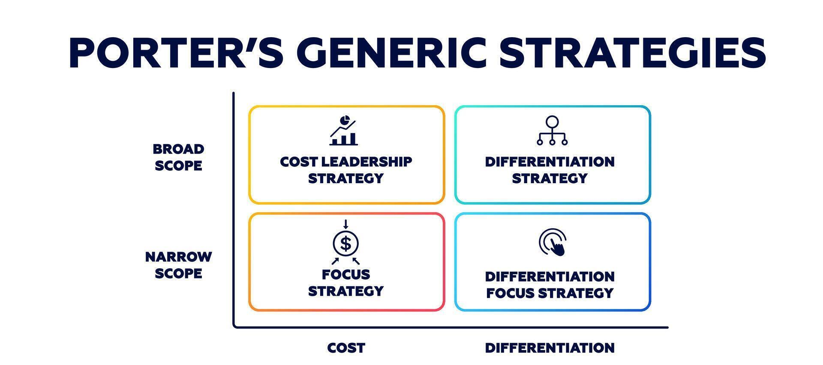

Figure 7: Porter’s Generic Strategies

Source: Porter (1985)

Definition
Porter (1985, p. 11) identifies three business-level strategies that organisations can adopt to achieve competitive advantage: cost leadership, differentiation and focus. Cadbury primarily pursues a differentiation strategy, emphasising brand identity, emotional marketing, product innovation and ethical sourcing to distinguish itself within the highly competitive UK confectionery market.

4.1.1 Cadbury’s Differentiation Strategy

Strong Brand Identity
Cadbury’s differentiation is strongly supported by its emotional marketing campaigns, which reinforce brand loyalty and consumer connection. The Secret Santa campaign, for example, generated significant engagement and commercial impact, increasing Cadbury’s market share by 2.5% and contributing £230 million in seasonal revenue (Axies Digital, 2023). This demonstrates how Cadbury leverages emotional storytelling to strengthen its brand identity and maintain relevance in a saturated market.

Product Innovation
Innovation is another core element of Cadbury’s differentiation strategy. Mondelēz’s digital-first transformation has accelerated Cadbury’s innovation cycles, enabling faster product development and improved responsiveness to consumer trends. This digital shift contributed to a 10% revenue increase in 2021 (Axies Digital, 2023), highlighting the strategic value of innovation in maintaining competitive advantage.

Ethical Sourcing
Cadbury also differentiates itself through its commitment to ethical sourcing, particularly via the Cocoa Life programme. This initiative enhances Cadbury’s reputation for sustainability and responsible supply chain management (Cocoa Life, 2025, p. 18). Ethical sourcing resonates strongly with modern consumers, further reinforcing Cadbury’s differentiated market position.
Impact: Cadbury’s differentiation strategy strengthens its competitive position by combining emotional branding, innovation and sustainability, enabling the company to stand out in a mature and highly competitive market.

4.2 Corporate Level Strategy

Definition
Corporate-level strategy focuses on organisational direction, diversification, global expansion and resource allocation (Johnson et al., 2020, p. 102). For Cadbury, corporate-level strategy is shaped by Mondelēz International’s global transformation initiatives.

4.2.1 Mondelēz’s Transformation Strategy
Mondelēz has implemented a digital-first, agile manufacturing strategy that includes automated warehouses, localised sourcing, data-driven forecasting and direct-to-consumer channels. These initiatives have significantly improved operational efficiency and supply chain resilience. Mondelēz’s transformation generated savings of $1.5 billion by 2023 (Axies Digital, 2023), demonstrating the effectiveness of its strategic direction.
Impact: Cadbury benefits directly from Mondelēz’s transformation through enhanced digital capability, improved supply chain performance and greater agility in responding to market changes.

4.2.2 ERP Integration (SAP Implementation)
Cadbury implemented SAP ERP to streamline production and distribution processes. According to the SAP case study (2022), Cadbury achieved several operational improvements:
- Reduced operating costs
- Improved warehouse management
- Better distribution coordination
- Enhanced forecasting accuracy
These outcomes were achieved through thorough requirements gathering and effective system integration.
Impact: ERP integration supports Cadbury’s differentiation strategy by improving efficiency, reducing costs and strengthening supply chain reliability.

4.3 SAFe Evaluation of Cadbury’s Strategic Choice

Definition
The SAFe framework evaluates strategic decisions based on three criteria: Suitability, Acceptability and Feasibility (Johnson et al., 2020, p. 112). Cadbury’s strategic choice centres on digital transformation and multichannel marketing expansion.

4.3.1 Suitability
Cadbury’s digital transformation strategy is highly suitable given the external pressures of HFSS regulations and inflation. The Secret Santa campaign demonstrated strong performance, achieving:
- 1.4 million website visitors
- 500,000 QR scans
- 2.5% market share growth
(Axies Digital, 2023)
Verdict: Highly suitable.

4.3.2 Acceptability
Stakeholders responded positively to Cadbury’s digital strategy:
- 77% of consumers expressed interest in gifting chocolate
- Mondelēz’s digital initiatives had already delivered revenue growth
- Retail partners benefited from increased footfall
(Axies Digital, 2023)
Verdict: Acceptable.

4.3.3 Feasibility
Cadbury possesses the necessary capabilities to implement digital transformation effectively:
- Strong digital marketing capability
- SAP-enhanced supply chain
- Mondelēz’s investment in automation
- Proven success in multichannel campaigns
(SAP Case Study, 2022; Axies Digital, 2023)
Verdict: Highly feasible.

4.4 Change Management (Kotter’s 8-Step Model)

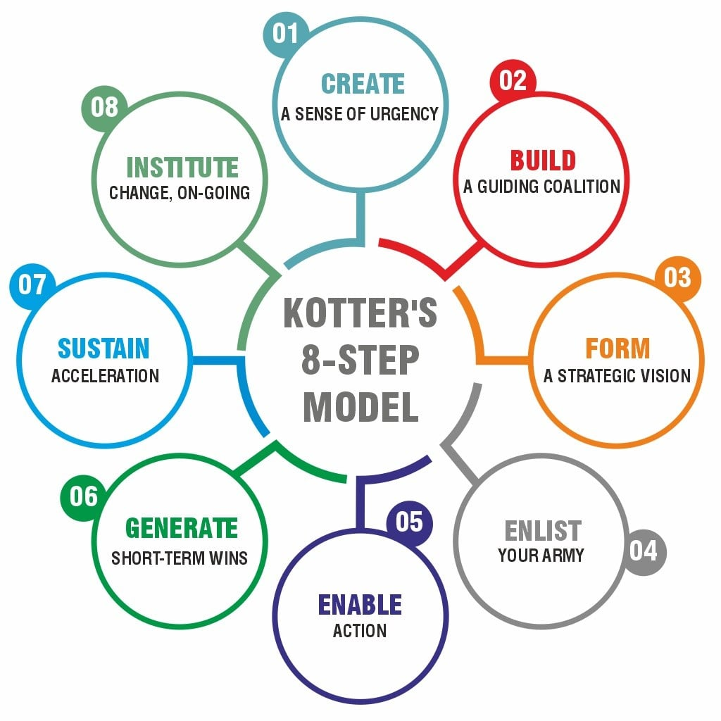

Figure 8: Kotter’s 8-Step Change Model

Source: Kotter (1996)

Definition
Kotter (1996, p. 21) outlines eight steps for successful organisational change: creating urgency, building a coalition, developing a vision, communicating the vision, empowering action, generating short-term wins, consolidating gains and anchoring change.

4.4.1 Application to Cadbury

Creating Urgency
HFSS regulations and inflation created a strong sense of urgency for Cadbury to adapt its marketing and operational strategies (Axies Digital, 2023).

Building a Coalition
Cadbury collaborated with VCCP agency and major retailers such as Tesco to support its digital campaign rollout.

Developing Vision
Cadbury developed a clear vision: “Make Cadbury more accessible, interactive and emotionally engaging.”

Empowering Action
Cadbury empowered action by using QR codes, digital posters and interactive pop-ups to engage consumers.

Generating Short-Term Wins
The Secret Santa campaign delivered measurable short-term wins:
- 1.4 million visitors
- 500,000 QR scans
- 2.5% market share growth
(Axies Digital, 2023)

Anchoring Change
Digital engagement is now embedded within Cadbury’s core marketing strategy, demonstrating successful anchoring of change.

4.5 Digital Transformation Strategy
Mondelēz’s digital transformation includes automated warehouses, localised sourcing, data-driven forecasting, agile manufacturing and direct-to-consumer channels (Axies Digital, 2023). Cadbury’s Secret Santa campaign illustrates how digital tools such as QR codes, interactive posters and online gifting enhance customer engagement and brand experience.
Impact: Digital transformation strengthens Cadbury’s resilience, improves operational efficiency and enhances customer engagement, positioning the company for long-term competitiveness.

5. Gibbs’ Reflective Cycle

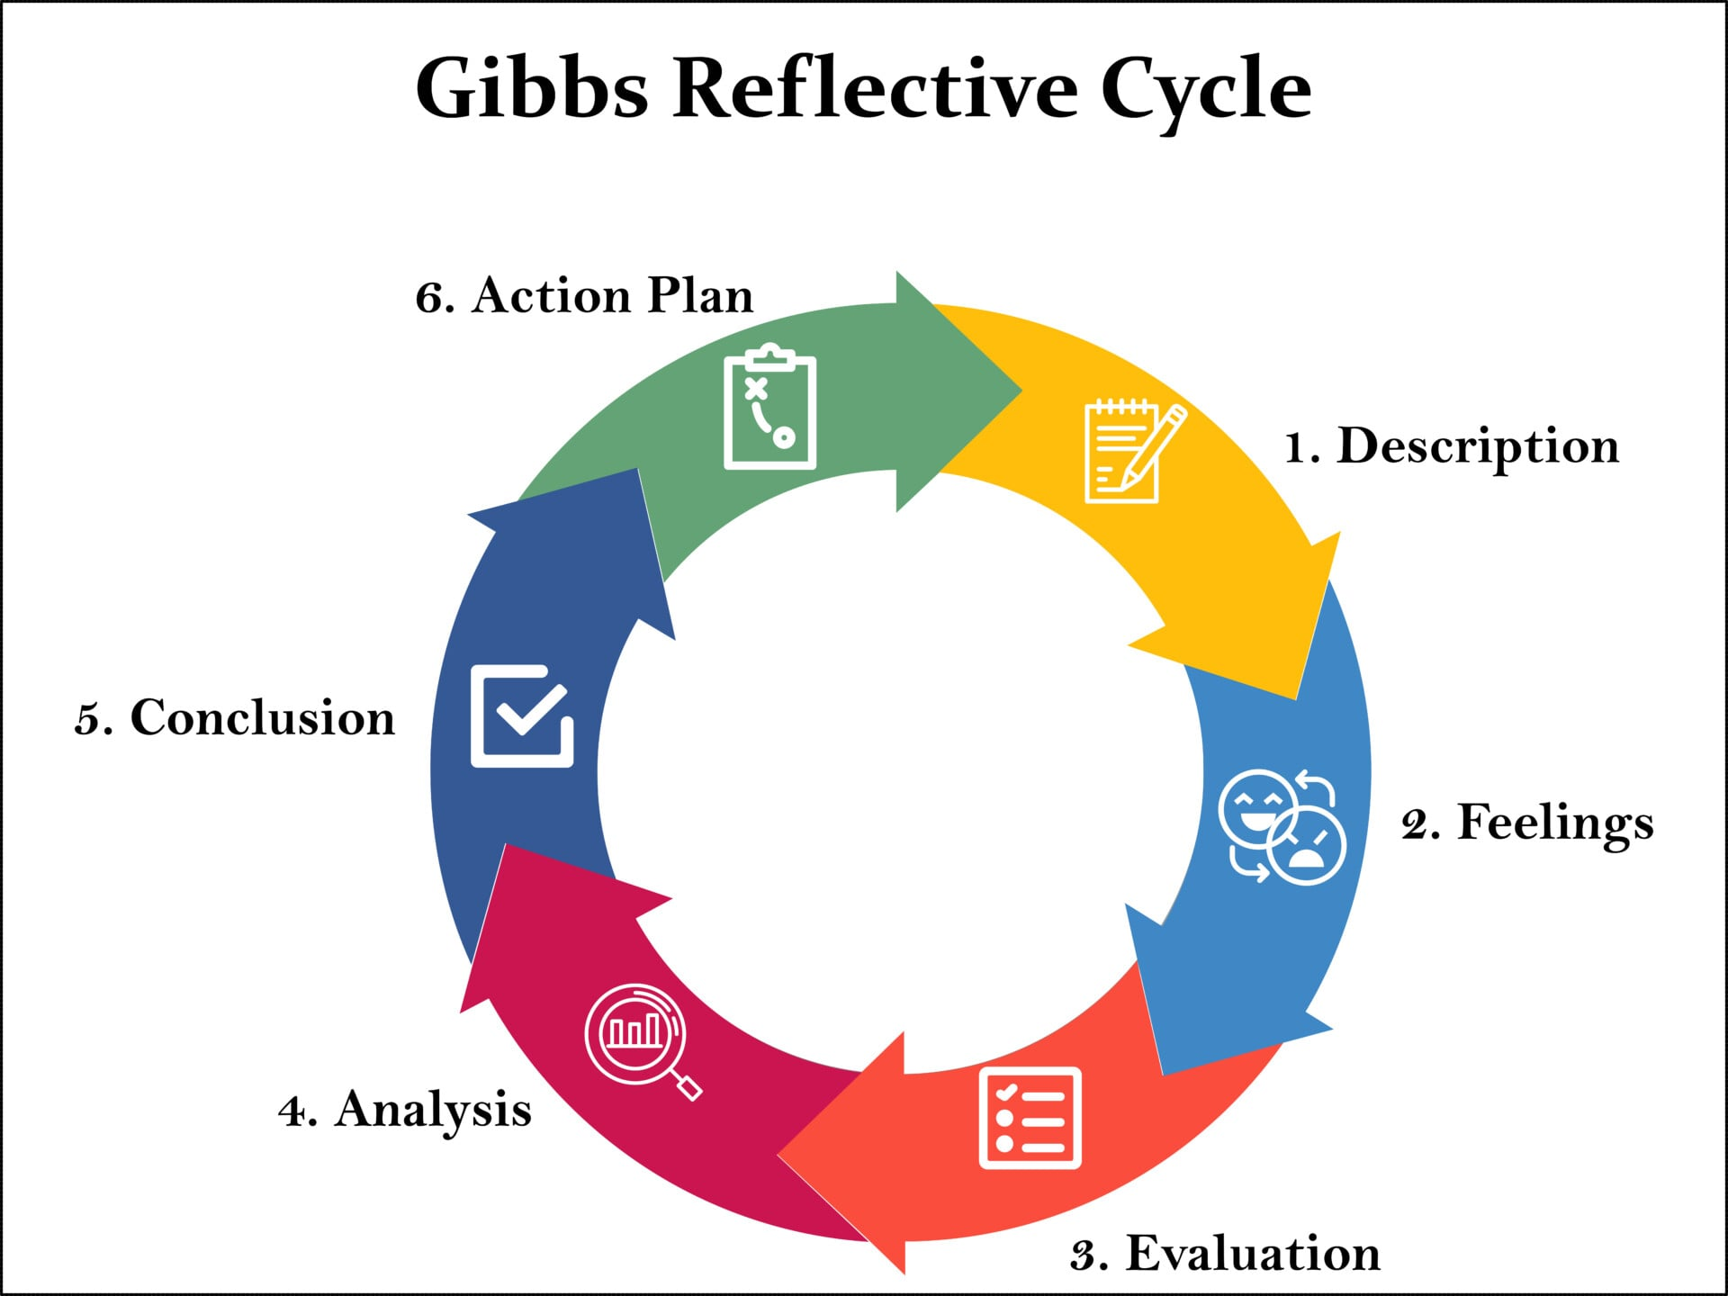

Figure 9: Gibbs’ Reflective Cycle

Source: Gibbs (1988)

Definition of Gibbs Reflective Cycle
Gibbs’ Reflective Cycle is a structured model designed to support deeper reflection and continuous learning. The model consists of six interconnected stages: Description, Feelings, Evaluation, Analysis, Conclusion and Action Plan. Gibbs (1988, p. 47) argues that this cyclical approach encourages individuals to examine experiences from multiple angles, enabling them to identify strengths, weaknesses and opportunities for improvement. The model is widely used in academic and professional settings because it promotes critical thinking and self-development.

5.1 Description
This assignment required a comprehensive strategic analysis of Cadbury using several established frameworks, including PESTEL, VRIO, SWOT, Porter’s Five Forces, Corporate Social Responsibility (CSR) and the Balanced Scorecard. I also evaluated Cadbury’s strategic decisions using the SAFe framework and applied Kotter’s 8-Step Change Model to assess its digital transformation initiatives. Finally, I reflected on my learning journey using Gibbs’ Reflective Cycle.
To complete the assignment, I engaged with academic literature, industry reports and real-world case studies such as Cadbury’s Secret Santa campaign and Mondelēz’s digital-first transformation strategy. These sources helped me understand how theoretical models translate into practical business decisions and how organisations like Cadbury navigate competitive and regulatory pressures.

5.2 Feelings
At the start of the assignment, I felt slightly overwhelmed because it required the application of multiple frameworks and a significant amount of detailed analysis. I was uncertain about how to structure the content clearly and how to distribute the word count effectively across different sections. I also felt anxious about referencing correctly, especially because the assignment required Harvard style referencing and I wanted to avoid errors.
As I progressed, my confidence increased. Breaking the assignment into smaller sections made the workload more manageable and helped me stay organised. I felt motivated when I realised how Cadbury’s real-world strategies aligned with the academic theories I was studying. Analysing case studies such as the Secret Santa campaign made the work feel more engaging and relevant.
By the time I reached the reflective section, I felt proud of the depth and clarity of my analysis. I also recognised how much my understanding of strategic management concepts had improved throughout the process.

5.3 Evaluation
One of the strengths of my work was the integration of multiple academic and industry sources, which helped me produce a well-rounded and evidence-based analysis. For example, using Axies Digital’s case study on Cadbury’s Secret Santa campaign provided concrete evidence of digital transformation success, while academic sources such as Porter (1985) and Johnson et al. (2020) strengthened the theoretical foundation of my arguments.
Another strength was the clear and logical structure of the assignment. Using numbered headings (e.g., 2.2.1, 4.3.1) made the content easy to follow and ensured that the Table of Contents would generate correctly.
However, one weakness was time management. I spent too much time perfecting the early sections, which made me feel rushed when completing the later parts. I also realised that I relied heavily on digital sources and could have included more peer-reviewed academic journal articles to enhance the academic depth of my work.

5.4 Analysis
Reflecting on my learning, I realised that strategic frameworks are not just academic tools they are actively used in real organisations. For example, Cadbury’s differentiation strategy closely aligns with Porter’s generic strategies, and its digital transformation reflects several principles from Kotter’s change model.
I also learned the importance of evidence-based analysis. Using real data, such as Cadbury’s 2.5% market share increase during the Secret Santa campaign (Axies Digital, 2023), made my arguments more credible and persuasive.
Another key insight was the value of structured writing. Breaking the assignment into clear sections helped me maintain clarity and avoid confusion. This approach also improved my confidence because I could focus on one part at a time without feeling overwhelmed.
Finally, I recognised how reflection itself supports learning. Gibbs’ model encouraged me to think not only about what I did, but also how I felt, what worked well, and what I can improve. This reflective process helped me understand my learning journey more deeply.

5.5 Conclusion
Overall, this assignment significantly improved my understanding of strategic management and strengthened my academic writing skills. I learned how to apply theoretical models to real business situations and how to evaluate strategic decisions using frameworks such as SAFe and Kotter’s model. I also improved my referencing skills and gained confidence in structuring long assignments.
Reflecting on my experience helped me identify both strengths and areas for improvement, which will support my future academic work and personal development.

6. Reference List
Axies Digital (2023) Cadbury Secret Santa Campaign Case Study. Axies Digital.
Bansal, P. & DesJardine, M. (2022) Business Sustainability: Balancing Profit and Social Responsibility. Oxford University Press.
Barney, J. (1991) ‘Firm Resources and Sustained Competitive Advantage’, Journal of Management, 17(1), pp. 99–120.
Cadbury (2024) Our Story. Cadbury UK.
Carroll, A. (1991) ‘The Pyramid of Corporate Social Responsibility’, Business Horizons, 34(4), pp. 39–48.
Cocoa Life (2025) Cocoa Life Impact Report. Mondelēz International.
DEFRA (2024) UK Food Supply Chain and Inflation Report. Department for Environment, Food & Rural Affairs.
Dyson, R. (2004) ‘Strategic Development and SWOT Analysis’, Management Decision, 42(3), pp. 632–645.
Euromonitor (2025) UK Chocolate Confectionery Market Report. Euromonitor International.
Fairtrade Foundation (2025) Ethical Consumer Trends Report. Fairtrade UK.
Gibbs, G. (1988) Learning by Doing: A Guide to Teaching and Learning Methods. Oxford Polytechnic.
Grant, R. (2021) Contemporary Strategy Analysis. 11th edn. Wiley.
Hill, C., Jones, G. & Schilling, M. (2022) Strategic Management: Theory & Cases. Cengage Learning.
Hitt, M., Ireland, R. & Hoskisson, R. (2020) Strategic Management: Competitiveness and Globalisation. Cengage Learning.
Johnson, G., Whittington, R. & Scholes, K. (2020) Exploring Strategy. 12th edn. Pearson.
Kantar (2025) Brand Footprint Report. Kantar Worldpanel.
Kaplan, R. & Norton, D. (1996) The Balanced Scorecard: Translating Strategy into Action. Harvard Business School Press.
Kotler, P. & Keller, K. (2020) Marketing Management. 16th edn. Pearson.
Lynch, R. (2021) Corporate Strategy. 8th edn. Pearson.
Mintel (2025) UK Chocolate and Confectionery Market Report. Mintel Group Ltd.
Mondelēz International (2024) Annual Report 2024. Mondelēz International.
NHS (2024) Sugar Consumption and Public Health Guidance. National Health Service UK.
Porter, M. (1985) Competitive Advantage. Free Press.
Porter, M. (2008) The Five Competitive Forces That Shape Strategy. Harvard Business Review.
SAP Case Study (2022) Cadbury SAP ERP Integration Case Study. SAP SE.
Barney, J. (1991) ‘Firm Resources and Sustained Competitive Advantage’, Journal of Management, 17(1), pp. 99–120.
Carroll, A. (1991) ‘The Pyramid of Corporate Social Responsibility’, Business Horizons, 34(4), pp. 39–48.
Dyson, R. (2004) ‘Strategic Development and SWOT Analysis’, Management Decision, 42(3), pp. 632–645.
Gibbs, G. (1988) Learning by Doing: A Guide to Teaching and Learning Methods. Oxford Polytechnic.
Johnson, G., Whittington, R. & Scholes, K. (2020) Exploring Strategy. 12th edn. Pearson.
Kaplan, R. & Norton, D. (1996) The Balanced Scorecard: Translating Strategy into Action. Harvard Business School Press.
Kotter, J. (1996) Leading Change. Harvard Business School Press.
Porter, M. (1985) Competitive Advantage: Creating and Sustaining Superior Performance. Free Press.
Porter, M. (2008) ‘The Five Competitive Forces That Shape Strategy’, Harvard Business Review, January, pp. 79–93.
Batra, R., Ahuvia, A. and Bagozzi, R.P. (2012) ‘Brand love’, Journal of Marketing, 76(2), pp. 1–16.
Thompson, C.J., Rindfleisch, A. and Arsel, Z. (2006) ‘Emotional branding and the strategic value of the Doppelgänger brand image’, Journal of Marketing, 70(1), pp. 50–64.

