Qualification: PGDip/MA in Strategic People Management

Module Name: Shaping Cultures and Behaviours (Task 1)

Word count: 3,836 words

Student Name: Joanne Thomas
Student Number: 1403229
CIPD Membership Number: 53274130

By signing below, I confirm that the work/evidence presented is my own, unaided work. I understand the regulations pertaining to candidate malpractice and the action that may be taken as a result.

Signed:  J. Thomas
Date: 26th February 2023

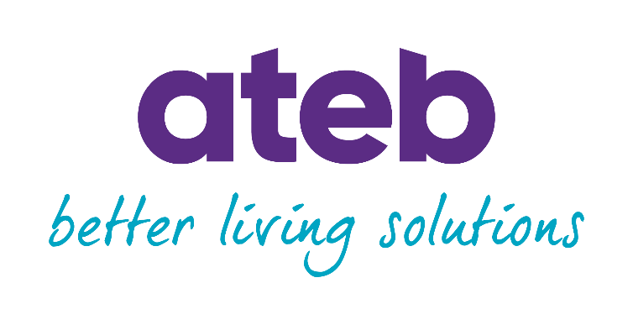
Organisational Culture: What’s Ateb’s Culture Really Like?
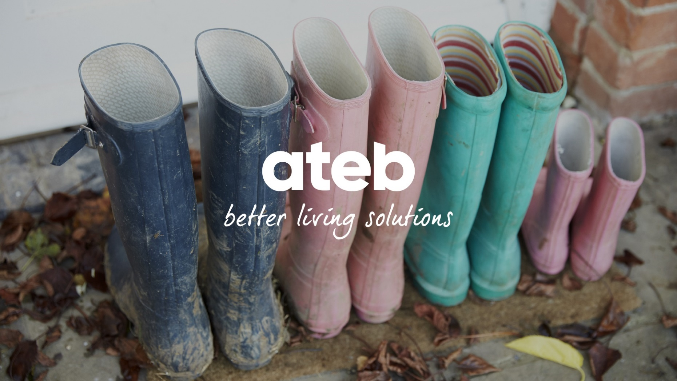

Completed by Joanne Thomas – People Partner
February 2023

Contents
- Ateb Overview ……..……………………………………………………………….. 4
- Introduction: What is Organisational Culture? ………………………………. 5
- Main Findings .……………………………………………………………………… 7
  - Critical Analysis of Ateb’s Culture …………………………………. 7
  - Behaviour and Personality Traits ….………………………………. 10
  - Engagement and Motivation ...………………………………………. 13
  - Positive Culture Benefits ………………………………………………15
- Conclusion …………………………………………………………………………...18
- Recommendations ...………………………………………………………………. 19
- Reference list ….……………………………………………………………………. 21
- Appendix ………………………………………………………………………………29

- Ateb Overview
Ateb is a small housing association currently employing 140 employees (Ateb, 2023a). Since the arrival of a new Chief Executive and organisational rebranding from Pembrokeshire Housing Association to Ateb in 2018, the organisation has undertaken cultural changes.
Historically, the organisation operated through fear and authority resulting in a poor culture where blame, inflexibility, and silo working was the norm (Ateb, 2018). With the introduction of Ateb, trust, togetherness and empowerment quickly became the cornerstones of the desired culture, with these values being central to Ateb’s DNA and core behaviours (Ateb, 2019a).
Ateb wants to be known as an employer of choice therefore, strives to create a positive culture where employees feel satisfied, fulfilled, valued, and are motivated to achieve success. It is intended that the DNA underpins positive behaviours and outcomes.
Levels of engagement and measurable DNA has long been a mystery as engagement has never been formally measured. For a substantial time, observational behaviour and ‘temperature testing’ was conducted by the Executive Team however, it was argued by the employee representative group that this was not a true representation of engagement and DNA.
A quarterly DNA and wellbeing survey was introduced in April 2022, focusing on organisational DNA by asking respondents to rate the organisational DNA within their team and the organisation, and state their wellbeing ‘temperature’. The results are anonymous and provided a different narrative to the previous informal measurements.
Ateb has gone through multiple change management processes with the vision that the correct structures will create better outcomes for the organisation, customer, and employees. Therefore, the culture will continue to evolve as Ateb does.

- What is Organisational Culture?
Organisational culture has been discussed and defined since the 1980s, at which time culture was thrust into the corporate spotlight. Buchanan and Huczynski (2015, p. 107) define culture as the “personality of an organization” concerning the norms and daily practices within the organisation; culture is different across organisations, alike national cultures, thus creating unique organisational identities. However, organisational culture is generally considered as being the shared behaviours and values between employees, and the traditions, norms, and customs within an organisation (Young, 2022); or as cited by Balogun and Johnson (2004, p. 523 – 549) culture is simply “the way we do things around here". As demonstrated, organisational culture can be problematic to truly define as there is no universal definition.
Young (2022) notes the difficulty of measuring organisational culture due to the lack of robust evidence, translating the invisible underlying assumptions into words, and the period of time to complete ethnographic studies; therefore, it is suggested to focus on organisational climate which is associated with the meaning, feelings and understanding individuals have of their organisation.
Organisational culture is central to positive outcomes; employees understand the organisation and feel valued, it influences job satisfaction, productivity, and retention, improves customer satisfaction, and attracts talent (CIPD, no date; Indeed, 2022). Research suggests that a positive culture, with strong emotions of optimism, can improve the level of resilience within teams whereby, teams are more likely to recover from poor performance (Adler et al., 2022). Thus, emotionality must be taken seriously with leaders creatively expressing positive emotions to their team members, to foster a positive emotional culture.
Positive culture creates a high-performing environment and influences the commitment of employees. Criveanu and Ivanescu (2019) states the culture promoted by the organisation’s leadership is paramount in creating strong relations between employees and organisation whereby, employees feel the working environment is more important than financial earnings.
Ethical behaviour in the workplace is linked with organisational culture, for example, poor culture is often at the centre of corporate scandals, with research demonstrating that people would engage in unethical behaviour if the behaviour were perceived as a social norm (Gifford et al., 2019). This is supported by Kennedy (2022) who states that within the housing sector there is a culture of blaming tenants and poor tenant treatment, which has been demonstrated by the UK Government in housing policy, which ultimately resulted in a fatal outcome. Therefore, a positive organisational culture is paramount to achieve ethical behaviour.

- Main Findings
3.1. Critical Analysis of Ateb’s Culture
Edgar Schein developed a model of organisational culture which is well known and widely used, dividing culture into three levels namely artifacts, espoused values, and shared basic assumptions (Clayton, 2021). It is a practical framework to consider and analyse the different elements of an organisation’s culture, instead of accepting the surface level behaviours however, it is criticised for its conceptual approach with little empirical evidence to test its true effectiveness (Hogan and Coote, 2014; Yilmas, 2014; Dauber, Fink and Yolles, 2012). Furthermore, the model is criticised for the lack of external considerations to develop a comprehensive analysis (Dauber, Fink and Yolles, 2012).
Artifacts Analysis
Artifacts are visible elements such as branding, job titles, dress codes, and observed behaviours; whilst this level is easily observable, it is difficult to understand as the observer will likely project their own background onto their interpretation (Schein and Schein, 2016).
Ateb’s visible elements such as décor, core colours, and displays promote a modern and vibrant organisation, valuing informality and a welcoming and relaxed atmosphere (Ateb, 2021a). Friendly and conversational language is used to create a welcoming environment and to foster positive relationships (Ateb, 2021a). Job titles use ‘soft’ words to demonstrate a collaborative and approachable atmosphere. Ateb’s dress code reflects its relaxed and modern image through the casual style the workforce has adopted, as role modelled from executive management levels.
The visible elements indicate to an observer that Ateb is non-authoritative, casual, and an informal organisation. Informal organisations are dynamic and built on relationships, supporting satisfaction, opportunities, and a bottom-up approach (Mullins and McLean, 2019), which echoes Ateb’s DNA.
Espoused Values Analysis
Espoused values and beliefs concern the declared values, behaviours, and norms of the organisation, informing people how things should be done including how to interact with people internally and externally (Schein and Schein, 2016; Farnham, 2015).
Ateb communicates the organisational DNA of trust, togetherness, and empowerment (Ateb, 2019a), forming the expected behavioural norms with expectations clearly detailed in the organisational DNA document. However, Ateb’s DNA engagement survey results showed a lack of DNA behaviours with only 67% of respondents identifying positive DNA behaviours; furthermore, the results showed a lack of leadership skills, declining wellbeing, and increased stress (Ateb, 2023b).
Ateb promotes a leadership style, clearly outlining the levels of responsibility, expected behaviours, characteristics, and attributes (Ateb, 2019b) however data suggests there is a lack of leadership strength and skills. 48% of management are either new starters or first-time managers (Ateb, 2023d) indicating there may be a lack of skills or understanding of expectations. Moreover, there is a lack of performance or capability cases despite managers raising concerns to the HR Team for advice (Ateb, 2023e) therefore, suggesting managers may not challenge poor performance or lack of DNA behaviours. Line managers are central to driving culture and behaviours and must be equipped with the right skills (Mullins and McLean, 2019).
Positive wellbeing at work is integral to Ateb’s values, with their benefits focused on creating a flexible and healthy work life (Ateb, no date). The current sickness absence rate of 1.76% is lower than the UK average and the organisational 2021 average (Ateb, 2022a; ONS, 2022; Ateb, 2021b), suggesting that wellbeing is good and has improved however, workplace stress cases within Ateb have significantly increased with workload cited as the main cause (Ateb, 2023f). This coupled with the DNA survey results citing workload as an issue (Ateb, 2023b) suggests presenteeism could be an issue whereby, employees continue to work whilst experiencing stress-related illness. Sinclair and Suff (2022) states presenteeism continues to be common across organisations, in particular for homeworkers. Furthermore, this suggests that Ateb has a high-intensity work environment which is conflicting against the promotion of a relaxed and flexible organisation.

Shared Basic Assumptions Analysis
Lastly, shared basic assumptions underpin everything else; they are the shared assumptions that something works to the point it is reality therefore, they are often taken for granted and not questioned (Schein and Schein, 2016; Makumbe and Washaya, 2022).
Legacy behaviours of poor management practice, fear and unacceptable behaviour, which were behavioural norms before the organisation rebranded to Ateb from Pembrokeshire Housing, and continue to be prevalent. The current DNA contrasts these legacy behaviours however, data suggests it continues with the poor DNA survey results (Ateb, 2023b), lack of performance and capability cases (Ateb, 2023e) and low engagement with employee voice platforms (Ateb, 2022b). Llopis (2017) note that managers lacking leadership capability may not challenge the norm, which resonates with Ateb’s leadership capabilities due to the volume of new managers.
Excessive and high-intensity working is accepted within Ateb whereby, it is not the norm to say no or push back. Davis (2019) states employees can adopt a mentality whereby, you are always available and prioritise work over personal needs in environments where the customer comes first, which reflects Ateb’s customer ethos. Working from home tends to result in bigger workloads and longer working hours (Osborne, 2021) and Ateb stress cases has increased since introducing homeworking (Ateb, 2023f). Ateb is a high-performing housing association suggesting high-intensity working has resulted in positive business outcomes however, it is not sustainable and can result in increased stress and burnout (Davis, 2019).
Analysis Findings
Ateb presents as an organisation that is welcoming, modern and void of traditional corporate norms such as inflexibility and formality. The analysis indicates that Ateb does not fully align with observed behaviours therefore, the true culture differs to the culture that is externally promoted. Observed behaviours are usually an output of the basic assumptions therefore, to resolve the unalignment of the observed behaviours and promoted culture, Ateb must address and change the basic assumptions (Schein and Schein, 2016). Lack of leadership strength, high intensity working and behaviours not identifying with the DNA are common themes in the analysis.
3.2. Behaviour and Personality Traits
Behaviourist Theory
The behaviourist theory of learning believes behaviours are learned through the external environment via conditioning whereby, all behaviours are a response to interactions with external stimulus (McLeod, 2022; Drew, 2022). The theory focuses on observable behaviours and discounts inherited or natural factors impacting behaviour (McLeod, 2022; Pritchard, 2018). For example, people are not born with leadership skills, instead they are learnt through observing and assessing behaviour (Indeed, 2021). The theory can define and scientifically measure behaviour changes and there have been a range of experiments to support the theory however, it is criticised that the experiments have low ecological validity whereby, it cannot be applied to real life conditions (McLeod, 2022). A common criticism is the exclusion of humanism such as thoughts, feelings, and inherited traits, which can influence behaviours (Cherry, 2022a).
The principles of learned behaviours is commonplace within Ateb. It is expected that the correct values and behaviours are exhibited by the workforce with management expected to role model behaviour (Ateb, 2019a). This is reinforced positively and negatively; positively through public praise and performance related pay, and negatively through no performance pay awards and being named in escalation reports for repeated non-compliance i.e., not following procedures (Ateb, 2022c).
Employees are influenced by the behaviour of their colleagues however, the colleagues may be unaware they are exhibiting certain behaviour (Gellar, 2015). A recent internal health and safety update demonstrated that the Property department has the highest average reports for incidents and overdue health and safety documentation to read (Ateb, 2023h); moreover, the same department has the highest average expired health and safety training courses (Ateb, 2022d). This indicates that poor health and safety behaviours and attitudes are commonplace to the department and likely to be influenced and learned from colleagues.
‘Big 5’ Personality Theory
In addition to behaviour, personality traits can also impact an organisation. A widely accepted personality theory, known as the ‘big 5’, is that individuals possess 5 primary personality traits namely, agreeableness, conscientiousness, extroversion, openness, and neuroticism; unlike other trait theories, the big 5 traits are based on a spectrum to measure individual personality differences (Lim, 2020; Cherry, 2022b). For example, an individual would not simply be conscientious or spontaneous, but plotted on the spectrum to identify their level of conscientiousness (Lim 2020).
Each trait encompasses a range of other characteristics across the trait spectrum (Figure 1) (Lim, 2020).
Figure 1: The Big 5 Personality Trait Spectrum (Lim, 2020)
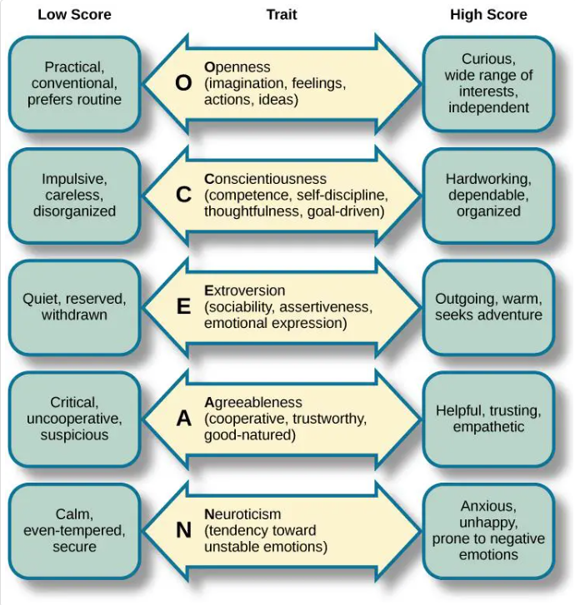
This theory is a good indicator of performance and team dynamics within the workplace; identifying employee personality traits and characteristics can assist employers to predict the impact individuals will have on the workplace (Thomas, 2022). For example, a combination of traits can predict the likelihood of unethical behaviour (Simha and Parboteeah, 2019) and conscientiousness predicts positive job performance and success (Robinson, 2022). These insights can assist organisations to predict behaviour, performance, and outcomes, which will positively influence decision-making.
The combination of personality traits can account for common behaviour at Ateb. The Property Team issues around health and safety indicates low levels of conscientiousness whereby, being impulsive may result in more incidents, or being disorganised and careless resulting in expired training courses. The ‘legacy’ employees demonstrate traits of low agreeableness and high neuroticism as they display difficult behaviour and negative emotions.
Simha and Parboteeah (2019) suggests that organisations complete personality assessments to assist the recruitment process, ensuring managers with the desired traits are appointed, to help achieve the best business outcomes. It is argued that behaviour is not an output of personality traits, as abilities and motives also impact behaviour (Harms and Brummel, 2021) therefore, it is wise to consider the wider context to fully understand the individual.
Ateb has not conducted personality assessments however, it would be beneficial to explore. Understanding team personality traits will assist Ateb to understand how traits may impact teams and performance, positively or negatively, and what traits teams need to flourish during periods of recruitment; knowing the traits of employees will help identify future leaders and delegate work accordingly to achieve success (MSU, 2022).

3.3. Engagement and Motivation
Alike the definition of organisational culture, there is not a universal definition of employee engagement; in fact, the UK Government report, Engaging for Success, identified more than 50 definitions (MacLeod and Clarke, 2009). However, employee engagement definitions tend to include elements of job satisfaction, organisational commitment, motivation, and effort (Bridger, 2018).
A definition of employee engagement is the involvement, satisfaction, and enthusiasm an individual has for their work (Gallup, no date; Harter, Schmidt and Hayes, 2002). Whereas, Engage for Success (no date) states it is creating the right conditions for individuals to demonstrate commitment to the organisation’s vision, be motivated to achieve success, and have a positive sense of wellbeing.
Positive employee engagement can result in improved job satisfaction, positive attitudes around change management, behaviour aligned to the organisational brand, improved wellbeing, reduced levels of absenteeism and turnover (Gifford and Young, 2021b).
Extrinsic (external factors) and intrinsic (internal factors) motivators drive employee engagement; extrinsic factors can motivate through tangible rewards and punishment whereas, intrinsic factors motivate through internal feelings of joy, satisfaction, and challenge (Nickerson, 2021). However, research has proven that intrinsic factors result in better long-term outcomes and drives increased motivation, compared to extrinsic factors (Wrzesniewski et al., 2014). Interestingly, recent research identified key motivation factors which are primarily intrinsically driven including: goal-setting, performance feedback, monetary and non-monetary recognition, line manager interaction, work meaningfulness, psychological safety and job autonomy (Gifford and Young, 2021b).
Ateb must ensure that management is skilled and consistent in their approach to employee interaction, as manager/employee interaction is fundamental in driving motivation and engagement, with their actions having a significant influence on engagement levels. Line managers have the ability to improve the working conditions of their employees for example, supporting wellbeing activities to promote positive wellbeing, and enabling learning to support development (Quilliam, 2022). Gallup (no date) found that individuals are three times more likely to be engaged if they receive daily feedback from their line manager. In addition, recent research found that there was a significant decline in engagement for individuals who did not receive frequent interaction with their line manager (Pass et al., 2023).
Performance feedback is at the core of Ateb’s quarterly appraisal process whereby, managers and employee provide honest feedback regarding their performance, not as a mechanism for criticism but to identify and celebrate successes, and to recognise areas for improvement for professional development (Ateb, 2021c). Pixar Animation Studios believe contributing to their success is honest feedback whereby, when failures happen managers are honest with their feedback to motivate the employee to recover and achieve success (Taylor and Perkins, 2021).
Job autonomy gives employees control over the content, planning and scheduling of their work thus, driving ownership, accountability, independent decision making, and intrinsic motivation, alongside improved performance, and wellbeing (Metin, 2019; Ryan et al., 2019); research found that 79% of employees with autonomy are engaged at work (Metin, 2019). Ateb’s DNA of empowerment lends itself to autonomy, allowing staff to freely make decisions using their best judgement, being accountable, and encouraged to have control over their work within their service area parameters (Ateb, 2019a).
Although, Ateb does not measure indicators of motivation and engagement such as job satisfaction and autonomy therefore, it is unknown whether employees feel autonomous, recognised for their successes, or if management interaction needs improvement. Ateb seeks the temperature of the organisational DNA however, this does not evidence how motivated or engaged the workforce is. Gifford and Young (2021a) notes that measuring DNA can be challenging, although it is important to understand what is working well and identify areas of improvement within the organisation.

3.4. Positive Culture Benefits
Organisations that are known for having positive cultures have environments where employees can thrive and feel fulfilled, wellbeing is prioritised, development is the norm, employees receive recognition, there is psychological safety, and tangible benefits such as flexibility and health coverage (Timms, 2020).
A positive culture isn’t essential for organisations to thrive; consider the Sports Direct scandal where the business was prosperous but the culture was exceptionally poor (Goodley, 2016). However, it will stifle organisations from achieving more as it will lack collaboration, lose talent and avoid tackling and resolving issues (Ryan, 2017); how long can an organisation continue to thrive in those conditions?
A positive culture will drive inclusivity which welcomes diversity, and appreciates, values and respect differences between individuals; inclusive organisations will likely have more diversity, equal opportunities, broader knowledge and skills, be high-performing exceeding financial goals, innovative and achieve superior business outcomes (Atcheson, 2019; Randolph, 2023; Owa, 2022). An inclusive culture links to increased wellbeing as barriers for underrepresented groups are reduced allowing employees to work in ways that suit them, feel valued, and be their true self (Green and Young, 2019); research found that 60%-67% of respondents claimed it was extremely detrimental to their sense of self to ‘mask’ parts of their identity (Yoshino and Smith, 2013) which would impact their wellbeing.
There is a bigger emphasis on managing a diverse workforce due to rising diversity, globalisation and cross-cultural organisations; it is argued that organisational processes, systems and structures do not transfer cross-culturally with ease as culture was not considered during conception (Mullins and McLean, 2019). Work practices will differ across cultures (Figure 2) which can impact management and business relationships. Cultural differences should be identified to understand different behaviours, reduce misunderstandings, foster good relationships and avoid assumptions or stereotyping (Council of Europe, no date).

Figure 2: Cultural Categorisation (Mullins and McLean, 2019).
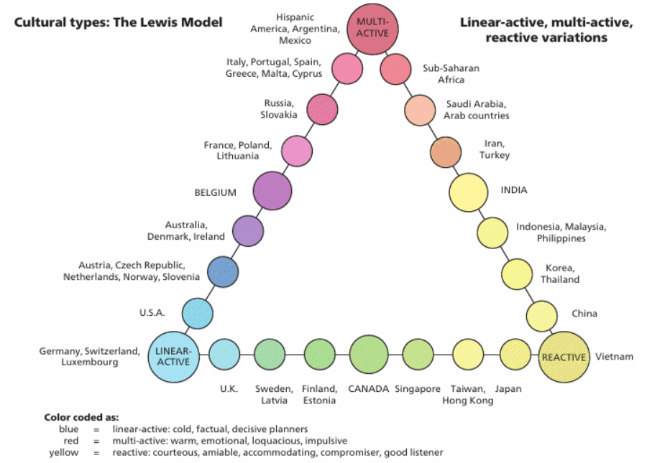
To create inclusivity, organisations must listen and understand the areas of improvement whilst being prepared to investigate and undertake meaningful action, which is crucial as engagement will deteriorate if employees perceive the organisation as taking no action. Moreover, to truly be inclusive, the entire workforce across all levels should be valued and listened to, with lines of communication open between junior and senior staff to create belonging and psychological safety to challenge (Atcheson, 2019; Washington and Patrick, 2018).
Management are central to create a positive culture where wellbeing is prioritised; they should demonstrate their own engagement in wellbeing to create a cascade effect where employees will engage, participate and prioritise their own wellbeing at work (Reilly, 2020).
Working from home has vastly increased since Covid-19, which reflects Ateb as 90% of the workforce are now hybrid workers compared to 0% pre-pandemic. Due to the dispersed nature of hybrid working, organisations can easily become disconnected from its values and strategies, and employees are more likely to experience higher levels of isolation and stress (Claydon and Marlow, 2021; Savage, 2021). A positive culture will foster trust, inclusivity, have psychological safety and positive relationships and interactions between manager and employee therefore, able to create a valued and meaningful environment to hybrid workers and address wellbeing issues before it escalates, despite working distantly from each other (Cook, 2021).
Evidence demonstrates the benefits of having a wellbeing inclusive culture, with a recent study finding high wellbeing in the workplace resulted in increased satisfaction, productivity and profitability (Krekel, Ward and De Neve, 2019). A further study demonstrated that positive wellbeing in the first year will result in increased wellbeing and engagement in the next year (Reilly, 2020) therefore, demonstrating the continued positive impact wellbeing has for the employee and organisation.

- Conclusion
The subject of organisational culture is broad with no one universal definition or culture model therefore, it can be challenging to assess and understand the organisation’s culture. A positive culture creates an environment for all employees to flourish, be their true self, and achieve success; embracing inclusivity and prioritising wellbeing. Culture is linked to positive business outcomes and brings a wealth of benefits to the organisation including engagement, a motivated and healthy workforce, improved productivity and performance, an environment of ethical behaviour and, inclusivity.
Using Schein’s culture model, it indicates that Ateb’s culture does not align with its promoted values and behaviours; furthermore, trends emerging from the analysis are lack of leadership strength and skills, high-intensity working and behaviour not aligned with the DNA. To achieve the true espoused values, Ateb must understand and change the underlying culture which is driving undesirable behaviour.

- Recommendations
Further to the culture analysis, it is recommended that Ateb implements the following recommendations, listed in priority order with estimated costs. Please note, breakdowns of costings are available (See Appendix A).
- Improvement of line management skills
Management is central to embedding a positive culture within Ateb as they are responsible for role modelling and implementing values and behaviours, regularly interact with their teams to drive engagement and motivation, and to monitor and address performance (McCosker, 2021). Data suggests a lack of management skills and strengths whereby, there is a lack of performance management and acceptance of behaviours not aligned with the DNA. Poor line management can result in performance unaligned with Ateb’s vision, poor wellbeing, loss of talent and decreased productivity.
- Deliver a bespoke leadership and management course to equip management with skills to undertake the expected levels of responsibilities, behaviours, and DNA.
3 month leadership course, monthly classroom session, with practical exercises in-between – recommended leadership consultant OPSIS.
- Estimated time
Average manager time of 21 hours classroom plus approximately 12 hours practical
Estimated total £36,164

- Identify and address high-intensity overworking
The purpose of Ateb’s flexible working system is to create work/life balance however, data indicates presenteeism and high-intensity working is being experienced, impacting wellbeing and talent retention.
It is expected a substantial change will occur over a long-term period therefore, this recommendation is the first step which involves educating, understanding, challenging, monitoring, role modelling behaviour and implementing wellbeing champions across the organisation, over a 12 week period.
- Educate HR, Management and Workforce
To include investigative work to identify trends; plus sessions with management and workforce to educate.
- Weekly monitoring of indicators
Managers and HRBP monitoring of indicators to identify if changes are taking place or where more support is needed.
- Wellbeing champions to support workforce
Five training sessions
Estimated total £3,286.28

- Implement a wellbeing strategy
Ateb is experiencing a significant rise of stress cases, which is continuing to grow. Ateb addresses wellbeing reactively and rarely takes a proactive approach; strategic approaches to wellbeing results in more positive outcomes for the organisation and individuals (Sinclair and Suff, 2022; Hesketh and Cooper, 2019). Ateb is experiencing the result of poor wellbeing such as stress cases and presenteeism, which will continue to worsen if wellbeing is not addressed proactively and strategically.
- Creation of wellbeing strategy including preparation, writing, and presenting
- Execute strategy
To include roll-out to the organisation to promote and ensure the workforce understands the strategy, wellbeing management training for managers, delivery of relevant wellbeing activities and monitoring success.
Estimated total £8,573.23

- References
Adler, A.B. et al. (2022) ‘Hitting the Mark: The Influence of Emotional Culture on Resilient Performance’, Journal of Applied Psychology, 107(2), pp. 319–327. Available at: https://doi.org/10.1037/apl0000897
Atcheson, S. (2019) Four Steps to Create a Truly Inclusive Culture. Available at: https://www.forbes.com/sites/shereeatcheson/2019/06/06/four-steps-to-create-a-truly-inclusive-culture/?sh=50dc24181173 (Accessed: 17 February 2023).
Ateb (2018) ‘Ateb – Our Future Workplace’. Ateb Group LTD. Unpublished.
Ateb (2019a) #2 DNA. Available at: https://www.atebgroup.co.uk/wp-content/uploads/2019/11/DNA-Nov-19.pdf (Accessed: 30 January 2023).
Ateb (2019b) Vision of what good looks like for Ateb. Available at: https://www.atebgroup.co.uk/wp-content/uploads/2019/11/Vision-Oct-19.pdf (Accessed: 4 February 2023).
Ateb (2021a) ‘Brand Guide – Version 2.0’. Ateb Group LTD. Unpublished.
Ateb (2021b) ‘SA/14 Wellbeing Performance Measures 21-22’. Ateb Group LTD. Unpublished.
Ateb (2021c) ‘What is Achieve?’. Ateb Group LTD. Unpublished.
Ateb (2022a) ‘SA/14 Wellbeing Performance Measures 22-23’. Ateb Group LTD. Unpublished.
Ateb (2022b) ‘i2i recruitment feedback’. Ateb Group LTD. Unpublished.
Ateb (2022c) ‘2022-2023 Reward Framework’. Ateb Group LTD. Unpublished.
Ateb (2022d) ‘Q3 iHasco data export’. Ateb Group LTD. Unpublished.
Ateb (2023a) ‘SA/15 PM Performance Measures 22-23’. Ateb Group LTD. Unpublished.
Ateb (2023b) ‘DNA & Wellbeing Survey Results’. Ateb Group LTD. Unpublished.
Ateb (2023c) ‘Role Profile A Template’. Ateb Group LTD. Unpublished.
Ateb (2023d) ‘BreatheHR Data Export’. Ateb Group LTD. Unpublished.
Ateb (2023e) ‘Disciplinary, grievance and performance log’. Ateb Group LTD. Unpublished.
Ateb (2023f) ‘Referrals’. Ateb Group LTD. Unpublished.
Ateb (no date) Why us? Available at: https://www.atebgroup.co.uk/about-us/working-with-us/why-us/ (Accessed: 5 February 2023).
Balogun, J. and Johnson, G. (2004) ‘Organizational Restructuring and Middle Manager Sensemaking’, Academy of Management Journal, 47(4), pp. 523 – 549. Available at: https://web-s-ebscohost-com.ezproxy.uwtsd.ac.uk/ehost/pdfviewer/pdfviewer?vid=0&sid=1fd97e31-f749-46aa-bb67-4485fc7c31e3%40redis (Accessed: 30 January 2023).
Bridger, E. (2018) Employee Engagement. A Practical Introduction. 2nd edn. London: Kogan Page.
Buchanan, D. and Huczynski, A. (2015) Organisational Behaviour. Harlow: Pearson Education Limited.
Cherry, K. (2022a) What is Behaviourism? Available at: https://www.verywellmind.com/behavioral-psychology-4157183#toc-criticisms-of-behaviorism (Accessed: 8 February 2023).
Cherry, K. (2022b) What Are the Big 5 Personality Traits? Available at: https://www.verywellmind.com/the-big-five-personality-dimensions-2795422 (Accessed: 13 February 2023).
CIPD (no date) Organisational Culture. Available at: https://www.cipd.co.uk/news-views/viewpoint/organisational-culture (Accessed: 31 January 2023).
Claydon, R. and Marlow, G. (2021) ‘Adaptive cultures: Enabling high-performance hybridity and employee wellbeing’, Governance Directions, 73(8), pp. 320–326. Available at: https://doi.org/10.3316/informit.050657381287364
Clayton, M. (2021) Edgar Schein’s 3 Levels of Organizational Culture. 29 July. Available at: https://www.youtube.com/watch?v=N37Foo0DOgE (Accessed: 1 February 2023).
Cook, S. (2021) Well-being in the workplace: A guide to resilience for individuals and teams. Ely: IT Governance Publishing LTD.
Council of Europe (no date) Language Support for Adult Refugees: A Council of Europe Toolkit. Available at: https://rm.coe.int/tool-4-responding-appropriately-to-cultural-difference-and-managing-in/168071717e (Accessed: 22 February 2023).
Criveanu, M.M., and Ivanescu, C.R. (2019) ‘The Importance of Organisational Culture in IT Companies’, Analele Universităţii Constantin Brâncuşi din Târgu Jiu : Seria Economie, (6), pp. 331-336. Available at: https://www.utgjiu.ro/revista/ec/pdf/2019-06/48_Criveanu.pdf (Accessed: 30 January 2023).
Dauber, D., Fink, G. and Yolles, M. (2012) ‘A Configuration Model of Organizational Culture’, SAGE open, 2(1), article number 215824401244148. Available at: https://doi.org/10.1177/2158244012441482
Davis, P. (2021) 3 Strategies Workers Use To Survive A High-Intensity Workplace. Available at: https://www.forbes.com/sites/pauladavis/2021/02/17/3-strategies-workers-use-to-survive-a-high-intensity-workplace/?sh=2ff6a4344d23 (Accessed: 6 February 2023).
Drew, C. (2022) Behaviorism – Skinner’s Education Learning Theory (27 Facts). Available at: https://helpfulprofessor.com/behaviorism/ (Accessed: 8 February 2023).
Engage for Success (no date) What is Employee Engagement? Available at: https://engageforsuccess.org/what-is-employee-engagement (Accessed: 14 February 2023).
Gallup (no date) What Is Employee Engagement and How Do You Improve It? Available at: https://www.gallup.com/workplace/285674/improve-employee-engagement-workplace.aspx (Accessed: 14 February 2023).
Geller, E.S. (2015) ‘Seven Life Lessons From Humanistic Behaviorism: How to Bring the Best Out of Yourself and Others’, Journal of Organizational Behavior Management, 35(1-2), pp. 151–170. Available at: https://doi.org/10.1080/01608061.2015.1031427
Gifford, J. and Young, J. (2021a) Employee engagement and motivation. Available at: https://www.cipd.co.uk/knowledge/fundamentals/relations/engagement/factsheet (Accessed: 14 February 2023).
Gifford, J. and Young, J. (2021b) Employee engagement: definitions, measures and outcomes. Available at: https://www.cipd.co.uk/Images/employee-engagement-discussion-report_tcm18-89598.pdf (Accessed: 15 February 2023).
Gifford, J. et al. (2019) Rotten apple, bad barrels and sticky situations: an evidence review of unethical workplace behaviour. Available at: https://www.cipd.co.uk/Images/unethical-behaviour-in-the-workplace_report-2_tcm18-57022.pdf (Accessed: 31 January 2023).
Goodley, S. (2016) ‘Culture of fear persists at Sports Direct despite promise to raise standards’, The Guardian, 6 September. Available at: https://www.theguardian.com/business/2016/sep/06/culture-of-fear-persists-at-sports-direct-despite-promise-to-raise-standards (Accessed: 18 February 2023).
Harms, P.D. and Brummel, B.J. (2021) The Big Five Personality-Trait Mistakes. Available at: https://www.talent-quarterly.com/the-big-five-mistakes/ (Accessed: 8 February 2023).
Harter, J.K., Schmidt, F.L. and Hayes, T.L. (2002) ‘Business-Unit-Level Relationship Between Employee Satisfaction, Employee Engagement, and Business Outcomes: A Meta-Analysis’, Journal of Applied Psychology, 87(2), pp. 268-279. Available at: DOI: 10.1037//0021-9010.87.2.268
Hesketh, I. and Cooper, C. (2019) Wellbeing at Work: How to Design, Implement and Evaluate an Effective Strategy. London: Kogan Page.
Hogan, S.J. and Coote, L.V. (2014) ‘Organizational culture, innovation and performance: A test of Schein’s model’, Journal of Business Research, 67(8), pp. 1609-1621. Available at: https://doi.org/10.1016/j.jbusres.2013.09.007
Indeed (2021) What is behavioural leadership theory? Definitions and types. Available at: https://uk.indeed.com/career-advice/career-development/behavioural-leadership (Accessed: 8 February 2023).
Indeed (2022) Organisational culture importance: benefits and examples. Available at: https://uk.indeed.com/career-advice/career-development/organisational-culture-importance (Accessed: 31 January 2023).
Kennedy, H. (2022) The victim-blaming culture of housing associations has trickled down from the government. Available at: https://neweconomics.org/2022/11/the-victim-blaming-culture-of-housing-associations-has-trickled-down-from-the-government (Accessed: 31 January 2023).
Krekel, C., Ward, G. and De Neve, J. (2019) Employee wellbeing, productivity and firm performance. Available at: https://cep.lse.ac.uk/pubs/download/dp1605.pdf (Accessed: 21 February 2023).
Lim, A. (2020) What Are the Big 5 Personality Traits? Available at: https://www.simplypsychology.org/big-five-personality.html (Accessed: 13 February 2023).
Llopis, G. (2017) 5 Reasons Leaders Are Afraid To Challenge The Status Quo. Available at: https://www.forbes.com/sites/glennllopis/2017/08/12/5-reasons-leaders-are-afraid-to-challenge-the-status-quo/?sh=6b44c02226fe (Accessed: 6 February 2023).
MacLeod, D. and Clarke, N. (2009) Engaging for Success: enhancing performance through employee engagement. Available at: https://dera.ioe.ac.uk/1810/1/file52215.pdf (Accessed: 14 February 2023).
Makume, W. and Washaya, Y.Y. (2022) ‘Organisational culture and innovation: testing the Schein Model at a private university in Zimbabwe’, Cogent Business and Management, 9(1), article number 2150120. Available at: DOI: 10.1080/23311975.2022.2150120
McCosker, C. (2021) The role of a manager as a guardian of culture. Available at: https://www.realityhr.co.uk/the-role-of-a-manager-as-a-guardian-of-culture/ (Accessed: 21 February 2023).
McLeod, S. (2022) Behaviourist Approach. Available at: https://www.simplypsychology.org/behaviorism.html (Accessed: 8 February 2023).
Metin, B. (2019) HR Analytics: autonomy and employee engagement. Available at: https://www.effectory.com/knowledge/hr-analytics-autonomy-and-employee-engagement/ (Accessed: 17 February 2023).
MSU (2022) Lead Your Team with the Big 5 Model. Available at: https://www.michiganstateuniversityonline.com/resources/leadership/lead-your-team-with-big-five-model/ (Accessed: 22 February 2023).
Mullins, L, and McLean, J.E. (2019) Organisational Behaviour in the Workplace. Harlow: Pearson Education.
Nickerson, C. (2021) Differences Between Extrinsic and Intrinsic Motivation. Available at: https://www.simplypsychology.org/differences-between-extrinsic-and-intrinsic-motivation.html (Accessed: 15 February 2023).
ONS (2022) Sickness absence in the UK labour market: 2021. Available at: https://www.ons.gov.uk/employmentandlabourmarket/peopleinwork/labourproductivity/articles/sicknessabsenceinthelabourmarket/2021 (Accessed: 5 February 2023).
Osborne, H. (2021) ‘Home workers putting in more hours since Covid, research shows’, The Guardian, 4 February. Available at: https://www.theguardian.com/business/2021/feb/04/home-workers-putting-in-more-hours-since-covid-research (Accessed: 6 February 2023).
Owa, O.A. (2022) ‘Mainstreaming Diversity, Equity, and Inclusion as Future Workplace Ethics: Effect of Diversity, Equity, and Inclusion on Organizational Performance’, in L. Raimi and J. Kah (eds.) Mainstreaming diversity, equity and inclusion as future workplace ethics. Hershey: IGI Global, pp. 28-48.
Pass, S. et al. (2023) Engage for Success UK Employee Engagement Levels 2022: Exploring the impact of the pandemic on employee engagement. Available at: https://engageforsuccess.org/wp-content/uploads/2023/02/EFS-Engagement-Survey-Report-2022_FINAL-VERSION-.pdf (Accessed: 15 February 2023).
Pritchard, A. (2018) Ways of learning : learning theories for the classroom. 4th edn. Abingdon: Routledge.
Quilliam, G.G. (2022) Line managers’ role in supporting the people profession. Available at: https://www.cipd.co.uk/knowledge/fundamentals/people/hr/line-managers-factsheet#8027 (Accessed: 15 February 2023).
Randolph, S. (2023). Inclusive Culture: 5 Ways To Foster Inclusivity at Work. Available at: https://www.indeed.com/career-advice/career-development/inclusive-culture (Accessed: 17 February 2023).
Reilly, C. (2020) Wellbeing Positively Impacts Firm Performance. Available at: https://www.forbes.com/sites/colleenreilly/2020/06/09/wellbeing-positively-impacts-firm-performance/?sh=4a8c76d37cc9 (Accessed: 21 February 2023).
Robinson, B. (2022) One Personality Trait Enhances Job Performance And Success The Most, New Study Finds. Available at: https://www.forbes.com/sites/bryanrobinson/2022/04/03/one-personality-trait-enhances-job-performance-and-success-the-most-new-study-finds/?sh=47fd85402848 (Accessed: 13 February 2023).
Ryan, L. (2017) Ten Unmistakeable Signs Of A Fear-Based Workplace. Available at: https://www.forbes.com/sites/lizryan/2017/03/07/ten-unmistakable-signs-of-a-fear-based-workplace/?sh=7c955d2d1e26 (Accessed: 18 February 2023).
Ryan, R.M. et al. (2019) 'The Nature and the Conditions of Human Autonomy and Flourishing: Self-Determination Theory and Basic Psychological Needs', in R.M. Ryan (ed.) The Oxford Handbook of Human Motivation, (2nd edn). New York: Oxford University Press, pp. 89-110.
Savage, M. (2021) ‘Revealed: rise in stress among those working from home’, The Guardian, 4 July. Available at: https://www.theguardian.com/business/2021/jul/04/revealed-rise-in-stress-among-those-working-from-home (Accessed: 19 February 2023).
Schein, P.A. and Schein E.H. (2016) Organizational Culture and Leadership. 5th edn. New Jersey: John Wiley & Sons.
Simha, A. and Parboteeah, K.P. (2020) ‘The Big 5 Personality Traits and Willingness to Justify Unethical Behavior - A Cross-National Examination’, Journal of Business
Ethics, 167(3), pp. 451–471. Available at: https://doi.org/10.1007/s10551-019-04142-7
Sinclair, A. and Suff, R. (2022) Health and Wellbeing at Work 2022. Available at: https://www.cipd.co.uk/Images/health-wellbeing-work-report-2022_tcm18-108440.pdf (Accessed: 5 February 2023).
Taylor, S. and Perkins, G. (2021) Work and Employment in a Changing Business Environment. London: Kogan Page.
Thomas (2022) What Are the Big 5 Personality Traits? Available at: https://www.thomas.co/resources/type/hr-guides/what-are-big-5-personality-traits (Accessed: 13 February 2023).
Timms, P. (2020) The Energized Workplace. London: Kogan Page.
Washington, E. and Patrick, C. (2018) 3 Requirements for a Diverse and Inclusive Culture. Available at: https://www.gallup.com/workplace/242138/requirements-diverse-inclusive-culture.aspx (Accessed: 17 February 2023).
Wrzesniewski, A. et al. (2014) ‘Multiple types of motives don’t multiply the motivation of West Point cadets’, Proceedings of the National Academy of Sciences , 111(30), pp. 10990–10995. Available at: https://doi.org/10.1073/pnas.1405298111.
Yilmaz, G. (2014) ‘Let’s Peel the Onion Together: An Application of Schein’s Model of Organizational Culture’, Communication Teacher, 28(4), pp. 224-228. Available at: https://doi-org.ezproxy.uwtsd.ac.uk/10.1080/17404622.2014.939674
Yoshino, K. and Smith, C. (2013) Uncovering talent – a new model of inclusion. Available at: https://www.dca.org.au/sites/default/files/06_uncoveringtalentpaper.pdf (Accessed: 17 February 2023).
Young, J. (2005) Organisational climate and culture. Available at: https://www.cipd.co.uk/knowledge/culture/working-environment/organisation-culture-change-factsheet (Accessed: 30 January 2023).

- Appendix A – Breakdown of Costings for Recommendations
Recommendation 1: Improvement of line management skills
- Deliver a bespoke leadership and management course focused equipping management with skills to undertake the expected levels of responsibilities, behaviours and DNA.
3-month leadership course, monthly classroom session, with practical exercises in-between – recommended leadership consultant OPSIS.
£7,500 plus estimated £2,000 additional expenses = £9,500
- Estimated time
Average manager time of 21 hours classroom plus approximately 12 hours practical
33 hours @ £20.20 average management hourly rate x 40 managers = £26,664
Estimated total £36,164

Recommendation 2: Identify and address high-intensity overworking
- Educate HR, Management and Workforce
To include investigative work to identify trends; plus sessions with management and workforce to educate.
- HR Business Partner to explore data further to identify trends across Ateb and teams
37 hours @ £18.12 HRBP hourly rate = £670.44
- Sessions with HR Business Partner and Management to discuss trends, impacts, and how to discourage it
20 hours @ £18.12 HRBP hourly rate = £362.40
- Sessions with HR Business Partner and Workforce to educate against overworking
30 hours @ £18.12 HRBP hourly rate = £543.60

- Weekly monitoring of indicators
Managers and HR Business Partner monitoring of indicators to identify if changes are taking place or where more support is needed.
12 hours @ £18.12 HRBP hourly rate = £217.44
12 hours @ £20.20 average management hourly rate = £242.40
- Wellbeing champions to support workforce
Five training sessions
5x £250 training course = £1,250
Estimated total £3,286.28

Recommendation 3: Implement a wellbeing strategy
- Creation of wellbeing strategy including preparation, writing and presenting
40 hours @ £23.31 HR Manager hourly rate = £932.40
- Execute strategy
To include roll-out to the organisation to promote and ensure the workforce understands the strategy, wellbeing management training for managers, delivery of relevant wellbeing activities and monitoring success.
Roll-out = 15 hours @ £13.73 Advisor hourly rate = £205.95
Training budget = £2,000
Wellbeing activities budget = £5,000
Monitoring success = 24 hours annually @ £18.12 HRBP hourly rate = £434.88
Estimated total £8,573.23

