Michael Folonsho

DS1 – Digital skills

Screenshot/Photo 1
Unidays Is a student discount app that provides special codes for students to find the best deals which offers help with both cost of living and student experience.
It is very user friendly with a simple layout to follow making it accessible to a wider audience, I personally love to use the Nando's discount code to save on meals and sometime even get free food!
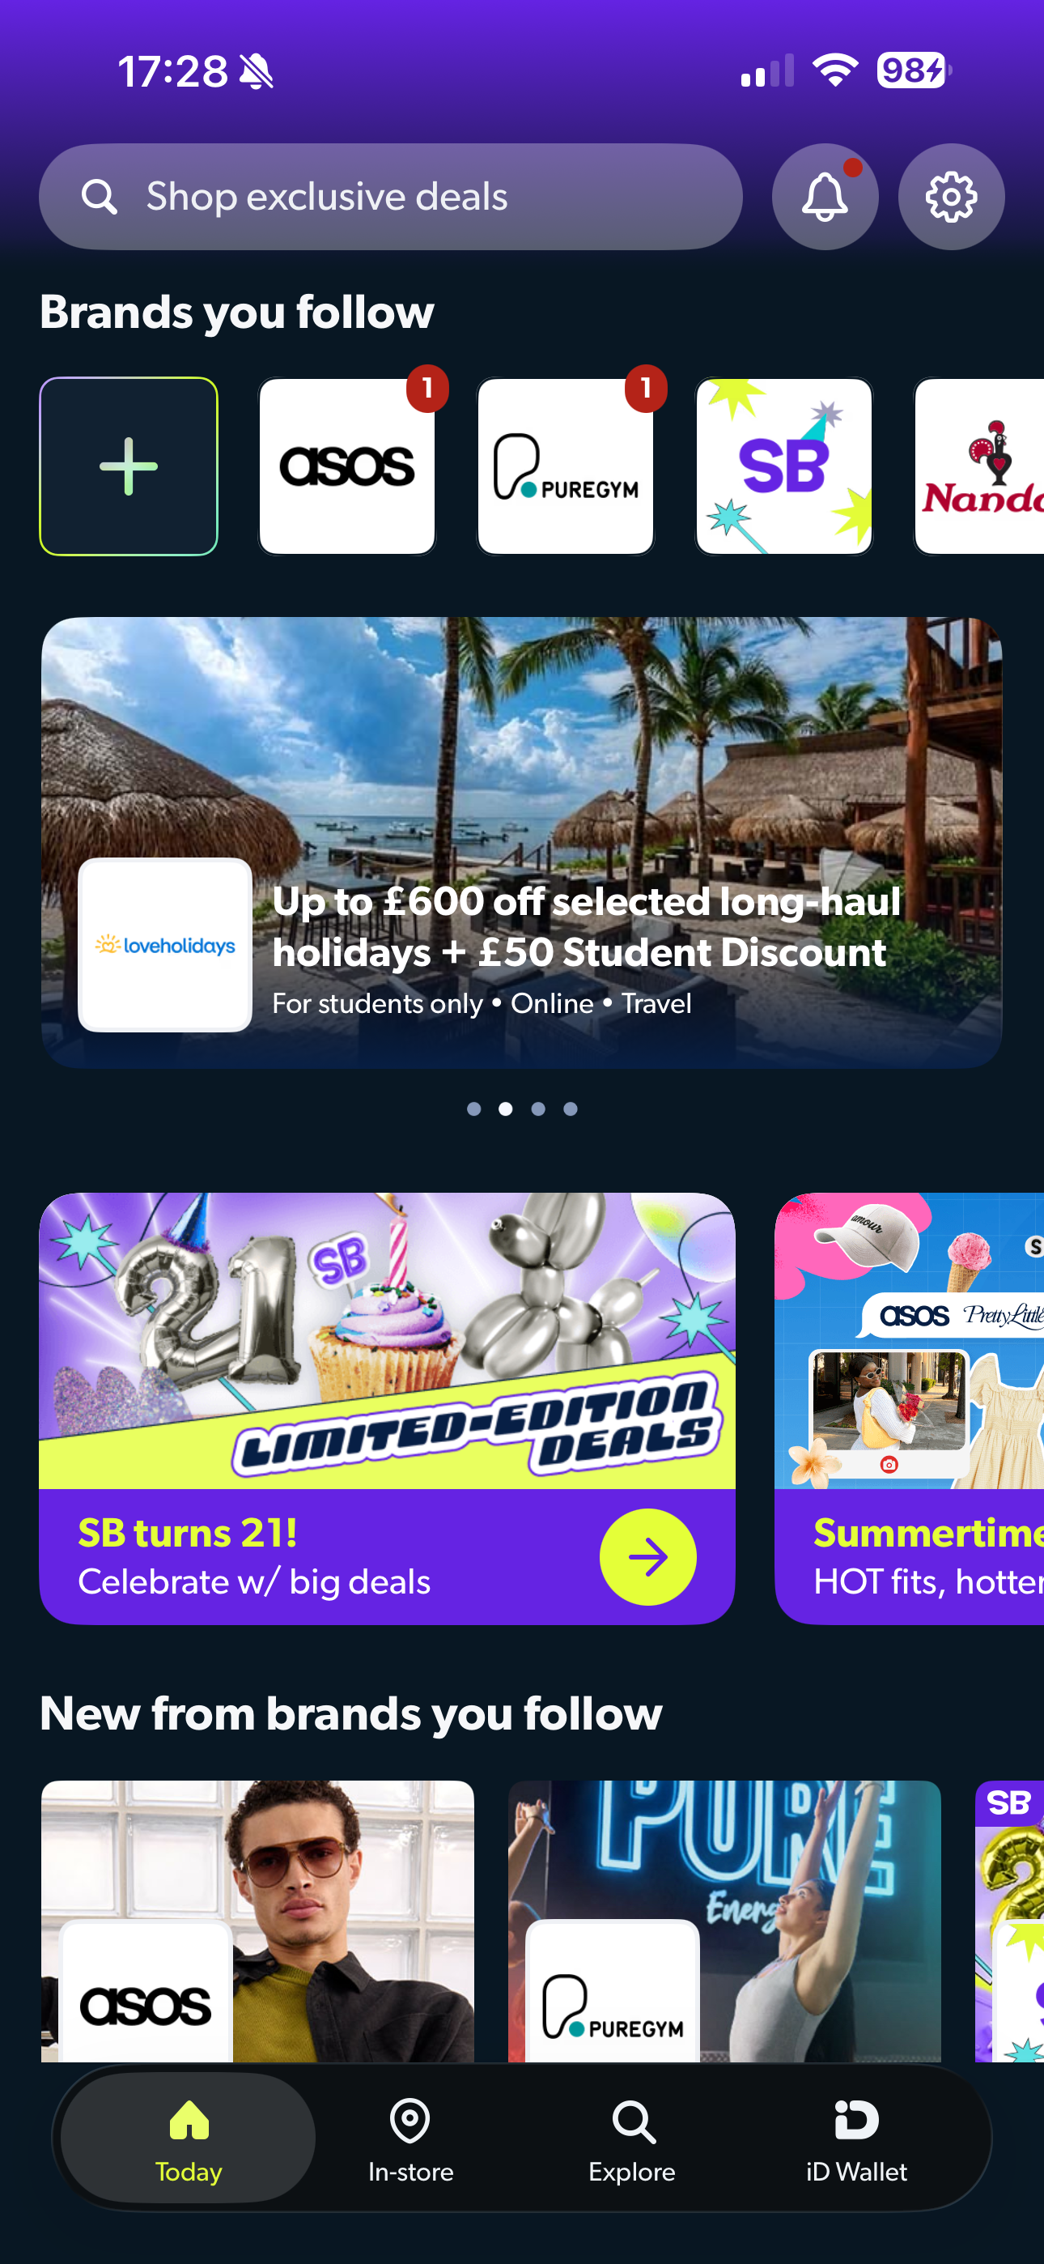
Upon reflection this shows in my digital life I can use search and analysis techniques on a day-to-day basis subconsciously whilst staying current with the latest digital advantages that the older generation like my mother would not have had access to when she was my age.

Screenshot/Photo 2
This App is Eventbrite – I use it to find tickets to events some of the categories of events include networking events, live music, conferences & even dance lessons!
This screenshot shows me looking up property networking events in my local city which is extremely helpful to further grow my business contacts and leads and find out more about the city.
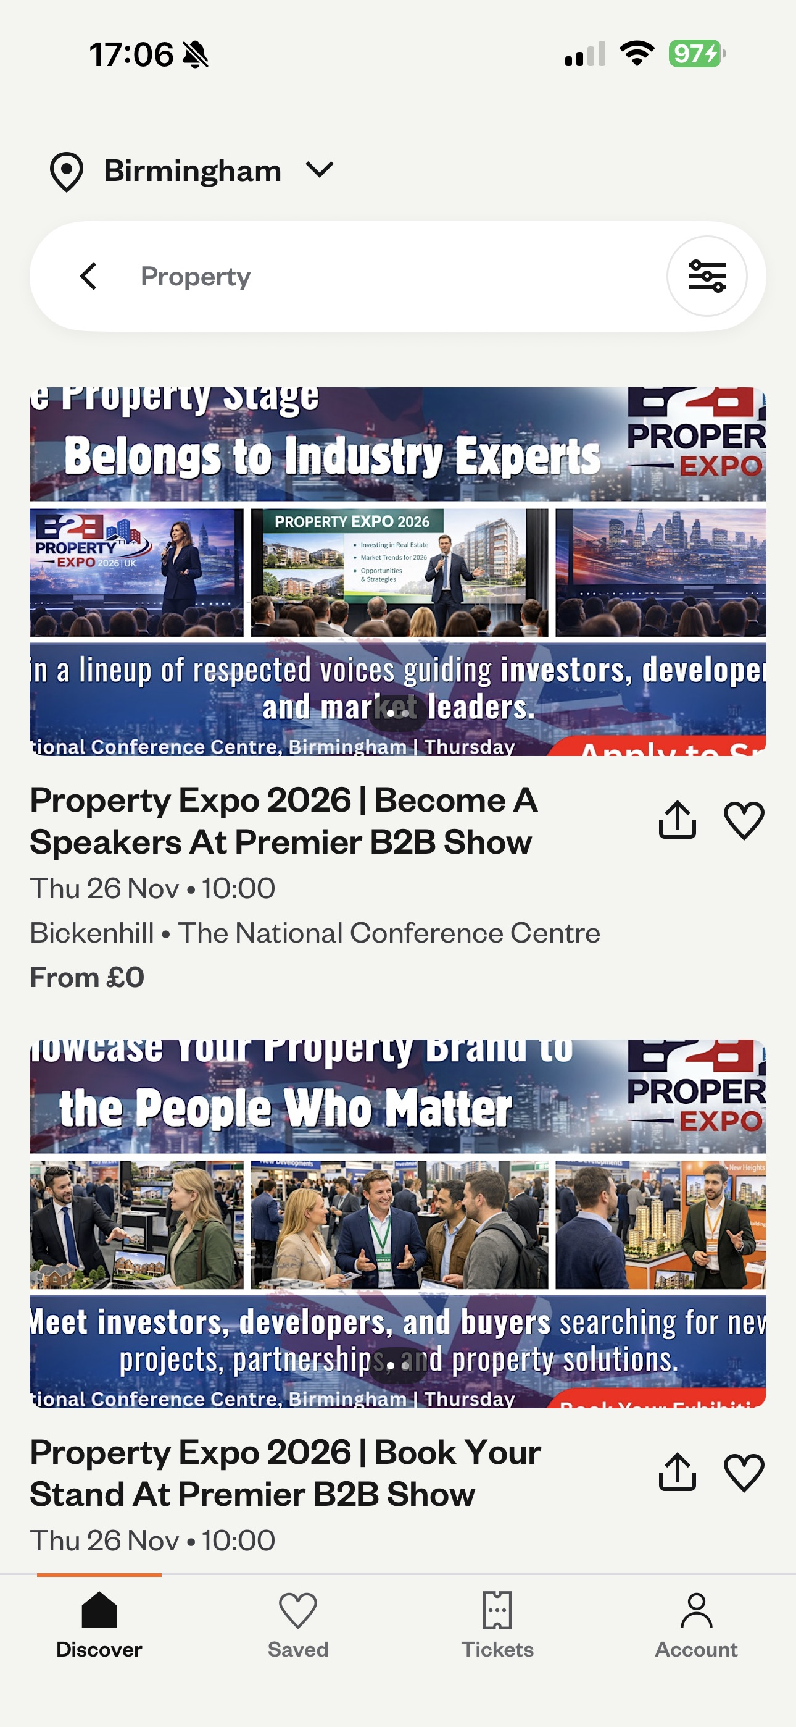
In business using apps like Eventbrite helping with scanning information and analysis in choosing the most relevant events as there are 100s of events and various levels of information and pricing.

Screenshot/Photo 3
This is my productivity folder section.
It has different apps such as google calendar I can use to organise my day and my time around business and studies and personal life you can also see other google connected apps that can linked.
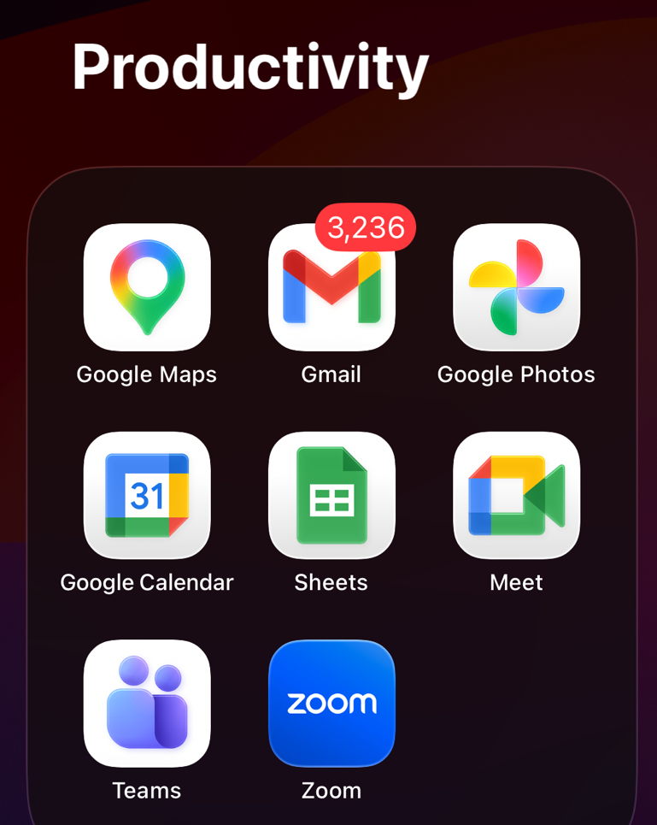
Upon reflection I made this productivity folder to be able to handle daily and weekly tasks both for my personal and business life which helps me grow my organisational and time keeping skills whilst keeping me connected as apps like zoom and teams can be used to do video calls with clients working in different time zones.

Screenshot/Photo 4
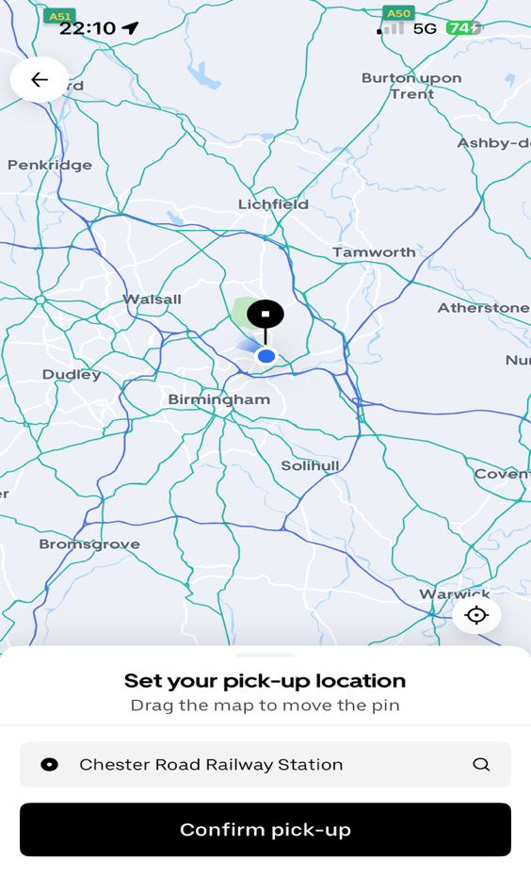
This shows the Home Screen of the uber app which is a taxi transportation that will find your location using gps and book a local cab to come and pick you up from the point shown and take you to your next destination.
This shows my digital skills in being able to navigate my methods of transportation. which in 2026 is essential as again I am carer for my mother, so I get to use this skill to get her to and from her ointments when she is struggling physically and I can communicate with the driver through texts and even leave notes with instructions

Screenshot/Photo 5
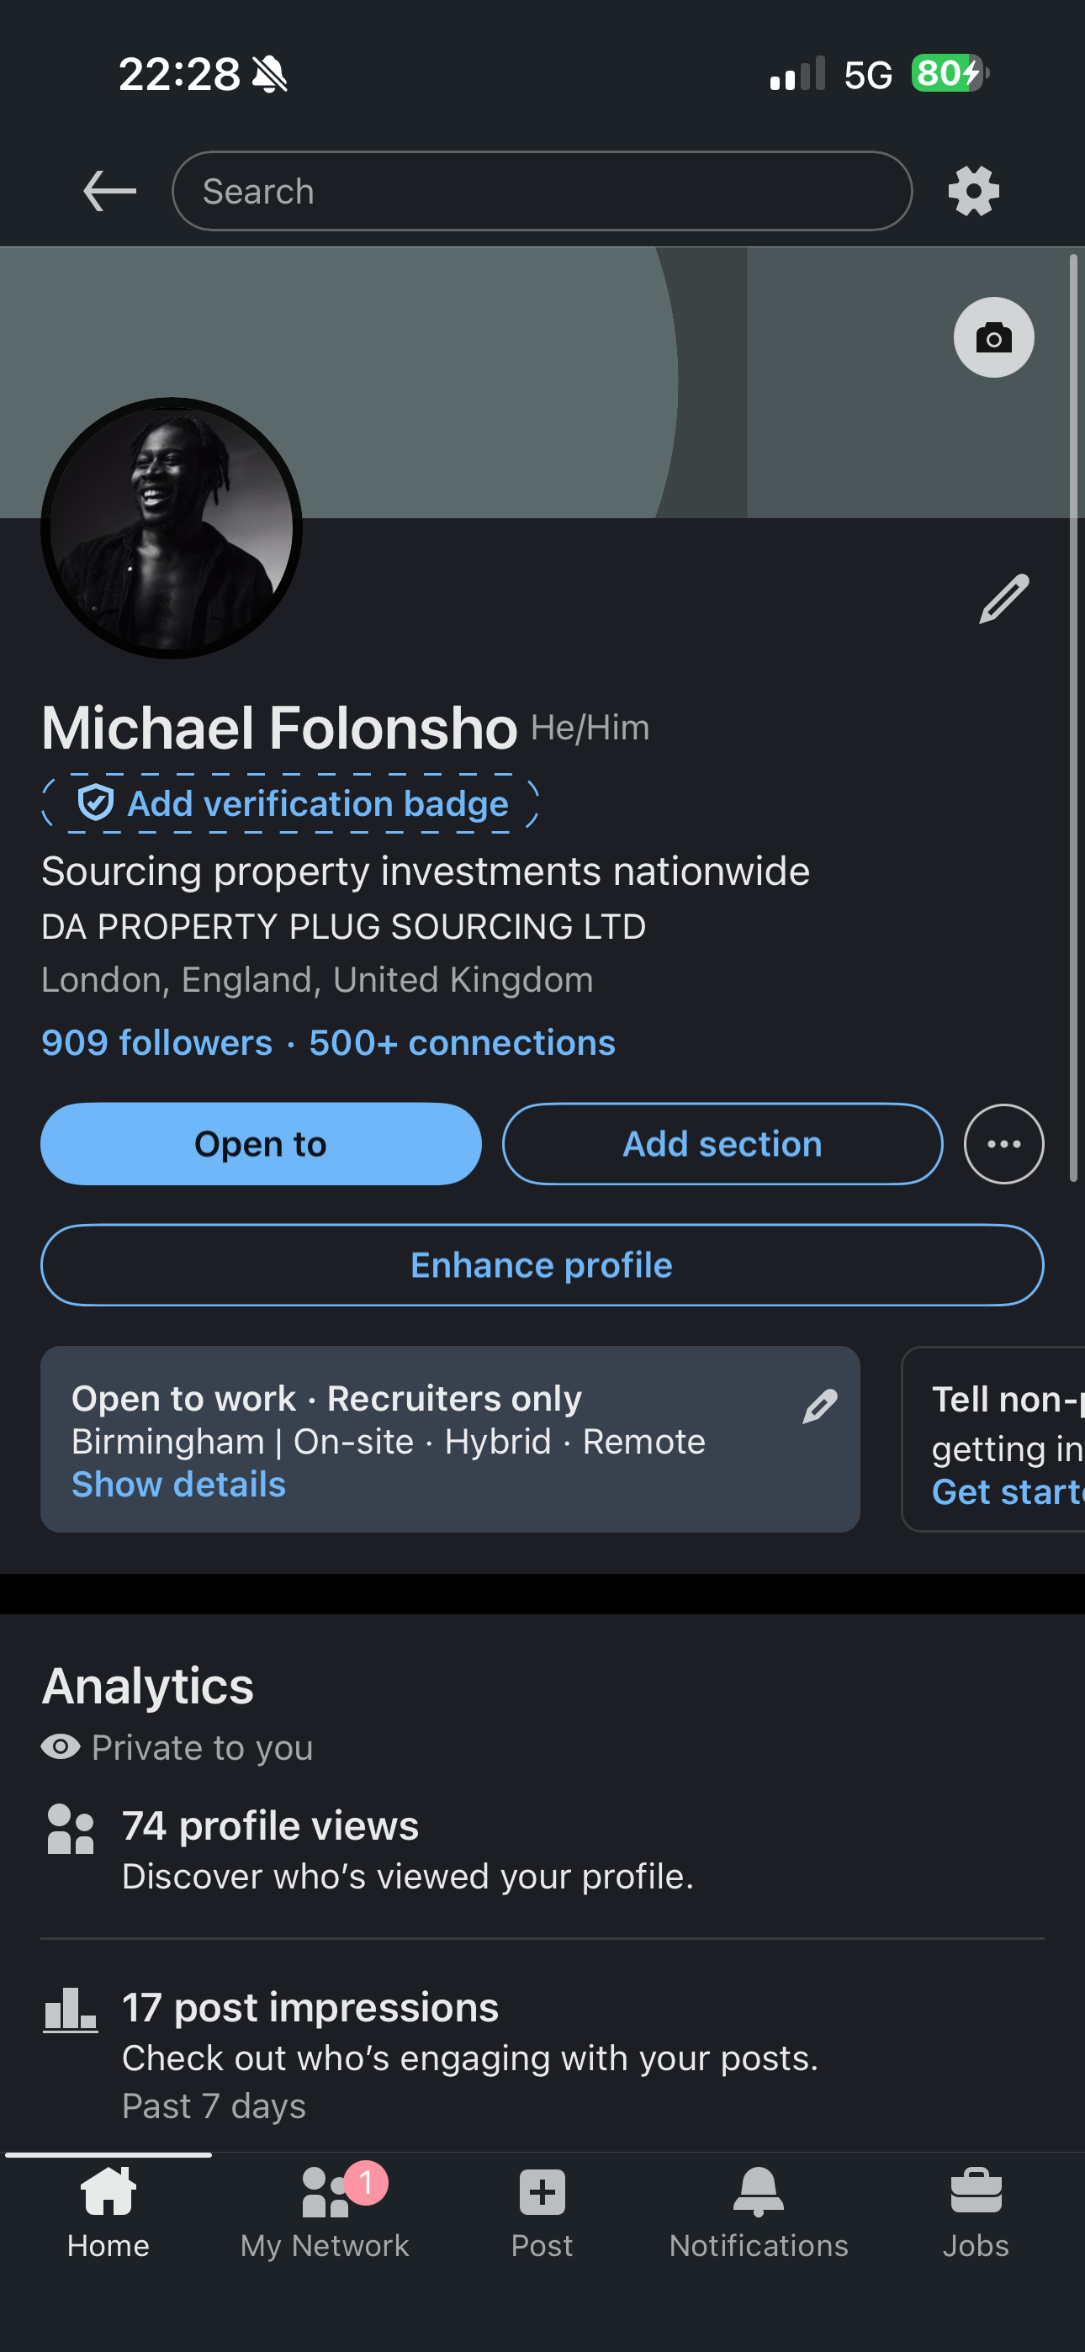
This app is my profile on LinkedIn which is like a professional social media and resumes where professionals meet, and employers can hire fresh staff and professional can share information I use this everyday for my business.

Upon reflection LinkedIn is one of the best platforms to exercise my networking skills and attract new business using information and content around what I do and current trends in the property space

Screenshot/Photo 6
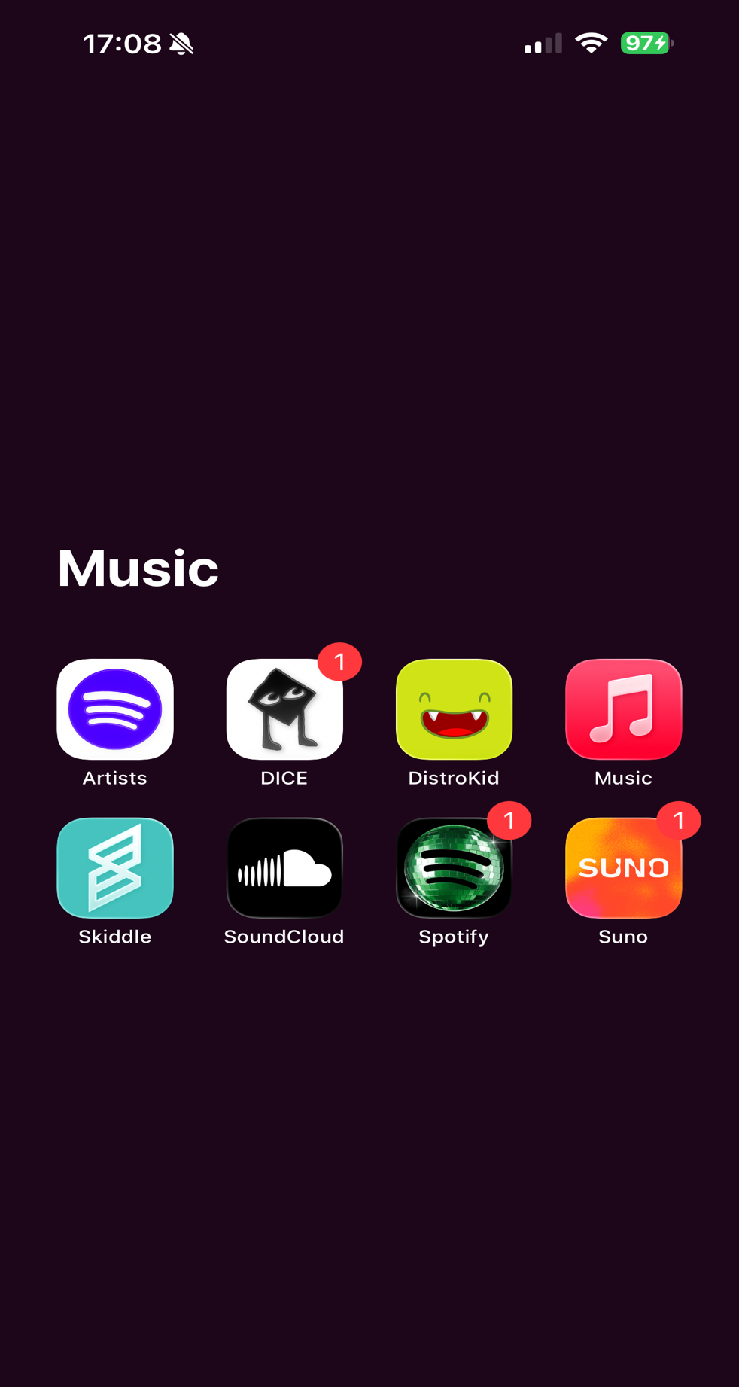
I use my music folder to create and listen to music I am noticeably confident in my use of music apps.

This shows in my digital life I am a music lover! I use an array of different apps to connect with music depending on my mood for example I will use Spotify for playlists and newest music…but I use SoundCloud for lengthy DJ mixes!
This folder has apps to listen, analyse and create music which is beneficial skillset that I can use internally as I am a music artist myself allowing me to stay on top of song organisation and uploads.

My Short Reflection
- Write 5–8 simple sentences about your digital life.
- You can use the sentence starters below if helpful.
I use digital tools to create, assess, and build my business and creative habits as-well as day to day living. This makes me think about the task that we sometimes feel we are not good in some areas like technology but I use a variety of skills and apps everyday to assist with tasks wether extremely important like getting my mum to hospital appointments or small as ordering a takeaway because it’s raining outside.
I feel confident using apps across phones and laptops especially on IOS, but I want to improve on my Microsoft office skills! Especially now being a student, I will be able to understand the fundamentals. By using Microsoft applications such as excel and word to do research and analysis for business and personal challenges going forward
I want to improve on organising my folders for my course work as I need clear structure to optimise my learning

Submission Checklist
Before you submit, please check:
​​​ ☒ I added 4–6 screenshots
☒ I wrote short sentences for each screenshot
☒ I wrote my short reflection
☒ My work is my own
☒ My file opens correctly
​​☒ My file opens correctly

