

BSc (Hons) Health and Social Care

Psychopathological Classifications & Provisions
Module code – BMHP6029 – BIRM
Lecturer – Neale Haddon

Component 1 – Individual Presentation Schizophrenia

Student - Claudia Gomes
Student No - 232679
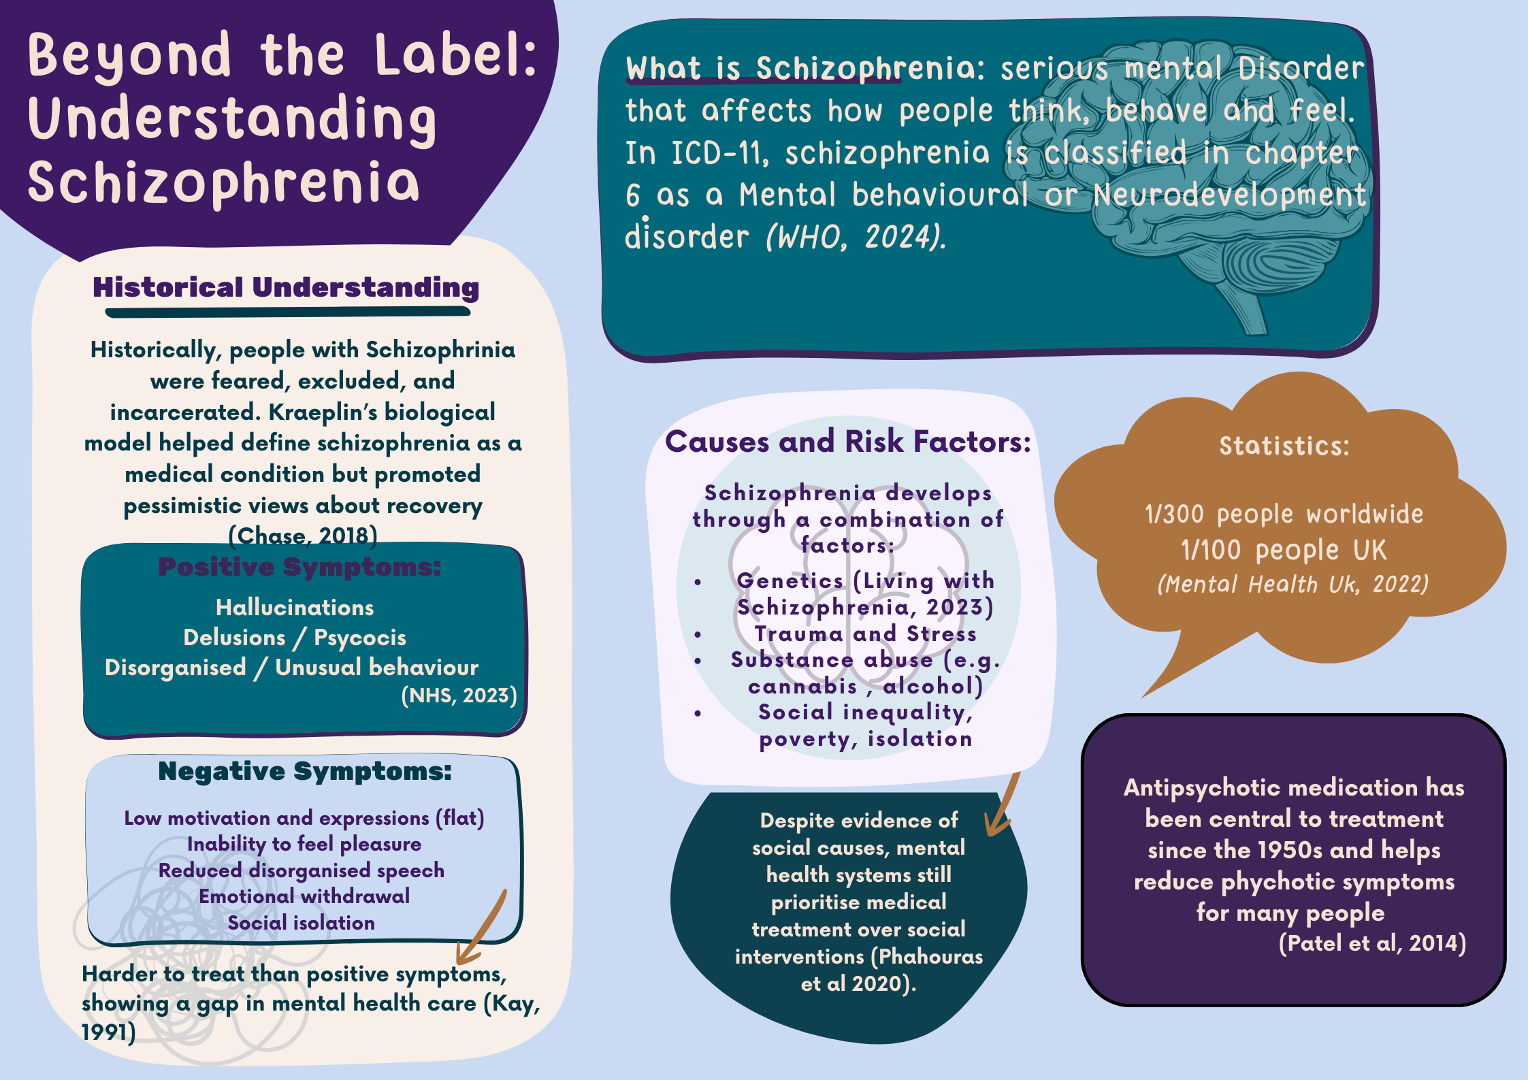

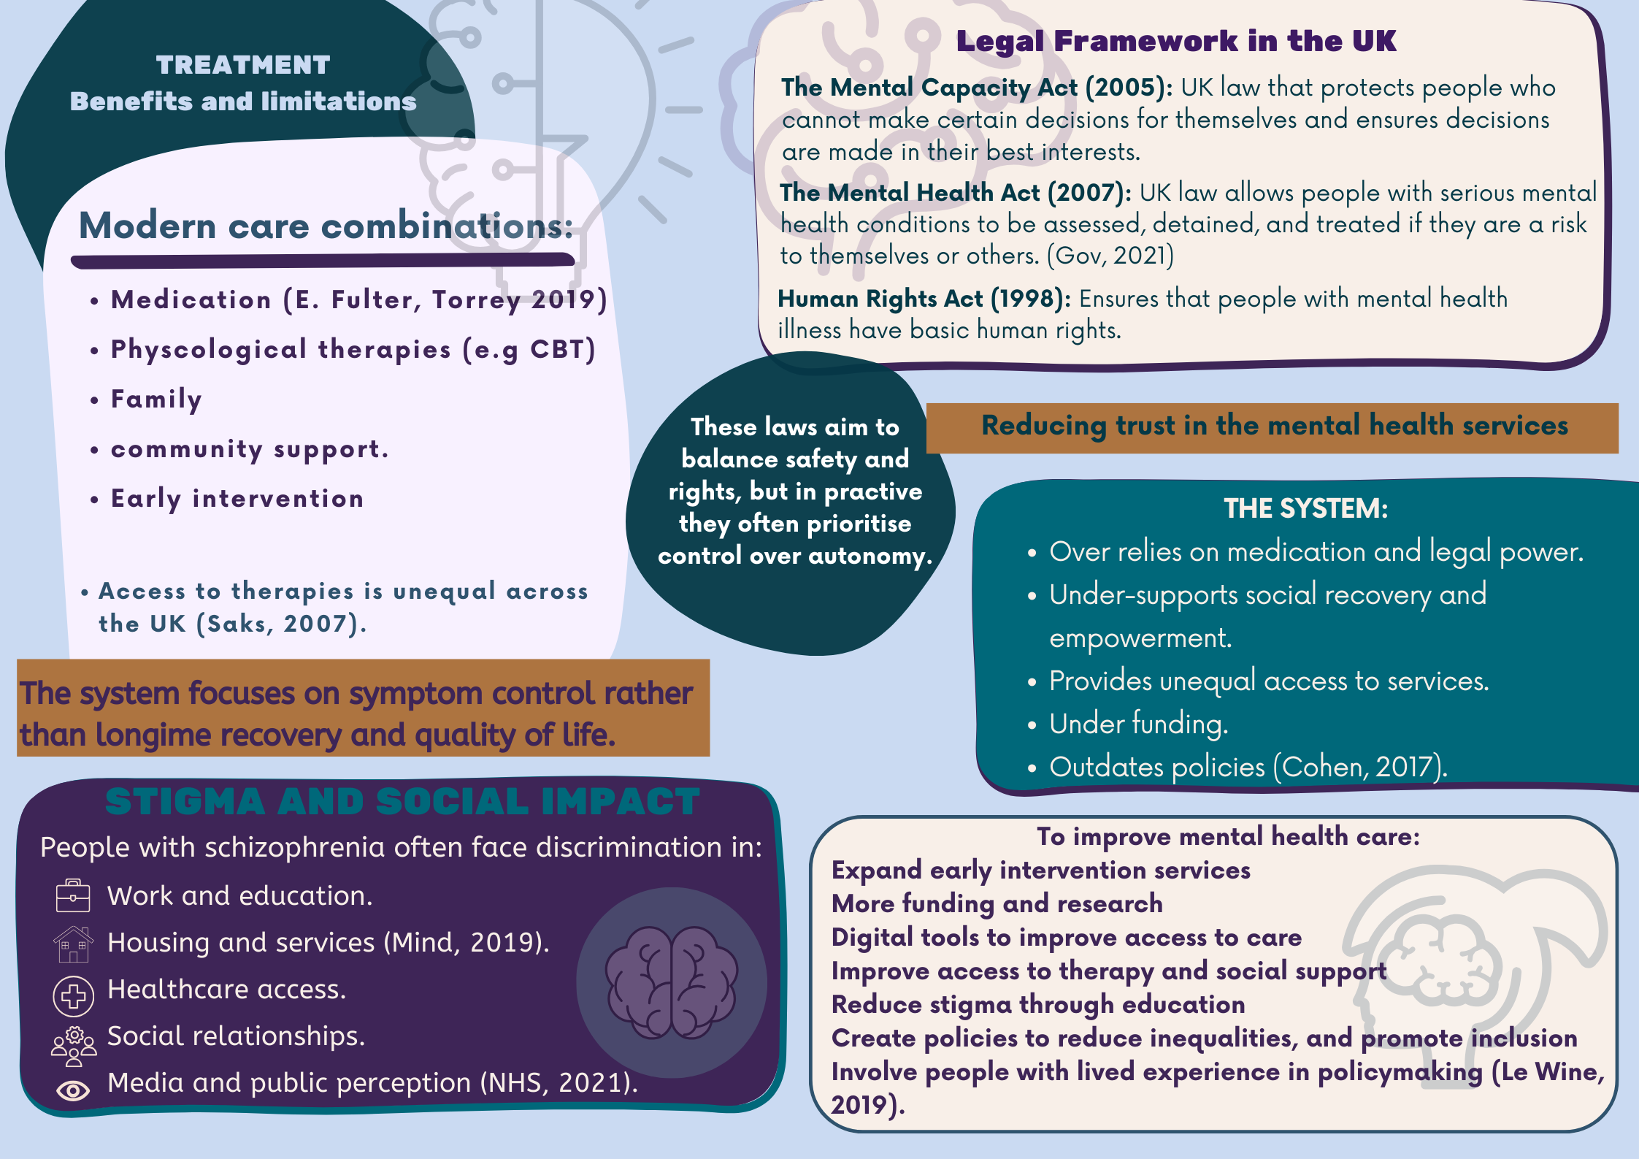

References
- Chase, R. (2018) The making of modern psychiatry. Berlin: Logos Verlag.
- Cohen, N.L. (2017) Public health perspectives on depressive disorders. Baltimore: Johns Hopkins University Press.
- E. Fuller Torrey (2019) Surviving Schizophrenia, 7th Edition. HarperCollins.
- GOV.UK (2021) Mental Health Act 2007: Explanatory notes. Available at: https://www.legislation.gov.uk/ukpga/2007/12/notes/division/6/1?view=plain (Accessed: 29 January 2026).
- Kay, S.R. (1991) Positive and negative syndromes in schizophrenia: Assessment and research. New York: Brunner/Mazel.
- Le Wine, H.E. (2019) ‘Schizophrenia’, Harvard Health Publishing. Available at: https://www.health.harvard.edu/mind-and-mood/schizophrenia-a-to-z (Accessed: 29 January 2026).
- Living with Schizophrenia (2023) Living with schizophrenia: Information and support. Available at: https://livingwithschizophreniauk.org/ (Accessed: 29 January 2026).
- Mental Capacity Act 2005 (2005). Available at: https://www.legislation.gov.uk/ukpga/2005/9/part/1 (Accessed: 29 January 2026).
- Mental Health UK (2022) Schizoaffective disorder. Available at: https://mentalhealth-uk.org/help-and-information/conditions/sch (Accessed: 29 January 2026).
- Mind (2019) Understanding schizophrenia. Available at: https://www.mind.org.uk/information-support/types-of-mental-health-problems/schizophrenia/understanding-schizophrenia/ (Accessed: 27 January 2026).
- NHS (2021) Living with schizophrenia. Available at: https://www.nhs.uk/mental-health/conditions/schizophrenia/living-with/ (Accessed: 29 January 2026).
- NHS (2023) Symptoms – schizophrenia. Available at: https://www.nhs.uk/mental-health/conditions/schizophrenia/symptoms/ (Accessed: 27 January 2026).
- Patel, K.R., Cherian, J., Gohil, K. and Atkinson, D. (2014) ‘Schizophrenia: overview and treatment options’, Pharmacy and Therapeutics, 39(9), pp. 638–645. Available at: https://pmc.ncbi.nlm.nih.gov/articles/PMC4159061/ (Accessed: 29 January 2026).
- Plahouras, J.E. et al. (2020) ‘Experiences with legally mandated treatment in patients with schizophrenia: A systematic review of qualitative studies’, European Psychiatry, 63(1). Available at: https://doi.org/10.1192/j.eurpsy.2020.37.
- Saks, E.R. (2007) The center cannot hold: My journey through madness. New York: Hachette Books.
- World Health Organization (2024) International statistical classification of diseases and related health problems (11th edn), chapter 06: Mental, behavioural or neurodevelopmental disorders. Available at: https://icd.who.int/browse11/l-m/en#/http://id.who.int/icd/entity/1410080352 (Accessed: 27 January 2026).

