Assignment 2

TASK A.

A production area in a factory measures 60 metres x 24 metres x 8 metres in height.
The factory’s work benches are set at a height of 1m above the floor level.
The area’s reflectance’s are 0.3 for the ceiling and 0.5 for the walls.
The Lighting design specifies Fluorescent lamps in recessed louvre with DLOR of 50%.
(The actual size for the luminaires is 1200mm (1.2m) in length and 200mm (0.2m) wide.)

A Lighting Design Lumen (LDL) output of 18,000 lumens is required.

The illumination required for the factory area is 200 lux at the working plane.
Light Loss Factor = 0.75

1: Calculate:

1) The Room Index
2) The Utilisation Factor (from tables)
3) The Number of lamps required
4) A suitable layout (value of S) for the lamp fittings

1. Calculations
Key for Room Index
RI – Room Index
L – Length of Room
W – Width of Room
Hm – Height of Luminaires.

The Room Index

RI = (L x W)
(Hm (L + W)

Hm = 8 – 1 = 7

L = 60

W = 24

RI = (60 x 24) = 2.45
(7 (60 + 24)

The Utilisation Factor (from tables)

Reflectance

Ceiling = 0.3

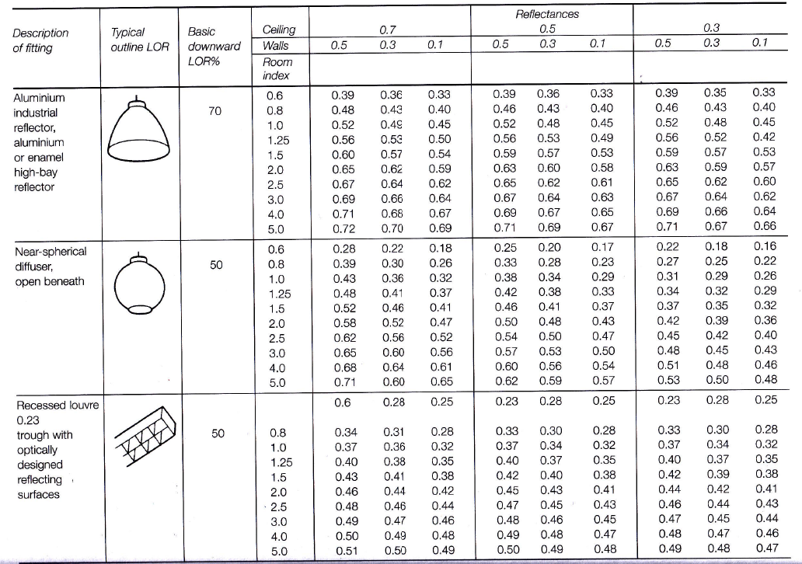
Walls = 0.5
Utilisation Factor Value = 0.46
Key for Number of Lamps
E = Illuminance level needed (LUX)
A= Area of Plane Height
F= Average Lux (1m)
UF= Utilisation Factor
LLF= Light Loss Factor
Number of Lamps

Number of Lamps = E x A
F x UF x LLF

Number of Lamps = 200 x 1440
18,000 x 0.46 x 0.75

Number of Lamps = 288,000
6210
These 47 Lamps round up to an even 48 when considering the 70% rule, this makes it easier to layout the lamps.

Number of Lamps = 46.38 when rounded up = 47 Lamps

A suitable layout (value of S) for the lamp fittings
Key for Suitable Layout
Hm – Height of Luminaires.

Smax = 1.5 x Hm

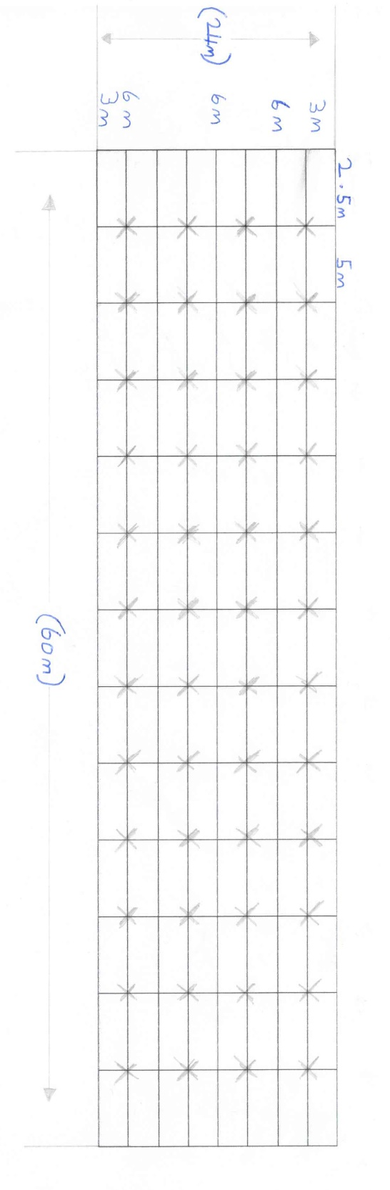
Smax = 1.5 x 7

Smax = 10.5

2. Drawing

Draw the plan layout on a scale drawing of the factory floor indicating. Your ‘best fit’ design for the luminaire installation. Points on the row layout should indicate the position of the lamp centers. You may use a software design package to generate your layout or draw this layout neatly by hand and to scale.

Assignment 2

TASK B.
A brick wall of area 20m² contains a window of area 4m². The values of sound reduction indexes are: 50dB for the brickwork and 10dB for the window.
Calculate the overall sound reduction index for the entire wall.

1. Calculations

Brickwork Part 1

SRI = 10 x (log10 (i/T)

50 = 10 x (log10 (i/T)

5 = log10 (i/T)

i/t = 10⁵

T = 10‾⁵

T = 0.000010

Brickwork Part 2

T = (T1 x A2) + (T2 x A2)
A1 + A2

T= (0.000010 x 16) + (0.10 x 4)
16 + 4

T = 0.000010 + 0.4
20

T = 0.40016
20

T = 0.020008

Window

SRI = 10 x (log10 (i/T)

10 = 10 x (log10 (i/T)

1 = log10 (i/T)

T = 10‾¹

T = 0.10

Sound Reduction Index

SRI = 10 x (log10 (i/T)

SRI = 10 x (log10) i/ 0.020008

SRI = 10 x (log10 (49.98)

SRI = 10 x 1.6987

SRI = 16.987

Overall Sound = 17db

2.Written Section

Discuss the implications of frequency and wavelength in internal sound management, partition wall construction technique and insulation choice. (500 words)

I will start this written section on a small introduction on exactly what sound is. They are disruptions that travel through the air with occurrences of vibration which can be either too high (which we call ultrasound), or too low (which we call infrasound) to be actually heard with a person’s ears.

Sound is measured in decibels and its these units which are taken strongly into consideration when discussing and deciding on sound management with certain partition wall construction techniques and insulation choices.

Now controlling sound measurement can be done in different ways, it starts before the design of acoustic management to weaken the noise at its foundation. The most common and simple way is to just move the foundation of sound further away or to a different location, this way its noise won’t grasp a noticeable level of volume of anyone listening.

Repairing or retuning the foundation of the sound / noise. The task of doing said repair is as simple as tightening loose and vibrating screws or bolts.

When working out what a sufficient amount of sound a room has, you must consider the volume of the room (measured in m³) and various additions to said room, these including plasterboards, plastic tiles, or plaster on brick. All of these items have different rates of absorption coefficients. You can multiply the coefficients by the area of the item to find out the sound absorption of that surface with the item on or near.

Plasterboards will be a specific item to consider when on the subject of partition or stud walls. Vertical beams within said partition walls called studs are needed for practical partitions to support structural loads, and these decrease the and also complicate theoretical modelling. Sound can travel through the airgap between the two boards, and also the steel frame provides a structural route for sound transmission. This meaning these partition walls need insulation but an option of insulation with good soundproofing.

As for insulation there are a few options that are great for sound control or soundproofing these include.

- (Any Branded) Rock board - is rigid mineral wool panel product ideal for use as noise and thermal barriers. Rock board has slightly lower sound absorbing performance, particularly at lower frequencies, they have enhanced thermal insulating abilities. With R-values over 4 per inch, products could be used on the inside to soundproof exterior walls on top of standard thermal insulation.

Rockwell Fire & Soundproof Insulation - soundproof insulation is a stone wool insulation product for use in interior wall partitions of residential wood and steel stud construction. It is especially useful when superior fire resistance and acoustical performance are required.

In my personal opinion I would use Rockwell insulation between the partition walls as it is very efficient for soundproofing and comes at a cheaper price than most over soundproofing insulation methods.

