Heather Kelman
1704216
Word count: 2264
Julia Lockheart

Looking at my own practice, something which has always interested me and something which I love is the botanical world. Nature and particularly the botanical kingdom are something which largely inspires a lot of the work which I produce. As I have learnt and developed over time, it has become an important part of my practice to start questioning everything I do, understanding why I have created something and what it means to me is key to making each design feel resolved. Flora and fauna are a very strongly reoccurring theme within my illustrations and designs and upon questioning these themes, the idea of biophilia came to my attention.
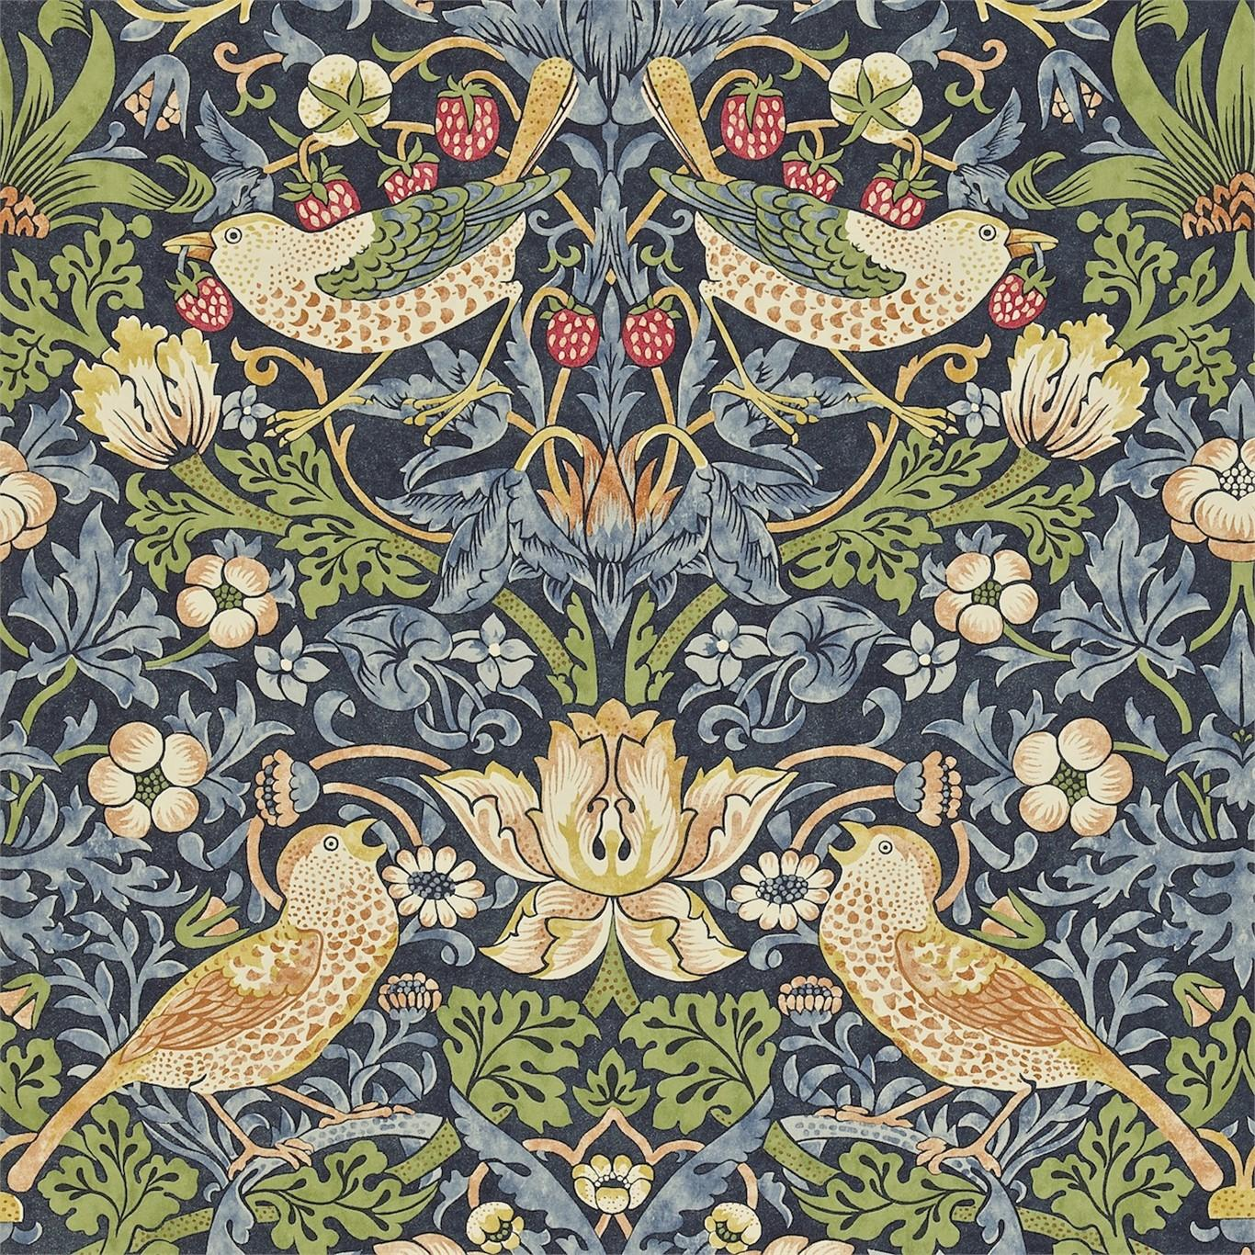
Biophilia can be defined as ‘love of living things and nature, which some people believe humans are born with.’ (Cambridge English Dictionary). The Biophilia hypothesis is a relatively new concept only introduced in 1984 by Edward O. Wilson. Wilson describes Biophilia as ‘the innate tendency to focus on life and lifelike processes’ (2009, p1). The biophilia hypothesis looks at the idea of human tendency to seek or make connections to nature. This theory can be looked at from an interior perspective as interior pattern stretching back to historical times and now in modern day interior design is heavily influenced by flora and fauna. Examples of historical biophilia can be seen in works the likes of William Morris and C.F.A Voysey. Figure 1 shows an example of William Morris’s ‘strawberry thief’ wallpaper design and clearly depicts various types of flora and fauna inspired by his natural surroundings, Morris used flora and fauna as the key element of his work, often stylising the various plants and animals which he chose to paint, however it is very clear that this was his muse. Equally in Figure 2 is a piece of work by C.F.A. Voysey. Voysey ‘The Anslem wallpaper’ used bright and exciting colours to bring the design to life, and like Morris, Voysey used a stylised version of the botanises which he chose to draw. Both of these designers have been cautious to ensure that the flora and fauna which they are drawing can still be identified as the species which it is, as opposed to being unidentifiable foliage. Particularly I find the concept of wanting nature as part of our interiors within our homes to be quite an interesting concept, why is it that we have such a great affinity to these natural forms as oppose to things such as toys or machinery?
Fig. 1
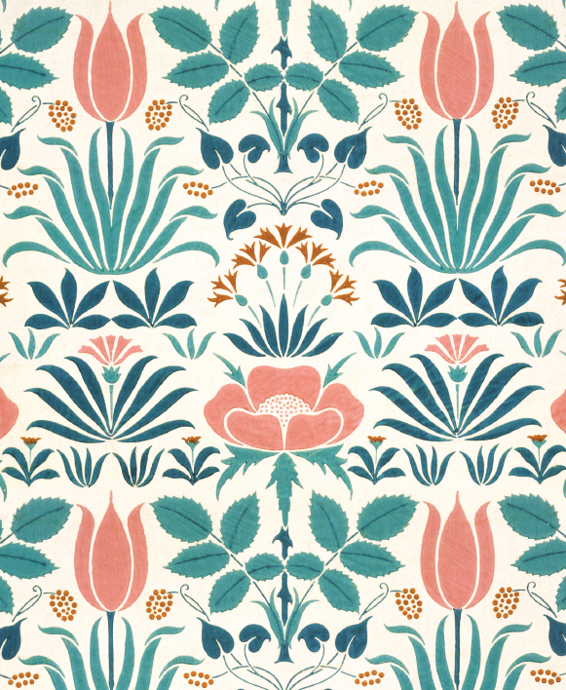
Fig 1
Fig. 2

I am interested in the reason for this deep love and fascination with nature, why it is such a huge part of modern-day design and how it has come to be are deeply compelling questions. Our deep love of nature and the want to surround ourselves with it both indoors and out can be explained by evolution. Stephen R. Kellert writes ‘We evolved in the in the company of other creatures and in a matrix of conditions making this varied existence possible’ (2003, p1). This quote suggests that we are programmed to crave the surrounding of nature because it has led to the development of us as modern day human beings, we have evolved in the company of nature and from nature and thus we have developed to cope with various types of weather conditions, and so it would only make sense for us to want to be around these environments, this is our natural habitat. Kellert quotes Wilson who goes on to say ‘people can grow up with the outwards appearance of normality in an environment largely stripped from plants and animals… yet something vitally important would be missing, not merely the knowledge and pleasure that can be imagined and might have been, but a wide array of experiences that the human brain is peculiarly equipped to receive.’ (2003, p2) I found this quote particularly interesting because it heavily supports the idea of biophilia being a cause of evolution and the result of industrialisation. It can be argued that the reason for this human fascination with the natural world is purely selfish. Kellert mentions in his book Kinship to Mastery, ‘we valued nature and living diversity because of the adaptive benefits it offered us physically, emotionally and intellectually’ (2003, p3) which really suggests the idea that actually the reason that our species is so transfixed with nature is because of our need to survive as a species. Humans rely on plants and animals to eat, on water to drink and on stone and mud and wood to build and adapt, and so this notion of loving and tending to nature could simply be down to our genetics and our ability to develop as a species.
Over time humans have become more and more industrialised and for the most part in city communities a lot of the natural diversity which was once present has been destroyed, built on or lost in giant ‘concrete jungles’. (1996) The term ‘Concrete jungle’ also stands out as a particularly interesting common biophilic reference, the idea of likening something manmade, harsh and forced to naturally occurring forms and cycles is a complete juxtaposition, perhaps created to fool our senses into believing that these new concrete landscapes are our correct surroundings.
Examples of architecture inspired by nature can be seen all over the world, heavily adorned engravings and detailed finishing can be seen in period buildings and modern-day builds alike, again this idea of a juxtaposition can be seen with the idea of a flower carved out of stone. As we have continued to revolutionise the way in which we build and design and create things in a modern world riddled with a climate crisis, biophilic design has come to light as a fascinating solution. Biophilic design ‘uses these ideas as principles to create a human centred approach that when applied improves many of the spaces that we live and work in today, with numerous benefits to our health and well-being.’ (Biophilic design:2019)
This way of designing incorporates all the elements of nature to bring together a building which works in harmony with its surroundings. Whilst some forms of biophilic design aren’t necessarily sustainable, it has become increasingly popular to harness sustainable design methods and also processes which make the most of nature. Examples of these natural processes include solar panels and compostable toilets.
It can be argued that as we have become more advanced and we have created more and built more, that our species is slowly losing touch with the very thing that shaped us. Timothy Beatley carried out a survey on postgraduate students, he showed them images of native common species of flora and fauna and asked if any of his students were able to identify them, the outcome of the survey showed that only one student was able to identify a species. Beatley goes on to state ‘For most of the current crop of young adults, nature is fairly abstract and rather general. They grew up in an age of computer games, indoor living and diminished free time. It is probably not surprising that common species of flora and fauna are not immediately recognisable, but it is an alarming indicator of how we have become disconnected from nature.’ (2011, p1) The idea of nature becoming more ‘abstract’ is a concept which I would like to think more about throughout my research into the dissertation. The way in which the word ‘abstract’ has been used to describe the lack of natural knowledge which has slowly come to light is quite a fascinating concept, suggesting that overtime humans have stopped identifying specific species of plants and animals and that slowly these things have merged into their much broader umbrella terms. Biophilia can mean different things to different people around the globe, depending on their cultures and the natural formation of their landscapes.
A topic which has stemmed from biophilia is Biomimicry. Biomimicry can be defined as ‘an approach to innovation that seeks sustainable solutions to human challenges by emulating natures time tested patterns and strategies.’ (Biomimicry:2019) Biomimicry is quite a fascinating approach to biophilia because this too, is an example of how human beings are able to use nature to our advantage. Natural processes and cycles are used as inspiration or mimicked to engineer things such as machinery which aid us in our lives and allow us to make technological advances. Janine M. Benyus says ‘Unlike the industrial revolution, the biomimicry revolution introduces an era based not on what we can extract from nature, but on what we can learn from her’. (1997, p2) This biophilic study of the world around us can be traced back centuries, examples including Leonardo Da Vinci’s ‘flying machine’ shown in reference 3 mimicked the wings of birds and bats with the hopes of being able to fly like them. Whilst his flying machine was unsuccessful for flight, the principles and ideas which Da Vinci put forward allowed for other people to start thinking in this way. Slowly we are learning about how nature works and how it has created everything so harmoniously and in a way that works simply and effectively. From a textile design perspective, Biomimicry has huge influences on the materials that we use today. George de Mestral invented velco in 1948 after a burr became attached to his trousers, upon inspection of the burr he discovered tiny hooks which could grasp and so using manmade materials Mestral was able to mimic the design of these hooks which the burrs had and thus velco was created. ‘After 3.8 billion years of research and development, failures are fossils, and what surrounds us is the secret to survival’ (1997, p3). This extract from Benyus’s book ‘Biomimicry: Innovation inspired by nature’ was really exciting to me. This suggestion that actually all that exists in the natural world today is everything we need to learn from to survive is a fascinating thought, these are the tried and tested methods of our world and they have been developing and changing to perfect themselves over millions of years. These careful methods are something which we could not create ourselves. Benyus goes on to say ‘The more our world looks and functions like this natural world, the more likely we are to be accepted on this home that is ours, but not ours alone’. (1997, p3) This suggests the notion that if we start to use methods which work more harmoniously with the earth rather than forcing our own which don’t support other means of life and take away from the environment rather than working alongside it, then we will be able to live sustainably here for a longer period of time.
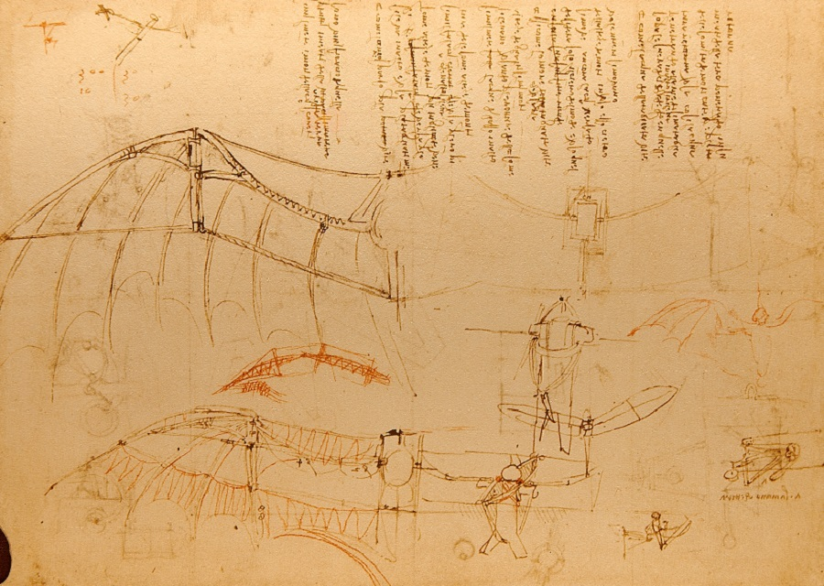
Fig.3

Meta-design is a solution to this idea of biomimicry, meta-design ‘is an emerging conceptual framework aimed at defining and creating social, economic and technical infrastructures in which new forms of collaborative design can take place. It consists of a series of practical design-related tools for achieving this.’ (Metadesign:2019) Metadesign uses a collaboration of designers to create solutions with a view of improving our way of life, inspired by the natural processes which happen in and around us. Meta-design is all about re-designing design, ‘now it is true that Aristotle attached moral value to the final states – he asserts that the end towards which things naturally tend are good. But there is no reason we can’t jettison this part of the theory while retaining the essential framework of explanation by appeal to natural goals’ (2014, p158) this quote by Benjamin C. Jantzen talks about this idea that design doesn’t have to have a final destination. The world is ever changing and slowly over time everything on earth will change and adapt to fit its new environment as it changes to accommodate human habits, the same thing must happen to design. There will always be room for improvement or adaptation to ensure that everything works the very best that it can in its surroundings, and this is what metadesign is able to address. This advance in our learning and understanding could be an exciting way to solve vast problems with human life.

Through looking at these three words and the closely woven ideas throughout the three key topics of discussion, I have become fascinated by the idea of how nature has abstracted in our modern day lives. Industrialisation has taken over our planet in vast quantities and this forced way of life which we now live has proved itself to be nothing but unsustainable and damaging on an irreversible level. I would like to look at how this innate fascination with nature which we all have ingrained somewhere within us has somewhere along the line become lost or skewed in a way which has allowed us to lose touch of the very environment which shaped us. I will look at how biomimicry and metadesign can be used to change the world we live in and allows us to live lives which are more in touch with the natural world which surrounds us.

The final question which I have drawn from my research is ‘how can nature be re-instated in our world and how can we adapt to live alongside it as oppose to on top of it?’ I have chosen this question as I feel that this really assesses my key interests within the research which I have carried out throughout my proposal. Other questions which I would also like to address throughout my dissertation are ‘Why have human beings developed to separate themselves from nature?’ and ‘how can design be used to create a more sustainable textile industry?’.

Bibliography
- Beatley, T., 2011. Biophilic Cities: Integrating Nature Into Urban Design and Planning. 1st ed. Washington D.C: Island Press.

- Biomimicry Institute. 2019. Biomimicry. (ONLINE) Available at: https://biomimicry.org/what-is-biomimicry/. (Accessed 9th May 2019).

- C. Jantzen, B., 2014. An Introduction to Design Arguments. 1st ed. New York: Cambridge University Press.

- C.F.A Voysey (1897), The Anslem Wallpaper (online). Available at https://www.fashioninteriors.co.uk/wallpaper/william-morris-and-co/strawberry-thief-216476/p180508.html (accessed 9th may 2019)

- Cambridge English Dictionary. 2019. BIOPHILIA. [ONLINE] Available at: https://dictionary.cambridge.org/dictionary/english/biophilia. [Accessed 2 May 2019].

- Inns, T., 2010. Designing for the 21st Century: Interdisciplinary Methods and Findings. 1st ed. Farnham: Gower Publishing Limited.

- Leonardo Da Vinci, (2019), Design for a Flying Machine [ONLINE]. Available at: https://www.leonardodavinci.net/design-for-a-flying-machine.jsp [Accessed 9 May 2019].

- M. Benyus, J., 1997. Biomimicry: Innovation Inspired by Nature. 1st ed. New York: Harper Collins.

- Morris, D., 1996. The Human Zoo. San Francisco: Kodansha International.

- O. Wilson, E., 2009. Biophilia. Cambridge, Massachusetts, London: Harvard University Press.

- Oliver Heath design. 2019. Biophilic Design. (Online) Available at https://www.oliverheath.com/biophilic-design-connecting-nature-improve-health-well/. (accessed 9th May 2019)

- R. Kellert, S., 2003. Kinship to Mastery. Washington D.C: Island Press.

- William Morris & Co, (2019), Strawberry Thief (online). Available at https://www.fashioninteriors.co.uk/wallpaper/william-morris-and-co/strawberry-thief-216476/p180508.html (Accessed 9th May 2019)

- Word Finder. 2019. What is metadesign. (ONLINE) Available at: https://findwords.info/term/metadesign. (Accessed 9th May 2019).

