BMSW5105
Workplace Culture and Its Impact on Organizational Efficiency

Tutor: Syed Jaffery

Student Name: Fahmida Rahman
Student ID: 1808700

Executive Summary
Workplace culture is defined as the shared beliefs and set of assumptions that are followed by the employees in an organization where a leader exerts his leadership approach to enhance organization efficiency through proper direction and control. The report discovers the ways the broader external environmental factors along with COVID-19 affect the organisational culture and performance of ASDA. Different management models, external environmental analysis, and how several issues regarding the internal environment of the organization and external factors can be sorted out has also been discussed. Hofstede gives more emphasis on a static culture that focuses on the same norms that are always applicable in a particular society. Whereas Gullestrup urges on a dynamic culture that is followed by ASDA. Porter's five forces model under external environmental analysis depicts that ASDA has a higher threat from buyers and rivals as the industry is very much competitive and ASDA has an ineffective marketing strategy compare to Tesco, a large competitor. Whereas PESTEL represents that it is emphasis much on carbon emission and stable political govt. positively affects decision making. At last, the report shows some improvement areas of ASDA that enhance organizations' efficiency more in the future.

Table of Contents
Introduction 4
Overview of ASDA: 5
Culture and its impact on ASDA: 5
Business ethics and ASDA performance: 6
Corporate Social Responsibility in ASDA: 6
Cultural management theories that underpin ASDA performance: 7
Hofstede’s cultural dimension model 7
Hall’s cultural model: 9
Gullestrup’s Culture Theory: 9
External Environment Analysis of ASDA: 10
PESTEL Analysis: 10
Porters Five Forces Model: 13
Cultural Web: 14
Recommendations 16
Conclusion 17
Reference: 18

Introduction
In a workplace, leadership, management, and decision are influenced by the culture. To enter into a business, an organization must emphasize the cultural issues of a society or nation. Both the internal and external environment is influenced by organizational culture and ethics (Chain, 2011). Culture can be static or dynamic and an organization has to decide based on the culture in which it will do business. ASDA, a retail super shop, is positively influenced by political, legal, and social factors of the external environment whereas it affects adversely by the recent economic issue, COVI-19, environmental and technological factors. It has a substantial amount of investment in fixed assets that reduce the threat of potential takeovers, suppliers, and new entrants (Asda.com - Online Food Shopping, George, & more, 2020). In the cultural analysis, it is seen that ASDA has low PDI that indicates less inequality in the workplace and they focus on shot-erm orientation rather than long-term orientation. Transactional leadership along with hierarchy management reduces internal conflicts of the organization substantially. Moreover, much emphasis on ethical and dynamic cultural development in the entire organization gives more fuel in enhancing efficiency.

Overview of ASDA:
ASDA, a subsidiary of Walmart, was established in 1949 in the UK. It has now operated more than 637 locations with 165,000 employees and becomes a renowned super shop over the years (Asda.com - Online Food Shopping, George, & more, 2020). Though its main products are retail groceries, it also provides financial services, mobile services to the customers. It has a diverse quality of products, ranges of prices, and an effective inventory system to sell and store products according to customer preferences. Roger Burnley, CEO, and President of ASDA operates business successfully in the last two years but generate declining revenue in this pandemic. It has two subsidiaries named ASDA mobile and ASDA money which contributes 20 to 35 percent per year. Due to its future attractiveness, EG Group shows its intention to buy ASDA at 7 billion euro within 2020 where Walmart holds minority shares.
ASDA follows a dynamic culture in operating businesses in different locations. It has clearly defined goals and objectives where every instruction is written as norms of the business. It considers knowledge, language, customer's beliefs, and preferences when introducing a new store in a new area. It does not entertain inequality in the business environment and hire employees according to merit, not age, and gender. It also follows a hierarchy management system that offers employees to share thoughts and confusion with immediate subordinates. In decision making, employees participate there as ASDA follows a transactional leadership strategy that refers to leaders motivate employees to get work done quickly by maintaining organizational norms and values.

Culture and its impact on ASDA:
Culture is the shared belief by a group of people that symbolizes communication and implicit and explicit behaviour. It is the summation of behaviour that is learned through different stages of life through communicating with different people and society. It can be a varied society to society or nation to nation according to perceived values (Wood et al., 2013). Due to cultural differences, a business can require to change the overall business model to run in a diverse culture. Organizational culture is defined as the pre-specified norms and beliefs that should be followed by the employees to earn sustainability in the business environment. An organization is required to follow dynamic business culture whether the society follows static culture because the business has to operate in a diverse location with different cultures. ASDA shares its means and goals orientation with clear instruction to its employees. They ensure a training system in the organization and motivate employees by extrinsic and intrinsic benefits (Asda.com - Online Food Shopping, George, & more, 2020). Their vision and mission statement is vivid that helps in a clear understanding of the organization's philosophy by stakeholders. Ensuring proper orientation and specific guidelines along with shared values, principles, standards enhances business performance over the years.

Business ethics and ASDA performance:
Business ethics defines what is right and what is wrong in a particular situation in a business environment. Business is being operated in a diverse culture with shareholders and stakeholders. Corporate governance is the process of seeing how the organization is performing to meet shareholders' expectations by following its several components such as code of conduct, company act, shareholders participation, statutory audit, etc. (De George, 2011). ASDA controls its retail store by complying with govt. rules and regulations and company acts. It restructured several organizational policies after restarting business in the post-COVID-19 lockdown. Their audit team comprises of different practitioners who has depth knowledge in financial statement analysis and independent auditors are perform their task ethically. Shareholders participate in decision making in annual general meetings of the firm. Shareholders select managers and exert control over the manager to do a better job. The Code of conduct is strictly maintained here by written norms and individual beliefs. Business ethics reduces conflict of interest among shareholders, stakeholders, and managers. As the above-discussed points are related to positive business performance and ASDA is doing well in the last several years except for this COVID crisis, business ethics helps to bear positive returns in ASDA.

Corporate Social Responsibility in ASDA:
CSR is regarded as the self-regulated business activity to being socially accountable to its stakeholders, shareholders, and the general public. Nowadays organizations are bound to do some CSR activities to become more generous to society as it increases corporate image and performance (Chain, 2011). ASDA believes that to sustain a competitive advantage in the market, it should invest in CSR activities. It invests in establishing different health-conscious projects in Wales and runs different awareness programs in different locations regarding the COVID-19 issue and the importance of a healthy life. It also contributes a substantial amount to the COVID vaccine under the support of Walmart. ASDA also making these attempts due to peer pressure as CSR activity enhance the performance of the firm by engaging more customers in the organization.

Cultural management theories that underpin ASDA performance:

Hofstede’s cultural dimension model
Hofstede’s cultural dimension model is a framework provided by Hofstede to assess the cultural differences among the organizations or nations, even it helps to distinguish the factors which are affecting the performance of the employees in an organization (Hofstede, 2011). In the following section, the six factors of this model will be discussed under the context of ASDA.
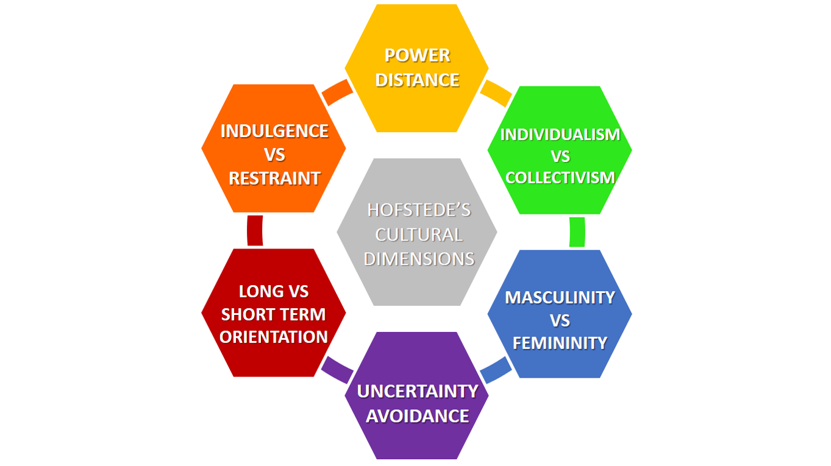
Figure 1 Hofstede Cultural Dimension Model in ASDA (Hofstede, 2011)

Power distance index (PDI): The degree of inequality in the workplace, that means the extent or level to which the low power employees think about the existence of inequality. The high power index indicates a centralized organization with more complex hierarchies and there belong many gaps in the compensation, authority, and respect. On the other hand, the high-power index indicates the flatter organizations where the authority and the employees having equal rights and responsibilities (Hofstede, 2011). From the perspective of ASDA, it has been noticed that there is a low power index because the organization is bounded by strict formal rules and regulations and the higher authority holds the maximum power.
Individualism Versus Collectivism (IDV): The strength of the interpersonal relationship among the individuals within a society or organization is referred to by IDV. Individualistic society refers to the culture where the people are bothered for their achievement and work for self-improvement. Whereas in the collectivist society, people want to work in a group and bother for the organizational goals and objectives (Chudzikowski et al., 2011). They want intrinsic motivation rather than extrinsic motivation from the authority. The employees of ASDA belong to the collectivist society as they work for the best of the organization so that the company can achieve the cherished goals.
Masculinity versus Femininity (MAS): Masculinity accompanies qualities like particular gender roles, decisive, and focused on material accomplishments and riches. In this culture, money, and achievement get the most priority, strong rigid rules and regulations enable the employees to achieve the targeted goals and objectives. On the other hand, Femininity accompanies the attribute like humble, sustaining, and concerned about personal satisfaction (Chudzikowski et al., 2011. According to this culture, the employees ought to be more relationship-orientated because the organizational culture is designed as more work-flexible so that the employees can accomplish the objectives with proper negotiation and collaboration. The employees of ASDA are focused on the feminine culture which has enhanced the skills and capabilities.
Uncertainty Avoidance Index (UAI): This dimension indicates the ways by which individuals can cope with anxiety. The high uncertainty avoidance index indicates that people want to control life so that they can predict events. The followers of high uncertainty generally belong to the rigid, formal, and structured culture because they possess high energy to get any work done. On the other hand, a low uncertainty index indicates that the freedom of changes which means they are ready to adopt any new changes in the work-life and they feel more relaxed (Cronjé, 2011). The culture of ASDA supports the low uncertainty index because the employees are open to change.
Long- Versus Short-Term Orientation: The people who follow the long-term orientation are pragmatic, modest, and thriftier, generally, the society which scores high in the power index show more long-term orientation in their activity. On the other hand, short term orientation pays attention to brisk outcomes and regard for custom (Cronjé, 2011). The followers often want the reason for something rather than asking how and what. In the short-term orientation, people tend to clarify themselves want to develop the skills and capabilities which has been noticed in the employees of ASDA. As they score low in the power index, they are more likely to possess a short-term orientation in the work culture.
Indulgence Versus Restraint: Indulgence shows that society permits moderately free delight identified with getting a charge out of life and having a ton of fun whereas restraint shows that a society stifles satisfaction of requirements and manages it through normal practices. In the indulgence culture, the employees of an organization get the freedom to place their opinion in the decision-making because the company regards themselves as the executors of the particular task (Chudzikowski et al., 2011). But in the restraint culture, the employees are restrained by strong and formalized rules and regulations imposed by the higher authority. By analysing the culture of ASDA, it has been found that there is the implication of indulgence culture in the workplace for giving satisfaction to the employees.

Hall’s cultural model:
It is another cultural model developed by Edward T Hall, which indicates two cultural contexts that define the differences between two organizations and even countries. Human is shaped and patterned by a culture that means all the activities of people are surrounded by cultures and according to Hall, there are two contexts of a culture which are high context and low context. Low context culture refers to the culture where the individuals are task-orientated because they are self-reluctant (Pflug, 2011). Moreover, there is a low sense of loyalty because the bond is fragile between the employees and organizations. The time flexibility of low context culture is very limited as the product gets the priority compared to the procedure. On the other hand, the high context culture refers to such environment where the individuals have a strong bonding which enhances the loyalty and they are a group focused that means out of the work, they enjoy with themselves for different achievement which indicates an interpersonal relationship. The time flexibility of high-context culture is very suitable as well as adaptable because the employees get the freedom to balance the work-life. From the context of ASDA, it can be said that the employees of this organization possess a high-context culture that has an impact on the performance of the overall company. However, the implication of high context culture in ASDA enables the employees to work comfortably with strong interpersonal bonding.

Gullestrup’s Culture Theory:
Culture can be both static and dynamic regarding the situation and cultural values that the organization belongs to (Othengrafen and Reimer, 2013). Several theories claim that culture is a static one and it has predetermined characteristics. But culture is changing by both internal and external forces of society. Globalization has increased its potentiality and affects different norms and values of ASDA as it operates more than 600 locations. ASDA fail to maintain a specific model for culture as different location belongs to different cultural beliefs and norms.
Horizontal Dimension:
Culture cannot be a static one under globalization is the main focused point in this dimension. It includes processing, distributing, managing, marketing, integrating, creating, securing, etc. All of these components need frequent updates and alterations to move on with demand (Knieling, J. and Othengrafen, 2015). ASDA has a dynamic culture in its business segment and it coordinates different issues frequently according to changes in demand and aspects. By following diverse issues in culture, ASDA improves its profitability as this help ASDA to enhance workplace diversity.
Vertical Dimension:
Vertical integration has three defined layers that focus on the dynamic perspective of culture. When an organization moves to another country for the very first time, it has to notice how people perceive culture in those countries, languages, preferences, etc. (Othengrafen and Reimer, 2013). ASDA as a retail store focuses mainly on the norms and values of the people where the norms represent rules of a society and values are the perceived behavior of an individual. Beliefs that are belonging to the society are properly analyzed by ASDA in improving the decision-making system.
Dynamic Dimension:
All the macro-level changes are focused here by integrating dynamic culture in the environment. It does not consider only individual or group culture to decide but focuses on the whole basis as a collective effort. ASDA incorporates 165,000 employees and 631 locations to decide the future process in delivering goods in the COVID-19 situation. All the factors will not change frequently but in a dynamic environment, most of the factors affect business performance.

External Environment Analysis of ASDA:

PESTEL Analysis:
The external environment is referred to as the group of functions that are related other than internal business activities. To operate a business, organizations should consider each component of external factors. Recently COVID-19 is one of the most important factors that influence the whole external environment. Culture in different countries affects this broader environment. ASDA operates in more than 631 locations, has to largely focus on PESTEL analysis to make a business decision by considering different cultural issues such as norms, values, three layers of culture, etc.
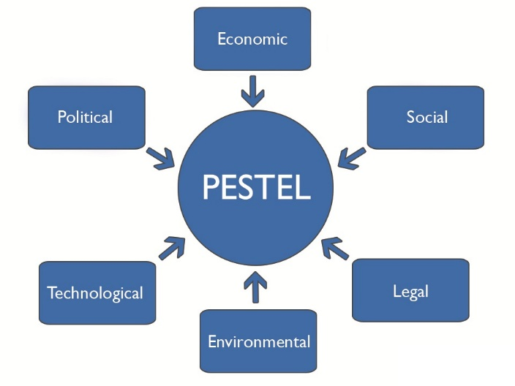
Figure 2: PESTEL analysis of ASDA (Hitt, Ireland, and Hoskisson, 2012)
Political Factor: Political factor represents to what extent government in a country intervenes in the business activity of local and foreign organizations. Govt. intervention includes political stability or instability, tax policy, foreign trade policy, employee expatriate policy, etc. It is the most important factor now in the UK after Brexit as it creates more uncertainty (Ansoff et al., 2018). ASDA has been affected by national and regional laws and regulations as it operates more than 600 locations. Different regional laws restrict some alcohol products that are produced under ASDA such as ASDA dry cough syrup etc. Though Brexit occurs, stable govt. and political condition in the UK makes the business of ASDA more profitable as laws are not frequently changing and they can strict in their plans. ASDA strategic planners also keep a close eye on political regulation on pricing and promotional strategy to adapt quickly (Asda.com - Online Food Shopping, George, & more, 2020). In the COVID-19 crisis, ASDA also follows govt. rules in opening and conducting business in its diverse location as they referred to it as norms of the company to follow govt. restrictions and regulations.
Economic Factor: Economic factor influences organizational profitability. If the world economy is under control or in a good shape that attracts people to consume more by earning more, the business will enough potentiality (Hitt, Ireland, and Hoskisson, 2012). Recently, the impact of COVID-19 is very negative and people suffer all over the world and many small and medium businesses closed down. As the whole economy slowed down and GDP goes to a negative figure, ASDA, a retail shop, faces negative shock as well. Its business operation reduces and spending pattern of people also decreases as working opportunities declined. In this post-COVID-19 time, ASDA has to reorganize operation and need to increase labor supply to gain a competitive advantage in the pricing of products as people are now looking for a health-conscious product more at the cheapest price and demand of health drinks and the nutritious item is increasing in the global market.
Social factor: Social factor influences by shared beliefs and attitudes of the members of a community (Easterby-Smith, Thorpe and Jackson, 2012). These factors include population growth rate, age of people, health consciousness, etc. The population of the UK has a higher life expectancy compared to some other local communities that are served by ASDA. Alcohol products are mainly served by this organization in the different locality to older people. COVID-19 positively influences this business as people are now taking more medicines in slight weakness such as fever, cough, headache compare to previous. So, in this sector, ASDA has a great opportunity to serve customers of all ages as medicine is required for all. Increasing health consciousness among society enhances the home delivery service of this organization.
Technological Factor: Recent business structure requires heavy investment in technology as it saves time, energy, and money (Fayol, 2016). Many organizations increase their profitability to more than doubled by introducing new technology that identifies the new process of making a product, deliver products to customers, and reduces the lead time. ASDA invests more in the delivery system recently and its retail shop has enough space to improve in the technological segment. ASDA has no super-fast delivery system of products and for this, they are losing foreign customers. If they introduce a mobile app, it will also increase its market share by gauging more customers in ASDA online shop.
Environmental Factor: Environmental factor is very essential due to reducing raw materials over the years. AN organization should conduct business by maintaining proper business culture and ethics. ASDA supports environmentally friendly work and they reduce carbon emission by more than 50% over a few years and 40% of its stores are ecofriendly (Asda.com - Online Food Shopping, George, & more, 2020). Working with BSI (British Standards Institute), ASDA finds out methods that can reduce the emitted carbon in the supply chain segment. This shows how ASDA follows its overall business ethics and standards to produce products that do not harm anyone in society.
Legal Factor: Health, safety, and equal opportunities are the main components of legal factors (Ansoff et al., 2018). Organizations have to know what the culture or people of the society required by the organization. ASDA cannot give a lower salary to its employees through the economy is going down in this COVID-19 situation. Recent govt. the imposition of laws affects the business decision of ASDA by the increment of salary and tax rate. The UK also increases legal charges for any misconduct in product processing and delivery as it contradicts business culture ad ethics.

Porters Five Forces Model:
It is a model for analyzing company competitiveness in the market. For increasing competitive advantage, this model is widely used by different organizations. It helps to identify different strategies through which a company can reduces threats and enhance strength and capitalize on the opportunity (Magretta, 2011). ASDA, a renowned retail company, is doing business in a competitive market with an enormous customer base. This model helps ASDA to identify potential new entrants, the number of competitors, buyers and suppliers, and its substitute products.
The threat of new entrants: The authority of an organization is being affected by the new potential entrants to the market. Tesco, ASDA are the major competitors of this industry and they have large economies of scale that are quite tough for a new entrant to capture. This industry requires enough investment due to product variety and high research costs for developing products according to customer demands. If after COVID-19 govt. stimulates stabilization projects to support new entrants then it will be a potential threat to ASDA. And if a new entrant started its business in a small portion, then it will not easy for ASDA to combat new entrants
Bargaining power of supplier: If there is a shortage of suppliers of raw materials, the supplier will urge more power to increase input cost (Dälken, 2014). ASDA operates in an industry where the supplier of raw materials is very high and they have a lower voice in pricing. It reduces the switching cost of ASDA as the number of suppliers is large enough to meet the demand for raw materials. The profitability of ASDA is closely related to the supplier as they contribute inputs of productions and if they both maintain a good relationship, it will give enough potentiality to generate more profitability to ASDA. So, a higher number of suppliers reduces the threat of the bargaining power of suppliers that enhances profitability and flexibility to ASDA.
Bargaining power of buyers: As customers are the main part of a business, a smaller number of buyers has threats to a business. Buying preferences vary from customer to customer according to their buying power in different shops, attractive offers of other shops (Dälken, 2011). ASDA from initiation not compromising product quality but ensuring a lower price, enhance its customer base and get enough loyal customers over the operated locations. In this retail industry, income pattern does not require to be high and people require product in regular interval, so, ASDA introduces product differentiation and cost leadership to reduce bargaining power in the industry by buyer.
The threat of substitute products: In grocery industries, each super shop sells more or less the same product at a varied quality, size, and price (Barney and Hesterly, 2014). ASDA operates in several locations where the substitute for its products is very low due to quality, reputation, and price. Tesco and other competitors have some substitute products that have higher quality and prices compare to ASDA. ASDA in alcohol products sees competition as there are enough substitute products in the market. In this case, ASDA needs to maintain and increase the quality of the product and as there is enough supplier of raw materials, keep a good relationship with suppliers to reduce input cost and increase quality. Product differentiation is will increase its customer base and increase the profitability of the organization. So, market research and unique features of the product will reduce the threat of substitutes.
Rivalry among existing firms: The larger the number of competitors in the industry including excessive product and services range, the lower the rivalry threats (Dälken, 2014). ASDA operates in the retail industry where there are a lot of large and potential competitors. There is increasing growth in this sector before COVID-19 and organizations are trying to get the growth back as products of the retail industry have growing demands over the years. As this industry requires a higher investment in fixed assets, in terms of lower demand for products, ASDA can reduce the per-unit cost of the product by producing a higher amount and keep it in future sales or at a lower price to attract and retain customers.

Cultural Web:
Culture influences the strategies and development process of an organization. It may affect positively or may create hindrance in different aspects. Cultural Web is regarded as an important tool for analyzing specific beliefs and practices surrounding the culture of a company (Freemantle, 2013). It has six interrelated components called a paradigm that suggests a clear picture of the wider cultural aspects of an organization such as ASDA. Using this model, ASDA can assume the cultural aspects of its organization and set work to align with organizational strategy and other elements.
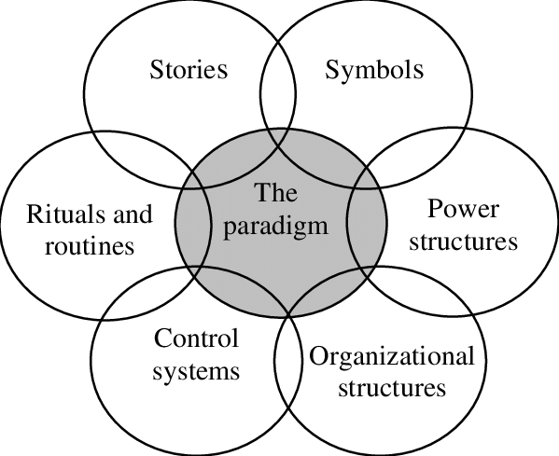
Figure 3: Cultural Web in ASDA (Freemantle, 2013)
Stories: Individuals discuss the company insides and outsides of the firm. Several past events also indicate organizations perceived value and behavior (Park, 2015). Employees of ASDA can know about this company by talking with other employees, a large customer base, and learning from the history of the company that gives a new employee a clear picture of ASDA.
Symbols: It is regarded as a visual representation of the organization’s logo, dress code of employees, office spaces, and advertisement in social media (Freemantle, 2013). It symbolizes how a firm appears on the outside and its employees. ASDA has its logo and good corporate governance that bears the image of its corporate culture to the stakeholders.
Riotous and Routine: It represents the routine activities of employees in the organization by following its culture and ethical standards. Customers' expectations and beliefs are considered where when performing daily tasks (Freemantle, 2013). ASDA has an employee handbook where a detailed plan of daily activities and required behavior in sudden situations is stipulated.
Power Structure: Power vests on senior executives, CEO, the board of directors, etc. These are regarded as genuine power and holders of this power have the final say in decision making (Park, 2015). CEO of ASDA, Roger Burnley along with other executives exerts power in developing strategy and solving internal conflicts.
Control System: The process of managing and directing organizations' activities is regarded as control. ASDA controls its financial system, quality of product, rewards, etc. by specific departments. Financial management and performance-based reward system are internally controlled by the control department of ASDA.
Organizational Structure: The organization follows a hierarchy about who follows whom or directs. Dynamic culture followed by an organization requires proper hierarchy management of employees (Al Saifi, 2015). ASDA has an organizational chart that directs the duty of employees and maintains ethical standards in dissecting information from one department to another. Here corporate culture governs employees following organizational strategy and structure in ASDA.

Recommendations
COVID-19 has changed the entire business strategy of an organization. It is an external environmental issue that reduces economic activity and takes away lots of lives. As it is a macro-environmental issue, govt. and the whole world needs to come forward to make everything stable again. But from the above analysis of ASDA, there are several issues sorted out and these are required to be solved quickly to become a market leader.
ASDA follows a dynamic culture that is essential as they operate more than 600 locations. But they have no integrated delivery system that takes away lots of customers to Tesco, one of the market leaders in the retail industry. Again, it has a weaker distribution channel in remote areas that hampers customer loyalty. Though the bargaining power of the supplier in this industry is very low, bargaining power is also very high. ASDA charges lower prices compare to others in several business segments but it raises questions about product quality. They are not efficient in marketing strategy and recently it is influenced by sold-out decision. The subsidiaries in the mobile accessories business but failed to develop apps that may track customers easily and share offers with them. Moreover, they follow dynamic culture but they are efficient enough to cope up with this culture. So, to run efficiently they have restructured the above-mentioned issues to serve customers efficiently.

Conclusion
Culture is the identification of a group of people in a society. People belong to different culture has several beliefs that affect the business decision and organizational efficiency. Organizational efficiency largely depends on following effective cultural models when making a decision and analyzing the external environment. Different models described in this report to analyze the culture that is followed by ASDA show that the organization follows dynamic culture as it operates in many locations. Different potential threats that are found out by external environmental analysis should be sorted out by introducing a new marketing strategy and delivery system. Due to the COVID pandemic, people are more conscious and less willing to go outside. If ASDA introduces the home delivery system culture more holistically, it will increase the profitability and efficiency of the firm. To cope up with a dynamic cultural environment every organization should emphasize much on cultural literacy when entering into a new culture and introduce an effective leadership strategy to motivate employees to do work efficiently.

Reference:
Al Saifi, S.A., 2015. Positioning organisational culture in knowledge management research. Journal of Knowledge Management.
Ansoff, H.I., Kipley, D., Lewis, A.O., Helm-Stevens, R. and Ansoff, R., 2018. Implanting strategic management. Springer.
Asda.com. 2020. Asda.Com - Online Food Shopping, George, & More. [Online] Available at: <https://www.asda.com/> [Accessed 9 November 2020].
Barney, J.B. and Hesterly, W.S., 2010. Strategic management and competitive advantage: Concepts (p. 408). Englewood Cliffs, NJ: Prentice hall.
Chain, L.V., 2011. Corporate social responsibility. Harlow: Pearson.
Chudzikowski, K., Fink, G., Mayrhofer, W., Minkov, M. and Hofstede, G., 2011. The evolution of Hofstede's doctrine. Cross cultural management: An international journal.
Cronjé, J.C., 2011. Using Hofstede’s cultural dimensions to interpret cross-cultural blended teaching and learning. Computers & Education, 56(3), pp.596-603.
Dälken, F., 2014. Are Porter’s five competitive forces still applicable? A critical examination concerning the relevance for today’s business (Bachelor's thesis, University of Twente).
De George, R.T., 2011. Business ethics. Pearson Education India.
Easterby-Smith, M., Thorpe, R. and Jackson, P.R., 2012. Management research. Sage.
Fayol, H., 2016. General and industrial management. Ravenio Books.
Freemantle, D., 2013. Part 2: Applying the cultural web–Changing the labour ward culture. British Journal of Midwifery, 21(10), pp.723-730.
Hitt, M.A., Ireland, R.D. and Hoskisson, R.E., 2012. Strategic management cases: competitiveness and globalization. Cengage Learning.
Hofstede, G., 2011. Dimensionalizing cultures: The Hofstede model in context. Online readings in psychology and culture, 2(1), pp.2307-0919.
Knieling, J. and Othengrafen, F., 2015. Planning culture—a concept to explain the evolution of planning policies and processes in Europe? European Planning Studies, 23(11), pp.2133-2147.
Magretta, J., 2011. Understanding Michael Porter: The essential guide to competition and strategy. Harvard business press.
Othengrafen, F. and Reimer, M., 2013. The embeddedness of planning in cultural contexts: theoretical foundations for the analysis of dynamic planning cultures. Environment and Planning A, 45(6), pp.1269-1284.
Park, J.Y., 2015. Cross-cultural language learning and web design complexity. Interactive Learning Environments, 23(1), pp.19-36.
Pflug, J., 2011. Contextuality and computer-mediated communication: a cross cultural comparison. Computers in Human Behaviour, 27(1), pp.131-137.
Wood, J., Zeffane, R., Fromholtz, M., Wiesner, R., Morrison, R., Seet, P.S., Schermerhorn, J., Hunt, J. and Osborn, R., 2013. Organisational behaviour: Core concepts and applications. John Wiley & Sons.

