
‘Data Mining’
Data Warehousing and Data Mining (ACCA6026)

Jonathan Lesmond (2300728)
BSc Applied Computing

Table of Contents
1. Introduction 3
2. Methodology 4
2.1 Data Exploration 4
2.2 Data Preprocessing 7
2.2.1 Secondary Pre-processing 9
2.4 Data Postprocessing 10
3. Sample Runs and Results 11
4. Recommendations 15
5. Reflection 16
5.1 Advantages and Limitations 16
5.2 Changes for Future Investigations 16
6. References 17
7. Appendix 18
6.1 Further Comparison Between the RF and SLR 18
6.2 Confusion Matrices for Tuned Models 18

Table of Figures
Figure 1 – Histograms for Each Attribute. 8
Figure 2 -G3 Attribute Before (Top) and After (Bottom) Discretisation. 10
Figure 3 - Dataset Before (Top) and After (Bottom) One-Hot Encoding. 11
Figure 4 - Class Legend. 12
Figure 5 - Top 15 Results from CorrelationAttributeEval. 14

Table 1 - Dataset Attributes and Descriptions. 7
Table 2 - Summary of First Sample Run Results 13
Table 3 - Confusion Matrices from First Run. 13
Table 4 - Results from Run After Dimensionality Reduction. 14
Table 5 - Confusion Matrices After Dimensionality Reduction. 15
Table 6 - Results from Hyperparameter Tuning. 15
Table 7 - Per-Class F1-Scores for the RF and SLR. 20
Table 8 - Confusion Matrices After Tuning. 21

Introduction
Data mining can be defined as the process of extracting and analysing a large amount of data to determine patterns and make predictive algorithms, data mining is also referred to as ‘Knowledge Discovery in Databases’ (KDD) as these large amounts are usually derived from a database.[1] One of the ways in which data mining is conducted within businesses is through following a set of de facto standards known as the ‘Cross Industry Standard Process for Data Mining’ (CRISP-DM). Within CRISP-DM are a set of phases which are: Business Understanding, Data Understanding, Data Preparation, Modelling, Evaluation and Deployment.[2][3]
During the business understanding phase, the business will discuss their intentions with data mining including a set of objectives and timelines. The data understanding phase involves the collection of data and evaluating whether the quality of the data is suitable for further analysis, statistical techniques are also used in the data understanding phase to explore the data. The modelling phase consists of fitting the data into a machine learning algorithm for cluster analysis or making predictions. In the evaluation phase, the predictive or clustering algorithms used in the modelling phase are examined to determine the results align with their objectives. Finally, the deployment phase can be interpreted differently in businesses, some businesses may create a final report, dashboard or software from the data mining depending on the objectives discussed in the business understanding phase.[2][3]
The next sections in this report will showcases the use of machine learning algorithms to predict the outcomes of students studying specific courses in Portuguese schools. The report will also discuss the initial exploration of the data, the various preprocessing methods used on the data to enable it to be fitted to the algorithms, and a reflection of the case study including the limitations and advantages of it.

Methodology

2.1 Data Exploration
Attribute Name | Attribute Description
School | The student’s school (Gabriel Pereira ‘GP’ and Mousinho da Silveira ‘MS’)
Sex | Student's gender (Male ‘M’ or Female ‘F’)
Age | Student's age
Course | Student’s course (Portuguese ‘Por’ or Maths ‘Mat’)
Address | Student's address type (Urban ‘U’ or Rural ‘R’)
Famsize | Student's family size
Pstatus | Whether the student’s parents live together (Together ‘T’ or Apart ‘A’)
Medu | Highest education level achieved by student's mother
Fedu | Highest education level achieved by student’s father
Mjob | Job of student’s mother
Fjob | Job of student’s father
Reason | The reason for why the student attends the school (‘Close to home’, ‘Reputation’, ‘Course preference’ and ‘Other’)
Guardian | Student’s guardian (‘Mother’, ‘Father’, ‘Other’)
Traveltime | Time taken to travel from home to the school
Studytime | Study time per week
Failures | Number of failures in previous classes
Schoolsup | Whether the student receives extra educational at school (Yes or No)
Famsup | Whether the student receives extra educational support at home (Yes or No)
Paid | Whether the student takes extra paid classes within their course (Yes or No)
Activities | Whether the student does extra-curricular activities (Yes of No)
Nursery | Whether the student attended nursey (Yes or No)
Higher | Whether the student wants to take higher education (Yes or No)
Internet | Whether the student has access to the internet at home (Yes or No)
Romantic | Whether the student is in a romantic relationship (Yes or No)
Famrel | Quality of family relationships
Freetime | The amount of free time the student gets after school
Goout | How much the student goes out with friends
Dalc | How much alcohol the student consumes on a workday
Walc | How much alcohol the student consumes on a weekend
Health | Student’s health status
Absences | Number of absences (0-93)
G1 | First grade (0-20)
G2 | Second grade (0-20)
G3 | Third grade (0-20)
Table 1 - Dataset Attributes and Descriptions.
The data used in this report is about student achievement in Portuguese secondary school. The dataset is split into 2 CSV files with one file including students studying the mathematics course, and the other file has students studying the Portuguese course, in this report the target variable is G3. Both datasets record their instances across 34 attributes, the ‘course’ attribute was manually added through Microsoft Excel before importing it into Weka, this was to help differentiate between the students on each course. The file for students studying Portuguese consists of 649 instances. The file containing mathematics students has 395 instances with both files not containing any missing values. To make the data easier to explore and process the data from both files were merged into one file resulting in a total of 1044 instances across 34 attributes.
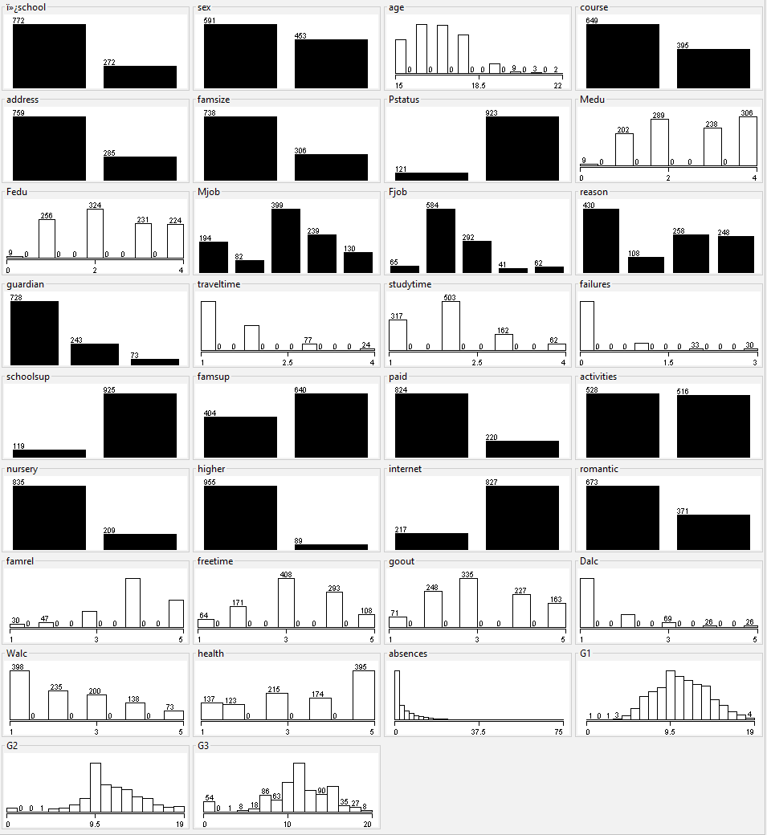
Figure 1 – Histograms for Each Attribute.
Figure 1 shows a collection of visualisations for each of the attributes in the dataset. For the histogram titled ‘school’ it is shown that Gabriel Pereira (GP) has significantly more students in the two courses than Mousinho da Silveira (MS), with 772 students recorded at GP and 272 at MS, this could suggest that GP is a bigger school than MS. For the graph showing gender distribution, it shows that there are more females (591) recorded in the dataset than males (463).
The G1 histogram shows an even distribution of student’s grade, in the histogram, grades ranged between 0 and 19, but the average grade was 11.2 and majority of students got a grade between 9 and 11 with a combined total of 276 students in that range. The distribution of grades in G2’s histogram was less even but the average grade remained the same from G1, most student in the histogram achieved a grade between 8 and 11 with 389 student in that range, it was observed that there were more students at the low and high end. The distribution of grades in G3’s histogram was very erratic compared to G1 and G2, some other observations include a higher range of grades achieved where student’s grades ranged between 0 and 20, the average grade was higher at 11.3 and most students got a grade between 9 and 12 with 407 students in that range, there were also more recorded instances at high and low ends of the grades.

2.2 Data Preprocessing
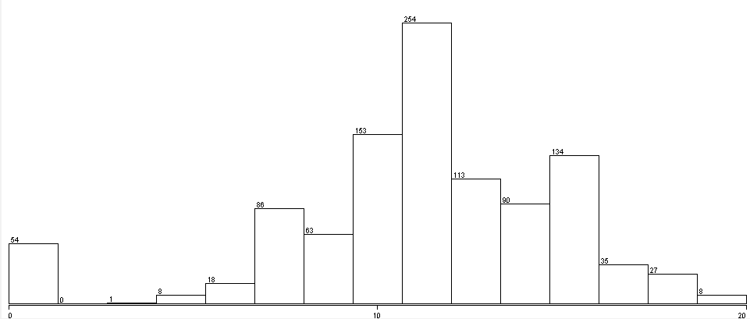
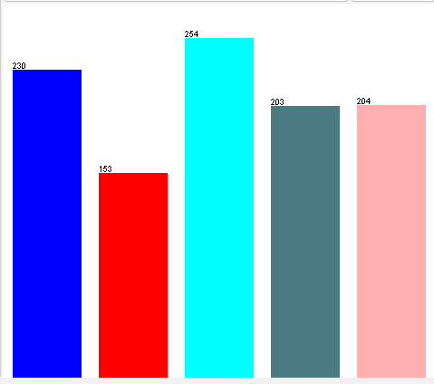
Figure 2 -G3 Attribute Before (Top) and After (Bottom) Discretisation.
When initially trying to run machine learning algorithms on the data, some of the algorithms chosen for testing in Weka were not available due to the numeric datatype of the target attribute. To fix this the discretize function was used to categorise the values into different bins, this would change the training from a regression problem into a classification problem. ‘Discretize’ was also used on several attributes to limit the influence of outliers on the algorithms. The chosen attributes included Age, G1, G2, G3 and absences. ‘Discretize’ was configured to set 5 bins on G3 and the same was done on G1 and G2. For the Age attribute, Discretize was configured to set 4 bins, and for the absences attribute the function set 3 bins.
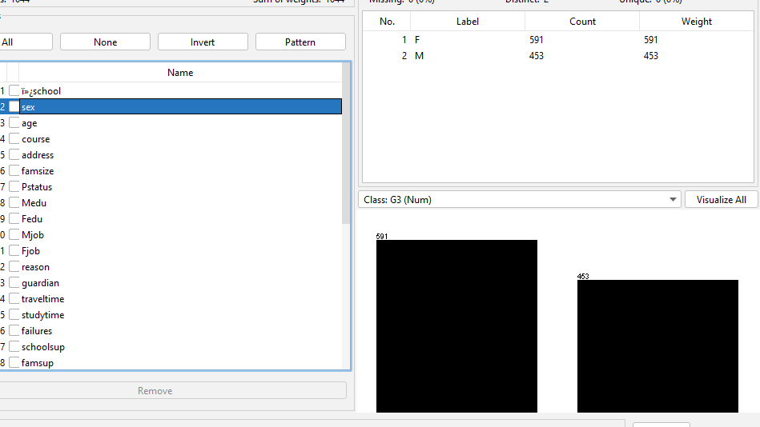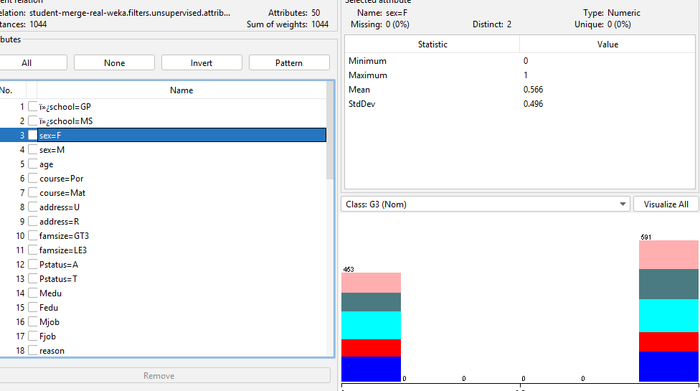
Figure 3 - Dataset Before (Top) and After (Bottom) One-Hot Encoding.
One hot encoding was used through the ‘NominalToBinary’ function on the sex, course and school attributes. One hot encoding was later applied to other attributes such as schoolsup, famsup, paid, activities, nursey, higher, internet and romantic etc. increasing the number of columns from 34 to 50.

2.2.1 Secondary Pre-processing
Some of the attributes were classed as numeric in Weka despite the numeric values being used to represent classes. To overcome the problems the ‘NumericToNominal’ function was used to convert numeric columns to the nominal type. ‘NumericToNominal’ was used on attributes such as Medu/Fedu, traveltime, studytime, failures etc.
When the files were merged, the maths student's dataset was added after the Portuguese students, this could lead to biases in the algorithm’s training data. To counteract this problem the ‘Randomize’ function was used to reorder the instances.
After preprocessing, the algorithms chosen for classification were; Random Forest (RF), Simple Logistic Regression (SLR), K-Nearest Neighbour (KNN) and the AdaBoost with a decision tree (REPTree) as the meta learner.

2.4 Data Postprocessing
The models in this report will be evaluated using percentage of correct/incorrect classifications, confusion matrices and F1-Score. F1-Score is a measurement which is the harmonic mean of precision and recall, since misclassifying student outcomes is not critical, focusing on precision or recall specifically was not chosen but they will be available in the appendix.
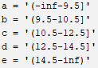
Figure 4 - Class Legend.
Figure 4 is the values and their respective value ranges from discretisation shown in figure 2, this is how the classes will be referenced for easier interpretation.

Sample Runs and Results
Algorithm | % of Correct/Incorrect Classifications | F1-Score
AdaBoost | 69.8% | 30.1% | 0.702
KNN | 55.9% | 44% | 0.553
RF | 70.8% | 29.1% | 0.706
SLR | 69.8% | 30.1% | 0.706
Table 2 - Summary of First Sample Run Results
In the first sample run before the removal of some attributes, all the algorithms were on default hyperparameters when trained. The worst performing algorithm overall based on percentage of correct classifications was the KNN algorithm configured with a k-value of 10 (55.9%), it also had an F1-Score of 0.553. The RF was the best performing algorithm in this sample run, the RF got 70.8% of classifications correct. The SLR and AdaBoost models had the same level of performance with both getting 69.8% of classifications correct, the SLR however had a better F1-Score (0.706) than the AdaBoost (0.702), it was also equal to the RF’s F1-Score, appendix 6.1 provides further information comparing the RF and SLR.
Algorithm | Confusion Matrix
AdaBoost | 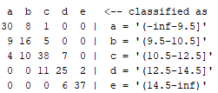
KNN | 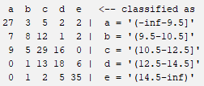
RF | 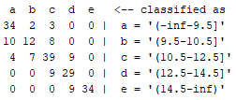
SLR | 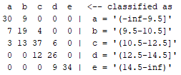
Table 3 - Confusion Matrices from First Run.
Table 3 shows the confusion matrix of each algorithm in the first run. On observation from the results is that the algorithms had the most difficulty classifying classes C and D. in relation to class C, the SLR misclassified class C as D 12 times which was almost as worse as the KNN despite being the best algorithm during that run, the AdaBoost was just behind the SLR in the same situation with 11.
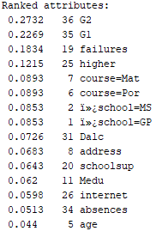
Figure 5 - Top 15 Results from CorrelationAttributeEval.
CorrelationAttributeEval (CAE) was used to reduce dimensionality in the data and to prevent the algorithm from overfitting. The results from running CAE on the dataset reduced the number of attributes (excluding G3) in the dataset from 50 to 22. According to the results in figure 5, the most relevant attributes were higher, failures, schoolsup, address, absences, school, G1 and G2. In addition to the results the Fedu attribute was added resulting in 23 attributes excluding G3.
Algorithm | % of Correct/Incorrect Classifications | F1-Score
AdaBoost | 73.2% | 26.7% | 0.740
KNN | 66% | 33.9% | 0.650
RF | 69.8% | 30.1% | 0.700
SLR | 69.8% | 30.1% | 0.706
Table 4 - Results from Run After Dimensionality Reduction.
In the second run after dimensionality reduction, the AdaBoost and KNN algorithms saw an improvement in performance. The AdaBoost specifically became the best performing algorithm in this sample run getting 73.2% of classifications correct. The KNN model saw a significant increase in performance getting 66% of classifications correct in this sample run compared to 55.9% in the initial run. The SLR did not see any changes in performance but got the same percentage of correct classifications as the RF, which got a slight decrease in performance (69.8%), the SLR (0.2791) does beat the RF (0.2838) in terms of RMSE and is the second best algorithm of this sample run.
Algorithm | Confusion Matrix
AdaBoost | 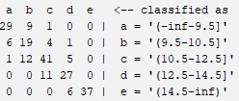
KNN | 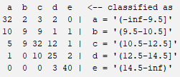
RF | 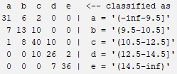
Table 5 - Confusion Matrices After Dimensionality Reduction.
The RF and KNN’s problems with correctly classifying student’s outcomes as class B, C and D got worse when looking at the confusion matrices of each model after dimensionality reduction. When looking at the AdaBoost’s confusion matrix in particular some observations can be made, such as the model getting slightly worse with predicting class A instances getting 29 correct classifications compared to 30, another observation is that it also got worse at predicting class B instances as it assign more class B instances as class A and C compared to the previous run. The SLR’s performance did not change after dimensionality reduction and was excluded from table 3.
Algorithm | % of Correct/Incorrect Classifications | F1-Score
KNN | 69.3% | 30.6% | 0.675
RF | 71.7% | 28.2% | 0.721
SLR | 71.2% | 28.7% | 0.715
Table 6 - Results from Hyperparameter Tuning.
This sample run included tuning the hyperparameters of the algorithms to extract some more performance from them. The KNN’s k-value in this run was change from 10 to 50 and was the only tweak that improved the performance of the KNN. For the RF the only tweak that was made was enabling the ‘breakTiesRandomly’ options which it allows the model to pick a class at random if multiple class receive the same number of votes. In a RF one of the ways a final prediction is made is through majority voting where the class with the most votes becomes the final prediction. The tweaks made to the SLR involved enabling the ‘errorOnProbabilities’ option which uses the error on probabilities to assign the optimal number of iterations. Another tweak was enabling ‘useAIC’ and disabling ‘useCrossValidation’. The AdaBoost did not improve in performance after tuning and was excluded from table 6.
From tuning the models after dimensionality reduction, all algorithms with the exception of the AdaBoost improved slightly on performance. The KNN saw the biggest improvement after tuning getting 69.3% of classifications correct in this run compared to 66% in the previous run, its F1-Score increased to 0.675 compared to 0.650 in the previous run. The RF got 71.7% of classifications correct which is a slight improvement from the previous run (69.8%), and narrowly ahead of the SLR which got 71.2%. Overall, the AdaBoost remains the best performing algorithm out of the selection while the RF is second best. To see commentary on the confusion matrices for the tuned models, see appendix 6.2.

Recommendations
From the results from all 3 sample runs, the AdaBoost proved to be a high performer initially, and then became the most performant algorithm for predicting student’s outcomes. This makes the AdaBoost the recommended algorithm for this scenario as it was able to achieve its high performance with a less attributes and minimal tuning to its hyperparameters.
Another recommendation is that the best attributes to look for in relation to student's grades is their number of failures, their course, their school and whether they want to pursue higher education. Although the results from figure 5 suggests that there are more attributes to consider, using the 4 mentioned attributes could lead to a more accurate model.

Reflection
This report has shown that machine learning algorithms can be used to predict student’s outcomes in certain courses, but it may not be a tool that can be solely relied on due to accuracy, although the best performing algorithm got around 73% of classifications correct, in another situation where machine learning is used to predict 1000 student’s outcomes an error of 24% can make the model inconsistent and can leave hundreds of inaccurate predictions.

5.1 Advantages and Limitations
Using a dataset of 1044 instances can provide a good generalisation of students at a similar level of education in Portugal who are enrolled on the same courses. The dataset having 31 attributes excluding G1, G2 and G3 makes the quality of the data quite high since it accounts for various factors relating to a student’s education.
Despite the dataset having 1044 instances across 34 attributes, the was a considerable bias in the dataset towards GP, with 772 students in the dataset attending GP. Because of this the dataset may not be representative of all students in Portugal. A similar point can be made regarding the variety of courses in the dataset, having students from only 2 courses may not be representative of all students in GP, MS or other schools in Portugal.

5.2 Changes for Future Investigations
A change that could be made for future investigations is the choice of models, since both ensemble algorithms in this report were high performers, conduction another investigation with ensemble models specifically could result in finding a more accurate algorithm, in the case of a stacking ensemble, it could be investigated whether a combination of different base algorithms could result in superior performance.

6. References
[1] B. N. Lakshmi and G. H. Raghunandhan, "A Conceptual Overview of Data Mining," .
[2] C. Schröer, F. Kruse and J. M. Gómez, "A Systematic Literature Review on Applying CRISP-DM Process Model," Procedia Computer Science, vol. 181, pp. 526, 2021. . DOI: 10.1016/j.procs.2021.01.199.
[3] J. Foulds, Data Mining: Practical Machine Learning Tools and Techniques. 2025.

7. Appendix

6.1 Further Comparison Between the RF and SLR
Algorithm | Accuracy Metrics
AdaBoost | 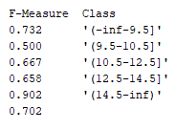
SLR | 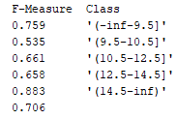
Table 7 - Per-Class F1-Scores for the RF and SLR.
This table shows the evaluation metric for the AdaBoost and SLR on each class. Despite the equal performance of the AdaBoost and SLR in proportion of correct classifications, in table 6 the SLR’s higher F1-Score can be derived from small improvements in scores in specific classes, the biggest differences come from the scores in class A where the SLR got 0.759 compared to the AdaBoost’s 0.732, and class B which the SLR got a score of 0.535 and the AdaBoost got 0.500. Another observation to made is that the AdaBoost had a higher score for class E where it got 0.902 and the SLR got 0.883.

6.2 Confusion Matrices for Tuned Models
Algorithm | Confusion Matrix
KNN | 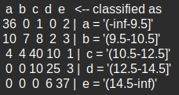
RF | 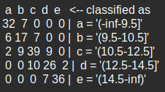
SLR | 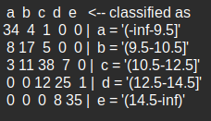
Table 8 - Confusion Matrices After Tuning.
The KNN’s confusion matrix show that it got better at predicting instances of certain classes, in this run the KNN was the most accurate in predicting class A instances with 36 correct classifications compared to the RF which got 32 and the SLR which got 34. The KNN was also most accurate with class C and E instances, getting 40 class C instances correct and 37 class E instances correct. However, it seems that the KNN was more prone to big errors as it shows specifically with class E instances where it misclassified a total of 9 instances included 2 as class A which is the opposite end of the grade range to it. The KNN was also the least accurate when it came to class B instances getting 7 instances correct compared to the SLR and RF which both got 17 instances correct.

