x
Afia Basharat (2027071)

effecive team working and communication
bmsw4002
component 1
lecturer: dale clarke

TABLE OF CONTENTS

SUMMARY 1
INTRODUCTION 2
OVERVIEW OF TEAMWORK 3
MODELS OF TEAM DEVELOPMENT 4
TUCKMAN’S MODEL
GERSICK’S MODEL

TEAM ROLES 5
ADVANTAGES OF EFFECTIVE TEAMWORKING 6
IMPACTS OF INNEFECTIVE TEAMWORKING

SUMMARY
A team is a collection of people who work together to attain a common purpose. There are numerous aspects that contribute to a successful teamThere are certain impediments to the team's effectiveness. To build an efficient team, managers must examine several team developement models and team roles and select the one that they believe is best suited to their tasks and projects. The most often used teamwork models are Tuckman's model and Belbin's team roles. While effective teamwork can be advantageous to an organization's productivity, bad teamwork can have the opposite effect. These beneficial and negative consequences must be identified and addressed.

INTRODUCTION

The purpose of this report is to discuss about the elements that can form an effective team. Tuckman’s model of team development will be analysed, and it will be explained that how moving through the five stages of Tuckman’s model can help a team perform better.
The importance of team working within the Health and Social Care settings will be conferred and what role effective team working can play in the progress of the Health and Social Care setting.
Along with the factors that are essential for a successful team working, there are some barriers that can reduce the effectiveness of the team. In this report some of these barriers will be identified, and some strategies to overcome these barriers will be explored.
The report will explain the importance of roles within the team and how assigning different roles to team members can help them perform better and ultimately how it can contribute to forming an effective and successful team. Belbin’s model of team roles will be explored in this report

OVERVIEW OF TAM WORKING
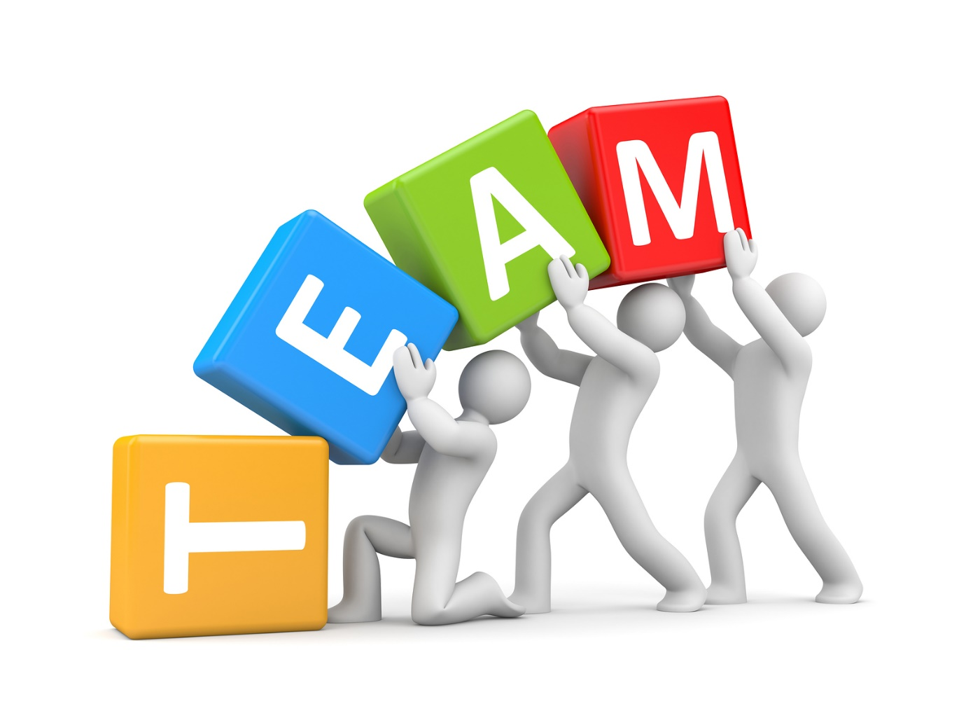
Fig1:(Mastricht University, 2017)

As defined by Kozlowski and Bell (2003,cited in Working in teams: Moving from High Potential to High Performance ) “Teams are groups of individuals who execute organization related tasks, have similar goals, associate socially, demonstrate project interdependencies, monitor and operate boundaries, and are integrated in an institutional culture that encourages them to do so."
When it comes to creating an effective team, there are many factors that are kept in mind. The key factors that contribute to an effective teamwork are as follows

Composition:
1.Potential of members
2.Character
3.Assigning roles
4.Diversity
5.Size of teams
6.Member resilience
7.Member Choices

7.Member preferences+

Process:
1 Appropriate Resources
2.leadership and Formation
3.Atmosphere of Trust
4.Reward on good performance
Process:
1.Common goal
2.Specific targets
3.Team effectiveness
4. Altitude of rivalry
5.Social loafing
Team Effectiveness

According to DEAKINCO. (2016) Communication, delegation, and ideas are all necessary parts for a successful team. If a firm is to succeed, its leaders must encourage and develop their employees' teamwork abilities. When facing a particularly challenging situation or dealing with the death of a team member, building trust and dependence on one another can be quite vital.

MODELS OF TEAM DEVELOPMENT
Transforming a group into an effective and productive team is a complex procedure. Groups go through a series of stages before becoming impressive teams. As narrated by Arrows et al. (2004) “groups are flexible social structures that evolve over time.”
Two different team development models will be explored to see how they reflect the course of events in a group's development from a group to a team. These models are intended to help pioneers and colleagues understand the progressions and monitor assumptions in the progression of groups to teams.
- Tuckman’s Model
- Gresik’s Model

Tuckman’s Model

Tuckman’s model which was published in 1965, is considered the most praised model of team development till date.
Tuckman's model, which is labelled Forming, Storming, Norming, and Performing (Adjourning was not initially included. Tuckman and Jensen added it in 1977).), was produced through a conceptual of 50 research-based studies on group development. More than 70% of the studies used in his meta-analysis relied on research on psychoanalytic studies of groups for therapy and laboratory training. (Cassidy,2007, p.413)
Tuckman (1965) acknowledged that his model was applied on a limited number of groups: "What has been described is basically research on consecutive development in therapy groups."
This model depicts the stages that most teams go through from the beginning of a project to its project accomplishment, and even the sections where the team and the venture may fail.”
Fig2: (Wilson, 2021)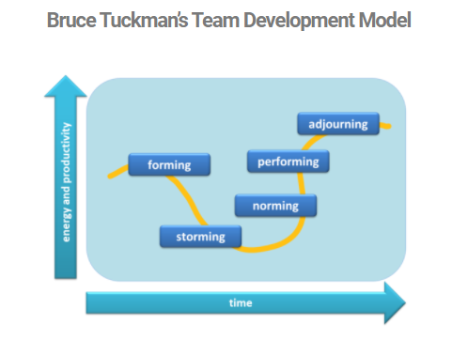

The stages characterized by Dr. Tuckman are as per the following:

Forming: Trying and relying' is the model's first phase, when members of a group start forming bonds with leaders, hierarchical rules, and one another. The group in this stage organizes the errand, establishes standards, evaluates the restrictions, and tests the limits.
Storming: This stage is related to emotional reactions, and dispute may occur as a result. This is due to students trying to become acquainted with each other and figure out how to collaborate with one another.
Norming: Moving to “norming” stage, team will begin working more effectively. Instead of focussing on their individual goals, they will be working together. Team’s rules will be set, and individuals begin regarding and helping one another. (Abudi,2010)
Performing: The group will begin to function as a cohesive unit. It will start working constructively towards common aims. There will be problem-solving and interactivity. Trust, respect, and effective discussions will be shared among members. Conflicts will start to resolve.
Adjourning: Adjourning is the final phase of Tuckman's model, which is the group's dissolution. Individuals may have formed strong relationships with one another and find it tough to say their goodbyes. An "ending festival" could be planned to aid attendees in ending the group.

Gersick’s Model
Compared to Tuckman’s model, Gersick (1988), stated the following three phases of team development:
- Phase 1 and First Meeting: Members of the team show the paradigm through which they tackle their tasks for the first half of their allocated time. Excerpts demonstrate the breadth, variety, and essence of those frameworks.
- The Midpoint Transition: The group undergoes significant transformation as it approaches the halfway point between when it began working and when it has to submit its final report.
- Completion: The completion is the phase of the group’s life in which groups have fully transitioned into a performing team with clear goals, directions and are determined to achieve their collective goals.
Although experts, to some extent, support both Tuckman’s and Gersick’s model but Tuckman’s model appears to be more effective as it defines the relationship among the group members.

Team Roles
Teamwork is like creating a gourmet meal - starting with the right people and ingredients is crucial, but it is also essential to put them together properly. A team cannot succeed without each member understanding their role and responsibilities. That is how assigning clear roles to the members of the team contributes towards creation of an effective team.
Belbin's team role paradigm is the most well-known and commonly used in pragmatic team and management development. He claims that the structure of a team has a big impact on how well it performs. It is important to consider how team members interact with one another and the roles they play. Three categories appear to exist. The first type of role relates to the position within the organization and the responsibilities and authority it comes with. The second type of role is the level of expertise and experience. People's decision-making processes, interactions with others, and capability use are not considered under functional roles. (van de Water, Ahaus and Rozier, 2008)
Team roles in Belbin’s theory are as follows:
Coordinator
Serves as a chairperson.

Team Worker
Promotes collaboration.
Specialist
Offers special competences.

Resource investigator
Explores opportunities outside.

Bbbb
Belbin’s Team Roles
Monitor-Evaluator
Evaluates the options.
Shaper
Encourages the team to improve.

Plant
Introduces innovative ideas.
Finisher
Conducts thorough, timely work.
Implementer
Implements ideas

In the process of recruiting staff for a team, there should be a procedure to test every candidate’s personality to determine which candidate is suitable for which role. This will help managers to determine if they have recruited the right people for the roles needed for the completion of the task. Assigning Belbin’s team roles to team members will help to increase the productivity of the organisation and to complete the tasks in the most effective manner.

Advantages of effective team working
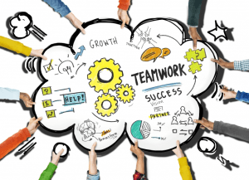
Fig3:(Worldlurst,2018)
Organizations thrive off success, however, in other cases, using teamwork in the workplace is a preferable solution for improved performance. Here are exact steps how teamwork can help to succeed at workplace.
1.Promotes Creativity: Teaming up on a task cultivates a longing to discover that performance work doesn't. Individual and group information develop when you can impart your experiences to the task group and partners. At the point when individuals cooperate collectively, imagination arises.
2.Combines supportive Strengths: Employees can capitalise on the skills of their colleagues by operating in a team. While you may excel in generating innovative ideas, another teammate may dominate at co - ordination. You can learn and develop your skills by observing one another's to become a better team member.
3.Strengthens Trust: A productive team has a strong chemistry and loves to work together. Believing your colleagues additionally builds a feeling of security, which empowers for the rise of ground- breaking thoughts. Great teams develop
each member and continually create and maintain additional skills at the individual level...while also developing and promoting a unique type of team togetherness.
4. Dispute Resolution Skills: It is impossible to avoid disputes when you
bring together individuals from a variety of origins with diverse work approaches and preferences. These exceptional perspectives can make the best work, but they can also create disdain that quickly turns into conflict. When a dispute emerges in a cooperative circumstance, workers are forced to determine the facts rather than turning to management. It won't take long for representatives to learn how to compromise first-hand and thus become proficient administrators.
5.Fosters a Broader Sense of Ownership: Getting outstanding results from team projects, handling deterrents, and creating fantastic work together leaves colleagues feeling satisfied. When representatives run after achieving organizational goals, they feel associated with the organization. As a result, workers are more likely to have greater occupation fulfilment after establishing steadfastness.

Impacts of ineffective teamwork
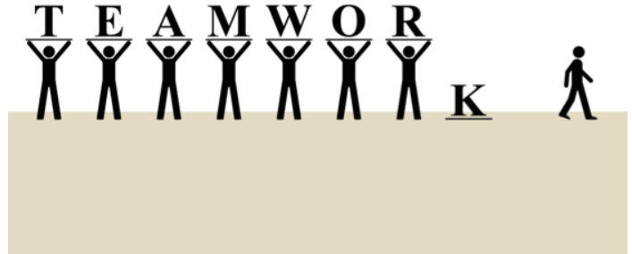
Fig4: (Maclaren, 2016)

According to Shannon (2017) Workplace teams might collapse for a variety of reasons, but the outcomes are the same: divisions emerge, conflicts are formed, collaboration ceases, and mistrust grows. The concentration changes away from work and toward what the other group is doing, as well as what you should do next.
The following areas will be examined in depth to better understand the negative impacts of inadequate teamwork:
- Interpersonal
- Innovation
- The bottom line

Creativity: The number one killer of creativity is stress. A failed team's stress leads to stagnation and prevents people from expressing fresh creative ideas.
Learning Opportunities:
Individuals in a well-functioning team can learn a great deal from one another. Teammates teach each other new abilities as a result of their shared vision and responsibilities. This unofficial learning evaporates when a team fails since members would preserve their information as a means of survival.
Collaboration: Collaboration among team members will be impossible if decency, common vision, accountability, and support are lost. Without collaboration, innovation will be extremely difficult to achieve and impossible to implement.
Productivity and Efficacy: Employee engagement has a substantial influence on productivity and excellence, which has a direct impact on the bottom line. It's impossible to see a team functioning well if they aren't communicating, don't have a common purpose, or a sense of shared responsibility.
Talent Retention: With a skills shortage coming, organisations must keep top talent to stay competitive, and the atmosphere created by a failed team will only drive talent away. As a result of the turnover, time, money, and creative ideas will be squandered.
Innovation: When a business falls behind in innovation, it becomes progressively difficult to catch up, and the company may eventually go out of business. A failed team suffocates creativity and, as a result, results in an unsuccessful firm.

The Bottom Line

Innovation
Civility: Poor teamwork results in fall of civility. Any effective dialogue will come to a stop as a result of the loss of mutual respect and, in some cases, downright hatred.
Joint Obligations: People who consider themselves a member of a clique instead of a member of the team, only
Worry about their own tasks.as a result, work falls through the cracks and shared duties are neglected.
Support: Individuals are forced to face difficulties alone, limiting their ability to meet them. Lack of civility and shared obligation leads to lack of support among the members of the team.
Employee Involvement:
When a team fails, everything that is lost has a significant impact on employee engagement. Employee participation has a significant impact on output and performance, as well as the bottom line.

Interpersonal

CONCLUSION AND
RECOMMENDATIONS
Effective teamwork is the main secret of an organisation’s good performance, but it has its own benefits and barriers. To make the most of teamwork, the organisations must evaluate different team development models and adopt the best model for most productive outcomes. Tuckman’s model appears to be most appliable model for a better team performance.
Recruiting staff can be a crucial task for the management but assigning the right person for the right role can be enormously beneficial for the organisation. Belbin’s nine team roles should be applied in process of recruiting team members.

REFERENCE LIST

- Abudi, G. ( 2010) The Five Stages of Team Development: A Case Study. [online] . Available at: https://www.projectsmart.co.uk/team-building/the-five-stages-of-team-development-a-case-study.php (Accessed 15 October 2021).

- Belbin.com. The Nine Belbin Team Roles. [online] Available at: https://www.belbin.com/about/belbin-team-roles (Accessed 25 October 2021).

- Bonebrigh, D. ( 2010) ‘40 years of storming: a historical review of Tuckman's model of small group development’. Human Resource Development International, 13(1), pp.111-120.

- Cassidy K. (2007) ‘Tuckman Revisited: Proposing a New Model of Group Development for Practitioners’, Journal of Experiential Education,29(3), pp.413-417. DOI:10.1177/105382590702900318

- DeakinCo | Powering workplace performance. (2016). The five elements of successful teamwork. [online] Available at: https://www.deakinco.com/resource/the-five-elements-of-successful-teamwork (Accessed 3 October 2021).
- Gersick, C. (1988) ‘TIME AN TRANSITION IN WORK TEAMS: TOWARD A NEW MODEL OF GROUP DEVELOPMENT’. Academy of Management Journal, 31(1), pp.9-41.

- Griffith, B. and Dunham, E. (2015) Introduction to Teams. Working in Teams: Moving from High Potential to High Performance, 55 City Road, London: SAGE Publications, Inc. pp. 1-18 Available at: http://www.doi.org.ezproxy.uwtsd.ac.uk/10.4135/9781506300153.n1 (Accessed 27 Sep 2021)
- JONES, A. (2019) ‘THE TUCKMAN’S MODEL IMPLEMENTATION, EFFECT, AND ANALYSIS & THE NEW DEVELOPMENT OF JONES LSI MODEL ON A SMALL GROUP’. JOURNAL OF MANAGEMENT, 6(4).
- Laiken, M. (1994) Anatomy of High Performing Teams. University of Toronto Press, pp.74-86.

- Mattson, D. (2017) 6 Benefits of Teamwork in the Workplace | Sandler Training. [online] Sandler Training. Available at: https://www.sandler.com/blog/6-benefits-of-teamwork-in-the-workplace/#:~:text=6%20Benefits%20of%20Teamwork%20in%20the%20Workplace%201,stick%20 (Accessed 23 October 2021).
- Maclaren, U. (2016) Poor Teamwork. [image] Available at: https://ulyssesmaclaren.com/2016/03/04/the-five-dysfunctions-of-a-team/ (Accessed 25 October 2021).
- Mastricht University. (2017). Meet the team# 1. [image] Available at: https://library.maastrichtuniversity.nl/meet-the-teams/ (Accessed 25 October 2021).
- Shannon, A., (2017). What Do You Lose When Teamwork Fails? | Kent State University. [online] Kent.edu. Available at: https://www.kent.edu/yourtrainingpartner/what-do-you-lose-when-teamwork-fails#:~:text=The%20failure%20of%20a%20team,innovation%20is%20next%20to%20i (Accessed 25 October 2021).
- Tuckman, B. W. (1965). Developmental sequence in small groups. Psychological Bulletin, 63, pp. 384-399.
- van de Water, H., Ahaus, K. and Rozier, R. (2008). ‘Team roles, team balance and performance’. Journal of Management Development, 27(5), pp.499-512.

- Wilson, C. Bruce Tuckman: The Forming, Storming, Norming & Performing Team Development Model. [image] Available at: https://www.coachingcultureatwork.com/bruce-tuckman-team-development-model (Accessed 25 October 2021).
- van de Water, H., Ahaus, K. and Rozier, R. (2008) ‘Team roles, team balance and performance’. Journal of Management Development, 27(5), pp.499-512.

- Worldlurst. (2018) teamwork. [image] Available at: http://wondrlust.com/knowledge/the-benefits-of-teamwork (Accessed 22 October 2021)

