Effective Team Working and Communication Skills
Introduction
According to Cambridge dictionary communication is ‘process of sharing information, especially when increasing understanding between people or groups.’ In light of this, communication plays vital role in a business or organisation, whether ineffective or effective, it contributes towards an individual’s performance and outcome of work. In this task, I will be discussing the importance of communication in management alongside various aspects that may be deemed as important in business. It will also define key theories and models of communication by Shannon and Weaver, Wilber Schramm and Berlo’s SMCR, providing an analysis of their advantages and disadvantages. I will then elaborate the importance of effective communication and methods of communication, drawing examples and personal experience in my work place. It will also explore the significance of communication between management and employees. Ultimately, this task aims to highlight the significance of communication and its impact within the business context.

Importance of Communication in Management
Communication in management plays vital role in companies and organisations as it can result in an increase in morale and efficiency within teams and a better relationship between individuals in the business. Synergy and efficiency are both affected by communication. With some circumstances of ineffective communication, synergy and efficiency are negatively impacted and consequently a business will not function to a high standard. In contrast to ineffective communication, effective communication leads to better results and performance within a business. For instance, improved teamwork, increased morale, and reaching goals faster due to a reduced amount of ineffective communication and error judgement. In the context of leadership and management, communication is very important in the application of hard and soft skills. As management, it is essential to extend and guide team effort and reach the set goals of a business or organisation. As a result, this promotes cooperation within the business and a mutual understanding between all parties. Communication in management also ensures satisfaction of all position levels, if done correctly, within the company.

Communication Models and Theory
Shannon and Weaver Model of Communication (1948)
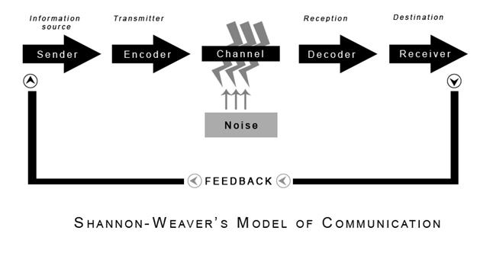
Figure 1.1
The mathematical theory of communication was formed to create an effective communication from the sender to receiver. It is also known as the ‘mother of all models’ because of its widespread popularity and the idea that it embodies the process of information source, transmitter, channel, reception and destination. The model outlines the procedure of the sender generating a message, in which is transformed into a signal by a transmitter and directed to an information channel – the receiver – and further changed into a message, reaching its destination (see figure 1.1).
This theory explores the protocols of a two-way communication system which makes it applicable in general communication terms. It can also aid communication skills to be improved as each concept of the stage can be analysed to find issues and miscommunication within individuals. However, because it is an interpersonal system, it is hard to apply amongst group communications, making it a time-consuming process. Additionally, it may not be 100% accurate as communication between people are often natural, as opposed to being a mathematical and structured procedure.

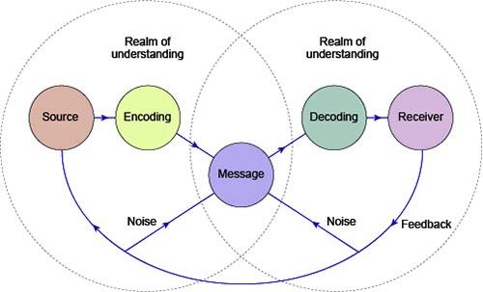
Wilbur Schramm’s Model of Communication (1954)

Schramm’s model of communication was a process between a sender with a message and a receiver, in which is transmitted through a medium and have feedback on the message. The sender will have to encode the message, primarily basing on their ‘field of experience’, which also guides the decoding (see figure 1.2) as without this, communication would not happen.
An advantage of this theory is that it emphasises that communication goes both ways as it is circular, as opposed to linear. The idea that it involves interpretation allows a clearer and a more understanding form of communication, especially if the message was decoded in a different way, as feedback is involved to allow further dialogue. On the other hand, like the Shannon theory, it is difficult to use for group or mass communication as it is a two-way involvement. This means it may be hard to get mass involvement in communication, taking longer to pass on a message or get feedback from other.

Berlo’s SMCR Model of Communication (1960)

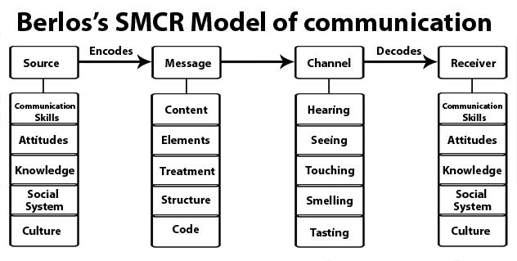
Figure 1.3

Berlo’s sender, message, channel and receiver (SMCR) theory highlights the various components in a basic form of communication, emphasising on the factors that are involved within the encoding and decoding. For instance, the source and receiver would have factors that affect communication, like their communication skills, attitude, knowledge or culture, which would therefore have a knock-on effect on the message, in terms of the content, structure or effectiveness of the message and the channel of which is used to send the message, such as technical or verbal (see figure 1.3).
This model of communication underscores that message and medium are aligned with the receiver and considers more factors that would influence communication in real life. The factors are realistic and conveys that if they are not considered, miscommunication may occur. A disadvantage of the theory is that it assumes the sender and receiver share common ground for the message to be understood effectively. This means no barriers to communication are not considered, nor is feedback, and therefore, expects a perfect form of communication.

The importance of Effective Communication
Effective communication is significant in terms of establishing rapport with others, whether it is via email, telephone or face-to-face. As Peter Morgan argues, ‘the ways we communicate can give others very different impressions of who we are, our thinking, our attitudes, our emotions and our self-confidence.’ This is often affected by the relationship with the person we are communicating with, and how we relate to them. For instance, it is easy to appear more comfortable and confident around friends or family, than, for example, your boss. S.M Rai and Urmilla Rai argue that ‘old fashioned business language is not suitable for modern business methods and practice.’ Emails have the purpose to build ‘goodwill and create positive and pleasant feelings in the reader… to get a favourable emotional response.’ This highlights the importance of establishing rapport through effective communication in order to urge a better response from the recipient.
In relation to this, effective communication is a transferable skill that equips us to perform better in our professional career, academic studies and personal lives. In his 2003 article titled ‘Effective Communication’ Ken Haycock states that a ‘focus on the audience’ largely contributes towards effective communication. This applies in all contexts where communication is present. When considering who the audience are, whether it’s a written academic piece, class presentation or within a work place, we consider the language and communication skills we will use to ensure clarity of what we are trying to communicate to ensure it is effective and fulfils its purpose.

Methods of Communication
As a front desk receptionist in the Travellers Club, London, communication is required on several levels, from written to verbal and non-verbal communication methods. This section draws upon examples from my work place.
Firstly, written communication comes in the form of emails, memos, letters, written notes, paper and pen, text and fax. In my work place the most popular form of written communication we use is email, most often when concerning member queries and passing on important messages. It is very effective and inexpensive way of written communication, which also has the benefit of being formal. This is followed by letters, fax and memos. In the context of modern technology, a less formal but equally effective method of written communication is via text. This is fast, short-hand written form of communication which includes messages and emojis which aid the recipients understanding. This is often used to reach colleagues in particular, as the message is received much faster.
Verbal communication is any type of interaction that makes use of spoken words and plays a vital role in the context of business world. Face-to-face and telephone conversation are integral part of communication in my work place. Such skills and ability to communicate effectively through speaking is a great asset which I often practice, and something recognised by my employer. I speak confidently and clearly, always seeking to help the guests and members of the club. With effective verbal communication, whether this is face-to-face or via telephone, satisfaction and compliments from guests and members of the club is always received by my employer.
Non-verbal communication are cues. This includes the way you listen, body language, eye contact and your response to the person you are communicating with. The subtility of this often misleads people to thinking they are not important however, non-verbal communication plays a key role in revealing whether you are an active listener and a responsive communicator. As argued by Morgan Peter, listening is one of ‘the most valuable communication skills sought by employers.’ In my work place, I take time to listen to the guests, members and colleagues at the Travellers Club. By paying attention and actively listening to understand their message, I am able to respond accurately and appropriately. An example of non-verbal communication using gestures would be in during extremely busy periods. By carefully chosen gesturing and movements, a person would understand that they have to wait to be attended next or sooner.
Ultimately, these methods of communication help an individual to express and pass messages either one to one or group communication, ensuring clarity between people in a work place- whether this is between colleagues, employers and employees, or customers and employers.

Communication between Management and Employees
Communication between management and employees is important for creating good relations and therefore, plays a fundamental role in maintaining a positive environment within the work place and the wider business. Modern managements generally believe in ‘keeping employees well informed about company’s aims, plans, progress and prospects, and also about working service conditions, training and promotion opportunities and the benefits available to them.’ This ensures that both employees and management have the same understanding of the company and business. This also allows the employee to make an informed decision on whether they want to remain with the company, and whether it is the right fit for them. Equally significant, it ensures that employees are aware of the expectations of them from the company and so they can perform to a high standard, or as required.
To emphasise the need to create a positive work environment, many companies also circulate news about employees such as their achievements, in order to create an ‘atmosphere of social friendliness.’ By making sure effective communication is present between employees and management, a good relationship may be formed between people in the work place, ultimately keeping employees on side with the company.

Conclusion
Ultimately, communication plays an especially vital role in the business world, from establishing relationships with colleagues and managers within the work place, to communicating with clients and customers. Using the models and theories of communication, we get a clearer understanding of its significance within the work place. Management and employees should work together to maintain positive environment, performs high standard of work leading to success of organisation or business. Effectiveness of communication should be present at all levels of positions to ensure the smooth running of business.

Bibliography
Haycock, Ken. (2003) ‘Effective Communication.’ Teacher Librarian. No. 30, Issue 4. 30(4

Hollnagel, E. and Woods, D. (2005) Joint Cognitive Systems. CRC Press

Morgan, Peter (2017) ‘Communicating Effectively’ in: The Business Student’s Guide to Study and Employability, London: SAGE Publications Ltd

Rai, Urmila. & Rai, S.M. (2008) ‘Objectives of Communication’ in: Effective Communication. Global Media

Schramm, W. (1954). How communication works. In W. Schramm (Ed.), The process and effects of mass communication. Urbana, IL: University of Illinois Press.
‘Communication.’ Cambridge Dictionary. [online] Available from: https://dictionary.cambridge.org/dictionary/english/communication [Accessed on 2 January 2020]

‘Why is communication important to management?’ E-notes. [online] Available from: https://www.enotes.com/homework-help/why-communication-important-management-358784 [4 January 2020]
‘Importance of Communication in Management of an organisation.’ Education Observer Career Discussions. [online] Available from: https://www.educationobserver.com/forum/showthread.php?tid=14537 [Accessed on 4 January]

‘Shannon and Weaver Model of Communication.’ Businesstopia. [online] Available from:
https://www.businesstopia.net/communication/shannon-and-weaver-model-communication [Accessed on 3 January 2020]

‘Berlos’s SMCR Model of Communication.’ Communication Theory. (online) Available from:
https://www.communicationtheory.org/berlos-smcr-model-of-communication/ [Accessed 4 January 2020]

‘Oral Communication.’ Inc. [online] Available from: http//www.Inc.com [Accessed 5 January 2020]

‘Non-Verbal Communication.’ Help Guide. [online] Available from:http//www.helpguide.org [Accessed 5 January 2020]

Appendix

1.

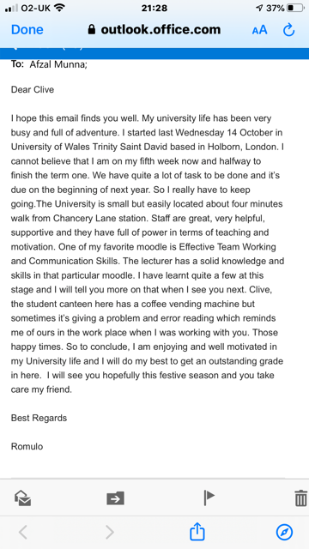

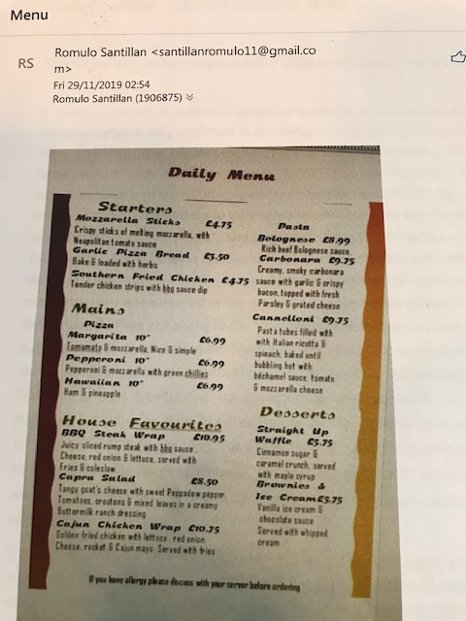
2.

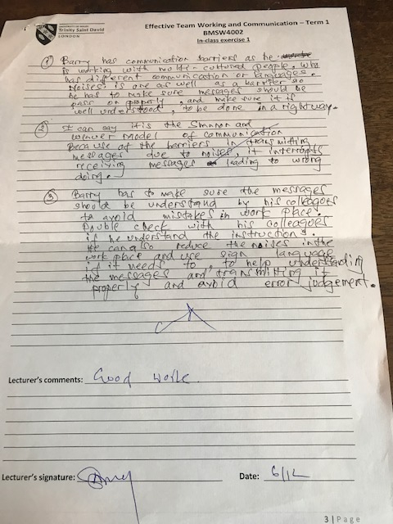
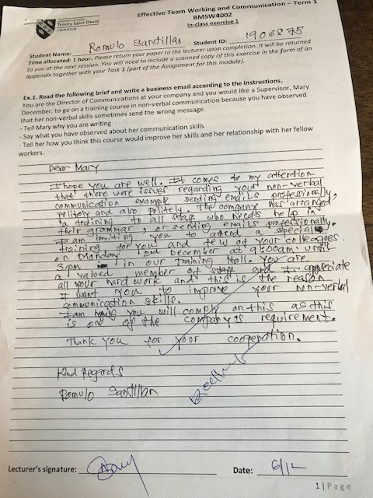
3.

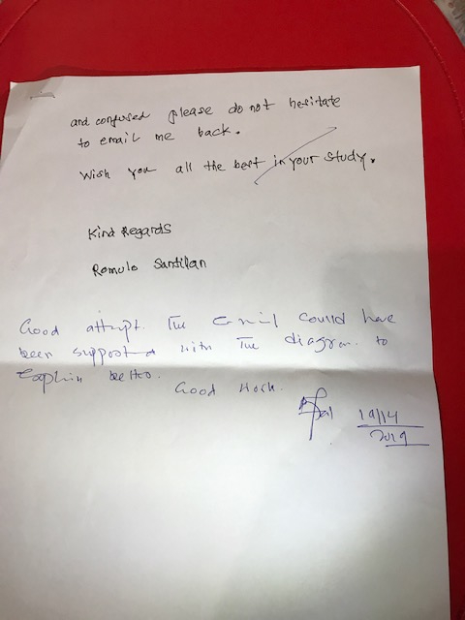
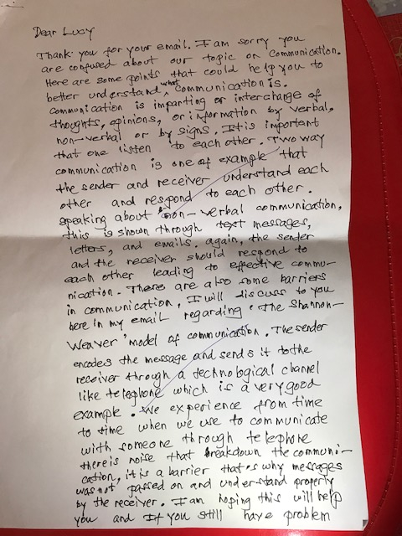

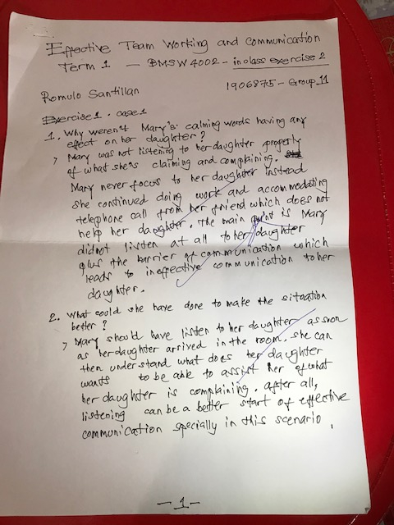
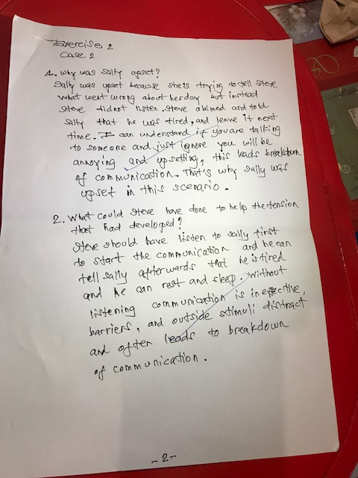
4

‘Communication.’ Cambridge Dictionary. [online] Available from: https://dictionary.cambridge.org/dictionary/english/communication [Accessed on 2 January 2020]
‘Why is communication important to management?’ E-notes. [online] Available from: https://www.enotes.com/homework-help/why-communication-important-management-358784 [4 January 2020]
‘Importance of Communication in Management of an organisation.’ Education Observer Career Discussions. [online] Available from: https://www.educationobserver.com/forum/showthread.php?tid=14537 [Accessed on 4 January]
‘Shannon and Weaver Model of Communication.’ Businesstopia. [online] Available from: https://www.businesstopia.net/communication/shannon-and-weaver-model-communication [Accessed on 3 January 2020]
Hollnagel, E. and Woods, D. (2005) Joint Cognitive Systems. CRC Press p. 11-14
Schramm, W. (1954). 'How Communication Works.’ In W. Schramm (Ed.), The process and effects of mass communication. Urbana, IL: University of Illinois Press.
‘Berlos’s SMCR Model of Communication.’ Communication Theory. (online) Available from: https://www.communicationtheory.org/berlos-smcr-model-of-communication/ [Accessed 4 January 2020]
Morgan, Peter (2017) ‘Communicating Effectively’ in: The Business Student’s Guide to Study and Employability, London: SAGE Publications Ltd, p. 260
Rai, Urmila. & Rai, S.M. (2008) ‘Attributes of Effective Communication’ in: Effective Communication. Global Media, p. 128
Rai, Urmila. & Rai, S.M. (2008) ‘Attributes of Effective Communication’ in: Effective Communication. Global Media, p. 128
Haycock, Ken. (2003) ‘Effective Communication.’ Teacher Librarian. No. 30, Issue 4. 30(4), p. 6
‘Oral Communication.’ Inc. [online] Available from: http//www.Inc.com [Accessed 5 January 2020]
‘Non-Verbal Communication.’ Help Guide. [online] Available from:http//www.helpguide.org [Accessed 5 January 2020]
Morgan, Peter (2017) ‘Communicating Effectively’ in: The Business Student’s Guide to Study and Employability, London: SAGE Publications Ltd, p. 266
Rai, Urmila. & Rai, S.M. (2008) ‘Objectives of Communication’ in: Effective Communication. Global Media, p. 9
Rai, Urmila. & Rai, S.M. (2008) ‘Objectives of Communication’ in: Effective Communication. Global Media, p. 9

