

Name: - Arman Mansuri
Student-Id: - 2240736
Module Code: - LCMB7001
Module 1: Marketing Assessment -1

Contents
Introduction 2
Communication 3
Integrated Marketing Communications 5
There are basically five stages of integrated marketing communication, which are as follows: 6
New Promotional Strategies 9
Branding 12
Branding equity 12
Keller Customer Based Brand equity Model 12
Customer Journey Map 14
Total Engagement Model 19
Conclusion 20
References 21
Reference 21

Introduction
Levi’s is a popular American clothing manufacturer company which has been in business from last 150 years. The business was established in 1853 by Levi Strauss and is well known for its denim jeans. With the development of the blue jean, which was originally intended as hardworking work-wear for miners during the California Gold Rush, Levi's transformed the fashion industry. Levi's has diversified its product offering over time to include different denim garments such jackets, shirts, skirts, and accessories (Levi Strauss & Co. 2019). Levi's has grown to be associated with traditional American style with to its recognizable red tab and timeless patterns. Through both its own stores and a number of retail partners, the company sells its items all over the world. As the demands and preferences of its customers change, Levi's continually adapts its product line to remain a leader in the denim sector. The report contains information about Claude Shannon and Waren Weaver’s macro model, which helps the company create transparent communication channels for employees and customers.
The integrated marketing communication framework helps to ensure consistency among all social media channels of Levi's. The customer journey map of Levi’s company informs the management of where they need to make changes so that the customer experience with company touch points may improve. The different promotional strategies are also explained, which help the company reach an international market and attract customers from faraway locations. The company has several stores in the UK, and various people mostly like to buy products from this brand only. The report's main purpose is to provide information about Levi’s company marketing strategies and communication model, which help the company shape it in a better way.
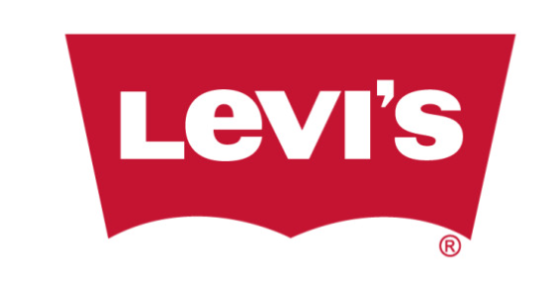

Communication
Communication means the exchange of information between various stores of the company at international level. The company uses an agile framework or communication method such as scrum and also uses different software tools or quality communication between and outside the company with team members.
Claude Shannon and Waren Weaver’s macro model
The Shannon-Weaver model, commonly referred to as Claude Shannon and Warren Weaver's macro model, is a communication theory framework that depicts the exchange of information between a sender and a receiver. This model is good for Levi’s company to improve its communication among employees, customers, and other stakeholders. This model has five elements, which are as follows:
- Sender: Levi’s company is itself a sender; the company communicates with customers through its website and social media platforms.
- Message: In the message, the information of the company's different products and launch dates is given.
- Channel: The Company uses different channels to send messages to customers, such as television, print media, and numerous online platforms.
- Receiver: The Levi’s company has numerous receivers, which include potential audiences, employees, retailers, and suppliers.
- Feedback: The feedback company receives in various forms, such as sales data and customer reviews, helps the company make necessary changes in communication strategies for the improvement and success of the business in the UK.
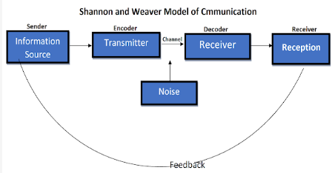
Figure 1: (Hub, S. 2019)
Levi's can effectively communicate with its target customer, properly communicate their brand message, and collect insightful feedback to enhance their goods and services by using the Shannon-Weaver model (Communication Theory 2014). With the use of this model, the business may better understand the communication process and improve their overall communication strategy.

Integrated Marketing Communications

The integrated marketing communications help the company send a uniform message to its target audience by making it consistent with all the channels that the brand uses to reach its audience. This strategic approach helps the company focus on multiple marketing channels at once (Patel, N. 2022). The IMC supports the company in achieving its marketing objectives in a better way. The following reasons explain why integrated marketing communication is very important for Levi's, such as:
- It helps the company establish a strong brand position in the market.
- Support different marketing channels to boost the campaign effectively.
- Create consistency for customers during the whole customer journey.
- IMC helps in raising Levi's brand recognition. The likelihood that the target audience will recall and recognize the brand is increased when the messaging is consistent across all platforms and helps to reinforce the company's image (Patel, N. 2022).
- IMC enables Levi's to use resources wisely and optimize its marketing activities. Levi's may get away of duplication and make sure that resources are used effectively by combining various communication channels. This may result in lower costs and a higher return on investment (ROI) for marketing efforts.

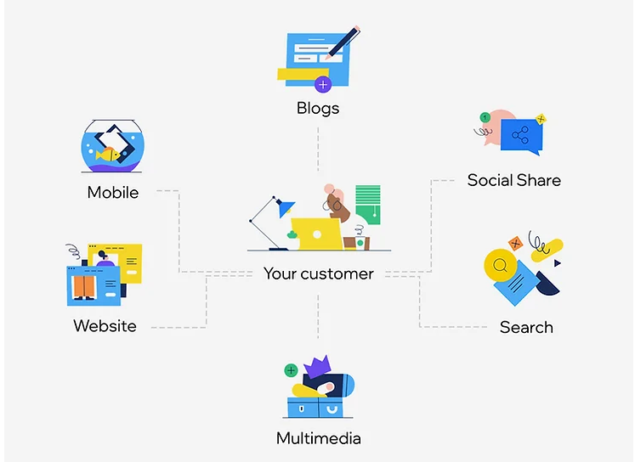
Figure 2: (Basin, H. 2021)

Stages in IMC

There are basically five stages of integrated marketing communication, which are as follows:

Table 1:- Stage of IMC
Stages | Description
- Define the target audience of Levis Company. | The company diversifies its target audience by providing quality products. Firstly, the company targets young adults, who demand products according to current fashions and the latest designs. The company provides a range of classy designs to this audience in denim. Next, the target audience of the company is fashion-conscious individuals; these customers’ demand value and quality from the company. The company offers innovative designs to these types of customers so that they can maintain their top position in the world of fashion. In the UK, Levi's also targets fans of denim. These people value the brand's long heritage and iconic position in the denim sector. The fact that Levi's constantly produces high-quality denim products makes it a top option for this market. The other target audience of the company is sustainable-minded customers. The company uses sustainable practices to prepare products for these kinds of customers. Lastly, in the UK, Levi's targets fans of popular music and culture. Customers who are enthusiastic about music and pop culture are attracted to the company because of its long-standing ties to these fields. Levi's is a popular option for this population because of partnerships with singers, artists, and cultural influencers, which present the company as a brand that matches their preferences and lifestyle.
- Set promotional Objectives | The company's promotional objectives are:  - The company wants to increase the brand awareness in the UK market. This company uses different promotional strategies.  - The second objective of the company is to increase sales and generate revenue for the growth of the company.  - Make a loyal relationship with customers so that they repeat purchases from the brand.  - Creating excitement among the target audience regarding new products before launching is one of the most important promotional objectives of the company's integrated marketing campaign.  - The company also educates customers about its brand value, quality of the product, and sustainable practices.  - The other promotional objective of the customer is to reach a wider market and attract new customer segments towards the brand.
- Set the promotion budget | According to research, it is found that Levis Company spent approximately 463.7 million US dollars on promotional activities in 2022. In the next upcoming years, the company spent more than this amount to expand its business at global scale.
- Design promotion mix | For designing the promotion mix for the company and focusing on the target audience, the company uses various promotion mix approaches such as advertisement, improving public relations, content marketing, influencer marketing, social media marketing, and event marketing, which help the company expand its business and achieve its marketing objectives.
- Evaluate the results | With the integrated marketing communications, people become aware of the company's different products, quality, and affordable prices, which increase the sale of the products in the UK market, and the company generates good revenue with this approach.

New Promotional Strategies
The company uses different promotional strategies to attract more customers towards brands and increase sales, which are as follows:

Figure 3: Promotional Strategies

Offline promotional strategies:-
The company management focuses on and spends a good amount on offline promotion of the brand in the international market using the following channels, such as:
- The company makes strong collaborations with fashion influencers and celebrities, which helps to run offline campaigns, which is good for the company to increase brand awareness.
- Establish temporary pop-up shops in busy areas or during special occasions in the UK to create a sense of exclusivity and spread information about the different products of the brand in the market.
- To engage the target population and present Levi's products in a real-world environment, sponsor fashion shows, music festivals, or other famous events. The company also forms partnerships with other brands for the promotion of the product on a wide scale (Claudia. L. 2022).
- To encourage people to visit Levi's physical stores and make purchases, offer time-limited discounts, loyalty programs, or exclusive product launches. Focus on in-store promotion.
- Plan special occasions for fashion influencers so they may use Levi's items personally and tell their followers about it to make the brand more influential in the market using influencer events.
Online promotional strategies:-
Levi’s Company spends on following online promotional strategies to increase brand awareness, such as:
- Interactive website and mobile apps: - The Company needs to design simple website and mobile application for customers so that they can easily purchase items from their mobile phone from any location. This provides customers a personalized product experience and information about exclusive offers of the brand virtually and easily.
- Influencer’s marketing:-To reach wider market, the company needs to host some online events to spread brand awareness and attract more customers (Claudia. L. 2022).
- Social media campaign: - the company needs to develop interested social media content, such as dressing style video and outfit ideas, which helps to attract customers from different locations from the world towards the brand.
- Email marketing: - the company needs to focus on email marketing in which they share information about product quality and next release which helps to create strong relationship with customers.
- Content marketing:-The Company needs to post high quality content on blogs and videos and different fashion trends which helps the company become top brand in fashion market.
- Online Partnerships: Work together with relevant online locations, lifestyle blogs, and fashion blogs, magazines, to highlight about different products of Levi’s in sponsored material or articles, reaching a larger online audience.

Branding
Levi's Company is a powerful and identifiable brand that is well-known throughout the world. Levi's branding focuses on its unique denim products, particularly its jeans. Quality, flair, and authenticity are trademarks of the brand. People associate Levi's with well-crafted, comfy, and trendy denim. Levi's has a rich history and legacy, which contributes to the brand's character. The brand has been around for a long time, which has contributed to its reputation and credibility (Marketing, E. 2022). The company has emotional connection with its customers. The company rich heritage history and quality of products make strong branding of the company in UK market.

Branding equity
The brand equity is a major indicator which helps the Levi’s Company to measure its performance and strengths in the market. The customer satisfaction, financial performance of the company, customer social media engagement and competitive position in the market factors help to measure the brand equity of the Levi’s company (Marketing, E. 2022). Positive financial results of the brand indicate that the company has positive influence in the market which increases its revenue and sale. Doing survey of the customers and collecting feedback, companies make changes in their strategies which good for their reputation in the market. Tracking the brand's reputation and consumer trust is critical in determining brand equity. Consumer perception of quality, ethical standards, and sustainability efforts can all be used to get insight into a brand's reputation and reliability. Levi's can analyze the success and robustness of its brand equity over time by continuously analyzing these factors. It is critical to monitor and analyze these data on a regular basis in order to make informed decisions and strategies to preserve and improve brand equity.

Keller Customer Based Brand equity Model
It is a framework which helps the Levi Company managing and understating the equity of the brand which is as follows:-
- Brand Salience: - Levi's has great brand salience, which means it is instantly recognized and comes to mind when customers think about jeans. The popular logo, red tab, and distinctive stitching on the rear pocket all contribute to the brand's visibility.
- Brand Performance and Imagery: Levi's has a reputation for producing high-performance denim. Quality, durability, and style are associated with the brand. Levi's imagery is centered on American tradition, durability, and originality, appealing to clients looking for authenticity in their denim (Mind Tools , 2022).
- Brand Judgments: Based on their experiences and impressions, consumers generate opinions about Levi's. Levi's is widely regarded as a dependable and trustworthy company, known for keeping its promises of quality and style.
- Brand feelings: - The brand has very emotional and positive relation with customers. Due to trust and loyalty with customers, the company has set unique position in the market.
- Resonance of the brand: - The highest level of brand resonance has been achieved by the company at international level. Customers actively interact with the brand and feel a strong emotional connection to it. By associating themselves with the Levi's brand, they create a sense of belonging and love.
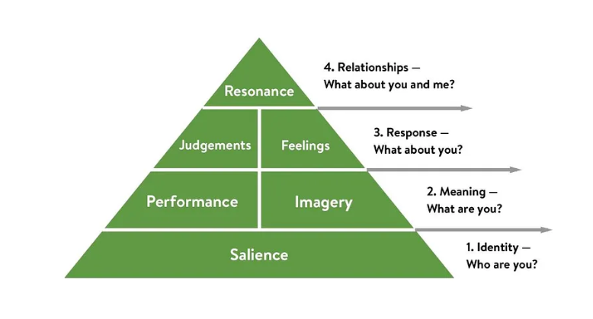
Figure 4: (Hawker, K. 2019)
By applying Keller's customer-based brand equity model, the company creates strong brand equity in the UK market and also helps to increase customer satisfaction and trust in the brand.

Customer Journey Map
The process that a customer goes through from the first step of awareness of a brand to making a purchase is called the customer journey for a brand. It includes every engagement and touch point a customer has with the brand over the course of their entire experience with the company (Mapping, J. 2019). The customer journey is a very linear process, so it is the The customer journey for the Levi’s brand is as follows:
- Awareness of the brand: Through different channels, the customer first gets to know about the brand and its value in the market.
- Considerations and Research: After knowing about the brand, do company research about the different products of the company and then its services in detail. After that, customers check the price and reviews of the company's products, compare the product price with other luxury brands, and find out the differences.
- Evaluation and decisions: After research, customers make purchases of the product by visiting the store physically or through the company website.
- Purchase: At this step, the customer makes the last purchase and buys the product.
- Post-purchase: At this point, the customer actually uses the product and gets services from the company. In which customers get support from the company and get overall satisfaction with the company's products and services (Mapping, J. 2019).
- Loyalty and Advocacy: If the customer is happy with the services of the brand and product quality, they will repeat purchases and build a strong relationship with the company over the long term. If the customer is not happy with the product quality, he or she can write a review and give suggestions to the company regarding the quality of the product.

Figure 4: Steps of Customer Journey

Customer touch-points
During the customer journey with the Levi’s brand, customers interact with numerous touch points of the brand, which include the company’s website, application, physical stores, social media platforms, online reviews, customer service interactions, and advertisement campaigns. One of the major touch points for customers is brand discussions with other customers of Levi's, which have a huge impact on customer purchase and experience. These touch point’s help the company shape the perception of the brand, improve customer satisfaction, and offer better services to customers.
Customer Journey map for Levi’s company

Customer Journey Map | Awareness | Discover | Purchase | Use  Check cloth using VR technology Try in fitting room | Bond
Website
Stores |  | Social media campaigns | In person or online purchase
Social Media
Newspaper |  | Frequently Updated advertisement
Advertisement |  |  |  |  | Partnership or gift cards of company
Email | Send promo code for next purchase
Web Forums |  |  |  |  | Rewards

Customer persona
After the deep research, marketing understanding, and looking out for the different choices of customers, the team member of Levi’s company developed the customer persona, which helped the company shape its promotional strategies and online platform interfaces, which helped the company provide a better customer experience (Testing, U. 2019). The two people listed below assist the company in making changes to its marketing strategies and delivering services to customers.
(CUSTOMER-PERSONA-1)

Customer -1 | David
 | Hey, I am David. I am looking for a luxury brand that will help me place an order for clothes from any location on my handy devices and also process my order within one or two days. Even I don’t want to compromise on the quality of the product, so please give me information about the products of Levi’s company.

Table 2: Customer persona example

(CUSTOMER -PERSONA-2)

Customer -2 | Karen Bared
 | Hi, I am working for a coal company, and I am looking for a brand that provides me with denim jeans that have good durability and quality so that I can work with that jean stuff for a long time.

Table 3: Customer persona example

Total Engagement Model
The total engagement model helps the Levi’s company put all the activities into one effective system to attract more customers to the brand. The main purpose of this model is to engage the employees and customers of the company in long-term relationships. The total engagement model can be implemented by the company in the following ways:
- For engaging the employees, the company management needs to provide training to managers and leaders so that they can create healthy relationships with customers and employees of the company.
- The company also needs to focus on the work-life balance of employees by providing them flexible working hours and providing resources for their mental and physical wellbeing. This increased employee engagement with the company for a long time.
- Levi's can motivate staff members with its social responsibility programs. Supporting sustainable practices, community engagement initiatives, and volunteer opportunities can all fall under this category. Employee involvement in important initiatives promotes a sense of purpose and pride in one's work.
- The company also needs to focus on the development of its employees by providing them with free training and workshops to learn advanced skills. This makes employees feel motivated and valued in the company, and they also put all their efforts into the company's growth (Model, C. 2021).
- The company also needs to plan a reward program for employees, in which it may offer bonuses, appraisals, and other benefits to employees so that they perform well on their tasks at work.
- Levi's may concentrate on developing a solid corporate culture and values that are consistent with its goals and objectives. This can be accomplished by emphasizing diversity, supporting effective communication and reinforcement of key values, and creating a sense of belonging among staff members. The better working culture in the company is also helpful for employee engagement in the company.
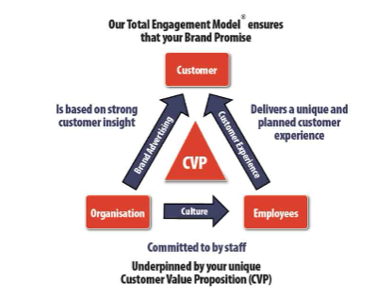
Figure 5: (Strategy, E. 2022)
So, the total engagement model implementation for Levi’s company is very beneficial for company progress in the present as well as in the future.

Conclusion
To conclude, the report provides detailed information about Levi's, which is one of the most famous brands for denim products in the UK market as well as in other countries. The company has maintained its position for a long time due to its rich history and quality product delivery in the market. The company needs to implement the Shannon-Weaver model for transparent communication among employees and customers to progress. The integrated marketing communications help the company send a uniform message across all marketing channels to customers so that uniformity of message is maintained in the market. The report also provides information about the customer journey map and touch points of the company, which helps the company shape its strategies in an effective way and attract more customers. The customer persona helps to design the online platforms of the company to provide better services to customers and a better customer experience. The company measures its financial performance and positive reputation in the market using the brand equity indicator.
The report contains information about each step of the customer journey so that Levi's company can make the necessary changes required for expansion of business in other areas. Keller's customer-based brand equity model helps the company maintain its competitive position in the market. Overall, in current times, companies focus on sustainable practices and reduce water wastage to meet the demand of customers for sustainable products effectively. The total engagement model helps the company make some changes in its working culture, working hours, and training programs so that more employees are engaged in long-term company objectives, which is good for company success in this as well as the upcoming era. It is suggested that companies focus on sustainable practices so that they can help the government achieve environmental goals in the UK.

References
- Study, H. (2019). Shannon and Weaver Model of Communication |. [online] Available at: https://jmcstudyhub.com/shannon-and-weaver-model-of-communication-mass-communication/.
- Basin, H. (2021). Integrated Marketing Communications - Meaning & Benefits. [online] Marketing91. Available at: https://www.marketing91.com/integrated-marketing-communications/.
- Hawker, K. (2019). Keller’s Brand Equity Model — What It Is & How to Use It. [online] Medium. Available at: https://medium.com/@keatonhawker/kellers-brand-equity-model-what-it-is-how-to-use-it-84e42d562299.
- Strategy, E. (2022). Total-Engagement-Model. [online] Engaged Strategy. Available at: https://www.engagedstrategy.com.au/engaged-marketings-proprietary-business-model-becomes-part-of-an-academic-book/total-engagement-model/.
- Mapping, J. (2019). What is Customer Journey Mapping? | Qualtrics. [online] Qualtrics. Available at: https://www.qualtrics.com/experience-management/customer/customer-journey-mapping/.
- Levi Strauss & Co. (2019). Levi Strauss & Co. [online] Levi Strauss & Co. Available at: https://www.levistrauss.com/.
- Testing, U. (2019). The 5 best guides for creating a customer persona | UserTesting. [online] User Testing. Available at: https://www.usertesting.com/blog/customer-personas.
- Patel, N. (2022). Create an Integrated Marketing Communications Plan That Highlights the Best of Your Brand. [online] Neil Patel. Available at: https://neilpatel.com/blog/integrated-marketing-communications/.
- Communication Theory (2014). Shannon and Weaver model of communication. [online] Communication Theory. Available at: https://www.communicationtheory.org/shannon-and-weaver-model-of-communication/.
- Model, C. (2021). What is a Customer Engagement Model? | Gainsight. [online] Gainsight Software. Available at: https://www.gainsight.com/glossary/what-is-customer-engagement-model/.
- Mind Tools (2022). Keller’s brand equity model. [online] www.mindtools.com. Available at: https://www.mindtools.com/ajnlcxe/kellers-brand-equity-model.
- Marketing, E. (2022). What Is Brand Equity? | Marketing Evolution. [online] www.marketingevolution.com. Available at: https://www.marketingevolution.com/marketing-essentials/what-is-brand-equity-marketing-evolution.
- Claudia, L. (2022). 9 Marketing Promotion Strategies From Concept To Practice. [online] Creatopy Blog. Available at: https://www.creatopy.com/blog/marketing-promotion-strategies/.

