Module: Independent Project
Module code: LCLM6005
Element 1
Topic: Investigating the importance of cybersecurity tactics for minimising the cyberattacks in the UK retail sector: A case study of Marks & Spencer (M&S)
Student Name: Ana Maria Dogaru
Student ID: 2111954

Acknowledgments
First of all, I want to express my thanks to my university for allowing me to complete this wonderful dissertation. Not only has it become a wonderful journey for me to gather knowledge but also helped me improve many of my skills. I would like to showcase my gratitude to my mentor as well as for constantly staying beside me and guiding through this complicated process. A lot of thanks to all of my classmates and seniors as they have shared their valuable viewpoints with me on many occasions throughout this journey. Lastly, my heartfelt gratitude goes to my parents for keeping me motivated during this time period and keeping their trust in me till the end.

Abstract
The following dissertation has demonstrated a good understanding of the way UK retailers are preventing or minimising cyber-attacks by integrating effective cyber security strategies. Through exploring the initiatives undertaken by M&S this study has also showcased the implementation related challenges and their mitigating strategies. A wide range of literatures have been used in this context for understanding the long-term impacts of cybersecurity risks among UK retail organisations. Companies have faced reputational damage and operational challenges. However, they have been unable to adopt strategic measures within businesses for a lack of an adequate budget and workforce. TAM has been an effective model which can support organisations to apply these efficiency measures properly. The research methodology section has stated that the researcher has ensured an effective completion of this entire research by mentioning qualitative and quantitative data points in a critical manner. The research has only searched the secondary resources to collect the informative data points. It has helped the researcher to gain informative findings for the research topic. The following chapter has included secondary quantitative analysis for highlighting the effectiveness of cybersecurity measures in the modern business landscape. The graphs and charts play a vital role in the discussion of data findings in this context. The secondary qualitative analysis has focused on the effects such as poor brand reputation, loss of finances, and others in the context of Marks & Spencer. The challenges such as lack of training, budget, resources, and others in terms of integrating cybersecurity measures has also been identified here. The strategies, such as use of AI-powered technologies to dela with cyber threat have also been mentioned here. An overall discussion of the literary sources and secondary analysis has been included here. The study has further provided some recommendations for M&S, which would make their cyber security process stronger and help them to tackle them. Improving the network security, keeping a backup of the data and providing training for the employees are some of the strategies that have been recommended here. Some limitations of this research involving data inaccuracy and lack of credible sources have been measured here, as the study has followed a secondary data collection method.
Table of Contents
Element 1: Dissertation 5
Chapter 1: Introduction 5
Chapter 2: Literature Review 8
Chapter 3: Research Methodology 14
Chapter 4: Results and Discussion 17
Chapter 5: Recommendations, Conclusion and limitations of the research 30
References 33
Appendix: Gantt Chart 39

Element 1: Dissertation

Chapter 1: Introduction
1.1 Research Background
The retail sector of the United Kingdom usually gathers and stores a huge amount of sensitive information such as transaction histories, payment details and contact information of their customers (Goldstein, 2023). All of that data is crucial for them as it allows them to make informed decisions, optimise their operations, examine customer behaviour and market trends alongside ensuring competitiveness. However, while having lots of advantages, businesses are also encountering a wide range of challenges and one such issue is cyber-attacks (Forrester, 2023). As most of the retailers are still utilising insecure or backdated technologies and complicated interconnected systems which makes them a perfect target for all the cyber criminals that are out there (Segal, 2022). Not only the technological limitation but the ongoing adaptation of modern technologies such as AI also has introduced many vulnerabilities which those criminals can easily utilise for their financial gains. Whenever retailers get cyber-attacks, they do not just lose their money, they also receive regulatory penalties, reputational damage as well as operational disruption. According to an article published by The Guardian, around 27% of UK firms have faced cyberattacks in 2024 (Kollewe, 2025). On the other hand, 73% businesses also strongly believe that they might receive a cyberattack in the next 2 years. Cyber criminals are not just attacking small retailers but also the industry giants like Marks & Spencer (M&S). A BBC report has highlighted that the cyber-attack this chain retail business encountered in April has created a wide range of disruption in its operation (Hooker, 2025). This incident also made the company lose around 300 million GBP profits as well as. Therefore, this research process is planning to explore the role of cybersecurity measures in minimising the chance of getting cyber-attacks within the UK retail sector. It will explore the current cyber security initiatives of M&S and try to develop perfect guidelines for all other similar businesses to refine their strategies.
1.2 Research Aim
To understand the significance of cybersecurity strategies for minimising the threat of
cyberattacks on business operations of Marks & Spencer.
1.3 Research Objectives
- To find out the effects of cybersecurity threat issues on the operational performance of M&S.
- To examine the challenges experienced by M&S while initiating practices for mitigating the effects of cyberattacks.
- To address possible strategies that M&S can adopt for accomplishing digital resilience through reducing cybersecurity threats.
1.4 Research Questions
- What are the effects of cybersecurity threats on the operational performance of M&S?
- How has M&S experienced the challenges while initiating practices for mitigating the impact of cyberattacks?
- Which strategies can M&S obtain to achieve digital resilience through minimising cybersecurity threats?
1.5 Research Rationale and Problem Statement
The UK retailers like M&S have developed various strategies to fight against cyber criminals and safeguard all of their stored sensitive information (Marksandspencer, 2025). There are many existing sources that are highlighting that nowadays companies are constantly investing into the development of multilayer defence systems in order to mitigate the risks of high-profile breaches (Mckinsey, 2025). For instance, after the recent attack M&S has integrated various new initiatives in its daily operations to prevent any similar incident in the future. Those involve introducing advanced threat detection systems, enforcing attack response systems, enhanced staff awareness and training protocols. In addition to that, it has also integrated stronger authentication and access control mechanisms, upgraded its legacy system and integrated third-party risk management system. However, the real potential of those new initiatives was not properly explored or demonstrated. There is not much empirical evidence that can deliver crucial insight on the real potential of modern cyber security strategies and the challenges retailers might encounter during the adaptation process. This is why most of the retailers are constantly struggling to determine which strategies will be most useful for them and will not cause much trouble for them. The following study plans to examine this critical business problem very carefully by putting its focus on one of the largest UK retailers M&S. Revealing its strategies will not just help an individual to understand the ongoing best practice of the UK retail sector but also can guide many companies with their strategies.
1.6 Brief Methodology
This study plans to utilise the methodological framework called Research Onion Model which was developed by Saunders (BBC, 2025). With the help of this model the investigator will be able to easily take the methodological decisions for this study especially, relevant to data collection and data gathering process. It will be a secondary study that involves both the qualitative and quantitative data. All the data here will be gathered by accessing published secondary sources and to interpret those a simple thematic and graph chart analysis will be utilised.
1.7 Dissertation Structure
Chapters | Chapter Descriptions
Literature Review | Within this second chapter, the researcher will examine the current published data sources to develop a foundational understanding of the ongoing research phenomenon. Moreover, both the theoretical and conceptual framework will be outlined here as well as the literature gap will be identified.
Methodology | Methodology is the third and one of the crucial chapters of this dissertation as the entire methodological planning will be developed here. The approaches involved in the study data gathering and analysis process will be addressed here. In addition to that the timeline will also be delivered in this specific section.
Analysis & Discussion | In this 4th chapter the data gathering process will take place and all that gathered data will be analysed by using proper and justified methods. Here, the collected findings will be compared with the outcome generated in literature review to bridge the knowledge gap.
Conclusion and recommendation | The final summary of this research process will be developed here. Along with that, the researcher will provide various suitable recommendations and address the limitation and future direction of this study.

Chapter 2: Literature Review
2.1 Introduction
Cybersecurity is one of the major areas which has been enriched by retail companies in the current times. However, some brands have still failed to execute these kinds of practices for a lack of resources and essential budget. Due to such aspects the threat related to hacking and cybercrimes has been uplifted within retail organisations in the UK. The major influences of these negative factors will be demonstrated in this context. The overall challenges will be also elaborated in the study which have been encountered by firms during their adoption of cyber security measures within the business context. Such a process will allow to understand strategies which can be applied by organisations for dealing with these problems and gain a competitive edge in the current market. The common theories and gaps of the study will be determined in this chapter.
2.2 The effects of cybersecurity threat issues on the operational performance of UK retail companies
Reputational damage
As stated by Cartwright et al. (2023), retail companies in the United Kingdom have been highly affected due to the rise of cybercrimes. People have lost their faith in such firms which have decreased their revenue as well as profits. Companies have faced consequences due to heavier reputational damage. This has also restricted them from extending their reach to different destinations. The sales of brands have been highly affected which has prevented them from making future developments in their business operations.
Lack of productivity and excellence in operations
According to Pärn et al. (2024), due to the cybersecurity-related challenges the productivity and business operations of firms from the UK retail sector have been slowed down. This has raised delays in delivery and influenced the performance of organisations in a negative manner. Such a process has also restricted firms from gaining engagement of people from distinct locations. The reach and revenue both have been affected of UK retail companies.
Affects on customer loyalty
As stated by Tiwasing et al. (2022), businesses in recent times have started to operate the essential details of their potential buyers for analysing their preferences and demands. However, due to the rise of threats and attacks people have lost of their faith toward these brands. This has negatively influenced the overall sales and revenue of companies. Such a process has prevented them from securing a high amount of revenue in their businesses. The loyalty of customer toward businesses have been decreased which has prevented organisations from making future developments in their operations and ensuring better performance and a competitive edge in the UK retail market.
Financial losses
As cited by Humphreys et al. (2024), companies have faced challenges in maintaining their overall budget and operations in a simultaneous manner. Due to the concerns related to data attacks and privacy concerns firms have been heavily fined by government bodies. Apart from that the engagement level of consumers has been also influenced negatively. This has decreased sales and revenue of retail brands which has prevented them from securing sufficient net profits in their businesses. Companies have faced tremendous losses in the past few years which have restricted them from reaching their future targets and gaining a competitive position in the market context.
Legal complexities
As opined by Okafor et al. (2023), the potential threat related to cyber-attacks has raised a wide range of concerns for organisations in the UK retail sector. Several legal complexities have been arrived due to such cases. This has negatively influenced the operational excellence of brands which has prevented them from delivering to their consumers as per their preferences. This has decreased the satisfaction levels of people from diverse destinations. Moreover, companies have also faced restrictions to extend their business within different places. This has reduced the reach and growth of organisations for which firms have primarily lost their competitive positions in the market.
Data breach
According to Olaniyan (2024), due to the threat of cybersecurity concerns firms have faced challenges in securing the personal information of their customers. This has restricted brands from managing the overall demand and preferences of their potential buyers. Apart from that the trust of people has dropped significantly which has negatively influenced the retention ratio of customers of UK retail organisations. Such a factor has also prevented brands from making future developments and advanced changes in their businesses.
2.3 The challenges experienced by retail companies of the United Kingdom while initiating practices for mitigating the effects of cyberattacks
Budgetary complexities
As stated by Paul et al. (2023), small and medium organisations from the United Kingdom have faced significant challenges in integrating technologies within infrastructure due to limitations of budget. Due to such a factor brands have faced consequences in preventing attacks by hackers. This has increased operational damages within businesses for which organisations have failed to meet the preferences of people in an adequate manner. Moreover, it has influenced the images of brands and revenue growth negatively. Companies which have integrated such practices have felt complexities in managing their other activities. This has negatively influenced the overall performance of firms from the UK retail sector.
Lack of an adequate workforce
As cited by Karahan et al. (2025), a skilled workforce is essential for the proper execution of cybersecurity measures within business contexts. Due to the lack of budget and infrastructure facilities organisations have primarily failed to engage equipped talents. After the COVID-19 the demand for active professionals has also uplifted. This has prevented small and medium retail organisations from engaging skilled labourers in the UK. Due to such factors companies have failed to manage and adopt these advanced strategies in their businesses. This has affected the performance of brands and restricted them from gaining a competitive edge in the current market.
Inefficient IT infrastructure
According to Moulton (2024), companies from the retail sector of the United Kingdom have failed to develop an advanced IT infrastructure in their businesses for a lack of budget and the absence of efficient investors. This has prevented firms from managing the data of their clients as well as customers. Moreover, they have been also unable to maintain their performance and minimise attacks by hackers. This has raised strong reputational damages which is also a major reason behind the lack of growth in businesses. Due to such factors organisations from the UK have been unable to integrate advanced facilities in the context of retail operations.
Lack of resources
As per the words of Alaba and Rocha (2025), a wide range of resources is essential for adopting data security-related practices within a business context. However, due to the lack of such options small and medium organisations have faced consequences in integrating these measures in their activities. The limitation of the budget has been a massive problem for brands which has negatively influenced the performance of companies. Several organisations have failed to reach their potential targets and deliver preferable services as well as products to their consumers for the complexities and operational challenges.
Internal vulnerabilities
As stated by Lehto (2022), primarily companies from the UK have been very less experienced relevant to such practices of cyber security. This has become a significant issue for brands to adopt new technologies to secure information of their clients as well as customers. For the absence of an efficiency leader within the business context firms have also felt complexities in aligning these plans. Such a process has significantly affected the performance as well as operational excellence of brands from the UK.
Industry-specific standards
According to Cartwright and Cartwright (2025), companies from the United Kingdom have started to adopt a new range of cybersecurity measures within their businesses for enhancing trust and loyalty among people. However, firms have somehow felt problems due to industry-specific standards. This has decreased the overall performance of brands which has influenced the productivity and performance of businesses. Due to such factors a wide range of organisations have failed to align these measures within their operations.
2.4 Some possible strategies that UK retail companies can adopt for accomplishing digital resilience through reducing cybersecurity threats
Advanced training programmes
As stated by Luca (2025), the adoption of advanced training programmers within the business context can be a significant strategy which can be applied by a range of retail organisations in the United Kingdom. Such a process can help them to align their new types of technologies in their operations in an adequate manner. Moreover, it can enhance the overall skills of their employees which can assist organisations to maintain their long-term performance. This can further allow brands to resist cyber-attacks by hackers effectively and decrease operational challenges.
Risk assessment strategies
According to Nkomo and Kalisz (2023), companies can use new-edge technologies in their business for understanding the upcoming risks effectively. Such a practice can assist brands to minimise those problems in an adequate manner. AI-driven tools can be used by firms to deal with such complexities. Such a process can allow brands to develop some effective plans or strategies in their businesses. This can further guide organisations to ensure continuous performance and growth within companies.
Allocation of resources
As stated by Elbassuoni (2023), the major UK retailers can focus on the allocation of potential resources within their business operations. Such a process can assist organisations to align their cybersecurity measures with their activities. This can also allow them to protect essential data from hackers and ensure better performance in a business context. Moreover, it can assist brands to enhance their reputation or image among their potential consumers. Such a process can further elevate the overall satisfaction of buyers and companies can be able to regain growth and revenue effectively.
Development of infrastructure
As opined by Falco and Rosenbach (2022), companies can make changes in their infrastructures and develop an IT atmosphere to align their new-edge cybersecurity technologies in their operations. Such a process can enhance their productivity and allow them to deliver their consumers with satisfactory products and services. Apart from that this can elevate the revenue and growth of organisations in an adequate manner. This can further assist firms to reach their future targets effectively and secure essential information relevant to finance and operations.
Accomplishment of audits and leadership commitment
As stated by Stephens et al. (2025), continuous audits for minimising data security concerns can be an effective measure for businesses. Apart from that firms can engage equipped leaders in their companies to encourage workers. Such a process can assist brands to manage their effective plans in an adequate manner and execute them in a business context. Organisations can also be able to understand the potential gaps in their operations with the help of internal audits. This can guide brands to minimise attacks by hackers and gain a competitive position in the current UK retail market.
Integration of new-edge technologies
According to Tiwasing et al. (2022), a significant rise in AI-driven technologies has been encountered in recent times within business contexts. Companies from the UK retail industry can integrate such tools into their operations. Such a process can allow them to identify upcoming risks accordingly and enhance security within their businesses. This can also allow them to mitigate problems relevant to data breaches and hacks.
2.5 Theoretical Framework
As per the words of Vorm and Combs (2022), TAM or the technology acceptance model can be a significant framework which can be applied by the UK retail companies. This can help businesses to align advanced cybersecurity measures in their operations in an adequate manner. Such a process can allow firms to mitigate concerns related to attacks by hackers as well as breaches of valuable information. This can further assist brands to ensure continuous growth and better performance simultaneously.
2.6 Conceptual Framework
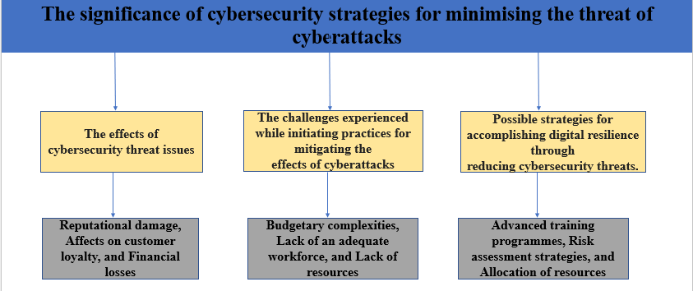
Figure: Conceptual Framework
Source: (Author)
Due to risks related to cyberattacks companies have suffered from reputational damages and have been also unable to maintain their productivity as well as performance. However, brands have failed to adopt such measures for the limitations of budget and resources alongside with an adequate workforce. Companies can initiate risk assessments and internal audits apart from adding new-edge technologies for dealing with complexities.
2.7 Literature Gap
The overall study has been based on the UK retail industry which can be inappropriate for the global scenario. Also there has been a major limitation of resources related to this topic which has decreased the reliability of the work. The particular literatures have somehow failed to determine extensive consequences related to cybersecurity measures as well as challenges.
2.8 Chapter Summary
This chapter has elaborated on the insights which are gathered by a wide range of literature based on the current topic. The negative influences as well as adoption-related challenges have been demonstrated equivalently in this context. Some tactics have been also addressed which can be used by firms for aligning cybersecurity measures in their businesses whereas TAM can be an effective framework.

Chapter 3: Research Methodology
3.1 Introduction
Research methodology considers overall procedures for collecting all kinds of informative data to establish valuable findings regarding the research topic. Research methodology generally states a proper structure for collecting essential information regarding the research. It generally guides the researcher to stay effective with their data collection process for providing effective results for their research project (Gamage, 2025).
3.2 Research Onion
Research onion is a critical research framework that significantly leads a researcher to be familiar with the six important layers for completing research work. The six important layers are philosophy, approach, strategy, choice of the research, time horizon and techniques & procedures (Musundire, 2025). Actually, by working through each and every layer, the researcher has ensured that the choice of research methodologies is logical, which leads to a well-justified and robust research design.
3.3 Research Philosophy
Research philosophy considers the fundamental beliefs about reality and knowledge that underpin the research. Specifically, most researchers use three core research philosophies involving interpretivism, positivism and pragmatism. Positivist research primarily prefers the use of quantitative information; interpretivist research fundamentally prefers the use of qualitative information and pragmatist researchers specifically prioritise the use of both data types. The researcher has typically implemented an effective use of the concepts of the pragmatist research philosophy to effectively complete the research along with both qualitative and quantitative data (Adeoye, 2024). It has been identified as the most reliable technique for gaining in-depth and informative outcomes for the research.
3.4 Research Approach
Research approach considers the entire plan as well as procedures for completing a research study, which typically involves extensive assumptions and logical steps for gathering, analysing as well as interpreting information. Most researchers typically complete their research procedures by taking three types of alternative approaches, like deductive, inductive and abductive. Deductive research approaches mean the completion of research with only quantitative data, and inductive research approaches mean the completion of research with only qualitative data. Abductive research approaches highlight the research with qualitative and quantitative data (Pregoner, 2024). The researcher has implemented the abductive research approach to ensure a better understanding of a research topic by involving qualitative and quantitative information.
3.5 Research Strategy
A research strategy is identified as a systematic plan that typically highlights how a research project is generally conducted, from formulating research questions to analysing data. Most researchers prioritise the case study research strategy, survey research strategy and others. A case study research strategy is an in-depth, mixed research analysis regarding the topic in the context of a company. The survey research considers only quantitative research techniques that collect data from a sample of the population to significantly identify trends and explain characteristics through a set of questionnaires (Daniel et al., 2024). The researcher has critically analysed both qualitative and quantitative information in the context of Marks & Spencer. It has led the researcher to apply the philosophical assumptions regarding the case study research strategy.
3.6 Research Method
A research method considers a systematic plan as well as a structured technique for gathering, analysing as well as interpreting information to answer a specific question. A justified selection of the research method generally helps researchers to provide a logical and planned framework for conducting a study. Most researchers are familiar with three types of research methods involving mono, mixed and multi research methods. The mono research method means the completion of research with only one type of data, either numerical-type or descriptive-type data. The mixed methods mean the collection of both data types in research. Moreover, when researchers use multiple techniques to collect qualitative or quantitative or qualitative and quantitative data. It is called the multi-research method (Stockless and Brière, 2024). The researcher has prioritised an important range of crucial frameworks of mixed methods research in this research. It has led the researcher to complete this research by combining numerical and descriptive-type data.
3.7 Time Horizon
A time horizon in research considers a specific period over which information is collected for conducting a research study. Most research works are completed with two alternative time horizons involving cross-sectional and longitudinal time horizons. The cross-sectional time horizon means the collection of informative data at a single, defined point in time (Saliya, 2023). The longitudinal data considers the gathering of informative data at multiple points in time over an extended period. A range of ideological concepts regarding the cross-sectional study has been applied here to complete the data collection process in a shorter period of time.
3.8 Techniques and Procedures
Data Collection and Analysis
Data collection and analysis is a reliable concept of collecting and analysing relevant data to shape research, along with a range of informative data. Primary and secondary sources are the two major sources which are used to collect crucial data points regarding the research. Original data sources such as interviews, focus groups, surveys, observations and others are known as primary research sources. Past research sources like books, articles, and others are known as secondary sources for the research. The researcher has only used the secondary sources to collect both types of data. The researcher has implemented thematic analysis to analyse qualitative data. The researcher has collected secondary graphs and charts to analyse numeric data. The completion of this research, along with a critical analysis of both data, has helped the researcher to gain an in-depth understanding of this research (Delios et al., 2023).
Ethical Considerations
The researcher has implemented an effective citation process to acknowledge the contributions of all authors of secondary sources. Moreover, the researcher has also followed a significant range of laws related to the Data Protection Act 2018 to ensure the completion of this project in a secure manner. It has helped the researcher to improve the reliability of this research effectively (Phillips, 2021).
3.9 Conclusion
Therefore, the researcher has ensured an effective completion of this entire research by mentioning qualitative and quantitative data points in a critical manner. The research has only searched the secondary resources to collect the informative data points. It has helped the researcher to gain informative findings for the research topic.

Chapter 4: Results and Discussion
4.1 Introduction
The following chapter is based on the secondary findings and discussion of results. Graphs and charts will be used for conducting simple statistical analysis. Apart from that, a wide range of secondary sources will be followed here in order to conduct thematic analysis. Some instances of sources are websites, journals, articles, books, industry reports and others. A set of relevant themes will be prepared here in order to obtain detailed and focused findings of this research project. The results of secondary data will be discussed here through comparative and contrast analysis. Furthermore, the literature findings will be used here to compare both secondary qualitative and quantitative data.
4.2 Results and Findings
4.2.1 Secondary Quantitative Results
Cyber security attacks and breaches have become a common threat in several sectors of the UK. As per the survey report, around 87% of consumers are concerned about the data handling procedure of the business (Beevers, 2025). Retailers have experienced diverse types of cyber threats such as ransomware and malware attacks. Phishing problems, data breaches, point-of-sale vulnerabilities, and issues in NFC systems. Ransomware has adverse impacts on the retail organisations. It includes reputational damage, downturn in sales volume and disruptions in the supply chain system. It has been seen that around half of companies have struggled with managing data privacy and security over the last 12 months. Around 84% of British companies have experienced a phishing attack in 2024 (GOV, 2024). In order to deal with these issues, the majority of entities have followed cyber-hygiene measures. Most common practices of these initiatives are strong password policies, updated malware protection systems, network firefalls, cloud back-ups and limited admin rights.

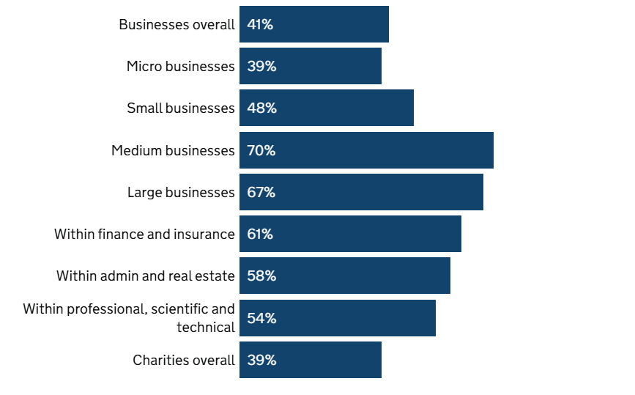
Figure: Percentage of UK organisations experienced cyber threats issue
Source: (GOV, 2024).
The upper-represented image indicates the rate of businesses in the United Kingdom have faced problems in protecting data. It has been found that around 48% of small companies and 70% of medium-sized companies have experienced major threats in managing business data. 67% of large businesses are likely to employ cybersecurity measures for major levels of data theft issues. Around 41% of overall UK-based companies are prioritising on collaborating with cybersecurity specialists to overcome this common threat in the upcoming future.
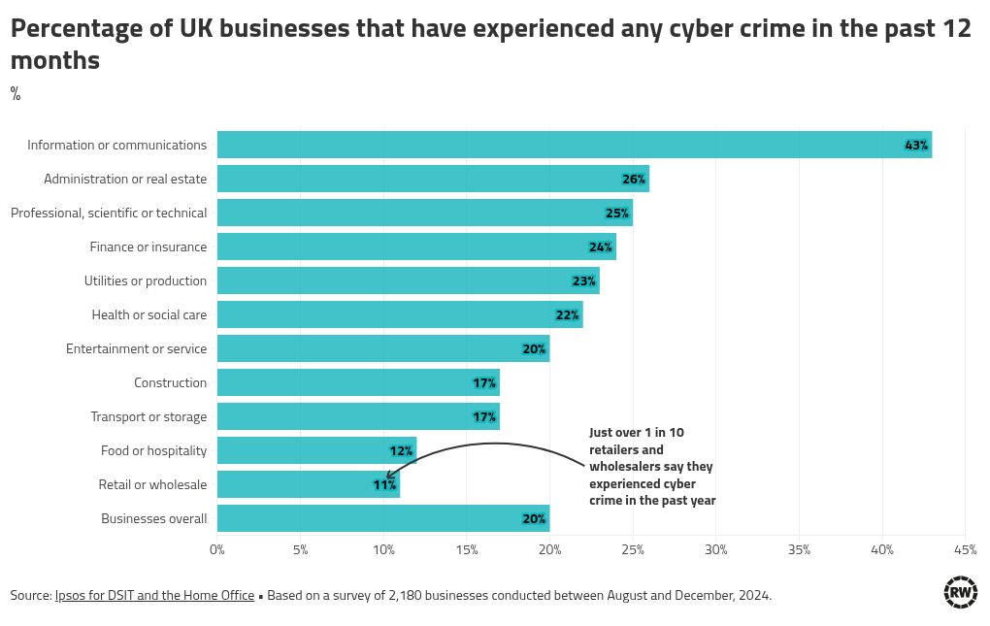
Figure: Proportion of UK retailers faced cyber-crime issues in past 12 months
Source: (Arnett, 2025)
The respective chart represents the proportion of various kinds of British companies that suffered from any kind of cybercrime in the last year. Around 43% of communication and information-related companies stated that they have experienced malware or other cyber crime problems. As per the particular image, over one in 10 UK wholesalers and retail stores highlighted that they also faced this notable problem in 2024 (Arnett, 2025).

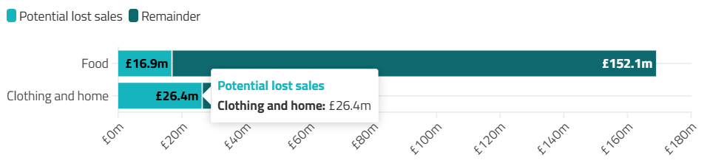
Figure: The impacts of Cyberattacks in M&S
Source: (Arnett, 2025).
According to the assumption of Bank of America or BofA, retailers could lose around £40m per a week for repeated cyber attacks. The respective organisation predicted that around 33% of online home and clothing sellers may face around £26m loss in sales margin due to data breach. It is also expected that around 10% of in-store food sellers could experience more than £17m decline in sales in a week. According to the industry report, the biggest retail brand of the UK, M&S has also faced issues in raising online sales due to the significant cyber-attacks. The respective threat has caused a massive decline of around millions of pounds in sales as well as low share price (BBC, 2025). The security experts detected that DragonForce has been utilised for breaching data security. An officer of the National Cyber Security Centre expressed that ransomware attacks have serious consequences. M&S has paused online delivery and ordering systems due to this disruptive event. The respective brand has confirmed that the personal information of customers like contact details, order histories and birth dates had been leaked during the period. M&S has also clarified that card and payment details and individual passwords have not been impacted by the cyber-attacks (Arnett, 2025).
The cyber vulnerabilities have reached around 80% as exposed by the British retail brands (Robinson, 2025). Around 29 numbers of companies stated that they have experienced the major risk exposure of ransomware attacks (GOV, 2024). Besides that, 40 numbers of retailers exposed that major type of cyber vulnerabilities is email security breach. Outdated software and certification issues are also common reasons for raising the record of cyber threats in the UK market.

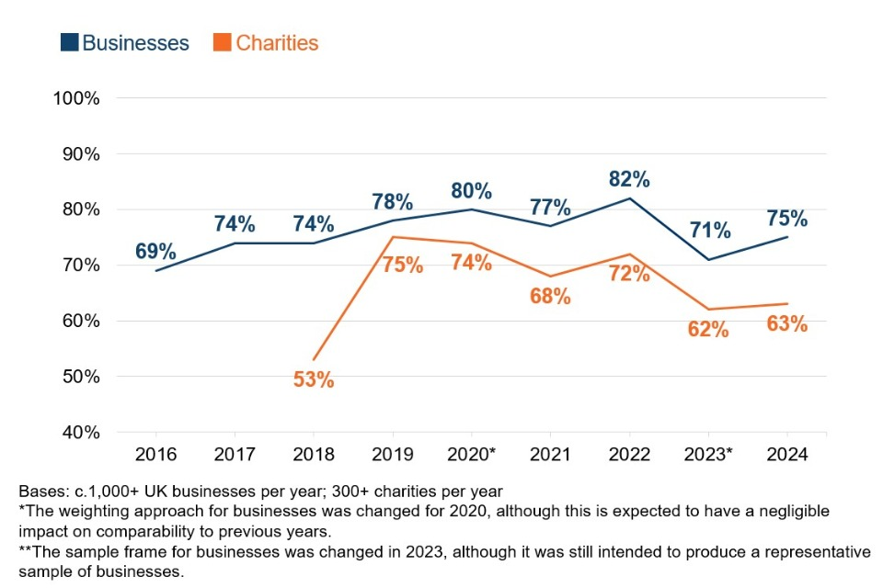
Figure: Priorities of cyber vulnerabilities among UK retailers and charity organisations
Source: (GOV, 2024).
Different sizes of UK businesses have prioritised the factors related to cybersecurity. 73% of micro firms said that the measures related to cyber-attack are a high priority and the percentage is higher than the report of 2023. 91% of medium-sized companies have prioritised cyber hygiene measures in that year. Around 98% of large companies stated that cybersecurity has the top priority for driving sales volume and retaining consumer trust as well. The number of cyberattacks has surged due to the rise of complex economic conditions. Many people have taken this advantage and caused cybercrime as well. The increased cyber-attacks led to the dramatic rise in phishing attacks (GOV, 2024). In response to that, several entities said that they are likely to invest more on the cybersecurity infrastructure.
Majority of the global firms are concerned about the severity of frequent levels of cyber-attacks during the era of digitalisation. 33.5% of organisations believed that the use of AI is the most relevant cause of successful attack in the last few months (VikingCloud , 2025). 71% of corporations reported a major surge in cybercrime frequency in recent times. 8% of cybersecurity leaders discussed that the team members did not report cyber incidents intentionally for fear of job threats.
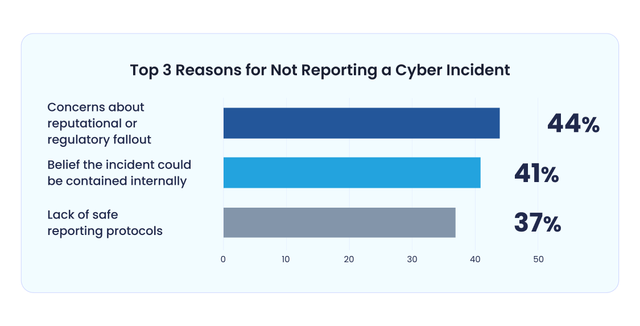
Figure: Reasons for not representing cyber incident
Source: (VikingCloud , 2025)
The particular graphical image represents a few reasons behind the improper representation of a cyber threat incident. Security leaders cited that they are not representing real-time reports of cyber incidents for various reasons. Around 44% of leaders reported that the significant concern is regulatory fallout and reputational damage. 41% of security specialists believed that this incident could have occurred internally for achieving their own purposes. 37% of security managers faced issues in reporting the cyber-attack incidents accurately due to lack of safe and transparent reporting protocols. Around 42% of security specialists argued that 245 of total incidents were caused accidentally (VikingCloud , 2025). 23% of individuals reported that 25-49% of total incidents have been caused by insider activities.
It is anticipated that 55% of SMEs would experience less than $50,000 for cyber incidents. The particular proportion of this organisation can experience operational disruptions and business downtimes due this common threat. 36% of businesses believed that they would lose potential numbers of customers because of these cyber incidents on a regular basis. 22% of companies could struggle with generating more sales due to ransomware and phishing attacks.
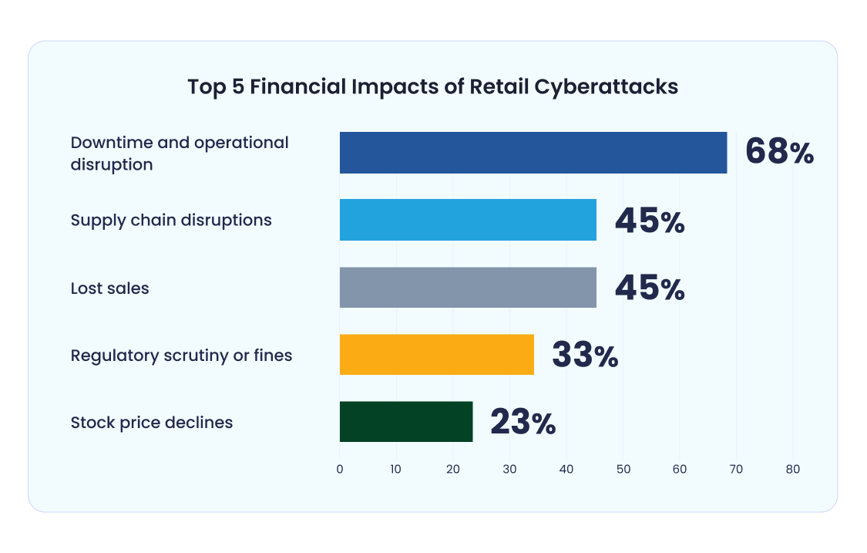
Figure: Financial impacts of retail cyber-attacks
Source: (VikingCloud , 2025)
The average cost of data beaches in the retail sector has increased by 18% over the time. It ahs been reported that the average cost will be around 3.48 million USD. As per the global report, around 80% of retail firms hit at least one time of successful attack in the past 1 year. 22% of organisations in that industry are being hit with around 15 attacks. 68% of retail brands experienced operational complexity as well as downtime because of this successful incident. 45% of retailers identified that the supply chain system got hampered due to frequent attacks. It also led to overstocks or understock issues and delays in delivery. 45% of companies have experienced the loss of sales volume (VikingCloud , 2025). As per the opinions of 23% of retail brands, their stock prices have been declined for the specific event. 33% of brands have been pressured with regulatory fines because of unsuccessful attempts to protect sensitive customer data.
The use of emerging technologies such as AI in cyber-crime is increasing drastically. Most of the criminals are willing to leverage this technology to evade detections, automate attacks and employ modern phishing campaigns. Most of the UK businesses have also spent capital on the maintenance and upgradation of several tools such as intrusion detection, firewalls and end-to-end security systems (Yanthan, 2023). Retailers can develop the robust incident response plan for dealing with cyberattacks seamlessly.
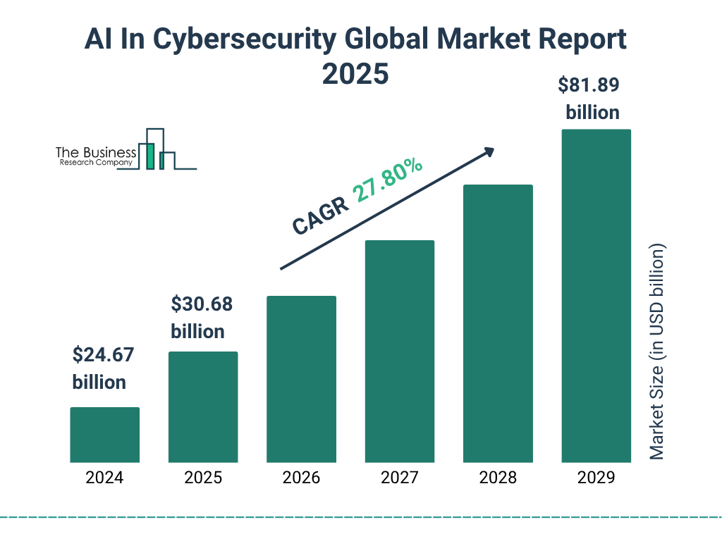
Figure: The growth of the AI-driven cybersecurity market
Source: (Borgeaud, 2025)
The respective column chart depicts the rapid growth of the AI-driven cybersecurity market in recent years. It is predicted that it will rise from 24.67 billion USD to 30.68 billion USD in the year of 2025. The significant growth can be attributed to the emergence of big data, predictive analytics and AI efficiency in the current cybersecurity landscape. The respective market will also reach 81.89 billion USD by 2029 accounting for around 27.8% of CAGR rate. It indicates that the retailers need to adopt and embrace AI in information sharing, real-time threat detection, prediction measures and endpoint security.
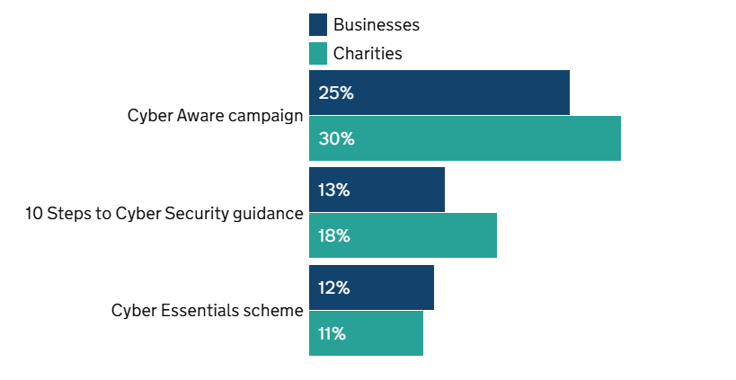
Figure: Cybersecurity awareness percentage among organisations
Source: (GOV, 2024).
The statistical image showcases the proportion of businesses aware of the communication campaigns, legal policies and government-undertaken campaigns. Around 57% of large corporations and 45% of medium firms are aware of Cyber-Aware guidance. Whereas, 37% of medium and 44% of large entities have awareness regarding the 10 steps guidance of cybersecurity. Whereas, 59 % of companies have knowledge in Cyber Essentials (GOV, 2024). Therefore, the UK retailers should focus on adopting 10 steps initiatives and cyber essential measures in order to reduce cyber threats and ensure data privacy for the long-term period. The adoption of these measures can allow UK retail firms to avoid legal penalties and improve customer engagement and retention rate.
4.2.2 Secondary Qualitative analysis
Theme 1: Importance of cybersecurity in retail businesses
Cybersecurity is essential for retail organisations in order to protect the sensitive data of customers, along with protecting financial data, which leads to win the trust of customers. In the contemporary era, businesses have become digitally more active. Therefore, the threat of cyberattack has also increased, leading to amplify the vulnerability of businesses. Hence, with the association of various cybersecurity measures, businesses can prevent unauthorised access and protect customer data (Ardhaninggar and Ramli, 2024). Techniques such as social engineering are used to infiltrate the systems of retail businesses. For instance, the cybersecurity strategy of Unilever is based on a zero-trust model. This allowed the business to attain a secure internet connection and protect the operational technologies of the business (Unilever, 2024). The cyberattack incident of Marks & Spencer also highlights the necessity of cybersecurity in businesses. The respective attack disrupted the availability of food items, click-and-collect services, as well as contactless payment. It impacted on the trust of customers and overall sales of the business (Senior, 2025). Therefore, to maintain the continuity of businesses, avoid any financial loss, and ensure regulatory compliance, focusing on the strategies of cybersecurity is crucial for businesses in the retail sector.
Theme 2: Effects of lack of cybersecurity on the operational performance of retail businesses
The scarcity of cybersecurity in businesses in the retail industry impacts the operational performance directly through reputational and financial damages. Attacks like ‘DDoS or Distributed Denial-of-Service’ can lead to flooding the website of a retailer with traffic creating disruptions in its services. For instance, the cyber-attack in Marks & Spencer disrupted its online sales of clothing along with other services. Due to these disruptions, the value of the stock market of the business dropped more than 500 million GBP. Further, it also led to a projected loss of 3.8 million GBP in terms of online sales (Senior, 2025). Further, a third-party breach can also impact the communication and inventory management system, which creates issues for retailers in terms of tracking delivery schedules and stock levels. The recovery process also gets delayed due to a ransomware attack. Malware that targets ‘POS or Point-of-Sales’ can steal the data of credit cards and close the system of in-store payment processing. The stock control system of businesses (Vaka, 2025). The attack on M&S led to operational disruptions, along with issues like theft of customer data, unstable payments, and more. The loss of customer data, the threat of misusing information, and others also impacted the reputation of the respective business. The M&S cyberattack also impacted the suppliers in terms of clothing and food items (McMahon, 2025). The productivity of employees can also be reduced after such an attack. Addressing the concerns of customers becomes difficult due to the disability of systems. The significant drop in the stock price of businesses due to ransomware attacks, software vulnerabilities, and other cyber threats impacts the operational performance of businesses in a negative manner (Chin, 2025).
Theme 3: Budgetary issues and lack of skills in integrating cybersecurity measures
There are several challenges that businesses in the retail industry experience while incorporating cybersecurity strategies. Budgetary issues can be indicated as a significant threat to the retail industry in terms of implementing robust measures of cybersecurity. Small retailers often consider spending on cybersecurity as a drain on the available resources, instead of a strategic investment. Hiring and retaining skilled professionals with clear knowledge in cybersecurity is also a significant challenge due to the lack of budget. Further, limitations of funds can also create delays in updating to modern technologies and legacy systems. For instance, the lack of investment in security audits and advanced monitoring can impact the overall security of the business. Further, skills gaps can be identified as a significant challenge in integrating the measures of cybersecurity (McLachlan, 2025). The rapid advancement of technologies requires employees with clear knowledge of cybersecurity systems. The scarcity of knowledge among employees regarding the use of AI, IoT, e-commerce, and others leads to failure in the implementation of effective strategies (Ejaz and Matthew, 2024). The lack of training regarding malicious social engineering calls, security awareness, and others can also be identified as notable challenges faced by the retail businesses. For instance, the complexities in the modern retail IT structure indicate that disruptions in one system significantly impact others (Watson, 2025). The dependency on real-time data led to the delay of the recovery process of Marks & Spencer and the integration of cybersecurity strategies in an effective manner.
Theme 4: Resource limitations and complex regulatory system
The limitations of resources pose a significant challenge in terms of incorporating effective cybersecurity in the retail sector. In the first-paced retail environment, assessing security regularly as well as vulnerability testing is ignored often. Due to the lack of attention, businesses fail to adopt a proactive approach (Bechara and Schuch, 2021). As a result of limited resources, the inclusion of a cybersecurity response plan in the organisation becomes difficult. The absence of in-house experts increases the aforesaid threat as well. Further, the complexity in the web regulations can also disrupt the integration of cybersecurity measures. Businesses that operate in different regions are required to deal with different GDPR and CCPA regulations. Businesses like Marks & Spencer can also face issues in navigating global regulations and industry standards while incorporating cybersecurity systems (Harpur, 2025). The lack of regulatory compliance can lead to transparency issues, impacting the reputation of the business. The cyber threat incident in M&S also indicates the scarcity of vendor management maturity, which can create issues in the supply chain. Therefore, businesses in the retail industry are required to offer necessary training to the workforce in order to implement strategies of data security in an effective manner.
Theme 5: The importance of AI-powered cybersecurity measure in safeguarding business information
The retail organisations must prioritise on taking initiatives for enhancing cyber resilience against successful data theft and manipulation. It is necessary for retailers to adopt and incorporate AI-powered technologies to protect business data. It can automate threat detection, improve response times and offer proactive defences against attacks. AI algorithms are effective for scanning real-time data sets, identifying anomalies and network traffic. Machine learning models can also recognise and eliminate threats automatically by limiting the responding times. AI-driven analytical tools can predict potential breaches and flag unusual behaviours (PWC, 2025). This emerging tool can differentiate benign activities and real threats, leading to decline in numbers of unnecessary detection alarms. Small and large companies can invest in AI-driven cybersecurity tools for ensuring robust protection of large-scale business data. The particular tool can analyse a massive range of data to identify indicators and patterns. This approach is essential for security teams for assessing external users, abnormal traffic from endpoints or IoT devices and improper network behaviour (kmtech, 2025). AI-based tools can help retailers to interpret user authentication data like typing styles, fingerprints, voice patterns and others. This modern cybersecurity tool can help users to achieve benefits from shared knowledge within security exposure and improve measures against AI-powered threats. Security specialists can also detect link incidents, behavioural patterns and IP addresses to understand threat causing factors (Adeyeye et al., 2024). It has become easier for security leaders to learn and segment the particular threat groups. The integration of AI within cybersecurity infrastructure also assists retail managers to optimise costs, restrict human error and make real-time decisions regarding further security strategies.
4.3 Discussion
The secondary analysis in the above section has highlighted the importance of cybersecurity strategies in retail businesses. The challenges and strategies in terms of integrating various cybersecurity strategies in the business operations have also been discussed here in the context of Marks & Spencer. Based on the discussion from the literature section, it can be said that due to the cybersecurity threat, the operational efficiency of businesses has decreased. The rise of cybercrimes led to damage to the reputation of retail businesses. Based on the secondary analysis, it can be identified that the respective issue in Marks & Spencer impacted customer trust and the reputation of the business. The phishing attacks, ransom attacks, and others can significantly impact the sales of the retail businesses. Based on the secondary quantitative data, it can be said that around 87% of customers are concerned about the data handling process in businesses. Data breaches, vulnerabilities in point-of-sales, disruptions in NFC systems, and others are some of the common issues faced by businesses. The above analysis has also highlighted that in 2024, around 84% of the businesses in the UK have faced phishing attacks. The graph analysis states that around 67% large businesses integrate cybersecurity measures to deal with the data theft issue. Based on the qualitative analysis, it can be said that due to the increased use of digital technologies, the threat related to cybersecurity has also increased. The above section has also highlighted the disruption of click-and-collect services in Marks & Spencer due to the ransomware attack. Based on the literary discussion, a reduction in productivity is one of the significant effects of cyberattacks in businesses. As a result, the loyalty of customers also gets disrupted. The above secondary quantitative analysis has shown that around 11% retail businesses faced cybercrime issues in the last 1 year. Businesses like M&S also faced issues in raising their overall sales after the cyber-attacks. Based on the data, around 10% of in-store food sellers are also estimated to experience over £17 million decline in sales in a week. It supports the findings in the literary section, which states that financial losses are one of the significant effects in terms of cybersecurity threats. The wide range of legal complexities has also occurred due to the increased number of cyberattacks. Based on the thematic analysis, it can be said that M&S also faced legal complexities while operating in different regions. The data breach issue also impacts the retail business in terms of managing demand as well as the preferences of potential customers. It is crucial to follow GDPR guidelines in order to overcome cyber threat issues. On the basis of the graph chart analysis, as per 73% of micro businesses, cyber-attack is one of the highest priorities. According to 91% medium-sized businesses, the priority of cyber hygiene is necessary in order to maintain their smooth operations. The discussion in the literary section has also highlighted the challenges retail businesses can face while integrating effective strategies of cybersecurity. Budgetary complexities, scarcity of skilled workforce, insufficiency in IT infrastructure, and others have been identified as notable challenges. This has also been supported by the information gathered from secondary qualitative analysis. The limitation of the budget as well as skilled individuals leads to delays in the integration of modern and improved technological systems to safeguard the data of customers and protect the business from any type of vulnerabilities. The thematic analysis has also depicted that the stock value of M&S dropped 500 million due to the cyber-attack incident. The quantitative data has cited that 44% of businesses do not represent cyber incidents due to reputational damage and regulatory fallout, which happened in the instance of M&S as well. Some of the financial impacts of cyberattacks include operational disruption, as per 68% of retail brands. It is followed by supply chain issues, loss of sales, regulatory scrutiny, declination of stock price, and others. Along with decreased stock value, Marks & Spencer has also faced around 3.8 million losses in online sales. The quantitative analysis has also highlighted that the growth of the AI-driven cybersecurity market can be beneficial for businesses in terms of strengthening the security system. Offering necessary training to the employees regarding the use of modern technologies and AI-driven systems can lead the businesses to sustain its reputation and protect customer data in the market. Further, it can be said that 57% of large entities and 45% medium entities are aware of the cyber aware guidance. Therefore, this knowledge can be used by the businesses in the retail industry to incorporate the respective strategies in an efficient manner. The discussion from the literary sources highlights that through advanced training programmes, risk assessment strategies, resource allocation, and others, mitigating the issues related to the implementation of cybersecurity can be easier. The retail businesses in the UK, along with Marks & Spencer are required to plan and allocate resources effectively to ensure better business performance. By conducting an extensive risk assessment, businesses can also be prepared for future challenges regarding cybersecurity. Further, constant audits for reducing the concerns related to data security can also encourage businesses to manage their operations in an effective manner. The above findings have shown that the AI-driven cybersecurity market is predicted to reach 30.68 billion USD by the end of 2025. Further, the qualitative analysis also ensures that AI algorithms are more effective in terms of scanning real-time data and preventing thefts. The use of machine learning models in businesses can be helpful in order to recognise as well as eliminate threats. The AI-driven analytical tools can also significantly predict potential breaches of data. Therefore, it can be comprehended from the above literary and secondary discussion, that businesses in the retail industry can integrate new-edge technologies to deal with similar issues and be prepared for the upcoming challenges. The way the malware attack in M&S impacted its reputation and trust of the customers has also been highlighted in the above section. Based on the accumulated information, it can be stated that reputational damage, financial loss, reduced productivity, and others are the potential impacts of cyber threat, which can disrupt the operational performance of the business. By offering necessary training regarding the security measures, and using AI-driven tools, the retail businesses can overcome such issues and integrate cybersecurity strategies efficiently.
4.4 Summary
The respective section has used websites to find out suitable graphs and charts. The simple statistical analysis method has been employed here to interpret quantitative data. Additionally, the websites have been utilised for gathering industry and company-specific data. Google Scholar has been incorporated here to find books, journal articles and others. Themes and patterns have been designed here to understand the impacts of cyber incidents in retail businesses of the UK. Furthermore, literature insights and both type of secondary data have been compared here to discuss the relevance of cybersecurity measures in decreasing cyber-crime incidents in the retail industry.

Chapter 5: Recommendations, Conclusion and limitations of the research
5.1 Conclusion
The researcher has conducted a study highlighting the cybersecurity measures in M&S, which belongs to the retail sector in the United Kingdom. The primary focus of this study is to showcase different issues with cybersecurity and further generate some strategies that could tackle those issues. Here, a secondary mixed method has been chosen by the investigator and both thematic and graph analysis have been used to get some fruitful outcomes. The researcher has also highlighted a detailed methodology section where all the used methods have been highlighted, including the philosophy, approach, strategy and method of the study. In that section, it has been highlighted that the researcher would maintain all the ethical aspects and maintain data privacy-related guidelines to make the research ethically approved. In the literature section and both the data collection sections, context related to the impact of cybersecurity issues and some challenges while controlling those cyberattacks have been highlighted. Furthermore, it has also revealed some effective strategies that could deal with the respective challenges and successfully manage cyber threats on the company's system. The evaluated results from the literature section, the graph and the thematic portion provide similar outcomes, which seem to benefit M&S in managing their online operations. Apart from the identified strategies through the research process, the investigator would also generate some effective recommendations for M&S. Applying those strategies, this retail organisation would successfully tackle its cybersecurity issues.
5.2 Recommendation
Future research directions
The study has been followed by identifying the different core concepts related to cybersecurity issues within M&S and generating some strategies to tackle those issues. To investigate different essential aspects, the researcher has chosen and followed the secondary mixed method. In this method, both thematic analysis and a graph evaluation have been done on the respective topic. Through the processes, a holistic set of data has been identified and evaluated, which describes the issues and some strategies in general for the whole retail market. Therefore, in further studies, the researcher can involve primary studies, which will have a more direct approach for improving the cybersecurity issues in M&S. Taking a survey from the cybersecurity and some other employees of this business who work with cybersecurity could provide more accurate and particular details about the respective issues in M&S. Moreover, the researcher can also take interviews with some leading people of the cybersecurity department and the management of the business. They will provide more in-depth case histories about the issues faced by their organisation and also how they are going to tackle those problems. Therefore, involving a primary data collection and analysis process would provide more direct conversation about the organisations and would benefit from generating more accurate findings.
Recommendations
Improving technical and network security
M&S is one of the largest fashion retail businesses, which has spread its operations globally and for that, they have to manage a large amount of customer data which are vulnerable to cyberattacks. In order to manage these issues, data encryption should be done where mostly the personal data and transaction data would be stored (Forbes, 2023). Regular maintenance of the software systems, operating technologies and anti-virus systems that are used in this business needs to be done. Introducing a Multifactor Authentication System and using different network security tools could also manage the unauthorised data access in the system of M&S (Hubbard and Seiersen, 2023).
Data management and backup
While data loss and cyber threats are major issues for M&S, they also need to safeguard their data management system and create backup for all their essential data. Apart from a centralised data management system, which is easier to attack, they need to initiate a decentralised medium of data where the data would be stored in multiple locations (FCC, 2025). Moreover, backing up all the data could also help them to retrieve the essential documents if their primary system gets hacked. After using different types of sensitive data like financial information, card details and more, their data management team should migrate that essential data to more secure platforms where access by hackers and digital thieves would be less.
Updating policies and providing training
The management of this retail business needs to be more efficient about having physical control over the systems, computers and the networks. Access to those systems should be limited and only the people with the passwords should be able to access them. Staying compliant with the cybersecurity regulations and having regular audits of the security also needs to be incorporated by the organisation (GOV.UK, 2025). The employees of the organisations are also facing some issues with handling the cybersecurity practices, attacks on systems and making strategies against them. Therefore, proper training should be provided to each of the employees, which will not only make them upskilled but will also boost their confidence about dealing with cybersecurity (GOV.UK, 2025).
5.3 Limitations of the research
The investigator has used a secondary mixed method for conducting this particular study and some issues with poor quality of the study and inaccurate data have been experienced here. The researcher did not have complete control over the data collection processes; a holistic set of data was collected through this process. Thus, it also did not provide detailed, accurate data about M&S, which reduced the accuracy of the outcome. This has created a significant gap in the study, which can be further mitigated by introducing a primary data collection and analysis process. There is also a chance of getting outdated information and inaccurate data, as the data provided in journals and books has been collected previously and now the trends or issues have changed (BBC, 2025). Therefore, it might not be similar to the issues with M&S and that will increase inaccuracy in the study. Therefore, to make the research process highly accurate and direct towards the actual issues faced by M&S, primary data collection and analysis processes could be integrated here.

References
Adeoye, M.A., (2024). Mastering the basics: A guide to research methodology for effective writing and publication. Chalim Journal of Teaching and Learning, 4(1), pp.30-41.
Adeyeye, O.J., Akanbi, I., Emeteveke, I. and Emehin, O., (2024). Leveraging secured AI-driven data analytics for cybersecurity: Safeguarding information and enhancing threat detection. International Journal of Research and Publication and Reviews, 5(10), pp.3208-3223.
Alaba, F.A. and Rocha, A., (2025). The Implication of Cyberattacks on Big Data and How to Mitigate the Risk. Springer.
Amosu, O.R., Kumar, P., Ogunsuji, Y.M., Adelaja, A., Faworaja, O. and Adetula, K., (2024). Enhanced cybersecurity measures: Protect customer data in e-commerce and retail industry.
Ardhaninggar, E.A. and Ramli, K., (2024). A Review of Cybersecurity Framework Implementation for Retail Industry-Challenges and Recommendation. ARRUS Journal of Engineering and Technology, 4(2), pp.211-219.
Arnett, G., (2025). Chart: Marks & Spencer cyber attack could have £40m weekly sales impact. [Online] Available at: https://www.retail-week.com/fashion/marks-and-spencer-cyber-attack-could-have-40m-weekly-sales-impact/7048694.article [Accessed 23 October 2025].
Arnett, G., (2025). Data: How often do retailers report cyber attacks?. [Online] Available at: https://www.retail-week.com/retailer-cyber-attacks [Accessed 23 October 2025].
Bassot, B., (2024). The reflective journal. Bloomsbury Publishing.
BBC, (2025). Marketing: Market Research: Secondary Research. [Online] Available at: https://www.bbc.co.uk/bitesize/articles/z72c6rd#zbrpkhv [Accessed 24 October 2025].
BBC, (2025). Planning and organisation. [Online] Available at: https://www.bbc.co.uk/bitesize/guides/z9rn3k7/revision/3 [Accessed 20 October 2025].
BBC, (2025). Why is the M&S cyber attack chaos taking so long to resolve?. [Online] Available at: https://www.bbc.com/news/articles/cz79547nywno [Accessed 23 October 2025].
Bechara, F.R. and Schuch, S.B., (2021). Cybersecurity and global regulatory challenges. Journal of Financial Crime, 28(2), pp.359-374.
Beevers, A., (2025). The most common retail cybersecurity challenges. [Online] Available at: https://www.theretailbulletin.com/retail-commentary/retail-cybersecurity-challenges-21-08-2025/ [Accessed 23 October 2025].
Borgeaud, A., (2025). Artificial intelligence (AI) in cybersecurity - statistics & facts. [Online] Available at: https://www.statista.com/topics/12001/artificial-intelligence-ai-in-cybersecurity/?srsltid=AfmBOopb-uIAo-a6vT0sck9vO53Ul-3-0u-7nZ23Qrkx56N1L7LQKoBG [Accessed 23 October 2025].
Burns, T. and Sinfield, S., (2022). Essential study skills: The complete guide to success at university.
Cartwright, A. and Cartwright, E., (2025). Underinvestment in cyber security: Quantifying cyber security behavior in UK businesses. Journal of Small Business Management, pp.1-36.
Cartwright, A., Cartwright, E. and Edun, E.S., (2023). Cascading information on best practice: Cyber security risk management in UK micro and small businesses and the role of IT companies. Computers & Security, 131, p.103288.
Cheong, H.I., Lyons, A., Houghton, R. and Majumdar, A., (2023). Secondary qualitative research methodology using online data within the context of social sciences. International Journal of Qualitative Methods, 22, p.16094069231180160.
Chin, K., (2025). Cybersecurity Challenges and Solutions for the Retail Sector. [Online] Available at: https://www.upguard.com/blog/cybersecurity-challenges-and-solutions-for-the-retail-sector [Accessed 23 October 2025].
Daniel, B.K., Harland, T. and Wald, N., (2024). Higher education research methodology: A step-by-step guide to the research process. Routledge.
Delios, A., Welch, C., Nielsen, B., Aguinis, H. and Brewster, C., (2023). Reconsidering, refashioning, and reconceptualizing research methodology in international business. Journal of World Business, 58(6), p.101488.
Disemadi, H.S., (2022). Lenses of legal research: A descriptive essay on legal research methodologies. Journal of Judicial Review, 24(2), pp.289-304.
Ejaz, U. and Matthew, B., (2024). Cost-Effective Cybersecurity Solutions for SMEs: Balancing Security Needs and Budget Constraints.
Elbassuoni, S., (2023). Securing Supply Chains: Leveraging Blockchain and Cybersecurity for Retail Resilience.
Falco, G.J. and Rosenbach, E., (2022). Confronting cyber risk: An embedded endurance strategy for cybersecurity. Oxford University Press.
FCC, (2025). Cybersecurity for Small Businesses. [Online] Available at: https://www.fcc.gov/communications-business-opportunities/cybersecurity-small-businesses [Accessed 24 October 2025].
Forbes, (2023). Four Ways To Improve Cybersecurity For Your Business. [Online] Available at: https://www.forbes.com/councils/forbestechcouncil/2023/05/25/four-ways-to-improve-cybersecurity-for-your-business/ [Accessed 24 October 2025].
Forrester, (2023). Retailers Are Being Barraged By Cyberattacks This Holiday Season. [Online] Available at: https://www.forbes.com/sites/forrester/2023/12/15/retailers-are-being-barraged-by-cyberattacks-this-holiday-season/ [Accessed 20 October 2025].
Gamage, A.N.K.K., (2025). Research design, philosophy, and quantitative approaches in scientific research methodology. Sch J Eng Tech, 2, pp.91-103.
Goldstein, J., (2023). Data-Driven Decision Making In Retail. [Online] Available at: https://www.forbes.com/councils/forbesbusinessdevelopmentcouncil/2023/12/14/data-driven-decision-making-in-retail/ [Accessed 20 October 2025].
GOV, (2024). Cyber security breaches survey 2024. [Online] Available at: https://www.gov.uk/government/statistics/cyber-security-breaches-survey-2024/cyber-security-breaches-survey-2024 [Accessed 23 October 2025].
GOV.UK, (2025). Cyber security guidance for business. [Online] Available at: https://www.gov.uk/government/collections/cyber-security-guidance-for-business [Accessed 24 October 2025].
GOV.UK, (2025). Cyber security. [Online] Available at: https://www.business.gov.uk/invest-in-uk/investment/sectors/cyber-security/ [Accessed 24 October 2025].
Harpur, R., (2025). M&S Breach. [Online] Available at: https://www.blackfog.com/marks-and-spencer-ransomware-attack/ [Accessed 23 October 2025].
Hooker, L., (2025). M&S cyber-attack disruption to last until July. [Online] Available at: https://www.bbc.com/news/articles/c93llkg4n51o [Accessed 20 October 2025].
Hubbard, D.W. and Seiersen, R., (2023). How to measure anything in cybersecurity risk. John Wiley & Sons.
Humphreys, D., Koay, A., Desmond, D. and Mealy, E., (2024). AI hype as a cyber security risk: The moral responsibility of implementing generative AI in business. AI and Ethics, 4(3), pp.791-804.
Karahan, Ç., Velioğlu, H. and Arslan, Y., (2025). Unveiling the Shadows: Anticipating Future Cyber Risks and Their Impacts on Businesses. In Futurisks: Risk Management in the Digital Age (pp. 17-55). Singapore: Springer Nature Singapore.
kmtech, (2025). AI-Powered Cybersecurity: Safeguarding Businesses in a Digital World. [Online] Available at: https://kmtech.com.au/information-centre/cybersecurity-in-the-age-of-ai-protecting-businesses/ [Accessed 23 October 2025].
Kollewe, J., (2025). More than 25% of UK businesses hit by cyber-attack in last year, report finds. [Online] Available at: https://www.theguardian.com/business/2025/jun/30/uk-businesses-hit-by-cyber-attack-last-year-report [Accessed 20 October 2025].
Lehto, M., (2022). Cyber-attacks against critical infrastructure. In Cyber security: Critical infrastructure protection (pp. 3-42). Cham: Springer International Publishing.
Luca, C., (2025). Digital Resilience in Cyber security Supply Chains.
Lussier, R.N. and Achua, C.F., (2022). Leadership: Theory, application, & skill development. Sage Publications.
Marksandspencer, (2025). M&S INTERNATIONAL CUSTOMER PRIVACY POLICY. [Online] Available at: https://www.marksandspencer.com/se/customer-service/privacy-security/privacy-policy.html [Accessed 20 October 2025].
Mckinsey, (2025). Cybersecurity in a Digital Era. [Online] Available at: https://www.mckinsey.com/~/media/mckinsey/business%20functions/risk/our%20insights/cybersecurity%20in%20a%20digital%20era/cybersecurity%20in%20a%20digital%20era.pdf [Accessed 20 October 2025].
McLachlan, P., (2025). M&S cyberattack. [Online] Available at: https://www.learningpeople.com/uk/resources/blog/ms-cyberattack-why-cybersecurity-education-matters-more-than-ever/ [Accessed 23 October 2025].
McMahon, L., (2025). What can I buy online at M&S since the hack?. [Online] Available at: https://www.bbc.com/news/articles/c0el31nqnpvo [Accessed 23 October 2025].
Moulton, S., (2024). Cybersecurity and Trade: The Increasing Use of Cybersecurity Measures and their Impact on International Trade.
Musundire, A., (2025). Understanding the Research Onion and Its Application in Educational Leadership and Management Research: Making Use of Saunders' Research Model. In Research Methods for Educational Leadership and Management (pp. 355-384). IGI Global Scientific Publishing.
Nkomo, L. and Kalisz, D., (2023). Establishing organisational resilience through developing a strategic framework for digital transformation. Digital Transformation and Society, 2(4), pp.403-426.
Okafor, C., Agho, M., Ekwezia, A., Eyo-Udo, N. and Daraojimba, C., (2023). Utilizing business analytics for cybersecurity: A proposal for protecting business systems against cyber attacks. Acta Electronica Malaysia, 7(2), pp.29-39.
Olaniyan, J., (2024). Balancing cost and security: Affordable IT solutions for small businesses facing social engineering risks. International Journal of Research Publication and Reviews, 5(12), pp.1551-63.
Pärn, E., Ghadiminia, N., de Soto, B.G. and Oti-Sarpong, K., (2024). A perfect storm: Digital twins, cybersecurity, and general contracting firms. Developments in the Built Environment, 18, p.100466.
Paul, E., Callistus, O., Somtobe, O., Esther, T., Somto, K., Clement, O. and Ejimofor, I., (2023). Cybersecurity strategies for safeguarding customer’s data and preventing financial fraud in the United States financial sectors. International Journal on Soft Computing, 14(3), pp.01-16.
Phillips, B., (2021). UK further education sector journey to compliance with the general data protection regulation and the data protection act 2018. Computer Law & Security Review, 42, p.105586.
Pregoner, J.D., (2024). Research approaches in education: A comparison of quantitative, qualitative and mixed methods. IMCC Journal of Science, 4(2), pp.31-36.
PWC, (2025). Responsible AI and cybersecurity: what you need to know. [Online] Available at: https://www.pwc.com/us/en/tech-effect/ai-analytics/responsible-ai-cybersecurity.html [Accessed 23 October 2025].
Robinson, M., (2025). Top UK retailers exposed to cyber vulnerabilities reaches 80%. [Online] Available at: https://www.retail-week.com/technology/top-uk-retailers-exposed-to-cyber-vulnerabilities-reaches-80/7049203.article [Accessed 23 October 2025].
Saliya, C.A., (2023). Integrated-flexible research methodology: an alternative approach. In Social research methodology and publishing results: A guide to non-native English speakers (pp. 1-10). IGI Global.
Segal, E., (2022). Small Businesses Are More Frequent Targets Of Cyberattacks Than Larger Companies: New Report. [Online] Available at: https://www.forbes.com/sites/edwardsegal/2022/03/30/cyber-criminals/ [Accessed 20 October 2025].
Senior, H., (2025). The Importance of Cybersecurity. [Online] Available at: https://www.whitelabelexpo.com/blog-library/importance-cybersecurity-lessons-ms-cyber-attack [Accessed 23 October 2025].
Stephens, D., Stubbs, M. and White, S. eds., (2025). Digital Resilience: International and Domestic Legal Responses to Cyber Security and Artificial Intelligence. Springer Nature.
Stockless, A. and Brière, S., (2024). How to encourage inclusion in a qualitative research project using a design-based research methodology. International Journal of Qualitative Methods, 23, p.16094069241227852.
Tiwasing, P., Clark, B. and Gkartzios, M., (2022). How can rural businesses thrive in the digital economy? A UK perspective. Heliyon, 8(10).
Unilever, (2024). Data Protection, Privacy Schedule and Cyber Security Policy. [Online] Available at: https://www.unilever.com/files/data-protection-privacy-and-cyber-security-policy.pdf [Accessed 23 October 2025].
Vaka, P.R., (2025). CYBER SECURITY IN THE RETAIL INDUSTRY. International Research Journal Of Modernization In Engineering Technology And Science, 7(2), pp.939-946.
VikingCloud, (2025). 207 Cybersecurity Stats and Facts for 2025. [Online] Available at: https://www.vikingcloud.com/blog/cybersecurity-statistics [Accessed 23 October 2025].
Vorm, E.S. and Combs, D.J., (2022). Integrating transparency, trust, and acceptance: The intelligent systems technology acceptance model (ISTAM). International Journal of Human–Computer Interaction, 38(18-20), pp.1828-1845.
Watson, K., (2025). What is The Damage of a Cyber Attack?. [Online] Available at: https://www.pentestpeople.com/blog-posts/what-is-the-damage-of-a-cyber-attack-marks-spencers-case-study [Accessed 23 October 2025].
Yanthan, N., (2023). Cyber Attack Statistics and Trends to Know in 2024. [Online] Available at: https://www.sprintzeal.com/blog/cyber-attack-statistics-and-trends [Accessed 23 October 2025].

Appendix: Gantt Chart
Features | 1st week | 2nd week | 3rd week | 4th week | 5th week | 6th week | 7th week | 8th week | 9th week | 10th week | 11th week | 12th week | 13th week | 14th week | 15th week
Choosing Investigation Topic
Aim
Objective
Preparing Literature Review
Conducting Methodology
Findings and Analysis
Using Resources
Discussion about the findings
Measurements and developments
Conclusion
Submission

