Matthew Hatherly (2306287)
2306287@student.uwtsd.ac.uk
Abstract
This study applies data mining techniques to a Student Performance dataset to forecast students’ final academic performances and identify meaningful groups based on demographic, behavioural, and educational characteristics. Using supervised and unsupervised learning methods, the analysis demonstrates how predictive modelling and clustering can support data-driven decision-making in educational settings.
Data warehousing & data mining
Data Mining (ACCA6026)

Table of Contents
1.1 Purpose and Practice of Data Mining 2
1.2 Dataset Description and Exploration 3
1.3 Pre-processing & post-processing 4
1.3.1 Primary Pre-processing 4
1.3.2 Secondary Pre-processing 4
1.3.3 Post-processing 5
1.4 Sample Runs, Results & Method Justification 6
1.4.1 Classification Analysis 6
1.4.2 Clustering Analysis 8
1.5 Business Recommendations 10
1.6 Reflective Commentary 11
Bibliography 12
Appendices 13

Figure 1: The results of using 'CorrelationAttributeEval'. 5
Figure 2: Linear Regression Results 6
Figure 3: J48 Decision Tree Results 7
Figure 4: RandomForest Results 8
Figure 5: Clustering Results using SimpleKMeans 9
Figure 6: Histogram Displaying Age Data in Worksheet 13
Figure 7: Histogram displaying Absences data in Worksheet 13
Figure 8: Histogram displaying Study Time data in Worksheet 14
Figure 9: Histogram displaying G1 data in Worksheet 14
Figure 10: Histogram displaying G2 data in Worksheet 15
Figure 11: Histogram displaying G3 data in Worksheet 15
Figure 12: Histogram showing Failure data from worksheet 16
Figure 13: Attribute selection to rank the most predictive relevance of the class attribute (G3) 16
Figure 14: Predicting final grades based on linear relationships in the model. 17
Figure 15: J48 decision tree to produce interpretable results 17
Figure 16: k-Nearest Neighbour 18
Figure 17: RandomForest 18
Figure 18: Second J48 without G1 and G2 19
Figure 19: SimpleKMeans Cluster 19

Purpose and Practice of Data Mining
Data Mining is the procedure of uncovering significant patterns, relationships, and predictive insights from sizable datasets utilising machine learning and statistical and computational techniques. It forms a vital stage of the Knowledge Discovery in Databases (KDD) process, which consists of data preprocessing and selection, as well as transformation, interpretation, and modelling. [1]. Data mining differs from traditional descriptive analytics as it is primarily focused on revealing previously unidentified structures in data and utilising them to reinforce evidence-based decision making.
Some frequently used data mining techniques involve clustering, classification, regression, association rule mining, and anomaly detection [2]. Classification and regression are supervised learning approaches utilised to foresee outcomes based on labelled historical data, while clustering is an unsupervised method utilised to recognise naturally occurring groups within datasets. These techniques tend to be implemented utilising algorithms such as decision trees, naïve Bayes, k-nearest neighbours, neural networks, and k-means clustering [3].
Within business industries, data mining can support strategic and operational decision-making by allowing for predictive modelling, risk assessments, fraud detection, customer segmentation, and performance optimisation. For instance, predictive analytics can predict customer churn or credit risk, while clustering can identify clear customer or user segments for targeted interventions. By transforming raw data into actionable knowledge, organisations can improve allocate resources more effectively, and in turn boost overall efficiency. As data volumes continue to trend upwards, the correct use of data mining remains a vital capability for gaining competitive advantage and driving data-informed strategy.

Dataset Description and Exploration
The student performance dataset was obtained from the UCI Machine Learning Repository [4], and it was originally compiled and analysed by Paulo Cortez and Alice Silva (2008) [5] to explore the utilisation of data mining techniques for predicting secondary school student results. This dataset contains academic and socio-demographic information relating to secondary school students studying Mathematics and Portuguese. The dataset consists of two specific-subject files: 395 instances for Mathematics and 649 instances for Portuguese, each containing 33 attributes. Each row represents a particular student, and each column relates to a social, demographic, or academic variable.
The attributes are a blend of categorical and numerical variables. Categorical variables include school (GP or MS), sex, address type (urban/rural), family size, parental cohabitation status, parental occupations, school support, family support, and extracurricular activities. Numerical attributes include age (15-22 years), parental education levels (scaled 0-4), study time, number of past class failures, alcohol consumption (weekday or weekend), health status (1-5), absences (0-75), and three grade variables (G1, G2, G3). The target variable for predictive modelling is the final grade (G3). Both datasets contain complete records with no missing values, which simplifies preprocessing and reduces the risk of bias.
Descriptive analysis of the mathematics dataset indicates a mean age of approximately 16.7 years, with most students attending the GP school and living in urban areas. The first (G1) second (G2) period games show strong numerical G3, suggesting high predictive potential. Second, absences demonstrate substantial variability (0-75). This indicates the presence of potential outliers and a possible link with performance. Also, behavioural variables such as alcohol consumption and social activity display moderate dispersion, enabling segmentation analysis. The combination of academic history, family background, and behavioural indicators provides a detailed multidimensional structure suitable for both supervised learning (prediction of outcomes) and unsupervised learning (identification of student groups). Overall, the dataset is well-structured, balanced in attribute types, and highly appropriate for educational data mining and the performance modelling tasks needed in this project.

Pre-processing & post-processing
Data preprocessing is a critical stage in the data mining, as raw datasets often require transformation and preparation before reliable analytical modelling can be performed. Effective preprocessing improves data quality, ensures compatibility with mining algorithms, and enhances the accuracy and interpretability of results. For this study, a structured preprocessing workflow implemented using Microsoft Excel for initial inspection and transformation, followed by further preparation within the Weka data mining environment.

1.3.1 Primary Pre-processing
The first stage involved initial data inspection and validation after importing the Student Performance dataset obtained from the UCI Machine Learning Repository. Both datasets (Mathematics and Portuguese) were examined to verify the number of instances, attribute types, and overall structure. The mathematics dataset contains 395 instances and 33 attributes representing demographic, social, and academic characteristics of individual students.
A preliminary quality assessment was conducted in Microsoft Excel to identify potential issues such as missing values, inconsistent data entries, duplicate records, and abnormal values. Using Excel’s search and filtering functions, the dataset was inspected for empty cells and inconsistencies. No missing values were identified across the attributes, which simplified subsequent analysis by eliminating the need for imputation techniques. Attribute ranges were also examined to ensure values fell within the expected described in the dataset documentation.

1.3.2 Secondary Pre-processing
Following initial preparation, the dataset was imported into Weka for further preprocessing and model preparation. G3 was selected as the target variable as it represents the final course grade, and therefore the overall academic outcome for each individual student. The objective of the predictive modelling stage was therefore to identify patterns within demographic, behavioural, and academic attributes that influence student performance.
Prior to modelling, numerical attributes were normalised using the ‘Normalize’ filter within the Weka preprocessing environment. The transformation scaled numeric variables to a common range between 0 and 1, reducing the influence of differing attribute magnitudes and improving the effectiveness of distance-based algorithms such as k-nearest neighbour and clustering methods.
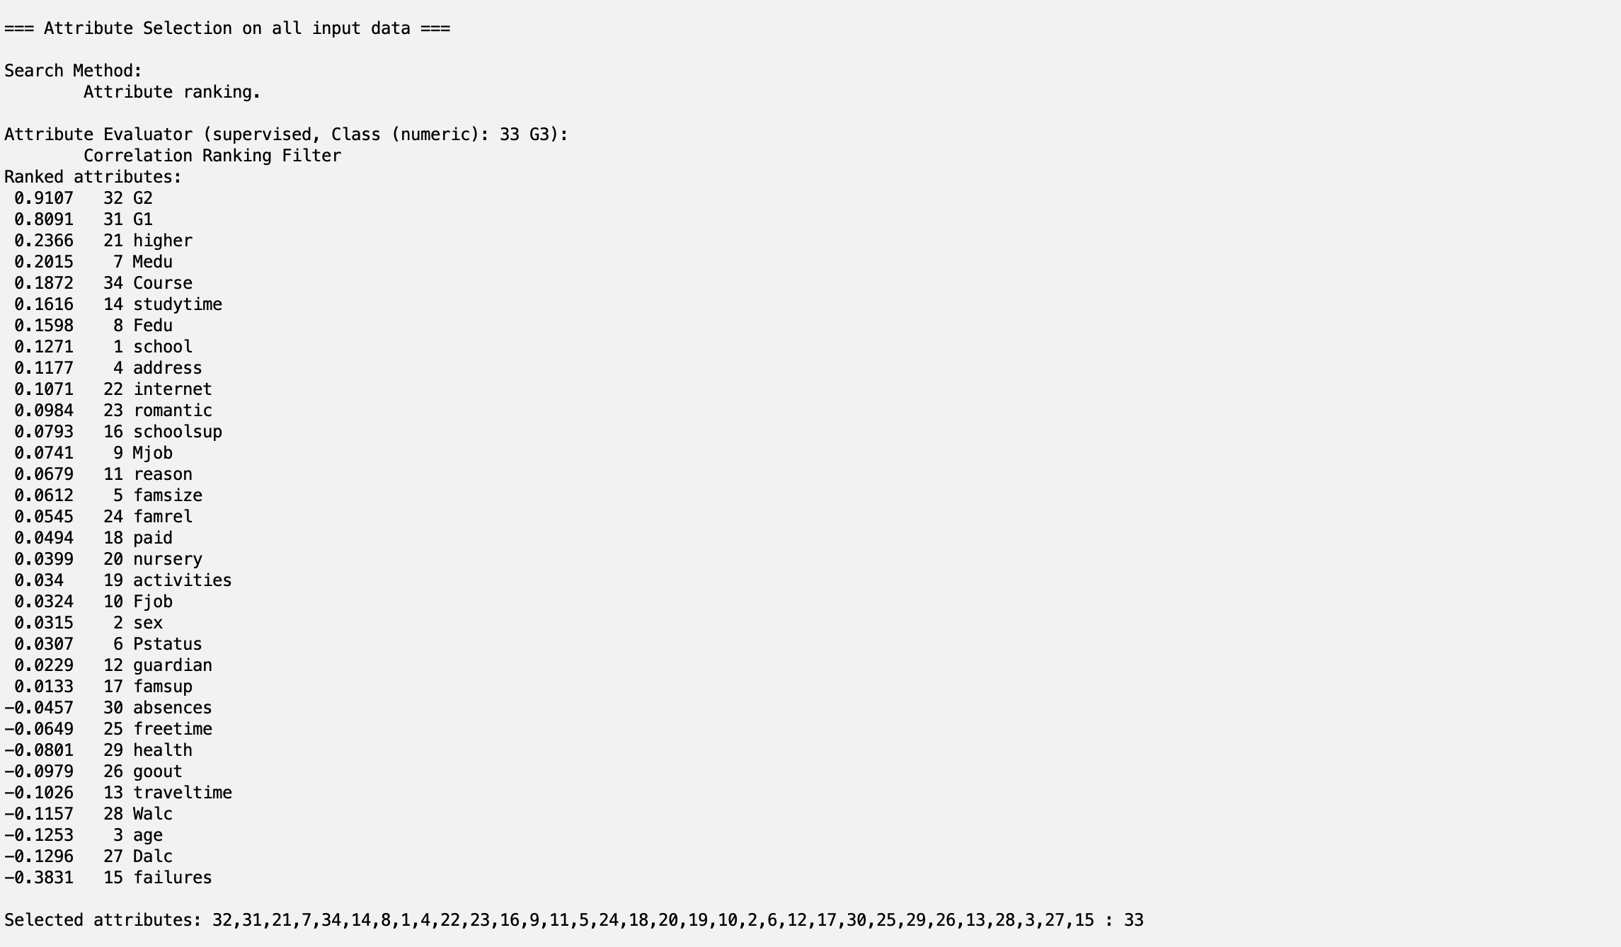
Figure 1: The results of using 'CorrelationAttributeEval'.
Attribute selection was conducted using the ‘CorrelationAttributeEval’ evaluator with the Ranker search method in Weka. The process classified attributes in line with their predictive relevance to the target variable (G3). The results demonstrates that prior assessment scores (G1 and G2), along with indicators such as subject and study time, were among the most influential predictors of final student performance.

1.3.3 Post-processing
Post processing was conducted after the execution of predictive and clustering models within Weka. Model outputs, such as accuracy scores and cluster summaries, were exported and interpreted to support the analytical objectives of the study. This post-processing stage ensures that technical model outputs are translated into relevant insights that can inform practical recommendations for improving student performance and institutional decision-making.

Sample Runs, Results & Method Justification

1.4.1 Classification Analysis
To predict the final student grade (G3), multiple predictive modelling techniques were implemented in Weka. While the tasks involve predicting a numeric outcome, regression-based learning algorithms within the classification framework were used to gauge final performance. Prior to modelling, the dataset was normalised and the target variable (G3) was specified as the class attribute. Model performance was evaluated using 10-fold cross-validation to ensure robust estimation and to reduce the risk of overfitting.
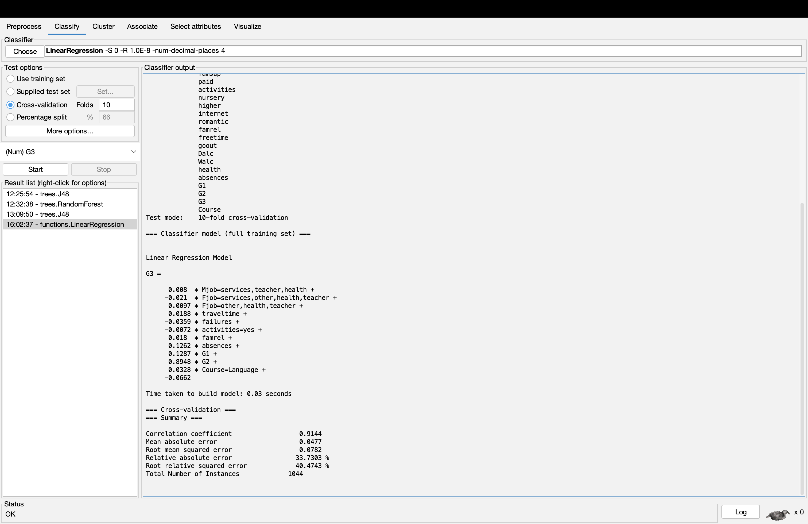
Figure 2: Linear Regression Results
A linear regression model was developed to forecast students’ final grades (G3). The model demonstrated outstanding predictive performance, with a correlation coefficient of 0.9144 and minor error rates (RMSE = 0.0782), an indicator of high accuracy.
This analysis demonstrates that G2 is the strongest predictor, followed by G1. This reaffirms the significance of continuous assessment in determining final outcomes. Different variables, such as failures and family relationships, had more minor but still notable effects. Positive family relationships contributed to improved performance, while failures negatively impacted performance.
Perhaps unexpectedly, absences displayed a positive coefficient. This suggests potential interactions within the normalised dataset as opposed to a direct-causal relationship. The differing subjects also had a minor influence, with students studying Portuguese slightly outperforming Mathematics students.
Overall, the regression model provides a highly accurate and interpretable benchmark, effectively capturing the stronger role of previous academic achievement alongside secondary behavioural factors.
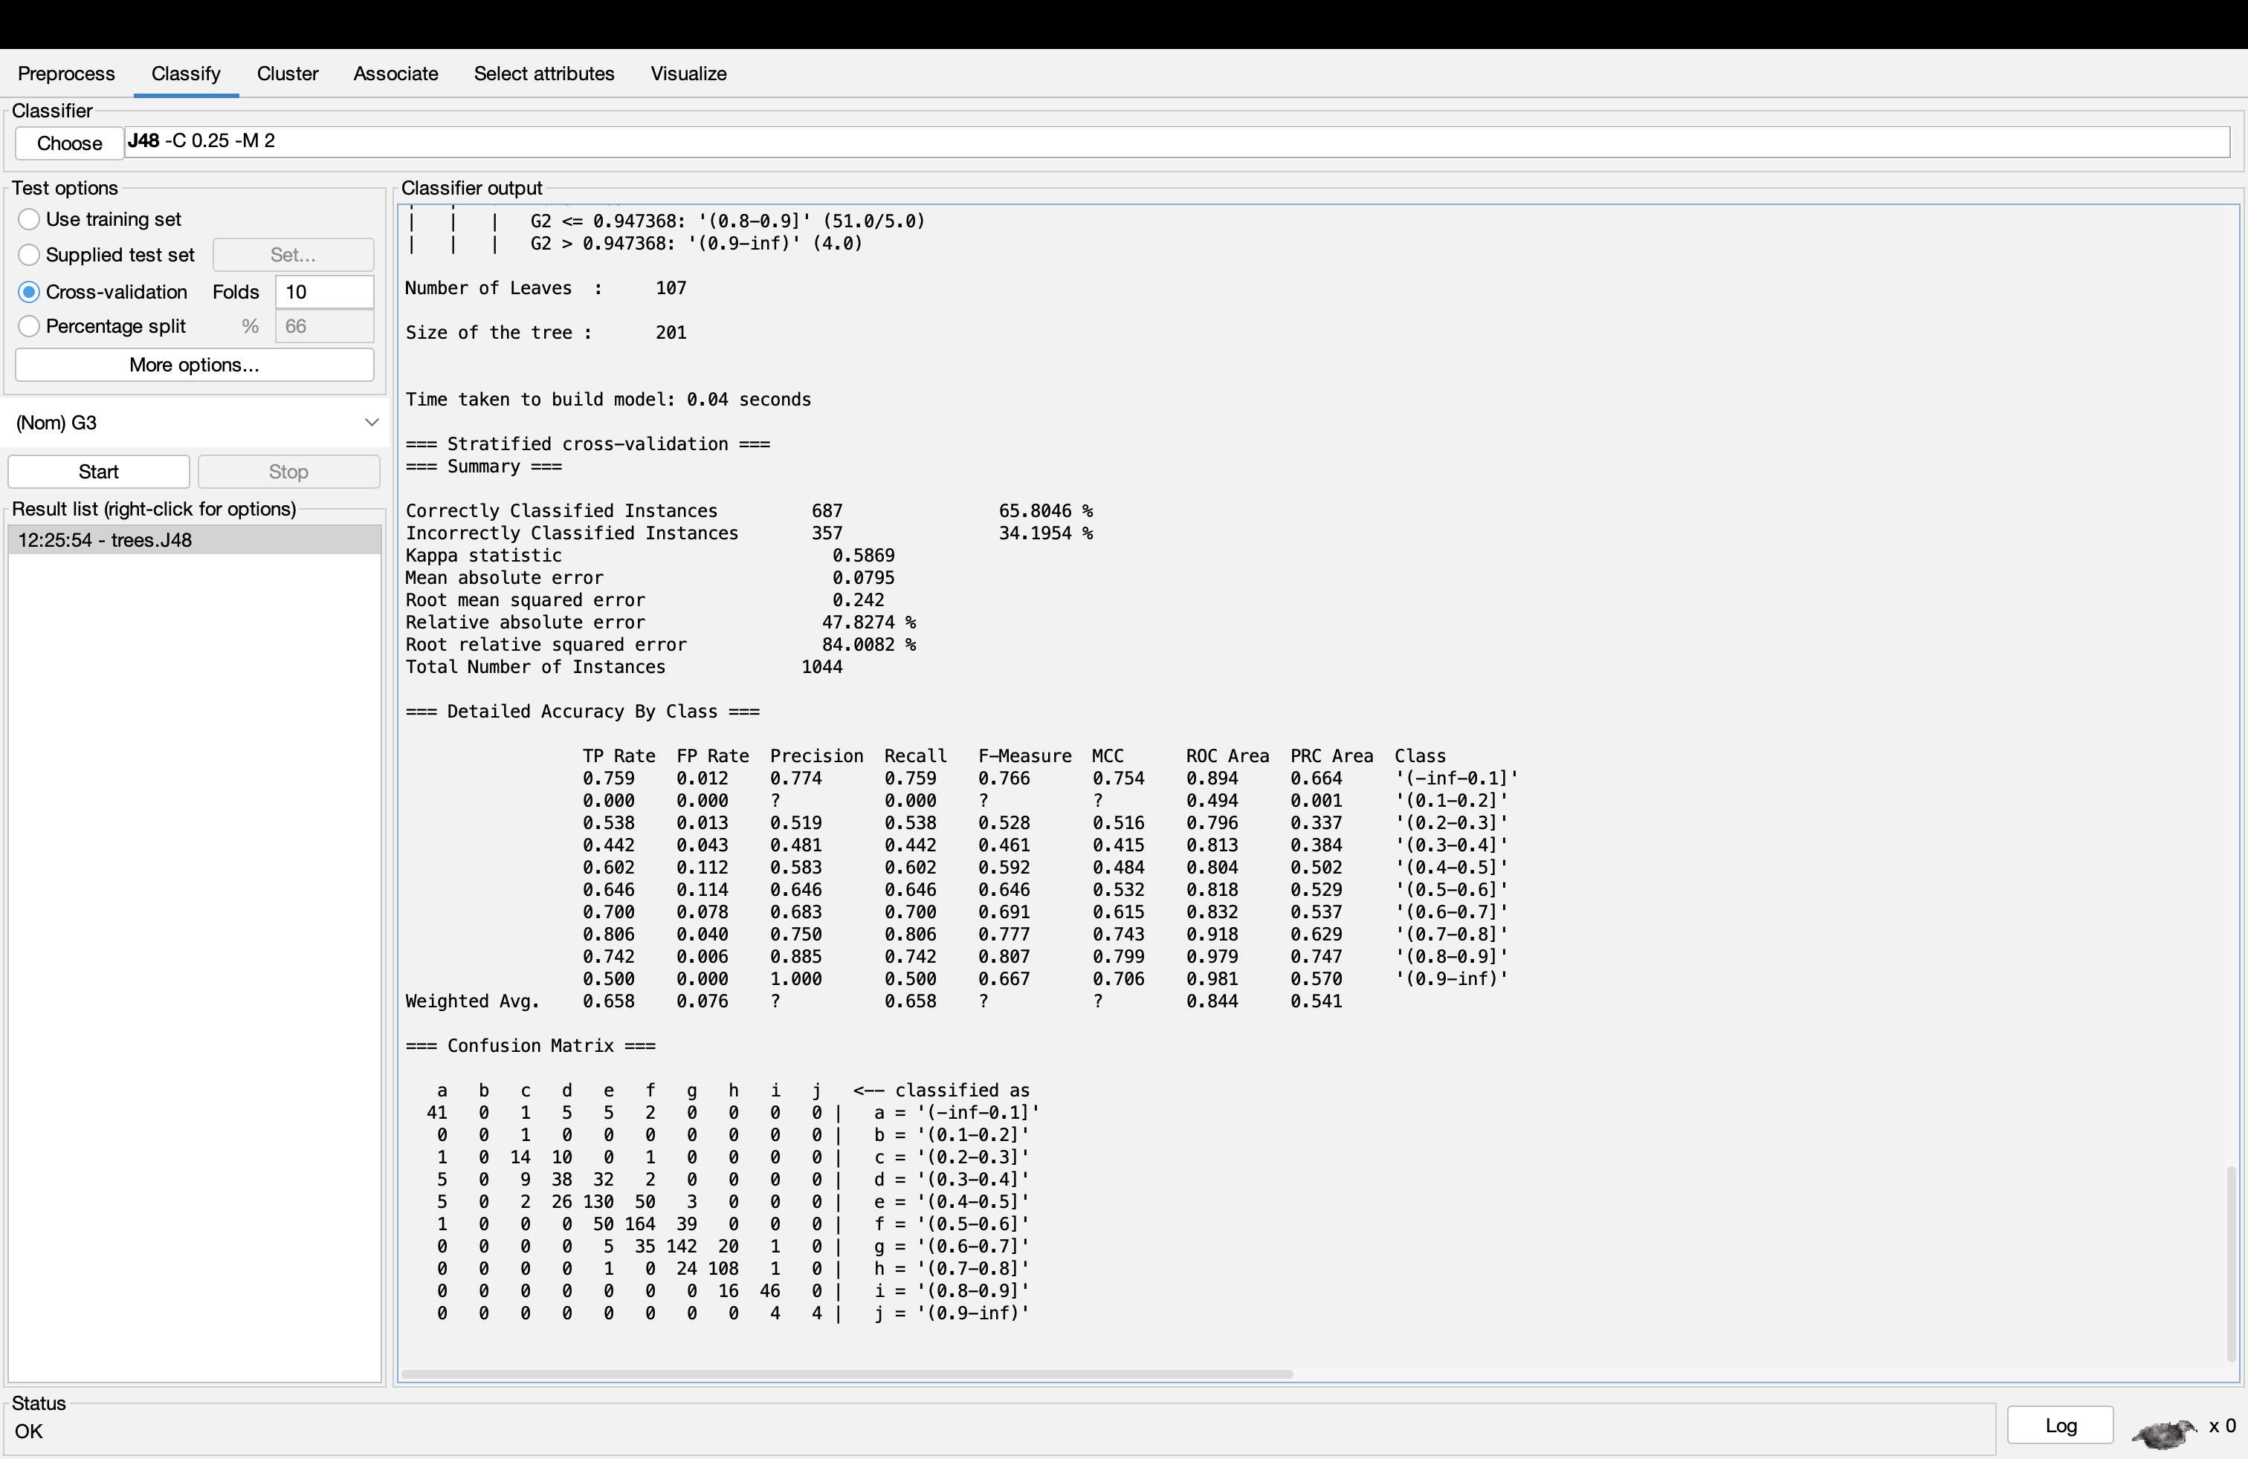
Figure 3: J48 Decision Tree Results
A J48 decision tree model was implemented to classify students’ final performance (G3). Using a 10-fold cross validation, the model achieved 65.8% accuracy with a Kappa statistic of 0.5869, indicating modest predictive reliability. The tree structure highlights G2 as the main influence, followed by G1, confirming that prior academic performance is the strongest determining factor of final performance.
Other variables, such as absences, social activity, study time, contributed to refining predictions within similar academic levels. These factors demonstrate that behavioural patterns be more of an afterthought but still play a vital role in performance. The model performed at its optimal level when predicting mid-to-high grade categories. On the other hand, lower categories showed weaker accuracy, likely due to class imbalance.
Overall, the J48 model demonstrates a strong balance between predictive performance and interpretability. This offers transparent insights towards identifying at-risk students and would be an excellent method of providing academic intervention to struggling students.
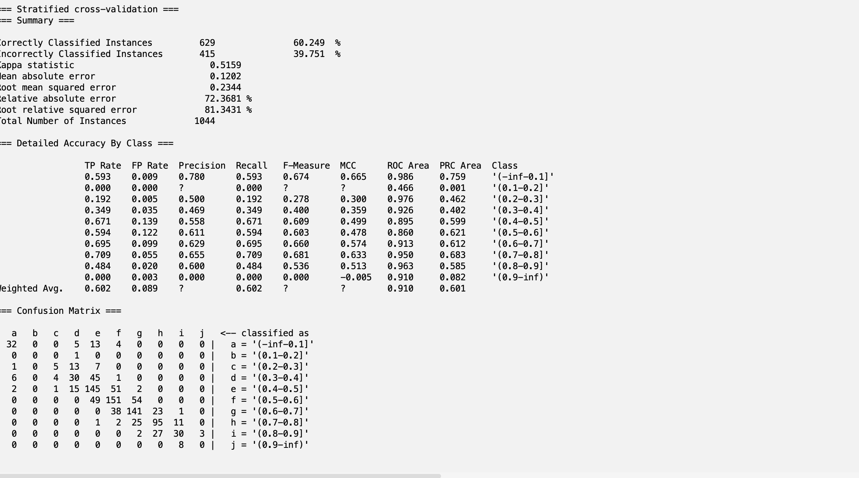
Figure 4: RandomForest Results
A Random Forest classified was applied using 100 trees to foresee categorised student performance. The model performed well, achieving an accuracy of 60.25% and a Kappa statistic of 0.5159. While slightly lower than the J48 model, Random Forest benefits from ensemble learning and improved robustness.
The model demonstrates strong discriminatory ability, reflected in a high ROC area (0.910), and performed best in mid-range grade categories (0.6-0.8). However, performance was weaker for some categories, particularly for very low and very high grades, likely due to class imbalance and fewer instances.
The confusion matrix demonstrates that misclassifications tend to occur between adjacent grade bands, suggesting the model effectively captures general trends but struggles with precise distinctions.
Overall, Random Forest provides valuable comparative insight and is an important reminder of the fine line between predictive power and interpretability, while reinforcing the significance ensemble approaches would be in educational data mining.

1.4.2 Clustering Analysis
Clustering analysis was conducted utilising the k-means algorithm to recognise naturally occurring groups of students based on their academic, behavioural, and demographic characteristics. The model converged after 12 iterations, providing three distinct clusters with a within-cluster sum of squared errors (WCSS) of 6150.49. This indicates a moderate level of cohesion within clusters.
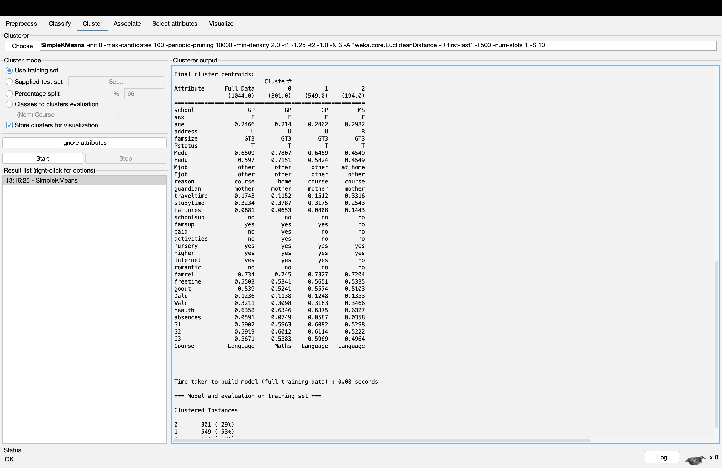
Figure 5: Clustering Results using SimpleKMeans
The largest cluster (53%) constitutes average-performing students, characterised by moderate prior grades (G1, G2) and final outcomes (G3 = 0M60). These students exhibit average study patterns, moderate social activity, and relatively stable family support, suggesting a balanced but unexceptional academic history.
The second cluster (29%) consists of slightly higher-performing students, with more reinforced study habits, lower failure rates, and slightly higher prior grades. These students also show greater engagement in activities and paid support, indicating a more proactive academic approach. Despite a slightly higher absence rate, their performance remains reasonably strong, suggesting resilience or effective time management.
The smallest cluster (19%) represents lower-performing students, with noticeably lower G1, G2, and G3 scores (G3 = 0.50). This group is characterised by higher failure rates, longer travel times, lower parental education levels, and reduced access to resources such as internet and family support. Collectively, these factors could be an indicator of potential socio-economic and structural disadvantages impacting academic success.
Overall, the clustering analysis highlights clear segmentation within the student population, demonstrating that academic performance is not simply driven by prior grades, but also influenced by behavioural and contextual factors. These insights are especially valuable for academic-intervention strategies, enabling institutions to tailor support based on distinct student profiles rather than adopting a one-size-fits-all approach.

Business Recommendations
Multiple actionable recommendations can be acquired based on the findings of this analysis, many of which could prove beneficial for educational institutions seeking to refine student performances. Initially, previous academic performance (G1 and G2) was consistently identified as the strongest predictor of final grades across all models. This suggests that institutions should implement early warning systems that observe results to identify to identify at-risk students prior to the G3 stage. At this early stage, proactive measures such as private tutoring can still take place.
The clustering analysis highlighted how certain student groups were affected, including a segment characterised by low academic performance, higher failure rates, and reduced access to resources such as the internet and family support. This underlines the need for targeted support plans, especially for students from disadvantaged backgrounds. Providing access to tutoring, study support programmes, and digital resources. Study support programmes may assist in mitigating these challenges.
Behavioural factors such as absences and study time also influenced performance levels. Therefore, Institutions should provide advice on how to retain good study habits and support students with low attendance through academic support services. Also, providing awareness towards lifestyle factors such as alcohol consumption and social activity could contribute to improved grades.
Finally, the interpretability of decision tree models provides practical value for institutions, enabling educators to make informed decisions based on key risk indicators. Overall, integrating predictive analytics into educational management systems can be hugely beneficial in supporting data-driven decision-making, fulfilling duty of care, and improving overall academic performance for students.

Reflective Commentary
Utilising Weka to apply data mining techniques proved effective in identifying key gauges of student performance by uncovering significant trends within the dataset. The models demonstrated strong predictive capability, particularly the linear regression model, which achieved a high correlation coefficient. This indicates an accurate estimation of final grades. Decision tree methods also performed well, providing the additional advantage of interpretability through clear rule-based structures.
A key strength of this approach is its ability to combine predictive accuracy with actionable insights. Techniques such as classification and clustering produced both reliable results in addition to providing a deeper understanding of the factors influencing student performance. That said, there are some key imitations. The discretisation of the target variable, while necessary for classification, could result in the loss of some information. Also, certain models, such as Random Forest, provided reduced interpretability despite their robustness.
If the analysis were to be repeated, multiple developments could be considered. Feature selection techniques could be a point of focus to improve the effectiveness of the model. Also, considering alternative algorithms or parameter tuning may increase predictive performance. Comprising external data, such as socio-economic indicators, could be another method of providing a more comprehensive understanding of student performance.
Overall, this project has proved that data mining could be an effective tool in educational decision-making, although factors such as data preparation, model selection, and interpretability should be kept in consideration.

Bibliography

[1] | M. K. a. J. P. Jiawei Han, “Data Mining: Concepts and Techniques, 3rd ed.,” The Morgan Kaufmann Series in Data Management Systems, 2011.
[2] | P.-N. T. a. V. K. Michael Steinbach, “Introduction to Data Mining (Second Edition)”.
[3] | C. M. Bishop, “Pattern Recognition and Machine Learning,” Springer, p. 738, 2006.
[4] | “UCI Machine Learning Repository,” University of California, [Online]. Available: https://archive.ics.uci.edu. [Accessed 25 February 2026].
[5] | A. S. Paulo Cortez, “Using data mining to predict secondary school student performance,” ResearchGate, 2008.

Appendices
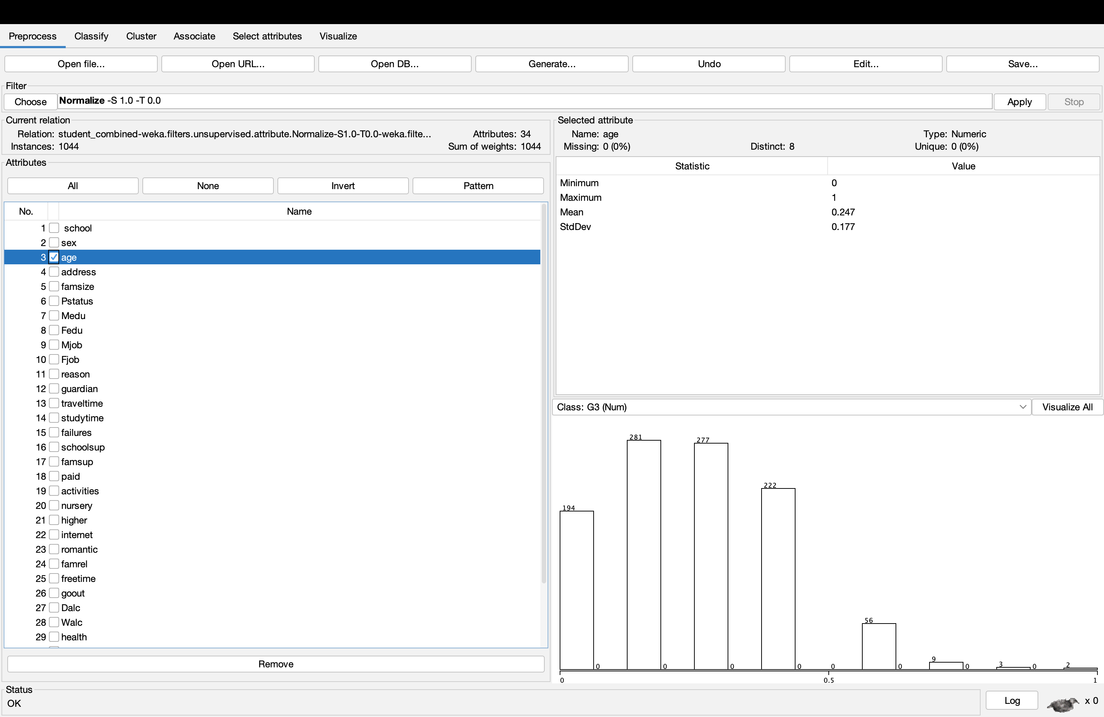
Figure 6: Histogram Displaying Age Data in Worksheet
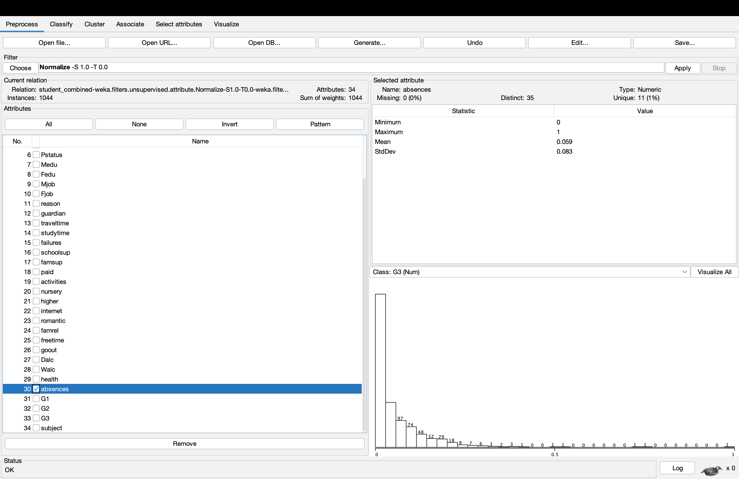
Figure 7: Histogram displaying Absences data in Worksheet

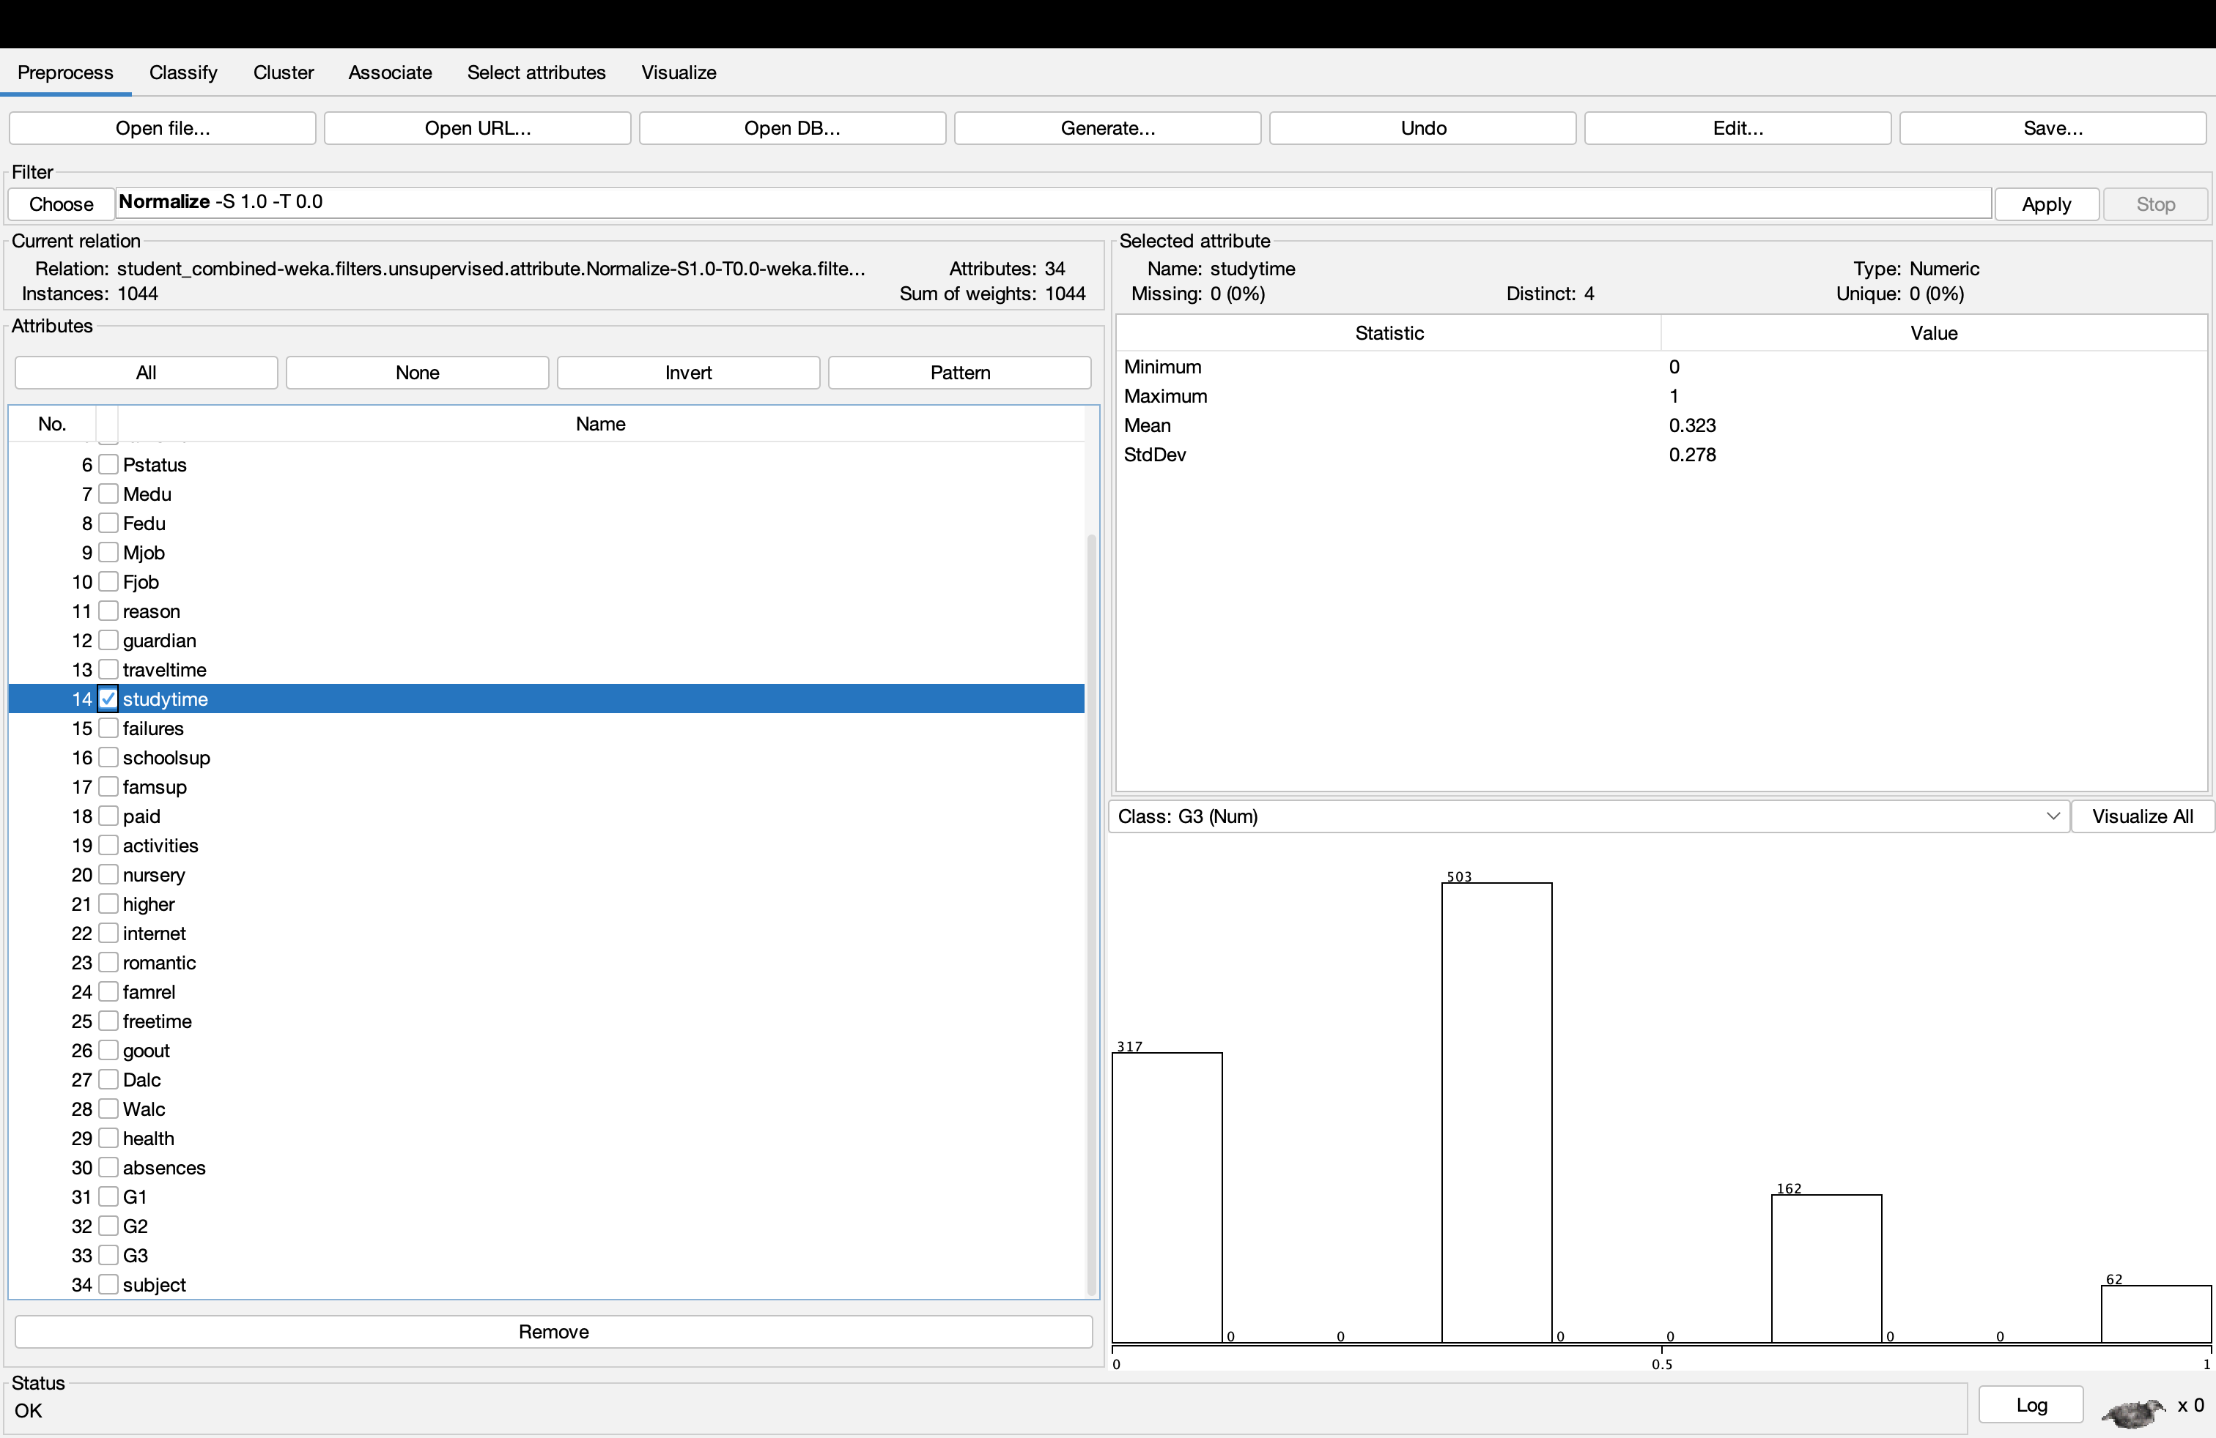
Figure 8: Histogram displaying Study Time data in Worksheet
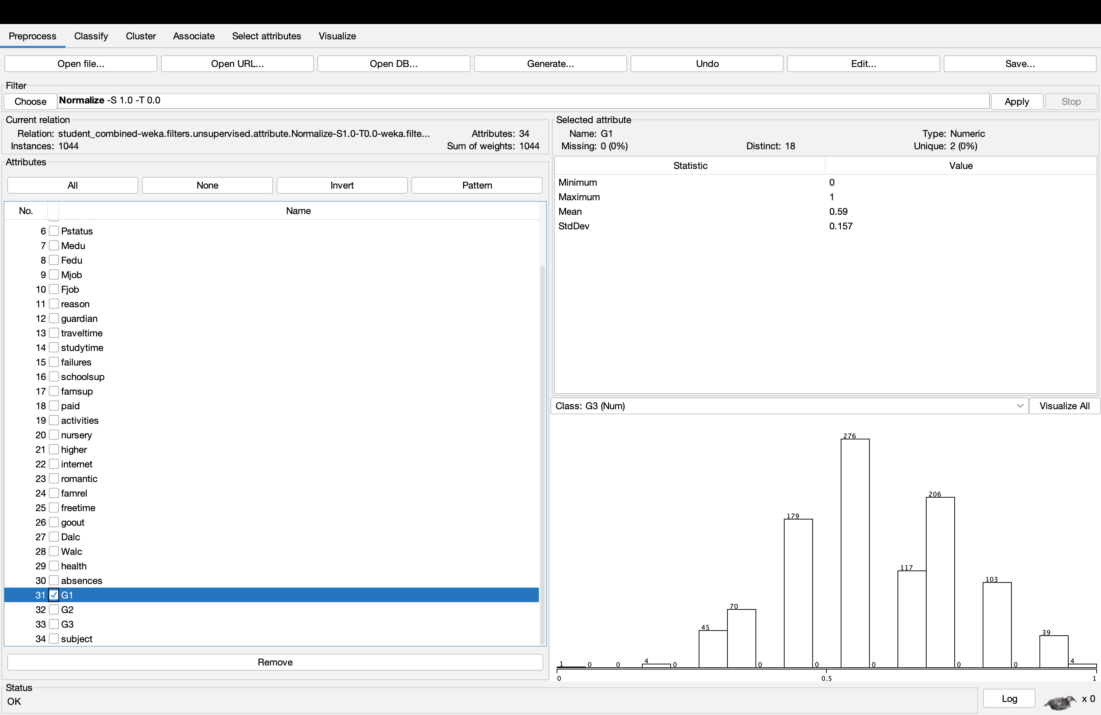
Figure 9: Histogram displaying G1 data in Worksheet

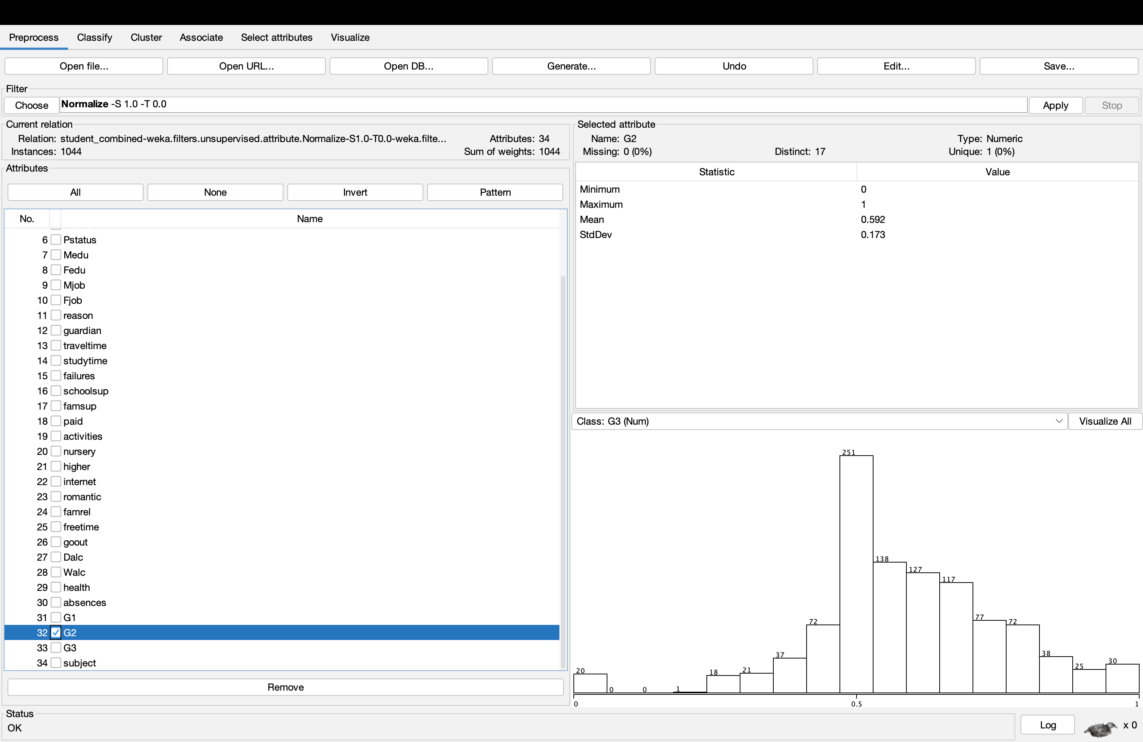
Figure 10: Histogram displaying G2 data in Worksheet
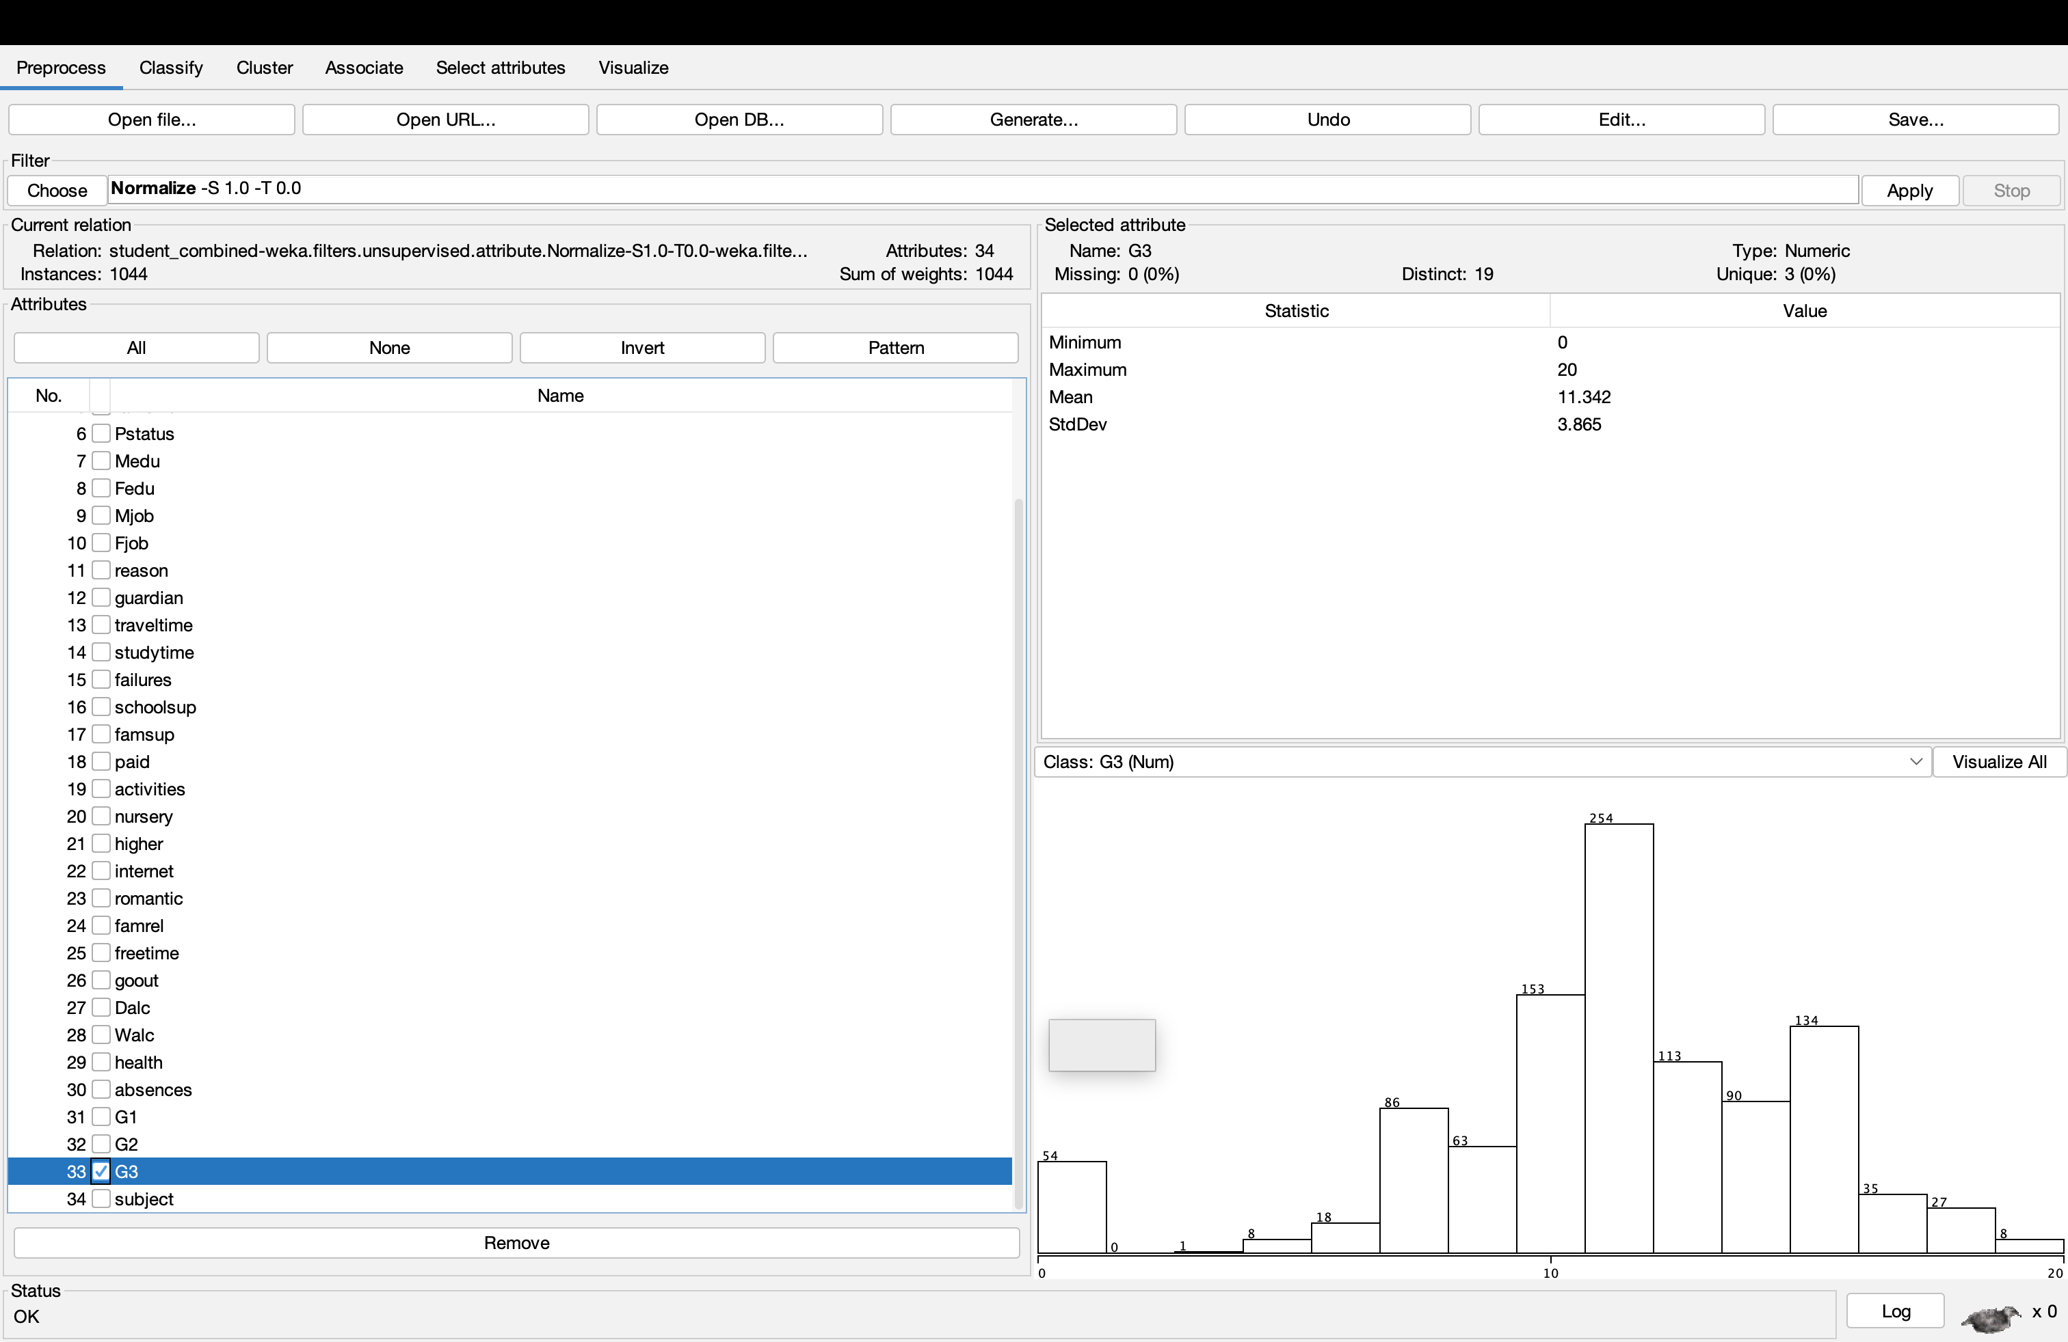
Figure 11: Histogram displaying G3 data in Worksheet

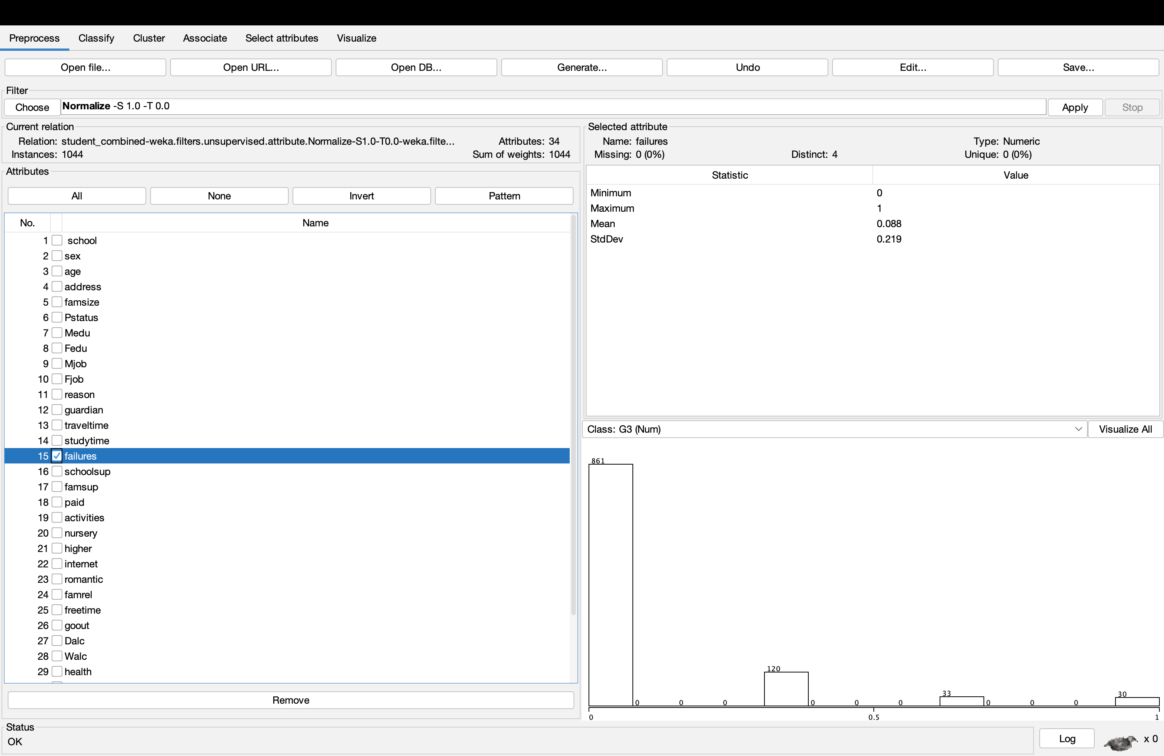
Figure 12: Histogram showing Failure data from worksheet
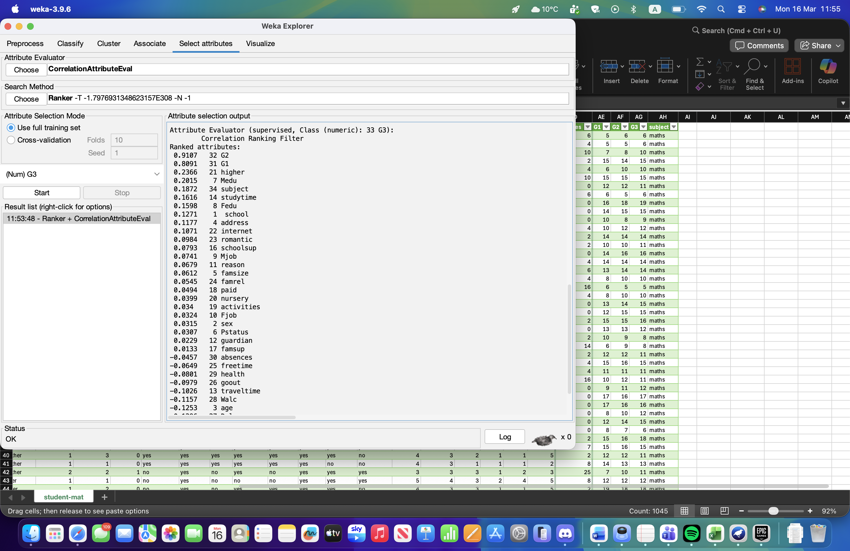
Figure 13: Attribute selection to rank the most predictive relevance of the class attribute (G3)
Figure 14: Predicting final grades based on linear relationships in the model.
Figure 15: J48 decision tree to produce interpretable results
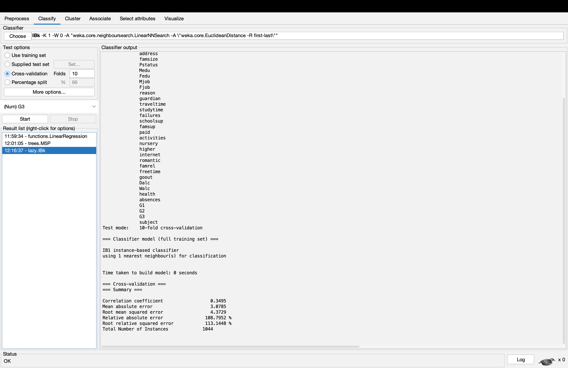
Figure 16: k-Nearest Neighbour
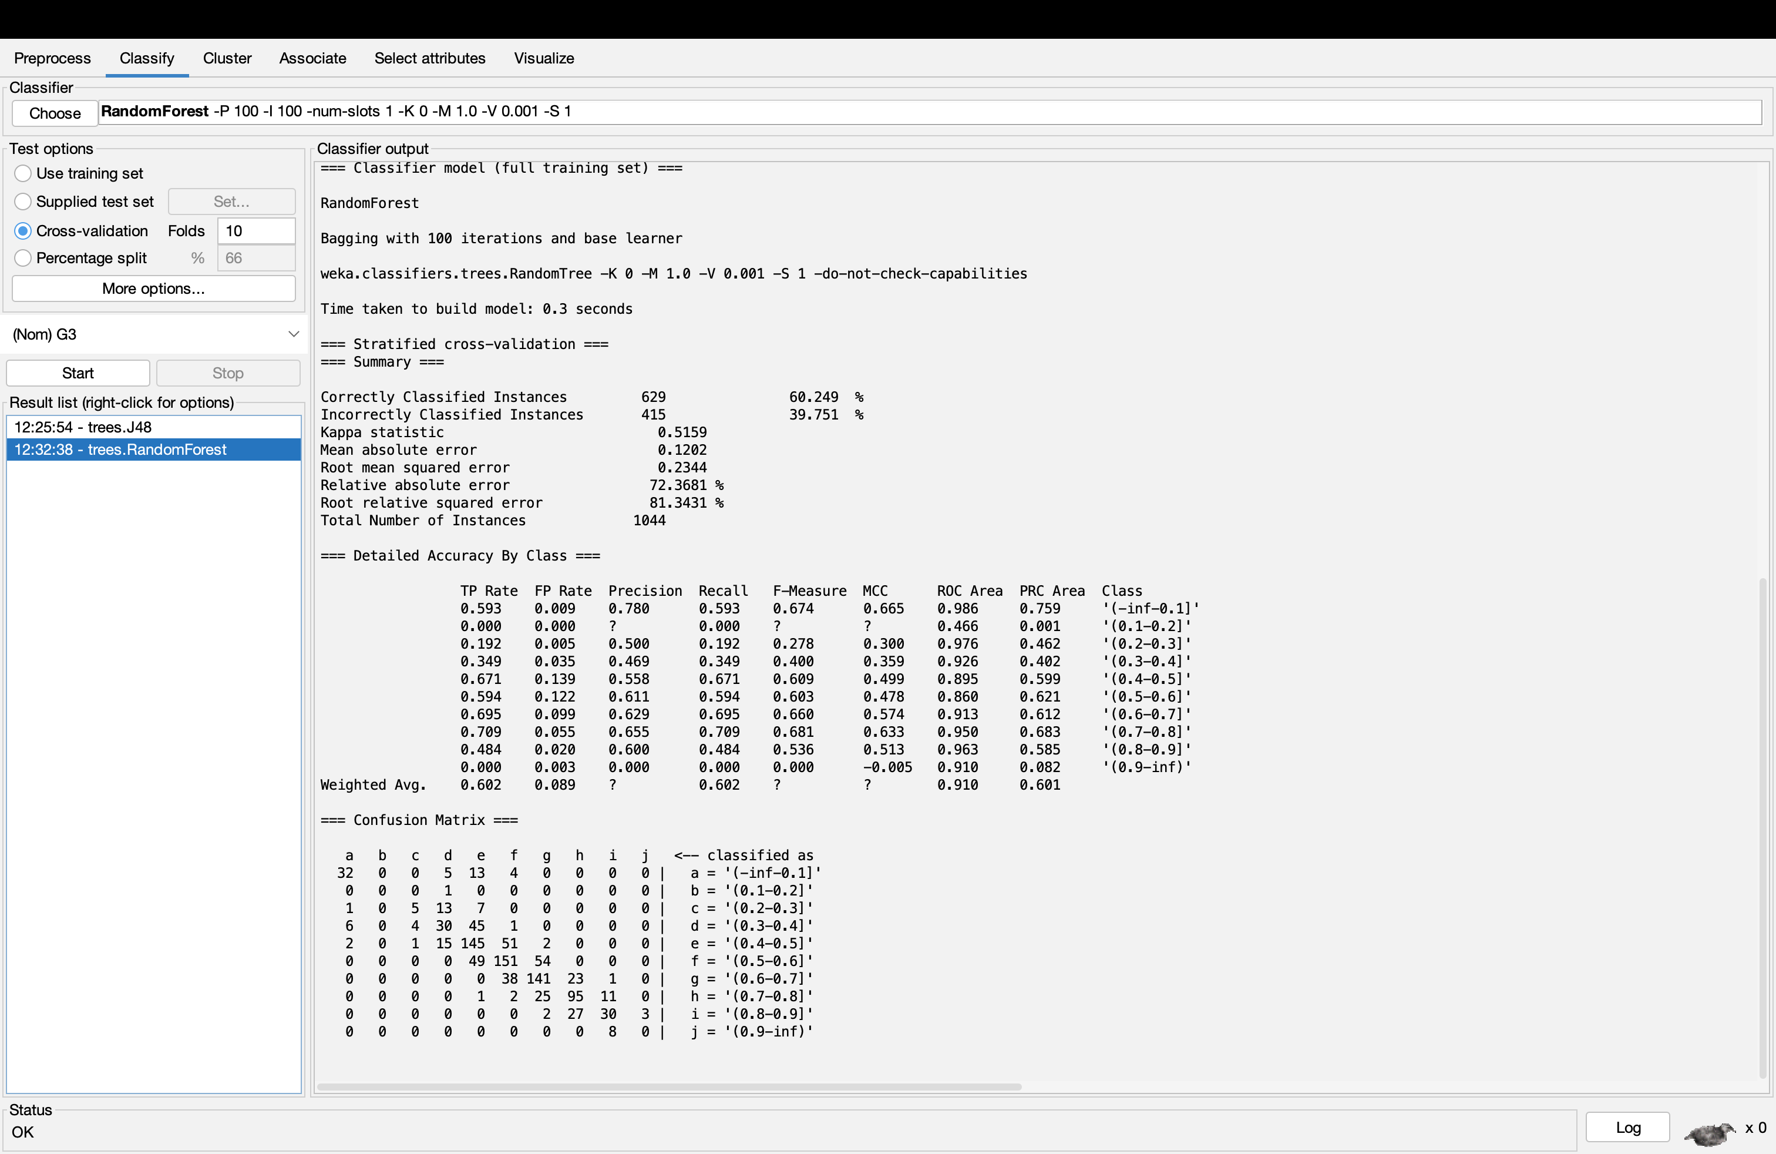
Figure 17: RandomForest

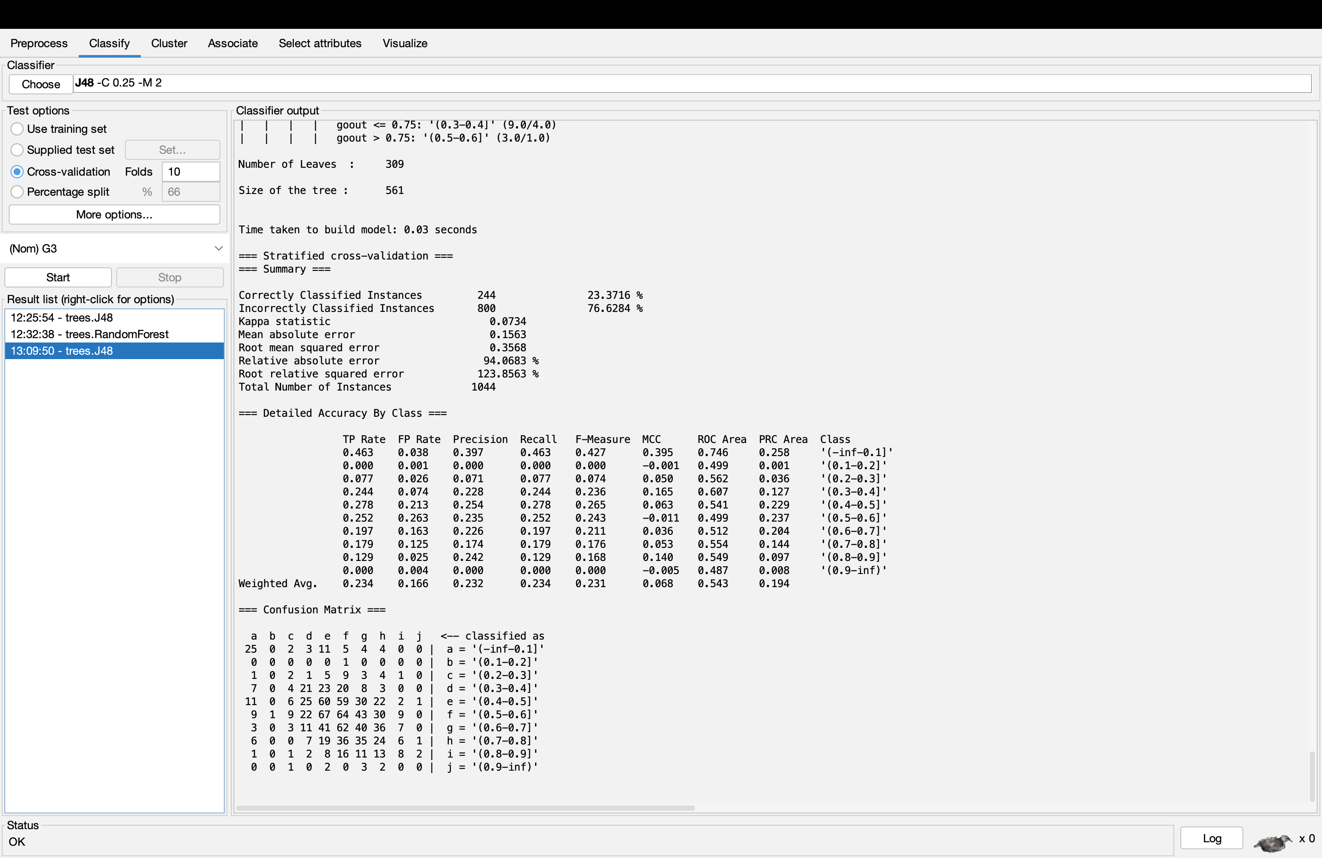
Figure 18: Second J48 without G1 and G2
Figure 19: SimpleKMeans Cluster

