

Postgraduate/Distance Learning
Assignment coversheet & feedback form

THIS SHEET MUST BE THE FIRST PAGE OF THE ASSIGNMENT YOU ARE SUBMITTING (DO NOT SEND AS A SEPARATE FILE)

For completion by the student:
Student Name: Camille Bates

Student University Email: 1806482@student.uwtsd.ac.uk
Module code: HPCA7008  Module title: Heavenly Discourses | Student ID number:  1806482 |  |  | Educational support needs:  Yes/No  No
Assignment title: Assignment One

Assignment due date: 8 June, 2020, 11:59pm
This assignment is for the 1st 2nd 3rd 4th 5th 6th module of the degree
I confirm that this is my original work and that I have adhered to the University policy on plagiarism.
Signed Camille Bates
Email submission:if you are submitting this form via email, please tick this box □
(as a substitute for your signature) to confirm that you agree to the above declaration.
Assignment Mark
1st Marker’s Provisional mark
2nd Marker’s/Moderator’s provisional mark
External Examiner’s mark (if relevant)
Final Mark

NB. All marks are provisional until confirmed by the Final Examination Board.

For completion by Marker 1 :
Comments:

Marker’s signature: |  |  | Date:
For completion by Marker 2/Moderator:

Comments:

Marker’s Signature: |  | Date:
External Examiner’s comments (if relevant)

External Examiner’s Signature: |  | Date:

HPCA7008 – ASSIGNMENT 1
Question:
Compare and contrast the expression or representation of the sky in two works of film, music, art, architecture, celestial cartography or literature in their expression or representation of the sky.
Word Count: 2078

This essay will compare and contrast the representation of the sky between two paintings: Keelmen Heaving in Coals by Moonlight by Joseph Mallord William Turner (1835, Washington, National Gallery of Art), and The Starry Night by Vincent van Gogh (1889, New York, The Museum of Modern Art). Both paintings present a stylised representation of the sky, although The Starry Night has a more abstract representation than Keelmen Heaving in Coals by Moonlight. The representation of the night sky in both the paintings has relied heavily on the colour white. Tim Ingold has suggested The Theory of Colours by Johann Wolfgang von Goethe can be seen in The Starry Night. C. S. Kӧnig and W. W. Collins have argued Turner did not agree with Goethe’s theory, and exploited colour far beyond theories. Albert Boime and also Charles A. Whitney have relied on astronomy to interpret the expression of the night sky in The Starry Night. A. W. Woodruff has suggested art can be used as a primary source to provide historical information. All these ideas will be explored.

The career of Turner spanned from the 1790s to 1851. Judith L. Fisher has suggested during the 1830s and 1840s Turner experimented with how to create the effects of light in his paintings, and Keelmen Heaving in Coals by Moonlight (Fig. 1), is one of the paintings produced during this period.
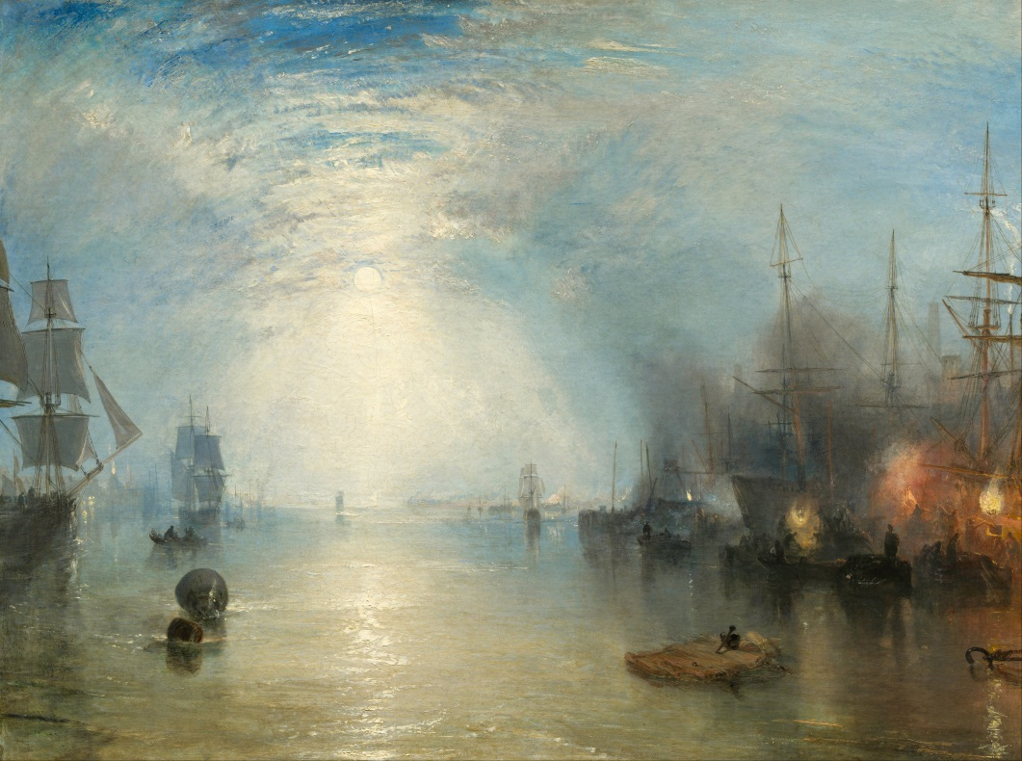
Figure 1. Joseph Mallord William Turner (1775-1851), Keelmen Heaving in Coals by Moonlight, 1835,
oil on canvas, 92.3 x 122.8 cm, National Gallery of Art, Washington. Image: National Gallery
of Art, Washington.
Turner was commissioned to paint Keelmen Heaving in Coals by Moonlight by Henry McConnel a textile manufacturer from Manchester. John Hayes noted McConnel had paid three thousand pounds for the painting which was more than the amount asked by Turner. The painting is of an industrial seaport on the River Tyne in northern England. The whole painting is glowing with light emanating from a bright full moon shining through a cloudy blue sky, and glistening on the water. The keelmen are seen on the right, flooded in light, shovelling coal alongside the glowing golden light of braziers. On the left, and in the distance a number of square riggers appear ghostly under the dazzling light of the Moon. The painting is an expression of the brilliance of light and the beauty of nature, alongside the activity of the docks.
Albert Boime has suggested that The Starry Night (Fig. 2), is one of the most recognised paintings in the world, and that the sky has been described as ‘hallucinatory’, and a ‘visionary work’. The painting was completed in June 1889, while van Gogh was living in a
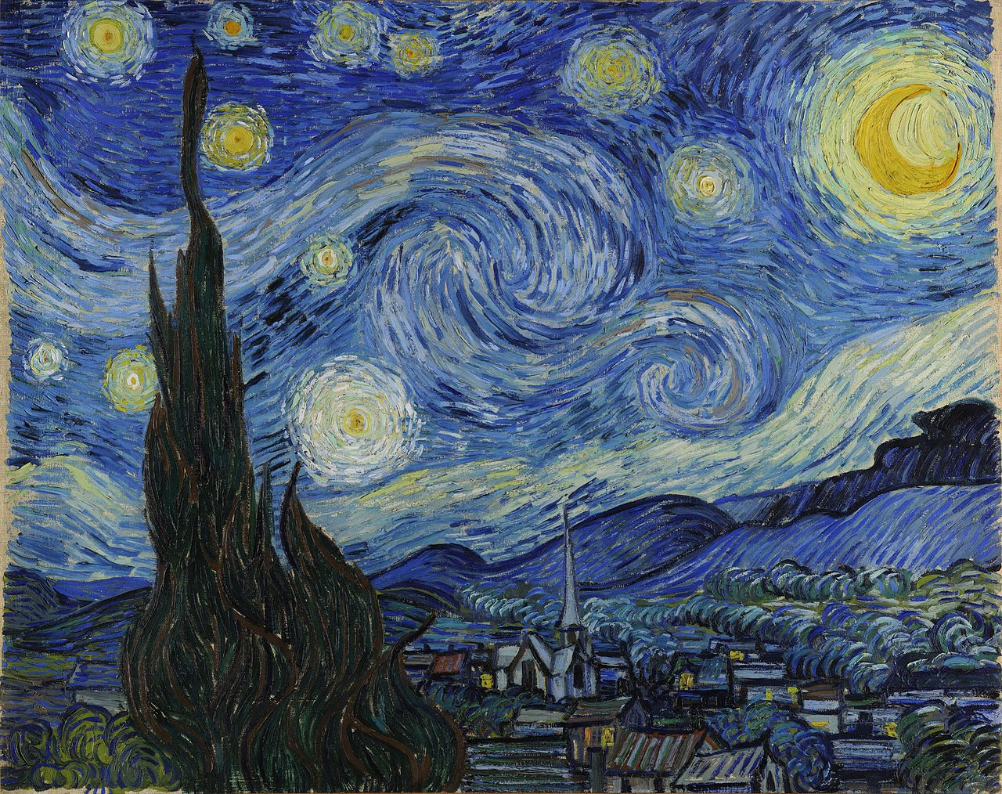
Figure 2. Vincent van Gogh (1853-1890), The Starry Night, 1889, oil on canvas, 73.7 x 92.1 cm,
The Museum of Modern Art, New York. Image: The Museum of Modern Art, New York.
convalescent home in Saint-Rémy where he spent two years. The painting depicts a village in the stillness of night overshadowed by a dominant sky swirling and curling, alive with activity. Two large curling patterns roll across the sky like ocean waves before they crash on the sand. The stars are depicted as yellow or white circles, and along with the crescent Moon are outlined in multiple circles of small dashed lines of white and pale yellow against a blue sky. The large cypress tree on the left stretches high into the sky. The Museum of Modern Art has noted that cypress trees were associated with graveyards and mourning, and could possibly be interpreted as connecting ‘heaven and earth’. In a letter to his brother Theo in July 1888, van Gogh said ‘Just as we take the train to go to Tarascon or Rouen, we take death to go to a star’. This view is similar to Plato’s, regarding one who lived well would ‘return and dwell in his native star’ at death. Based on van Gogh’s letters it seems he held beliefs about the night sky and stars, and their connection with death. Ingold is of the view we find the painting interesting because it evokes memories and feelings of ‘what it feels like to be under the stars’.

The representations of the night sky by Turner and van Gogh are similar in that they are exaggerated expressions of nature. A night sky painted in black would not seem out of place, but both artists were visionary, and black held little appeal. In a letter to his sister Willemien, van Gogh wrote ‘I definitely want to paint a starry sky now’, and he described the night sky as being ‘more richly coloured than the day, coloured in the most intense ‘violets, blues and greens’. Stars as described by van Gogh could glow in a number of colours including yellow, green, pink and blue, and therefore he believed to ‘paint a starry sky it’s not nearly enough to put white spots on blue-black’. The letters written by van Gogh indicate he had observed the night sky, and had considered what was required to paint stars. The stars of van Gogh seem to twinkle, and reflect his observations of the night sky. Alternatively, to Tim Ingold the stars ‘pulse’, and he described van Gogh as a ‘star-struck painter’. However, van Gogh’s brother Theo expressed the view that ‘I clearly sense what preoccupies you in the new canvases like the village in the moonlight or the mountains, but I feel that the search for style takes away the real sentiment of things’. To Theo it seemed a true representation of nature had been abandoned in the search for an identifiable style. However, aware that appreciation of art is subjective, Theo qualified his comment, ‘but in art there are no limits, so it’s quite permissible to do as one sees it’.
Judith L. Fisher has suggested the paintings of Turner in the latter part of his career, and the man himself, attracted criticism due to his experimenting with light and his unconventional style. In Keelmen Heaving in Coals by Moonlight, Turner exaggerated the representation of the night sky, but not in an abstract style like van Gogh in The Starry Night, rather through the depiction of light. During the 1830s and 1840s, Fisher has expressed the view that Turner had deliberately painted in a style that broke away from following conventional expectations in ‘line, colour, and lighting’, and experimented with the representation of ‘light in the atmosphere’. Fisher has noted Turner attracted the attention of a number of art critics who criticised him for not painting nature as it had ‘traditionally’ been painted, and neglecting to paint ‘narrative art’. Alexandra Harris has argued Turner continued to paint ‘narrative art’, but ‘his narratives are told through the battle of elements rather than in the tiny human forms he relegates to the edges of his canvases’. This style of positioning ‘human forms’ to the edges is seen in Keelmen Heaving in Coals by Moonlight. A critical review in Fraser’s Magazine commented that the painting ‘is thought highly of; it is nevertheless a failure. The night is not night; and the keelmen and the coals are anything’. Regardless, of the criticism, Fisher has noted Turner was admired by younger members of the Royal Academy, and his paintings sold well and provided him a good income.

In both the paintings by Turner and van Gogh the representations of the night sky are filled with light. Alexandra Harris has described Turner as an artist ‘obsessed by light’ and to replicate the light of the Sun, he used white paint. Turner also used white paint to depict the light of the Moon as seen in Keelmen Heaving in Coals by Moonlight. In The Starry Night, van Gogh painted the large star to the right of the cypress tree in white, and the other stars in shades of yellow and pale blue. Ingold has suggested the colour choices were based on Goethe’s Theory of Colours (1810), in which Goethe considered white to be the most intense expression of light, and when dimmed or darkened it became yellow. Therefore, Ingold suggested the large white star would be the brightest star in the sky, and the other stars would be seen as receding into the background. Kӧnig and Collins have argued Turner did not agree with Goethe’s colour theory, but they shared a similar view about polarities: that is ‘light and dark’; ‘warm and cool colours’; the closest colour to white was yellow; and the closest to black was blue. Kӧnig and Collins have suggested Turner was already experimenting with colour, and was aware of polarities long before he had read Goethe’s theory, and the evidence of this is seen in Keelmen Heaving in Coals by Moonlight. In addition they suggested Turner ‘exploited any available approaches to colour theory’. The night sky represented in blue in The Starry Night, and Keelmen Heaving in Coals by Moonlight, is an understandable choice of colour , as blue being the closest to black is visually acceptable to represent night.

A. W. Woodruff has argued pictures such as paintings, wood engravings and other forms of art hold a ‘wealth’ of historical information, and are valuable primary sources about the time in which they were created. There is historical information in Turner’s Keelmen Heaving in Coals by Moonlight, as it can be interpreted as a primary source for the types of industry working from the River Tyne in the 1830s. The painting has provided information about the ‘labour-intensive’ work on the docks, the types of sailing vessels of the time, and of the keelman, a trade which McKiernan has explained was gradually being taken over by the railways. In addition McKiernan stated Turner had been interested in the rapidly changing working conditions that had occurred during the industrial revolution, but Turner did not make a ‘social commentary’ on the working conditions of the keelmen; instead, Turner had concentrated on ‘capturing the fleeting impressions of light and movement’. Although placed at the edges of the painting, the working conditions of the keelmen are still evident, as they are pictured working at night surrounded by thick black smoke in what appears to be a cold and damp environment.

Ingold has suggested The Starry Night has not provided any indication that the painting is an exact representation of the sky observed by van Gogh. Rather it is van Gogh’s ‘vision’ of the sky. Yet, what Ingold has interpreted as a vision of the sky, others have seen as providing astronomical information. In a letter to his brother Theo between the 31st May and 6th June 1889, van Gogh stated, ‘This morning I saw the countryside from my window a long time before sunrise with nothing but the morning star, which looked very big’. Boime has suggested in a planetarium recreation of the sky of mid June 1889, that Venus was visible in the early morning sky. He has argued that the crescent Moon was actually a gibbous moon around the time the painting was completed and van Gogh had painted over a gibbous shape to produce a crescent shape which was a more traditional representation of the Moon. Whitney is of the view a crescent moon was the preferred shape as it had a more symbolic meaning, and was an astronomical indicator of ‘twilight, both morning and evening’. In addition Boime has suggested the stars at the top left of the painting are stars in the constellation of Aries which would have been visible in the early morning sky. Furthermore, Whitney has suggested the curling wavelike patterns across the sky are a representation of the Milky Way. It has also been suggested by Whitney and by Boime that the swirling shapes of the stars could have been based on drawings by William Parsons of spiral nebula discovered in 1844. For those interested in astronomy, the painting provided historical information about the sky that has inspired further investigation,

This essay has compared and contrasted the representation of the sky by the two paintings: The Starry Night by Vincent van Gogh, and Keelmen Heaving in Coals by Moonlight by Joseph Mallord William Turner. Both artists have represented the sky in an unconventional manner: van Gogh in an abstract presentation in his search for individual style, and Turner in a visual display of light in the atmosphere, which was his passion. In both paintings light has been represented using the colour white, and the night sky has been represented by the colour blue rather than black which to the non-artist may be the obvious colour. As suggested by
A. W. Woodruff, both paintings can be used as primary sources to provide historical information: van Gogh’s for astronomy, and Turner’s for the conditions of workers in an industrial seaport in England. Irrespective of the learned commentaries discussed in this essay, the visual impact of the paintings is spiritually uplifting.

Table of Images
Figure 1. Joseph Mallord William Turner (1775-1851), Keelmen Heaving in Coals by
Moonlight, 1835, oil on canvas, 92.3 x 122.8 cm, National Gallery of Art,
Washington. Widener Collection, 1942.9.86. Image: National Gallery of Art,
Washington.
Figure 2. Vincent van Gogh (1853-1890), The Starry Night, 1889, oil on canvas,
73.7 x 92.1 cm, The Museum of Modern Art, New York. Acquired through the
Lillie P. Bliss Bequest, 472.1941. Image: The Museum of Modern Art, New York.

Bibliography
PRIMARY SOURCES
Turner, Joseph Mallord William , Keelmen Heaving in Coals by Moonlight, 1835,
oil on canvas, 92.3 x 122.8 cm, National Gallery of Art, Washington,
Widener Collection, 1942.9.86.
Van Gogh, Vincent, The Starry Night, 1889, oil on canvas, 73.7 x 92.1 cm,
The Museum of Modern Art, New York. Acquired through the
Lillie P. Bliss Bequest, 472.1941.
Plato, Timaeus, in The Dialogues of Plato, trans. by Benjamin Jowett, ed. by
R. M. Hare & D. A. Russell, (London: Sphere Books Limited, 1970).

SECONDARY SOURCES
Billy, Denis J., ‘Under the Starry Night’, New Blackfriars, 76 (1995), 43-48.
Boime, Albert, ‘Van Gogh’s Starry Night: A History of Matter and a Matter of History’,
Arts Magazine, 4 (1984), 86-103, http://albertboime.com/Articles/Dec1984.pdf,
[accessed May 10, 2020].
Fisher, Judith L., ‘Magnificent or Mad? Nineteenth-Century Periodicals and the Paintings
of Joseph Mallord William Turner’, Victorian Periodicals Review,
29 (1996), 242-260.
Harris, Alexandra, Weatherland: Writers & Artists Under English Skies, (London:
Thames & Hudson Ltd, 2015).
Hathi Trust Digital Library, Fraser’s Magazine for Town and Country, 12 (1835),
https://babel.hathitrust.org/cgi/pt?id=uc1.c032015028&view=1up&seq=63, [accessed
May 10 , 2020].
Hayes, John, British Paintings of the Sixteenth through Nineteenth Centuries, (Washington:
Cambridge University Press, 1992), https://www.nga.gov/research/publications/pdf-
library/british-paintings-of-the-sixteenth-through-nineteenth-centuries.html, [accessed
May 10, 2020].
Ingold, Tim, ‘Reach for the Stars! Light, Vision and the Atmosphere’, in The Imagined
Sky, ed. by Darrelyn Gunzburg, (Sheffield: Equinox Publishing Ltd, 2016).
Kӧnig, C. S., and Collins, M. W., ‘Goethe, Eastlake and Turner: From Colour Theory to
Art’, International Journal of Design & Nature and Ecodynamics,
4 (2009), 228-237.
McKiernan, Mike, ‘JMW Turner, Keelmen Heaving in Coals by Moonlight 1835’,
Occupational Medicine, 66 (2016), 266-267.
The Museum of Modern Art, ‘Vincent van Gogh: Emotion, Vision and A Singular Style’, in
MoMA Learning, https://www.moma.org/learn/moma_learning/vincent-van-gogh-the-
starry-night-1889/, [accessed May 30, 2020].
van Gogh, Vincent, The Letters of Vincent van Gogh, The van Gogh Gallery, 638, 678, and 813,
http://vangoghletters.org/vg/letters.html, [accessed May 30, 2020].
Whitney, Charles A., ‘The Skies of Vincent Van Gogh’, Art History, 9 (1986), 351-361.
Woodruff, A. W., ‘J M W Turner and some of his predecessors and successors, from
the viewpoint of medical history’, Journal of the Royal Society of Medicine,
73 (1980), 381-392.

Tim Ingold, ‘Reach for the Stars! Light, Vision and the Atmosphere’, in The Imagined Sky, ed. by Darrelyn Gunzburg, (Sheffield: Equinox Publishing Ltd, 2016), p. 229.
C. S. Kӧnig and M. W. Collins, ‘Goethe, Eastlake and Turner: From Colour Theory to Art’, International Journal of Design & Nature and Ecodynamics, 4 (2009), 228-237 (p. 228).
Albert Boime, ‘Van Gogh’s Starry Night: A History of Matter and A Matter of History’, Arts Magazine, 4 (1984), 86-103 (p. 86); Charles A. Whitney, ‘The Skies of Vincent Van Gogh’, Art History, 9 (1986), 351-361 (p. 351).
A. W. Woodruff, ‘J M W Turner and some of his predecessors and successors, from the viewpoint of medical history’, Journal of the Royal Society of Medicine, 73 (1980), 381-392 (p. 381).
Judith L. Fisher, ‘Magnificent or Mad? Nineteenth-Century Periodicals and the Paintings of Joseph Mallord William Turner’, Victorian Periodicals Review, 29 (1996), 242-260 (244).
Judith L. Fisher, ‘Magnificent or Mad?’, p. 245.
Mike McKiernan, ‘JMW Turner, Keelmen Heaving in Coals by Moonlight 1835’, Occupational Medicine, 66 (2016), 266-267 (p. 266).
John Hayes, British Paintings of the Sixteenth through Nineteenth Centuries, (Washington: Cambridge University Press, 1992), p. 279.
John Haynes, British Paintings of the Sixteenth through Nineteenth Centuries, p. 279.
Mike McKiernan, ‘JMW Turner, Keelmen Heaving in Coals by Moonlight 1835’, p. 266.
Albert Boime, ‘Van Gogh’s Starry Night: A History of Matter and a Matter of History’, Arts Magazine, 4 (1984), 86-103 (p. 86), http://albertboime.com/Articles/Dec1984.pdf, [accessed May 10, 2020].
Denis J. Billy, ‘Under the Starry Night’, New Blackfriars, 76 (1995), 43-48 (p. 43).
The Museum of Modern Art, ‘Vincent van Gogh: Emotion, Vision and A Singular Style’ in MoMA Learning, https://www.moma.org/learn/moma_learning/vincent-van-gogh-the-starry-night-1889/, [accessed May 30, 2020].
Vincent van Gogh to Theo van Gogh, letter, 9 July or 10 July 1888, The Letters of Vincent van Gogh, The van Gogh Gallery, 638, http://vangoghletters.org/vg/letters.html, [accessed May 30, 2020].
Plato, Timaeus, in The Dialogues of Plato: trans. by Benjamin Jowett, ed. by R. M. Hare & D. A Russell, (London: Sphere Books Limited, 1970), 42B, p. 246.
Tim Ingold, ‘Reach for the Stars!’, p. 220.
Vincent van Gogh to sister Willemien, letter, 9 September to 14 September, 1888, The Letters of Vincent van Gogh, The van Gogh Gallery, 678, http://vangoghletters.org/vg/letters.html, [accessed May 30, 2020].
Vincent van Gogh, to sister Willemien, letter, 9 September to 14 September, 1888, The Letters of Vincent van Gogh, The van Gogh Gallery, 678.
Tim Ingold, ‘Reach for the Stars!’, p. 220.
Theo van Gogh to Vincent van Gogh, letter, 22 October, 1889, The Letters of Vincent van Gogh, The van Gogh Gallery, 813, http://vangoghletters.org/vg/letters.html, [accessed May 30, 2020].
Theo van Gogh to Vincent van Gogh, letter, 22 October, 1889, The Letters of Vincent van Gogh, The van Gogh Gallery, 813.
Judith L. Fisher, ‘Magnificent or Mad?’, p. 243.
Judith L. Fisher, ‘Magnificent or Mad?’, p. 245.
Judith L. Fisher, ‘Magnificent or Mad?’, P. 245.
Judith L. Fisher, ‘Magnificent or Mad?’, p. 243, 245 and 249.
Alexandra Harris, Weatherland: Writers & Artists Under English Skies, (London: Thames & Hudson Ltd, 2015), p. 272.
Hathi Trust Digital Library, Fraser’s Magazine for Town and Country, 12 (1835), p. 55, https://babel.hathitrust.org/cgi/pt?id=uc1.c032015028&view=1up&seq=63, [accessed May 10, 2020]; John Hayes, British Paintings of the Sixteenth through Nineteenth Centuries, (Washington: Cambridge University Press, 1992), p. 279, https://www.nga.gov/research/publications/pdf-library/british-paintings- of-the-sixteenth-through-nineteenth-centuries.html, [accessed May 10, 2020].
Judith L. Fisher, ‘Magnificent or Mad’, p. 256.
Alexandra Harris, Weatherland: Writers and Artists Under English Skies, p. 268.
Tim Ingold, ‘Reach for the Stars!’, p. 229.
Tim Ingold, ‘Reach for the Stars!’, p. 229.
C. S. Kӧnig and M. W. Collins, ‘Goethe, Eastlake and Turner’, p. 232 and 236.
C. S. Kӧnig and M. W. Collins, ‘Goethe, Eastlake and Turner’, p. 236.
C. S. Kӧnig and M. W. Collins, ‘Goethe, Eastlake and Turner’, p. 228.
A. W. Woodruff, ‘J M W Turner and some of his predecessors and successors, from the viewpoint of medical history’, Journal of the Royal Society of Medicine, 73 (1980), 381-392 (p. 381).
Mike McKiernan, ‘JMW Turner, Keelmen Heaving in Coals by Moonlight 1835’, p. 266.
Mike McKiernan, ‘JMW Turner, Keelmen Heaving in Coals by Moonlight 1835’, p. 266-267.
Tim Ingold, ‘Reach for the Stars!’, p. 221.
Tim Ingold, ‘Reach for the Stars!’, p. 221.
Vincent van Gogh, to Theo van Gogh, letter, 31 may to 6 June,1889, The Letters of Vincent van Gogh, Vincent van Gogh Gallery, 777, http://vangoghletters.org/vg/letters/let777/letter.html, [accessed 30 May, 2020].
Albert Boime, ‘Van Gogh’s Starry Night’, p. 86-87.
Charles A. Whitney, ‘The Skies of Vincent Van Gogh’, Art History, 9 (1986), p. 361.
Albert Boime, ‘Van Gogh’s Starry Night’, p. 87.
Charles A. Whitney, ‘The Skies of Vincent Van Gogh’, p. 357.
Charles A. Whitney, ‘The Skies of Vincent Van Gogh’, p. 358; Albert Boime, ‘Van Gogh’s Starry Night’, p. 88.

