Innovating ways of capturing ephemeral moments in print design with exploration into the ideas of presence and absence

Emma Landek
1803146
Research and Innoavtion
Innovating ways of capturing ephemeral moments in print design with exploration into the ideas of presence and absence

Keywords: Movement, motion, weather, change, blurred vision, light, shadow, absence, presence.

Prior to this investigative enquiry, I completed a thought experiment project responding to a random piece of text and title from the book ‘101 experiments in the philosophy of everyday life’ by Roger-Pol Droit. The aim of this project was to expand our research trajectory and allow the research to be loose and fluid, broadening our scope when seeking inspiration.
The title I selected at random was ‘Fix the ephemeral’. The word ephemeral has connotations of transience and fleeting, defining the idea of something being impermanent (Vocabulary.com, 2022). The concept of fixing the ephemeral unpicked ways of capturing moments, allowing moments to last longer than time itself. The title led me to keywords such as movement and change, which imply ideas of unpredictability. I found myself fully engaged with this project, creating visual interpretations of ‘fleeting moments’ focusing on motion, light, shadow and presence.
Within this report I aim is to extend this thought process and remove systematic ways of thinking by immersing myself in experimentation and explorative research to enhance my own technical innovation and develop a deeper meaning to my work. I aim to embrace the uncertainty and capricious nature of weather as a starting point for this investigative inquiry.
Weather changes can be fleeting from a vibrant sunrise to a down pour of rain, often lasting for short periods of time without ever completely being replicated (Virtual Nature, 2022). I will continue with the idea of ‘fixing the ephemeral’ through ways of capturing these fleeting moments and implementing them within my practice.
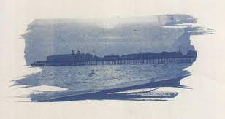

Figure 1- ‘Hastings pier’ by Linda McCartney (McCartney, 2001)

Exploring ways of capturing the ephemeral, the work of Linda McCartney has been a great inspiration. Combining modern day photography with 19th century printing processes developed by W.H Fox Talbot, McCartney experimented with a series of sun printing techniques (McCartney, 2001). McCartney would use negatives from her photography work to block the suns light source creating new versions of the image with a slight etched quality (McCartney, 2001).
‘Hastings Pier’ in figure 1, showcases more experimental use of brush strokes combining painting and photography, allowing the brushstrokes to invade on the image injects movement into a still photograph capturing the essence of a fleeting moment.
Using the sunlight as a tool to create image, the outcomes can never be guaranteed.
I experimented with sun printing using cyanotype solution, utilising the shadows created by the sunlight as the subject matter to the images.
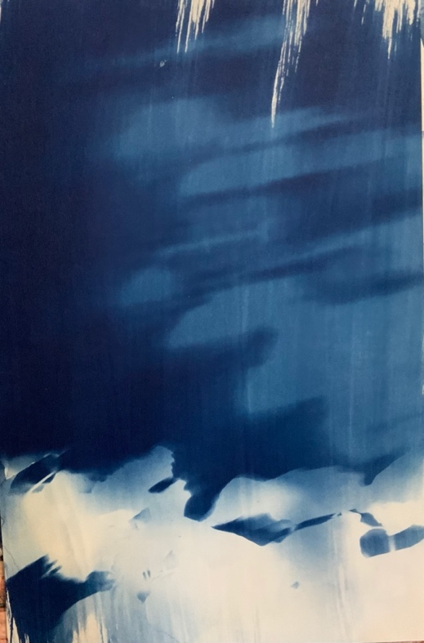
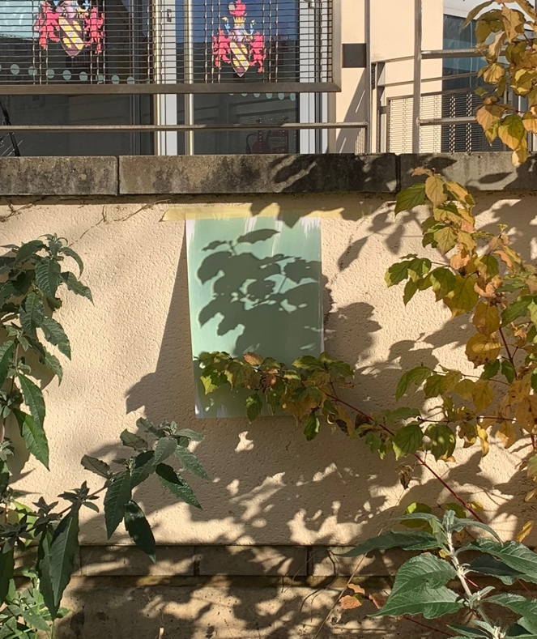

Figure 2- Cyanotype showcasing movement. Figure 3- Cyanotype whilst in sunlight

As each day alternates from day to night, the light from the sun is in a constant state of change, forcing a transience of different shadows cast from nature and the built environment. The outcome of one of my cyanotype experiments shown in figure 2 implies a ‘fixed’ ephemeral moment through blurred castings of the natural foliage shown in figure 3.
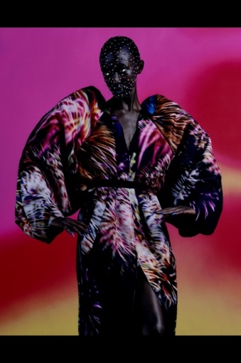
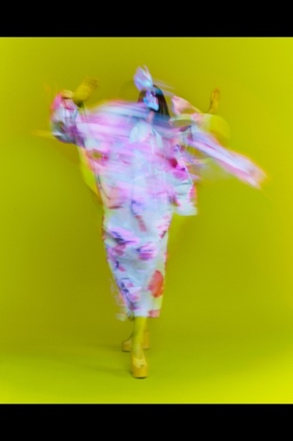
Relating back to my practice as a surface pattern and textile designer, I feel these shadow castings offer a similar visual to the fashion collection of Dries Van Noten spring/summer 2022.
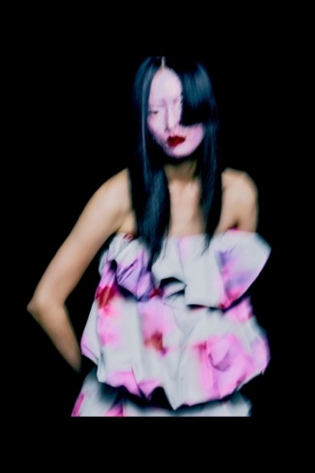

Figure 4- Dries Van Noten Spring/Summer 2022
Inspired by the Holi festival in India, Dries Van Noten used blurred photography and rich pigmented colour of the festival to create large-scale abstracted prints as a celebration of new beginnings post-pandemic (Design Scene, 2021).
In addition to exploring movement through natural sun prints, the shadow castings outlined silhouette forms of the subject blocking the light. Clearer silhouette shapes were formed when the solution was exposed for shorter amounts of time, giving less opportunity for the sunlight to move.
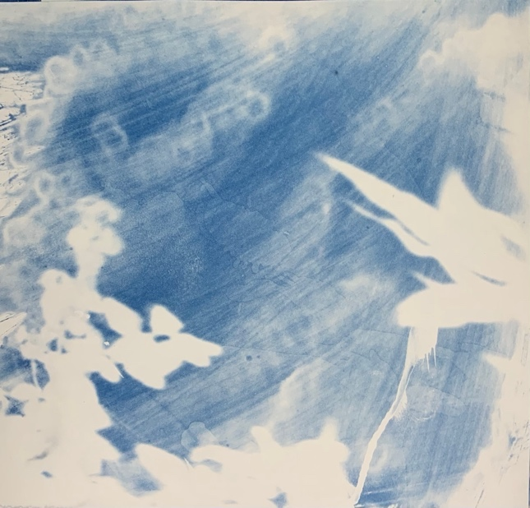

Figure 5- Sun print experiment

The sun prints offer an experimentation of positive and negative spaces. The positive and negative spaces created by the natural forms suggest the idea of presence and absence. The meaning of presence and absence can be described as “the fact or condition of being present” (Bell, 2003) and “The state of being absent or away” (Bell, 2003).
French philosopher Jacques Derrida developed the term ‘deconstruction’ to critically examine conceptual distinctions which he referred to as ‘oppositions’ (Britannica , 2022) These oppositions would consist of a pair of terms where one would be identified as binary and fundamental, while the other is hierarchical and derivative, one cannot exist without the other (Britannica , 2022). Examples of oppositions include nature and culture, writing and speech and mind and body.
To deconstruct the oppositions of absence and presence within my sun prints as shown in figure 4, we must examine the contradictions and tensions of them. When discussing speech/writing, the speaker delivers unmediated truth and is present, whereas the writing of the speech mediates the presence of the speaker in their absence (Britannica , 2022).
Similarly, through my sun print experiments, the prints mediate the presence of the plants, they represent what once was present but no longer is- the prints become secondary information.
Between presence and absence is a transcendence of disappearance. Nothing vanishes, everything has movement. The signification of the sun prints implies the absence of presence suggesting the in-between state of both oppositions.
Derrida believed that “Trace is the absent part of a signs presence” (Mambrol, 2016). Attacking the view of absolute presence or absolute absence, Derrida explored how things leave traces of their presence even when the sign itself is absent.
The interplay of presence and absence evoke feelings of transitory and ephemerality which is some of the inspiration behind the work of artist Catherine Bertola. (Bertola, 2023).
An integral part of Bertolas work is its temporality and its precarious nature. She is inspired by history and creates responses that in turn become a part of history themselves. One of her many works include a series of 20 pin pricked papers, the designs were based on lace underwear (Bertola, 2023).
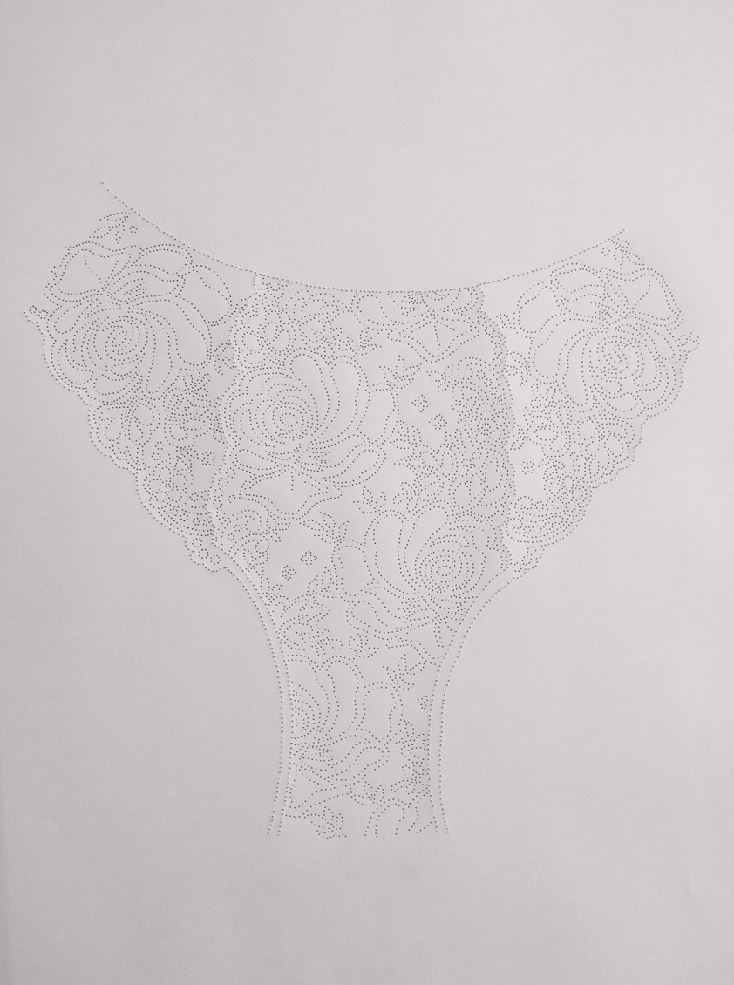

Figure 6- Catherine Bertola ‘Anatomy’ 2006-8
Through drawing with pins, Bertola was able to leave her own ‘trace’ as suggested by Jacques Derrida. An interesting approach to drawing which relates to the ideas I have mentioned of presence and absence. Creating an absence within the surface through pin pricking creates a new presence of an image, again interplaying between the absence and presence and how both leave traces of each other.
Experimenting with this way of drawing, I created my own versions of pin pricked imagery. I used the shadows created by natural sunlight to guide my drawings.

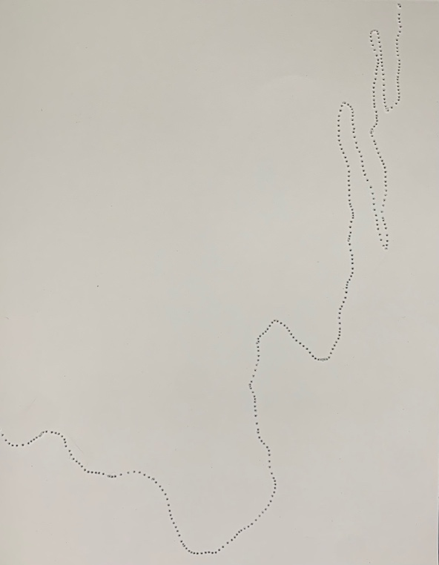

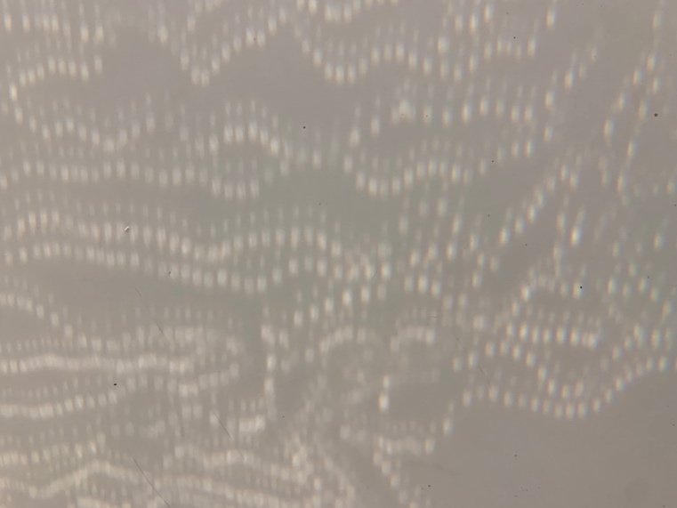

Figure 7 & 8 - Shadows pricked into paper and projected onto the wall.

By using a sewing machine to puncture holes into paper, I was able to imbed pattern directly into the material. Using the paper as new lenses, I projected them onto the wall to cast new shadows. I was able to create an immersive light experience of moving image through experimental play.
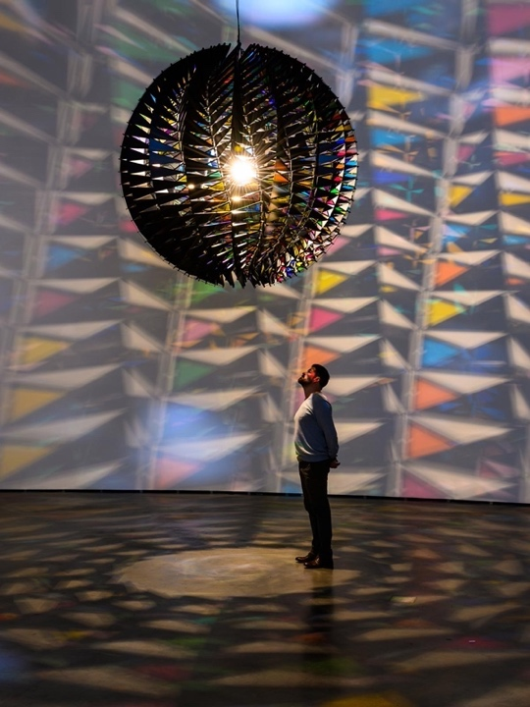
Using natural phenomena such as light, air, water and the environment, artist Olaffur Eliasson stives towards creating immersive experiences on a communal platform (The art story, 2022).

Figure 9 - Olafur Eliasson- Kaleidoscope- In real life 2019
As shown in figure 8, Eliasson created a large sphere composed of geometric shapes made of aluminium and panes of coloured glass, the sphere acted as a lampshade with a lamp at its centre projecting light (Olafur Eliasson, 2022). The kaleidoscope installation set out to create a playful visual experience, re-configuring patterns, shapes, and colours through individual experiences. The installation blurs the line between subject and space, re-shaping the traditional role of art beyond the aesthetic (The art story, 2022).
Experience is at the forefront of Eliassons work, he hopes that these experiences encourage individuals to engage with their own senses and the senses of others to form temporary communities within the spaces (Tate , 2019). Eliasson’s work is dependent on the concept of phenomenology, which is the understanding of human behaviours through the eyes of the participant (IGI Global, 2022). Each human being encounters unique experiences which holds individual meaning and value (Armstrong, 2005).
Phenomenology is the philosophy of experience (IGI Global, 2022). Each person will engage in different experiences throughout their life which will cultivate unique interpretations. As time is in a continuous state of moving, these experiences can be interpreted as ephemeral moments, as they are singular moments that make up the wider experience of life (IGI Global, 2022).
As a designer, I typically work towards achieving an aesthetic that is visually pleasing for a client or brand, I don’t often think of the phenomenology of my designs or the potential experience my work could offer. Through the use of light and shadow play, I have engaged with new ways of thinking and experimenting to unpick new and innovative ways of working within my practice to evaluate new ways of working.
Allowing nature to guide my imagery, I captured images that I felt reflected natures ephemerality, showcasing natural patterns and textures created by frost.

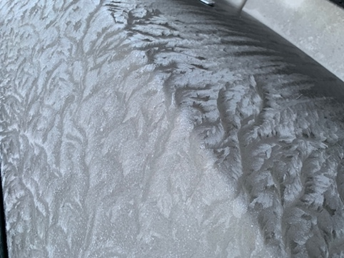
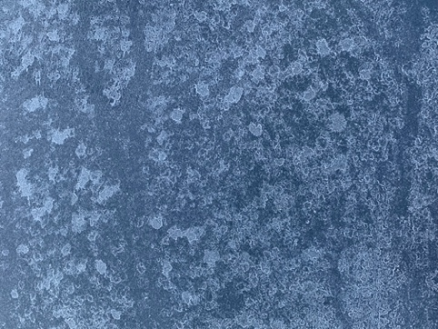
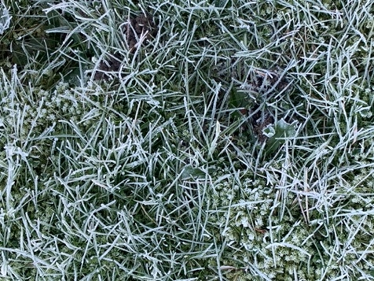

Figures 10

Frost is an ephemeral phenomenon; it occurs only in freezing temperatures and vanishes when temperatures rise (met office , 2022). Its impermanence relates to the concept of ‘traces’ by Jacques Derrida, the patterns are neither completely present nor completely absent.
Thinking more innovatively in terms of my practice, I experimented with a series of laser engravings from the images I captured to explore deeper concepts of ephemerality.
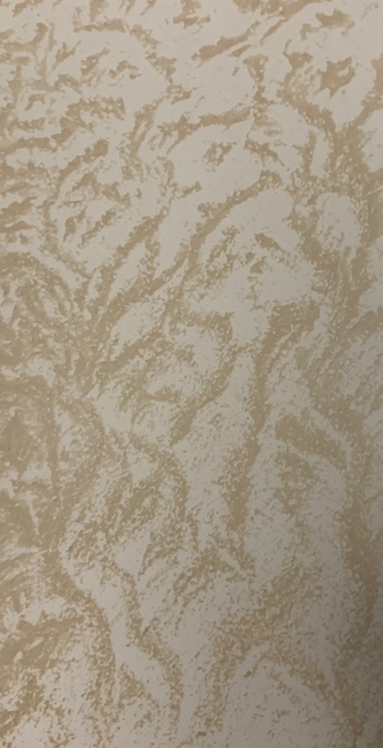

Figure 11- Frost engrave onto paper

I experimented with the laser cutter by rasterizing the images of frost onto paper, creating engravings of the frosted patterns. Through subtracting into the surface of the substrate, I am creating absence within a physical surface, visually interpreting the ideas of presence and absence.
By working this way, I feel the process offers a permeance to ephemerality, by ‘fixing’ these moments onto a surface. These laser engravings create a physical image that lives beyond the moment. In effect, creating a ‘trace’ of a ‘trace’.
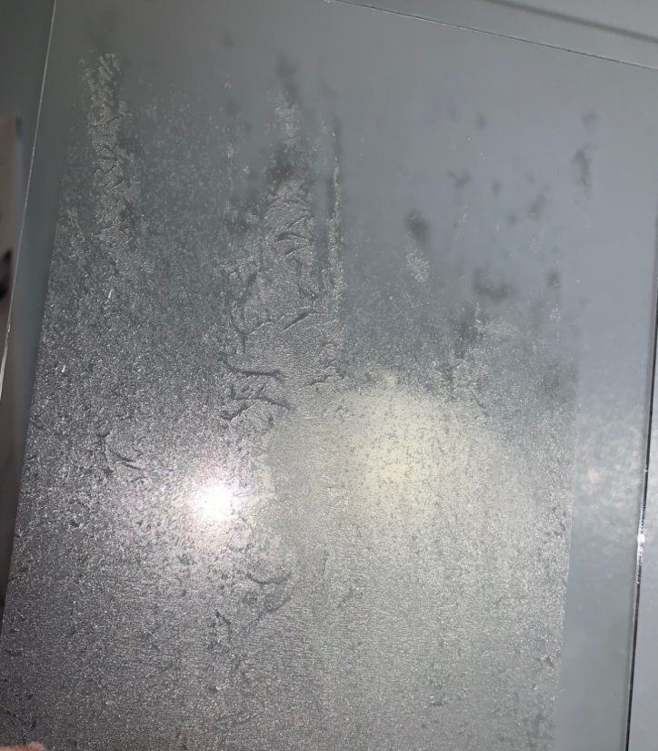

Figure 12- Engraved glass

I further experimented with laser engraving onto other surfaces such as glass. Engraving onto a transparent surface created a subtle effect that can only be seen through certain lighting, creating a more interactive visual that expresses the feelings of ephemerality and transience.
As a material glass offers a sense of ephemerality due to its fragility, therefore when combined with laser engraving, the effect is very transient and replicates the appearance of frost. To compare with the engravings on paper, the glass offers a 3D effect as the translucency of the material allows the engrave to be seen from both sides. The glass can also be used to project the engravings, playing on the ideas of presence and absence. By creating an absence within the material, we can create a new presence of shadows when projecting.
After working across hard surfaces, I begun thinking of ways to capture ‘fleeting moments’ through textiles by contemplating both presence and absence, exploring ways of translating this conceptual way of thinking through material. Further experimenting with shadows and their transitory state of being, I aimed to mirror this transcendence through experimental ombre dyeing of wool.

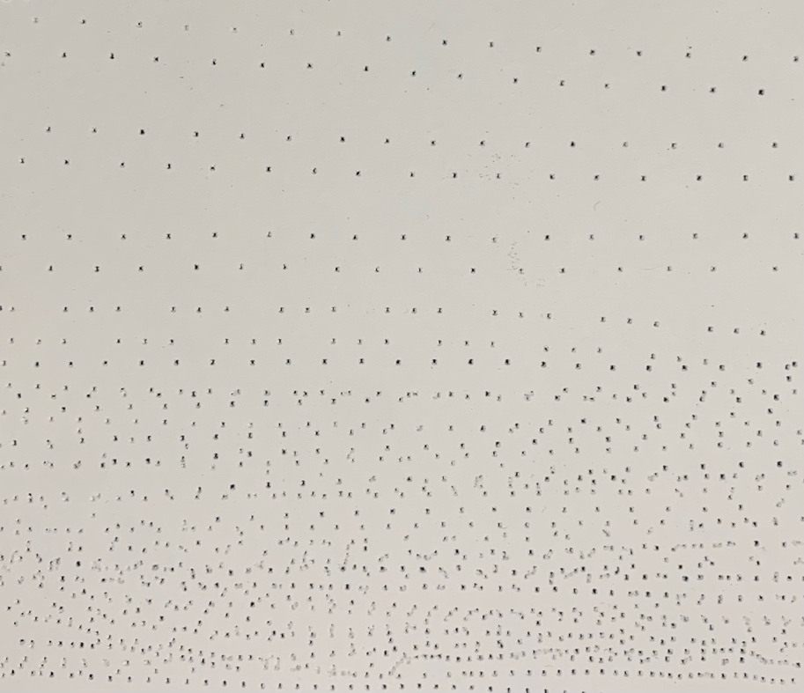
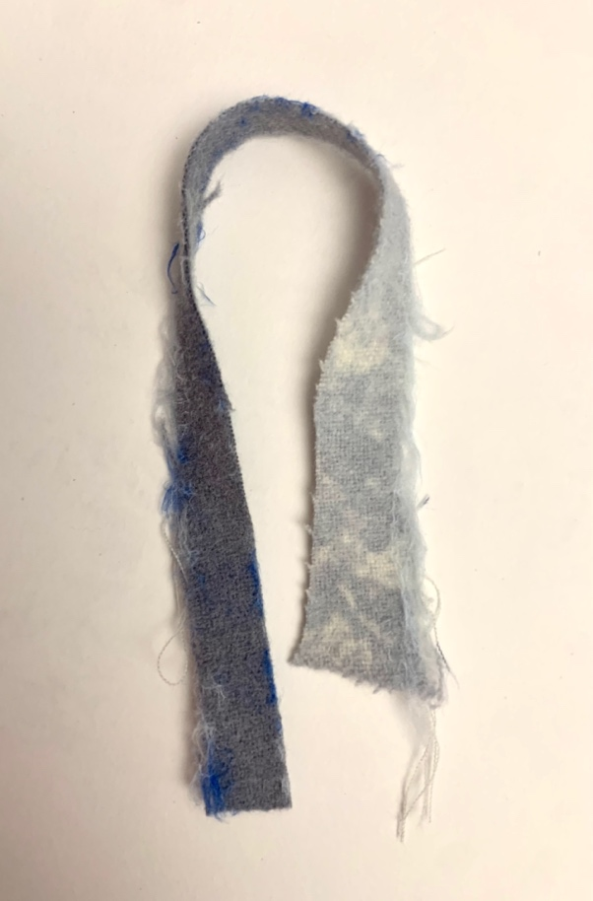
Figure 13- Ombre dyed wool Figure 14- Gradient pierced into paper

I chose to experiment with wool as the material has a soft quality that I feel corresponds with the connotations of shadows. I dyed the fabric by gently placing the bottom of the material into the dye bath and allowing the dye to bleed up the wool, creating a gradient effect. I emulated this gradient effect through the pin picking process, working from high density to low density to represent the diffusion of light and the transcendence between absolute presence to absolute absence.
Applying ideas of diffusion into layering is artist Idris Khan. Khan works across a range of different media including sculpture, painting, and photography (Victoria Miro, 2023). His way of working relies on creating, erasing, and layering (Victoria Miro, 2023).
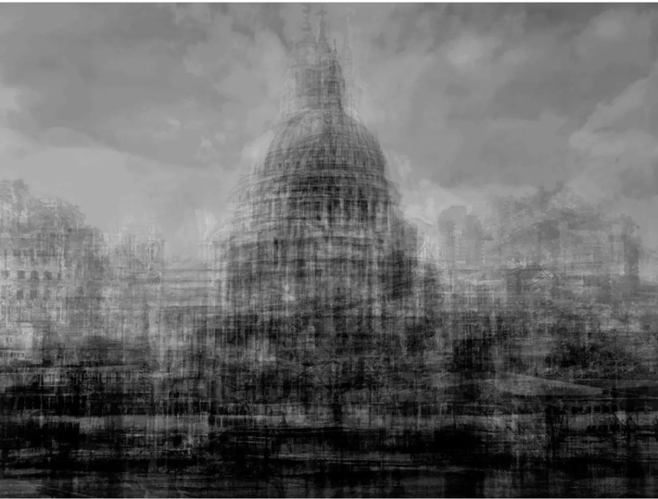

Figure 15- Idris Khan ST Pauls London 2012
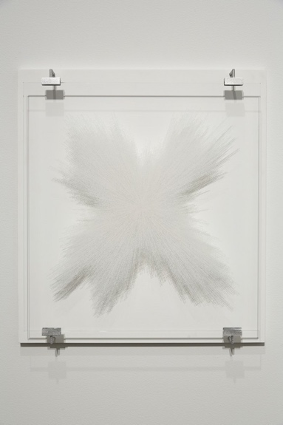
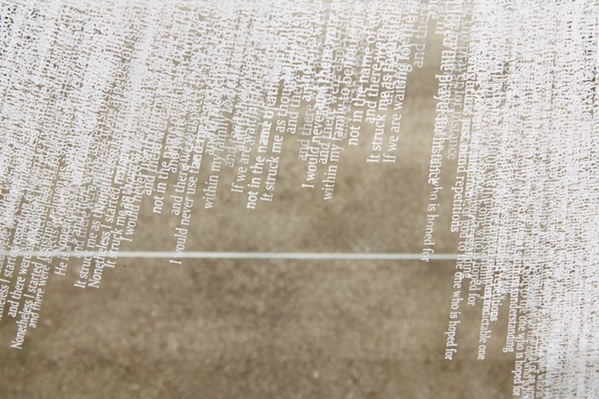
Figure 16- Idris Khan- Overture 2015

Idris Khan works with a multi-layered approach to create a sense of expanded time, through layering, erasing, and creating, khan creates a palimpsest of traces. These traces become obscured by superimposition, subjecting the viewer into a metaphysical collapse of space and time (Darbyshire, 2015). Khans layering to the point of non-definitive reading or understanding, creates an image that acts as a time capsule consisting of single ephemeral moments.
Idris Khan relies on Roland Barthes theory of ‘punctum’ (Victoria Miro, 2023). According to Barthes Punctum is defined as “the sensory, intensely subjective effect of a photograph on the viewer” (Smolik, 2014). The theory of punctum is connected to the philosophy of phenomenology as suggested by Derrida, as both theories explore the experience of the person/viewer and their affect.
Adopting Khans ideology of layering, erasing, and creating to merge multiple moments into one. I explored the qualities and effect of needle punching as a process to capturing ephemeral moments within textiles.
Needle punching, similarly, to Idris Khan, works by welding different fibres/layers into one to create a multi-layered effect within a textile. I sandwiched the ombre dyed wool with digital prints of silhouettes on linen and allowed the needle punch to invade on the fabrics, welding the fibres together to consolidate a new textile piece.
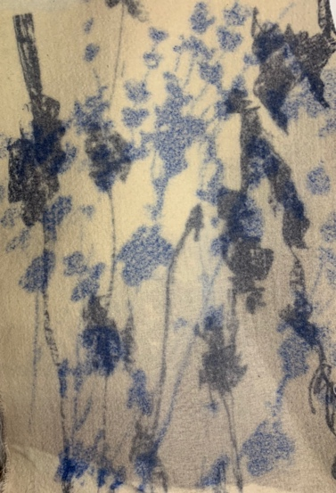

Figure 17- Needle punched textile piece. Ombre dyed wool sandwiched between digitally printed linen.

As shown in figure 17, the needle punch infused 3 layers together creating a new image. The silhouette outlines were diffused by the punching, creating softer edges that is a more accurate reflection the shadows they were initially inspired by. The digital print from behind the wool feeds into the front, creating a varying shade of ‘shadows’ within the piece. The softness in tactility and colours further explore the combined ephemeral moments, Creating my own palimpsest of traces.
Exploring new conceptual ways of thinking throughout this report, I have been able to understand the use of process and its ability to portray a deeper level of meaning of how time is transitory. I have learnt to be more aware and conscious of design techniques that will elevate the meaning of the work to portray the ephemeral.
Throughout this investigative enquiry I have built upon my knowledge of existing principles and approaches of research within my field of study. Experimenting with both analogue and digital technologies I have been able to create a varied body of work that is based on the ideas of ‘fixing the ephemeral’.
I have experimented with a range of techniques including sun printing, pin pricking, laser engraving, dyeing and needle punching. All these techniques have led me to an advanced level of research into philosophical concepts and theories that further unpick meanings of ephemerality within my work.
Understanding the meaning of ephemeral, I have been able to outline relevant connections to theoretical and conceptual ways of thinking. Exploring deep meanings within my work and the works of Catherine Bertola, Olafur Eliasson and Idris Khan has enhanced my knowledge on theoretical and practical principles within my field of practice.
As a surface pattern designer, I feel this enquiry has unveiled a new way of thinking. Exploring complex philosophical terms and meanings such as phenomenology and trace, I have been able explore ways of capturing the ephemeral with relevant conceptual thinking, which I feel has subsequently brought a valued significance to my work informing new technical innovations I can further progress in the future.
Throughout this report explored connections between theoretical and practical principles.
I have gained an understanding of the importance of materiality and their properties to further explore innovative processes. Continuing from my thought experiment this enquiry outlines a framework of potential innovations that could be further developed and enhanced in s2. I hope to continue with this advanced level of theoretical approach within my work, by exploring other theories that is suggestive of ephemeral moments, time, space, absence, and presence.

Bibliography
Armstrong, P. B. (2005). Architecture,body and performance . Retrieved from Brown.edu: https://www.brown.edu/Departments/Joukowsky_Institute/courses/architecturebodyperformance/1065.html
Bell, A. (2003). Absence/presence. Retrieved from The chicage school of media theory : https://lucian.uchicago.edu/blogs/mediatheory/keywords/absence-presence/
Bertola, C. (2023). Retrieved from Catherinebertola.co.uk: https://www.catherinebertola.co.uk/about/
Britannica . (2022, 12 23). Jacques Derrida- French philosopher . Retrieved from Britannica.com: https://www.britannica.com/biography/Jacques-Derrida#ref748407
Darbyshire. (2015, October 14th). Idris Khan – Overture – Fabrication. Retrieved from Darbyshire.uk.com: http://www.darbyshire.uk.com/idris-khan-overture-fabrication/
Design Scene. (2021, 09 30). PFW: DRIES VAN NOTEN Spring Summer 2022 Collection. Retrieved from Designscene.net: https://www.designscene.net/2021/09/dries-van-noten-ss22.html
IGI Global. (2022). what is phenomenology. Retrieved from IGI global publisher of timely knowledge: https://www.igi-global.com/dictionary/phenomenology/22618
J IAAW WORKPLACE. (2023). Architecture, body and perfomace "phenomenology". Retrieved from J IAAW WORKPLACE: https://www.brown.edu/Departments/Joukowsky_Institute/courses/architecturebodyperformance/1065.html
Leithart, P. (2004, Januray 12). Derrida on presence and absence . Retrieved from Theopolis institute: https://theopolisinstitute.com/leithart_post/derrida-on-presence-and-absence/
Mambrol, N. (2016, March 22). Derrida: Trace and play. Retrieved from Literary theory and critisicm : https://literariness.org/2016/03/22/derrida-trace-and-play/
McCartney, L. (2001). Sun Prints. Little, Brown and company.
met office . (2022). What is frost? Retrieved from Metoffice.gov.uk: https://www.metoffice.gov.uk/weather/learn-about/weather/types-of-weather/frost-and-ice/frost
Olafur Eliasson. (2022). Retrieved from https://olafureliasson.net/archive/artwork/WEK110888/in-real-life.
Philosophy of time. (2022). Retrieved from exactlywhatistime.com: https://www.exactlywhatistime.com/philosophy-of-time/
Roberts, H. (2021, 3 31). Pen. Retrieved from Pen-online.com: https://pen-online.com/arts/shadow-an-indication-of-presence-or-absence/
Smolik, N. (2014, November 14). ‘Punctum. Reflections on Photography’ Brings Barthes to the Digital Age. Retrieved from Frieze: https://www.frieze.com/article/punctum-reflections-photography-2014-review
Tate . (2019). Olafur Eliasson: In real life. Retrieved from Tatw.org.uk: https://www.tate.org.uk/whats-on/tate-modern/olafur-eliasson/exhibition-guide
The art story. (2022). Olafur Eliasson. Retrieved from Theartstory.org: https://www.theartstory.org/artist/eliasson-olafur/
Victoria Miro. (2023). Idris Khan . Retrieved from Victoria-miro.com: https://www.victoria-miro.com/artists/14-idris-khan/
Virtual Nature. (2022). Ephemeral phenomena. Retrieved from Virtual-Nature.com: https://virtual-nature.com/ephemeral-phenomena
Vocabulary.com. (2022). Retrieved from vocabulary.com: https://www.vocabulary.com/dictionary/ephemerality

Figures-
- ‘Hastings pier’ by Linda McCartney
- Cyanotype showcasing movement
- Image of cyanotype in process
- Dries Von Norten- spring/summer 202
- Cyanotype of silhouette
- Catherine Bertola-‘Anatomy- 2006-8
- Pin pricked shadows onto paper
- Pin pricked images porjeccted onto walls
- Olafur Eliasson- Kaledioscope- ‘In real life’ 2019
- Images of frost
- Paper engrave
- Glass engrave
- Ombre dyed wool
- Gradient effect pierced into paper
- Idris Khan- St Pauls London 2012
- Idris Khan- Overture 2015

