Ethan Needham - 1908704

Build, deploy, configure and manage a Type 2 Hypervisor platform based Virtualised network
Network Operating Systems and Services

Contents
Task 1: Building a Virtual LAN, using Type 2 Hypervisor Management Software 2
Creation of Server 1: 2
Installation of Server 1 Server 2019 Essentials (x64): 5
Creation of Client 1: 7
Installation of Client 1 Windows 10 Pro (x64): 7
Creation of Server 2 and Client 2: 10
Virtual Network Configurations – PublicNet: 12
Server 1 12
Server 2 13
Testing Server Connectivity - PublicNet: 13
Virtual Network Configurations – PrivateNet1 and PrivateNet2: 14
Server 1 and 2: 14
Client 1 and 2: 15
Testing Network Connectivity – PrivateNet1 and PrivateNet2 16
Task 2: Deploying a Network Directory Service and Creating and Understanding Active Directory Network Objects 17
Prerequisites: 17
Deploying Active Directory as a role or feature based installation: 20
Creating user account objects using Active Directory Users and Computers snap-in console: 21
Adjoining the domain and testing user logins: 23
Task 3: Observational Tasks 26
References 29
Appendix A 30
Appendix B 30
Appendix C 31

Task 1: Building a Virtual LAN, using Type 2 Hypervisor Management Software

Creation of Server 1:
As part of the first task, the first requirement was the installation of a Virtual Server inside of Oracle VM VirtualBox Manager (A Type 2 Hypervisor Management software). Multiple factors can affect a Virtual Servers performance. It was ensured that the implemented specifications, at a minimum, met the recommended requirements for Windows Server 2019. These requirements can be seen here: https://docs.microsoft.com/en-us/windows-server/get-started/hardware-requirements
The specifications for the Server can be seen in the following screenshots:
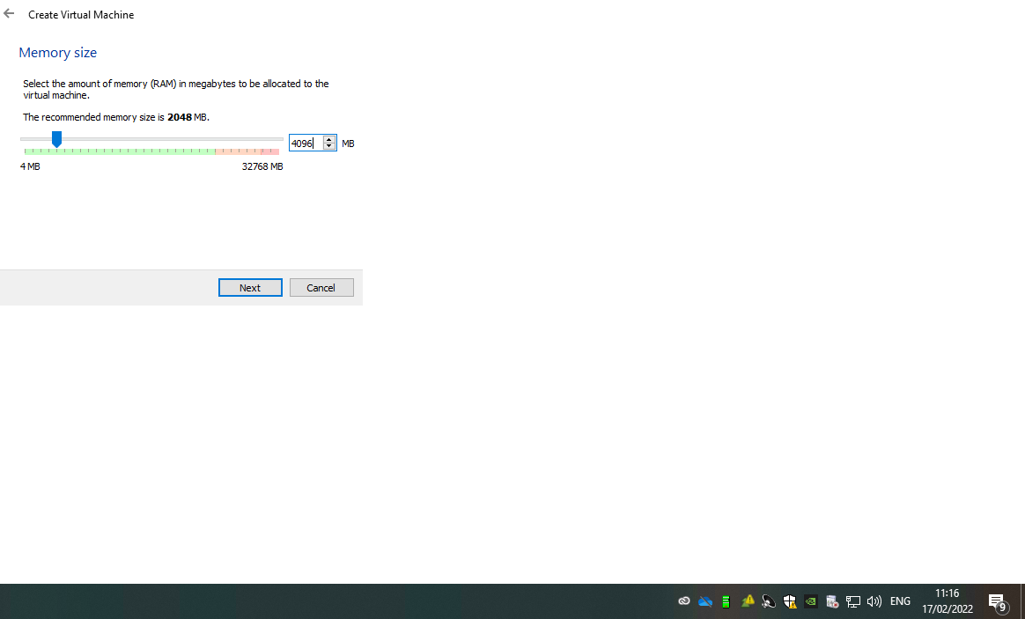
VDI (VirtualBox Disk Image) was then selected due to it being the most compatible and interoperable option.
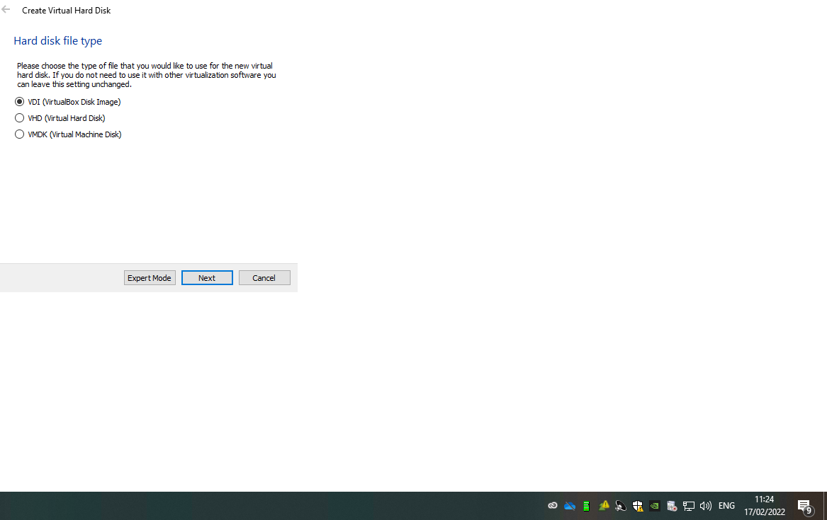
In order to avoid future issues such as blue screening and poor system performance due to storage issues, dynamically allocated storage was selected. This allows for the storage to expand and grow whenever that is required.
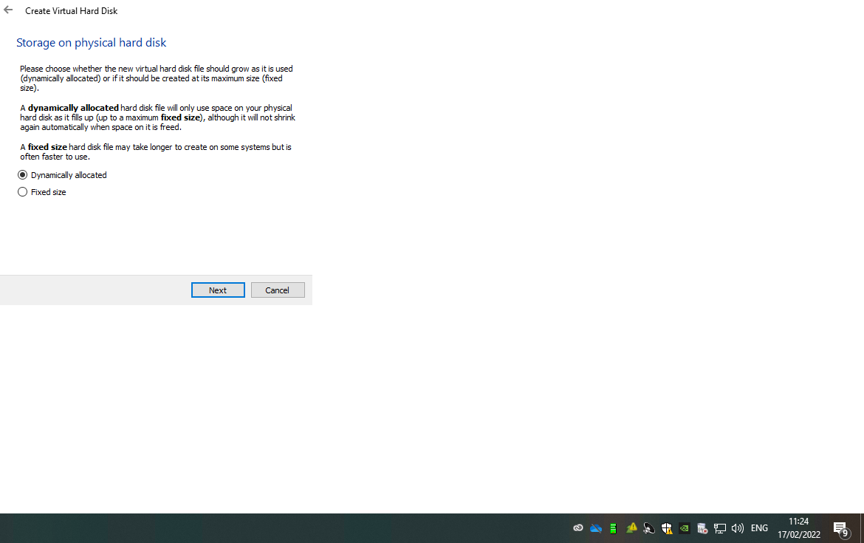

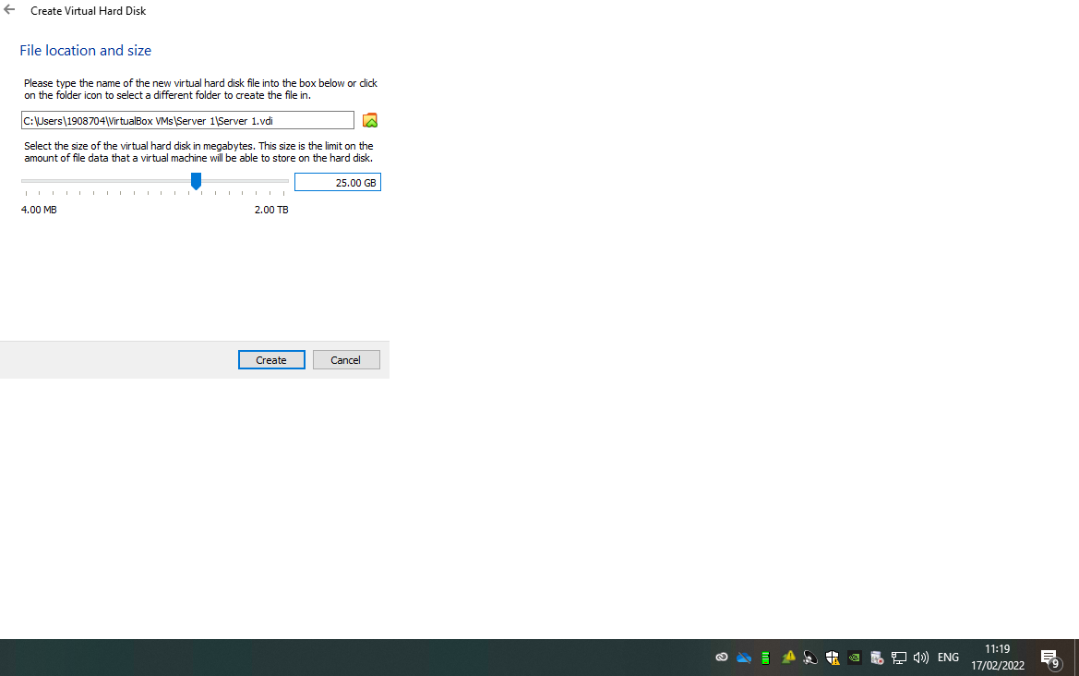
The final creation step was to enable PAE/NX and increase the amount of vCPU’s. PAE/NX has been enabled in order to increase the servers priority when demanding the host systems resources.
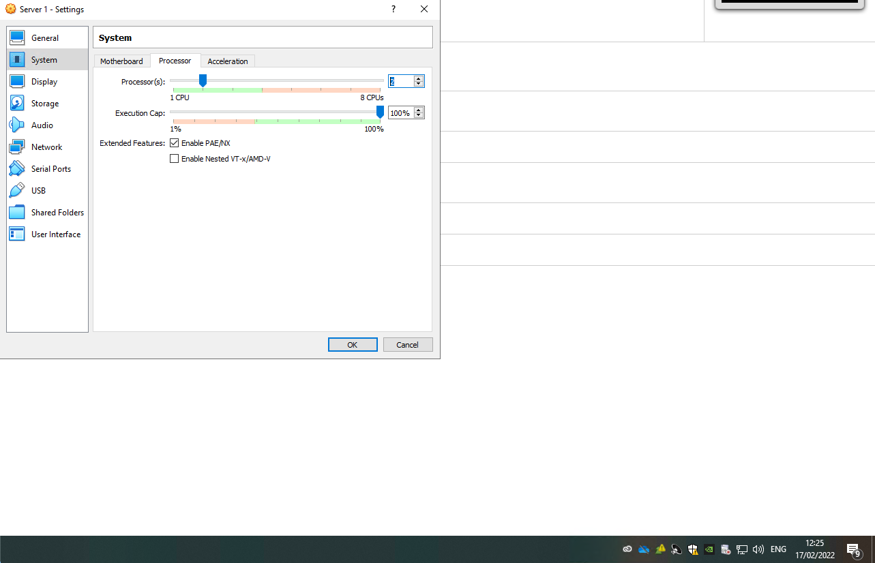

Installation of Server 1 Server 2019 Essentials (x64):
The first step was to download the Windows Server 2019 ISO file from portal.azure.com then add it as the optical disk file within Server 1’s storage settings.
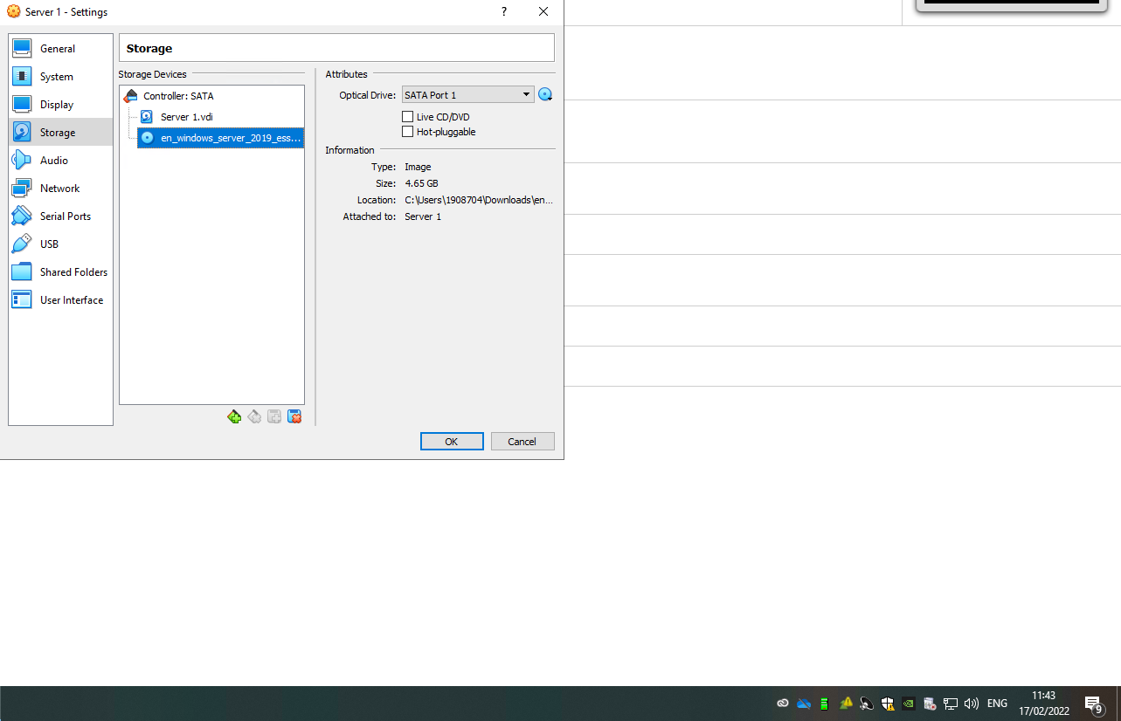
When Server 1 was started up, it booted straight into the ISO file from the optical drive folder. This kicked off the Windows 10 installation setup. The first step was to change the Time and Currency format to English(United Kingdom) and the Keyboard and Input method to United Kingdom.
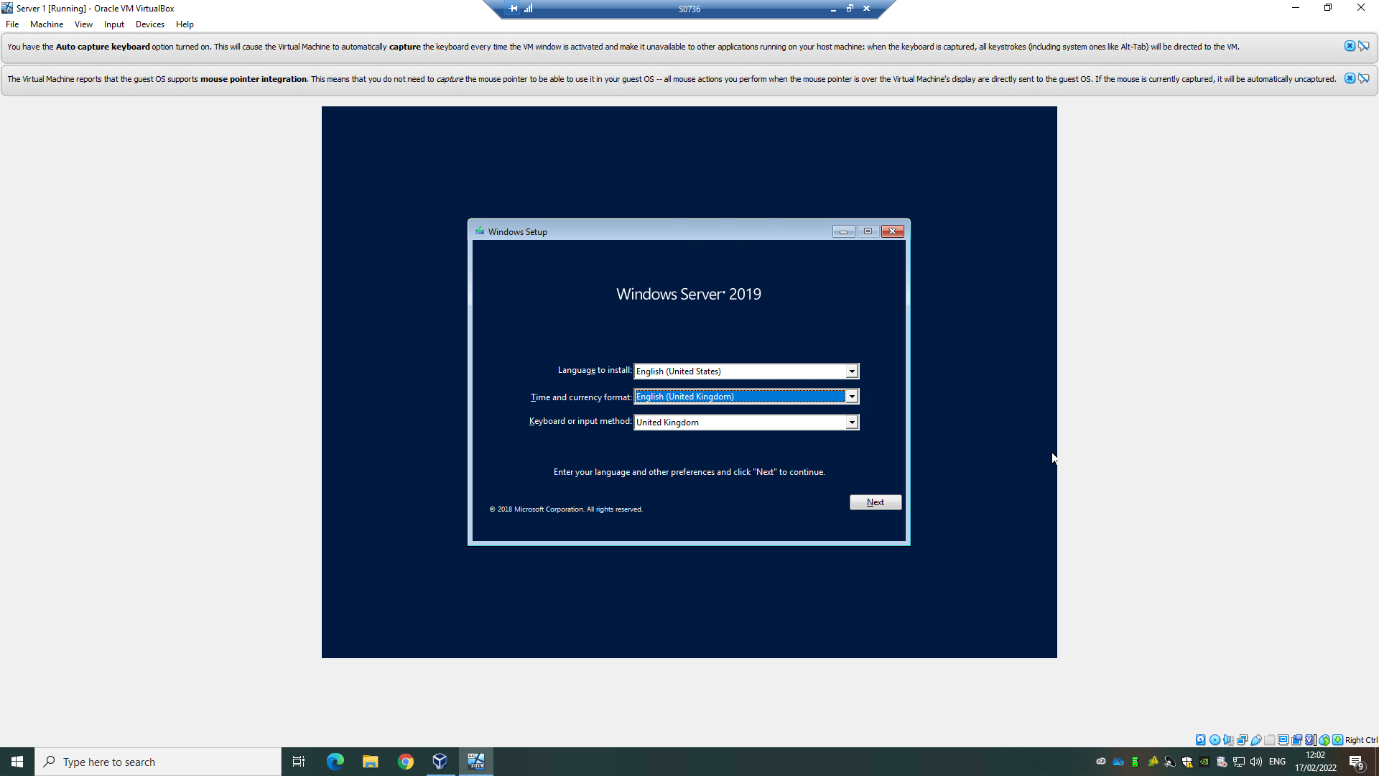

The only available place for Windows Server 2019 to be installed is on drive 0, which is the 25GB of storage space that was allocated to Server 1 earlier. The version installed was the Standard with desktop experience.
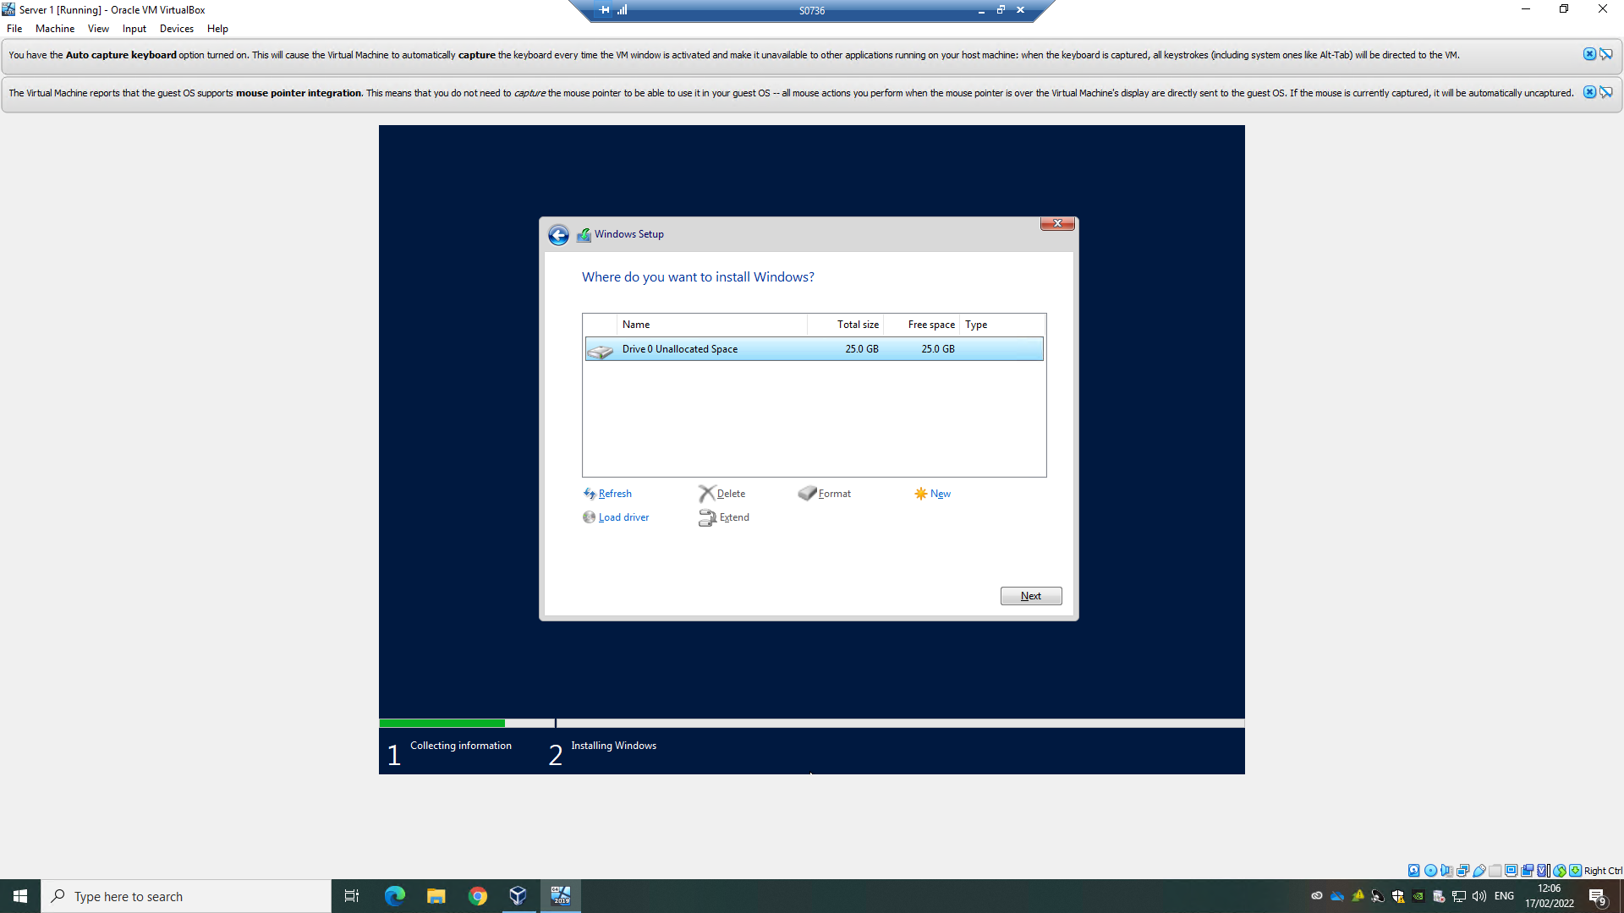
Once Windows has installed, it is required that an admin account gets set up. An admin account is needed to carry out tasks that require special permissions, such as installing software or renaming a computer.
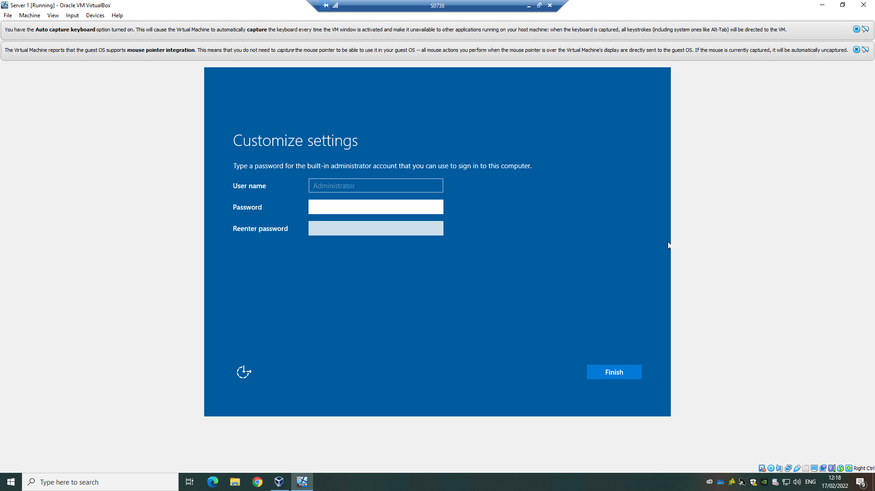

Creation of Client 1:
Also part of the first task, there was a requirement that a Virtual Windows 10 system be set up for a client. It was insured that this system at least met the Windows 10 minimum requirements.
The creation and windows installation of this system was almost identical to that of Server 1.

Installation of Client 1 Windows 10 Pro (x64):
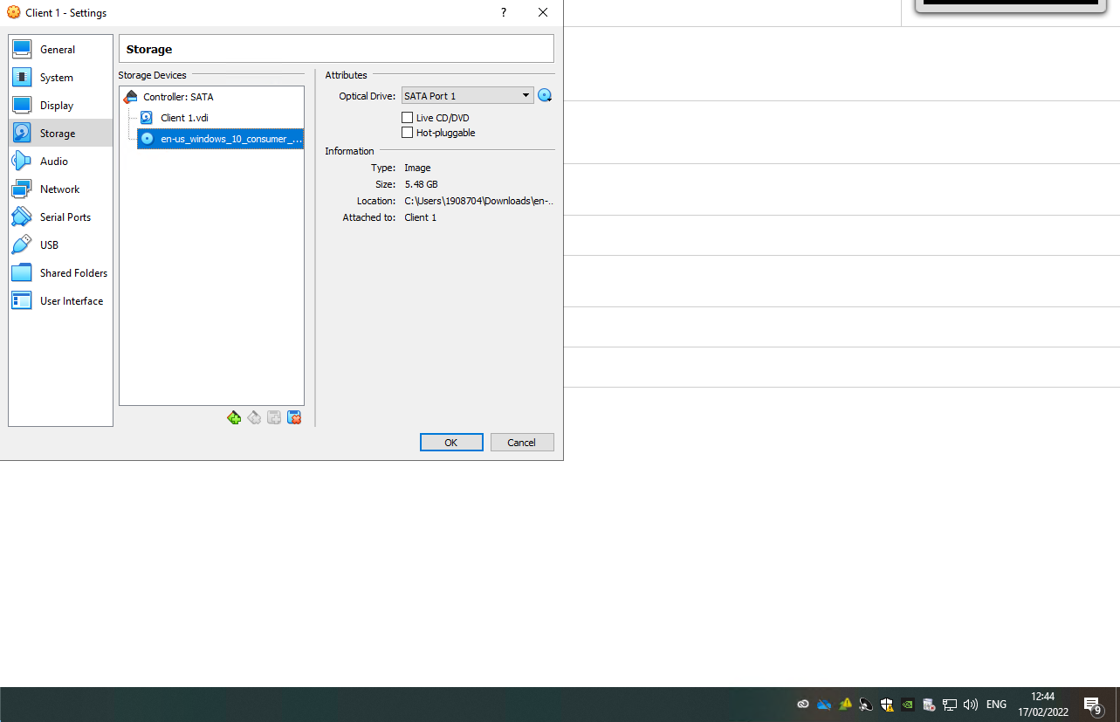

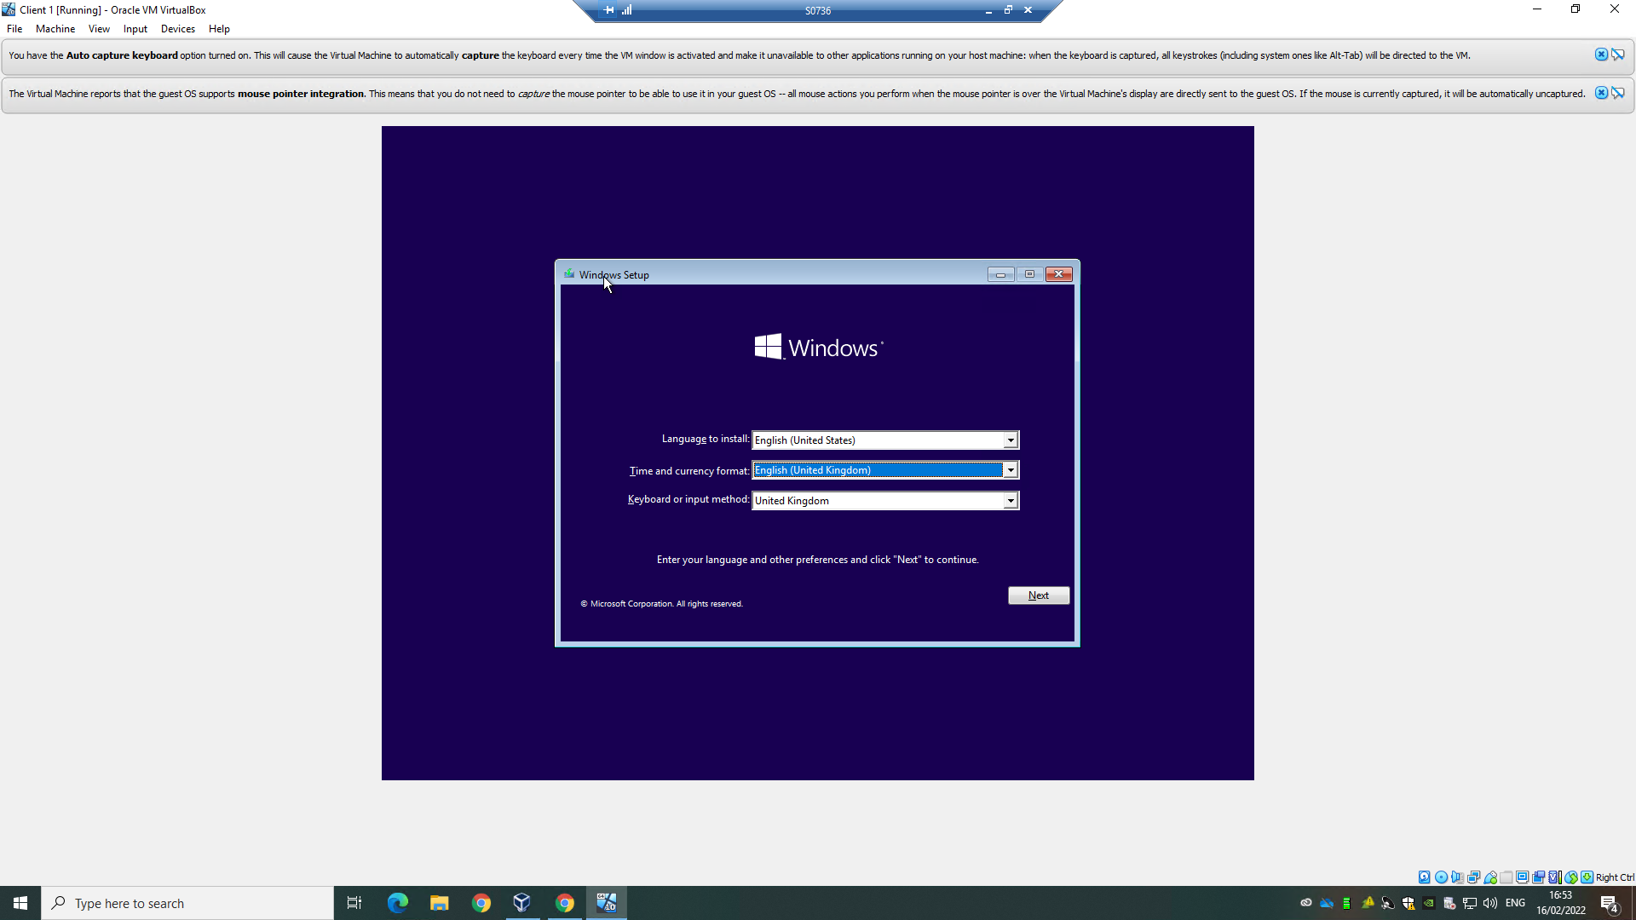
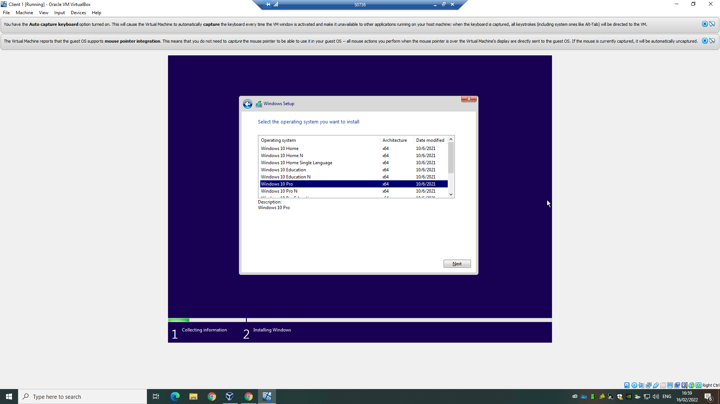

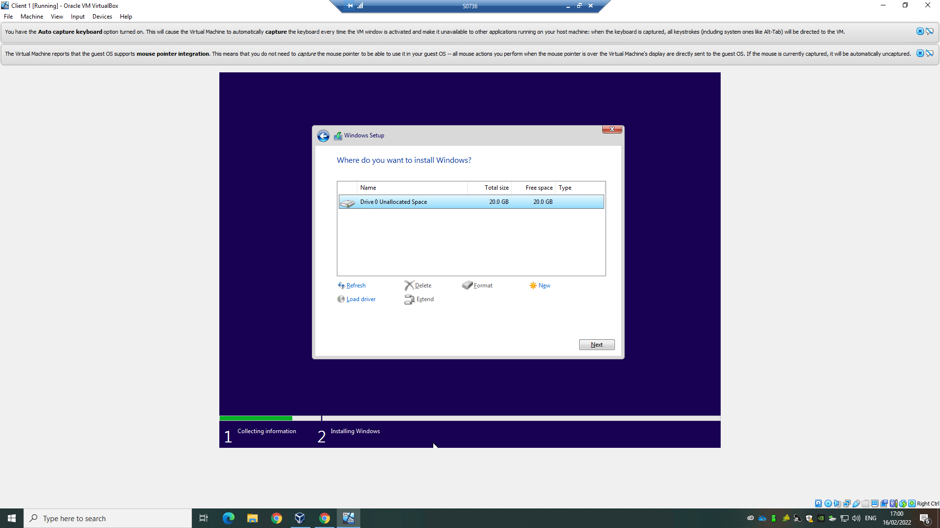

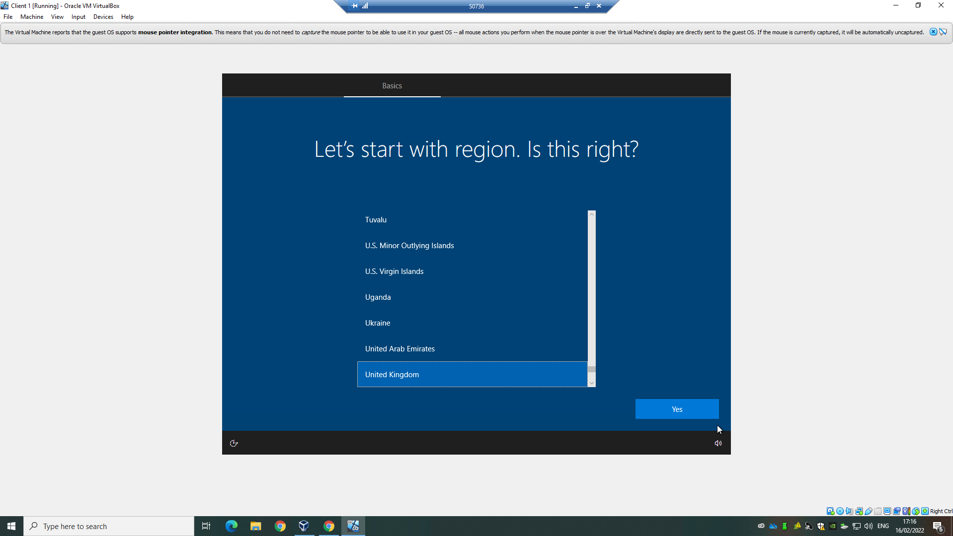

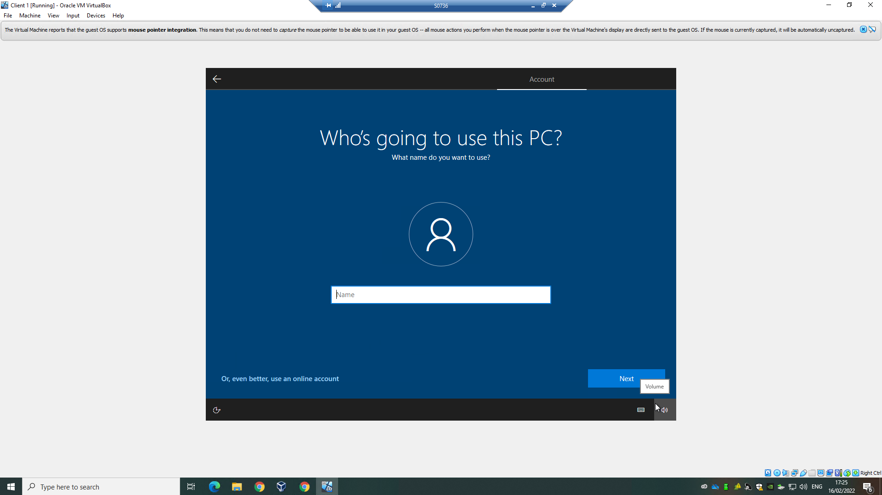

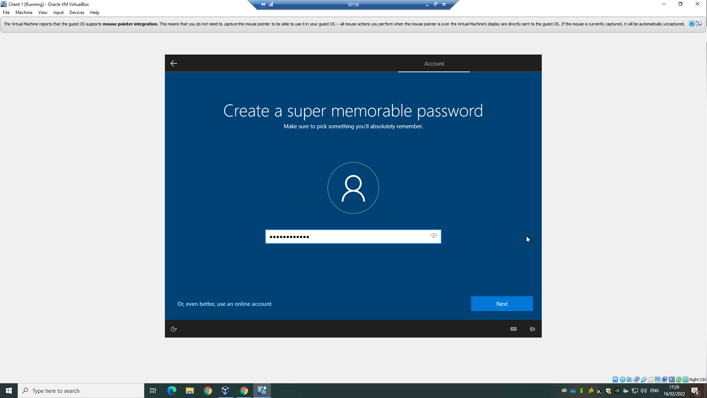
Windows then gives some optional system applications and services, all of these were not allowed in order to lessen the security risk of the system. Optional personalization for windows was skipped, along with Cortana and other features.
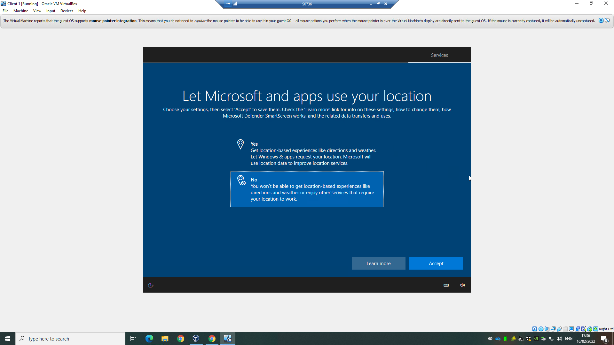

Creation of Server 2 and Client 2:
The process is the exact same for setting up Server 2 and Client 2 as it was for Server 1 and Client 1. Therefore, clones were made.
MAC address policy needs to be set to Generate new because without different MAC addresses, building a network will not be possible, due to the systems not being able to communicate with each other. A MAC address is a unique physical address and are assigned to each network adapter in a system. More information on MAC addresses can be found in Appendix A.
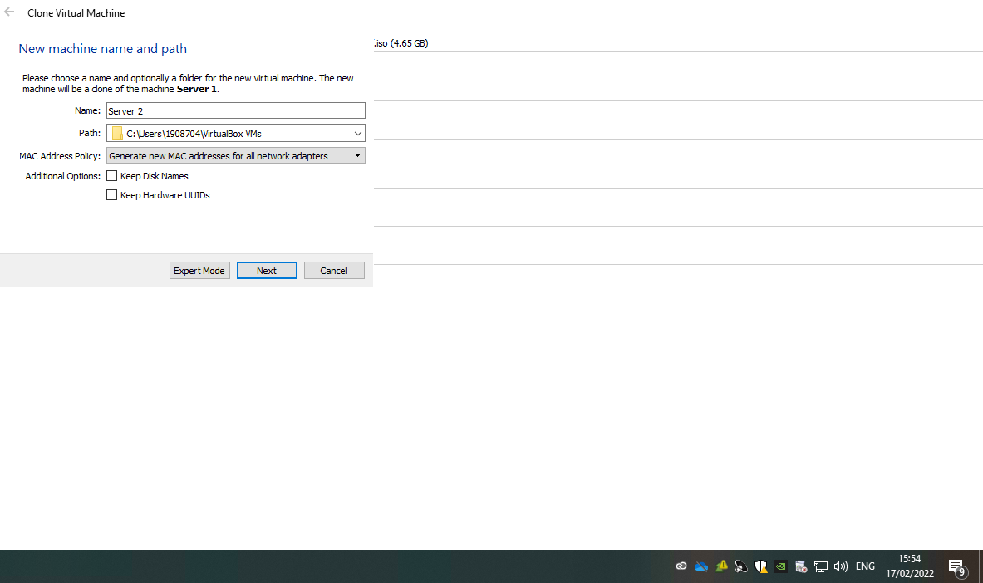
Full Clone is needed in order to have all the same functionality set up on Server 2 and Client 2. This includes already having installed Windows server 2019 and all the specifications already set.
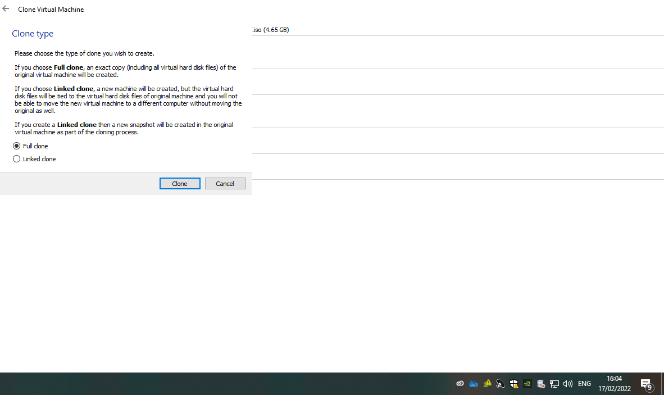

Virtual Network Configurations – PublicNet:

Server 1
An internal network called PublicNet was then set up connecting to Server 1. It is stated on the Oracle VM VirtualBox user manual that internal networking is “used to create a different kind of software-based network which is visible to selected virtual machines, but not to applications running on the host or to the outside world.” [1] Essentially, with the use of internal networking, a virtual switch was created to link Server 1 and Server 2. This network, will not be visible to the host machine or to the internet.
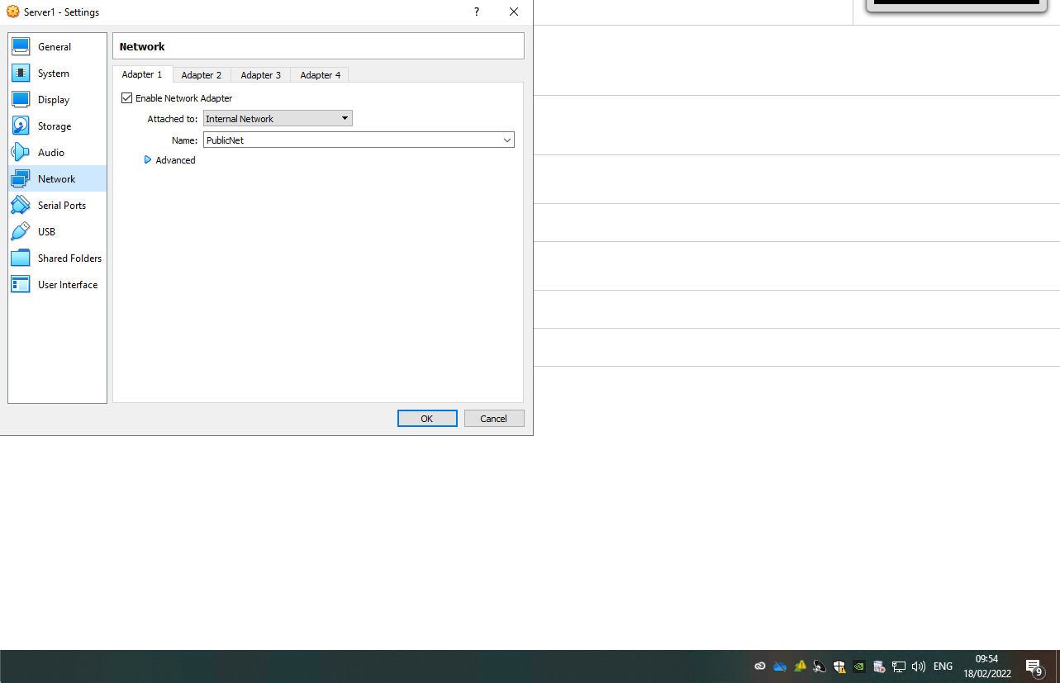
Within IPV4 properties, the IP settings were changed to use a specific IP address set as 192.168.10.200, instead of using DHCP which would automatically obtain an IP address. See Appendix B.
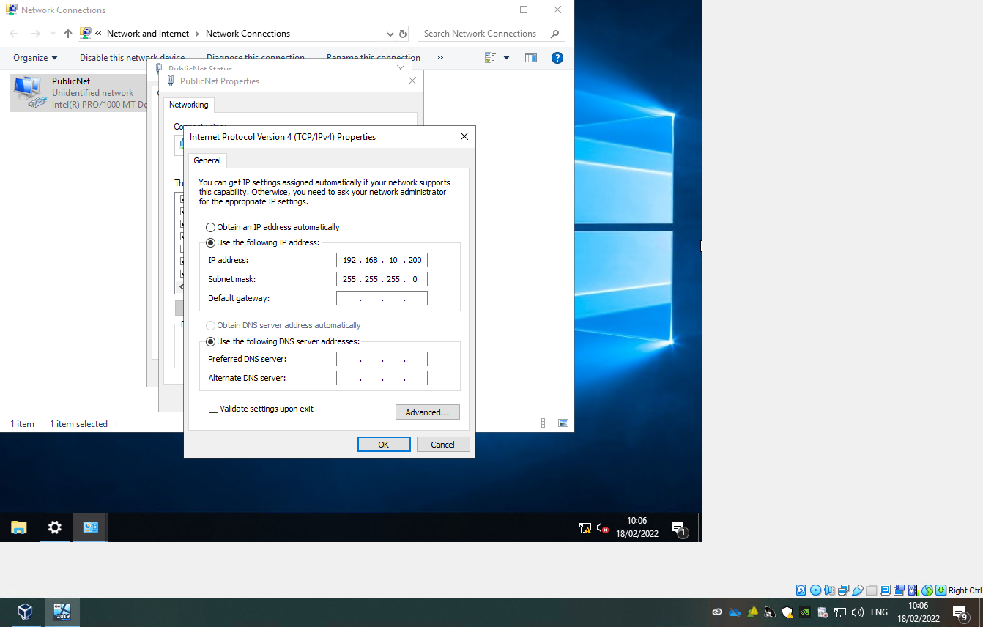

Server 2
Server 2 was set up identically to Server 1, with the exception of different IP addresses.

Testing Server Connectivity - PublicNet:
The ipconfig command was used to ensure that IP addresses have been assigned correctly. Then the ping command was used to check connectivity between the two servers.
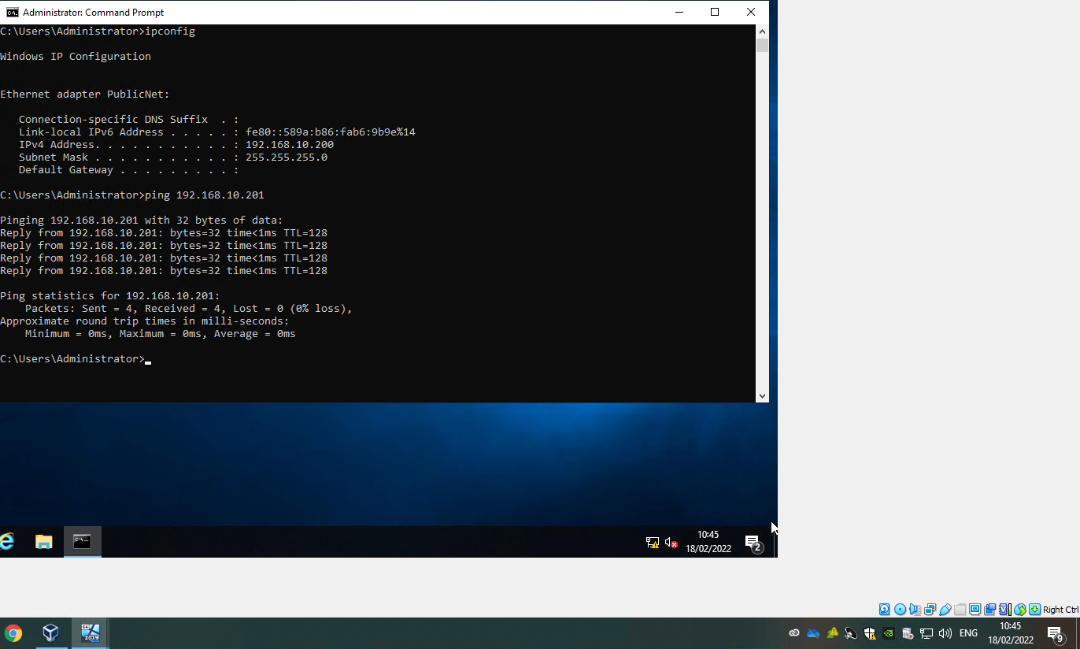

Virtual Network Configurations – PrivateNet1 and PrivateNet2:
PrivateNet1 and PrivateNet2 were setup the same way as PublicNet.

Server 1 and 2:
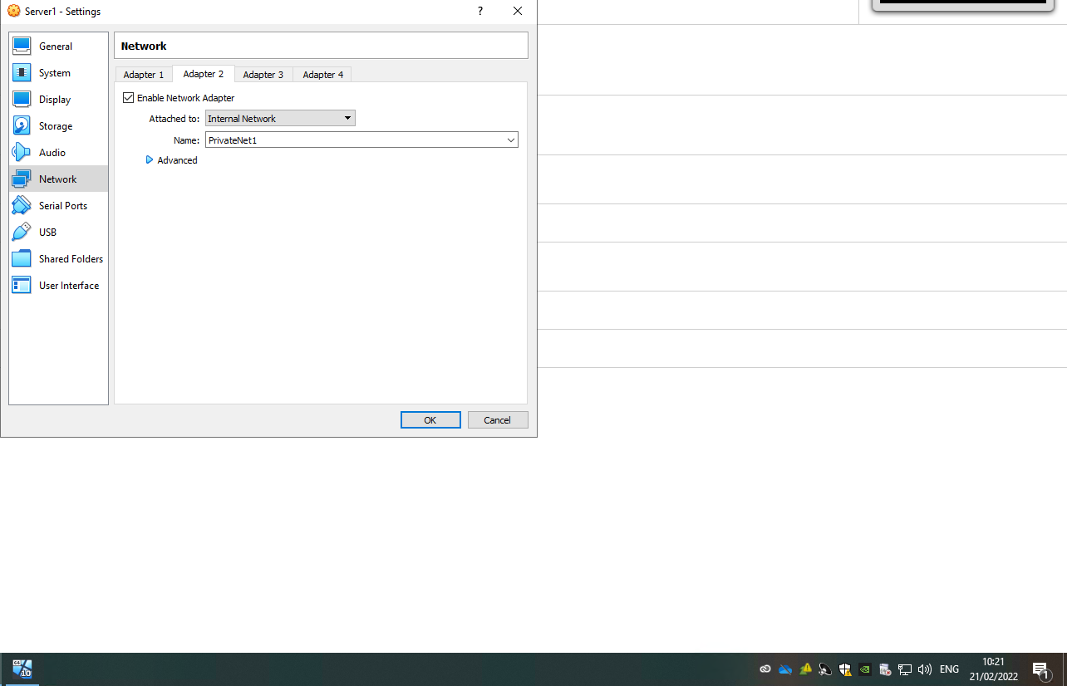

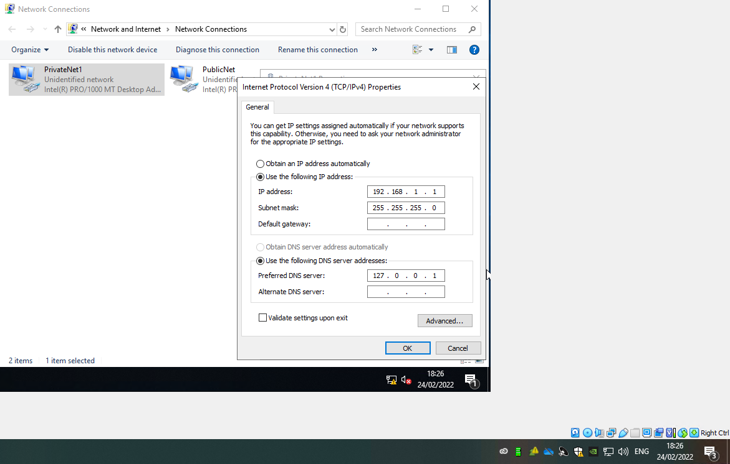

Client 1 and 2:

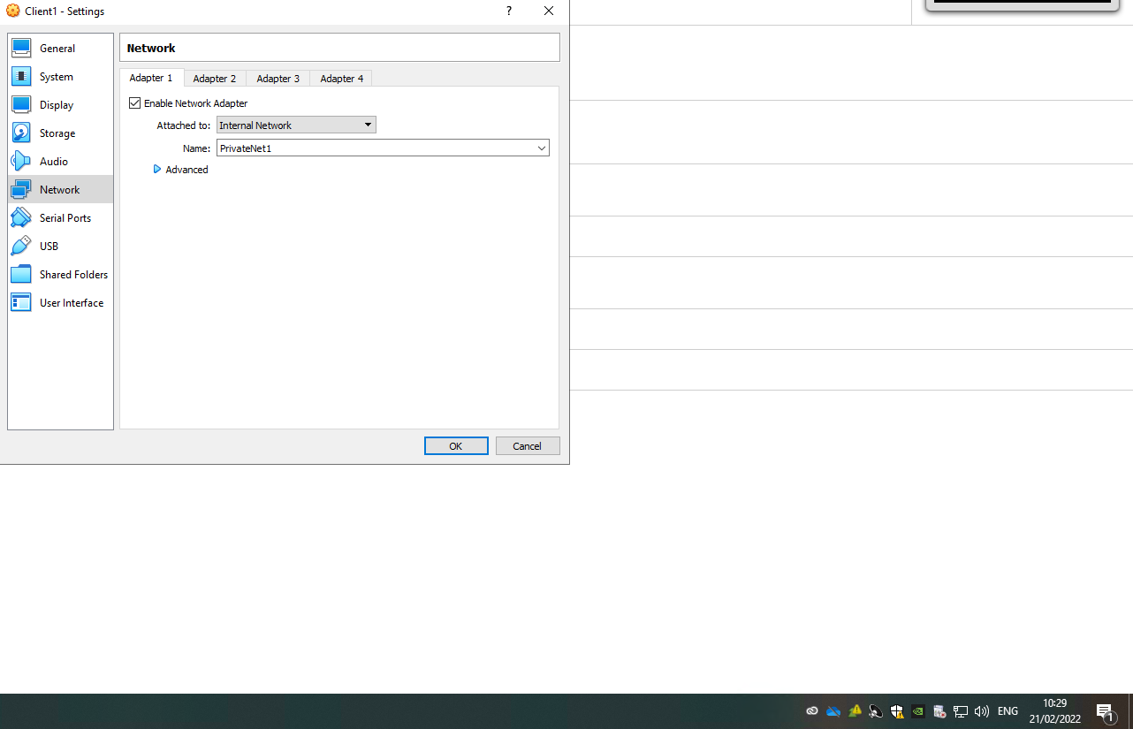
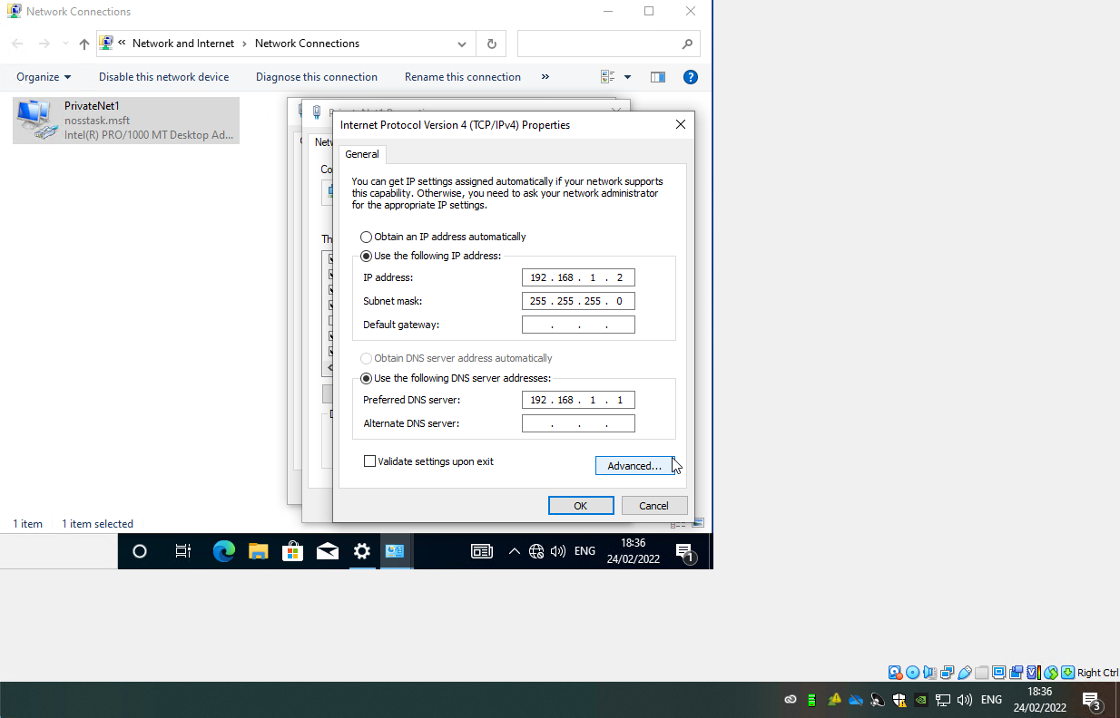

Testing Network Connectivity – PrivateNet1 and PrivateNet2
Windows Defender Firewall had to be disabled in order to establish a connection between Server 1 and Client 1 over the network. It is safe to disable the firewall at this stage because it is not connected to the internet.
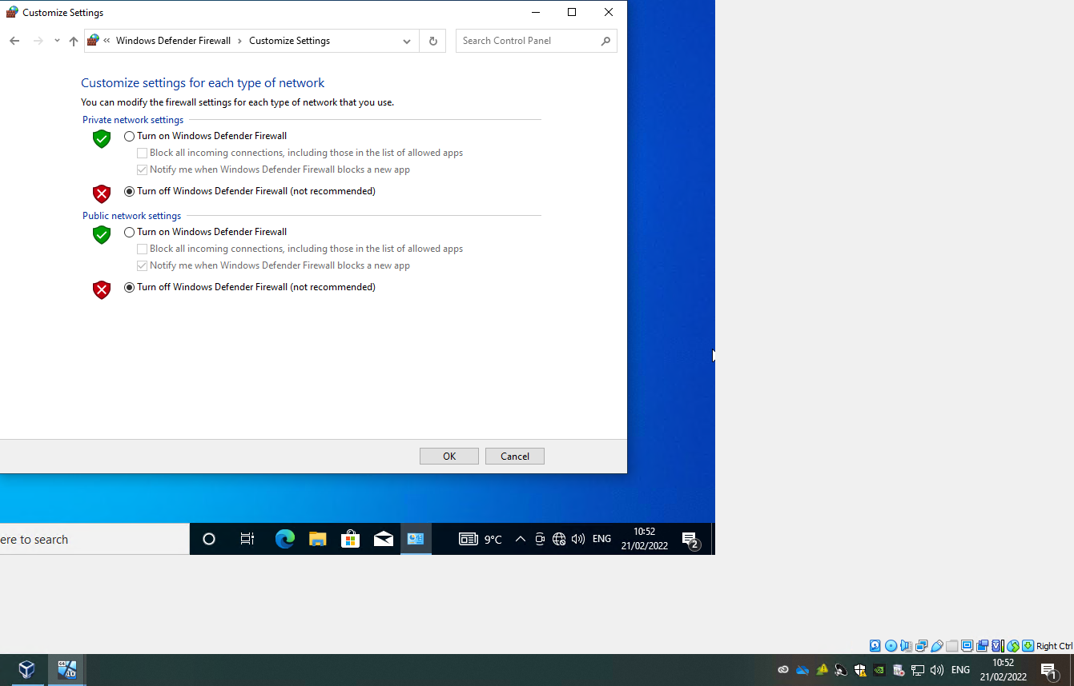
Again, the ping command was used to test connectivity between Server 1 and Client 1, and Server 2 and Client 2.
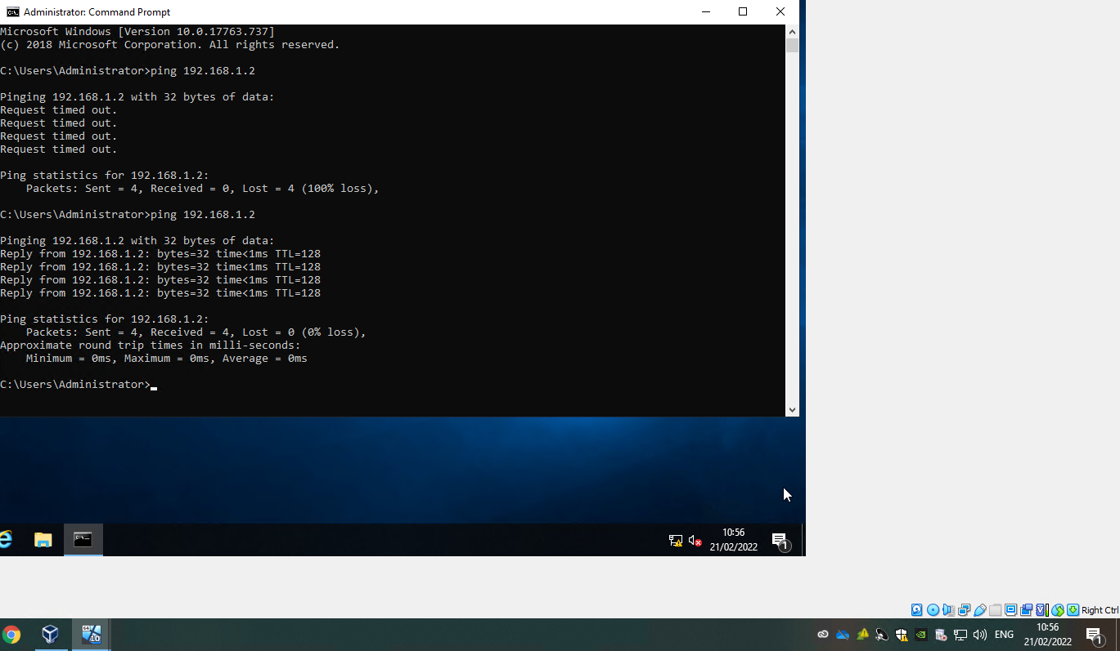

Task 2: Deploying a Network Directory Service and Creating and Understanding Active Directory Network Objects

Prerequisites:
One of the prerequisites for task 2 was to verify that no DNS lookup is setup on either PublicNet or PrivateNet1. Also that the firewall wasn’t enabled on Server 1.
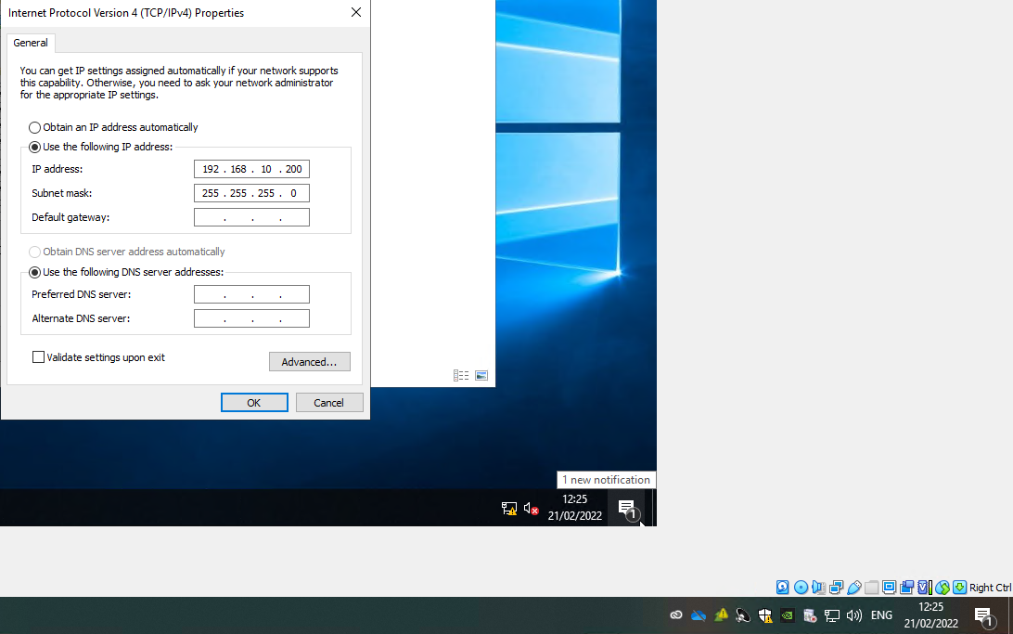

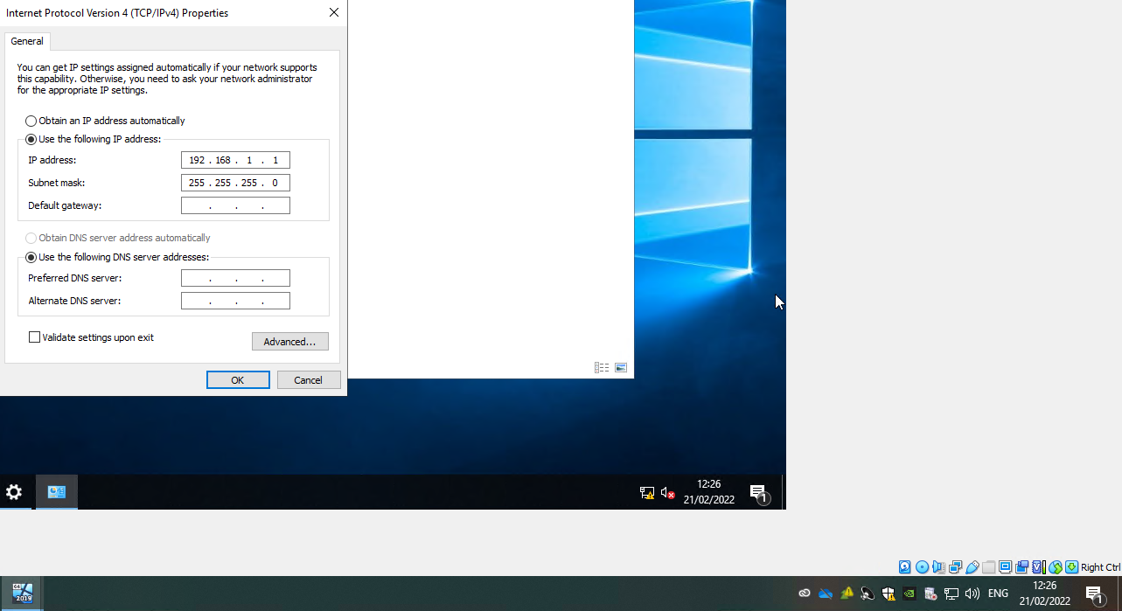

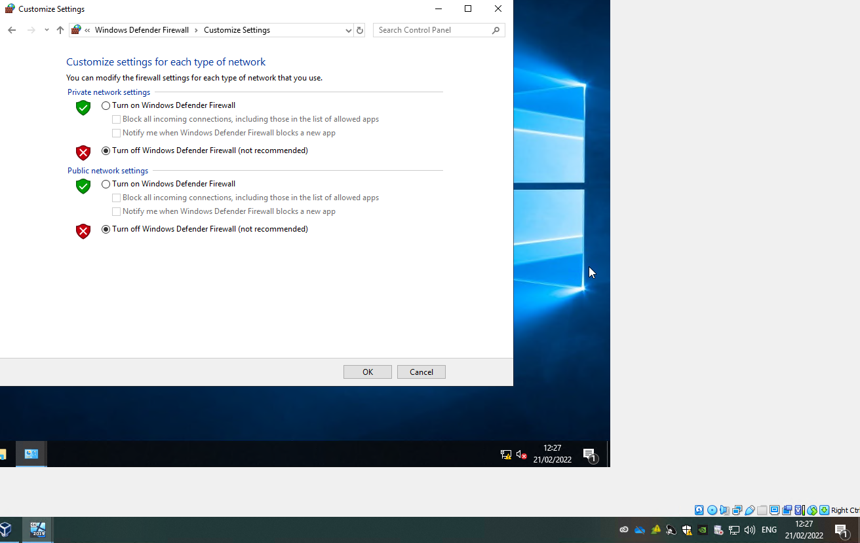
The third and final prerequisite was that the system name for Server 1 was set to DC1-NWT.
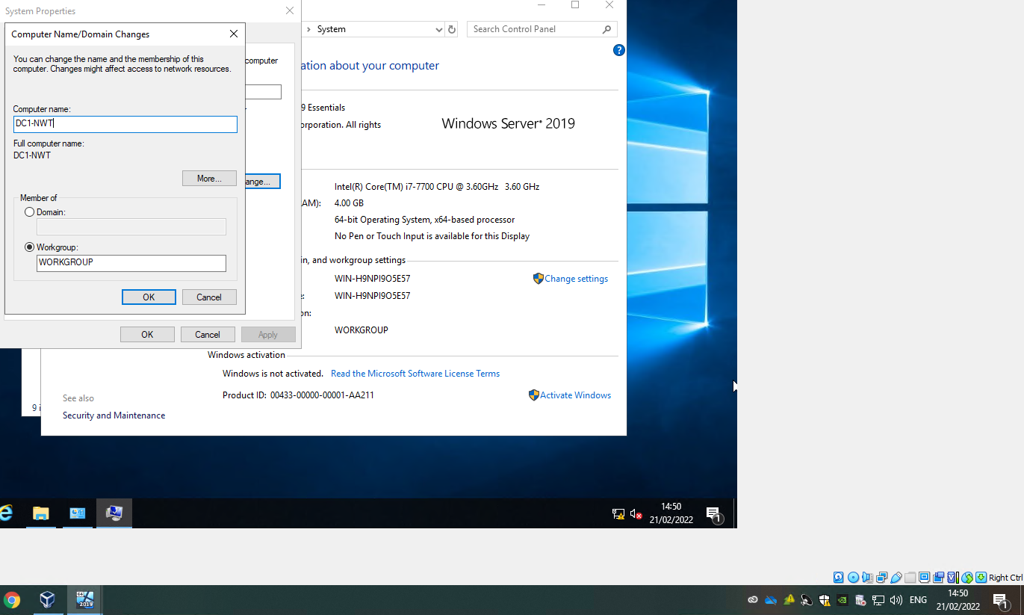

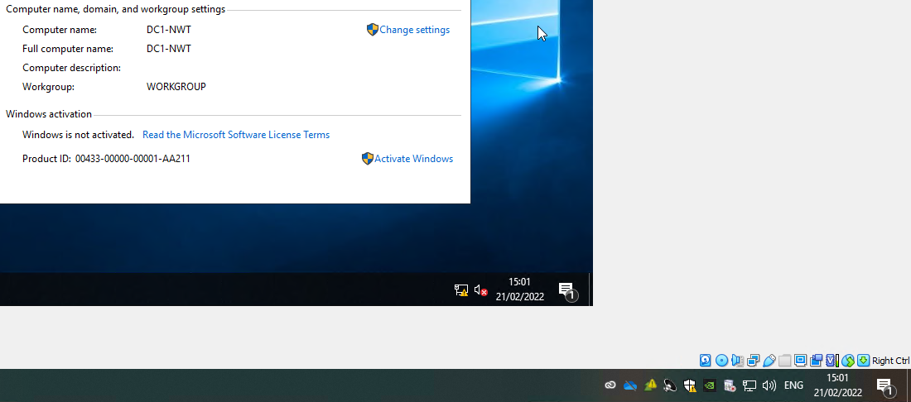

Deploying Active Directory as a role or feature based installation:
Active Directory Domain Services has the features required in order to manage the network effectively.
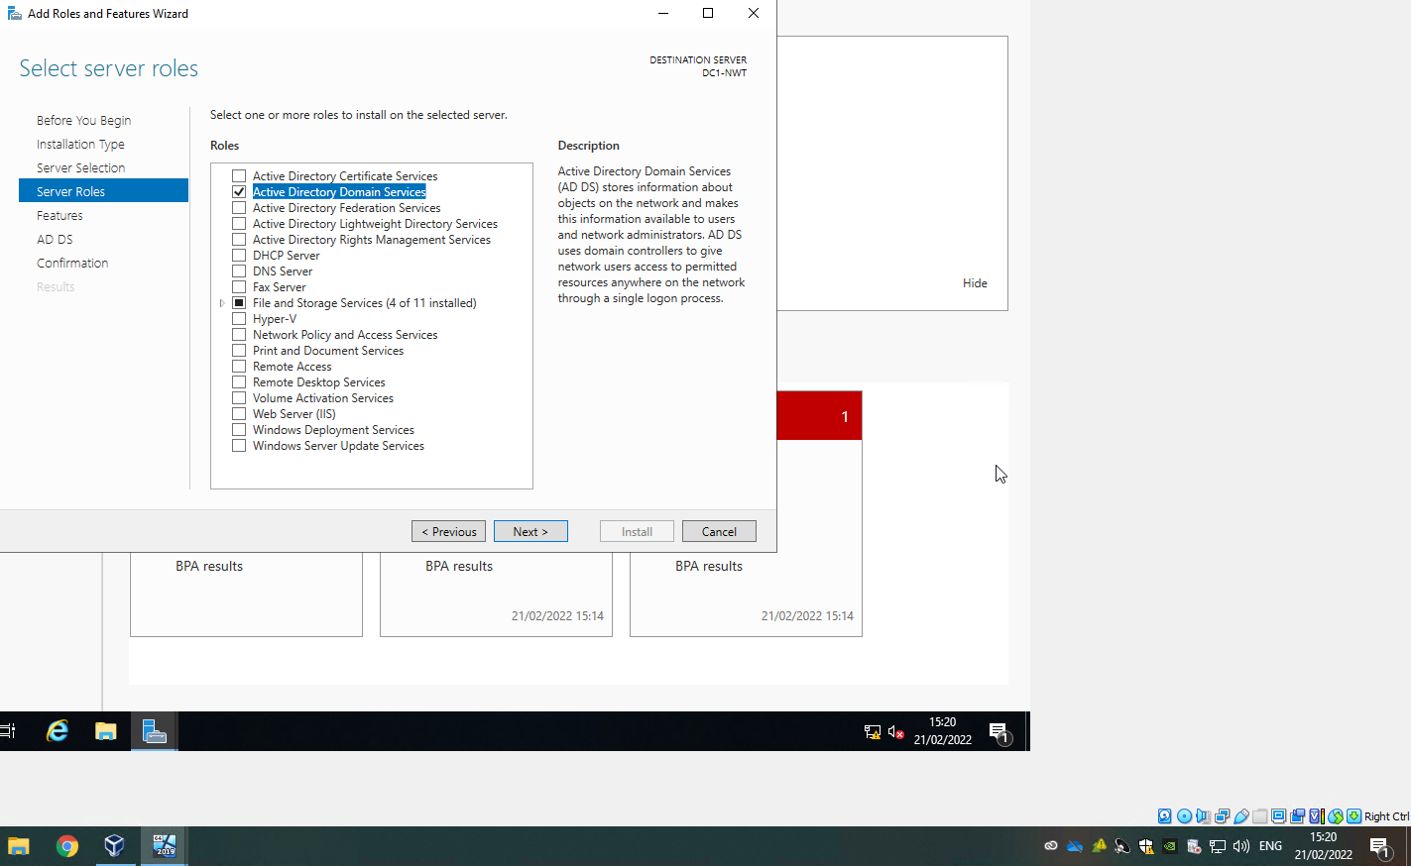
A new forest had to be added with the root domain name “nosstask.msft”.
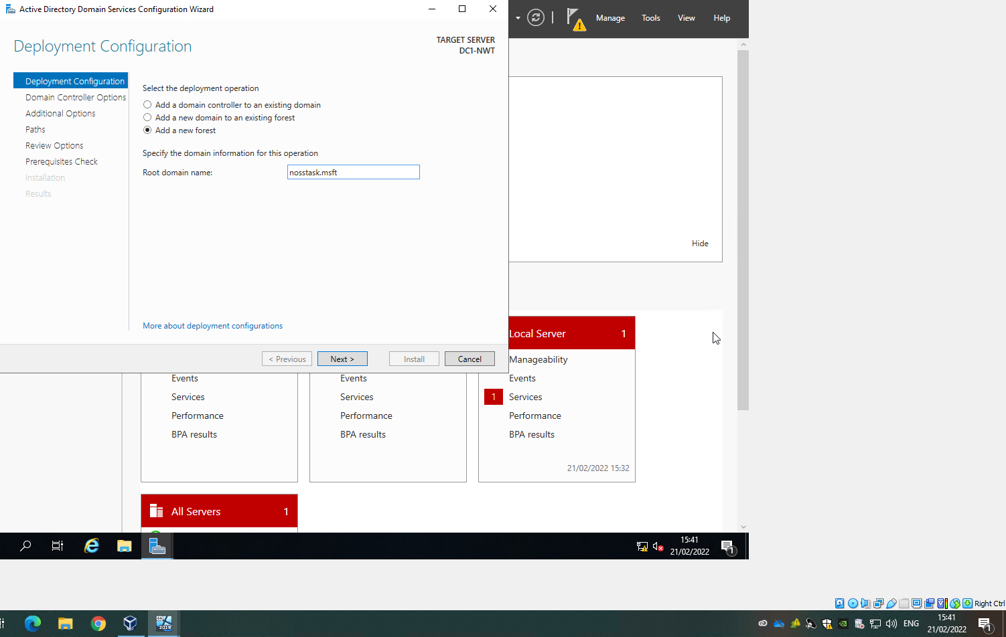

Creating user account objects using Active Directory Users and Computers snap-in console:
Below is evidence of Server 1 being the nosstask.msft Domain Controller.
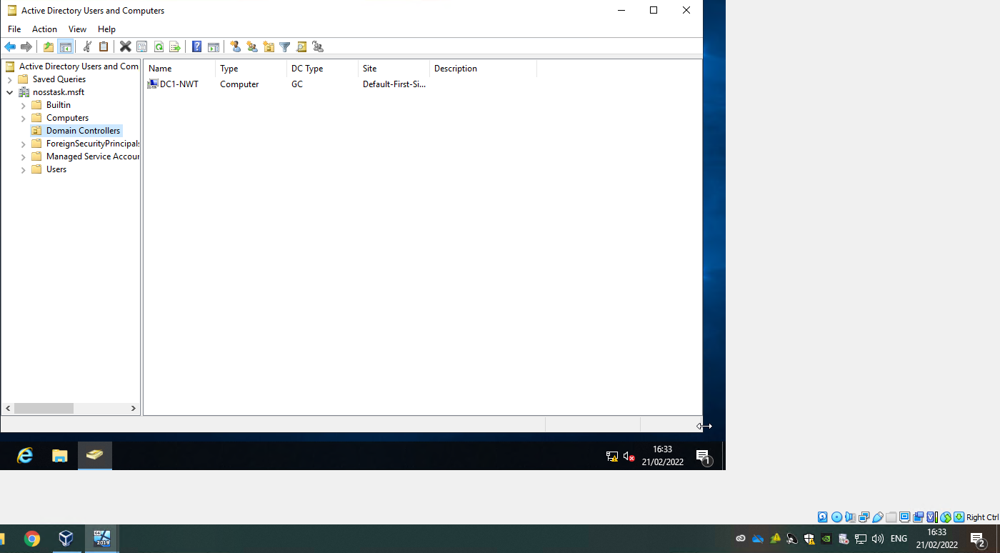
An account had to be created as a failsafe for security purposes. This account will be added to the domain admins group so that it has permissions to access the server.
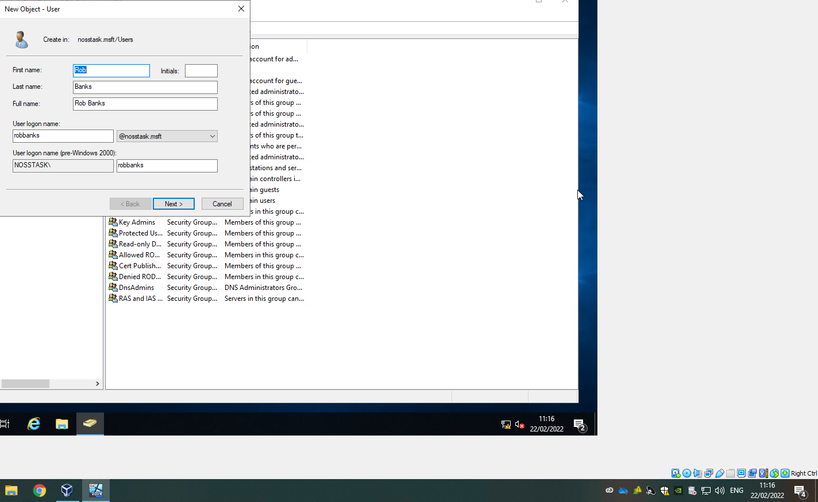

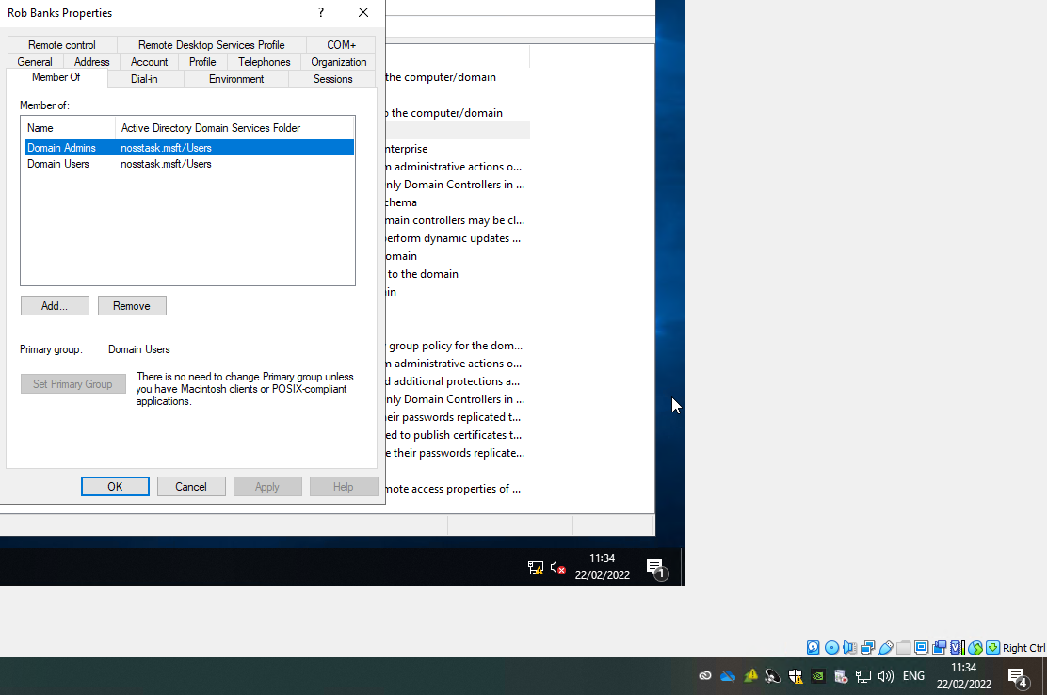
There are many different management tools available to admins, one being able to alter the login hours for users.
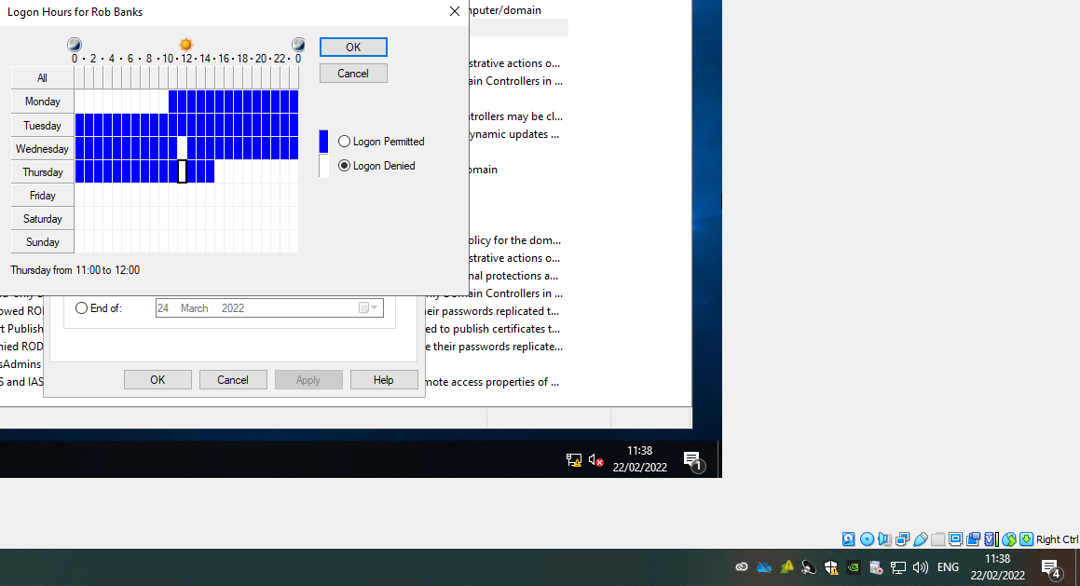

Adjoining the domain and testing user logins:
Entering the preferred DNS server as Server1’s IP address.
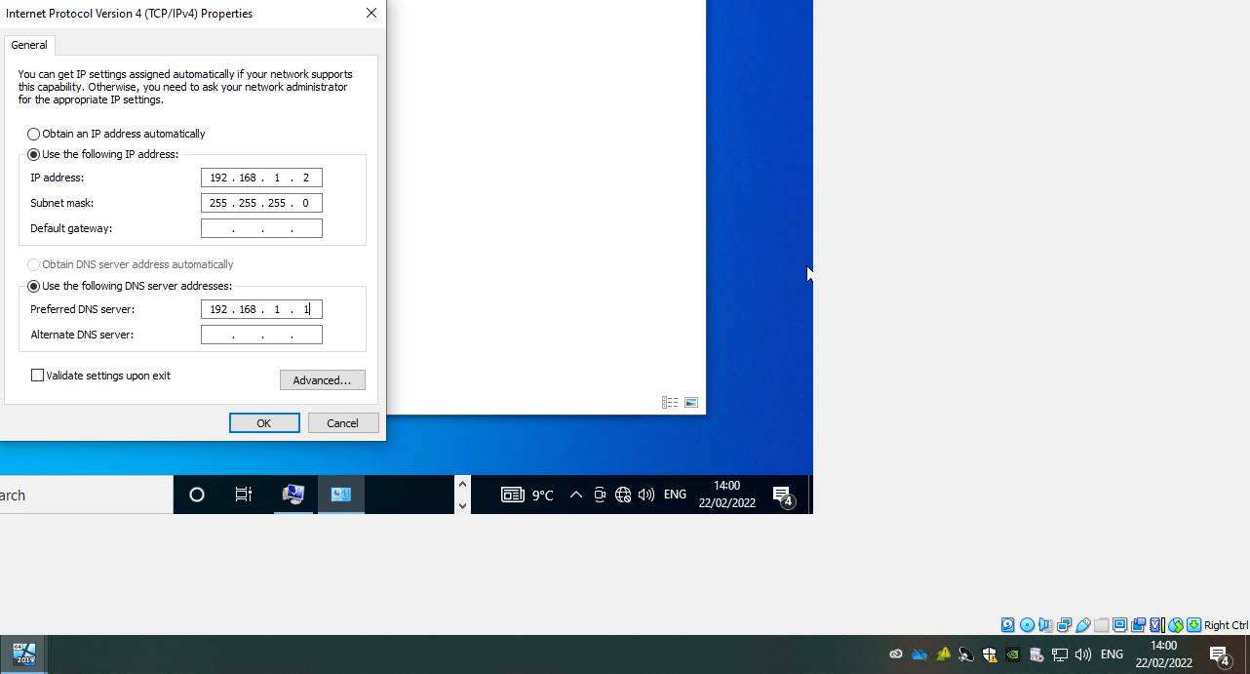
Adjoining client 1 to the nosstask.msft domain.
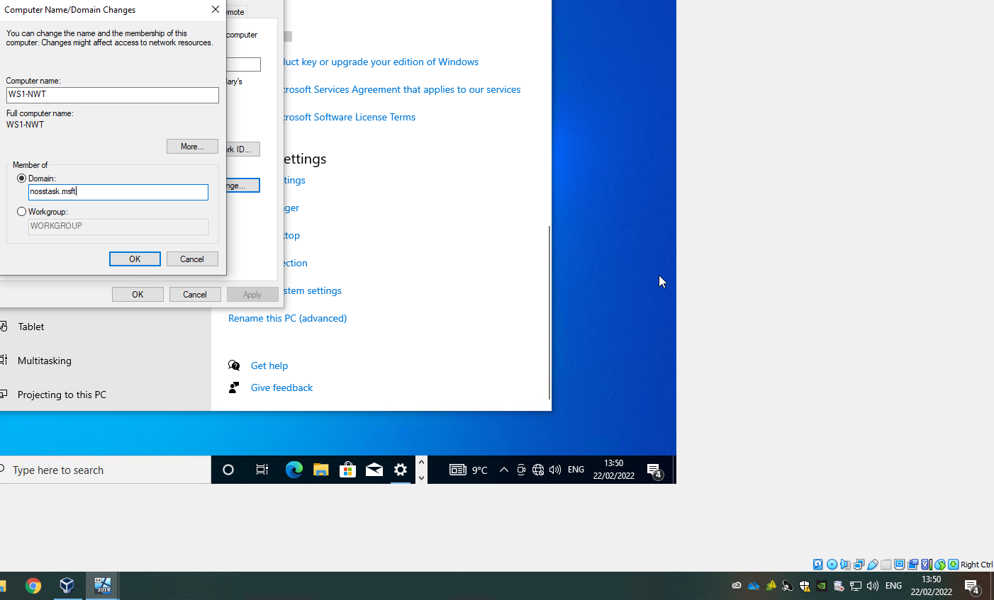

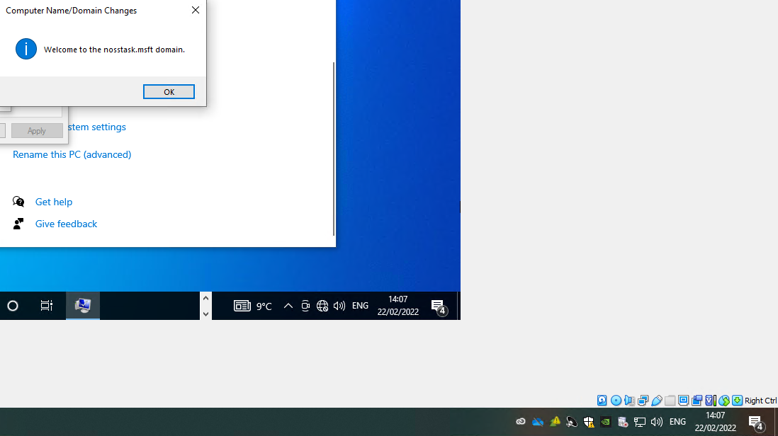
Creating a regular user account in AD.
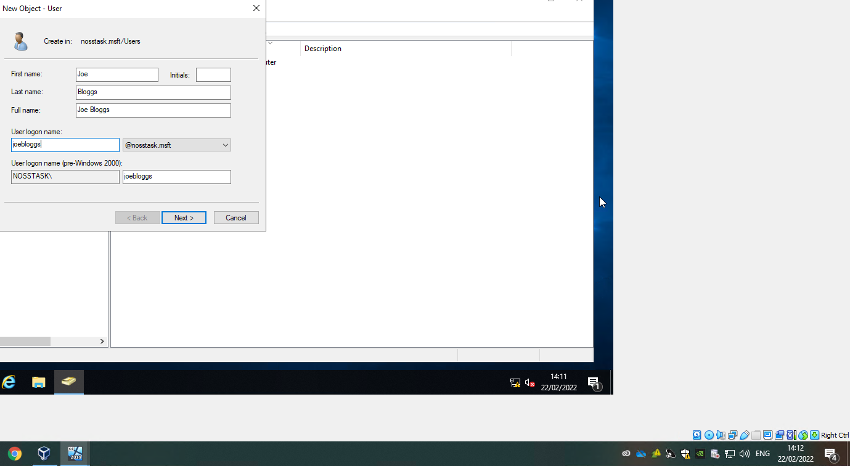

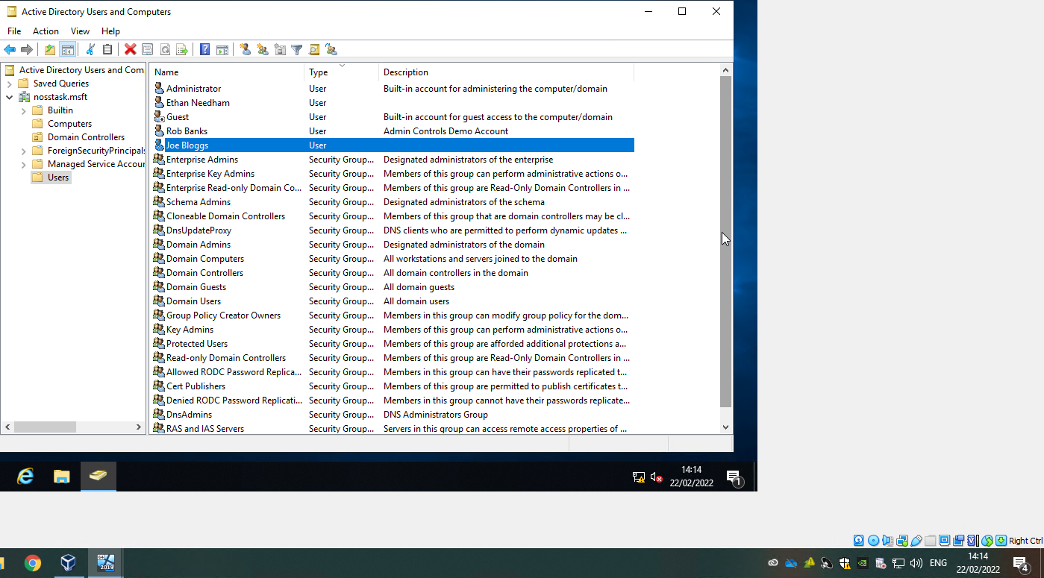
Using it to login to the client machine, this can be done because client 1 is now part of the nosstask.msft domain.
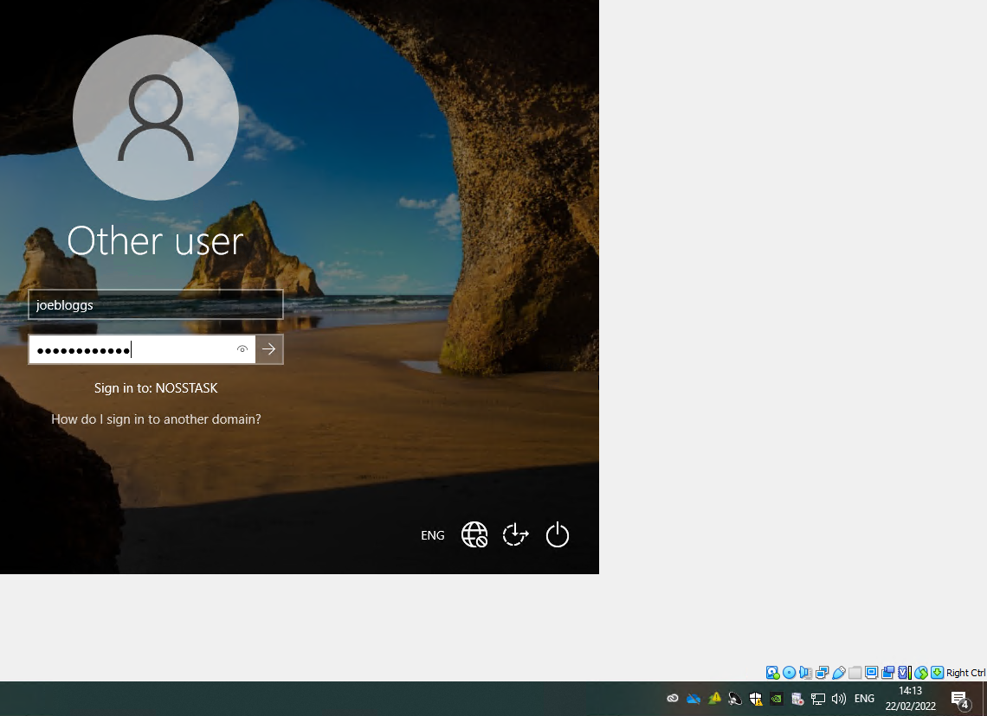

Task 3: Observational Tasks
Type 1 hypervisors are most commonly referred to as “bare-metal” hypervisors. This is due to the fact that they run directly on the systems physical hardware, meaning it interacts directly with the CPU, RAM and physical storage. A type 2 hypervisor runs as an application within the systems OS, instead of running directly on the hardware. [2] For this reason, type 2 hypervisors are often referred to as hosted hypervisors. Popular vendors for type 1 and type 2 hypervisors include VMware, Microsoft, Oracle and Citrix. VMware Sphere is the most popular type 1 hypervisor product, it includes the ESXi hypervisor and vCenter management software to provide a suite of virtualization products, such as the vSphere Client, vSphere software development kits, Storage vMotion, the Distributed Resource Scheduler and Fault Tolerance. [3] VMware Workstation pro is the most popular type 2 hypervisor product. It has features that include host/guest file sharing, the creation and deployment of encrypted VMs, and VM snapshots. While being capable of implementing virtualization on Windows and Linux systems. [3] Both hypervisor types are useful in different scenarios, due to their independence from the host operating system, type 1 hypervisors are preferable for cloud computing and enterprise applications. They do not rely on the OS, making them a more secure option. They generate less overhead and any problems within an individual VM does not harm the rest of the system. [4] The fact that type 2 hypervisors rely on the OS, costs it some of its performance and efficiency. Also, latency is almost inevitable with type 2 hypervisors because it does not have direct access to the hosts hardware and resources. Even with these downsides, type 2 hypervisors are still popular for personal use and SMBs. When access is required to multiple OS’s, type 2 hypervisors are the recommended option. [4]
Cloud computing is the delivery of various services via the Internet. Tools and applications such as data storage, servers, databases, networking, and software are examples of these resources. Instead of storing files on a proprietary hard drive or local storage device, cloud-based storage allows them to be saved to a remote database. As long as an electronic device has internet access, it has access to the data and the software programmes needed to run it. [5] Payroll software, project management and recruitment are a few common uses of cloud computing. [6] The widespread adoption of cloud computing shows that there are a range of benefits. Some of these benefits are:
- Lowered IT costs – Costs are reduced due to reduction in the purchasing, installing, configuring and managing the companies on-premise infrastructure. [7]
- Less risk of data loss and easier data access – Cloud computing allows users to access their data from almost any device as long as it has an internet connection. The files can be stored on one if not multiple services such as Dropbox and GoogleDrive, almost completely mitigating data loss from hard drive failure.
- More cost effectively and easily scaled – Capacities can be scaled up or down when required in response to spikes and dips in traffic, instead of purchasing excess at startup and it being left unused during quieter periods. [7]
Although there are many benefits of cloud computing, there are also a few disadvantages. The main concern about cloud computing are the security risks, the company must share the majority of its sensitive information with a third-party cloud computing service provider. Depending on the level of security implemented by the cloud computing service provider, hackers may be able to gain access to this information. [5]
When a new Active Directory forest and domain are installed, DNS is installed as the forest and domain's Global Catalogue server. [8] DNS is the domain controller location mechanism used by Active Directory Domain Services (AD DS). Systems use DNS to locate Active Directory domain controllers when performing any of the main Active Directory operations, such as authentication, updating, or searching. [8] In all client and server versions of Windows, the DNS Client service is included and is enabled by default upon installation. When you specify the IP address of a DNS server in a TCP/IP network connection, the DNS Client queries the DNS server to discover domain controllers and resolve computer names to IP addresses. When a network user with an Active Directory user account logs in to an Active Directory domain, the DNS Client service queries the DNS server to locate a domain controller. When the DNS server responds to the query by providing the client with the domain controller's IP address, the client contacts the domain controller and the authentication process begins. [8] This can be seen in Appendix C. Making manual entries into the DNS database every time the computer's IP address changes is time consuming and may result in some entries being missed. As a result, Dynamic DNS is required to automate these updates. Any newly installed server can also register its IP address and SRV records with the DNS server automatically. Such Dynamic updates are supported by Active Directory. [9]
There are many other role or feature based installations like Active Directory Domain Services that are a critical part of enterprise networks. DCHP servers and Hyper V see widespread use throughout enterprise networks. A DHCP server is a network server that provides and assigns IP addresses, default gateways, and other network parameters to client devices automatically. It responds to broadcast queries from clients using the standard protocol known as Dynamic Host Configuration Protocol (DHCP) (as seen in task 2). Without a DHCP server, network administrators have the task of manually setting up every client that joins the network. DHCP servers typically assign each client a unique dynamic IP address that changes once the client's lease for that IP address expires. [10] Hyper V is a virtualization software that not only virtualizes operating systems but also entire hardware components such as hard drives and network switches. [11] It is regarded as a direct competitor to Oracle VM VirtualBox, which was used in tasks 1 and 2. In many ways, Hyper V can be a valuable tool for enterprise networks; it can establish or expand a private cloud environment or virtual desktop infrastructure (VDI), and it can allow for more efficient use of hardware by consolidating servers and workloads onto fewer, more powerful physical computers that use less power and physical space. [12]
Throughout tasks 1 and 2, lots of networking and computing terminology was used. Some of these will now be described and their functions will be discussed.
The Ping utility is a system administrator's tool for determining whether or not a computer is operational and whether or not network connections are intact. [13] It sends an ICMP echo request to a system over the network, and the system responds with an ICMP echo reply. [14] Ping can also tell the user how many hops there are between two computers and how long it takes for a packet to complete its journey. An administrator can also use Ping to test name resolution. If a packet bounces when sent to an IP address but not when sent to a name, the system is having trouble matching the name to the IP address. [13] The ping utility works the same across most OS’s such as Windows, MacOS and linux, and it is always used from a command prompt or terminal window.
Windows Defender Firewall provides a device with host-based, two-way network traffic filtering. It prevents unauthorised network traffic from entering or leaving the local device. Windows Defender Firewall also works with Network Awareness to apply security settings appropriate to the network types to which the device is connected. The configuration settings alongside Internet Protocol Security (IPsec), are integrated into a single Microsoft Management Console (MMC) named Windows Defender Firewall. MacOS’s firewall works in almost the exact same way to Windows Defender firewall. The user can configure firewall rules to suit their needs but by default, all traffic is permitted to leave, but only Apple administrative ports and established traffic are permitted to enter. [15] These firewalls are sometimes set to block incoming ICMP “pings” and therefore are sometimes required to be disabled during the setup of systems, which can be seen in task 2.
In a local area networks, the Address Resolution Protocol (ARP) is a procedure for mapping a dynamic IP address to a permanent physical machine address (MAC). ARP operates on the OSI model's Layers 2 and 3. Layer 2 of the OSI model, the data link layer, contains the MAC address. The IP address exists on the network layer, Layer 3. ARP's job is to convert 32-bit addresses to 48-bit addresses and vice versa. This is required because IP addresses in IPv4 are 32 bits long, whereas MAC addresses are 48 bits long. [16]
In task 1, four virtual machines were created, two with Windows Server 2019 and two with Windows 10 installed. These virtual machines were then given basic network configurations, allowing them to be separated onto two different local area networks. In task 2, an Active Directory service was deployed, with ‘failsafe’ admin accounts being created for security purposes. One client system was adjoined to the network and standard admin accounts were created and tested.

References

[1] | Oracle Corporation, “Oracle VM VirtualBox User Manual,” [Online]. Available: https://www.virtualbox.org/manual/ch06.html#network_internal. [Accessed 25 February 2022].
[2] | IBM Cloud Education, “Hypervisors,” IBM, 8 May 2019. [Online]. Available: https://www.ibm.com/uk-en/cloud/learn/hypervisors#:~:text=A%20Type%201%20hypervisor%20runs,of%20the%20host%20operating%20system.. [Accessed 25 February 2022].
[3] | B. K. Stephen J. Bigelow, “What's the difference between Type 1 vs. Type 2 hypervisor?,” TechTarget, 13 January 2021. [Online]. Available: https://searchservervirtualization.techtarget.com/feature/Whats-the-difference-between-Type-1-and-Type-2-hypervisors. [Accessed 25 February 2022].
[4] | K. Taylor, “Type 1 VS. Type 2 Hypervisors,” HiTechNectar, [Online]. Available: https://www.hitechnectar.com/blogs/hypervisor-type-1-vs-type-2/. [Accessed 25 February 2022].
[5] | J. Frankenfield, “Cloud Computing,” Investopedia, 28 July 2020. [Online]. Available: https://www.investopedia.com/terms/c/cloud-computing.asp. [Accessed 25 February 2022].
[6] | SalesForce, “What is Cloud Computing?,” SalesForce, [Online]. Available: https://www.salesforce.com/uk/learning-centre/tech/cloudcomputing/. [Accessed 25 February 2022].
[7] | S. Vennam, “Cloud Computing,” IBM, 18 August 2020. [Online]. Available: https://www.ibm.com/uk-en/cloud/learn/cloud-computing. [Accessed 25 February 2022].
[8] | J. Gerend, “Domain Name System (DNS),” Networking Documentation, pp. https://docs.microsoft.com/en-us/windows-server/networking/dns/dns-top, 1 10 2022.
[9] | A. Garba, “DNS and Active Directory,” SimpleIT Pro, 28 August 2018. [Online]. Available: https://simpleitpro.com/index.php/2018/08/28/dns-and-active-directory/. [Accessed 28 February 2022].
[10] | “What is a DHCP Server?,” InfoBlox, [Online]. Available: https://www.infoblox.com/glossary/dhcp-server/#:~:text=A%20DHCP%20Server%20is%20a,to%20broadcast%20queries%20by%20clients.. [Accessed 28 February 2022].
[11] | S. Iva, “What is Hyper-V & How Do You Use It? A Beginners Guide,” Cloudwards, 28 March 2020. [Online]. Available: https://www.cloudwards.net/hyper-v/. [Accessed 28 February 2022].
[12] | B. Armstrong, “Hyper-V Technology Overview,” Microsoft, 29 July 2021. [Online]. Available: https://docs.microsoft.com/en-us/windows-server/virtualization/hyper-v/hyper-v-technology-overview#:~:text=Hyper%2DV%20is%20Microsoft's%20hardware,an%20operating%20system%20and%20programs.. [Accessed 28 February 2022].
[13] | “Introduction to ICMP/Ping,” ActiveExperts Software, [Online]. Available: https://www.activexperts.com/network-component/tutorials/ping/. [Accessed 28 February 2022].
[14] | Unknown, “What are ICMP PING responses?,” NetApp, [Online]. Available: https://docs.netapp.com/ess-11/index.jsp?topic=%2Fcom.netapp.doc.ssm-sam-117%2FGUID-649BE1AD-24F5-4B3D-892D-8AF14C37619C.html. [Accessed 24 February 2022].
[15] | M. H. P. G. Robert Kite, Apple Training Series: Mac OS X Security and Mobility v10.6: A Guide to Providing Secure Mobile Access to Intranet Services Using Mac OS X Server v10.6 Snow Leopard, Peachpit Press, 2010.
[16] | M. Zydyk, “Address Resolution Protocol (ARP),” TechTarget, September 2021. [Online]. Available: https://www.techtarget.com/searchnetworking/definition/Address-Resolution-Protocol-ARP#:~:text=Address%20Resolution%20Protocol%20(ARP)%20is,access%20control%20(MAC)%20address.. [Accessed 28 February 2022].
[17] | A. Cole, “All You Need to Know about MAC Address,” Clever How-To's, 9 January 2020. [Online]. Available: https://www.cleverfiles.com/howto/what-is-mac-address.html. [Accessed 25 February 2022].
[18] | J. Gerend, “Dynamic Host Configuration Protocol (DHCP),” Microsoft, 29 July 2021. [Online]. Available: https://docs.microsoft.com/en-us/windows-server/networking/technologies/dhcp/dhcp-top. [Accessed 25 February 2022].
[19] | Efficient IP, “Dynamic Host Configuration Protocol,” Efficient IP, [Online]. Available: https://www.efficientip.com/what-is-dhcp-and-why-is-it-important/. [Accessed 25 February 2022].

Appendix A
MAC address, is short for Media Access Control address. MAC addresses are used in the filtering process on wireless networks, which is one of their applications. To prevent strangers from connecting to a network, the router is configured to accept only specific MAC addresses. As a result, even if the IP address changes, as in the case of dynamic IP addresses, the MAC address can still be used to identify the device. Filtering can be used to track and limit network users' access. It can also be used for other purposes, such as detecting when a stolen device connects to a network. Many companies and institutions require the MAC addresses of their members' devices for these reasons. As a result, device owners must be careful not to reveal their MAC addresses to anyone other than authorised personnel. [17]

Appendix B
The Dynamic Host Configuration Protocol (DHCP) is a client/server protocol that automatically assigns an IP address to an Internet Protocol (IP) host as well as other configuration information such as the subnet mask and default gateway. [18] There are four major DHCP use cases:
1. Initial Client Connection: The client requests an IP address and other parameter values from the DHCP server in order to access network services. [19]
2. IP Usage Extension: The client contacts the DHCP server to request that its current IP address be extended. [19]
3. Client Connection Following Reboot: The client contacts the DHCP server to confirm that it can use the same IP address as before the reboot. [19]
4. Client Disconnection: the client requests that its IP address be released by the DHCP server. [19]

Appendix C


