Student Name: Vadym Kozlov
Student Number: 1703901
Module Code: EMPL4010
PATHWAY PROJECT 2
Module Tutor: Mushfiqur Rahman

Table of Contents

Introduction.....................…………………………………………………………………...3
Identifying personal skills set relevant to the project…………………………………….3
Reflection on developing identified skills set while working on the project……………8
Conclusion……………………………………………………………………………….......8
References…....………………………………………………………………………….….9
Appendices…………………………………………………………………………….10 - 13

Introduction:
In this essay I would like to express my reflection and gained life experience on the work within the group of my fellow students while preparing the Business Proposal Plan for International Supermarket “Buy to Save”. I will also attempt to identify the personal skills set I had to use and applied while working on the project presentation and how those skills were improved and developed at the end of presentation. I realised that writing the individual summary is more difficult task than preparing the actual presentation. The main challenge was the starting point and formatting the general idea and the structure of the individual summary.

Identifying personal skills set relevant to the project:
According to DayJob.com (2018), before starting work within the group on the project of presentation it is very important that the relevant personal skills set must be identified and prioritised to ensure the most efficient way of delivering of the final product. Being selected as a group leader I had very difficult task to do. I never managed the group of people before and for me it was completely new life experience. Therefore, I created the diagram of the skills I needed in order of their importance.

Picture 1: Personal skills diagram, source: (Mind Tools, 2018)

I have set my priority to the leadership skills because it’s very important skill for every leader. According to Mind Tools (2018), the leader is the executive person in the group or company responsible for developing the company’s strategy to overcome competitors. Other responsibilities of the leader are setting up the direction, building the vision, inspiring and leading the team and finally, managing the delivery of the project. In my case I had to use all the knowledge I have gained through the semester to use this skill and develop it further plus extensive learning through internet resources was needed.
The interpersonal and communication skills are also very important skills when working within the team, especially for the group leader. According to MTD (2008), interpersonal skill can be described as the ability of the group leader to communicate and get full understanding of the group, also known as getting alone with people on the personal level. MTD (2008) states that communication skill is the ability of the group leader to transfer his or her instructions to the members of the group in the way they can be fully understood. That’s why these two skills can be combined, because they always used together. I can say that I already had those skills in the stage of developing thanks to the previous experience of working within the group but becoming the group leader required further studying and research the interpersonal and communication skills.
According to Starks (2016), achieving strong internal and external networking within the team is vital for the leader to complete the project. In the diagram below I’ll explain 5 main factors of successful networking within our group:

Picture 2: Five main factors of successful networking, source: (Starks, 2016)
According to Coaching Positive Performance (2017), time management for the group leader is a highly personal skill. Once I became the leader of the group I immediately outlined eight major skills for the time management within the group.
- Goal setting: At the first group meeting after the election of the group leader it was the first thing. The goal of delivering the Business Proposal Plan presentation on time was set.
- Prioritisation and planning: Very important skill which helps to avoid of doing unnecessary tasks. That’s why the whole structure of the presentation was agreed in general and the completion of the slides was also planned.
- Delegation: The next step was to distribute agreed tasks between the group members including the leader.
- Avoiding multitasking: My responsibility as a group leader was to make sure that no one was doing the same task.
- Focus: I decided that the best way to achieve focus will be to give each member of the group just one task to complete. After completing this task and reporting the result to me via WhatsApp or during the meeting they were given another task to do.
- Decision making: Was required during the whole process of managing the group. Which task to give more priority, who will be doing this and who will be doing that, how much time to give members to complete the task – all these are examples of decision making.
- Work effectively with others: As a group leader I had to ensure that members of the group communication with each other all the to keep up with the progress of the project. Therefore, I encouraged the discussions at our meetings with all the members involved and insisted that those meetings were attended by everyone all the time.
- Record keeping: According to Stoker (2017), the only failure makes us to learn, not the success. It’s one of the most important skills of the time management. Keeping the regular track of your activity will help to make the better project in the future and avoid potential failure. It helped me a lot when I was working on the next presentation.

According to ITS (2016), group problem solving can be very effective way of dealing with some issues within the group if it’s being used in the right way and in the right time. It’s another important skill I had to use and improve while working with my group. The diagram shown below describes the use of problem solving within our group:
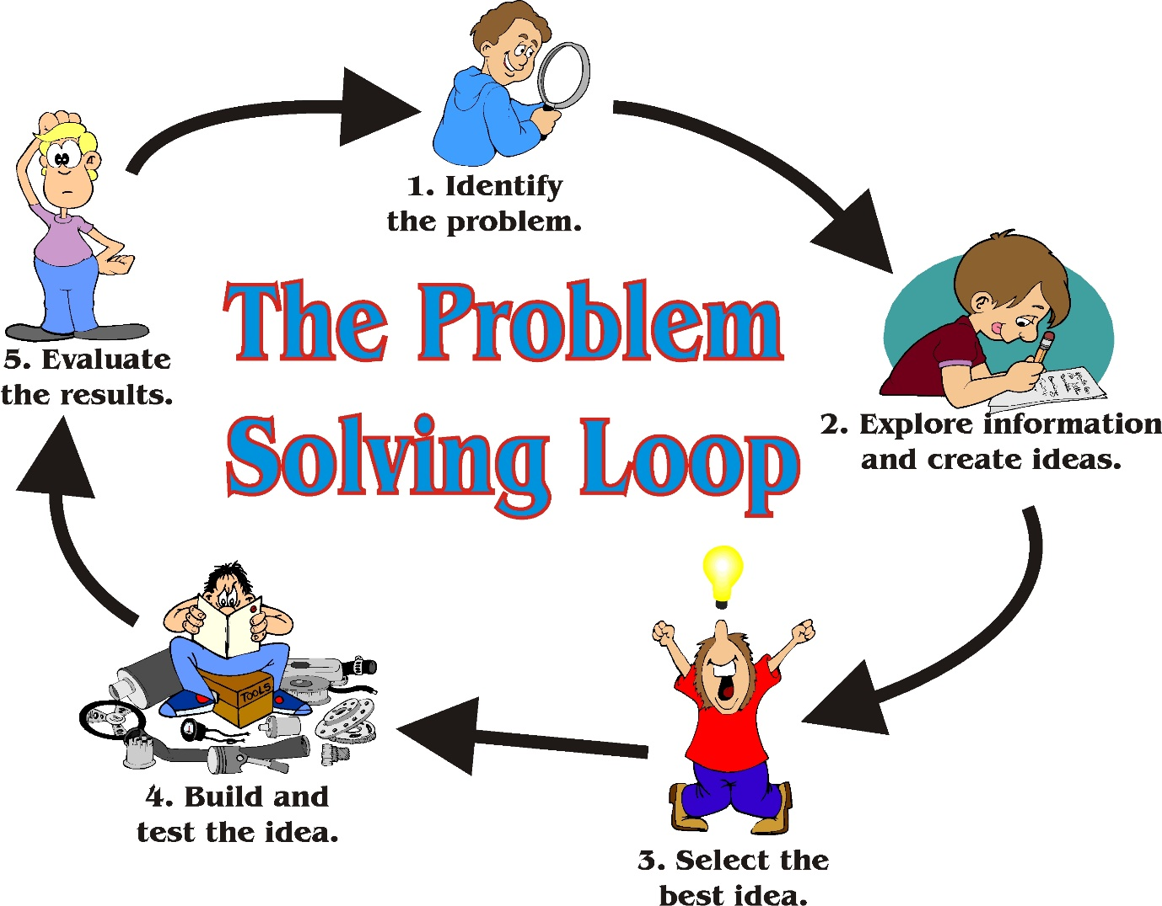
Picture 3: The problem-solving loop, source: (Jdy Ramble On, 2013)

According to Erstad (2018), analysing of an issue or the situation and the evidence related to it, is the critical thinking. This is the last set of personal skills I needed to develop and improve while leading the group. The diagram below shows 6 crucial thinking skills which my group was encouraged to use while working on the project:

Picture 4: 6 crucial skills of critical thinking, source: (Erstad, 2018)
First step was the identification of the problem we were facing in our group. The main problem was to complete the presentation in time and deliver it. That’s why we needed to distribute all the tasks to all the group members and set up the time deadlines for completing those tasks. Any problems during the completion of the tasks had to be resolved through our communications on the meetings or via WhatsApp and emails. While we were having arguments relating the tasks which were already completed, I always tried to do an independent research by myself to eliminate questionable resources of information. Identifying biases is basically the ability to set aside your personal preferences and thoughts and be fair and objective when it comes to evaluation of credibility sources of the information provided by the group members. The ability to draw the conclusions based on the results of researches is called inference. As a group leader I was always encouraging members of the group to do so and of course did it myself. Determining the relevance is one of the hardest skills in critical thinking to engage and improve. Finding the most important and relevant information while completing the tasks was challenging thing to do.

And finally, curiosity. As a curious person by nature I was always tried to question facts and information I was receiving. While working in the group this skill helped me to assess the data received from the group members and by questioning “Why?” establish the real value of this information.

Reflection on developing identified skills set while working on the project:
In this part of an essay I will reflect on the progress of developing my personal skills while leading the group. My leadership skills received a great boost and improved a lot. I gained the experience of managing the group of people and it made me more confident towards future similar roles or as a business manager of the company for example. My interpersonal and communication skills were upgraded to the new level during the work on the project. I became more confident in keeping conversation with other people, I also started being the good listener. These skills are also very important for the managerial position within the company. Networking within the team was quite new experience and it developed greatly. Before this project I already possessed some time management, problem solving and critical thinking skills, but thanks to this project and especially being the group leader, these skills became much stronger. I can say that I came one step closer to my lifetime dream of being the business owner and managing the company, no matter how many people will be working there. The skills I gained and developed can be upgraded in the future process of studying, because learning never ends.

Conclusion:
In overall, being the group leader while working on the Business Proposal plan was the priceless life experience. Interacting with so many people from different backgrounds and cultures has made me more open minded, more interactive and communicative person. I achieved and developed personal skills such as leadership, networking within the team, time management which can be used for my future studies and for work in business environment. I think our presentation was successful and I want to thank all the members of the group for all the hard work they did while working on the project.

References:
Coaching Positive Performance, (2017). 17 Essential Time Management Skills. Coaching Positive Performance online. Web Research.
DayJob.com, (2018). Identifying your skills. DayJob.com online. Web Research.
Erstad, W. (2018). 6 Critical Thinking Skills You Need to Master Now. Rasmussen College, Inc. Web Research.
ITS, (2016). Solving Problems Using a Group – Advantages and Disadvantages. ITS Education Asia. Web Research.
Jdy Ramble On, (2013). A Ridiculously Simple Way to Solve a Problem. Web Research.
Mind Tools, (2018). Leadership Skills: Become an Exceptional Leader. Mind Tools online. Web Research.
MTD, (2008). Communication Skills vs. Interpersonal Skills. Management Training Specialists online. Web Research.
Starks, F. (2016). Leaders Help Team Members Build a Professional Network. About Leaders. Web Research.
Stoker, B. (2017). 17 Essential Time Management Skills. Coaching Positive Performance online. Web Research.

Appendices:

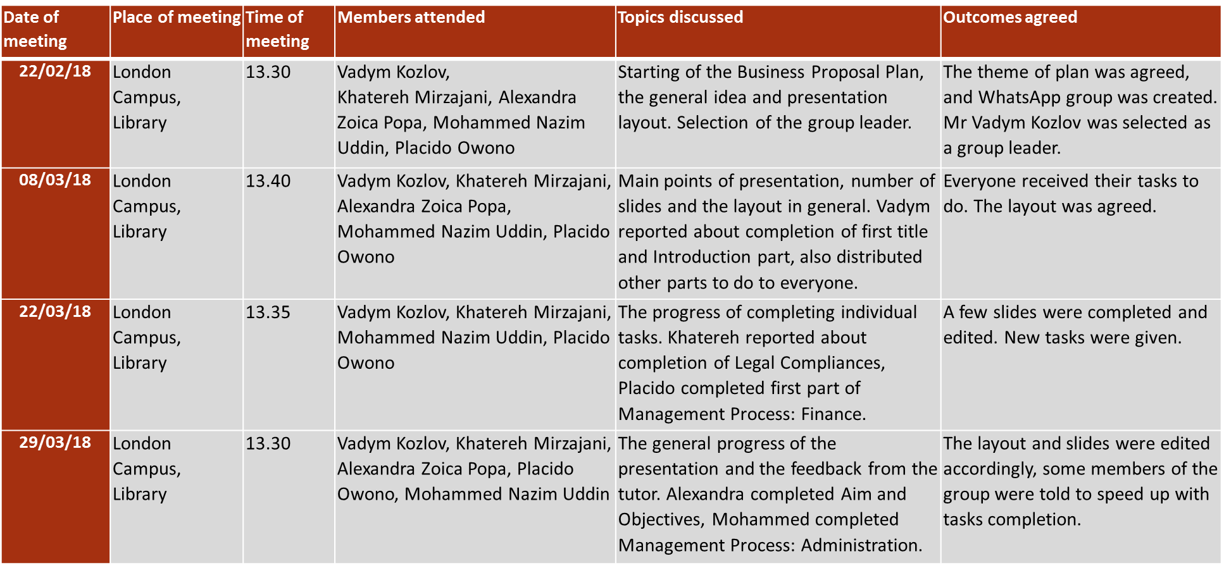
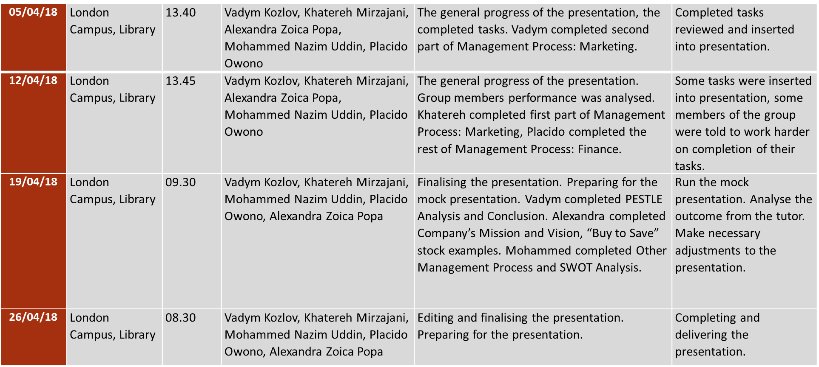
Figure 1: Group learning log

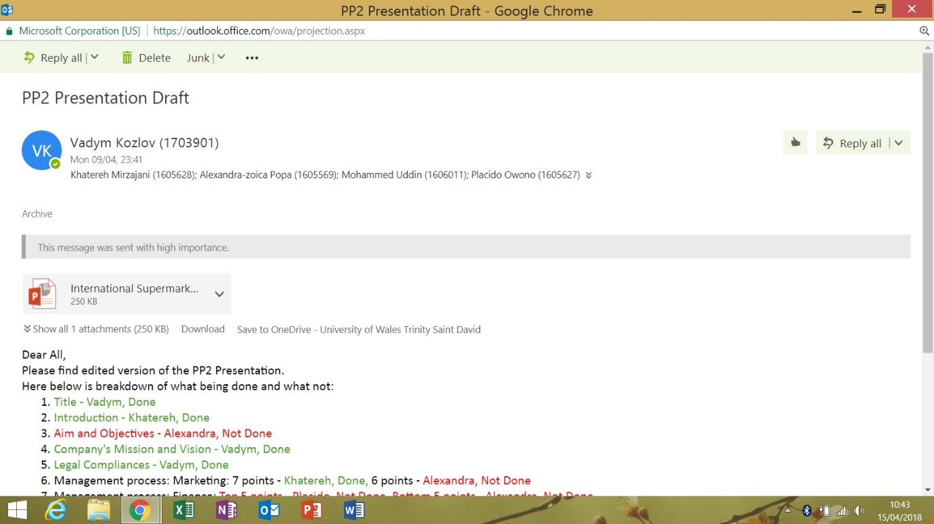
Figure 2: Internal group communication email
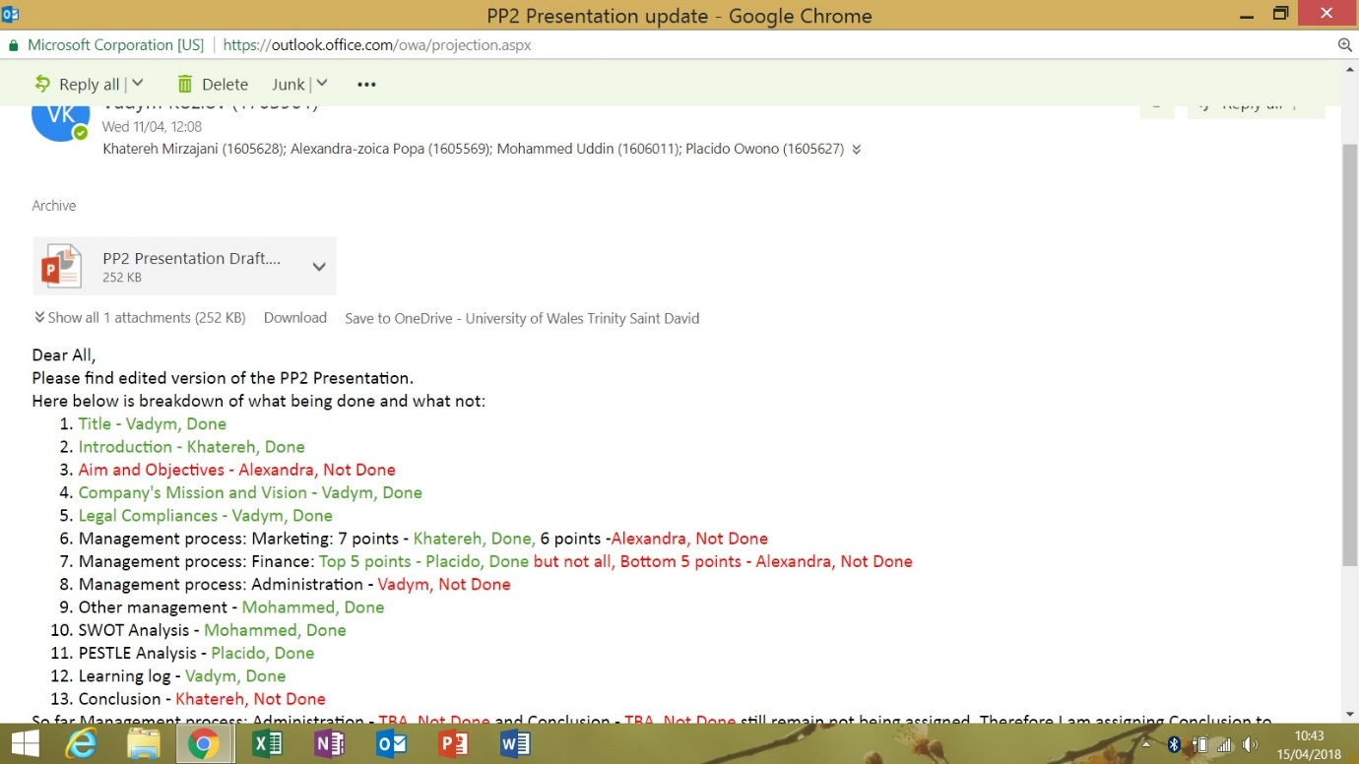
Figure 3: Internal group communication email

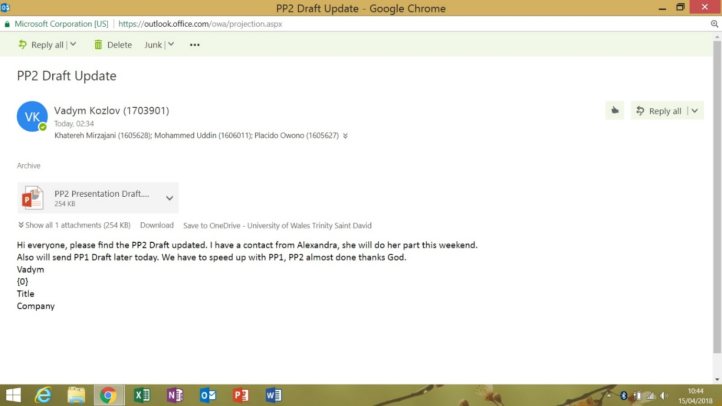
Figure 4: Internal group communication email

Figure 5: Internal group communication email

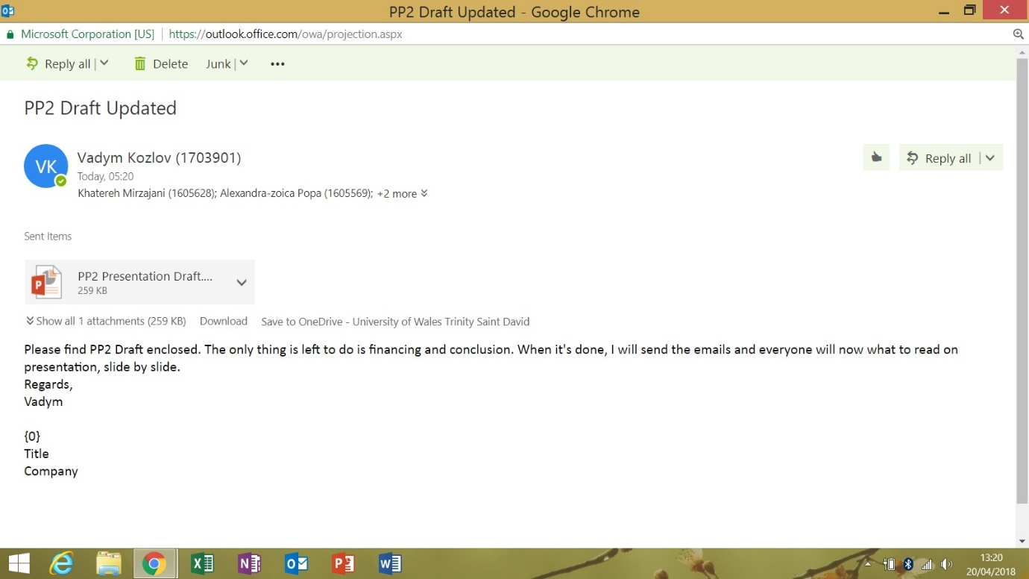
Figure 6: Internal group communication email
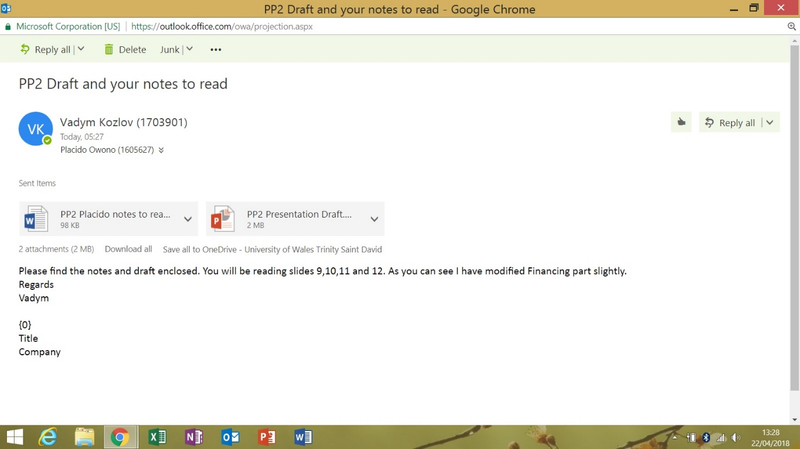
Figure 7: Internal group communication email

