

  - BA Business MANAGEMENT
  - Assignment 1
  - Module: Marketing Fundamentals
  - Code: LCBB4004
  - Lecturer: Tushara Balendran
  - Name: Elena Mihaela Bucur
  - Student ID:2133670

The Rise of Adidas

In the world of sportswear, Adidas is one of the most well-known and respected brands. The company manufactures apparel, footwear, and accessories for both sports and non-sporting occasions. Adidas now owns a slew of well-known brands, including Reebok, CCM, and Rockport, Taylor Made. Adidas has a market share of 20%, a brand value of $ 14.3 billion, and a market capital of $31.93 billion as of July 2022. The leading manufacturer of athletic apparel in both Europe and the globe, Adidas, categorises its customers into separate subgroups according to psychological, demographic, and behavioural criteria. Adidas, Reebok, Rockport, and Taylor made are the four brands that are part of the Adidas group. These brands serve a diverse variety of client demographics and preferences. Adidas' specific targeting approach is to reach students of all ages as well as children who have a keen interest in physical activity and sports. This is the company's primary market segmentation objective. Figure 1 shows the logo and creator of Adidas (Adidas, 2022).

Adidas AG is a manufacturer of athletic footwear, apparel, and accessories for athletes. At the turn of the 21st century, it was the most important manufacturer of athletic apparel in Europe (behind Nike). The iconic three-stripe design of Adidas is included into the "trefoil" and "mountain" insignia of the corporation. Herzogenaurach, Germany. The name Adolf "Adi" Dassler is shortened to form the brand name Adidas (Figure 2). After World War I, the Dassler family began producing shoes. At the 1936 Berlin Olympics, American sprinter Jesse Owens competed with a pair of shoes designed by Adi Dassler. The medals won by Owens helped increase Dassler's prominence on a worldwide scale. After World War II, Adi and his brother Rudolf ("Rudi") Dassler made attempts to revive the Dassler Corporation, but by 1948, their relationship had broken down beyond repair due to personal differences. Rudi's business evolved into Puma, while Adi's became Adidas (Anon., 2022).
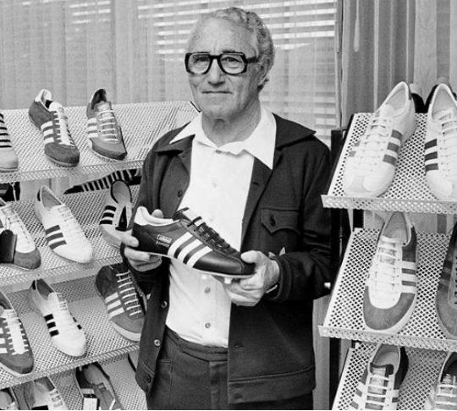
The sales growth and their net income growth is increasing day by day. According to the data provided by Global Data report the graphs are shown below;

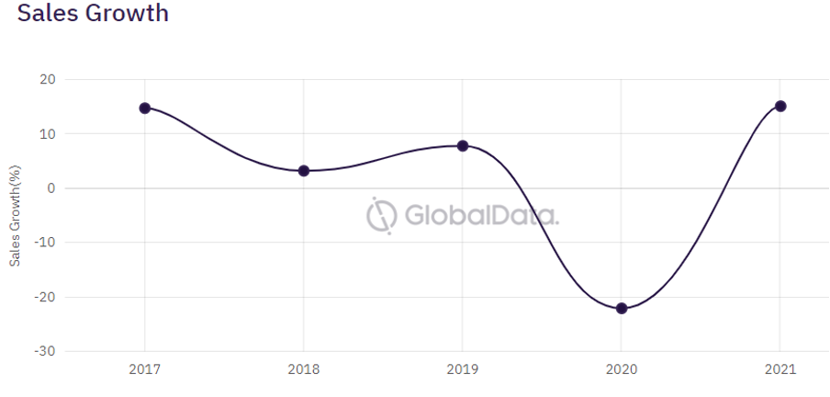
The graph shows that aside from the hurdle of 2020, the company has managed to maintain a steady growth in sales over the past few years.

Adidas: A whole range of possibilities
The product range offered by Adidas has more depth than it does width. The footwear, clothing, and accessories produced by Adidas all have a strong emphasis on fashion (sportswear). A diverse assortment of items, ranging in dimensions, hues, and other distinguishing characteristics, may be found within each of these product categories. Men's and women's clothing (jackets, shirts, jeans) come in many colours and sizes.
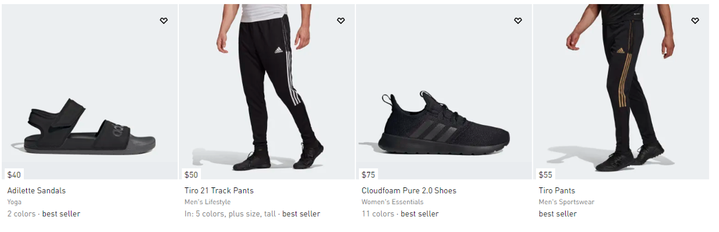

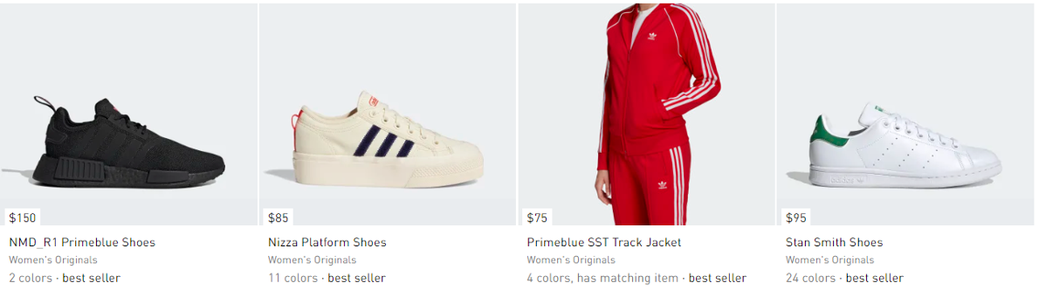
The high top and low top sneakers are some of the all-time fan favourites from the catalogue of Adidas that has revolutionised the footwear industry.
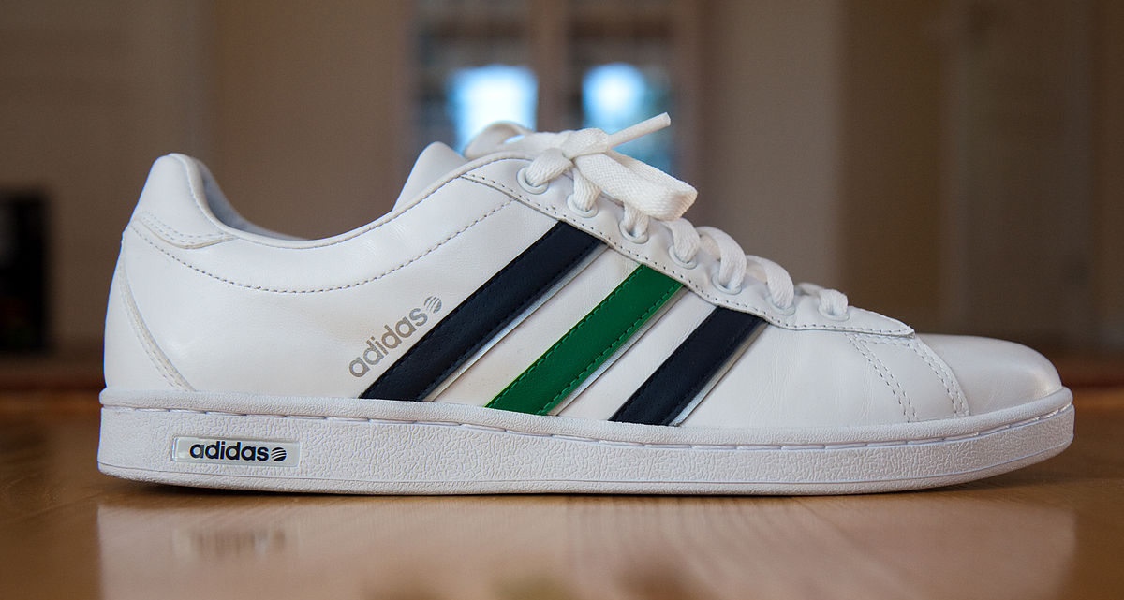

Is Adidas Overpriced: An in-depth look at the company’s pricing mechanism
Due to the fact that Adidas prioritises fashion, design, and promotions, the company offers attractive and reasonable price. In order to compete with Reebok, Nike, and Puma, Adidas offers basic items at prices that are competitive. Adidas undercuts competitors' costs on new and unique items. Because Adidas owns the brand in the clothing industry, their merchandise is always sold at inflated prices. Customers from the upper middle class and above are the kind of consumers Adidas seeks to attract. Penetrative pricing hurts Adidas' brand equity. Psychologically, people think a higher price means better quality. Adidas' prices rarely drop.
The soft version of Yeezy 500 which was Adidas’ answer to Nike Air Jordan 1 had started a mad rush over the product. However, with the progress of the time, Adidas realised that most of the buyers online were automated bots. This led to a great fiasco at the marketing dept of Adidas which prompted the use of sneaker bots embedded to each of the shoe.

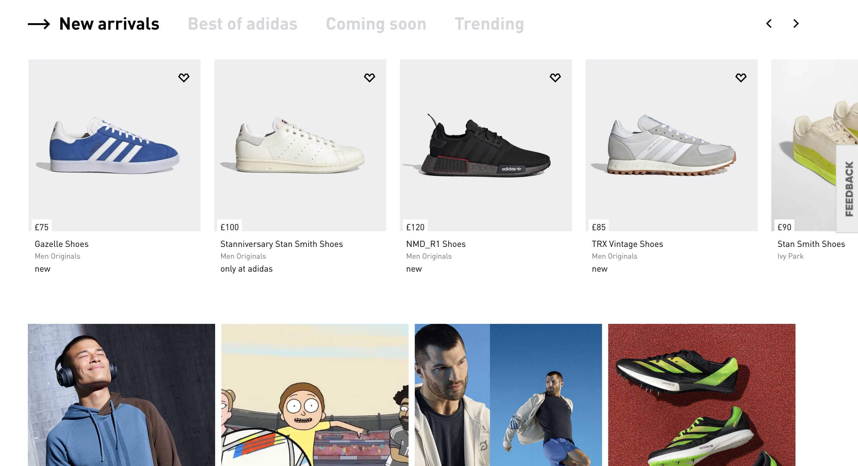
Another reason why Adidas may seem overpriced to a particular category of consumers is the presence of sneaker bots inside the laces of the shoes. This is also problematic for retailers since more sneaker bots mean less bandwidth for retailers as they cope with, increasing the size of packaging that befalls every pair of shoes.
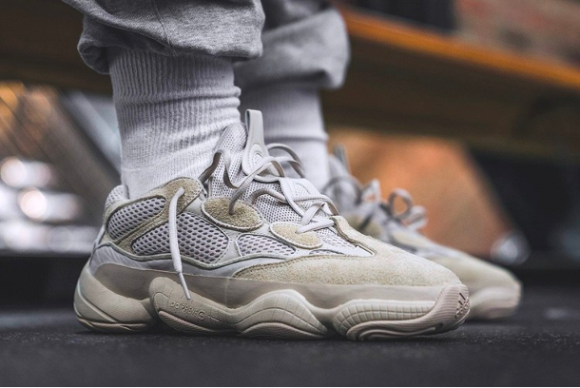
Adidas has however introduced many schemes for its customers including Loyalty fan club and Priority service.

How do we hear about Adidas so much!
Marketing for Adidas is done through broadcast as well as product placement. The creative team at Adidas is well-known for generating advertising that is not just well-made but also original and full of energy. Customers are drawn in by these advertisements because they provide the appropriate message about marketing. Product placement is the second marketing approach used by Adidas. The popularity of the brand may be attributed to the fact that it supports notable athletes like a number of other teams that are supported financially by Adidas. The following is a list of Adidas endorsements. Have below marketing efforts of Adidas include their participation in outdoor and event projects. In order to increase overall brand sales, Adidas provides its channel partners with sales discounts and trade promotions (Shah, 2021).
Adidas appears to have a well-thought-out strategy for digital marketing success, as seen by an examination of the company's present tactics.
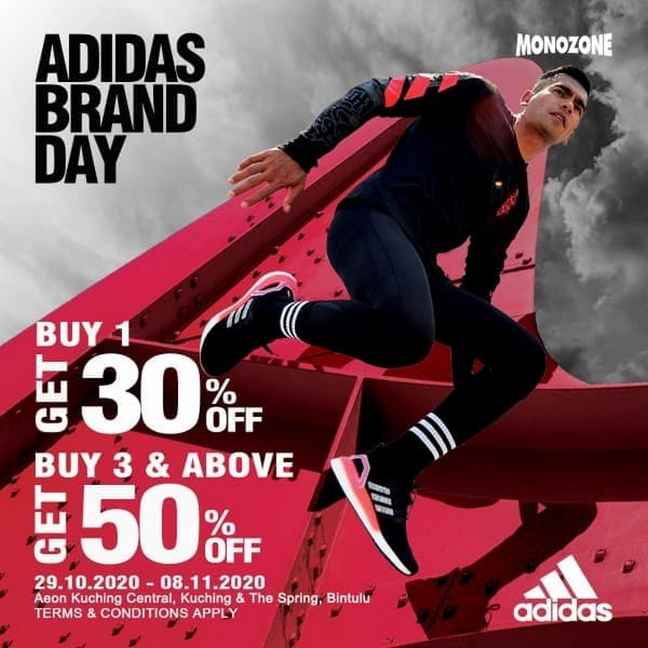
Mobile marketing campaigns can only be effectively evaluated by setting measurable targets in advance, which is why it's important for a firm to make clear and attainable objectives. It is compatible with the importance of imagery and design by adapting the advertising campaigns to mobile devices. In an effort to enhance the company on smart phones, Adidas creates relevant content, mobile applications, and a website that is optimised for mobile use. In addition, the use of geolocation settings is one of the most efficient methods for lowering the bounce rate since it restricts the delivery of advertising to just that which is relevant to the audience being targeted.
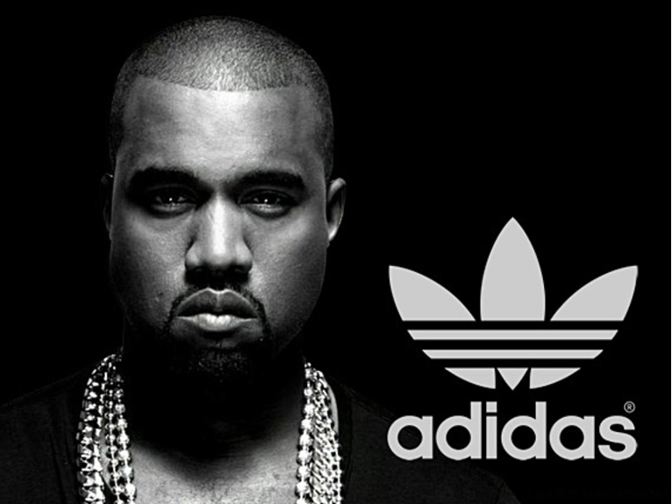
Advertisements that are tailored to a potential customer's preferences are sent by use of GPS and other location-based services like Local Inventory Ads. Adidas has had a lot of success experimenting with mobile devices. As an example, the company uses a variety of mobile phone characteristics to produce adverts that can be altered easily by users (Kotler and Armstrong, 2009).
So instead of showing customers a static image of a product in an ad that cannot be stopped, Adidas shows customers images that can be slowed down, fast-forwarded, sent, and more. By engaging its audience with intriguing content, the organisation builds buzz and, ultimately, sales. Fans of Adidas flocked to Kanye West's line of items in 2014, which included a number of collaborations with the brand (Bahsin, 2017).
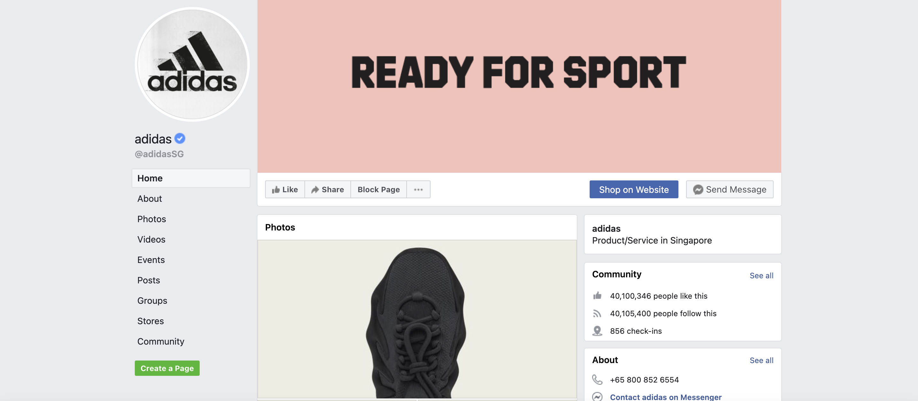
Figure 1: Adidas facebook (Adidas, 2022)

The new marketplace of Sportswear: An Adidas Case Study
The best sportswear brands have always had an advantage. For example, when it comes to putting together their marketing plans. An aggressive advertising campaign that targets both professional and amateur athletes is the best way to reach their intended market (Armstrong et al., 2017). As a result, businesses would be prudent to take note of the successful marketing strategies employed by well-known sportswear companies like Adidas.
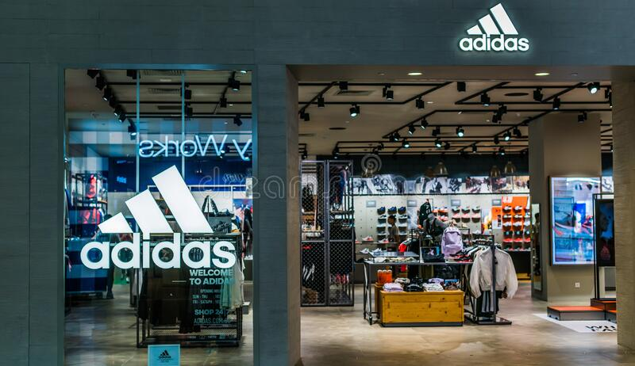
Adidas’ flagship stores around the world have quickly becomes one of the hotspots of footwear lovers and admirers from all over the world. However, with the turn of the covid 19 pandemic, the retail store business has taken a great hit, partly due to the high maintenance cost of operation as opposed to an all-time low sale.
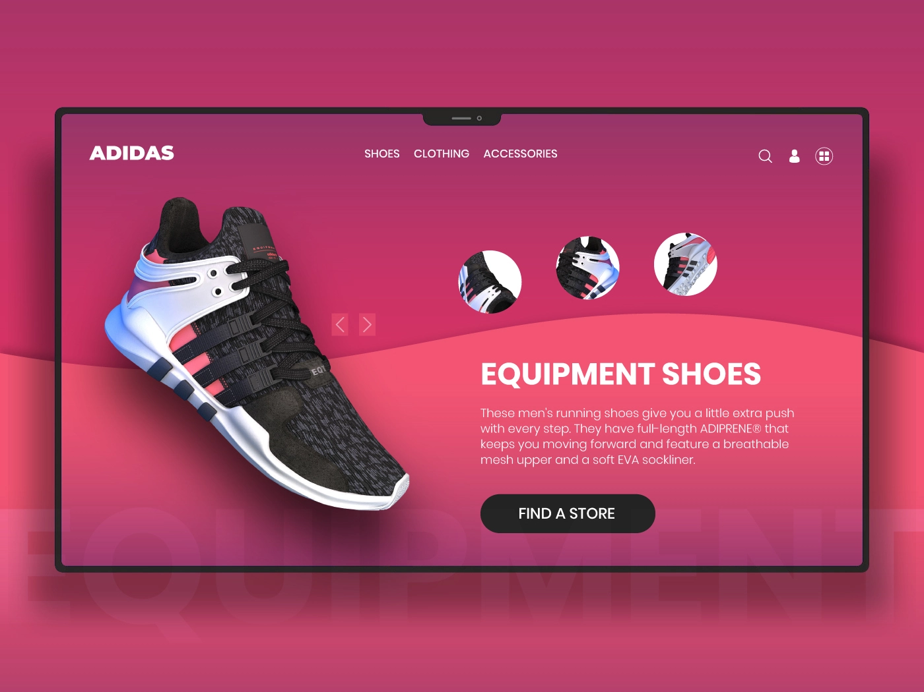
This has prompted the company to accelerate its position in the online retail marketplace. The company has made itself more accessible to customers through its own store portals and via 3rd party marketplaces like Amazon, eBay and Walmart.
Marketing provides organisations a competitive edge by attracting loyal customers. Businesses convince consumers that their product satisfies their wants and criteria consistently. As a result, the devoted customer stops looking at the competition. This is why global firms value marketing concepts so highly.
Adidas targets young adults, adults, and children who love fitness and sports. It targets customers ages 13-40, but most are 15-30 and upper middle class or wealthy. Adidas employs user & benefit-based positioning to build a distinct brand image. Adidas maintains its brand spirit by promoting excellent, trustworthy items.

The brand value of Adidas
"Impossible is Nothing" The company's most renowned tagline. This phrase, which promotes fitness and hard work, is one of Adidas' best assets and may sum up their marketing strategy.
Adidas has a competitive edge in terms of its supply chain, quality of products, and consumer perception of the Adidas brand. A total of $4.3 billion is generated from 2400 retail locations globally (2014 data). With the help of these sponsorships, it hopes to establish ties with the local population. Products from Adidas are renowned for being both pleasant to wear as well as long lasting (Akutina, 2014).

Since 2015, Adidas has used the term "creating the new" as part of its marketing campaign. The slogan now is "impossible is nothing." In order to achieve this goal, it is expanding its range of sportswear.
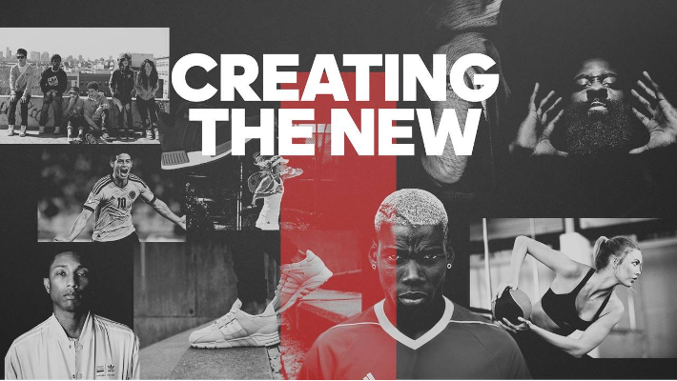
The fashions, points of view, and shopping patterns of customers in six of the world's most important cities have an impact on Adidas' target audience. This is a list of major cities that includes the following: Los Angeles, Hong Kong, Shanghai, New York, and Tokyo. Selling soccer gear is Adidas' principal goal in this country. Basketball or baseball are the primary products in New York or Los Angeles. If your company offers things abroad, it is imperative that you establish which items are most popular in each region. In addition, you want to make sure that your marketing plan fits the demands of customers all around the world.
Sportsmen and IT businesses have boosted Adidas' creativity. This includes branding and marketing. Consistent, collaborative marketing helped the brand connect with customers. By collaborating closely with elite athletes, Adidas can ensure marketing consistency. Adidas partners with athletes and celebrities. Music and fashion talents are involved. Adidas offers must-have designs for more than just athletes (Adidas, 2022).
Adidas' consumer base is dominated by upper- and upper-middle-class socioeconomic groups. To be successful in today's market, mass manufacturing and marketing are no longer adequate, as Adidas has publicly acknowledged. Adidas is one of the most successful sports organizations with respect to investments in digital marketing and managing smartphones and digital marketing. They only make sense to customers if they know what motivates them to engage in sport, what they do, where they do it (and where), and what kind of purchases they make.
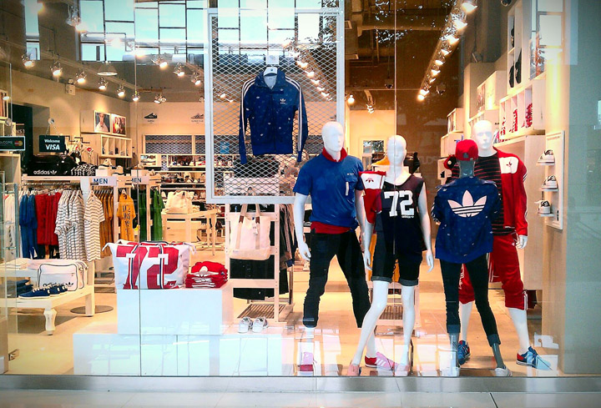
Figure 2: Adidas Display

Reference
Adidas, 2022. adidas. [Online]
Available at: https://www.adidas.co.uk/
[Accessed 10 7 2022].
Akutina, 2014. Digital-marketing as an integrated strategy of interaction with customers in the internet environment. Journal of Economics and Social Sciences, Volume 5.
Anon., 2022. Britannica. [Online]
Available at: https://www.britannica.com/topic/Adidas-AG
[Accessed 10 7 2022].
Armstrong, G., Adam, S., Denize, S. and Kotler, P., 2014. Principles of marketing. Pearson Australia.
Bahsin, H., 2017. Marketing91. [Online]
Available at: https://www.marketing91.com/marketing-strategy-of-adidas/
[Accessed 10 7 2022].
Facebook. 2022. You’re Temporarily Blocked. [online] Available at: <https://web.facebook.com/adidasSG/?_rdc=1&_rdr> [Accessed 30 July 2022].
Kelly, B., 2021. Peep Srategy. [Online]
Available at: https://peepstrategy.com/introduction-to-marketing-fundamentals/
[Accessed 10 7 2022].
Kotler, P. and Armstrong, G., 2013. Principles of Marketing (16th Global Edition).

