

Master of Business Administration
International Business

Module code: LCMB7014
Assignment title: Internationalization strategy of Toyota in the China market
Name – Nayankumar Bipinbhai Patel
Student I’d – 2243076
Lecturer – Dr Liyanage Sampath Rodrigo

Executive summary
The internationalization strategy of a business is generally considered as the expansion approach of a business in terms of import and export. This report will discuss the internationalization strategy of Toyota, which is one of the leading automobile companies in Japan. In the global market, Toyota is popular for being a good corporate citizen, and so it is trusted by all of its stakeholders. This allowed the business to expand its operation in financial services providing also. The entry strategy of Toyota in the Chinese auto market is quite successful, and they are known for establishing a more aggressive goal. Operating
business in foreign location requires a proper internationalisation approach.
The leader of Toyota company has been preferring polycentric approach. Through
thus approach it is better to maintain the balance between two countries. Pestle
analyse help to understand the external business scenario in China. Through fombrun IHRM strategy company has been localised their market strategy in China.

Table of Contents
1. Introduction 5
2. Background analysis 5
2.1 Overview of Toyota company 5
2.2 Operating history of this automobile company 6
2.3 Internationalization journey of Toyota 7
Value chain analysis for China 8
2.4 Key home country (Japan) and host country (China) operations of Toyota 8
3. Internationalization strategies 9
3.1 Critical analysis of the features and characteristics of internationalization strategies of Toyota 9
Ethnocentric – 10
Polycentric – 11
Geocentric – 11
3.2 Comparison and contrast of these approaches to identify the impact on global expansion of Toyota 12
4. Internationalization approach of Toyota 13
4.1 Critical analysis of the selected internationalization strategy and efforts of Toyota 13
4.2 Critically analyses of IHRM, International Marketing for polycentric approach which supports localized approach 14
4.3 Exploration of those factors that influence Polycentric strategic decision making of Toyota in Chinese Market 14
Cultural factors – 14
Clear Communication and transparency 15
Save cost of relocation – 15
5. PESTLE analysis 15
5.1 Identification and examination of PESTLE factors in the company’s decision-making process and foreign subsidiaries 15
5.2 Analysis of the company’s response to these factors for driving internationalization 17
6. Integration of contextual factors and internationalization strategy 19
6.1 Integration of the findings from PESTLE analysis with the internationalization strategy of Toyota 19
6.2 Impact of these contextual factors on strategy implementation 20
7. Recommendations for the company 21
8. Conclusion 22
Reference List 24
Appendix 28
Application of Value Chain analysis in China 28

1. Introduction
The internationalization approach allows a business to export and import its services to other countries while maintaining the head office operations in its home country (Panibratov, and Klishevich, 2020). Through the process of internationalization, a business becomes able to expand its operations beyond the domestic market and becomes eligible to establish a strong presence in the international market. The key focus of the business is to increase the market share of the company along with profitability and competitiveness while entering new markets through accessing resources and opportunities outside the organization's premises (Bai, et al., 2021). The strategic process of internationalization helps a business to adapt its product, focusing on a specific market easily. With the help of this strategy, any business can easily adapt the product to a chosen market (Wach, and Głodowska, 2021). Most importantly, this approach is used in business to make a product and service easily available in the host market and, at the same time, expand their operational activities.
Identification of the internationalization strategy of Toyota will help to measure its global operation strategy and its position in other international markets. In this report, a detailed background analysis of Toyota will be performed to analyse its journey from the beginning, followed by an analysis of the internationalization strategies of the company. A PESTLE analysis will be performed to examine the factors that impact the decision-making process for internationalization. The findings from the PESTLE analysis will be linked with the internationalization strategy of Toyota in China. Lastly, future opportunities for global expansion and potential challenges will also be discussed in this section.

2. Background analysis

2.1 Overview of Toyota company
Toyota is a renowned company in the automobile sector. With its operational efficiency, Toyota has gained international popularity and brand value. It is popular for designing, manufacturing and selling passenger cars, minivans, buses, speciality cars and trucks (Anoop, and Muhammed, 2020). It also provides recreational and sport-utility vehicles, which increases its demand in the market. Toyota is known for providing financing services to dealers and customers in case of purchasing any vehicle or giving the vehicle on lease. Not only that, Toyota also has hands-on housing services and telecommunication, which allows the business to reach a wide range of customer base. The information technology services provided by Toyota enhance its operational capability and brand value at the same time.
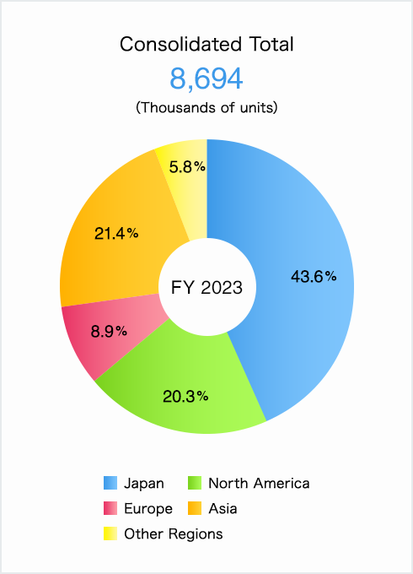
Figure 1: Financial performance
(Idea derived from source: Annual Report, 2022) https://www.sec.gov/Archives/edgar/data/1094517/000119312522179197/d696693d20f.htm]

2.2 Operating history of this automobile company
Toyota started its operation in 1937 in Japan by Kiichiro after getting the patent rights of his automatic loom. After four years of its establishment, Toyota started producing its passenger cars and later also manufactured the KB truck. In 1947, after the establishment of Toyota Auto Body Co., it produced more than 10,000 vehicles in Japan. Afterwards, it slowly expanded its business operations to other countries. Being an automobile manufacturer, Toyota always focused on the quality and durability of its cars, which helped it to become a world-famous manufacturer (Dave, 2020). Now, it is popularly known for manufacturing high-quality, high-value cars, vans and trucks, which has already set the standard for long-term value and durability.
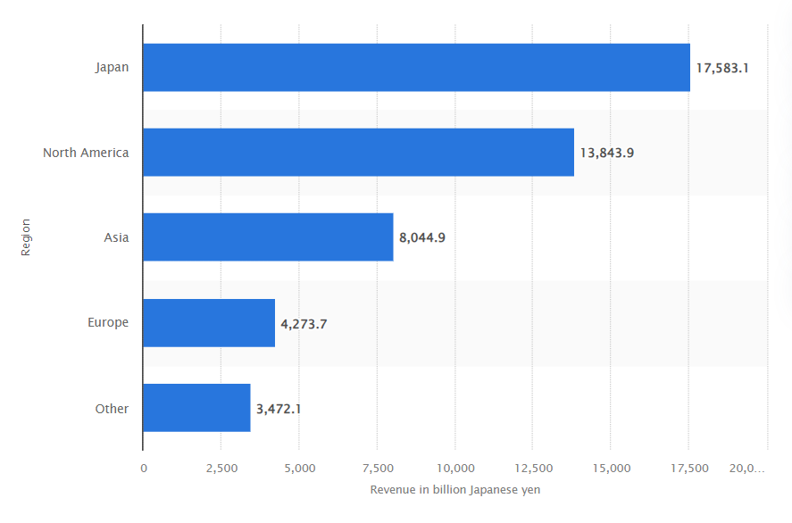
Figure 2: Toyota's revenue by region (in FY 2023)
(Idea derived from source: Annual Report, 2022)
https://www.sec.gov/Archives/edgar/data/1094517/000119312522179197/d696693d20f.htm]

2.3 Internationalization journey of Toyota
The internationalization strategy of a business allows it to gain global popularity. With the strategy internationalization approach, Toyota is not only able to gain a global customer base but also be able to make use of global raw materials, human resources operations, and technological advancements. It also helped the business to strategically make use of the unexplored fresh markets and its key advancements. After making successful operations in the Japanese market, Toyota started its international expansion, and for the first time, it produced its vehicles in Brazil besides its own plant.

Value chain analysis for China
Factors | Description
Primary activity
Inbound logistics | They used Just-in-Time approach for inbound logistical operations
Operations | It has established a reliable and long-lasting vehicle for their well-deigned moderated operational process
Outbound logistics | Toyota controls its vehicle distribution from the factory to all their global branches
Marketing and sales | It emphasizes on the product innovation and efficiency of the business while integrating the best practices of Japanese ways
Service | It provides reliability to the service delivery with qualified personnel ensuring all service option
Support activity
Firm infrastructure | Toyota uses management information system as the key strategic plan in China
Human resource management | It uses lean production system to use the workforce in much more productive and efficient manner
Technological development | Toyota combines with the forces with the collaborative safety to check the technological advancements of the vehicles
Procurement | Toyota used e-buying and outsourcing methods to manage its procurement activities in its China market
However, it continued its manufacturing subsidiaries and affiliates in Japan. Through this strategic expansion, Toyota manufactured Toyota and Lexus brand vehicles throughout the world and became one of the most popular vehicle manufacturing brands across the globe (Simon, and Simon, 2021). Being a global auto manufacturer's Chinese market is very important for Toyota, so it followed a strategic globalization approach to enter the Chinese market, which was phenomenal in the brand's history. At the time of internationalization in the Chinese market, due to the open economy, demand for automobiles increased, which Toyota used as an opportunity and use the technological gap of that market to ensure its sustainability.

2.4 Key home country (Japan) and host country (China) operations of Toyota
Japan market of Toyota corporation - Japan is the home market of Toyota, so it is well aware of the market situation and its demand. Considering the market demand in the Japanese market, Toyota focused on delivering high quality products, which became one of the key reasons for success in its home market. It is not only the largest car manufacturer in Japan but also in Asia.
Chinese market of Toyota Corporation - Through its Chinese market expansion, Toyota conquered another step in the global automotive market. The reason behind this expansion is the low-cost car market in China, and Toyota established almost three new factories to meet the market demand. As China is registered as the country with the highest economic growth, it has a very large expansion in the automotive market. Toyota made the most dynamic sale in the China market in 2006. As per Weng, (2021), in 2008, it sold more than 62% of cars in China, and the demand rate was so high that it needed to produce more than 450000-unit cars annually only for the Chinese market. As per Nkomo, (2019), Toyota has 7% market share in China market and more in other countries. Such strong market competition is beneficial for improving its operational competencies in the market. It is one of first Japanese multinational company which started its operation in the Chinese market. With the development of its strategic sales structure the business is able strengthen its logistics network in that market. Toyota adopted hybrid car strategy for its Chinese market which helped the to increase market share. But they are significantly impacted by World War II and the increased political tension between China and Japan increased operational challenges. Over the years these issues increased and labour unrest affected the business operation of Toyota in China.

3. Internationalization strategies

3.1 Critical analysis of the features and characteristics of internationalization strategies of Toyota
Internationalization strategy helps Toyota to expand its business in a foreign market. An appropriate internationalization strategy helps to correctly sell goods and services outside of the home country. There are many international strategies available from which a company needs to choose according to the business capability (Eduardsen and Marinova, 2020). The international market helps Toyota to explore new opportunities outside the home market. To grow the business, the leader always tries to explore new opportunities. A successful international strategy helps to focus on one point when exporting services and products around the global market. This strategy is often used when the leader decides to operate their business in a second market except the home market.
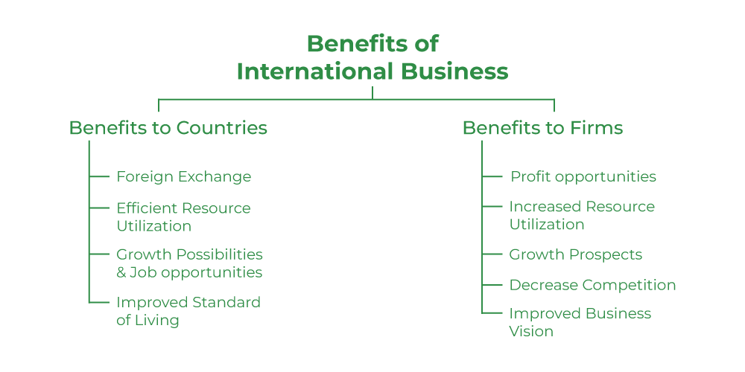
Figure 3: scope of business
(Idea derived from source: Weng, 2021)
Goggle link: https://www.jstage.jst.go.jp/article/jabes/28/0/28_essay2/_article/-char/ja/
When planning for Internationalization, the business leader needs of Toyota choose a mode of entry. As per the opinion of the author, O’Connor (2018), It helps to penetrate Toyota in a new market. The main advantage of using an international strategy is it helps to grow the market. For a small-scale company, it helps to provide all the possible growth options. The market share of the Toyota gets enhanced through this option. Toyota get global recognition through an internalization strategy. It has been noticed that three main approaches are followed by the business organization, which are discussed below.
Ethnocentric – this is the most cost-effective option for the business organization. Mainly, the IT industry prefers to use this option. In this approach, the business organization needs to involve their company staff in the most important position in the foreign market. Garrido et al (2021), claimed that the main benefit of using this approach is there is no need to follow the full-fledged international labor market. A parent company like Toyota’s staff helps clear out all the doubts to the host country. The communication process gets easier. The business leader gets high control over the subsidiary brand in the foreign location. This is an option where a hosting company can follow the culture decision. Toyota work culture easily gets transmitted through the trained and efficient staff in foreign locations (Shi, Graves and Barbera, 2019). The company's technical expertise is easier to share, which is today's main prime business operation.
Polycentric – Toyota, at the time of operating their business in a foreign location, need a proper workforce. In some cases, it has been noticed that the leader hires and recruit their member from the local market. According to, Lofthouse (2019), The polycentric approach is filling up the position from the local or foreign market. The company's leader can contract with the local recruitment agency or post their position in the local job portal. This approach is mainly used when a company can improve the local scenario. Mostly, this approach is used in developing or developing countries. Cause of the low wage, the company can get their staff whom they can educate and utilize for their business process. Toyota does not need to invest in the relocation of employees and also get support from the local community.
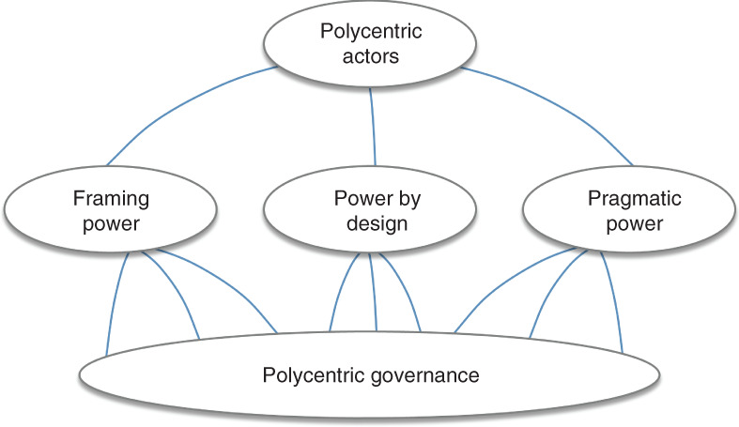
Figure 4: system of polycentric approach
(Idea derived from Source: O’Connor, 2018) https://pure.aber.ac.uk/portal/files/25348526/SOC_Final_Submission_PDF_1_.pdf
Geocentric – geographic approach refers to the recruitment procedure which indicates that the company needs to transfer or recruit employees within the same geographic location to fill the open position in business operation. The reason for using this approach is the cultural factors. Social factors and environmental factors remain the same (Buckley, 2018). An authentic site claimed that this approach helps regional and international companies like Toyota hire the best employees from nearby or neighboring countries. A similar culture helps to develop the work culture and enhance work integration. Companies that are more conscious about employees and their work culture follow this approach during internationalization.

3.2 Comparison and contrast of these approaches to identify the impact on global expansion of Toyota
Every approach has its advantages and disadvantages, which have a significant impact on the business process. It has been seen that initially, the business leader prefers to follow the first-mentioned approach. Cause it helps to save the cost of training and other essential operational activities. Standardization approach helps to well connected with the international market. According to, Kofman, Lee and Tse (2023), A trained employee’s manager all the necessary activity in the foreign location. In the IT sector, Standardization approach is still followed by many companies. Technical activities are an important part where a company needs to send their staff to manage the entire task to handle the client. However, those company does not have enough support and investment capital to use a polycentric approach. It helps to get support from the government of the country. Social and political factor is important for business, which is easily supported through this option. However, there are some drawbacks to the polycentric approach at the time of internalization cause the company needs to adjust to the host country’s policies (Magnani and Zucchella, 2019). The host companies or parent companies cannot implement the same strategy in the foreign market. In the polycentric approach, a company does not get the chance to do proper market research, which affects the decision-making procedure. It becomes difficult to control the subsidiary branch and implement strategy. The influential power of the leader decreased in foreign markets. In the case of the geocentric approach, it has been noticed that the manager maintained the workplace and considered the employee's benefits in a foreign location. As per, Tang and Buckley (2020), Building a strong relationship with the host country is important through Localization approach. Otherwise, geopolitical factors help to impact the business. In recent times, several geopolitical factors have reduced the business opportunity. Market saturation and fluctuation impact the market share. Before entering the market, geographical and political phenomena and relationships must be considered properly. Localization approach helps to maintai8n the same business rules which helps t increase stakeholder satisfaction.

4. Internationalization approach of Toyota

4.1 Critical analysis of the selected internationalization strategy and efforts of Toyota
The administrative body of Toyota has noticed that the Chinese market is enriched with recent technology. There is no shortage of skilled labour. So, it is easy to expand their business in this location. The Chinese market has a high demand for the automobile industry as a recognized brand; Toyata has been decided told follow a joint venture at the time of entering this market. If the administrative body has been relocating its staff to the Chinese location, it must invest a huge amount (Shi, Graves and Barbera, 2019). It is not a cost-effective business decision. So, the firm should follow a polycentric approach. Through the help of the polycentric approach, it is easy for them to build a good relationship with the government.
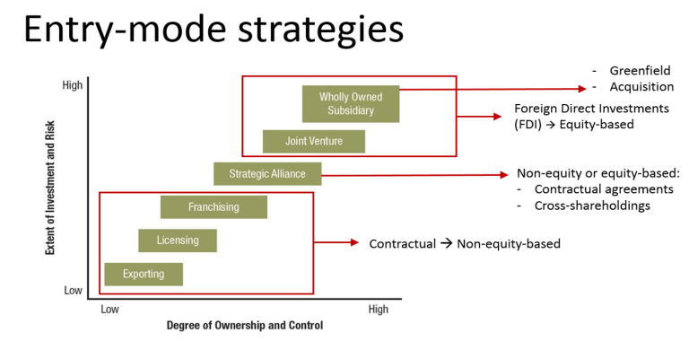
Figure 5: theory of internalization
(Idea derived from source: Buckley, 2018) https://link.springer.com/article/10.1007/s11575-017-0320-4

The Chinese government has announced that any automobile company to follow a joint venture strategy for this location. The Chinese government always consider their growth for a better geo-political position and market. As the administrative body of Toyota has been ready to follow this approach, it is not a big issue for them. The company's main target is to enter and explore the huge population. The company's market segmentation is appropriate for this location, which helps to get a good position within a year.

4.2 Critically analyses of IHRM, International Marketing for polycentric approach which supports localized approach
The IHRM of Toyota has been adopted fombrun approach which helps to build strong integration among the employees. The staff of the localized outlet has been following the instruction of the leader. Toyota has enormous benefits and facility for employees which helps to adopt the polycentric approach. Strict controlling and monitoring power of IHRM helps to work under polycentric approach. As the leader is starting to recruit staff from the Chinese market, it is easy to understand the choices and needs of the customer (Eduardsen and Marinova, 2020). The customer's financial capacity plays a huge role in buying a product. There is a huge difference between Chinese and Japanese culture. The managing director and IHRM of Toyota has realized that if they relocate their staff, it will be difficult for them to sustain and adopt the culture. Better to hire from this location, which helps to build a strong working community. When entering China, Toyota noticed that Chinese people were more concerned about safety measures. So, there are some modifications have been made to the car model and employee job security (Lofthouse, 2019). The leader decides quickly to improve the business performance in the foreign location. Cultural fit is a huge criterion for adopting this approach. Cause it is difficult to build a strong team in this region. The working pattern and culture are different from Japan.

4.3 Exploration of those factors that influence Polycentric strategic decision making of Toyota in Chinese Market
There are a few factors which help to motivate the leader to follow this approach. The joint venture is the only mode of entry to enter this market. But selection, of internationalization approach, is selected by the leaders. The main factors which influence the managing committee are discussed below,
Cultural factors – cultural dimension plays an important role in this segment. Cause the leader has been noticed from the cultural rank that happens in advance in many aspects and follows diffusion and assimilation. But Chinese government does not support the assimilation process. So, better to follow a polycentric approach (Eduardsen and Marinova, 2020). Local people as staff help to predict the market condition. The team member does not need to adjust to any other culture. Employee morale increased cause the same support and benefits were avail to the staff.
Clear Communication and transparency – as the leader, are start to follow joint venture, so before entering the market, the leader clarify all the strategic decision and policies with the government. So that they do not follow any problem. Transparency in the business process is very important, which can easily follow through a polycentric approach. Cause the same characteristics people are working at a place (Lofthouse, 2019). The leader can collect information from the local office, enhancing the business operation knowledge. The market-oriented decision gets smoother if the company can get a clear picture of the local market.
Save cost of relocation – the main factor of using the polycentric approach is it helps save the company's operational cost. There is no need to invest extra money for employee relocation and settlement. Lower manpower cost in the Chinese region is an extra benefit for the company. The leader is not required to form a specialized business operation for Chinese locations. Cause Chinese staff are very well mannered bds skilled.

5. PESTLE analysis

5.1 Identification and examination of PESTLE factors in the company’s decision-making process and foreign subsidiaries
Different external environment factors like political influences, economic scaling, social requirements, technological advancements, etc., impact Toyota’s decision-making for its internationalization. Different factors also impact the company's foreign subsidiaries operations. Such factors are like
Political Factors- Having political stability in the host country, China, is one of the crucial factors for Toyota’s investment in internationalization. Political instability leads to business disruption and risks (Allera, 2022). Different political factors regarding rules and regulations, trade regulations, emission and safety standards, foreign investments, etc in China impact Toyota’s decision-making. Regulations like auto policy in the China market emphasis that the automobile industry is one of the pillars of China's economic future, which influences Toyota's decision-making too. Navigating through various political environments in China, including several rules and foreign ownership regulations, joint venture requirements, etc., impacts Toyota’s market entry strategies and foreign subsidiaries.
Economic Factor- Different economic conditions such as currency exchange rates, changes in GDP, inflation rates, China's economic growth, consumer spending, etc., influence Toyota's competitive pricing strategies and investment strategies in the Chinese market. Economic downturns lead towards reduced customer spending and impact on the automobile industry. As per SODA (2022), economic factors impact majorly on Toyota’s profitability in their foreign subsidiaries. Economic stability in the China market also impacts sales volume, profitability and pricing of the company.
Social Factor- Understanding China's consumer preferences, cultural norms and domestic demands, lifestyle trends become much more important for Toyota in product design, development, marketing and branding in China (Ajami, 2020). Consumers have their own choices in the China market with other standard brands' presence too, where meeting with consumers changing preferences becomes a much influential factor for Toyota decision making. Foreign subsidiaries of the company in China are tailored towards aligning their products with local dynamics and provide offerings that vary across regions.
Technological Factor- China has advancements in technology like advanced electric vehicles, autonomous driving technology, Automation in supply chain processes, digital facilities etc, that require Toyota to adapt towards an enhanced product portfolio, process execution techniques and invest in enhanced research and development (Wang, 2022). Toyota's foreign subsidiaries in China also need to adjust to the pace of the rapidly evolving technological landscape, where they need to match up technologies to maintain a competitive advantage in the local market.
Environmental factors- China has environmental regulations that focus on sustainable business practices and have strict rules towards emission standards, green vehicle incentives and customer preference towards eco-friendly choices, influencing Toyota to develop products that meet the regulations and maintain sustainability initiatives. As per SODA (2022), Toyota also needs to maintain business practices that meet with sustainability actions with lean manufacturing and maintain their sustainability in supply chain processes. Toyota's foreign subsidiaries in the China market had to align with the country's standards towards the environment, where Toyota need to focus towards adapting towards green manufacturing practices, reducing waste generation and producing eco-friendly vehicles (Overholt, 2023).
Legal Factors- China has strict rules and regulations regarding security, data security, emission standards, safety measures, cultural selectivity of contents and intellectual property, which is paramount in the country for successful business operations. Non-compliance with the regulations leads towards legal consequences and develops a negative market impact on brand (Nibe, Nakamura and Yamaguchi, 2022). Toyota had to adhere towards this regulatory need for establishing their successful operations in the China market, where these factors deeply influence the company’s decision-making. Toyota's Foreign subsidiaries in the Chinese market had to navigate complex legal factors and ensure that their operations complied with local standards and national regulations.
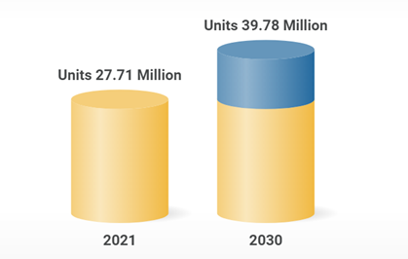
Figure 6: China Automobile Market
(Source: springer.com, 2023)

5.2 Analysis of the company’s response to these factors for driving internationalization
China had to face several factors in the Chinese market where the company has to adopt different multifaceted approaches and strategies for addressing the influential factors for their successful internationalization in the Chinese market where the different approaches of the company are like
Government relations- Toyota maintains established and smoother constructive relationships with the Chinese government authorities while keeping abreast of changing government rules and policies, like meeting with auto policy (Tang, 2023). The company tries to adhere to different legal regulations like sustainability approaches, data privacy rules, emission rules, etc, including forming joint ventures in the Chinese market with companies like FAW, GAIG, etc., which is a requirement for the Chinese law (Overholt, 2023).
Local partnership- The company Toyota focus towards collaborating with local partners in the China market, which helps them in navigating the Chinese political landscape and providing understanding and knowledge towards cultural nuance for the company. Joint ventures help Toyota develop local preferences and effectively access local market information and resources (Ajami, 2020).
Market adaptation- Toyota focuses towards developing products that meet market demands in China, where the company focus towards developing customizable product offerings that suit consumer choices in the Chinese market, like launching electric vehicles, car models with extended seat legroom etc, which meet local consumer preference for rear seat comfort (Wang, 2022). This also provides a competitive advantage for the company in the market. Toyota has also bought just in time (JIT) concept in their production to maintain strict requirements of the suppliers like AISIN, DANSO etc in the market with the cost, quality and delivery factors.
Technological investment- Toyota invests in advanced technologies in their processes and research and development centres in the China market to gain better market information that helps the company know about the latest market trends and demands (Allera, 2022). This approach helps the company stay competitive in the technological market with cars like electric vehicles, automated driving technologies, etc. Toyota also gains access towards cutting-edge technologies with this approach.
Geographical and environmental commitments- Toyota has focused towards expanding its businesses in China, covering the coastline where the market has been relatively lucrative, which has helped the company gain better profits and supplier advantages. Toyota has also matched up with the environmental regulations of the country, where different environmental initiatives by the company have helped them meet China's strict standards (Cha, 2023). The company's approach towards JIT and waste management by developing products with hybrid and electric vehicles in the local market to comply with emission regulations has helped them gain government incentives.

6. Integration of contextual factors and internationalization strategy

6.1 Integration of the findings from PESTLE analysis with the internationalization strategy of Toyota
Integrating the factors that have emerged from the PESTEL analysis with Toyota's chosen internationalization strategy of the joint venture has provided many valuable insights into the company's developed strategies and approaches for navigating the complex Chinese market. As per Shih (2020), Toyota has focused towards internationalization in the Chinese market with a combined approach of polycentric and geocentric strategy, which has been influenced by the company's different external factors, like
Political stability in the China market is one of the crucial factors for Toyota's investments in the China market. Toyota has formed joint ventures with local Chinese companies like FAM and GIGA etc, forming Tianjin FAW Toyota Motors and Guangzhou Toyota Motors, which aligns with the company Toyota's polycentrism (Overholt, 2023). This has allowed the company to meet Chinese regulations of auto policy and meet the mandate of doing joint ventures in the market and automotive sector while gaining local knowledge and relationship benefits.
The rapid growth of the chain economy has presented an opportunity for the Toyota company. The currency fluctuations and pricing pressure has created a challenge with pricing strategy and product decisions where meeting with the factors has encouraged Toyota to adapt towards localization production and develop customized products with tailored pricing with economic conditions for catering to different economic segments in the market with their polycentric approach (Cha, 2023).
Having an understanding towards social demand and Chinese consumer preference in the market is one of the crucial factors where Toyota focused towards product design and tailored marketing approach that meet with the Chinese market and local preferences while reflecting their polycentric approach to ensuring consistency in their quality and global brand identity (Nibe, Nakamura and Yamaguchi, 2022).
China has advanced in technology, specifically electric vehicles, influencing Toyota's product portfolio. The company has leveraged local technologies with joint ventures, which aligns with its polycentric approach. As per Liou (2022), Toyota's geocentric approach has encouraged the company to invest towards local research and development using Chinese technologies to stay competitive in the changing market.
The environmental regulations and policies have encouraged Toyota to emphasis eco-friendly processes and adapt towards green manufacturing practices in the Chinese market. As per Shih (2020), The geocentric approach of the company emphasized aligning with global sustainability initiatives and adapting towards developing products with local market needs.
The legal factors and compliance with regulations like meeting sustainability rules and developing joint ventures were crucial for Toyota. Toyota has formed joint ventures with local partners to meet legal requirements, reflecting Toyota's polycentric approach (Dăianu and Abrudan, 2020). The company's geocentric approach also emphasizes harmonizing with global standards and quality demands.

6.2 Impact of these contextual factors on strategy implementation
The contextual factors of PESTEL have their influence and significantly impacted shaping Toyota's strategy in the China automobile market.
Political factors The Chinese government's emphasis towards joint ventures were one of the major factors which have compelled Toyota to develop a partnership with local companies where such political requirement has impacted Toyota's market entry strategy, company management structure and partnership approach (Chernyshenko, Vertakova and Mkrttchian, 2020). Refer to Figure 2 Toyota Motors Corporation joint venture has developed Tianjin FAW Toyota Motor(TFTM) where the body manufacturing affiliation company has been restructured to Sichuan FAW Toyota Motor Co and engine designing companies has afflicted to Tianjin FAW Toyota Engine (TFTE) and FAW Toyota Changchun Engine (FTCE)
Economic growth of the China market with the emergence of middle-class consumer demand in the automobile sector has influenced Toyota's pricing strategy and diversification of its product portfolio. Toyota has aimed to access different economic segments by offering economic diversity in the market.
Changing the preferences of Chinese consumers was vital in influencing Toyota's strategies, where Toyota has shaped its product designs, marketing approach and branding to ensure a meeting with local market preference (Dăianu and Abrudan, 2020).
Sharing basic technologies with Chinese joint ventures and leveraging advanced technologies in the China market by Toyota has profoundly impacted their strategies and approach with technology transfer, introduction of JIT and enhanced R&D in China.
Compliance with regulation and mandatory joint ventures has shaped the company's legal and operational strategies. Toyota has formed Joint ventures and meets with legal constraints with eco-friendly production and other adherence (Tang, 2023).
The environmental factors and policies in the Chinese market have shaped Toyota's strategies too, where meeting the regulations has developed strategies sin the company towards developing electric and eco-friendly vehicles, adapting green manufacturing practices, etc., with participating in global sustainability initiatives (Tošović-Stevanović and Bajković, 2019).
Different factors have their pivotal role in Toyota's market entry, growth in the China market and adaptation to different approaches in the China automobile market.
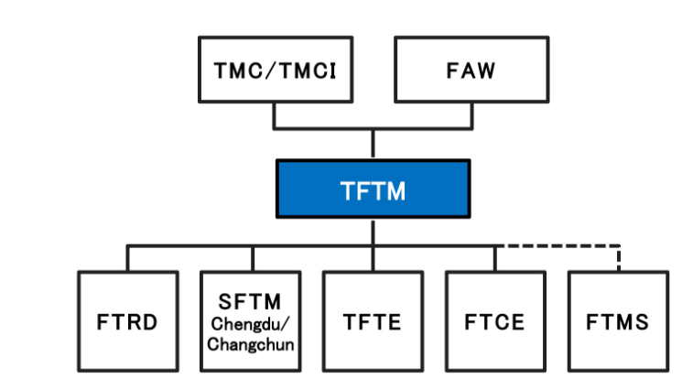
Figure 7: Toyota and FAW joint venture restructured company management system
(Source: igi-global.com, 2020)

7. Recommendations for the company
On the basis of the above analysis of the internationalization strategy of Toyota Corporations, some recommendations are provided. It can help the business to improve its future internationalization exposures, and these suggested strategies will help to mitigate potential challenges in future.
Managing market threats - the management of Toyota Corporation must be conscious of the threats that exist in the operating market. It is essential for a business to identify the threats to the market and the automobile industry large number of threats exist in the market. In the Chinese market, multiple local and foreign manufacturers offer similar products, which is challenging for Toyota, and to sustain itself in the market, it needs to upgrade its service and product qualities. This will help them to stay one step ahead in the competition and beat the coming challenges.
Identification of cultural differences - Being an international brand, focusing on the culture of each country becomes essential. For example, China has a unique culture which is significantly different from Japan, which automatically imposes a threat to Toyota. So, for other markets, Toyota also needs to be sensitive about the market opportunities and its culture, which can be gained from in-depth market analysis. Being aware of the target market will help to identify the needs of its customers so that they will be able to make products according to that. It will further help the business to meet market demand and increase its market share. On the other hand, the inability to understand the local culture and tradition might have serious consequences for the business.
Managing political challenges - Political aggression can damage the business operation of a firm, and these impacts are large in the case of international market expansion. The political situation of a country has direct control over the businesses operating in those countries. The government policies and the economic reforms of the Chinese market are completely different from Japan. So Toyota needs to focus on those reforms which are in favour of local businesses and develop their operating strategies in that market to avoid serious threats from those firms. Close monitoring and analysis of the government policies and political situation of the target country can help Toyota gain a competitive advantage in future operations.

8. Conclusion
Toyota has changed its internationalization strategy with time according to the market demand. These changes have helped the company to successfully work with the local governments and develop their strategy as per market demand. During its operation, Toyota adopted a Global strategy while taking advantage of the available opportunities in the global market. But at the same time, it focused on the characteristics of the current market. In its internationalization approach, Toyota adopted the slogan of thinking Global and acting global, which employees that the business focuses on the local market requirements even in cases of international expansion. This has helped Toyota to achieve large-scale success and meet the demand of local consumers like no other competitors. The success of Toyota in both the Japanese market and Chinese Markets because of its focus on providing high quality products and being perfect in the innovation of new generation Automotive Technology. Please approach always to attract new generation consumers and also support environmental changes. The development of hybrid system cars reflects the rising bar of the company and also displays the environment-focused approach of Toyota. After being successful in the home country market, Toyota focused on entering the internationally growing market through its internationalization strategy, which helped the business to achieve massive success in China. The Chinese expansion of Toyota played a major role in the Global success of the company and allowed it to conquer the market with low-cost cars. The large population is the key target of Toyota and became the prime reason for expanding in the China market. After its success in the Chinese market, it can be seen that the global economic crisis was not able to impact Toyota at a massive rate as compared to other successful multinational companies in the automotive industry.

Reference List
Ajami, R.A., (2020). US-China trade war: The spillover effect. Journal of Asia-Pacific Business, 21(1), pp.1-3.
Allera, G., (2022). Similarities and differences of entry strategies of international automotive companies in host developed and developing countries: the case of Toyota in the USA, the UK, Indonesia, and China
Annual Report (2022) www.sec.gov.
Anoop, G.M. and Muhammed, V.S., (2020). A Brief Overview on Toyota Production System (TPS). International Journal for Research in Applied Science and Engineering Technology, 8(5), pp.2505-2509.
Bai, W., Johanson, M., Oliveira, L. and Ratajczak-Mrozek, M., (2021). The role of business and social networks in the effectual internationalization: Insights from emerging market SMEs. Journal of Business Research, 129, pp.96-109.
Buckley, P.J., (2018). Internalisation theory and outward direct investment by emerging market multinationals. Management International Review, 58(2), pp.195-224.
Cha, V., (2023). How to stop Chinese coercion: The case for collective resilience. Foreign Aff., 102, p.89.
Chernyshenko, V., Vertakova, Y. and Mkrttchian, V., (2020). Development and Implementation of Adaptive Trade Policy in the Era of Digital Globalization Based on Virtual Exchange of Intellectual Knowledge. In Avatar-Based Models, Tools, and Innovation in the Digital Economy (pp. 131-140). IGI Global.
Dăianu, D.C.D. and Abrudan, D., (2020). CORPORATIONS AND ENVIRONMENTAL ISSUES. Anale. Seria Stiinte Economice. Timisoara, 25, pp.25-33.
Dave, P.Y., (2020). The history of lean manufacturing by the view of Toyota-Ford. International Journal of Scientific & Engineering Research, 11(8), pp.1598-1602.
Eduardsen, J. and Marinova, S., (2020). Internationalisation and risk: Literature review, integrative framework and research agenda. International Business Review, 29(3), p.101688.
Garrido, I., Vasconcellos, S., Faccin, K., Monticelli, J.M. and Carpenedo, C., (2021). The moderating role of polycentric institutions in the relationship between effectuation/causation logics and corporate entrepreneur's decision‐making processes. Global Strategy Journal, 11(4), pp.740-766.
Kofman, E., Lee, M. and Tse, T., (2023). China and the internationalisation of the sociology of contemporary work and employment. Work, employment and society, 37(4), pp.1070-1086.
Liou, T.H., (2022). The Romance of Three Economic Blocs: EU-China Economic Relations Evolving in an Era of Uncertainty. In Middle-Power Responses to China’s BRI and America’s Indo-Pacific Strategy (pp. 53-72). Emerald Publishing Limited.
Lofthouse, J., (2019). Self-Governance, Polycentricity, and Environmental Policy. Available at SSRN 3503918.
Magnani, G. and Zucchella, A., (2019). Coping with uncertainty in the internationalisation strategy: An exploratory study on entrepreneurial firms. International Marketing Review, 36(1), pp.131-163.
Nibe, N., Nakamura, M. and Yamaguchi, H. eds., (2022). Toyota City in Transition: A Motor Town Facing Globalization and Social Changes. Springer.
Nkomo, T., (2019). Analysis of Toyota Motor Corporation.
O’Connor, S. (2018). Problematising strategic internationalisation: tensions and conflicts between international student recruitment and integration policy in Ireland. Globalisation, Societies and Education, 16(3), 339-352.
Overholt, W.H., (2023). Development and security in the twenty-first century: China and America. China International Strategy Review, pp.1-13.
Overholt, W.H., (2023). Development and security in the twenty-first
Panibratov, A. and Klishevich, D., (2020). Dynamic capabilities during the internationalization of MNCs from post-socialist emerging markets. Multinational Business Review, 28(3), pp.307-331.
Shi, H.X., Graves, C. and Barbera, F., (2019). Intergenerational succession and internationalisation strategy of family SMEs: Evidence from China. Long Range Planning, 52(4), p.101838.
Shih, W., (2020). Is it time to rethink globalized supply chains?. MIT Sloan Management Review, 61(4), pp.1-3.
Simon, H. and Simon, H., (2021). Eastern Journeys: From Japan to the Edge of the World. Many Worlds, One Life: A Remarkable Journey from Farmhouse to the Global Stage, pp.111-126.
SODA, S., (2022). Modern Asia and Environmental Issues: Diversity and Dynamism Edited by Tomoyo TOYOTA, Yasuhiro HAMADA, Yuji FUKUHARA, Shintaro YOSHIMURA, Tokyo, Kadenshya, 2020. Asia-Japan Research Academic Bulletin, 3, pp.3-0.
Tang, Q., (2023). Basic Characteristics and Strategic Insights of “Going Out” from a Historical Perspective—Comparing Current Trends in China with Japan’s Experience. In Strategies for Chinese Enterprises Going Global (pp. 19-38). Singapore: Springer Nature Singapore.
Tang, R.W. and Buckley, P.J., (2020). Host country risk and foreign ownership strategy: Meta-analysis and theory on the moderating role of home country institutions. International Business Review, 29(4), p.101666.
Tošović-Stevanović, A. and Bajković, S., (2019). THE INFLUENCE OF CULTURE ON THE OPERATIONS OF MULTINATIONAL COMPANIES. Annales Universitatis Apulensis: Series Oeconomica, 21(1), pp.85-93.
Wach, K. and Głodowska, A., (2021). How do demographics and basic traits of an entrepreneur impact the internationalization of firms?. Oeconomia Copernicana, 12(2), pp.399-424.
Wang, Y., (2022). How Do Companies Effectively Manage Their Operations and Co-Ordinate Production Across Borders? in the Case of Toyota. Industrial Engineering and Innovation Management, 5(1), pp.10-14.
Weng, X., (2021). Towards business resilience against business crisis in China, Japan, and South Korea by stage model comparative case study on Sanlu, Toyota, and Samsung. Journal of Japan Society for Business Ethics Study, 28, pp.209-224.

‌

Appendix

Application of Value Chain analysis in China


