Leoni Lewis

Application Development ACCA5012

Contents
Introduction 2
Application Development Concepts 2
Cross-Site Scripting(XSS) 2
SQL Injections 2
Broken Authentication and Session Management 2
Keeping software up-to-date 2
Enforce a strong password policy 2
Encryption within login pages 2
Secure hosting 2
Backing up data 3
Security scans 3
Software Design Patterns 3
Requirements 3
Purpose 3
Intended Audience and Intended Use 3
Scope 4
User Needs 4
Design 4
Implementation 4
Home 4
About 5
Students 5
Courses 7
Instructors 7
Departments 8
Evaluation 8
Software verification 8
Evaluation and Improvements 11
References 12

Introduction
Contained within this report is a discussion of my research into application development concepts relevant to the application software I have implemented. Also within the report is relevant documentation of my application development activities.

Application Development Concepts
Even the most experienced web security experts must stay aware for professionals who may target their web application when they least expect it. It is important to know what to look out for here are some of the most common security vulnerabilities:

Cross-Site Scripting(XSS)
XSS is one of the most popular application attacks, the attack targets scripts embedded within a page/page(s) that are executed on the user’s web browser. XSS targeting the internet security weaknesses of client-side scripting languages by manipulating these scripts within web applications to execute in the way they wish. This manipulated code can then be embedded so that every time the page is loaded, or an event is performed it is carried out. The result can be remote browser control, tampered data or sensitive data theft.

SQL Injections
An SQL injection is a type of web application security vulnerability where a person attempts to use code to access or remove database content. If the individual manages to perform SQL injection successfully they can create, read, alter or remove data stored within the database. [1]

Broken Authentication and Session Management
Broken authentication and session management can cause multiple security issues to arise, these issues are associated with maintaining the identity of a user/users. If authentication and session identifiers are compromised at any time an individual can take over an active session and take over the identity of a user.
To improve a web applications security there are basic procedures to follow these include:

Keeping software up-to-date
It is important to keep all platforms and/or scripts up-to-date, when software isn’t kept up-to-date individuals will target security flaws within popular web software programs that are due/need to be updated to patch security flaws, because of this it is important to maintain and update every piece of software implemented.

Enforce a strong password policy
It is important to ensure strong passwords are used, if not individuals will use advanced software that use brute force to decipher passwords. To prevent this, passwords should be complex containing a mixture of upper and lowercase letters, numbers and special characters. Passwords should also be a minimum of 8 characters long.

Encryption within login pages
SSL encryption should be placed within all login pages, SSL ensures that sensitive information is transmitted securely. Information entered on SSL encrypted pages is encrypted so that if anybody was to attempt to intercept it the information would be meaningless.

Secure hosting
Ensuring that a secure and notable hosting company is chosen is paramount, the host should be aware of the most common threats and should be dedicated to keeping the website application secure. Hosts should also ensure data is backed up to a remote server for restoration purposes if an attack was to occur.

Backing up data
Website data should be backed up regularly, website files should be backed up in case of inaccessibility or data loss. Content management software is available which can be set-up to automatically back up websites.

Security scans
Regular web security scans should be performed to identify any vulnerabilities. These could be performed on a schedule as well as after any change or addition to the website. Ensuring professional scans are performed ensure that a review and explanation of the vulnerabilities is provided.

Software Design Patterns
Design patterns are repeatable solutions to common occurring problems within software design. A design pattern is a template that can be followed in order to solve a problem within different situations. Design patterns are able to provide developers with tested and effective design models which can be used when considering issues that may not arise until implementation has progressed. Design patterns can prevent small issues from turning into larger problems.
The abstract factory pattern provides an interface for creating families of related objects without having to specify their concrete classes. The factory object is responsible for creating objects within the whole program, users don’t create objects themselves they simply ask the factory to do it for them.
There are both advantages and disadvantages of the abstract factory pattern, it removes the creation of objects from the user that needs them allowing the user to only access them through the interface making manipulation easier. The class is made up of a concrete factory which can only be seen within the code which makes exchanging product families simpler. The pattern also makes it easy to use objects created from one family at a time. However, adding new products to an already existing factory can be hard due to the interface using a fixed set of products.

Requirements
The web application I have created is a university application which allows a user to view, create, edit and remove students, courses, instructors and departments. The target audience of this web application is universities, schools or tutoring services which want to have a system where they can input data stated above.

Purpose
The purpose of the web application is to provide universities, schools or colleges with a web application to manage student, instructor, course and department information.

Intended Audience and Intended Use
The intended audience of the application is staff members within said universities, schools or colleges who need to access, edit, remove or create data held within the web application. The intended use of the web application is for individual users (members of staff) to input student, staff and course information which can then be held, viewed, updated, removed and created. From here users can then see how students are performing within their studies, see which instructors are teaching which courses and see how much money departments are being provided with

Scope
The web application will provide users with all the functionality needed to create, view, edit and delete data inputted. The objective of the web application is to provide colleges, universities and schools with hub of information for their institutions.

User Needs
Users should be able to navigate the web application with ease, all information held within the web application should be easily identifiable and labelled correctly.

Design
Web applications that lack proper design can perform poorly and prevent users from using the application to its full potential. To ensure the web application is engaging, useful and memorable for users I have ensured to research and implement several design principles, these include:
Purpose: I have catered to the needs of the user by creating paged that have clear purposes and fulfil the needs of the user in the most effective way possible.
Communication: I have communicated clearly and ensured the information within my web application is easy to read and flow. I have organised my information using headlines, sub headlines and clear navigation.
Typefaces: I have ensured that my font size is large enough and type of font used is clear to read. The font size and type are also used across all pages to streamline the web application.
Colours: I have used complementary colours to create balance and harmony in order to enhance the users experience, I’ve ensured colours for text and background are contrasting to make reading easier for the user. I’ve made use of white space to ensure the web application looks uncluttered.
Navigation: I’ve implemented a navigation drop down which features a logical page hierarchy with clickable buttons, I’ve made use of the ‘three click rule’ where users can find the information they are looking for within three clicks.

Implementation

Home

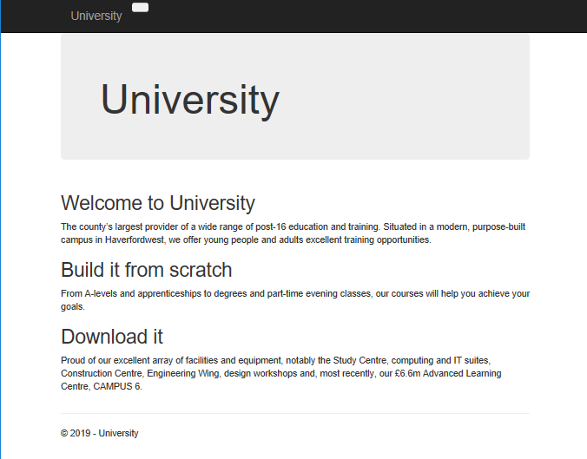
The home page of the web application features a navigation bar with a drop-down feature implemented to allow users to navigate to the corresponding pages.

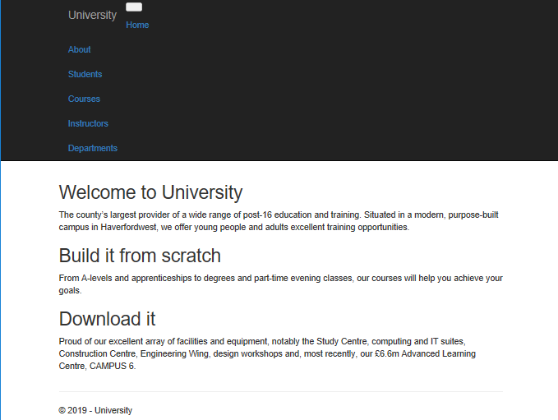

About

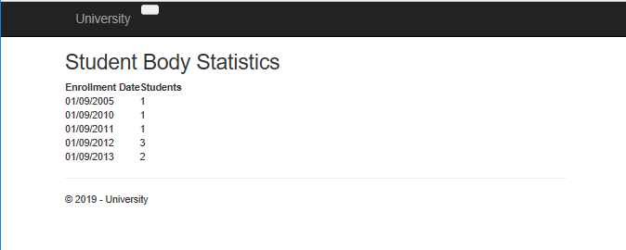
The about page features a running total of how many students enrolled on what date.

Students
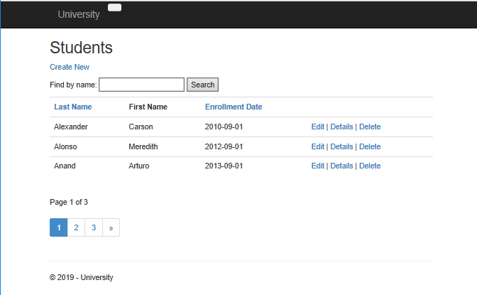
The student page has a several different functions implemented into the page. Users can make use of the search bar to locate a student they wish to view instead of going through the pages of students. Students can also be sorted into either last name, first name or enrollment date order.
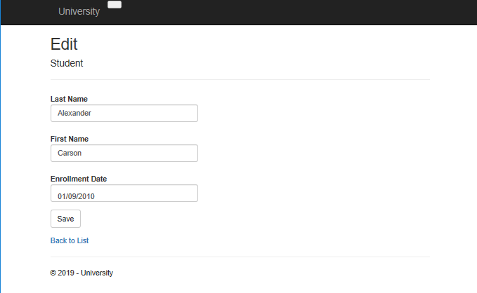
By selecting the edit button available on each student users are brought to this page, from here information on the student can be altered and saved to the web application which is then updated to hold this new information.
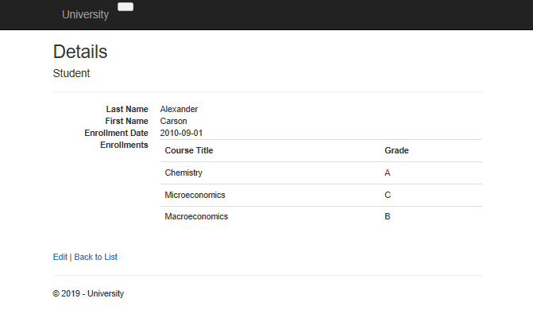
If the details button is selected users can view what courses students are enrolled onto and what grade they are achieving.
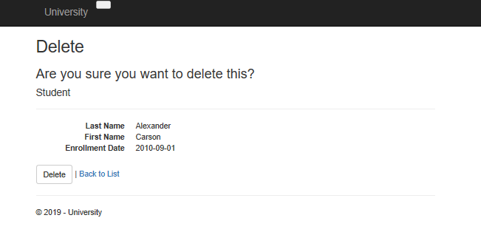
If a student needs to be removed from the web application users can select the delete button they are then brought to the above page and asked if they are sure they wish to delete said student. Users can then choose to permanently delete the data or navigate back to the list of students.
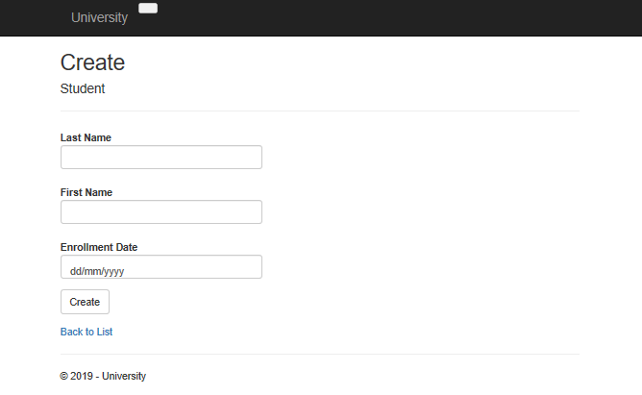
If a new student joins and needs to be added into the system users simply select the create new button located at the top of the page, this allows them to create a new student by inputting all the data requirements and selecting create.

Courses

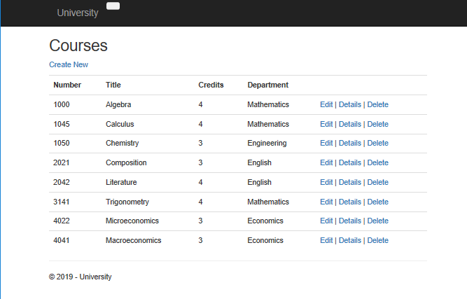
The courses, instructors and departments pages use the same layout and functionality as the student’s page but hold alternative data. Here users can use the edit, details, delete and create new buttons in the same way they do on the student’s page to alter, view, remove or create courses, instructors or departments.

Instructors

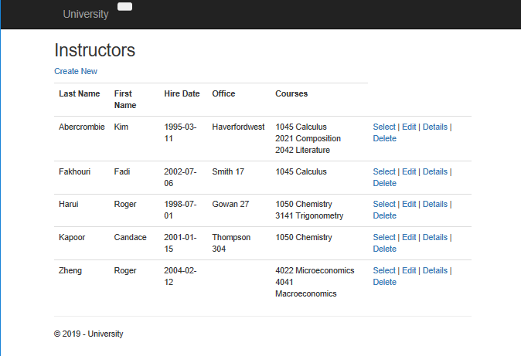

Departments

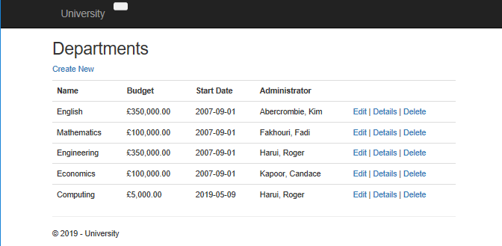

Evaluation

Software verification
Student Search Bar

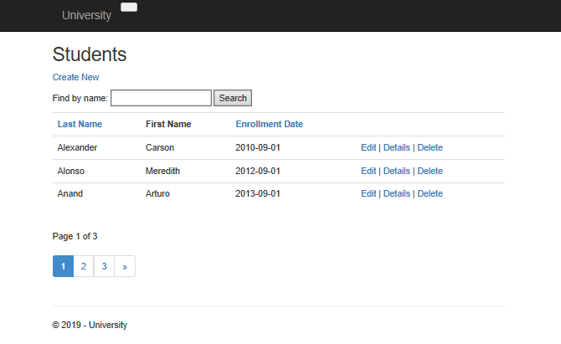

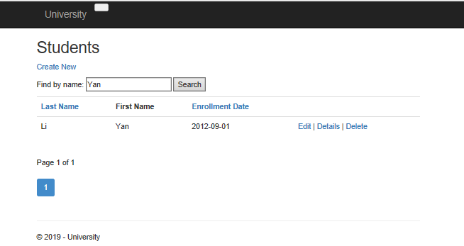

Create New Instructor
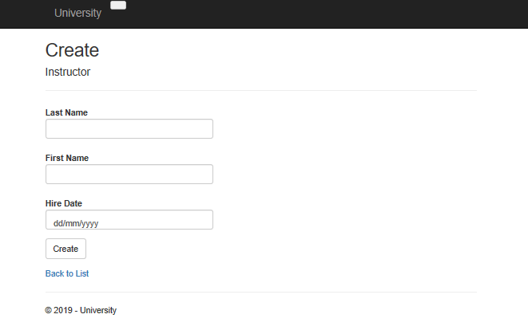

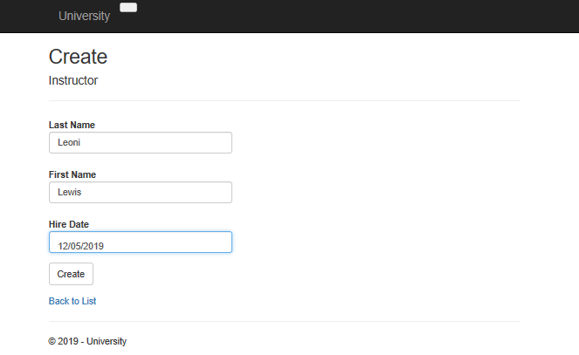

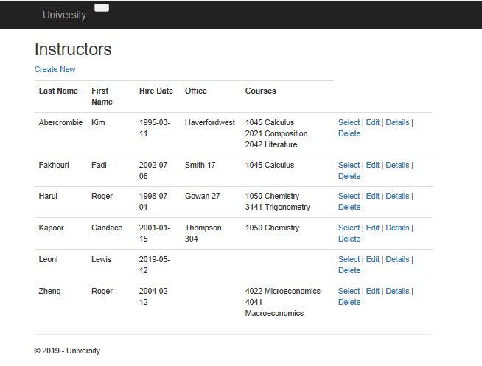

Edit Course

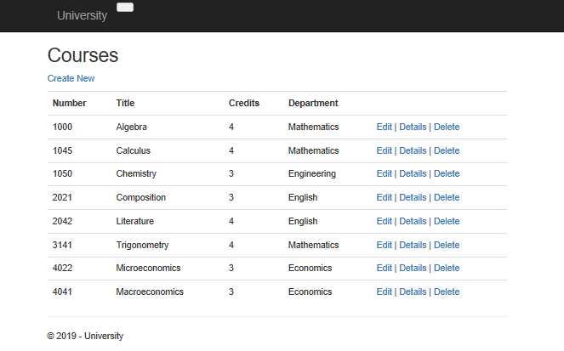
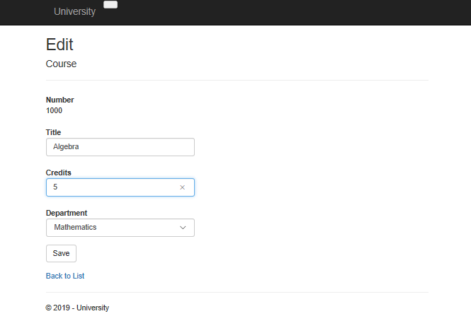
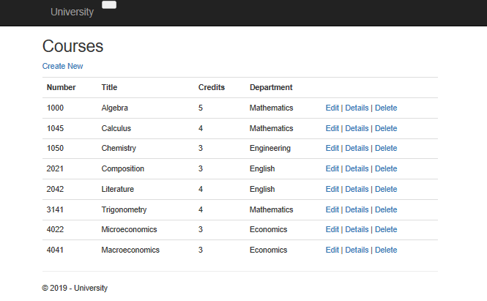

Evaluation and Improvements
In my opinion I think that the web application I have designed and implemented has met the requirements set. The application allows users to create, edit, view and remove several sets of data which all link together and provide users with the information they wish to view. All features implemented work as they should and are easy to use. The web application itself has a simple interface which only contains the information needed and nothing extra, this prevents confusion and overloading users with useless data.
To enhance the web application further I would change up the navigation to feature a horizontal navigation bar, I would do this as it could be difficult for first time users to work out where the drop-down feature is located. I would also add more information to the home page to enhance user experience and make it more interactive.
[2] [3] [4]

References

[1] | B. Bassi. [Online]. Available: https://www.commonplaces.com/blog/6-common-website-security-vulnerabilities/.
[2] | T. Teacher, “Tutorials Teacher,” [Online]. Available: https://www.tutorialsteacher.com/mvc/asp.net-mvc-tutorials.
[3] | A. Freeman, Pro ASP.Net MVC 5, Apress, 2013.
[4] | T. Point, “Tutorials Point,” [Online]. Available: https://www.tutorialspoint.com/mvc_framework/index.htm.

