Programme: Master of Business Administration
Module: Business Development Proposal
Module code: LCMB7037

  - Integrating Skyscanner's Travel Discovery Capabilities with Trip.com's Transactional Infrastructure through Agentic AI

Table of Contents
1. Introduction 3
1.1 Background 3
1.2 Scope and significance 3
1.3 Aim 4
1.4 Objectives 4
2. Methodology 4
2.1 Research Philosophy and Approach 4
2.2 Research Design and Strategy 5
2.3 Data Collection 5
2.4 Data Analysis 5
3. Market Research and Validation 5
3.1 Current Market and Industry Context 5
3.2 Trip.com's Current Market Position 6
3.3 Customer and Booking Journey Trends 6
3.4 Competitor Analysis 6
3.5 Comparative Benefits and Industry Evidence 7
3.6 Technology and Agentic AI Opportunity 8
3.7 Proposed Strategic Analysis Frameworks 8
3.8 Business Opportunity Validation 9
4. Risks 9
4.1 Research and Ethical Considerations 9
4.2 Business Development Risks 9
5. Timeline/Gantt Chart 10
References 11

1. Introduction

1.1 Background
Digital technology has changed the way consumers search, compare and buy travel products and services. Online travel platforms allow users to conveniently access flights, hotels and other travel services, while metasearch platforms help customers find and compare travel options. However, if a customer has to change platforms after they move from discovering to booking (Yakubovskyi and Kyrychenko, 2024). This divide can cause friction throughout the customer journey and is an opportunity to build a more seamless, streamlined and convenient digital booking process.
The Trip.com Group is relevant to the opportunity since they already have a presence in the online travel market and a transactional infrastructure. The main goal of the proposed development is to integrate the travel discovery component of Skyscanner with the transactional component of Trip.com, using agentic artificial intelligence. The idea proposes a fusion of Skyscanner's travel discovery capabilities and Trip.com's booking fulfilment services. Agentic AI has the potential to bridge these stages by assisting customers through the transition from research and planning to booking (Popșa, 2023). The study will then test if this would help mitigate the friction in customer journey and help Trip.com monetize more outbound travel opportunities.

1.2 Scope and significance
The proposed integration is a potential business development and not an exisiting partnership between both companies. The research will check if the idea is strategically suitable and practically possible regarding Trip.com. Specifically, the integration of the customer value created by a more connected discovery-to-booking path, the tech demands of agentic AI, operational demands, competitive ramifications, and the possible financial worth will be covered. Key issues such as consumer trust, transaction security and how metasearch and online travel agency businesses differ will also be explored. For this reason, the investigation will investigate the prospects for a viable and valuable business development opportunity by pairing the discovery capabilities of Skyscanner with the transactional infrastructure of Trip.com using agentic AI.

1.3 Aim
To evaluate the feasibility and business value of integrating Skyscanner's travel discovery capabilities with Trip.com's transactional infrastructure through agentic AI to improve the customer booking journey and capture additional outbound travel opportunities.

1.4 Objectives
- To analyse Trip.com's existing business model, market position, capabilities and competitive environment within the online travel industry.
- To identify the opportunity for reducing friction between travel discovery and booking in the online travel journey.
- To evaluate the strategic, technological and operational feasibility of using agentic AI to connect Skyscanner's travel discovery capabilities with Trip.com's transactional infrastructure.
- To assess the potential customer, competitive and financial value of the proposed Skyscanner and Trip.com integration and develop recommendations for Trip.com.

2. Methodology

2.1 Research Philosophy and Approach
The study will follow a positivist research philosophy because the study is oriented towards finding answers to the proposed business development opportunity based on objective and measurable evidence. The study makes use of positivism because it aims at finding the observable patterns and relationships in the online travel industry and assess the potential business value of the proposed development. The research will try to reduce the subjectivity and seek to evidence by measurable, comparable and evaluable evidence in order to establish conclusions in a systematic way (Ali, 2024).
The study will use deductive research method in which concepts and theories that have been developed are applied to the research problem. The theoretical framework will be supported by relevant concepts related to technology acceptance, digital platform ecosystems, online travel agencies and the Resource Based View to analyse the proposed integration of Skyscanner's travel discovery functionalities and Trip.com's transactional one (Okoli, 2023). These established concepts will be used to evaluate the research goals and draw logical conclusions from the evidence available, using the deductive approach. The philosophy and approach then support a structured process to assess feasibility, strategic relevance and potential business value of the proposed development.

2.2 Research Design and Strategy
The study will use a quantitative secondary research design. The research will involve analyzing the current numerical and factual evidence to assess the proposed business development opportunity. Trip.com will be used as the central business case, with relevant industry and market evidence to focus its position and the wider opportunity within the online travel industry. The study design will concentrate on measurable indicators related to market development, customer behavior, adoption of digital travel, company performance and financial conditions (Thomas and Zubkov, 2023). This design is suitable because it would be possible to assess the proposed project based on available evidence rather than collecting new data.

2.3 Data Collection
Secondary data will be gathered from academic journals and company reports, financial disclosures and credible industry sources. Academic sources from 2020 to 2026 will be identified from databases like Scopus, Web of Science and EBSCO. Agentic AI, online travel agencies, metasearch, travel booking, customer behaviour, technology adoption and digital platforms are all keywords to be used in search terms. The information of the companies will be sourced mainly from the annual reports of Trip.com Group and statutory documents and official corporate publications of the companies. Credible organisations and business sources will also be used to collect relevant industry information (Tang et al. 2026). The data will be directed towards measurable aspects associated with market trends, consumer behavior, competition, and technology development and financial performance. Data will be arranged in an organised manner to facilitate comparison and quantitative analysis.

2.4 Data Analysis
The data collected will be analysed using quantitative analysis techniques such as descriptive statistics, percentage change, comparative analysis and financial ratio analysis as appropriate. Information will be presented numerically and compared across the relevant periods and indicators to show trends and patterns in the online travel industry and in Trip.com's business performance. Proposals will be evaluated in terms of their commercial viability through financial analysis including revenue performance, profitability, liquidity and investment needs (Hamzani et al. 2023). The quantitative results will then be analysed with the PESTLE, SWOT, Competitor Analysis, Porter's Five Forces and Ansoff Matrix to evaluate the external environment, competitive position and strategic growth opportunity. The Business Model Canvas will also help to assess Trip.com's business model and identify areas of potential value creation in the proposed development. The quantitative and strategic analysis will be used to give an evidence-based assessment of the feasibility and potential business value of the proposed Skyscanner and Trip.com integration.

3. Market Research and Validation

3.1 Current Market and Industry Context
Digital technology is impacting nearly every step of the tourism journey, from search to planning, payment to service delivery. According to OECD, travellers are increasingly demanding seamless experiences in their digital journeys, and technologies like generative AI are presenting a chance for the tourism sector to enhance services and operations. Digital intermediation platforms also have an important role in international travel markets. In 2024, foreign-headquartered platforms generated approximately 54% of travel and accommodation platform traffic across OECD countries, while the sector remained competitive rather than being controlled by one dominant platform (OECD, 2026). This environment opens the door for companies that can minimise the friction between discovery, planning and booking. Therefore, the proposed study will assess whether deeper integration of travel discovery and transaction functions could strengthen Trip.com Group's position in this increasingly digital market.

3.2 Trip.com's Current Market Position
Trip.com Group maintains a portfolio of companies that consist of Ctrip, a global online travel agency, and Skyscanner, in which its 2025 Form 20-F identifies Trip.com as a global online travel agency and Skyscanner as a global travel-search company (SEC, 2023). As of the end of 2025, Trip.com was available in 27 languages, 44 currencies and 48 local sites. More than 90% of Group transaction orders were completed through mobile channels. Revenue rose by 17 percent to RMB62.5 billion in 2025, with RMB26.1 billion coming from accommodation and RMB22.5 billion from transportation ticketing revenue (SEC, 2023). International growth also remains strong, with revenue from the international platform increasing by more than 50% year-on-year in Q2 2026 (Trip.com, 2026). These capabilities represent a solid foundation to explore further integration between Skyscanner discovery and Trip.com transactions.

3.3 Customer and Booking Journey Trends
Customer behaviour suggests that convenience and trust are central to online travel purchasing. According to a study that analyzed 494 OTA users, the utilitarian value and convenience were factors that facilitated purchase intention, while privacy, security, and usage constraints led to higher perceived risk (Hien, et. al., 2024). Recent Research also found that website functionality, usability, social presence and product variety influence trust and online hotel-booking intentions (Dulay, et. al., 2026). AI creates a further tension. The 2026 survey of over 5,700 travellers by Expedia Group revealed that 53% would feel comfortable receiving travel suggestions from AI, while 68% would prefer to book through their preferred travel brand over an AI-driven chatbot or agent (Expedia Group, 2026). This suggests that AI may support discovery and planning, but transaction design must preserve trust and reliability.

3.4 Competitor Analysis
Today, key travel platforms are transitioning to connected AI- supported journeys. According to Booking Holdings, its Connected Trip strategy is about the blend of AI based inspiration and planning, booking, payments and in-trip services, all in a personalised manner (SEC, 2025). Expedia's Romie similarly supports planning, shopping, booking and disruption management (Expedia, 2024). AI Agent takes this one step further, integrating conversational discovery, shopping and servicing in a single experience (Expedia, 2025). KAYAK launched Ask AI in 2026, linking conversational planning with live flight, hotel and rental-car search (KAYAK, 2026).
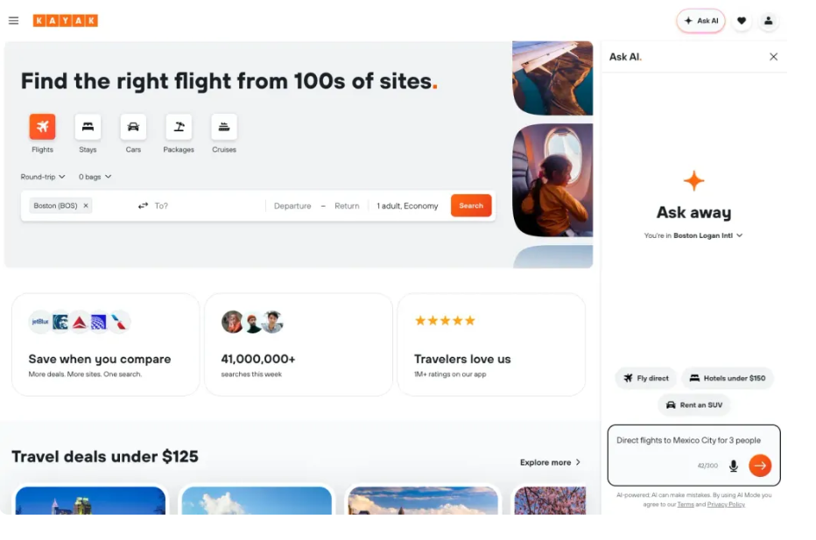
Figure 1: KAYAK Ask AI
(Source: KAYAK, 2026)
These advancements reveal a change in the competition from price comparison to integrated digital journeys. The proposed research will therefore analyze and compare the customer journey, artificial intelligence (AI) capability, product scope, international reach and booking integration of Trip.com with other relevant competitors and assess whether deeper Skyscanner–Trip.com integration could create meaningful differentiation.

3.5 Comparative Benefits and Industry Evidence
Comparable initiatives indicate potential benefits, although they do not prove that integration alone causes improved performance. In 2025, Booking Holdings reported a 37% increase in flight-ticket revenue, and around 80% growth in attraction-ticket revenue, as it continued to grow its Connected Trip strategy (SEC, 2025). According to Expedia, its AI service agent processes over 143 million interactions per year and is responsible for assisting over 50% of travelers in self-service, resulting in satisfaction rates twice that of those who call for assistance (Expedia, 2025).
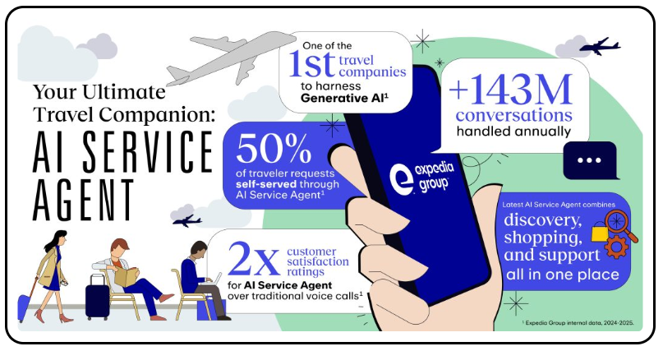
Figure 2: Expedia’s AI Service Agent Benefits
(Source: Expedia, 2025)
Expedia is also bringing the power of AI from discovery to shopping and servicing (Expedia, 2026). The cases highlight potential gains for engagement, cross-selling and service efficiency. The research will assess whether comparable benefits are realistically transferable to Trip.com Group rather than assuming identical outcomes.

3.6 Technology and Agentic AI Opportunity
Trip.com Group already possesses relevant AI capabilities. Its 2025 Form 20-F states that TripGenie and Trip.Planner use AI to support itinerary planning, information gathering and customer interactions (SEC, 2023). Trip.Planner integrates flights, trains, hotels, restaurants and attractions with real-time availability and enables direct booking from the itinerary view (Trip.com, 2025). Therefore, the proposed opportunity should go beyond simply introducing AI-enabled booking. Instead, it will explore if agentic AI can generate further value by integrating Skyscanner's discovery capabilities with Trip.com's transactional platform. There are recently emerging tourism-related academic concerns about trust and reliability issues as challenges for travellers to consider when taking up recommendations generated by AI (Seyfi, et. al., 2025). Therefore, more robust controls, transparency and human oversight would be needed for autonomous activities like booking or changing travel plans.

3.7 Proposed Strategic Analysis Frameworks
The final research will apply strategic frameworks using different strategic analysis frameworks. PESTLE will provide an evaluation of the macro-environmental factors and SWOT will give a broader strategic overview by linking the capabilities of Trip.com Group to the external opportunities and threats, in which the combination of these frameworks can support wider strategic evaluation. Porter's Five Forces will assess competitive pressures within the OTA and digital-platform environment; recent research confirms its continued relevance while highlighting the need to consider digital-market conditions (Dedeke, 2026). Competitor analysis will involve comparing the AI and booking systems of other competitors, and the Ansoff Matrix will be used to categorize the chosen growth strategy (Puyt, et. al., 2024). These frameworks will later be populated using collected market, company, customer and competitor evidence.

3.8 Business Opportunity Validation
Based on the preliminary evidence opportunity looks viable enough to require further investigation, although the evidence is not yet conclusive to prove commercial viability. Trip.com Group runs both Trip.com and Skyscanner and has already been investing in AI throughout the travel journey (SEC, 2023). The final research will therefore evaluate the proposal in six areas including Customer Value, Strategic Value, Technological Feasibility, Operational Feasibility, Financial Feasibility, and Competitive Value. Trust, transaction accuracy, integration costs, regulation and expected return on investment will be given particular attention. These factors will be considered together before making the recommendations.

4. Risks

4.1 Research and Ethical Considerations
The study will involve only secondary data from academic literature, company reports, financial disclosure documents and reputable industry sources. As a result, there will be no human participants, and no data collection, interviews, surveys or experimental procedures. Ethical practice will nevertheless remain important throughout the research process. The integrity and reliability of the findings will be ensured by the selection of academic sources and the representation of them accurately. References will be made in an appropriate manner to give credit to other authors and organisations, and copyright will be respected when accessing and presenting published material (Thomas and Zubkov, 2023). Company data will be gathered from reliable and legitimate sources and will be tried to differentiate between inaccurate data and assumptions or interpretations. The research will also not promote any unsupported claims about Trip.com, Skyscanner or possible consequences of Agentic AI integration. Ethical approval will be secured prior to the start of the research as per the University's research ethics policy.

4.2 Business Development Risks
The proposed development may entail technological, operational, financial and market risk. Agentic AI can result in inaccurate recommendations or errors in transactions, and privacy and security issues may impact customer trust (Perelygina et al. 2022). The added technical complexity and dependency risk can also be caused by integration with an external discovery platform. Additional regulatory implications for AI, digital transactions and customer data could also impact implementation. Furthermore, significant technology and infrastructure investments could cause financial uncertainty (Nugroho et al. 2024). These risks will be analysed by strategic, operational and financial analysis, including considerations relating to the reliability of the technology, security, implementation, investment, and possible customer value.

5. Timeline/Gantt Chart
The research will be carried out within a 16-week period starting with the project planning and literature research, followed by market, strategic, technological and financial analysis. In the later weeks, work will be developed to make recommendations, finalize the Business Development Proposal, edit final work and prepare for submission.
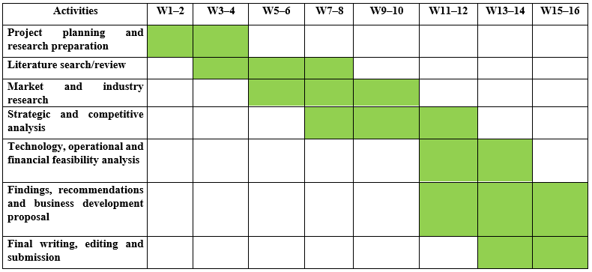
Figure 3: Gantt chart
(Source: Created by Author)

References
Ali, I.M., 2024. A guide for positivist research paradigm: From philosophy to methodology. Idealogy Journal, 9(2).
‌Dedeke, A., 2026. Extending Porter’s five forces framework for the digital era: A. Dedeke. Business Economics, pp.1-13.
Dulay, E.L.D., Fernandez, M.S., Muna, N., Satiadji, A.R. and Sarukunaselan, K., 2026. Digital Platform Attributes and Online Hotel Booking Intention: A Stimulus–Organism–Response Model of Trust in Hotel Booking. Tourism and Hospitality. https://www.mdpi.com/2673-5768/7/10/322
Expedia Group, 2026. Expedia Group Reveals ‘The AI Trust Gap’: Travelers Embrace AI for Planning but Rely on Trusted Brands to Book. [online] Available at: https://ir.expediagroup.com/news-and-events/news/news-details/2026/Expedia-Group-Reveals-The-AI-Trust-Gap-Travelers-Embrace-AI-for-Planning-but-Rely-on-Trusted-Brands-to-Book/default.aspx.
Expedia, 2024. Put Your Trip on Autopilot: Expedia Group Introduces New Innovations at EXPLORE to Take the Stress out of Travel and Enhance Partner Experience - Expedia Newsrooms. [online] Expedia Newsrooms. Available at: https://www.expedia.com/newsroom/spring-product-release-2024/.
Expedia, 2025. Expedia Group Expands B2B Platform and Launches GenAi Partnerships to Enhance Travel Discovery. [online] Expedia Newsrooms. Available at: https://www.expedia.com/newsroom/expedia-group-expands-b2b-platform-and-launches-genai-partnerships/.
Expedia, 2025. Expedia Group Sets the Standard with AI-Powered Service Agent - Expedia Newsrooms. [online] Expedia Newsrooms. Available at: https://www.expedia.com/newsroom/expedia-group-sets-the-standard-with-ai-powered-service-agent/.
Expedia, 2026. Expedia Group expands B2B platform and launches GenAI partnerships. [online] Expedia Newsrooms. Available at: https://www.expedia.com/newsroom/expedia-group-expands-b2b-platform-and-launches-genai-partnerships/.
Hamzani, A.I., Widyastuti, T.V., Khasanah, N. and Rusli, M.H.M., 2023. Legal research method: Theoretical and implementative review. International Journal of Membrane Science and Technology, 10(2), pp.3610-3619.
Hien, N.N., Vo, L.T., Ngan, N.T.T. and Ghi, T.N., 2024. The tendency of consumers to use online travel agencies from the perspective of the valence framework: The role of openness to change and compatibility. Journal of Open Innovation: Technology, Market, and Complexity, 10(1), p.100181.
KAYAK, 2026. KAYAK launches Ask AI to simplify travel planning. [online] Travel Hacker Blog. Available at: https://www.kayak.com/news/ask-ai/.
Nugroho, I.S., Priyanto, D. and Purnama, Y., 2024. Exploring the role of artificial intelligence (AI) in designing and optimizing personalization strategies to enhance customer experience in the tourism industry. Technology and Society Perspectives (TACIT), 2(3), pp.292-298.
OECD, 2024. Strengthening the tourism workforce: OECD Tourism Trends and Policies 2024. [online] Available at: https://www.oecd.org/en/publications/oecd-tourism-trends-and-policies-2024_80885d8b-en/full-report/component-6.html.
OECD, 2026. The role of digital intermediation platforms in opening up international markets. [online] Available at: https://www.oecd.org/en/publications/the-role-of-digital-intermediation-platforms-in-opening-up-international-markets_238a0030-en/full-report/component-4.html.
Okoli, C., 2023. Inductive, abductive and deductive theorising. International Journal of Management Concepts and Philosophy, 16(3), pp.302-316.
Perelygina, M., Kucukusta, D. and Law, R., 2022. Digital business model configurations in the travel industry. Tourism Management, 88, p.104408.
Popșa, P.E., 2023. Digitalization: a strategic approach for the travel and tourism industry. Expert Journal of Marketing, 11(2), pp.181-187.
Puyt, R.W., Antoniou, P.H. and Caputo, A., 2024. The Ansoff archive: Revisiting Ansoff's legacy and the holistic approach to strategic management. Strategic Change, 33(6), pp.513-518.
SEC, 2023. Form 20-F: Trip.com Group Limited. [online] Available at: https://www.sec.gov/Archives/edgar/data/1269238/000119312526183379/d27369d20f.htm.
SEC, 2025. Form 10-K: Booking Holdings Inc. [online] Available at: https://www.sec.gov/Archives/edgar/data/1075531/000107553126000009/bkng-20251231.htm
Seyfi, S., Kim, M.J., Nazifi, A., Murdy, S. and Vo-Thanh, T., 2025. Understanding tourist barriers and personality influences in embracing generative AI for travel planning and decision-making. International Journal of Hospitality Management, 126, p.104105.
Skyscanner, 2026. It’s no myth — there’s a best time to book. [Online] Available at: https://www.skyscanner.ie/
Tang, X., Zeng, Z., Huang, H. and Symonds, J., 2026. Quality appraisal tools for quantitative, qualitative, and mixed-methods studies: A review and a brief new checklist. ECNU Review of Education, 9(3), p.20965311251371227.
Thomas, D. and Zubkov, P., 2023. Quantitative research designs. Quantitative research for practical theology, 5(6), pp.103-114.
Trip.com, 2025. Trip.com Launches Trip.Planner: Smart Itineraries Tailored to Your Travel Style with Real-Time Recommendations. [online] Available at: https://www.trip.com/newsroom/trip-com-launches-trip-planner-smart-itineraries-tailored-to-your-travel-style-with-real-time-recommendations/.
Trip.com, 2026. Trip.com Group Limited Reports Unaudited Second Quarter and First Half of 2026 Financial Results. [online] Trip.com Group Limited. Available at: https://investors.trip.com/news-releases/news-release-details/tripcom-group-limited-reports-unaudited-second-quarter-and-4/.
Yakubovskyi, S.O. and Kyrychenko, O.V., 2024. The role of digitalization in the development of the global tourism industry.

