

Program: Master of Business Administration

Module: Strategic Management
Module Code: LCMB7003

Strategic Management of Samsung in the UK
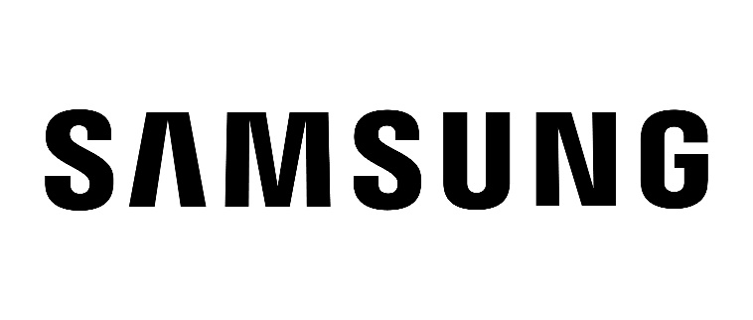
Student ID: 2519666
Student Name: Godhani Hevin Ashvinbhai
Word count: 5487

Table of Contents
Section 1 4
Introduction 4
1.0 Organizational Context and Overview 4
1.1 Organisational Historical Perspectives 4
1.2 Industry, Key Competitors and Market Position with Porter's Five Forces Analysis 5
2.0 External and Internal Analysis 7
2.1 External Analysis: PESTEL 7
2.2 Internal Analysis: VRIO 9
2.3 SWOT Analysis 11
3.0 Comprehensive and Holistic View of the Organisation 12
3.1 Corporate Social Responsibility (CSR) Strategy and Alignment 12
3.2 The Balanced Scorecard Application 14
4.0 Strategic Choices and Implementation 17
4.1 Strategic Choices at the Business Level 17
4.2 Identifying and Validating the Appropriate Strategy 18
4.3 Delivering Optimum Performance and Competitive Advantage 19
4.4 Potential Challenges and Mitigation Solutions 19
Conclusion 20
Section 2 21
1.0 Overview 21
2.0 Reflection using Kolb’s Reflective Cycle 21
3.0 Summary 23
Reference List 24

Section 1

Introduction
This report will give Samsung a management consultancy for their strategy evaluation in the UK and give several recommendations for Samsung to ensure they can gain a greater competitive advantage. Section 1 begins with a very broad understanding of the organisational context and business model. Then conducting internal and external analysis with the assistance of normal models like PESTEL, VRIO, SWOT. Then, using the Balanced Scorecard, the corporate social responsibility strategy is analysed, thus presenting a comprehensive picture of the organisation and includes strategic options and concludes with a focus on a broad differentiation option.

1.0 Organizational Context and Overview

1.1 Organisational Historical Perspectives
Samsung was established as an electronics brand in 1963. The brand is headquartered in Seoul, South Korea. In 2017, Samsung Electronics became the largest IT company, consumer electronics, and chipmaker globally. In 2025, the annual revenue of the brand was $233.4 billion USD, while the operating profit of the business is $ 3.5 billion (Diniso, 2026). In the UK market, the company operates in Smartphones, TV, Electronic appliances, semiconductors, and connected technologies segment.
Mission
Samsung brand mission is to enhance people’s life with quality, contribute to society wellbeing through innovative technology implementation in product development and R&D.
Vision
The core vision of the brand is “Inspire the world, create the future”.
Business Model
Samsung has a diversified business model with a focus on technology development, Smart manufacturing, R&D, supply chain, and direct and indirect sales across the world. The brand includes device experience (DX) model to supports consumers and enhance customer satisfaction via smartphones, TVs, and appliances, and its DS division is for semiconductors (Abraham, Nair and Mtegha, 2024). This vertical integration in the business model supports the brand to enhance control over technology, production, and innovation, and opens the door for the integration of products in the form of an integrated ecosystem.
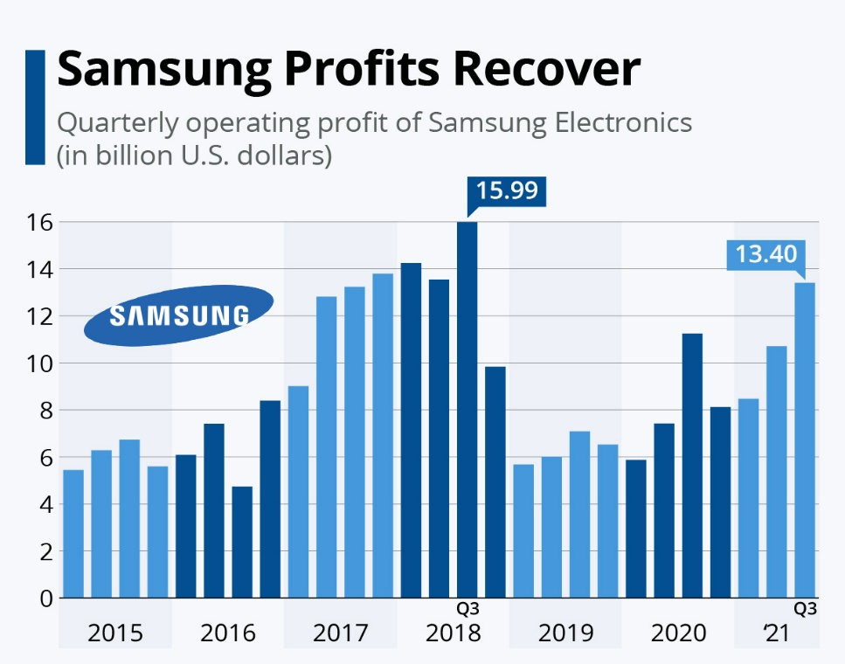
Figure 1: Samsung Profts data from 2015 to 2021 quarterly
(Source: Buchholz, 2021)

1.2 Industry, Key Competitors and Market Position with Porter's Five Forces Analysis
Samsung operates in the UK consumer-electronics sector, which is characterized by high rivalry, high levels of innovation, powerful brands, and short product life cycles.
Implementation of Porter's 5 Forces
Competitive rivalry: There is a high level of competition among the firms in the mobile market. In the UK, Apple has a dominance of 51.28%, and Samsung is the closest competitor with 29.54% mobile market share in June 2026.
The bargaining power of Buyers: With mobile devices, the power of the buyer is massive, and switching from Apple, Google, Xiaomi, and Motorola is so easy that Samsung will be under pressure to rise above the pack with AI and capabilities for its ecosystem (Ramadhani and Wandebori, 2025).
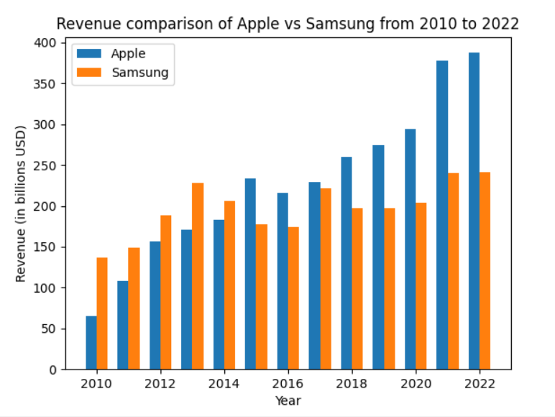
Figure 2: Comparison of Apple and Samsung
(Source: Reddit, 2023)
The bargaining power of suppliers: Supplier power is relatively low as Samsung has a relatively strong vertical integration in semiconductors, but the technology inputs are still open to supply volatility and costs.
The threats of new entrants: Significant R&D and brand and distribution requirements of Samsung include difficulties for new brands and others to enter this market (Febrianti et al., 2022).
The threats of substitute products: The market share leaders Samsung hold in televisions with 29.1% of the world market share points to the fact that the most promising lines for the company are televisions, whereas Apple's control of the UK market shows that there's still plenty of ground to cover before Samsung can achieve the technological breadth that leads to a loyal customer base.

2.0 External and Internal Analysis

2.1 External Analysis: PESTEL
PESTEL is a framework which has been used for analysing the external environment for organisations. However, this is relevant for Samsung to address the changing conditions of those organisations in the UK electronics market. Position of Samsung in the UK has been shaped by the entire political, economic, social, technological, environmental and legal factors.
Table 1: PESTEL Analysis
Factor | Impact on Samsung | Opportunity/Threat
Political | Brexit and UK trade rules can increase customs, import and compliance costs across Samsung’s electronics supply chain can have impact on component sourcing and prices (Cho et al., 2023). | Threat
Economic | Inflation, interest rates and household budget pressures can reduce demand for premium smartphones and appliances, although affordable ranges can maintain sales. | Threat
Social | Demand for connected lifestyles, convenience, sustainability and personalized digital experiences supports Samsung’s smartphones, wearables and SmartThings ecosystem (Putthiwanit and Vēvere, 2022). | Opportunity
Technological | AI, foldable devices and smart homes create differentiation opportunities, although rapid competitor imitation increases research and development pressure. | Opportunity
Environmental | E-waste and carbon concerns encourage recyclable products, energy efficiency, repair and trade-in initiatives, strengthening Samsung’s sustainability reputation (Lee, 2024). | Opportunity
Legal | Consumer protection, product safety, data protection and WEEE requirements increase compliance costs while supporting customer trust. | Threat
Table 1 highlights the detailed PESTEL analysis of Samsung. In the political factors, the company is associated with the trading of UK and South Korea relations, while the post-Brexit customs arrangements are related to influencing the imported electronics, costs and components. As per Murad and Sfhea (2023), Samsung Electronics in the UK has operated in Britain for a long time, which indicates providing a stable local base. This also includes policy uncertainty, which can still have an impact on the entire supply chain process.
Economically, inflation, along with interest rates, can put pressure on household budgets, which can reduce discretionary spending on appliances, premium smartphones and televisions. It is essential to note that the replacement cycles and demand for AI-integrated devices are associated with the creating of opportunities for value-added products. Therefore, Samsung also faces component and cost volatility in 2026 (Jeong and Park, 2023). However, a strong demand for AI has contribution of the global economy's memory shortage, which increases the cost for electronics manufacturers.
Socially, UK consumers are associated with increasing expert convenient which includes connected and sustainable technology usage. However, Samsung can exploit this through trade-in schemes along with Galaxy ecosystems and SmartThings. As per Teece (2022), its UK mobile and tablet vendor share was 29.54% in the first quarter of 2026, which is far behind Apple's 51.28%. Therefore, this indicates a significant gap in the customer base and shows a major competitive gap in the UK marketplace. It can be said that the opportunity is to convert Android users into a broader Samsung ecosystem rather than only competing on handset specifications in the entire market.
Technologically, generative AI, along with connected homes, advanced displays and foldable devices are associated with providing major opportunities for the company. As per Teece (2025), Samsung’s Vision AI and Galaxy AI provide a demonstration of the ability to integrate AI throughout the products. Therefore, the Chinese manufacturers, along with Google and Apple, can have innovation of rapidly, which makes it difficult for Samsung to sustain its technological leadership in the UK marketplace.
Environmentally, the e-waste along with the energy consumption process creates pressure for the repairable, recyclable and long-lasting products in the marketplace. As per Kornelakis and Petrakaki (2025), UK WEEE regulations are associated with the requirement of producers to provide support for responsible management of the electrical waste. Therefore, it can be said that the trade-in programs of Samsung provide representation of opportunity for the circular economy while it indicates support for the compliance suitable approaches.
Legally, environmental obligations along with data protection, consumer rights and product safety are related to the increment of compliance costs. As per Farah (2025), the privacy concerns associated with smart devices creates reputational threat for Samsung. It is essential to note that the AI-integrated demand, along with ecosystem growth and circular consumption, are the strongest opportunities, while the dominance of Apple creates threats. The regulation compliance, along with privacy risks, price sensitivity and component shortage, are the main threats for Samsung.

2.2 Internal Analysis: VRIO
Samsung’s environmental approach provides resources, but these are not associated with providing advantages. However, under VRIO, the strongest resource has been technological capability for the R&D process.
Table 2: VRIO Analysis
Capability | Value | Rare | Difficult to Imitate | Organisation | Competitive advantage
Brand reputation | Yes | Yes | Yes | Yes | Competitive advantages
Advanced R&D | Yes | Yes | Yes | Yes | Competitive advantages
Broad ecosystem | Yes | No | Yes | Yes | Competitive advantages
Supply chain | Yes | No | No | Yes | Temporary advantage
Financial capability | Yes | No | Yes | Yes | Competitive advantages
Technological capability | Yes | Yes | No | Yes | Competitive advantages
Table 2 highlights the VRIO analysis of Samsung. Samsung has an investment of approximately KRW 35 trillion in R&D in 2025, which supports AI, smartphones, displays and semiconductors. As per Hajarath and Chaitanya (2025), this capability has been valuable and relevant at scale, while it has been difficult to imitate since it has a combination of manufacturing knowledge, engineering expertise and patents. This has been associated with the organisationally supported, which can provide sustained advantages.
While conducting VRIO analysis for Samsung UK, it has been noted that the company generates partial, temporary and sustained competitive advantage across the market. This is widely based on the idea that Samsung UK is a part of a wide electronics brand with massive capital and spending capabilities. Thus, providing significant advantages over other competing companies.
Based on the attached VRIO analysis table, it can be observed that one of the major capabilities with sustained competitive advantage for Samsung UK is its brand reputation. This is related to the idea that Samsung UK was ranked 5th in the UK in 2025 (Fitala et al., 2023). This is further linked to the report where Samsung UK had generated approximately £67.9 billion while maintaining its position on a global scale.
Another major sustained advantage for Samsung UK is its technological and R&D capabilities. This is widely related to the prospect that Samsung UK is a part of a larger brand on a global scale that has always been known for its technological pioneering. This is based on the idea that Samsung invested more than £19.76 billion in R&D in 2025. Similar competitive advantages have also been reported for its intellectual property compared to competitors. As per Suh and Williams (2024), based on public records that go as far as March 2026, Samsung UK currently holds more than 288770 patents globally. Therefore, their scale of innovation, development and IP protection can be easily comprehended. This shows the sheer capability for Samsung UK to gain a significant competitive advantage over other companies.
Though the transition and ecosystem may not be as seamless as their major competitor Apple, the inclusion of home amenities such as a fridge, washing machine and TVs in their product ecosystem makes the experience much more unique (Durosaro, 2023). This serves as a major portfolio for the company while also reflecting on the overall operations and the choice of products that are sold to their customers.
Apart from the mentioned capabilities for Samsung UK, there have been capabilities including retail relationships and financial strength that seem weaker than competitors. As per Wardhana (2024), this links to the major aspect that showcases their position compared to Apple, Google, LG and Sony in the UK. While Samsung UK has a strong foothold in the UK, the mentioned competitors have better advantages over the mentioned capabilities. This further relates to the possibility that such resources could easily be initiated by the mentioned competitors as they are major players within the same business segment as Samsung UK. Though their product range may be different, it is important to note that manufacturing capabilities and ecosystem development are widely based on similar aspects.

2.3 SWOT Analysis
Table 3: SWOT Analysis
Factor | Impact on Samsung
Strengths | Strong global brand, advanced technology, diversified products, extensive R&D capability, and established UK market presence.
Weaknesses | Weaker premium smartphone position than Apple, high innovation costs, and dependence on continuous technological development.
Opportunities | Increasing AI adoption, smart-home demand, sustainable products, trade-in schemes, and expansion of connected digital ecosystems.
Threats | Apple’s dominance, aggressive Chinese competitors, component shortages, economic uncertainty, privacy concerns, and stricter UK environmental regulations.
- Strengths: Samsung's strength in the UK is widely related to their strong brand reputation and recognition. This further links to the ideas where Samsung UK has a wider range of product portfolio compared to their major competitors. Furthermore, Samsung UK has a major spending capability that supports their major R&D investments. As per Cho et al. (2023), this fundamentally allows the company to maintain their competitive advantages over the stated market and other major economies globally. This could be affirmed by some sources confirming that over 29% of mobile vendors prefer selling Samsung products over others based on customer preference and strong presence as of 2026.
- Weakness: A significant weakness for Samsung in the UK shall be the strong presence of their major compactor Apple Inc. Some may even state that Apple often poses as Samsung's 'arch competitor’ with more than 51% UK mobile market share in 2026 (Putthiwanit and Vēvere, 2022). This significantly shrinks the overall market for Samsung to propose its business in the UK specifically for its mobile phones. However, AI innovation and frequent innovations allow the company to stay afloat in the stated market. Yet, it is important to note that Apple has a major fan following with loyal customers that often makes major companies with technologically advanced tech as Samsung, falter in market share.
- Opportunities: Galaxy AI, Bixby, Vision AI, telecasting and SmartThings are major growth possibilities for Samsung. This is widely related to the idea that individual products from Samsung currently come with AI-enabled features and are part of their integrated ecosystem. Furthermore, this has become a major area of development considering Samsung has been investing in their in-house datacentres to power their AI (Lee, 2024). These services are currently free and are offered with Samsung's flagship or premium products, thus allowing customers to be a part of the growing ecosystem and providing a sense of royalty.
- Threats: Currently, the primary threat for Samsung UK will be the current operations from Google, Apple and other players such as Sony. However, an unnoticed yet major threat that needs to be considered is the aggressive market expansion and business operations of Chinese companies in the UK such as Xiaomi. As per Murad and Sfhea (2023), often considered ‘the Apple of China,' Xiaomi has a similar product portfolio as Samsung UK and may create a threat of replacement in the stated market. Apart from the mentioned, the current memory shortage has forced Samsung UK to increase prices for their products, which has been steadily decreasing people's interest in procuring their products.

3.0 Comprehensive and Holistic View of the Organisation

3.1 Corporate Social Responsibility (CSR) Strategy and Alignment
Social empowerment and the environment are both important aspects of Samsung UK's Corporate Social Responsibility strategy which is an integral part of its business's goals.
Social Initiatives: By the same time, we stand out our vision: "Together for Tomorrow!". At Samsung UK, we work on 'Enabling People' and have a particular focus on STEM learnings (Science, Technology, Engineering and Mathematics) for the next generations (Samsung, 2026). An important part of this work is through the ‘Solve for Tomorrow' programme. The goal of this campaign is to encourage creativity in young people in the UK in considering technological solutions and social issues (Bradbury, 2026). Under the initiative of collaboration through the themes of a greener and better future and a smarter sports and online safety, Samsung actively nurtures students, equipping them with the essential digital skills and design-thinking. These teaching partnerships are an opportunity for the company to have a first-hand look at tomorrow's technologic workforce.
Environmental Initiatives: In the field of the environment, the company is based on a comprehensive "New Environmental Strategy". One of the core commitments of this strategy is to become an enterprise-wide net zero carbon emission company by 2050 (Samsung Electronics, 2025) through Scope 1 and 2 carbon emissions. In order to achieve this lofty target, Samsung is aggressively shifting its overall operations worldwide – including in the UK – towards renewable energy. Moreover, resource circularity plays a key role in the strategy. The company's utilization of recycled materials, including shredded fishing nets to produce high-quality smartphone components and recycled plastics to make home appliances, greatly decreases its environmental impact and encourages sustainable manufacturing techniques.
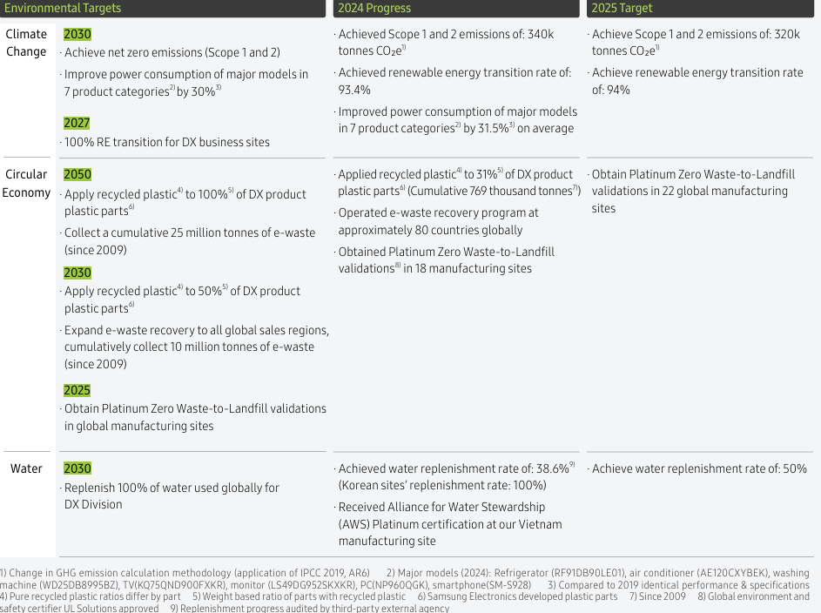
Figure 3: 2024-2025 major targets
(Source: Samsung Electronics, 2025)
Strategic Alignment: These CSR activities are perfectly in line with the concept of Samsung's business. In their aim for sustainability and digital education, the company has an eye on sustainable growth. Focusing on the environment will help influence the brand's reputation, consequently sparking higher interest from the UK's evergreen eco-conscious consumers (Rashid and Ahmed, 2025). Moreover, by committing itself towards society and environment, Samsung also ensures it stays competitive in the rapidly changing technology sector with the highest job-seeking talents.

3.2 The Balanced Scorecard Application
The Balanced Scorecard (BSC), developed by Kaplan and Norton, is a very powerful strategic tool which enables an institution to measure their overall operating performance (Coskun and Nizaeva, 2023). It transcends the traditional accountancy which is based on financial data only and seeks to incorporate, both the financial and the non-financial data, for effective business management. Samsung UK will be able to ensure that they are doing daily activities with and because of their core perspectives (Scribd, 2024): Financial, Customer, Internal Business Processes and Learning and Growth.
Table 4: Samsung UK Balanced Scorecard
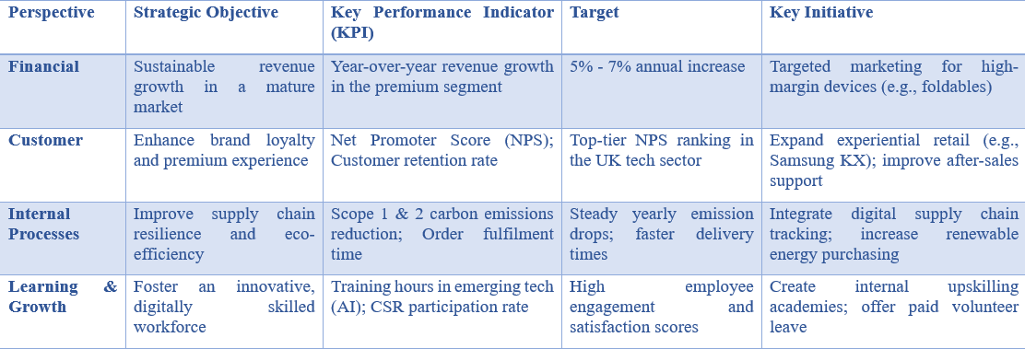
Financial Perspective
From a financial point of view, the financial area concentrates on the financial wellness of the business. The trend of owner-ship of smartphones and home electronics is already high in the UK. Hence, a Samsung UK's key target should be about sustainable revenue growth in a mature market (Partanen, 2025). It is difficult for it to get completely new customers, therefore stressing the buyers to buy better quality sold products. The one to monitor this is the year-on-year revenue growth of the premium business segment. The appropriate level of growth for each of these sales is 5% to 7% per year. To do that, one strategy is targeted marketing of high margin devices. The company can put the advertising budget for its high-quality products and innovative gadgets such as a foldable phone or a top-tier smart TV into a process that boosts its profit margin on every single sale (Nemirovsky, 2026).
Customer Perspective
Customer Perspective: This is how the customer feels when they come in touch with the brand. The major goal here is customer experience and the brand loyalty of the customers. Measurements of this success include Net Promoter Score (NPS), indicating the likelihood of customer recommendation, and customer retention rates, measuring the percentage of customers turning into repeat buyers from Samsung (Typeform, 2026). The goal is to deliver and then sustain a high ranking NPS in the highly competitive UK tech industry. Real-world customer interactions need to be the focus of initiatives if this target is to be met. When people can discover technology in a calm and hands-on setting, like Samsung KX, they're making the most of experiential retail (Stellar, 2026). Moreover, with the help of improved after-sales services, if the customers encounter a problem, they can handle their troublesome appliances in a simple, quick and less stressful way.
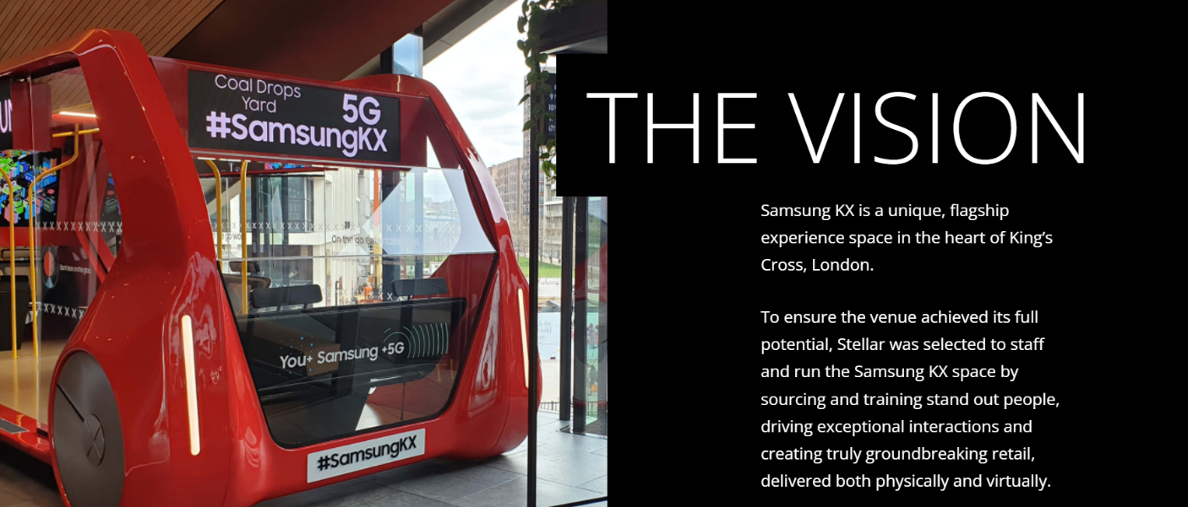
Figure 4: L Samsung KX
(Source: Stellar, 2026)
Internal Business Processes
This is the space dedicated to the activities that occur backstage, but are important to the smooth running of business. At the top of Samsung UK's agenda is to make the whole supply chain more resilient and eco-efficient. Efficient supply chain is good for the planet and managing the supply chain will not have single points of failure. These are the overall carbon footprint reduction including the scope 1 and 2 emission reduction and velocity (cycle time) across the order fulfilment business (Kamal, 2025). Target should be properly positioned based on Samsung's worldwide strategy for the environment and should consistently realize emission reduction every year and warehouse to buyer delivery time reduction. For this purpose, important work can be conducted: integration of state-of-the-art digital supply chain tracking. This technology allows managers to be able to see where products are at all times and not suffer from shipping delays. There is also a push to purchase more renewable energy for across all offices and logistics centres in the UK (Carter, 2026).
Learning and Growth
The last one is the perspective of the people that make the company successful: the employees’ point of view. It has to foster the outthrusting of a very innovative and digitalized workforce. The technology industry is a very volatile one, and workers need to ensure that they are continually learning. The specific KPIs chosen include average number of training hours of employees in emerging technologies (such as AI) and employee participation rate in CSR (Samsung, 2026). The specific goal is to have high employee engagement scores, in order to keep your employees highly motivated and happy. Developed to deliver these goals are such projects as establishing in-house upskilling academies. These learning programs are designed to get to know staff members with new digital tools in a safe setting. In addition, when employees provide Volunteer paid programs, they are giving the added benefit of their time to serve in other communities which can develop a very positive company culture that is reflected in the overall employee happiness levels.

4.0 Strategic Choices and Implementation

4.1 Strategic Choices at the Business Level
At the business level an organization has to make the important decision about how it will battle out in the market in the eyes of the people and retain its market position. Porter's Generic Strategies is an extremely useful model for seeing the choices. With this model, a business may have a competitive advantage by keeping its operating costs low, by providing very different products compared to the competition, and by attempting to appeal to either a large or small market segment (EBSCO, 2026). The two main major strategies are Samsung can select from in the UK are Cost Leadership and Broad Differentiation, due to Samsung's status as a major technology company.
Table 5: Porter's Generic Strategies
Market Target | Low-Cost Advantage | Product Uniqueness Advantage
Broad Market | Cost Leadership | Broad Differentiation (Samsung Strategy)
Narrow Market | Cost Focus | Differentiation Focus
Cost Leadership is attempting to be the lowest cost provider in the industry. This is rather a risky decision in the extremely competitive and saturated UK consumer electronics market (Mohammad, 2022). A low-price-only strategy may have to stop the brand from being perceived as too cheap and cutting down on profitability. Apart from that, there are there are a lot of reduced cost brands that always attempt to do even more affordable, so this is not an effort to actually keep up over the longer term.
On the other hand, Broad Differentiation means producing different products with the properties that are different from other products in the market due to their unique features, quality or brand appeal. An exciting feature, such as a new screen type or allowing the product to integrate seamlessly into existing smart home systems could be enough to encourage consumers to upgrade if this is indeed the case in the UK and the field is already saturated. So in the two, a broad differentiation is much more feasible and profitable strategy to succeed.

4.2 Identifying and Validating the Appropriate Strategy
The strategy you choose will be of deciding importance - it's key to get right. It's obvious that Samsung UK has its best shot with “Broad Differentiation.” Most of its intent of their strategy is attributed to its high-end brand and the interdependency of the products, its deep involvement in continuous technological advancements (Dananjaya, 2024). Samsung doesn't seek to be the cheapest, but they're providing something that people will pay more for. By connecting their devices, ranging from a smart phone to a smart TV and other home appliances, to a single strong Samsung network, Samsung offers a high-end user experience virtually impossible for budget brands to replicate.
For us to validate this strategic decision, it will be useful to use the Ansoff's Matrix which is a tool for planning business growth. According to this matrix, Samsung's strategy fits well in two strategy categories: Product Development and Market Penetration.
The company applies the Product Development extensively as it launches and develops a large amount of new and highly sophisticated products into its established market in the UK (Samsung, 2026). A case in point is the many AI-enabled innovations poised to enter the market in the imminent future, including Galaxy's latest smartphones and the cutting-edge health tracking wearables. All of these new capabilities provide a very good motivation to upgrade an older technology for existing customers.
Secondly, through Market Penetration Samsung expects to increase its market share with the established population in UK. The company has thrown vigorous and influential marketing campaigns with the Business Model Analyst to the market. With this demonstration, Samsung can offer a broader overview to the general market of what it has to offer with its new set of AI-empowered solutions, and how they can make their daily lives easier and better, potentially increasing customer preference and establishing Samsung as a market leader.

4.3 Delivering Optimum Performance and Competitive Advantage
The wide differentiation technique serves the principle of maintaining and sustaining Samsung UK's competitiveness. The Resource Based View (RBV) framework can be used to explain for this success. Recent research has identified that Samsung's extensive research and development efforts and global reputation act as decision-making VRIO resources (Martynova and Chen, 2025). They are Valuable, Rare, Inimitable and Organized and really hard for other brands to be able to copy.
Table 6: Resource-Based View (RBV)
Resource Type | Samsung Resource | Business Value
Tangible | R&D centers and factories | Creates advanced physical products
Intangible | Premium brand name | Builds strong customer trust
Intangible | Patents and technology | Stops competitors from copying
The unique internal resource translates into real-world innovations in the industry, such as the SmartThings home ecosystem that seamlessly connects Galaxy devices and appliances, as well as the availability of Galaxy AI on a wide variety of mobile appliances. Televisions, smartphones, and home appliances are all connected to a convenient and easy-to-use network through SmartThings. Galaxy AI, in contrast, brings features such as intelligent assistance and health monitoring capabilities to the daily gadgets. In combination, these technologies provide incredible value experiences each day and are connected. After a consumer has created a home environment that connects Samsung branded devices, it will be difficult, inconvenient and expensive to switch to a competitor. This enables the ecosystem lock-in and ensures high customer loyalty, preservation of Samsung's market position or the provision of optimum long-term performance of businesses in the UK tech market.

4.4 Potential Challenges and Mitigation Solutions
The two main problems Samsung faces with its recommended differentiation are:
Financial pressure for AI investment: The Continuous investment in AI, semiconductors, and product innovation is revealing a high financial exposure, particularly in view of the speed at which tech becomes obsolete (Abdulameer Kawther and Abdulsattar Mahmood, 2026). Samsung therefore needs to apply agile development, stage-gate investment decision making, and strategic cooperation with software and chip suppliers to ensure the diffusion of innovation and the avoidance of technological risks.
Economic Pressure due to Inflation: The cost-of-living pressures in the UK can weaken the demand for premium smartphones and consumer electronics. Samsung can market accessibility to all people in the UK market by providing flexible financing options, better trade-in schemes and product tiers, and by bringing consumers to the new technologies at various prices without much losing the "premium" tag (Noui and Boucetta, 2025). The analysis of customer segments and demand forecasting should be followed by measures, so that the promotional activity not only increases sales, but does not endanger the margin. These can provide more strategic flexibility and help Samsung stay competitive in terms of innovation.

Conclusion
In the end, Samsung UK is playing in one of the world's most fiercely competitive markets in the electronics market. The brand's emphasis on technology and its commitment to sustainable initiatives give resources for its sustainable positioning while ensuring a strong presence in the market. The differentiation involved in Samsung's chosen broad strategy allows them to offer Samsung related interrelated "product ecosystems" to their consumers that are hard to replicate on affordable terms by the budget competitors. To sustain this competitive edge and guarantee the long-term growth of Google, it is crucial for the company to continue investing in research and effectively manage its supply chain.

Section 2

1.0 Overview
This reflection will provide an analysis of the process that I went through to research, analyse and prepare my strategic management report on Samsung Electronics UK. The structure chosen is Kolb's Experiential Learning Cycle as it links experiences with reflection, conceptual understanding and future applications. The evidence was gathered by conducting an organization and industry data analysis, analysing the organization's strategic position, and applying frameworks such as PESTEL, VRIO, SWOT, Porter's 5 Forces, Ansoff's Matrix, and the Balanced Scorecard.

2.0 Reflection using Kolb’s Reflective Cycle
Concrete Experience
I began the analysis with the development of a historical background, Samsung's business model, as well as Samsung's market position and competitive position in the UK market. The first research yielded a lot of information, since Samsung is active in the field of semiconductors, appliances, television, and smartphones. However, the information was not enough to provide a strategic understanding. For this reason, it was more important to find evidence that might shed light on Samsung's competitive position, rather than merely describing Samsung's activities. The information on the market share, on the financial performance, on the investments in R&D, on the competitors' activity and technological development proved to be very helpful in the assessment of the organization.
The use of the frameworks was a more structured experience for me. PESTEL helped me to think about external factors that might affect the business, and VRIO helped me to reflect on the fact that Samsung could make sure that its resources can give them sustainable advantage (Wu et al., 2025). This then allowed them to make links between the competitor's power and the buyer's power with Samsung's strategic decisions. Porter’s Five Forces enabled them to correlate the power of the competitor with the buyer's power and Samsung's decision making.
Reflective Observation
I found the amount of information available to be useful, as Samsung has a lot of corporate and financial information published. The challenge of the volume of information, however, was the lack of strategic relevance of all the facts. I knew that it was vital to tell what Samsung has done and the reason for doing it and understanding the implications. Another problem came when Apple and Samsung were pitted against their competitors. The innovativeness of the product may not be the only reason for competitive market performance, so the strength of the ecosystem, the product's price and positioning in the market should also be considered when looking at competitive performance (Noui and Boucetta, 2025). The research process in this manner was more important since I began my learning process questioning whether a certain strength is really a competitive advantage.
Abstract Conceptualisation
The analysis enabled me to gain a greater understanding of strategic management as a process which requires linkage to the various frameworks, rather than being a process in isolation. PESTEL discussed the opportunities & threats caused by technological, economic, environmental, and regulatory changes. VRIO revealed that the scale and R&D capacity, along with technological expertise, of Samsung are valuable, but the strategic value lies in how much it is converted into customer value.
I also knew that if the brand doesn't have a competitive advantage, then the brand has to be the first to have advanced technology. The Samsung vs. Apple battle is an example of how crucial it is to integrate with the ecosystem and foster customer loyalty (Diniso, 2026). The Balanced Scorecard also showed that the results with the customers should be taken into consideration, rather than just financial results, internal processes, and organisational learning. Gained a greater understanding of evidence-based strategic decision making.
Active Experimentation
To improve my strategic management skill in future first I develop my strategic research and clear the objectives and gather efficient data and information. This supports the understand the research scope clearly. Through this module I would like to tie more market data in strategic recommendations in future analysis. For instance, I focusing on a strong R&D capability is not a strength, but rather I analyse how their investment in AI and connected technologies impacts on customer retention, market share or profitability (Abraham, Nair and Mtegha, 2024). This skill supports me to offer quantifiable and marketable recommendations. I would also do a comparison of strategic options, rather than jump to a recommendation from analysis to select best recommendation strategy.

3.0 Summary
The Samsung project helped me to become more adept at collecting information and then transforming it into a strategic interpretation. The most significant learning from the module was effective strategic analysis, I gain knowledge to develop critical thinking between organisational capabilities, strategic choices and market pressures.

Reference List
Abdulameer Kawther, H., and Abdulsattar Mahmood, N. (2026). From Leadership to Addiction: How Does a Brand Create a Lasting Impact? a Descriptive Analytical of The Opinions of a Sample Customers of Apple, Samsung, and Huawei Companies. F1000Research, 15, 155. https://f1000research.com/articles/15-155
Abraham, C., Nair, K., and Mtegha, A. (2024). Samsung Innovation and Technology. https://www.researchgate.net/profile/Caroline-Abraham/publication/343721698_SAMSUNG_INNOVATION_AND_TECHNOLOGY/links/5f3bd7b992851cd302018994/SAMSUNG-INNOVATION-AND-TECHNOLOGY.pdf
Bradbury, T. (2026) From a blank page to Piccadilly Circus: meet the student inventors who won Samsung Solve for Tomorrow 2025/26. Available at: https://community.stem.org.uk/blogs/tim-bradbury1/2026/05/14/from-a-blank-page-to-piccadilly-circus
Cho, W. C., Atukeren, E., and Yim, H. (2023). Overseas Market Expansion Strategy of the Global Electronic Components Company Based on the AHP Analysis of Factors in Technology, Organization, and Environment Context: A Case of Samsung Electro-Mechanics. Systems, 11(11), 532. https://www.mdpi.com/2079-8954/11/11/532
Coskun, A., and Nizaeva, M. (2023). Strategic performance management using the balanced scorecard in educational institutions. Open Education Studies, 5(1), 20220198. https://www.degruyterbrill.com/document/doi/10.1515/edu-2022-0198/html
Dananjaya, K. A. L. (2024) Strategic analysis of Samsung Electronics Co. Ltd. University of Bedfordshire. Available at: https://www.researchgate.net/publication/384663593_STRATEGIC_ANALYSIS_OF_SAMSUNG_ELECTRONICS_CO_LTD
Diniso, C. (2026). The influence of brand awareness, brand image and perceived quality on Generation Y’s brand satisfaction and brand love: a Samsung smartphone case study. African Journal of Economic and Management Studies, 17(1), 104-118. https://www.emerald.com/ajems/article/17/1/104/1313051
Durosaro, M. (2023). The Impact of Cooperation and Competition on Firms' Response to Grand Challenges. https://www.academia.edu/download/129129590/The_Impact_of_Cooperation_and_Competition_on_Firms_Response_to_Grand_Challenges.pdf
Farah, O. A. (2025). Strategic Management in High-Level Decision-Making: Long-Term Strategy Development and Organizational Success. https://uniselinus.education/sites/default/files/2025-10/AHMED%20FARAH%20OSMAN.pdf
Febrianti, R. A. M., Kusriyantini, D., Safitr, F. A., and Roespinoedji, D. (2022). Increasing brand loyalty through social media marketing and brand awareness (samsung case study). Central asia and the caucasus, 23(1). https://repository.widyatama.ac.id/server/api/core/bitstreams/45959fa0-0d40-438e-9c97-b28598edf745/content
Fitala, P., Kozakova, J., Skypalova, R., and Srbova, A. (2023). Strategic management: factors influencing (de) centralisation in multinational corporations operating in Slovakia. Marketing i menedžment innovacij, 14(4), 223-238. https://savearchive.zbw.eu/bitstream/11159/652863/1/1877940666_0.pdf
Hajarath, K. R., and Chaitanya, K. (2025). Geopolitical trade tensions and their strategic impact on global supply chains. International Journal of Global Innovations and Solutions, 2(2). https://www.researchgate.net/profile/Krishna-Chaitanya-Raja-Hajarath/publication/391239319_Geopolitical_Trade_Tensions_and_Their_Strategic_Impact_on_Global_Supply_Chains/links/6831fb0cbe1b507dce901adc/Geopolitical-Trade-Tensions-and-Their-Strategic-Impact-on-Global-Supply-Chains.pdf
Jeong, G. Y., and Park, B. I. (2023). Strategic management and organisational innovation: Strategic innovation as a means to improve organisational sustainability. Sustainability, 15(21), 15292. https://www.mdpi.com/2071-1050/15/21/15292
Kornelakis, A., and Petrakaki, D. (2025). Technological innovation, industry platforms or financialisation? A comparative institutional perspective on Nokia, Apple, and Samsung. Business History, 67(8), 1983-2008. https://www.tandfonline.com/doi/pdf/10.1080/00076791.2024.2377688
Lee, J. (2024). The role of institutional logics in shaping sustainable talent management: A comparative study of two south korean conglomerates. Systems, 12(7), 227. https://www.mdpi.com/2079-8954/12/7/227
Martynova, N., and Chen, T. (2025). STRATEGIC DEVELOPMENT MANAGEMENT IN GLOBAL ELECTRONICS COMPANIES WITH FOCUS ON SAMSUNG ELECTRONICS UKRAINE. Scientific Bulletin of the Odessa National Economic University, 92-99. https://nv-oneu.com.ua/index.php/journal/article/view/172/136
Mohammad, N. L. B. (2022). Innovation Strategy and Product Quality as the Competitive Advantage Key in Saturated Markets. Journal of Social Science Studies, 2(1), 81-86. https://jos3journals.id/index.php/jos3/article/download/158/223
Noui, F. Z., and Boucetta, Z. (2025). Marketing Innovation and Its Contribution to Achieving Organizational Excellence: A Case Study of Samsung. Revue des Economies financières bancaires et de management, 14(1), 379-399. https://asjp.cerist.dz/en/article/266377
Putthiwanit, C., and Vēvere, V. (2022). Samsung’s Organisational Culture Regarding Business Competitiveness and Innovation in the Post-Pandemic Era. European Proceedings of Social and Behavioural Sciences. https://www.europeanproceedings.com/article/10.15405/epsbs.2022.12.02.11
Ramadhani, N. R., and Wandebori, H. (2025). Proposed Marketing Strategy to Increase Brand Awareness and Sales of Portable Smart Projector (A Case Study of Samsung the Freestyle). JURNAL INDONESIA SOSIAL TEKNOLOGI Учредители: Publikasi Indonesia, 6(1), 452-468. https://digilib.itb.ac.id/assets/files/2024/MjAyNF9UU19QUF9OYWJpbGxhIFJpemt5IFJhbWFkaGFuaV8yOTEyMjQ1Ml9GdWxsIFRleHQucGRm.pdf
Rashid, H., and Ahmed, W. (2025). Sustainable branding and green marketing strategies: Engaging eco-conscious consumers and building responsible brand equity across emerging and developed economies. Journal of Asian Development Studies, 14(3), 779-790. https://poverty.com.pk/index.php/Journal/article/download/1520/874
Suh, J. H., and Williams, R. (2024). The complex temporal dynamics of an emerging infrastructure innovation: revisiting the ‘failure’of the ‘successful’innovation of Wireless Broadband (WiBro) in South Korea. Technology Analysis & Strategic Management, 36(11), 3592-3607. https://www.tandfonline.com/doi/pdf/10.1080/09537325.2023.2216812
Murad, M.R.H. and Sfhea, R.N., (2023). Importance of a Good Relationship between Local and International Employees in an MNC: A Case Study on Samsung, London, UK. Canadian Journal of Business and Information Studies, 5(2), pp.22-48. https://www.universepg.com/public/img/storage/journal-pdf/1729703103_Importance_of_a_Good_Relationship_between_Local_and_International.pdf
Teece, D. J. (2022). A wider‐aperture lens for global strategic management: The multinational enterprise in a bifurcated global economy. Global Strategy Journal, 12(3), 488-519. https://sms.onlinelibrary.wiley.com/doi/pdfdirect/10.1002/gsj.1462?download=true
Teece, D. J. (2025). The multinational enterprise, capabilities, and digitalisation: governance and growth with world disorder. Journal of International Business Studies, 56(1), 7-22. https://link.springer.com/content/pdf/10.1057/s41267-024-00767-7.pdf
Wardhana, A. (2024). Business Strategy and Policy in The Digital Edge 4.0. Eureka Media Aksara, 1-142. https://www.researchgate.net/profile/Aditya-Wardhana/publication/385077937_Understanding_Business_Strategy_and_Policy/links/67140fdd24a01038d0f84f1f/Understanding-Business-Strategy-and-Policy.pdf
Wu, Y. S., Tonsukchai, G., Chatpokponjaroon, P., Wu, C. Y., and Molina, M. F. D (2025). Ahead of the curve: the strategic analysis of Samsung. http://dspace.fcu.edu.tw/handle/2376/4770
Websites
Reddit (2023). ShreckAndDonkey123. [OC] Apple’s and Samsung’s Revenue From 2010 to 2022 Compared. 3 Mar. 2023. https://www.reddit.com/r/dataisbeautiful/comments/11hcmlr/oc_apples_and_samsungs_revenue_from_2010_to_2022/. Accesses on 10th Aug 2026.
Buchholz, Katharina (2021). Infographic: Samsung Profits Recover In 2020. 3 Dec. 2021. https://www.statista.com/chart/23918/samsung-quarterly-profits/ Accesses on 10th Aug 2026.
Samsung (2026) Samsung CSR UK. Available at: https://csr.samsung.com/uk/
Samsung Electronics (2025) Samsung Electronics Sustainability Report 2025. Available at: https://www.samsung.com/global/sustainability/media/pdf/Samsung_Electronics_Sustainability_Report_2025_ENG.pdf
Scribd (2024) Balanced Scorecard. Available at: https://www.scribd.com/document/736466182/Balanced-Scorecard-Aj
Partanen, T. (2025). Smartphone Software Support as an Enabler for Circular Economy-Case Apple vs. Samsung. https://www.theseus.fi/bitstream/handle/10024/885019/Partanen_Teemu.pdf?sequence=2
Nemirovsky, D. (2026) Samsung marketing strategy: campaigns, product, partnerships, and the growth system. Available at: https://www.brandvm.com/post/samsung-marketing-strategy
Typeform (2026) NPS survey template. Available at: https://www.typeform.com/try/nps
Stellar (2026) Reimagining the retail experience with Samsung. Available at: https://stellar.global/case-studies/samsung-kx/
Kamal, S. (2025). Sustainable supply chain management: optimizing supply chains to reduce carbon footprints. https://lutpub.lut.fi/bitstream/handle/10024/169478/bachelorsthesis_kamal_shueb.pdf?sequence=1
Carter, J. (2026) Samsung Electronics advances renewable energy, resource circularity and sustainable supply chain management. Available at: https://www.pacificaesg.com/samsung-electronics-advances-renewable-energy-resource-circularity-and-sustainable-supply-chain-management/
Samsung (2026) Sustainability Report document. Available at: https://www.samsung.com/global/sustainability/popup/popup_doc/AY6tdfX624QAIx-d/
EBSCO (2026) Porter's generic strategies. Available at: https://www.ebsco.com/research-starters/marketing/porters-generic-strategies
Samsung (2026) R&D center. Available at: https://www.samsung.com/uk/about-us/business-area/r-and-d-center/
Business Model Analyst (2026) Samsung marketing strategy. Available at: https://businessmodelanalyst.com/samsung-marketing-strategy/

