Learning in the Digital Era
(Workshop Skills)

ACCA4025
Proteus Simulation of Operational Amplifier
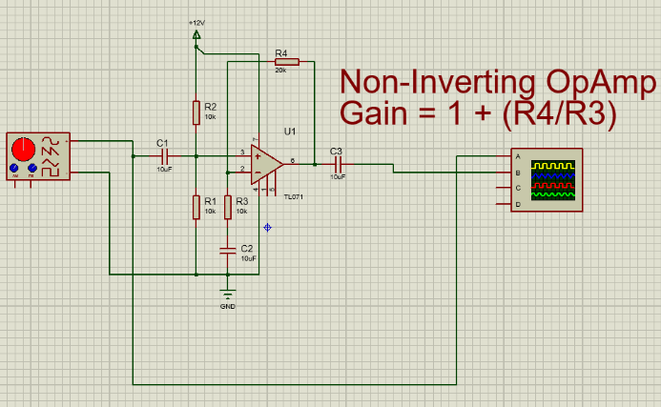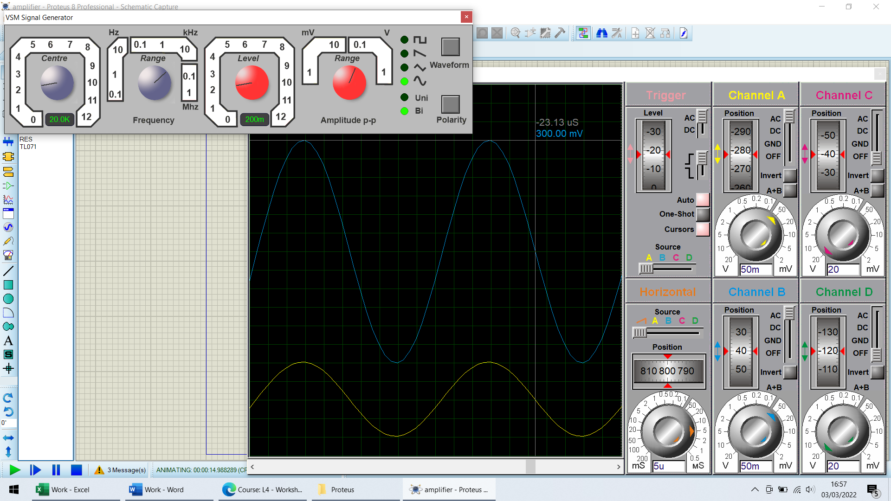

The function generator produces a frequency and amplitude based on the four dials, the waveform type is selected using the button, this cycles through Square, Saw-Tooth, Triangular and Sinusoidal waveforms. The grey dial running 0-12 selects the magnitude of the frequency and the second grey dial is a multiplier ranging from 0.1Hz – 1MHz, similarly the red dial running 0-12 selects the magnitude of the waveform amplitude and the second red dial is a multiplier ranging from 1mV to 1V.
The Oscilloscope displays the waveform output by the function generator, the wheel allows you to independently move x-axis of each wave vertically to allow you to better see the wave you are intending to measure. The slider allows you to select the type of coupling used at each channel or to turn off that particular channel, there is also a button to invert the waveform displayed. The two nested dials provide a course and fine adjustment the y-axis of each waveform displayed. I did not change any of the trigger settings – leaving it as AC coupled, triggered by the rising edge of a waveform, and leaving the Auto, One-Shot, Cursors and the source as they were. The time axis is controlled by the selector, horizontal position wheel and the orange nested dials. The dials change the time base per division allowing signals to be seen more easily by matching the time base to the wavelength based on the frequency of the signal. The signal amplitude was measured by aligning a cursor with the peak of the waveform.
The simulated test was conducted with a 200mV amplitude output from function generator.
LM741
Frequency (kHz) |  | Voltage (mV)
0.1 |  | 300
0.2 |  | 300
0.5 |  | 300
1 |  | 300
2 |  | 300
5 |  | 300
10 |  | 300
20 |  | 298.75
50 |  | 297.5
100 |  | 288.75
200 |  | 245
500 |  | 115
Maximum Value | 300 x 0.707 = 212.10 |  | 250 < Max Value < 260 kHz

TL071
Frequency (kHz) |  | Voltage (mV)
0.1 |  | 295
0.2 |  | 300
0.5 |  | 300
1 |  | 300
2 |  | 298.75
5 |  | 300
10 |  | 300
20 |  | 298.75
50 |  | 298.75
100 |  | 298.75
200 |  | 292.50
500 |  | 267.50
1000 |  | 210.00
Maximum Value | 300 x 0.707 = 212.10 |  | 960 < Max Value < 980 kHz

We performed the simulation twice with two different Operational Amplifier Integrated Circuits to show the difference between common available op amp chips. The main difference between the two simulated chips is the bandwidth of the two chips, the LM741 has a greater bandwidth than the TL071. This can be seen by the difference in voltage around 100Hz, the TL071 chip had a smaller gain from 100Hz – 200Hz when compared to the LM741 as this chip has a consistent gain from 100Hz – 10kHz.
Breadboard Test of Operational Amplifier
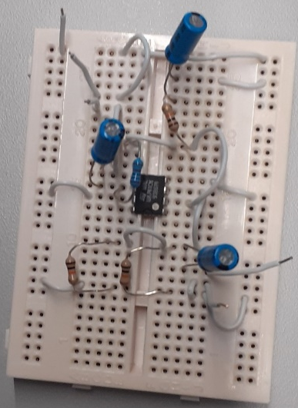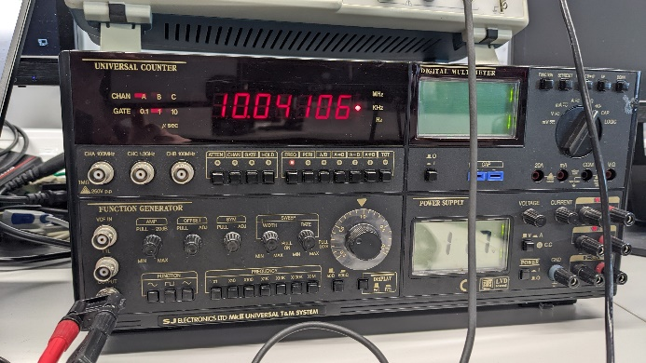
To test the circuit in breadboard I used a function generator and an oscilloscope. The function generator produces a waveform based on the frequency selected using the dial and the multiplier buttons along the bottom, and the level dial changes the amplitude of the output signal.
I selected a 1, 2, and 5 from the frequency dial and then scanned through the frequencies being measured using the multiplier buttons, this allowed me to quickly develop my results table by testing the full range of frequencies by only changing the number three times.
I then used the measure function on the oscilloscope to measure the frequency and peak to peak value of the incoming signal, I measured a set value from the function generator to the oscilloscope to set the output level of the generator, I could then place my circuit between the generator and oscilloscope to test the amplification of the circuit.
This test was conducted with a 200mV amplitude from Function Generator
UA741CN
Frequency (kHz) |  | Voltage (mV)
0.1 |  | 372
0.2 |  | 376
0.5 |  | 376
1 |  | 376
2 |  | 380
5 |  | 380
10 |  | 380
20 |  | 380
50 |  | 384
100 |  | 376
200 |  | 192
500 |  | 82.4
1000 |  | -
Max Value | 384 x 0.707 = 271.49 |  | 140 < Max Value < 160 kHz

Easy-PC Production of Operational Amplifier
Circuit Schematic
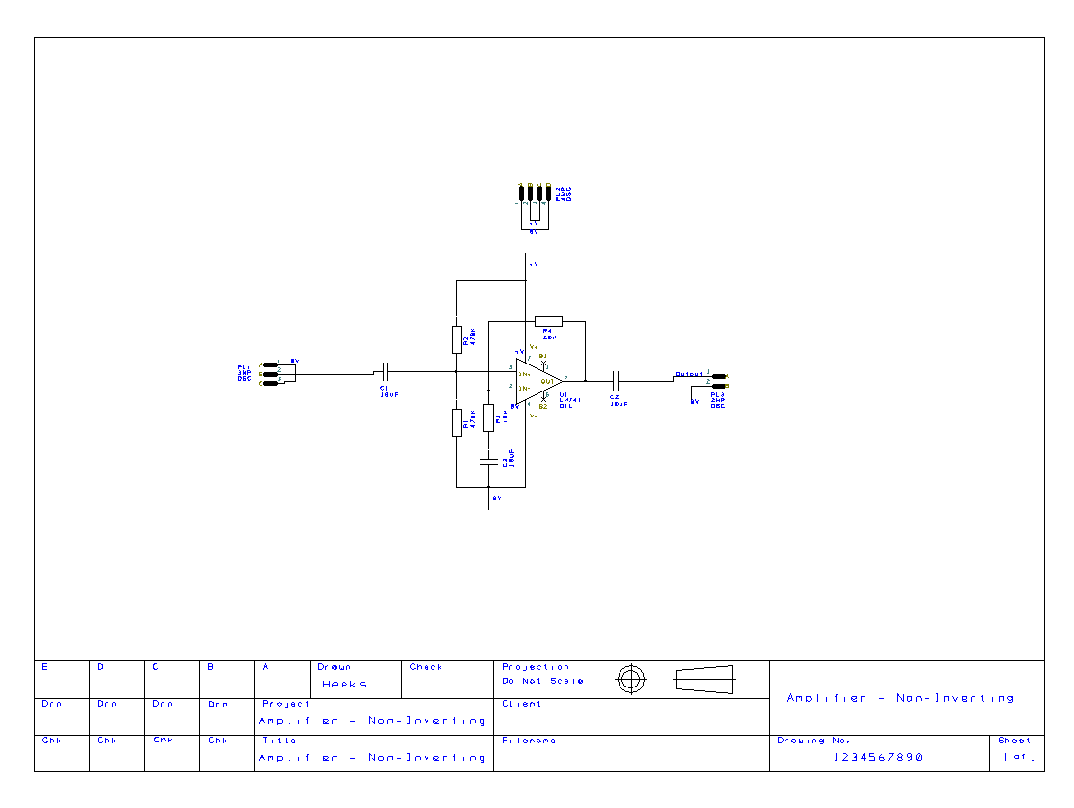
Schematic Design
I selected the components to produce the circuit from the easy-pc library, these components include the UA741CN operational amplifier integrated circuit, resistors, capacitors and the 2WP, 3WP and 4WP pins. I layout out the resistors and capacitors around the Op Amp, next I made all the wire connections between the components, then I labelled all the resistors and capacitors with their values. Finally, I connected the pins to the relevant wires or nets.
To produce the nets on easy pc I had to right click on each wire that needed to be assigned a net to bring up a menu. I then selected change net to bring up the available nets that can be used, I was then able to change the names of the nets that I wanted to. I was then able to assign the wires on the pins the same net, this provides an electrical connection between wires with the same nets through the net lists.
To finish off the schematic design I added the relevant design information: Title, Drawing Number, sheet number, name of designer, and the project name.
When I was ready to produce the PCB layout of the circuit I preformed a design rule check to ensure that there were no issues with the schematic before I translated it to the PCB design.

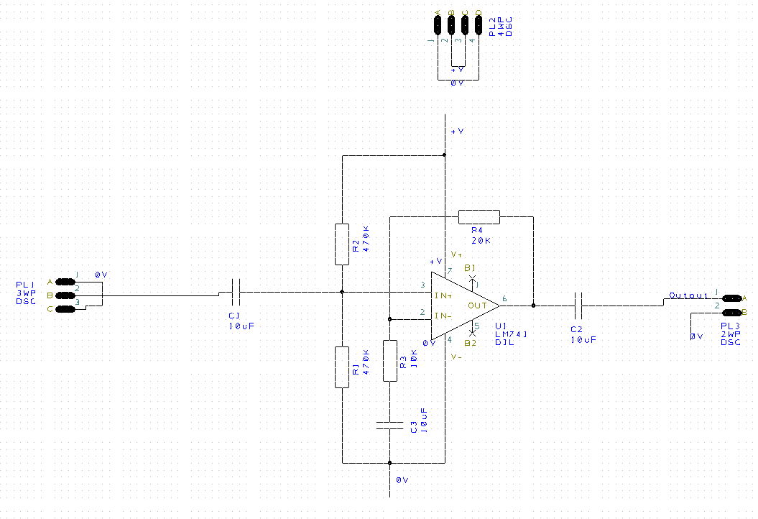

PCB Design
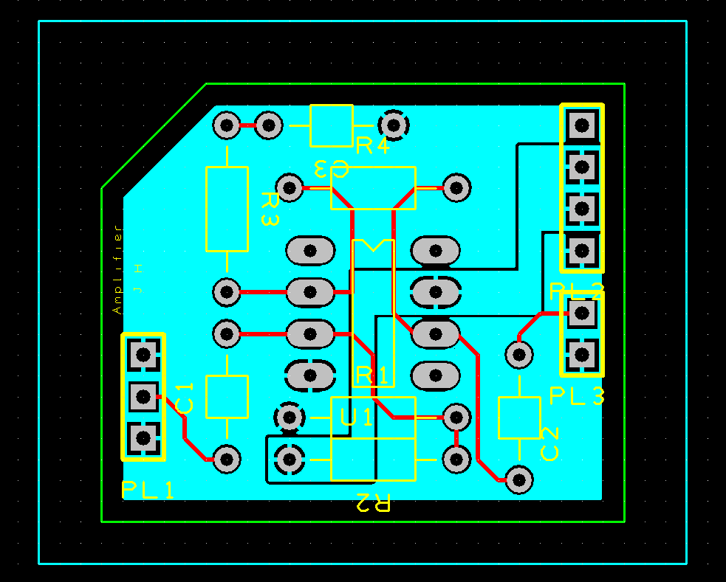
Design Process
On the schematic viewer select the tools tab from the menus and select translate to PCB. From there I placed all of the components, using the ‘rats nest’ I tried to align components that had signal line connections to try and keep them short and ensure there were few 90 degree bends in the track. I then drew a board area around all the components to set the physical size of the PCB that all the layers and copper pour areas had to adhere to.
My next task was to draw out copper pour areas for the +V and 0V nets, I did this by highlighting the two nets to see which pins were attached to the two nets and then draw around the pads attached to the +V nets without trapping any of the pads attached to the 0V net. Once I had drawn the shape, I could then right click within the pour area boundary and select pour copper and repeated the process for the 0V net. I then had to ensure that they two copper areas made up the bottom layer of copper, I could then draw out the signal lines between components on the top layer of copper.
The final addition to the PCB was a title to identify what type of circuit the board was produced for and my initials to ensure that I could identify the board as my own among others.

Improvements for Future Design
Some improvements that I could make for future PCB production are. I should have moved the silk screen labels to ensure all are visible when components are soldered into place, typically they should all be in the same orientation and should not intersect other silk screen printed on board. PL2 is close to a pad, this could misprint and cover the pad causing the solder joint to make a poor electrical connection.
Some smaller design changes for the future include. The PCB title, this should ideally be written in copper not silk screen as it will last longer and not rub off over time. It is good practice to ensure the power pins should be either side of the 0V pins. And any alteration to the board shape add to the manufacture costs.
Physical PCB
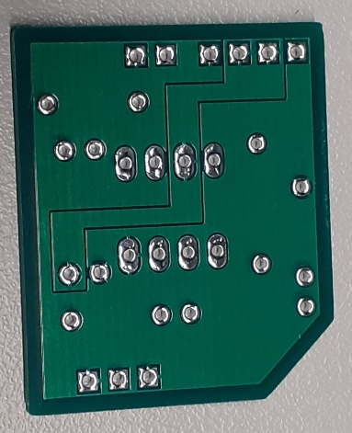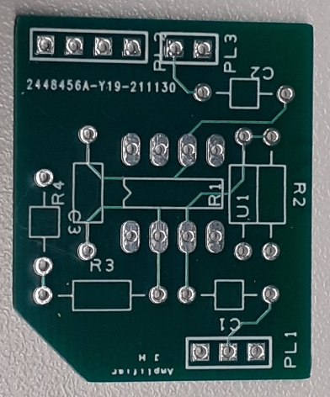

Soldering
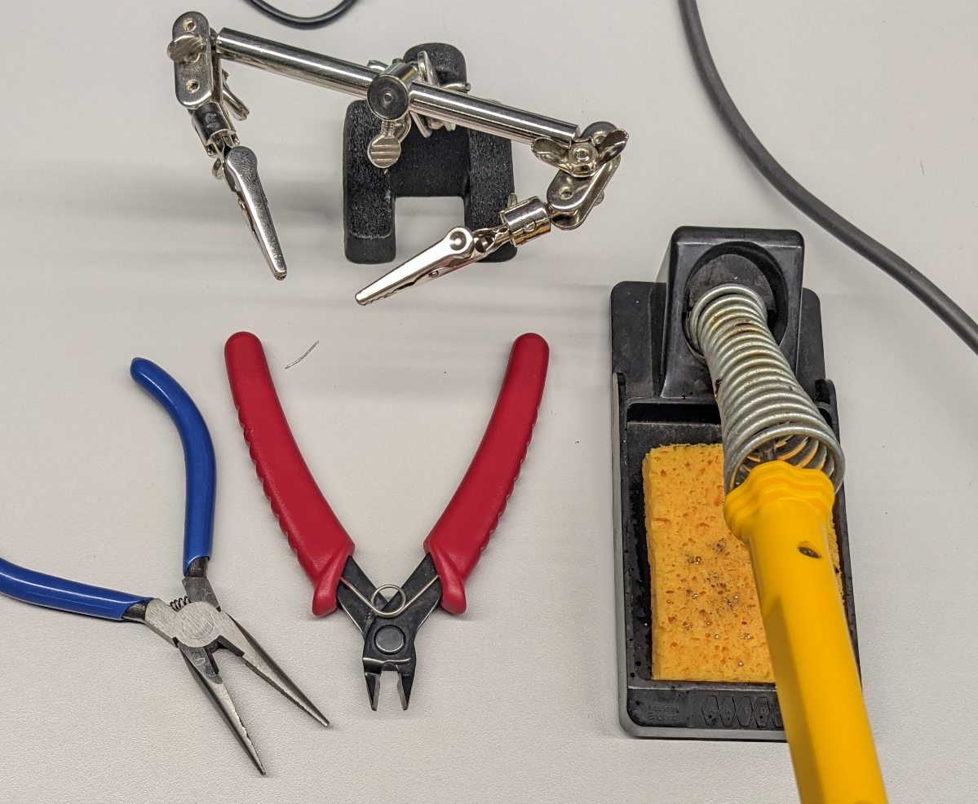
I used a soldering iron to melt the solder wire to form the electrical connects between the components and the pads on the PCB. I used the board holder to hold the PCB while I soldered components onto the board this ensured that I was able to solder and hold the board in one position for the duration of soldering more easily. I used the long nose pilers to pre-bend the component legs so that they sat flat against the board to produce a neater looking circuit which will be easier to follow. I used the side cutters to cut off the excess leg of the component once soldered in place, and to cut the wire to length.
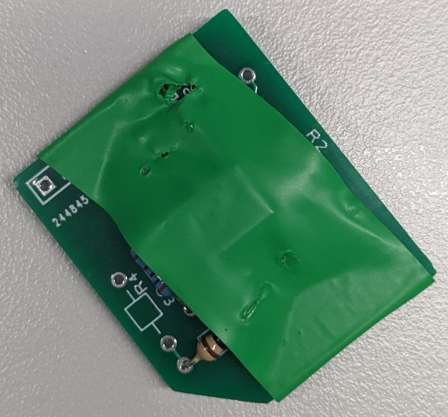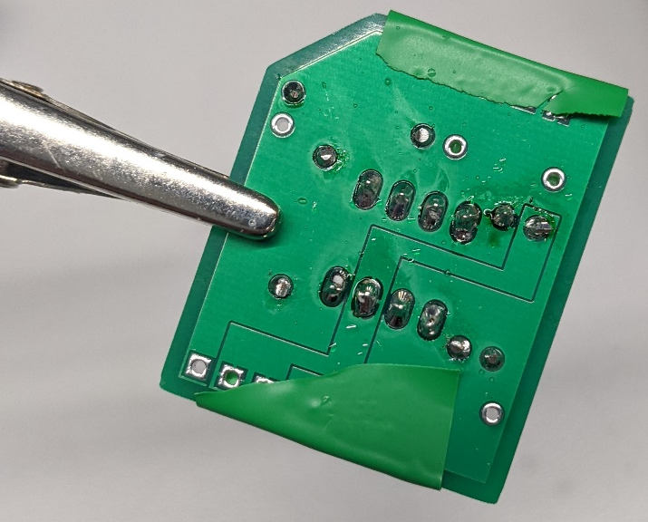
I used electrical tape to hold the resistors and IC in place while I soldered them so that I did not have to bend the legs of the resistors out and the pin did not fall out while being held above the desk by the board holder. Having not folded the legs of the resistors over I was able to produce cleaner solder joints, and the solder was able to completely surround the components legs and cover the pad this provides a much better electrical connection.

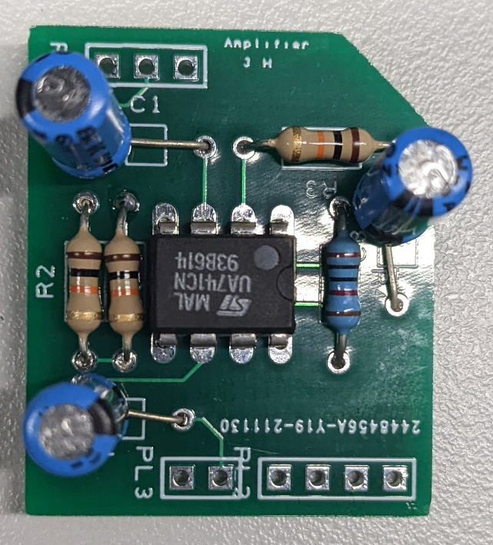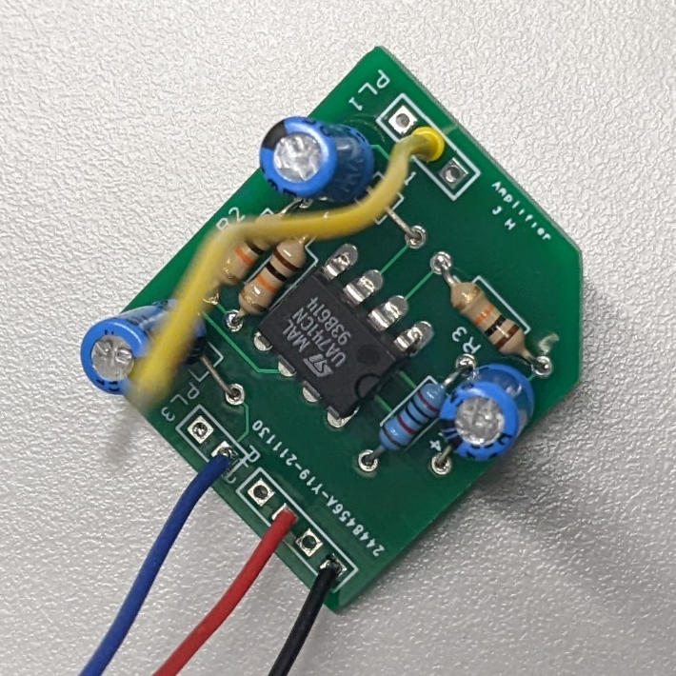

Physical PCB Testing
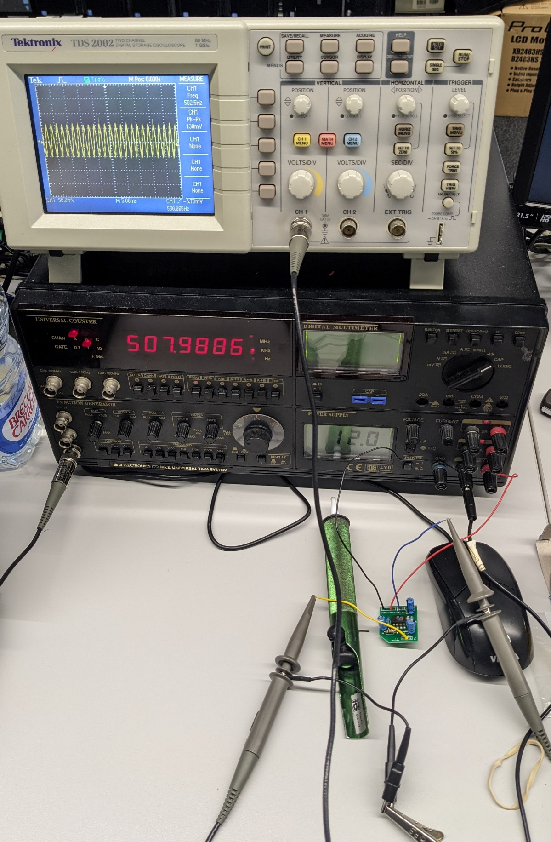

Frequency (kHz) | Voltage (mV)
0.1 | 126
0.2 | 130
0.5 | 128
1 | 130
2 | 136
5 | 134
10 | 128
20 | 120
50 | 86
100 | 68
200 | 48
500 | 36

This test was conducted with a 110mV amplitude from Function Generator
The test of the PCB was carried out in the same way as the breadboard test. However, this time the input amplitude from the function generator was set at 110mV. This will give a lower gain than the other tests conducted prior to this.
Comparison
I completed four tests; I completed two simulated tests with two different operational amplifiers, I also completed two physical tests on a breadboard and later with a PCB. The three ICs I used where LM741, TL071, and UA741CN.
I simulated the LM741 and TL071 ICs on Proteus circuit design and simulation software, the two ICs produced very similar results for output voltages, gain and gain bandwidth products. In contrary the breadboard and PCB results were much different to the baseline simulated results, the breadboard tests provided larger output voltages and therefore gain and GBP values. However, the PCB results were much lower results.
The gain produced by the simulations peaked at 1.5, with a minimum value of 0.575 for the LM741 IC and 1.05 for the TL071 IC. Whereas the breadboard peaked at a gain of 1.92, with a minimum of 0.412 and conversely the PCB produced a peak gain of 1.24, with a minimum value of 0.327. The gain bandwidth product of the TL071 IC is far greater than the other two ICs as it typical has a GBP of 4MHz in comparison to the two other ICs with a typical GBP of 1MHz.
The typical differences between simulation and physical testing are the resistances of power supplies, wires and components, tolerances of components and ideal test equipment. The simulation does not account for the resistances in wires and at power supplies as these are physical attributes of real components and will alter the data received from the test circuit. The tolerances of components are also discounted in low end simulation software delivering different results to the real components as these have a tolerance that will sway the results of the physical test in comparison to the simulation. Simulation assumes ideal test equipment with no internal resistance and perfect continuous output whereas in a physical test the test equipment will vary over time and produce internal resistances on top of the external resistances.

Frequency (kHz) | LM741 |  |  | TL071 |  |  | UA741CN |  |  | PCB
Frequency (kHz) | Voltage (mV) | Gain (dB) | Gain Bandwidth  Product (Hz) | Voltage (mV) | Gain (dB) | Gain Bandwidth  Product (Hz) | Voltage (mV) | Gain (dB) | Gain Bandwidth  Product (Hz) | Voltage (mV) | Gain (dB) | Gain Bandwidth  Product (Hz)
0.1 | 300 | 1.5 | 0.15 | 295 | 1.475 | 0.1475 | 372 | 1.86 | 0.186 | 126 | 1.145454545 | 0.114545455
0.2 | 300 | 1.5 | 0.3 | 300 | 1.5 | 0.3 | 376 | 1.88 | 0.376 | 130 | 1.181818182 | 0.236363636
0.5 | 300 | 1.5 | 0.75 | 300 | 1.5 | 0.75 | 376 | 1.88 | 0.94 | 128 | 1.163636364 | 0.581818182
1 | 300 | 1.5 | 1.5 | 300 | 1.5 | 1.5 | 376 | 1.88 | 1.88 | 130 | 1.181818182 | 1.181818182
2 | 300 | 1.5 | 3 | 298.75 | 1.49375 | 2.9875 | 380 | 1.9 | 3.8 | 136 | 1.236363636 | 2.472727273
5 | 300 | 1.5 | 7.5 | 300 | 1.5 | 7.5 | 380 | 1.9 | 9.5 | 134 | 1.218181818 | 6.090909091
10 | 300 | 1.5 | 15 | 300 | 1.5 | 15 | 380 | 1.9 | 19 | 128 | 1.163636364 | 11.63636364
20 | 298.75 | 1.49375 | 29.875 | 298.75 | 1.49375 | 29.875 | 380 | 1.9 | 38 | 120 | 1.090909091 | 21.81818182
50 | 297.5 | 1.4875 | 74.375 | 298.75 | 1.49375 | 74.6875 | 384 | 1.92 | 96 | 86 | 0.781818182 | 39.09090909
100 | 288.75 | 1.44375 | 144.375 | 298.75 | 1.49375 | 149.375 | 376 | 1.88 | 188 | 68 | 0.618181818 | 61.81818182
200 | 245 | 1.225 | 245 | 292.5 | 1.4625 | 292.5 | 192 | 0.96 | 192 | 48 | 0.436363636 | 87.27272727
500 | 115 | 0.575 | 287.5 | 267.5 | 1.3375 | 668.75 | 82.4 | 0.412 | 206 | 36 | 0.327272727 | 163.6363636
1000 | - | - | - | 210 | 1.05 | 1050 | - | - | - | - | - | -

