

DSR Research Topic
  - the impact virtual leraning envirioment
Pamela Santos Cepeda ( 196655)| Digital Skills and Research Methods | 15/08/2020

Table of Content

Introducction 1
Background 2
Aims and Objectives 3
Conclusion 4
Survey 5
Exel

Introduction to the Research Topic (VLE)
OVERVIEW OF VIRTUAL LEARNING ENVERIOMENT
Virtual learning education is a way with which we can all work in some way and get closer to being more face to face. This process is somewhat complicated since for this to be known to all the members, they must have the commitment and focus on it in the best possible way.
Computer Based on ‘’Internet Based, Remote Teacher Online, Blended Learning, facilitated virtual Learning, Online Learning, Full time online were introduced’’. (Chapter 11)
We all have at our disposal (VLE). In some way or another, what is most used are students of all grades and teachers, to carry out all this process and be effective.
All this is a great leap in our way of living because it makes life “easier” and more affordable. Since we all have all the information we need at hand and we can (KANIMOZHI, 2018)

Background
In this typical educational institution, you sometimes have trouble making these measurements quickly and efficiently. They usually use the IT department, they also have support for the classes, they also have the (CMS) course of management system to download and be able to receive the assessments in an efficient way, we also have the modules which is where we can access all the classes and your readings, schedule. This also technology is also characterized by is supervised by information and learning manager of e-learning and web services, which use communication technology, IT functions, digital graphics, communications and IT, systems analysis and design, diploma Extended Resources range from basic word to quizzes, link games, and interactive work. The students responded well to the interesting and well-populated course. (Lindsay Jonhston, 2012) (Archives, 2013).
An investigation at the Rodillian Academy in Wakefield which is ranked 5, made an investigation on the VLe, in this investigation it was shown that it is possible to have successfully made this great invention, since a platform has been created in which the students have everything necessary to immediately access all the information, schedule, books created by it, as well as monitoring the attendance of each of these students, in this they have the same commitments, and reach their marks if not fail. Also, the ability to deliver courses to many students. On this platform, teachers are given authorization to call their attention if they do not complete their duties. Institution benefits because you can pay less for your employees, since it does not require as many, hours instead of work, savings in printing, etc. (John Catt Educational, 2017).
This new technology is posing a challenge that involves the person doing it, both students and teachers, who must be able to adapt and carry all these as are:
- More investment of time by the teacher.
- Minimum technological skills by the teacher of the students.
- Requires students to have autonomous learning skills.
- It can decrease the quality of training if there is not an adequate teacher-student ratio.
- Requires more work than conventional.
- It supposes the low quality of many resources and current contents.
- Know how to identify the quality of information found on the internet.

- Use different multimedia information resources as new learning methods.
- Understand the importance of teamwork, even if it involves doing individual work.
- Develop oral and written skills.
- Know as much as possible digital tools that allow facilitating actions related to your professional area (digital editing programs, creation of plans, data management, among others).
- Development of an investigative spirit that seeks to solve doubts through the breadth of knowledge that you can find on the internet.
- Know how to adapt to the real world, outside of virtual reality. (Archives, 2013)
For all this to be effective we need some things to work like, these tools that are essential for the realization of this advance in technology and:
- Panopto (Lecture Recording)
- Blackboard (Virtual Learning Environment)
- Turnitin (Plagiarism detection)
- Meantime (Real-time polling)
- Leganto (Reading list tool)
- WebPA (Peer assessment)
- Mobius assessment (Mathematics tool)
- Piazza (W&A tool)
- Starfish (Welfare and academic support)
(Campus, 2020)
Also I can add, they use Moodle through we can use this tools: Course Management, Class management, Communication Tools, Student Tools, Content Management, Assessment Tools and Management System (CMS) (Which is ideally to make dynamic course). (D. Benta, 2015).

Lack of experience, resistance in which some teachers to be able to use this platform, the sending of works, documents and emails to the students whose many times they accredit not seeing or knowing nothing about this matter, lack of attention of the classes, hindered in learning and capturing everything the teachers say, sometimes the forums or books are not complete and do not have everything they need to carry out their work, much more effort on the part of the teachers, lack of communication between the teachers and students, you cannot do interactive exercises in a way that is totally successful, you have to be monitoring and constantly calling on the students as they get confused and do not attend adequately, it is not a teaching that can be qualified as quality or truly adequate, students do not show a high learning power like a normal classroom (face-to-face). It must also be recognized that many teachers are not truly qualified to teach online, it is not one of their greatest strengths, that the skill is different, the role of teachers changes, with this I am not saying that it is not a good advance to a project, innovative technology, but to make it effective and efficient it is necessary to have several criteria, concepts, and adequate teaching staff,
‘’ For me, life at the UOC is a desert. I do not communicate with anyone. I think most of the students are not looking for any relationship with people, just looking for a degree.’’ (Ros Híjar, 2001).

- Validate the material that we are going to use material.
- Fix possible accessibility issues.
- Available validators include these: Bobby from
- Centre for Special Applied Technology (CAST) and the W3C HTML Validator.
- View the material in a text browser.
- Explore your site through a voice browser.
- See the material in alternative conditions
- try to get copyright
- in team recordings be sure that each member has accepted the terms and conditions.
- use an original and special platform.

The opportunity is that the VLe gives us is that it allows us to expand the teachings of those people who are in the university and also the postgraduate courses, along with the correct capacity of the people of these companies, these normal spaces allow us a greater expansion in our schedules and innovation in teaching beyond classes.
Meaningful learning: the main objective as a student is for students to have meaningful learning, that is, they assimilate information and the possibility of putting it into practice. Virtual education gives students access to review the content as many times as necessary and develop activities at their own pace. The advantage over traditional education is that the student has the possibility of reviewing your sessions without interrupting the process of other students, which in the long term will be beneficial for both him and his companions.
Asynchronous communication: in virtual education, communication between the student can be asynchronous, that is, the interaction through digital means takes place at deferred times, avoiding delays in the learning process. Traditionally, the teacher can respond at a time at his convenience and take the time he needs to answer the questions of his students.
Additional economic income: This allows students to work outside their area or far from where they live and to be able to acquire money and study at the same time.
Reduction of costs: Low costs since being able to stop printing pdfs, documents, paper, schedules ... you save more online, and in transportation, just like for teachers. Less investment of time. (Quiroz, 2014)

Aims and Objectives
AIMS OF THIS RESEARC
For VLe it has software that we can connect and be in class from any country in the world and at the same time be able to have a more flexible schedule, savings in costs, papers, faster interaction between students and teachers.
The negative of this is that it is much more difficult to calculate or to know how many students are really capturing the main of the entire subject or if they are finding out or not, or at the same time if their learning level is correct and we also run risks of disconnecting or discouraging us, and not having face-to-face communication and a closer relationship with your teachers can also be very negative.
To all this process of VLe, I have to say that it does a lot to improve since it is a new system and takes its due time. (Nejad, 2012)
According to an investigation from the University of Cumbria, the VLe had a positive impact on the students, this indicates that they obtained a better score and learned more than studying from the university. This makes students more willing to study on their own and in an independent way, this helps students to grow so that they study better. It is also a way to help students become independent, and to help the government as it would save a lot of labour and materials.
This research also concluded in the students that in class they are not as participation in online classes, they turn out to be more introverted and adapt better

CONCLUSION:
for me it was very interesting to analyse all this data with respect to the VLE, because I have realized that the new systems and software are helping us to have a closer and better personalized education available to everyone, it is already easier for everyone via an app in this case Microsoft team, it has its negative side but it is the best invention so far.

Survey
Question a | Strongly Disagree | Disagree | Neutral | Agree | Strongly Agree | Minimum m Score | Maximimum m Score
Q8 | 1 | 1 | 10 | 4 | 2
Q9 | 1 | 3 | 13 | 1 | 1
Q10 | 2 | 1 | 9 | 4 | 2
Q11 | 3 | 1 | 9 | 3 | 2
Total Score | 7 | 6 | 41 | 12 | 7
Average Score | 1,75 | 1,5 | 10,25 | 3 | 1,75

Question a | Always | Often | Sometimes | Rarely | Minimum m Score | Maximimum m Score
Q1 | 3 | 6 | 7 | 2
Q2 | 5 | 8 | 4 | 1
Q3 | 2 | 10 | 5 | 1
Q4 | 6 | 4 | 5 | 3
Q5 | 2 | 8 | 6 | 2
Total Score | 18 | 36 | 27 | 9
Average Score | 3,6 | 7,2 | 5,4 | 1,8

Question a | 1 | 2 | 3 | 4 | 5 | Minimum m Score | Maximimum m Score
Q6 | 1 |  | 9 | 3 | 5
Q7 | 5 | 4 | 5 | 3 | 1
Total Score | 6 | 4 | 14 |  | 6
Average Score | 3 | 4 | 7 |  | 3

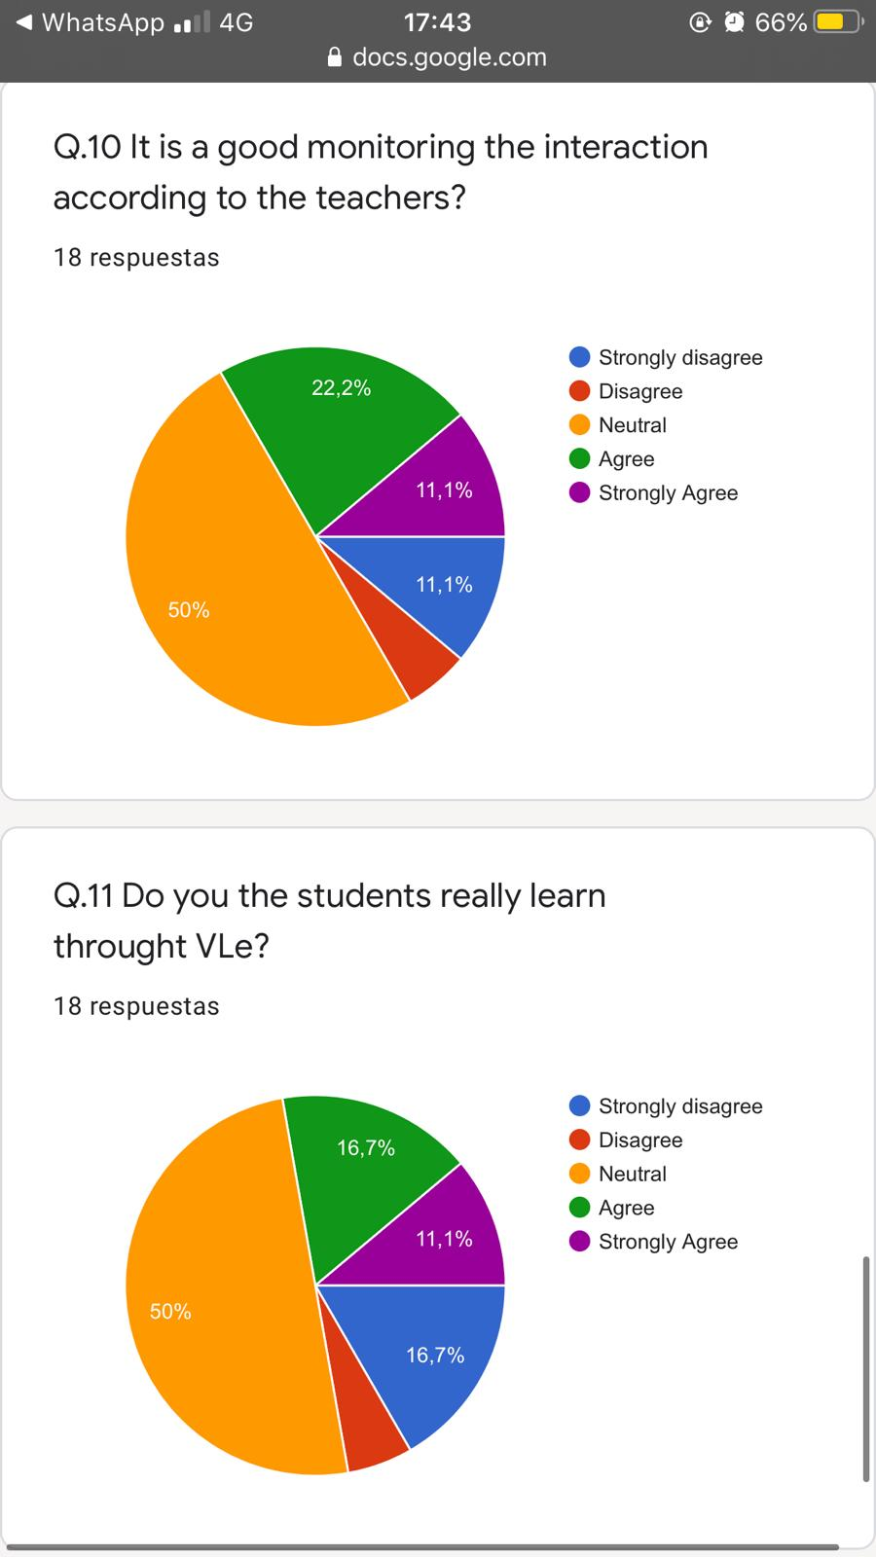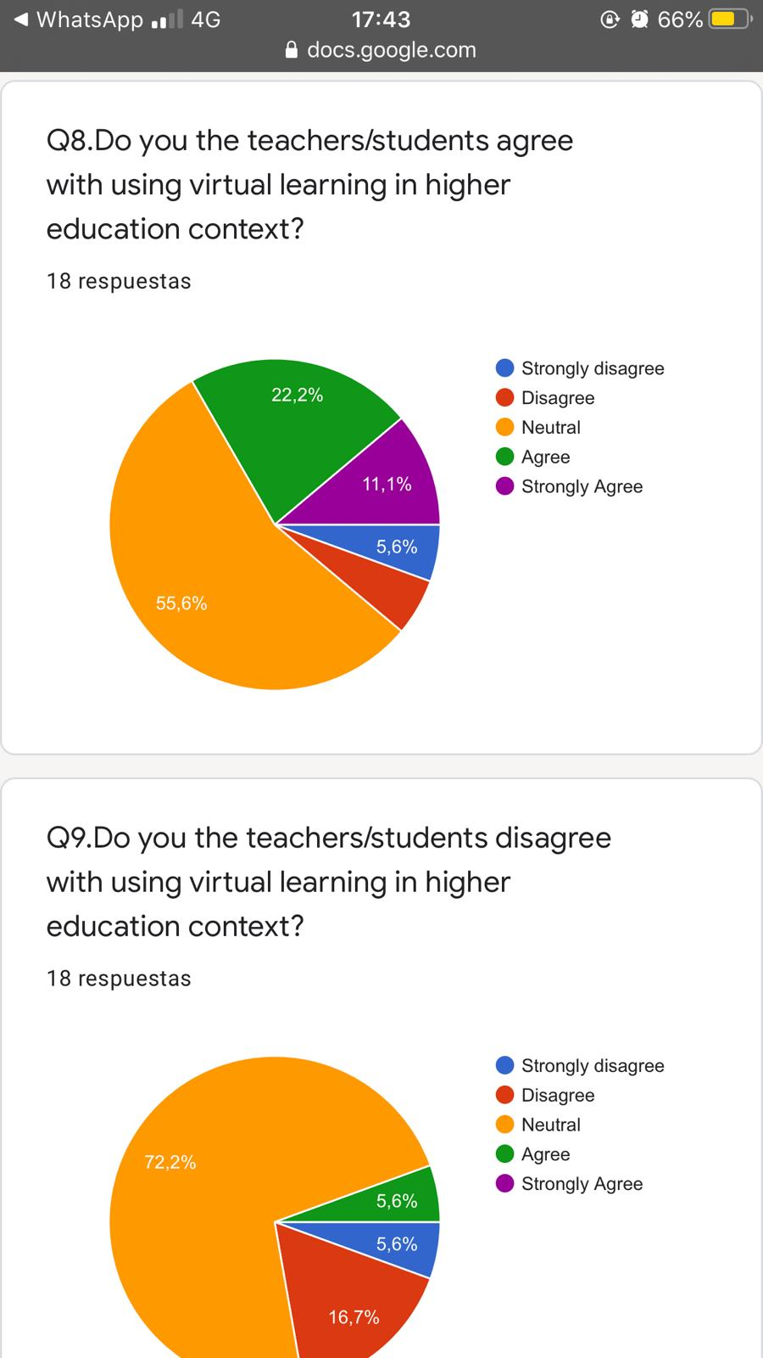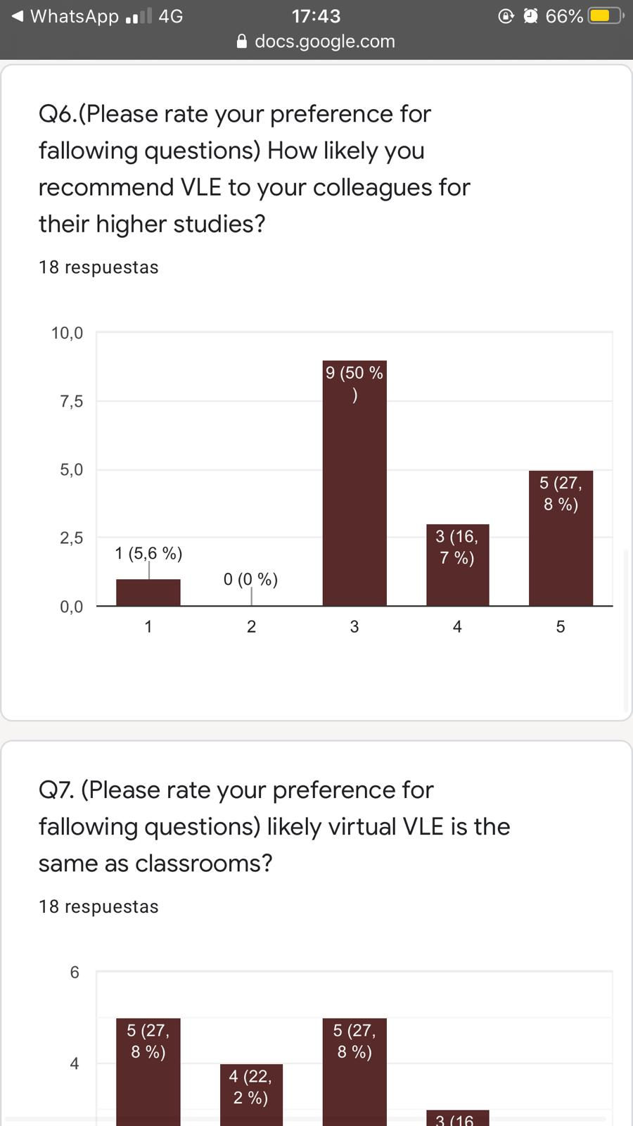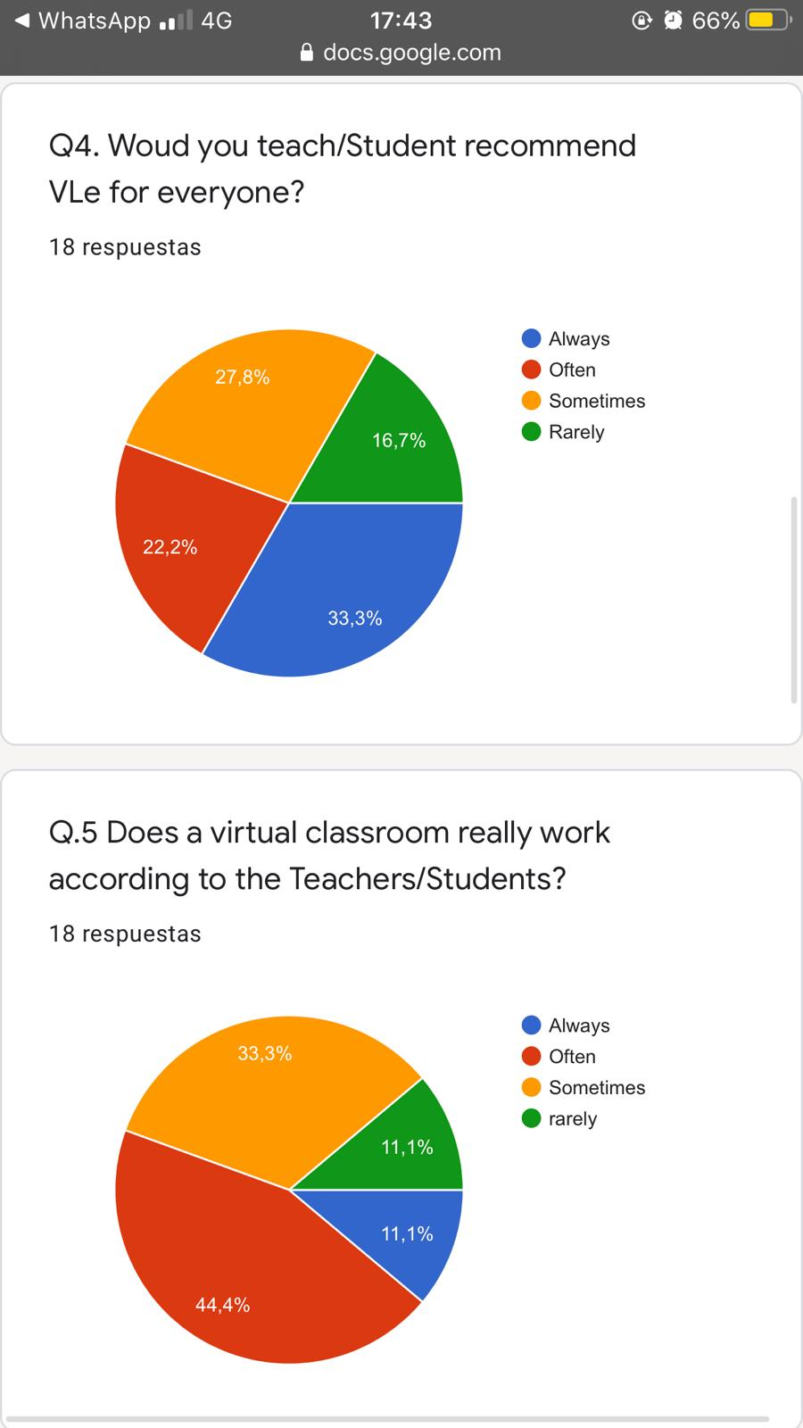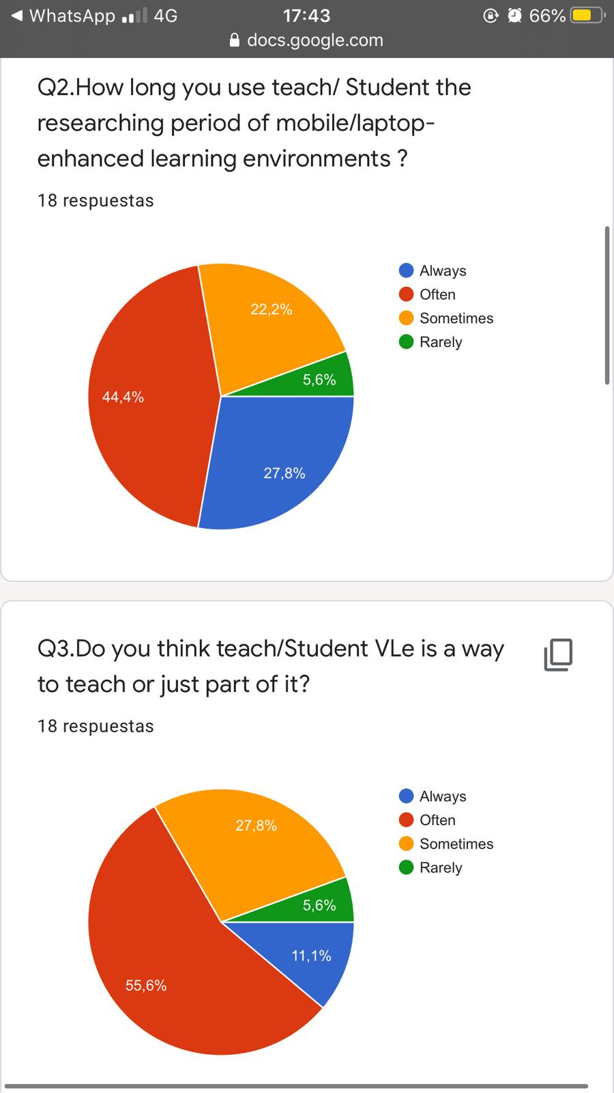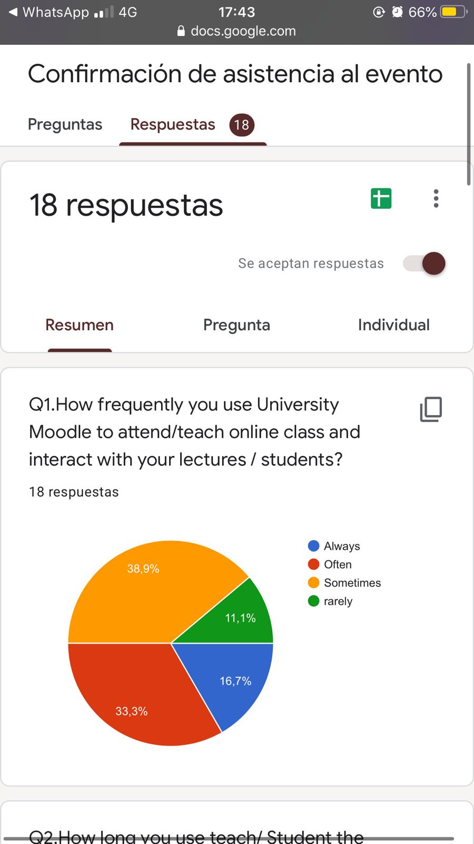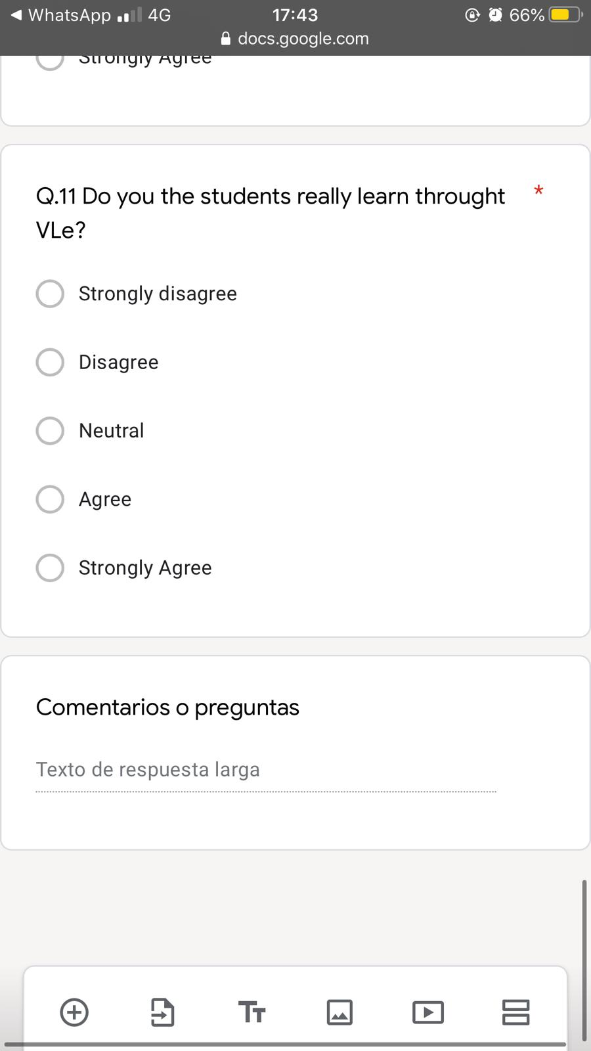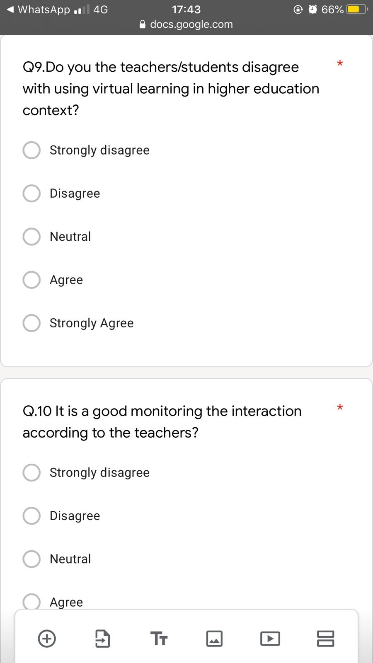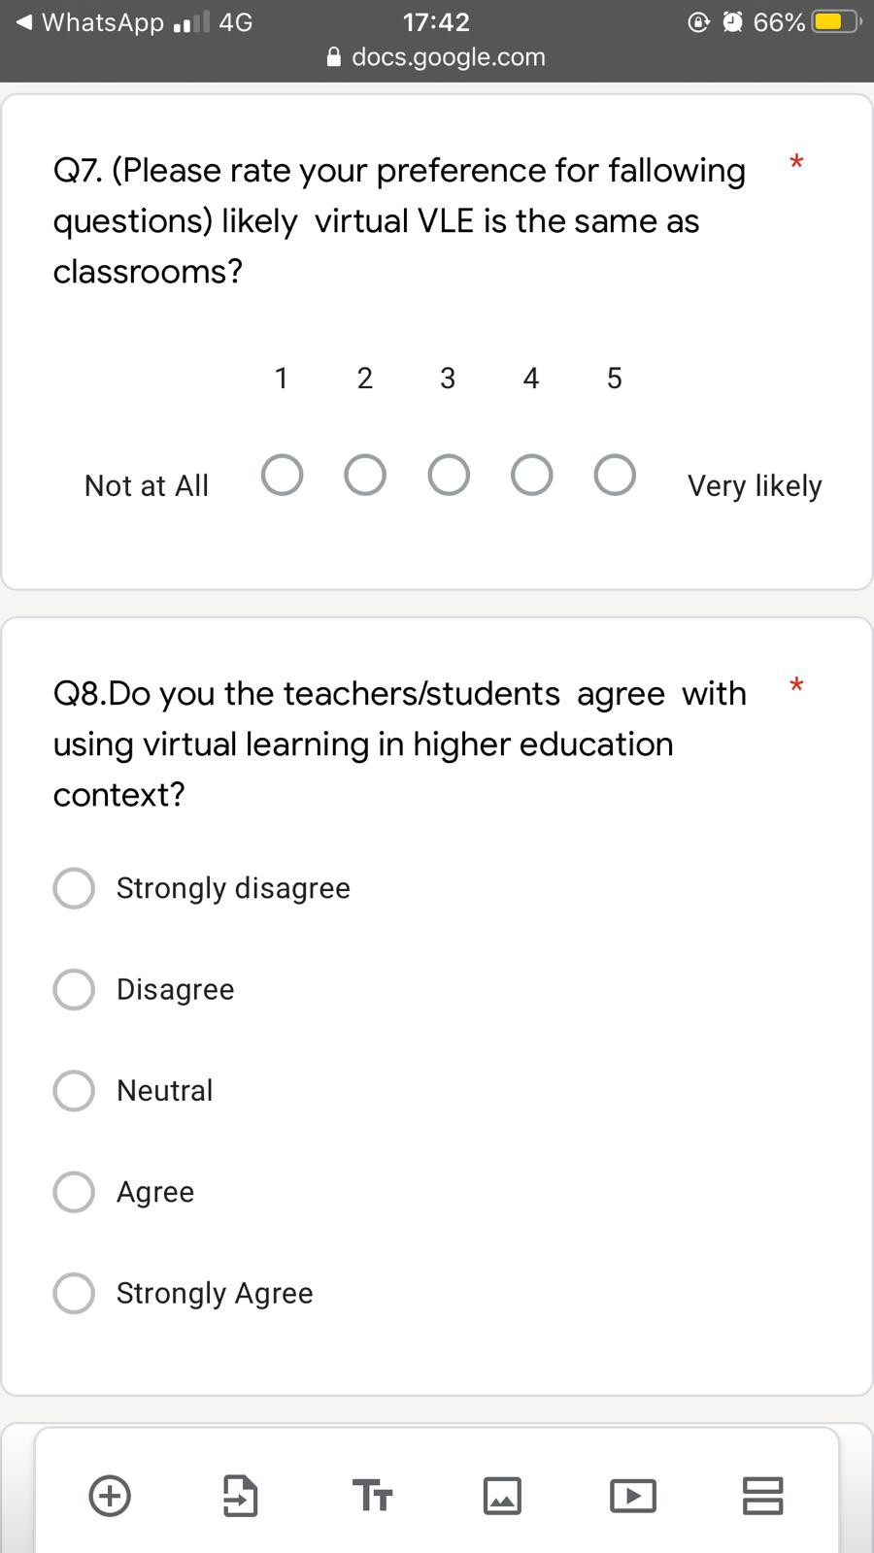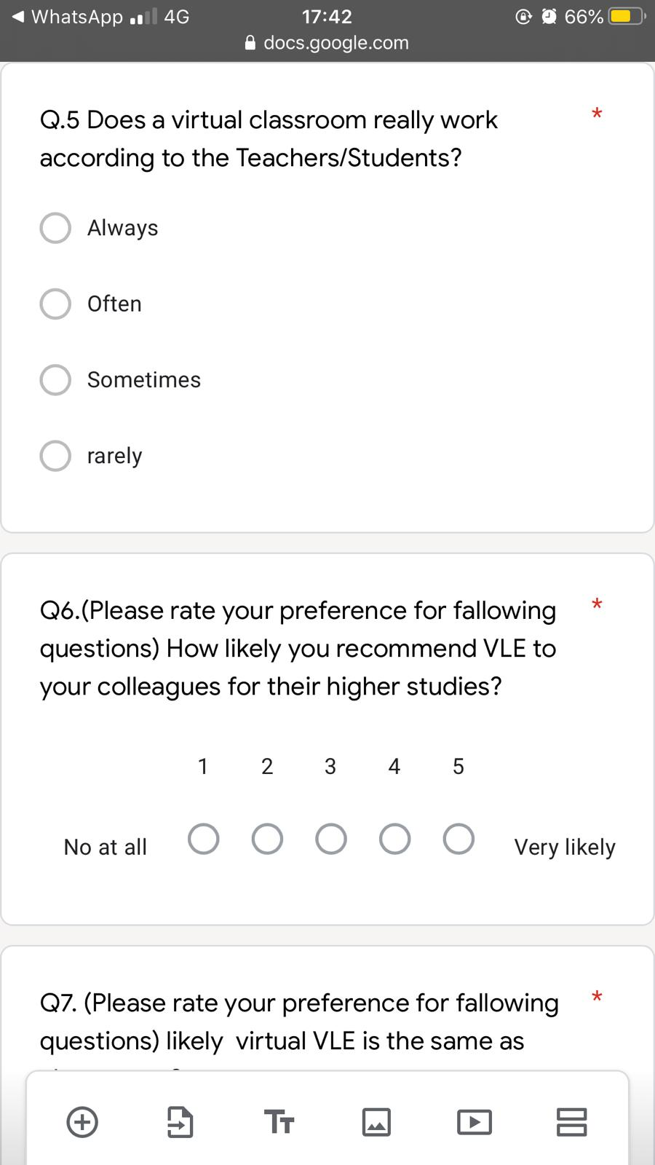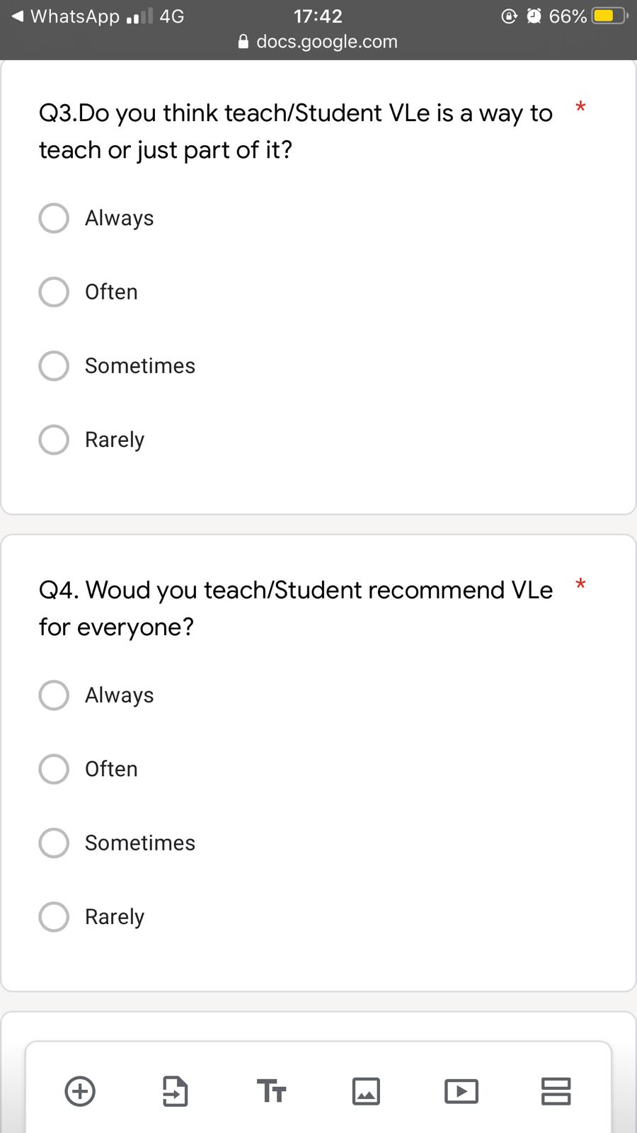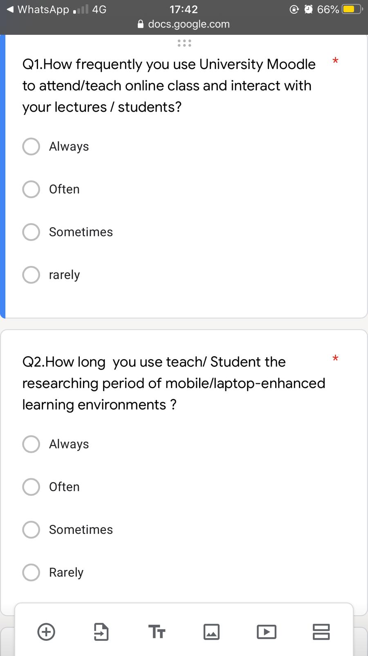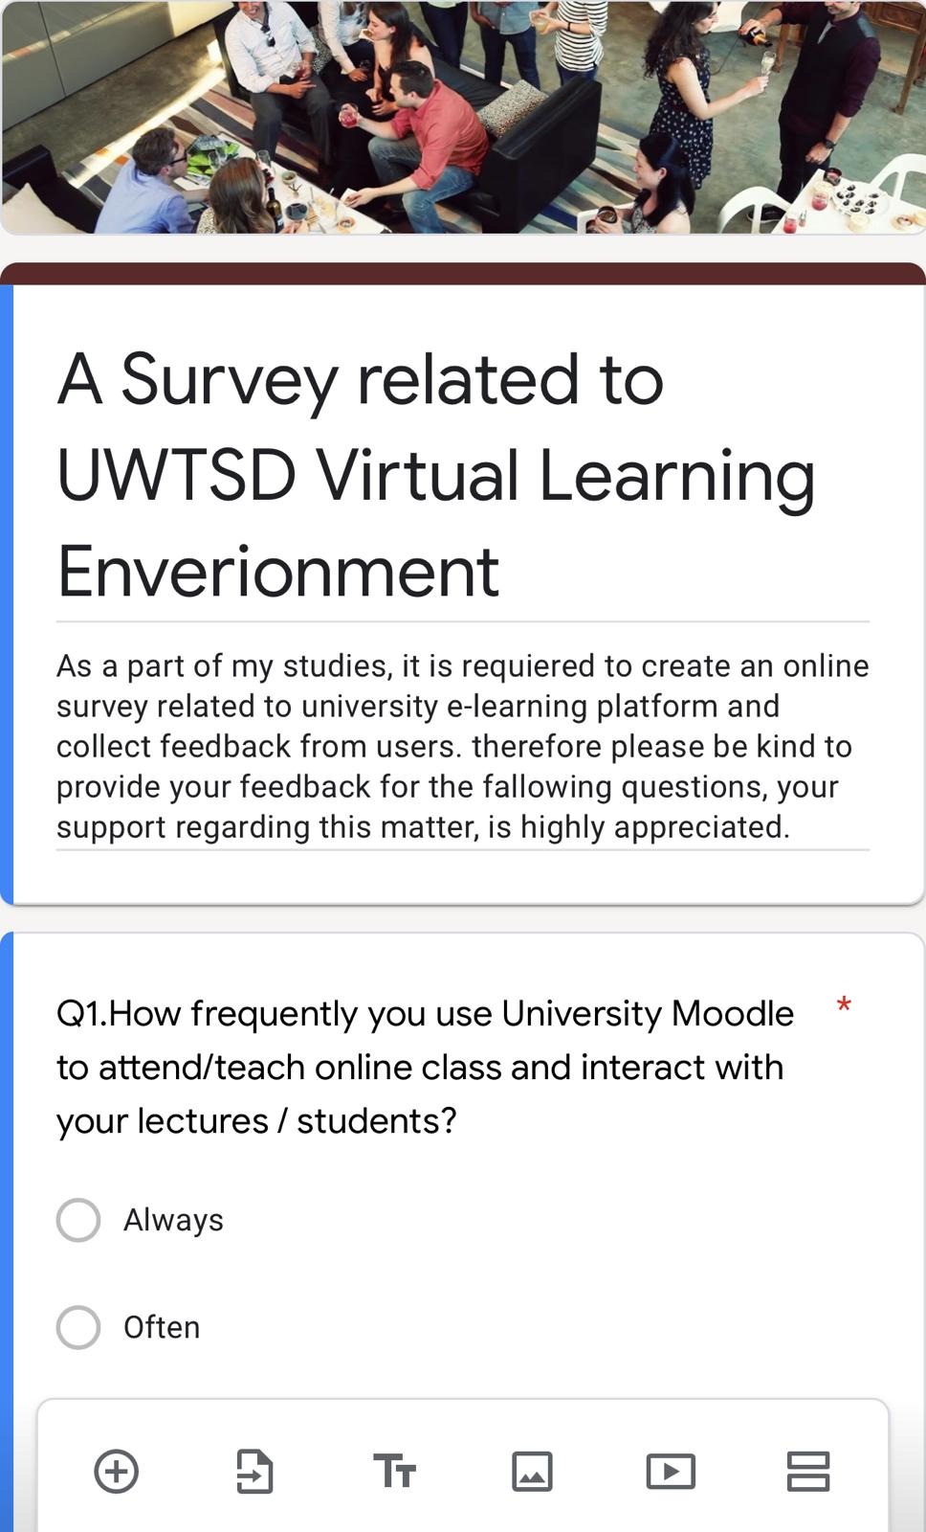

References
Archives, T. N. (2013). Virtual learning environments: e-portfolio. London: Government Licence.
Campus, S. K. (2020). Teaching and learning. London: Imperial College London.
D. Benta, G. B. (2015). Information Technology And Quantitative Magnagement . University Level Learning and Teaching via E-learning Platforms, 1366-1373.
John Catt Educational, L. (2017). VIRTUAL LEARNING. Academy Magazin, 45.
KANIMOZHI, .. (2018). VIRTUAL LEARNING ENVIRONMENT. International Journal of Advanced Research in Computer Science,, 9, pp. 11-14.
Lindsay Jonhston. (2012). In H. Probst, Virtual Learning Enverionments (pp. 436-444). United States Of America: Information Science Reference (An Imprint of IGI Global).
Nejad, E. B. ( 2012). Impact of E-learning on learning and realizing Information Society. slamic Azad University, 4(23): 5016-5020,.
Quiroz, J. E. (2014). In VIRTUALITY THE OPPORTUNITY TO INNOVATE IN EDUCATION: A MODEL FOR THE DESIGN OF VIRTUAL LEARNING ENVIRONMENTS (pp. 2224-2643). Cuba: Didasc@lia: Didáctica y Educación. .
Ros Híjar, A. (2001). Risks and opportunities of virtual learning: the experience . UOC. Digithum, (3).

