

Programme: | MBA- Masters of Business Administration
Module: | Marketing Management – Assessment 1
Module code: | LCMB7001
Student Name: | Raval Maulik Rameshchandra
Student ID: | 2209391
Lecturer: | Tushara Balendran
Internal Verifier: | Gladius  Kulothungan

Table of Contents
Introduction 3
Chosen organization Background 4
Critically appraising how Tesco can create innovative marketing strategies 6
Tesco's present issues with enhancing customer experience 7
Innovative marketing strategies for raising awareness of the brand 8
Supporting with practical examples with appropriate theory 10
Conclusion 15
References 16

Introduction
Marketing Management is the process of managing the marketing activities of an organization (Deepak and Jeyakumar, 2019). It requires generating value and communicating the right way with the customers in ways that become beneficial for both the organization and the stakeholders. It includes the planning, implementation, and control of programs designed to generate and maximize customer satisfaction and long-term customer loyalty. It focuses on the four Ps of marketing: product, price, place, and promotion. It also includes activities such as customer segmentation, market research, market analysis, customer relationship management, and product and brand management. Marketing management at Tesco involves a variety of strategies that allows for gaining a competitive leverage. Tesco utilizes a number of marketing strategies, including advertising, promotional activities, and customer service, to reach its customers and create a positive brand image (Azan and Karimah, 2022). Tesco also actively engages in research and development to ensure that it stays ahead of its competitors. Additionally, Tesco plans and implements targeted marketing campaigns to reach specific customer segments and boost its sales.
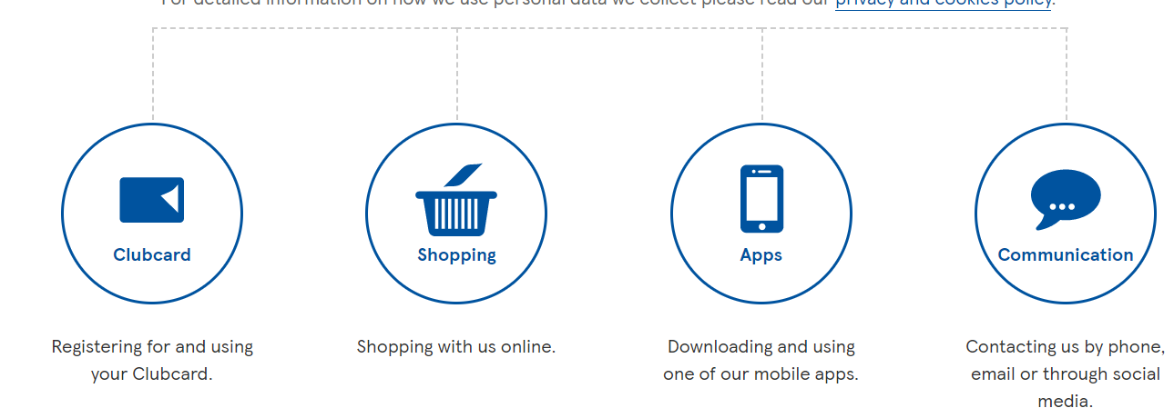
Figure 1: Tesco Customer Journey map
(Source: www.tesco.com, 2021)
Finally, Tesco utilizes digital marketing tools, such as social media, to reach its customers and boost its online presence. Marketing management plays a critical role in Tesco's success. It helps the company to understand the needs of the customers and develop the right products and services to meet those needs. It also enables Tesco to identify the right markets, set competitive prices and ensure that the right promotional activities are undertaken to increase sales (Wolny, 2022). By monitoring the performance of its marketing activities, Tesco can adjust its strategy to meet any changes in the market environment. Marketing management also helps Tesco to gain a competitive advantage by creating a unique and attractive brand identity that resonates with customers. Finally, it helps the company to build relationships with customers and create loyalty.

Chosen organization Background
Tesco is a renowned British multinational retailer. The headquarter of the organization is located in Welwyn Garden City, Hertfordshire, United Kingdom. It is the 3rd biggest retailer in the world as per gross revenues and the 9th biggest in the world in terms of revenues. It has stores in seven countries across Asia, Europe, and North America. Tesco is listed on the London Stock Exchange and is a constituent of the FTSE 100 Index (Yao and Memon, 2019). The total market capitalization of Tesco is approximately £18.1 billion as of 22 April 2015, the 28th biggest of any organization listed on the London Stock Exchange (Buisan, 2016).
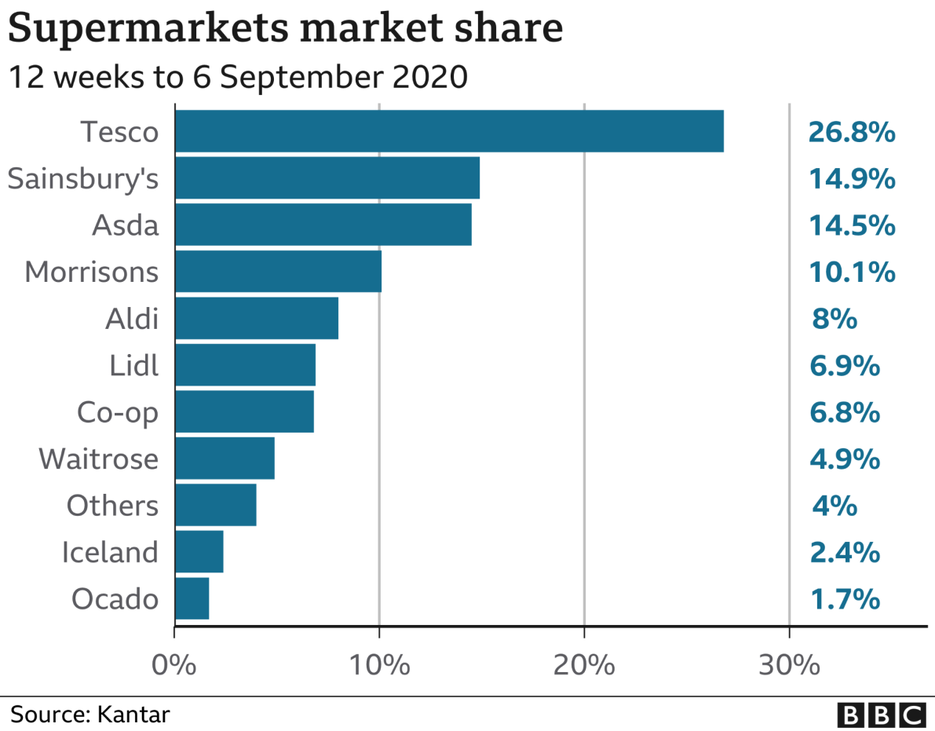
Figure 2: Supermarket share of Tesco in 2020
(Source: bbc.com, 2021.)
Tesco is one of the world's leading retailers, with a strong focus on customer service, operational excellence, and innovation. The company has developed a comprehensive management strategy designed to ensure success in the ever-changing retail landscape. This strategy focuses on four key areas:
Enhancing Customer Experience:
Tesco aims to provide customers more-than-satisfactory service through their best quality services and products (Singh et al. 2021). The company is focused on continually improving the customer experience by offering innovative solutions. This includes offering online services, expanding into new markets, and introducing new payment methods.
Delivering Operational Excellence: Tesco has a focus on delivering operational excellence. This includes leveraging modern technology and processes to optimize operations, such as using data-driven insights to make decisions. Additionally, the company seeks to drive down costs while maintaining high standards of quality across its operations.
Investment on People: Tesco holds the firm belief that its customers are their greatest asset. The company is committed to providing employees with the skills and resources they need to become successful (Hussainy, 2020). This includes investing in training and development opportunities, offering competitive pay and benefits, and promoting diversity and inclusion throughout the organization.
Developing Sustainable Growth: Tesco is focused on creating a sustainable future for itself and its customers. This includes investing in renewable energy sources, reducing its carbon footprint, and working with suppliers to ensure ethical and sustainable practices. The company also seeks to develop new products and services that satisfy changing customer requirements.

Figure 3: Enhancing Customer Experience
(Source: Created by author)

Critically appraising how Tesco can create innovative marketing strategies
The customer journey has become an increasingly important focus for companies in recent years, and Tesco is no exception. In order to create an innovative marketing strategy for raising awareness and managing the customer journey, Tesco needs to implement a comprehensive strategy that takes into account both customer touchpoints and the entire customer experience.
Firstly, Tesco should focus on developing personalised, customer-centric marketing campaigns that are tailored to meet the needs of their target audience. This could be achieved through segmentation and targeting techniques, such as using customer data to design campaigns that are tailored to the preferences of different customer segments (An et al. 2021). Additionally, Tesco should also strive to build a strong brand image that conveys a sense of trust and reliability. This could be achieved by utilizing a variety of marketing channels, such as social media, television, radio, and print media, to ensure maximum reach.
Furthermore, Tesco needs to ensure that they are providing customers with a seamless and cohesive experience across all touchpoints. This could be achieved by using customer feedback to improve customer service and product offerings, as well as making sure that customers have access to the same information and services regardless of the channel they are using. Additionally, Tesco should also focus on creating an omnichannel strategy that allows customers to move seamlessly between different platforms and devices. This could be achieved through the implementation of a loyalty program, which rewards customers for their loyalty and encourages them to engage with the brand across multiple channels (Abou-Shouk and Soliman, 2021).
Finally, Tesco should also focus on evaluating the customer journey in order to ensure that they are meeting customer expectations. This could be achieved through the use of customer surveys, focus groups and other methods of customer feedback. Additionally, Tesco should also use analytics and data to track customer behaviour and gain insights into customer preferences and behaviours. This will allow them to make informed decisions about their marketing strategy and create a more tailored customer experience.
Overall, Tesco needs to develop a comprehensive marketing strategy that takes into account both customer touchpoints and the entire customer experience. By focusing on segmentation and targeting, building a strong brand image, creating a seamless omnichannel experience, and evaluating customer feedback, Tesco will be able to create an innovative marketing strategy for raising awareness of the brand and managing the customer journey.

Tesco's present issues with enhancing customer experience
There are a few significant issues that are identified in the management strategies of Tesco that are:
- Poor Store Experiences: Many customers have reported poor store experiences, such as long queues, slow service, and a lack of staff. This can leave customers feeling frustrated and dissatisfied (Turner and Szymkowiak, 2019).
- Lack of Online Presence: Tesco's online presence is limited and lacks the same level of customer engagement as other retailers.
- Poor Customer Service: Customer service is often cited as being inadequate by customers, with complaints regarding long wait times, unhelpful staff, and a lack of understanding of customer needs.
- Difficulty in Accessing Special Offers: Tesco's loyalty schemes and special offers can be difficult for some customers to access and understand, resulting in them missing out on great value.
- Poor Product Selection: Tesco's product selection is often seen as limited and outdated, leaving customers feeling like they have to shop elsewhere for the items they want (Singh, 2019).
Stakeholders of Tesco can be divided into the following categories:
- Customers: Customers are the primary stakeholders in Tesco. They are the ones who purchase Tesco's products and services and are affected by the company's decisions. They are interested in the quality of products and services offered, as well as the price (Aiello et al. 2020).
- Employees: Employees are the second most important stakeholders in Tesco. They are the ones who are responsible for providing services and products to customers. They are affected by the company's decisions in terms of salary, working conditions, and job security.
- Suppliers: Suppliers are another important stakeholder in Tesco. They provide the company with the materials and services needed to produce its products and services. They are interested in the terms of the contracts, the payment terms, and the quality of the products and services that they provide.
- Investors: Investors are also important stakeholders in Tesco. They are interested in the financial performance of the company, as well as the returns that they can get from their investments.
- Government: The government is another important stakeholder in Tesco. They are interested in the company's compliance with various laws and regulations.
- Community: The community is another important stakeholder in Tesco. They are interested in the company's activities and how they might affect the local area.

Innovative marketing strategies for raising awareness of the brand
Develop an Integrated Marketing Communications Strategy
Develop a comprehensive integrated marketing communications (IMC) strategy that will ensure that all stakeholders are exposed to Tesco's brand and its message. This strategy should include the use of traditional and digital channels, such as television, radio, print, online, and social media. Utilize a variety of traditional and digital channels to increase exposure to the Tesco brand, such as television, radio, print, online, and social media. This includes creating advertisements that feature creative and engaging content, as well as utilizing influencers and other forms of media to connect with the target audience and spread brand awareness. Develop and share content that is tailored to each target audience's interests, needs, and values (Anshari et al. 2019). This content should be developed in order to effectively engage and persuade the target audience to interact with the Tesco brand.
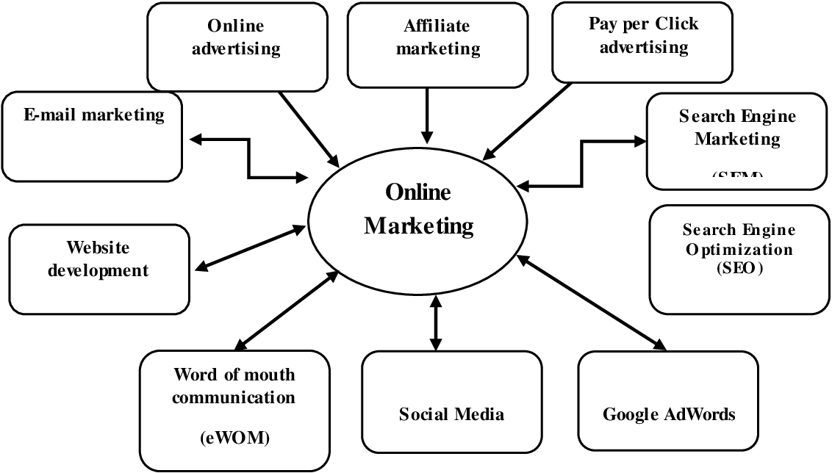
Figure 4: Integrated Marketing Communications Strategy
(Source: semanticscholar.org, 2022)
Utilize existing assets such as loyal customers and employees to spread Tesco's message and increase brand recognition. This includes leveraging customer and employee testimonials, as well as leveraging existing partnerships and relationships with other brands. Utilize social media channels such as Facebook, Instagram, Twitter, and YouTube to distribute content and engage with customers. This includes creating engaging posts and promotional campaigns that are tailored to the specific target audience (Pilgrim and Bohnet-Joschko, 2019). Utilize promotional strategies such as discounts and offers, loyalty programs, and giveaways to increase customer engagement and sales. Utilize analytics tools to track and measure the performance of each marketing campaign and channel. This data should be used to inform future marketing strategies in order to maximize results.
Leverage Influencers
Reach out to influencers who can help spread the word about Tesco's brand and its message. This could include partnering with bloggers, celebrities, and other people who have a large social media following. Offer them incentives such as free products, discounts, or other rewards to encourage them to share Tesco's messages and products with their followers. Additionally, create content that resonates with their followers, such as helpful tips, recipes, or ideas for using Tesco products (Schiro et al. 2020). Finally, provide them with the tools they need to spread the word, such as pre-written social media posts and images.
Create Engaging and Interactive Content
Develop compelling, engaging, and interactive content that will keep customers interested in Tesco's brand and its message. This could include blogs, videos, infographics, tutorials, and more.
Utilize Digital Advertising
Take advantage of digital advertising platforms, such as Google AdWords, to reach potential customers and increase awareness of Tesco's brand.
Offer Incentives
Offer incentives to customers, such as discounts or free products, to encourage them to purchase from Tesco's website or stores.
Host Events and Promotions
Host events and promotions in the local area to increase brand awareness and generate interest in Tesco's brand.
Invest in Branding
Invest in Tesco's brand by creating a consistent look and feel across all communication channels. This could include creating a logo, website, and other marketing materials that are cohesive and reflect the brand's identity.
Tesco can be critically appraised to identify innovative marketing strategies for managing and evaluating the customer journey across channels to ensure stakeholders' expectations are met.
1. Leverage customer data: Tesco should leverage customer data to understand their buying patterns and preferences. This will enable them to create targeted marketing campaigns based on customer needs and interests.
2. Optimize digital customer journeys: Tesco should optimize digital customer journeys across multiple channels such as mobile, web, and social media. This will ensure customers have a seamless experience regardless of the platform they choose to shop on.
3. Personalize content: Tesco should use personalization to tailor their marketing messages to each customer's individual needs and interests. This will not only make customers feel appreciated and valued but will also increase the chances of converting them into loyal customers.
4. Utilize customer feedback: Tesco should use customer feedback to optimize its customer journeys. This will help them identify customer pain points and address them in a timely manner.
5. Measure success: Tesco should measure the success of its customer journey by tracking customer satisfaction, loyalty, and conversions. This will enable them to understand what works and what doesn't and make the necessary changes to improve customer experience.

Supporting with practical examples with appropriate theory
Tesco should consider employing the '4Ps' (Product, Price, Place, Promotion) of marketing for a competitive advantage.
Factors | Analysis
Product | Tesco offers a wide range of products and services, including food and non-food items, electronics, clothing, toys, home appliances, furniture and more. Tesco also provides a variety of services, such as online shopping, home delivery, loyalty programs, and financial services.
Price | Tesco offers competitive prices across its range of products. The company has a price-matching policy, where they guarantee to match the lowest price of any of their competitors. Tesco also offers discounts and promotions on a regular basis to encourage customers to purchase their products.
Place | Tesco has stores located in the UK, Ireland, Hungary, Poland, the Czech Republic, Slovakia, Thailand and Malaysia. The company also has an online store, providing customers with the convenience of shopping from the comfort of their own homes.
Promotion | Tesco uses a variety of promotional strategies to market their products and services. These include television, radio and print advertising, online campaigns, direct mail, in-store promotions and loyalty programs. The company also uses social media to reach a wider audience and to promote special offers.

Figure 5: Tesco's '4Ps' analysis
(Source: Created by author)
Develop a customer-centric approach
Tesco should focus on developing a customer-centric approach to ensure that customers have an effortless and enjoyable shopping experience. This can be achieved through using technology such as artificial intelligence and machine learning to personalize the customer experience, providing customers with tailored content, offers, and recommendations. Tesco should also leverage digital channels to enhance customer engagement and provide customers with a seamless shopping experience. Additionally, Tesco should use customer feedback and data to better understand what customers want and need, and then use this information to create better customer experiences. By leveraging customer data, developing a customer-centric approach, investing in digital marketing, improving customer service, analyzing customer journey, and utilizing customer segmentation, Tesco can create innovative marketing strategies for managing and evaluating the customer journey across a variety of communication channels to ensure current and future stakeholders' expectations are fulfilled.
AIDA model implementation in Tesco:
The AIDA model can be used to understand the customer journey of a Tesco customer.
Awareness | Tesco can use a variety of marketing strategies and tactics to increase awareness of its brand and products. This can include traditional advertising, digital marketing, and social media campaigns.
Interest | Once a customer is aware of Tesco and its products, the next step is to generate interest in the customer. This can be done through targeted promotions, discounts, and loyalty programs.
Desire | Once a customer is interested in what Tesco has to offer, the next step is to create a desire to purchase their products (Rosnizam et al. 2020). Tesco can use persuasive sales tactics and create compelling content to create a desire to purchase.
Action | The last step is to take action, and Tesco can incentivize this by offering discounts or free shipping. They can also use easy-to-use payment methods to encourage customers to complete their purchase.

Behavioural Theory
Customer relationship enhancement using behavioural theory can be achieved by understanding customer behaviour, needs, and motivations and tailoring the service or product to their needs. Companies can use behavioural theory to better understand the psychological and emotional drivers of customer behaviour and use this knowledge to create or modify their products or services to meet the needs of their customers (Szymkowiak et al. 2021). Companies can also use behavioural theory to create loyalty programs that reward customers for their loyalty, or to develop targeted marketing campaigns that appeal to customers on an emotional level. Additionally, companies can use behavioural theory to create customer feedback systems that allow them to gain valuable insights into customer behaviour and make necessary changes to improve customer satisfaction.
Differentiation Strategy
Differentiation Strategy is a strategy that focuses on creating a unique product or service offering to differentiate the business from competitors.
Product Differentiation | Tesco can differentiate its products by offering more organic, sustainable, and locally sourced options. This will help to attract more health-conscious and environmentally-conscious customers.
Price Differentiation | Tesco can differentiate its prices by offering competitive prices in comparison to its competitors. This will help to attract cost-sensitive customers.
Service Differentiation | Tesco can differentiate its services by providing a more personalized shopping experience for customers. This includes offering exclusive discounts and rewards for loyal customers.
Brand Differentiation | Tesco can differentiate its brand by engaging customers through social media and creating a unique in-store experience. This will help to create a stronger relationship with customers and build loyalty.

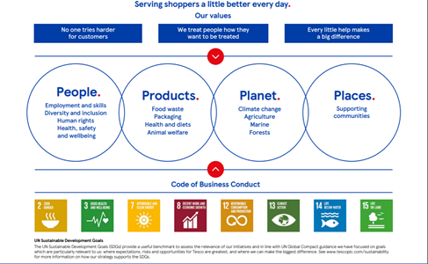
Figure 6: Tesco's Differentiation Strategy
(Source: thestrategystory.com, 2022)
Positioning
Positioning is a marketing strategy that establishes an image or identity for a product or service in the minds of consumers.
Employ a Multichannel Approach: Tesco should employ a multichannel approach to reach its target audiences, which includes traditional media such as television, radio and print, as well as digital and social media. This will allow Tesco to reach a larger and more diverse audience.
Focus on Brand Awareness: Tesco should focus on increasing brand awareness through its marketing efforts. This includes using a variety of platforms to promote their products and services, such as television commercials, radio spots, billboards, online ads and social media campaigns.
Focus on Customer Experience: Tesco should focus on providing a positive customer experience, both online and in-store. This includes ensuring that customers have a great shopping experience, from browsing to checkout.
Utilize Personalization and Targeting: Tesco should utilize personalization and targeting to better understand its customers and provide them with tailored experiences. This includes using data to create personalized offers and promotions, as well as targeted advertising.
Utilize Word-of-Mouth Marketing: Tesco should take advantage of word-of-mouth marketing to build brand awareness and loyalty. This can be done through customer loyalty programs, referrals, and content marketing.
Stakeholder expectations
Quality products at competitive prices: Customers expect Tesco to provide them with high-quality products at competitive prices.
Reliable delivery: Customers expect Tesco to offer reliable delivery services so they can have their goods delivered on time.
Good customer service: Customers expect Tesco to provide excellent customer service so they can get help with any queries or problems they may have.
Transparency: Customers expect Tesco to be transparent about its products, pricing, and policies so that customers can make informed decisions.
Innovation: Customers expect Tesco to continuously innovate and introduce new products and services to keep up with the changing market.
Sustainability: Customers expect Tesco to act responsibly and ethically, and to work towards reducing their environmental impact.
Loyalty rewards: Customers expect Tesco to offer loyalty rewards to reward them for their loyalty and encourage them to keep shopping with Tesco.

Conclusion
From the above discussion, it has been stated that the mentioned business organization has faced different types of problems in satisfying its customers with the help of present strategies. Poor online presence and poor customer service are other critical issues among them. In order to overcome these problems, Tesco needs to be focused on the integrated marketing strategy. It has been identified that the integrated marketing communications strategy of Tesco should focus on providing customers with a consistent message across all channels. This should include a combination of traditional and digital marketing methods, as well as leveraging social media platforms to further engage customers.
Additionally, Tesco should ensure that their messaging is tailored to the individual needs of each customer, as well as creating an omnichannel customer experience to ensure a seamless transition between physical and digital touchpoints. By implementing an effective integrated marketing communications strategy, Tesco can ensure that their customers are consistently engaged, informed, and satisfied with their shopping experience. In addition, this strategy will be beneficial for the company to improve present as well as future stakeholder expectations. Therefore, it can be concluded that Tesco can improve its business performance and customer satisfaction along with stakeholder expectations with the help of the new business strategy.

References
Abou-Shouk, M. and Soliman, M., 2021. The impact of gamification adoption intention on brand awareness and loyalty in tourism: the mediating effect of customer engagement. Journal of Destination Marketing & Management, 20, p.100559.
Aiello, L.M., Quercia, D., Schifanella, R. and Del Prete, L., 2020. Tesco Grocery 1.0, a large-scale dataset of grocery purchases in London. Scientific data, 7(1), pp.1-11.
An, J., Kwak, H., Qureshi, H.M. and Weber, I., 2021. Precision Public Health Campaign: Delivering Persuasive Messages to Relevant Segments Through Targeted Advertisements on Social Media. JMIR formative research, 5(9), p.e22313.
Anshari, M., Almunawar, M.N., Lim, S.A. and Al-Mudimigh, A., 2019. Customer relationship management and big data enabled: Personalization & customization of services. Applied Computing and Informatics, 15(2), pp.94-101.
Azan, M.E.M. and Karimah, W.N., 2022. The Relationship between Customer Loyalty Program and Customer Retention at Tesco. Research in Management of Technology and Business, 3(2), pp.174-184.
Blakeman, R., 2018. Integrated marketing communication: creative strategy from idea to implementation. Rowman & Littlefield.
Buisan de la Figuera, I., 2016. Private Label on food market. Comparing Spain and Europe. How will be the next 10 years?.
Chakraborty, R., 2018. Do Retailers Manipulate Prices to Favour Private Label over Brands?. Available at SSRN 3147151.
Deepak, R.K.A. and Jeyakumar, S., 2019. Marketing management. Educreation Publishing.
Gilboa, S., Seger-Guttmann, T. and Mimran, O., 2019. The unique role of relationship marketing in small businesses' customer experience. Journal of Retailing and Consumer Services, 51, pp.152-164.
Hussainy, S.S., 2020. Review on Motivational Theories & Models: Its application for Employees' Retention in Organizations. International Journal of Business and Applied Social Science, 6(1), pp.40-46.
Kar, S.K., Bansal, R. and Mishra, S., 2021. Tesco: Entry and Expansion Strategy in India. Emerging Economies Cases Journal, 3(2), pp.65-76.
Pilgrim, K. and Bohnet-Joschko, S., 2019. Selling health and happiness how influencers communicate on Instagram about dieting and exercise: Mixed methods research. BMC public health, 19(1), pp.1-9.
Rosnizam, M.R.A.B., Kee, D.M.H., Akhir, M.E.H.B.M., Shahqira, M., Yusoff, M.A.H.B.M., Budiman, R.S. and Alajmi, A.M., 2020. Market opportunities and challenges: A case study of Tesco. Journal of the Community Development in Asia (JCDA), 3(2), pp.18-27.
Sarkam, S.F., Mohd Nasir, N.S. and Saad, S., 2019. The relationship of brand image and service quality on student loyalty of a university shop. Jurnal Intelek, 14(2), pp.68-79.
Schiro, J.L., Shan, L.C., Tatlow-Golden, M., Li, C. and Wall, P., 2020. # Healthy: smart digital food safety and nutrition communication strategies—a critical commentary. NPJ science of food, 4(1), pp.1-11.
Singh, P., Ranjith, P.V., Fathihah, N., Kee, D.M.H., Nuralina, N., Nurdiyanah, N. and Nursyahirah, N., 2021. Service Quality Dimension and Customers' Satisfaction: An Empirical Study of Tesco Hypermarket in Malaysia. International Journal of Applied Business and International Management (IJABIM), 6(3), pp.102-114.
Singh, R., 2019. Why do online grocery shoppers switch or stay? An exploratory analysis of consumers' response to online grocery shopping experience. International Journal of Retail & Distribution Management.
Szymkowiak, A., Gaczek, P., Jeganathan, K. and Kulawik, P., 2021. The impact of emotions on shopping behavior during epidemic. What a business can do to protect customers. Journal of Consumer Behaviour, 20(1), pp.48-60.
semanticscholar.org, 2022. Available at: https://www.semanticscholar.org/paper/Integrated-Marketing-Communication-Tools-%3A-vs-.-Oancea-Diaconu/df220fdb61a5b35d7d26b31c1fe7c31f1d0ea914[Accessed on:23.12.2022
Turner, J.J. and Szymkowiak, A., 2019. An analysis into early customer experiences of self-service checkouts: Lessons for improved usability. Engineering Management in Production and Services, 11(1), pp.36-50.
Wolny, J., 2022. Customer Journey as Participatory Service Ecosystem. The SAGE Handbook of Digital Marketing, p.17.
Yao, H. and Memon, B.A., 2019. Network topology of FTSE 100 Index companies: From the perspective of Brexit. Physica A: Statistical Mechanics and its Applications, 523, pp.1248-1262.
thestrategystory.com, 2022. Available at: https://thestrategystory.com/2021/06/10/tesco-business-model/[Accessed on:23.12.2022]
www.bbc.com, 2021. Available at: https://www.bbc.com/news/business-54445399[Accessed on:23.12.2022]
www.tesco.com, 2021. Available at: https://www.tesco.com/help/privacy-and-cookies/privacy-centre/tesco-and-your-data/your-data-journey/[Accessed on:23.12.2022]

