Digital Skills and Research Methods

Shibbir Ahmed
1706689

May 2018

University of Wales
Trinity Saint Davis

Table of Contents

Introduction 1
Big Data Technology 2
Big Data Technology at Walmart 5
Effectiveness of the Usage of Big Data technology at workplace 5
Effectiveness of Big Data Technology at Walmart 7
Usage of Big Data Technology for Ethical Data Collection and Interpretation 9
Data Interpretation by Big Data Technology 11
Ethical Consideration of Big Data Technology 12
Conclusion 13
Reference 14

Table of Figures
Figure 1: Adoption of Big Data 2
Figure 2: Edge Computing 4
Figure 3: Big Data Technology by Walmart______________________________________7
Figure 4: Big Data Annual Savings_____________________________________________9
Figure 5: Usage of AI_______________________________________________________9

Introduction
As the time passes, different technologies come to know and understand the users. New methods undertake traditional methods. Companies use their own techniques to get information about the customers. The retail corporation Walmart has its own process. It is using big data technology to compete with other companies. With big data technology, large amount information can be processed in real time and decisions can be taken based on that. This technology is used in many industries and the usage is increasing day by day. Valuable insights can be known and used for different purpose like to meet the demands or to create ads for customers.

Big Data Technology
Technology is a catalyst in modern civilization. The alchemy of communication is quite bigger nowadays because of technology (Krishnan, 2015). In current time, big data technologies are shaping the industry. In technology, it includes different models, processes, techniques by which scientific knowledge is used for practical reasons. In Big Data Technology, there are data storage, data mining, data science, machine learning, and predictive analysis and so on. Big data technology is being increasingly used by the companies (Krishnan, 2015).
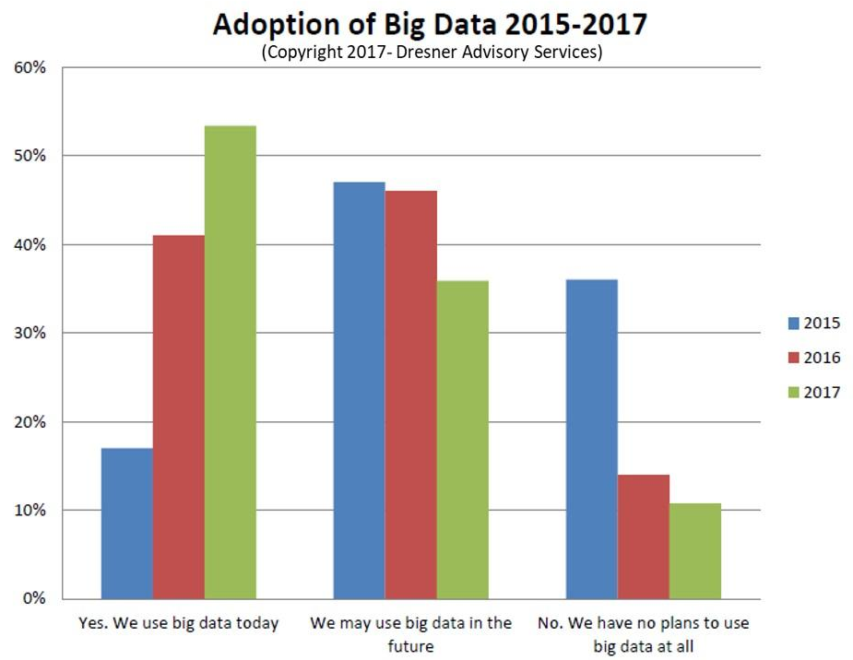

Figure 1: Adoption of Big Data
Source: (Colombus, 2017)
In an interview by Dresner Advisory Services, it has been found that in 2017 around 53% companies use big data in giving services but in 2015 this was only 17% (Colombus, 2017). So the technology has greater usage in the business. Big data technology includes the following:-

R
R is a programming language which is made for statistical usage. This has become fifth most used programming language in the world now. Statisticians, data miners use this programming language. In different data projects this language has can give great solutions to real organizational problems (Krishnan, 2015).
Artificial Intelligence
Artificial intelligence has been widely used in different areas of industry. In artificial intelligence, there are two parts. One part is machine learning and other part is deep learning. In machine learning, the computer has the ability to do work by itself without explicit programming (Krishnan, 2015). In deep learning technology, artificial neural network is used so that multiple algorithms can be used to analyse different data (Krishnan, 2015).
Predictive Analysis
Predictive analysis is very much connected with my machine learning. In predictive analysis previous data are deeply searched to ge find out valuable insights about why things are not working and even can give can directions (Finlay, 2014). It comes with some kind of logic about why a person has failed in certain case and how people survive in the hard time. Statistical techniques are used to know the future events (Finlay, 2014).
IoT
IoT refers to internet of things. This means a network with different electronic devices y which information can be shared or exchanged. By the technology of IoT, one can control other electronic devices, remotely and without internet innovation. IoT works a lot to let the company do the business and save time and money for different parties. In IoT, “things” are called the different devices by which valuable information is collected (Krishnan, 2015).
Edge Computing
Edge computing is optimization process of cloud computing system. Because of the technology of IoT, there is a usage of edge computing. This paves a way to use the resources which are not frequently connected with network. Resources can be laptops, smart phone, tablets etc (Finlay, 2014).
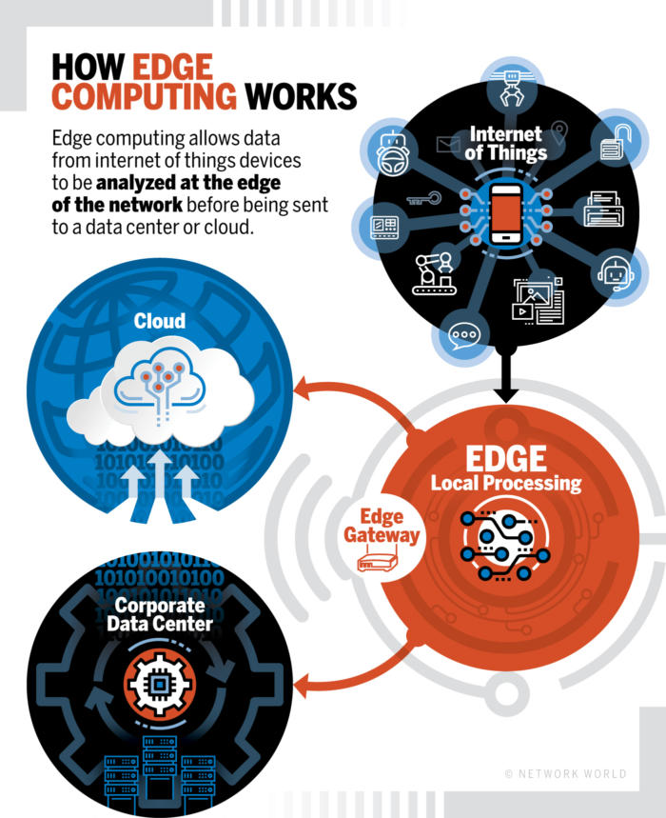

Figure 2: Edge Computing
Source: (Shmueli, 2016)

Prescriptive Analytics
In, predictive analysis, huge amount of data are analyzed to give information about the prediction but in prescriptive analytics this will test what the company can do to get a great result. For example: in a situation of crisis market, what courses of action can be taken will be analyzed by prescriptive analytics (Finlay, 2014).

Big Data Technology at Walmart
Walmart is global retail company having 11 thousand stores in more than 28 countries. At Walmart, big data technology is used to know the demand of the product or give customize benefit to the customers or extract huge amount of information about the customers (Zhang, 2018). The information will give them the opportunity to create pleasing ambience or create great offers for the customers (Zhang, 2018). Customers will get a more personal touch in this process. Simulations are created by which it can be known that how course of actions are needed for the company. Walmart has developed infrastructure for huge amount of data. About 2.5 petabytes of data are processed every hour at Walmart (Zhang, 2018).

Effectiveness of the Usage of Big Data technology at workplace
Big Data technology has three factors: volume, velocity and variety. Big data technology observes and keep track about large amount from different sources such as transactions, website data, recommendations, social media and so on (Akerkar, 2016). The velocity of processing data is very high, accurate and done with real time results. The variety of data is also huge as because, huge amount of data such as: audio, video, email, text documents etc. are used in data technology to achieve reliable results (Akerkar, 2016). The effectiveness of Big Data technology is great in nowadays. These are discussed below:-
Cost Savings
Cost can be saved in huge amounts as there are enormous data to process and it is quite impossible to find the real and reliable data to take a decision, big data technology helps a lot give great results in real time and save money for the company and increase profits (Akerkar, 2016).
Creating Business Strategy
Business strategies can be created, modified and rectified by this technology within a very short period. Data given by data analytics can be used as input to take further decisions in strategies (Akerkar, 2016). This helps to know the dynamic changes of business needs and gives valuable suggestion about how to cope up with the problems or what can be to succeed in the market (Akerkar, 2016).

Improving Understanding of Huge Data
When there is huge amount of data in a company or organization, Big Data technology helps a lot to create a sense about data. When analytics is done with the data, data become more simplified, reliable, helpful and convenient for the organization (Akerkar, 2016).
Time Saving
Time can be saved by this technology as different models and scientific processes. There are big data technology tools like in-memory analytics and Hadloop technology (Catlett, 2015). These technologies are used to identify new data from different sources and give immediate decisions. Thus it saves time a lot (Catlett, 2015).
Product or Service development
As new information come by processing of huge amount of data, product or services development can be possible. Much essential information comes with the data analyses. There can be different needs and demands of the customers and big data technology helps a lot to do the prediction and can give valuable suggestions about how new or customized product can be produced and satisfy the needs of the customers (Catlett, 2015).
Understanding Marketing Environment
Market is a dynamic place. Many things come and change within time. New fashion comes and older ones are gone. As the customers wants are different in different regions, the market characteristics are also different (Catlett, 2015). Purchase behaviour can be different as the time changes. So, this technology can give essential data. Thus companies can have the solutions for the marketing environment (Catlett, 2015).
Finding New Opportunities
New opportunities may come with analysis of different data. With predictive analysis, the business can know what kind of demands is created in the market. The opportunity to serve the market will help the company giving greater profits for the company (Catlett, 2015).

Effectiveness of Big Data Technology at Walmart
Making Pharmacies Efficient
At Walmart big data is used to create and analyze the simulations for pharmacies. The company can learn a great deal about how many prescriptions are filled in a day, week or month. The volume of data determine in which time there is rush to fill the prescriptions (Zhang, 2018). The information gives direction about time schedule of the staff. When there is increased amount of customers, Walmart can give more staff to handle the situation. Thus, the company achieves efficiency, reducing time and labour at the same time (Zhang, 2018).
Improving Store Checkouts
Walmart uses predictive analytics so that it can know the demand of products at certain hours. Besides, the number of associates can be determined by the predictive analytics (Zhang, 2018). So, this helps to have keep store checkouts more efficient and effective (Zhang, 2018). Walmart can also know about self and facilitated checkouts for each store.

Figure 03: Big Data Technology by Walmart
Source: (Zhang, 2018)

Managing Supply Chain
To manage supply chain, Walmart uses simulations and identify the steps of products that reach to the store (Zhang, 2018). Company evaluates steps from dock to store and create more optimized and fastest way or routes to shipping docks (Zhang, 2018). The number of products is counted that get touched in the way to the customer. Thus transportation routes and lanes are evaluated so that company can determine the fleet of trucks. Overall, the cost gets minimized of transportation and driver timing is scheduled in a more efficient way (Zhang, 2018).

Optimizing Products Assortments
Walmart can determine the purchase behaviour of the customers and get reliable information via big data technologies (Zhang, 2018). The company knows how to stock the different products in shelves and how the products need to be displayed. They have useful information about different products and about different brands that the customers have preference (Zhang, 2018).
Personalizing Shopping
With big data technologies, there can be more personalizing shopping for the customers. With the different data coming from mobile or from other resources company can optimize the activity of shopping and anticipate the needs of the customers. Different techniques are be followed by the smart data of shopping at Walmart (Zhang, 2018).

Usage of Big Data Technology for Ethical Data Collection and Interpretation
Big Data technologies are increasingly and widely used around the world. The technology is adopted in big companies because of the increasing amount of data and this has become very hard to know which data is informative giving the company more benefits. So, big data analytics paves the way to know data in different perspectives giving different perspective. In a survey conducted by Ketan Pundit, some facts are found about big data and analytics. It is seen that about $30 million can be saved from fraud claims using big data (Pandit, 2017). Investment in artificial intelligence is 300 percent more in 2017 than in 2016. The market of augmented reality ($90 billion) will be bigger than virtual reality ($30 billion) (Pandit, 2017). 94 percent marketing professional said that customer personalization is extremely important (Pandit, 2017).
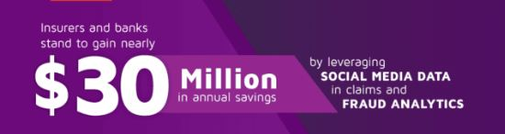
Figure 04: Big Data Annual Savings
Source: (Pandit, 2017)
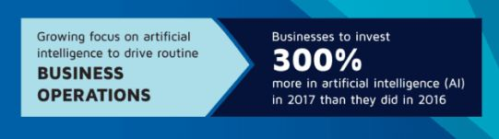
Figure 05: Usage of AI
Source: (Pandit, 2017)

By using big data technologies, data can be collected from various sources. These are discussed below:-

Recordings of Electronic Devices
There are different recording of different electronic devices. Much information is kept in electronic devices because customers give accent to the agreement of the data usage. For example: cameras collected visual data about customers or about the rush of customers in the shopping centres (Yu et al., 2017). The information will help the authority to know where customers show great demand for the needs where the security should be tightened and so on. Walmart is also doing the same for effective checkouts and giving ample staff to tackle business transactions (Yu et al., 2017).
Interactions in Social Networks
In a connected world, people are connected with facebook, twitter, instagram etc. Huge amount of data are produced in the social networking sites. Both qualitative and quantitative data are seen with geo-demographical differences. Trends can be seen and analyzed with business tools given by social media platforms. The sentiments and kudos can evaluate in terms of different types of products. Big data analytics use these interactions of social network and make necessary decisions for customers (Yu et al., 2017).
Public Website
Millions of public websites are available in the internet. Many websites keep different information about the visitors (Yu et al., 2017). Cookies are kept so the data can be used for advertisement purpose. Data analytics will keep this information via different websites and use it to know the customers behaviour in depth (Yu et al., 2017).
Business Applications
There are different applications by which data can be taken. These applications will monitor the user behaviour and create necessary predictions about the user. There are gaming application social media websites (Yu et al., 2017). These applications contain conditions to give personal initials about the user. The personal information then has been used to create predictions or simulations (Yu et al., 2017).

Imagery by Satellites
There are different satellites of different companies which can be used for identify and track the user and get valuable data about the locations or areas. Google maps and earth use satellite imagery (Yu et al., 2017).
Database of Employee
Employee communicates directly with customers. This data can be used to know more and know the preferences. Big data analytics can be used in this case and give valuable inputs to the company. Walmart has used the opportunity as employees are connected with different customers (Yu et al., 2017).

Data Interpretation by Big Data Technology
New Marketing Trends
As big data analytics is used new marketing trends can be known by the huge amount of data (Dumbill, 2013). For example: when Walmart knows about the preference about the customers it can give necessary information to their customers about different products. This will benefit the customers as well as the business (Dumbill, 2013).
Predicting Next Purchase
When customers buy the products through credit cards, they give information about them which can be interpreted for future buy. By using data analytics, advertisements can be given to potential buyer (Dumbill, 2013).
Changing Lifestyles
Data can be interpreted for changing lifestyles. With the passage of time the needs and preferences are changed (Dumbill, 2013). With changing needs, lifestyle can also be changed. For example: when range of income is changed the lifestyle can be changed. When people become parents the lifestyle changes because of new born child (Dumbill, 2013).

Creating Ads
When people surf internet, they get the different that can suit with their personality. Advertisers know from the analytics about customer’s preference and they give ads according to trends, choices and preferences of the traffic of websites (Dumbill, 2013).

Ethical Consideration of Big Data Technology
The data collection and interpretation by big data technology can create problems because information is collected without the consent of the customers. In UK, there are laws such Data Protection Act 1998 and Human Rights Act 1998 (Docherty, 2014). These acts ensure privacy of people. Many researches are done with the consent of the customers but all the conditions may not comply with the law and the person and the company may face legal problems. For example: a person named Dan Gray face legal complications in 2015, because of misogynist speech. About 60 thousand tweets from twitter are collected. But he has to face legal difficulties for representing the data (Docherty, 2014). Besides, there are de-identification, integrity and privacy issues for using the data. So, it is crucial for any company to create policies that match do not breech laws. Thus data can be taken with users’ consent and better strategies can be taken for customers as well as for the company (Docherty, 2014).

Conclusion
Big data technology has given new shape in the industry. Companies can get in-depth knowledge about their customers. A retail corporation like Walmart smoothes the business activities in supply chain, product assortments, scheduling and so on. This technology saves much time, labour and cost of the company. Strategies can be made with different analytics. By social interactions, public websites, applications, database, data can be gained to use in big data. Marketing trends, preference, and lifestyle can be known by this technology. As this technology has greater access of data, the procedures may not comply with the laws. So, policies of collecting and using of those data should created that comply with laws and do not break privacy of the people. Thus, information can be used and explored for further works.

Reference
Akerkar, R. (2016). Big data computing. 10th ed. Boca Raton, FL: CRC Press.
Catlett, C. (2015). Cloud computing and big data. 12th ed. Amsterdam: IOS Press.
Colombus, L. (2017). 53% Of Companies Are Adopting Big Data Analytics. [online] Forbes.com. Available at: https://www.forbes.com/sites/louiscolumbus/2017/12/24/53-of-companies-are-adopting-big-data-analytics/ [Accessed 1 May 2018].
Docherty, A. (2014). Big Data - ethical perspectives. Anaesthesia, 69(4), pp.390-391.
Dumbill, E. (2013). Making Sense of Big Data. Big Data, 1(1), pp.1-2.
Finlay, S. (2014). Predictive analytics, data mining and big data. 8th ed. Basingstoke [u.a.]: Palgrave Macmillan.
Krishnan, K. (2015). Data warehousing in the age of big data. 7th ed.
Pandit, K. (2017). Big Data & Analytics Trends 2017. [online] Aureus Insights. Available at: https://blog.aureusanalytics.com/big-data-analytics-trends-2017/ [Accessed 1 May 2018].
Shmueli, G. (2016). Analyzing Behavioral Big Data: Methodological, Practical, Ethical, and Moral Issues. SSRN Electronic Journal.
Yu, J., Wang, K., Li, P., Xia, R., Guo, S. and Guo, M. (2017). Efficient Trustworthiness Management for Malicious User Detection in Big Data Collection. IEEE Transactions on Big Data, pp.1-1.
Zhang, J. (2018). Big Data in Retail Business Applications—Walmart Case. DEStech Transactions on Social Science, Education and Human Science, (icems).

