ASSESSMENT COMPONENT 2 – COMMUNITY ENGAGEMENT

MODULE CODE: LCBB4002

MODULE: COMMUNITY ENGAGEMENT

STUDENT NAME: BOGDAN PACURARU

STUDENT ID NUMBER:2245496

Table of Contents
Part B: Reflection 3
Introduction 3
Reflection using the Gibbs Reflective Model 3
Conclusion 11
References 12

Part B: Reflection

Introduction
The reflection is all about the way of coordinating a community engagement programme like "Tackling Food Poverty" by the Urban Communities Project in the future (Urban Community Projects, 2023, a). The idea of the community engagement project is to reduce the rate of food poverty in UK society by offering healthy meal boxes. In order to consider the most suited practices, techniques, models, approaches, principles and standards of the community engagement model, the existing standards and approaches are properly analysed. This way, the difference between the existing and future strategies has been demonstrated in an in-depth manner. The role of stakeholder participation, active consultation, effective communication and inclusion in terms of making a difference in community engagement in tackling food poverty have been also considered in this reflection. I have also considered relevant recommendations for planning and coordinating a future event successfully while conducting community mapping and social engagement at the same time.
The future project is going to focus on a broad number of people living in poverty in the UK based on the use of traditional communication channels. The future project by Urban Communities Project will be focused on implementing policies while providing opportunities for stakeholder engagement and participation by registering their feedback or complaints on online platforms like social media.

Reflection using the Gibbs Reflective Model
As per the Gibbs Reflective Model, there are six stages including Description, Feelings, Evaluation, Analysis, Conclusion, and Action Plan about exploring an experience (Harithuddin, 2021). In this context, I will be focusing on the way of coordinating a community engagement called “Tackling Food Poverty” by considering effective design, process and principles suited for this project.
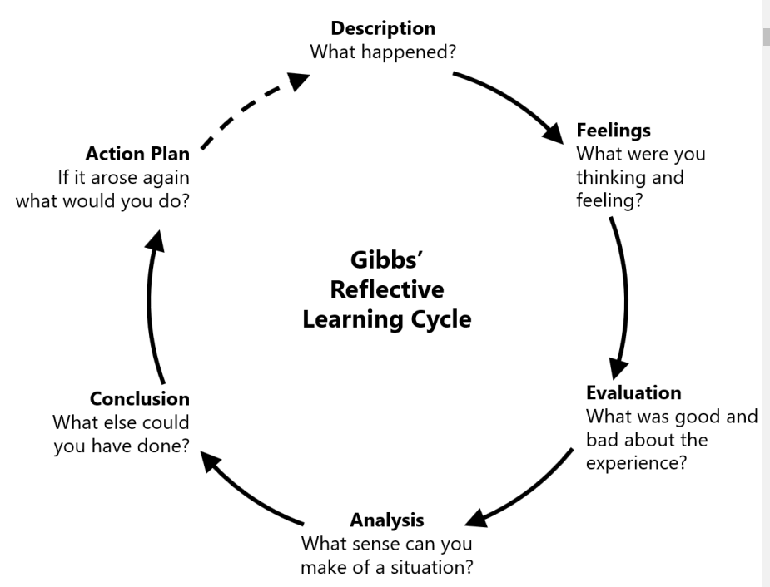
Figure 1: Gibbs Reflective Model
(Source: Harithuddin, 2021)
Description
The most significant strategy used in the live project is accepting self-referrals or even referrals from local organisations, health centres, housing associations and others through its official websites. As per my knowledge, people living in poverty may have to make a referral to an online portal of Urban Community Projects. On the other hand, the future project will also consider traditional channels in terms of developing connections with people with needs. For that, not every person needs to access Camden Mobile Food Bank service for that matter. For building the traditional communication channels, I suggest the project engage approximately 6 more volunteers dedicated to communicating and facilitating meal boxes for people living in poverty. Moreover, as stated by Shackleton et al. (2019), in terms of increasing stakeholder engagement and participation in future development, strategic thinking about the engagement design, implementation of specific policy and development of a broad approach is most significant. In the future project, I will prioritise scheduling a senior leadership discussion about the implementation of policies or the engagement of stakeholders.
Feeling
As per my understanding, I have a feeling that the strategies the project has used in the past few years have significantly played an excellent role in terms of uprooting societal curses like poverty in the UK. However, I also have a feeling that the future project needs to take advantage of social media platforms like Instagram and Facebook in terms of increasing engagement with more stakeholders who can also make referrals for those who are living in poverty and seeking help. Young children and school or college students are most likely to use social media these days. Through social media platforms, they can also help a huge number of people living in poverty by simply referring them to Urban Community Projects through social media which is much easier and convenient as compared to the strategies used by the project earlier. As per my understanding, the most significant practice or technique that can be implemented for community engagement is to take advantage of sustainable outcomes of community-driven development (CDD). In this context, as opined by Zurstrassen (2020), the CDD can help to achieve positive outcomes in uprooting poverty while achieving sustainable practices with a favourable policy environment, good governance and instructional strengthening.
Evaluation
In the future community engagement project of tackling food poverty in a better way in the UK, I have planned that Urban Community Projects will be more dedicated while following a community mapping.
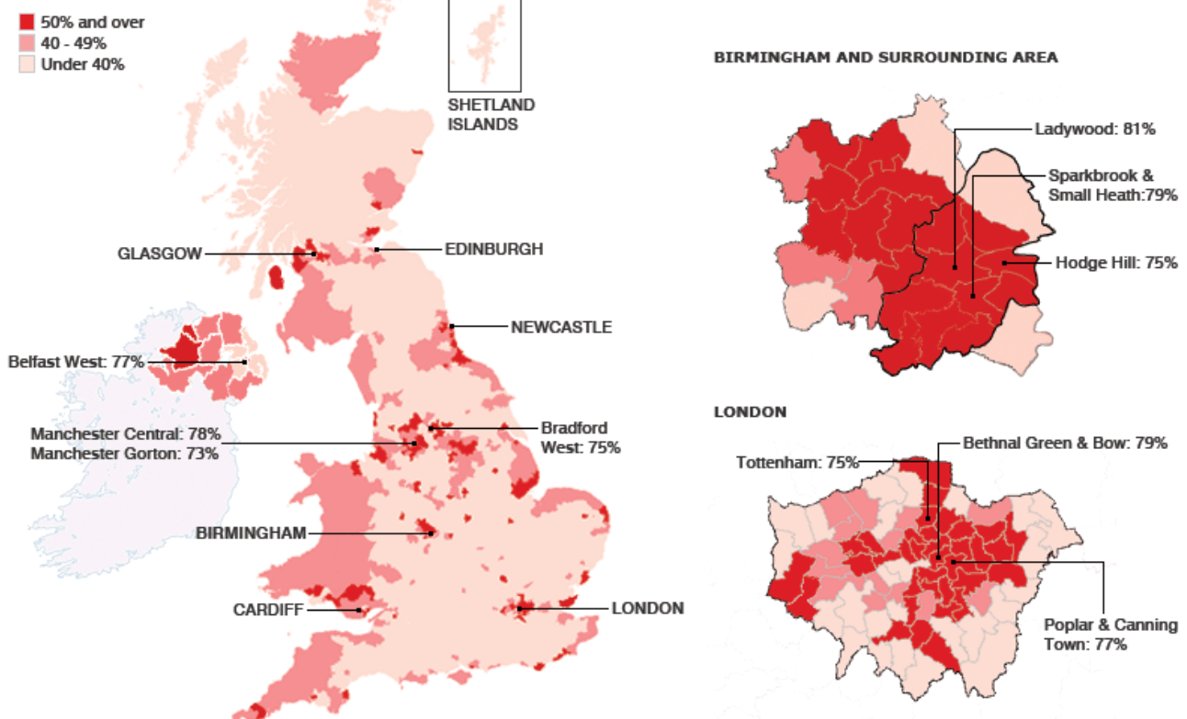
Figure 2: Community Mapping of Child Poverty in the UK
(Source: BBC, 2023)
From the above figure, almost 81% of children in the UK are living on the brink of poverty and most belong to lower-income families (BBC, 2023). Moreover, based on the Campaign to End Child Poverty, almost 77% of children from Poplar and Canning Town have the experience of living with poverty in the UK (BBC, 2023). As per my understanding, Quebec’s proposal is the most suitable model in terms of eliminating poverty as it is based on participatory democracy and community empowerment. Quebec's proposal can help in implementing a permanent government action program through the facilitation of active civic participation in each stage of eliminating poverty (Plante, 2019). Urban Community Projects can take advantage of creating a citizen-based council while having agencies like Health, education, professional training and social services. I can also state that a citizen-based council can help increase citizen participation in uprooting Poverty, facilitating consultations and monitoring the implementation of policies related to poverty elimination.
Analysis
As per my knowledge, the best approach to eliminate poverty from society is to serve the UK community living in poverty by providing them with time, money and required goods. I have learnt that the project has already taken a good approach to teaching the way of making food from scratch to those who live in poverty. About making a difference in eliminating poverty in the UK, I have decided to have a new approach to serving people living in poverty by donating money and goods so that they can cook on their own. In addition, I have learned that they can provide all the required ingredients including fuel and groceries for making nutritional foods in terms of helping people to fight against poverty. In this context, the 3 C's model of successful participatory community engagement, the most significant three themes are consultation, communication and collaboration (Nyirenda et al. 2018).
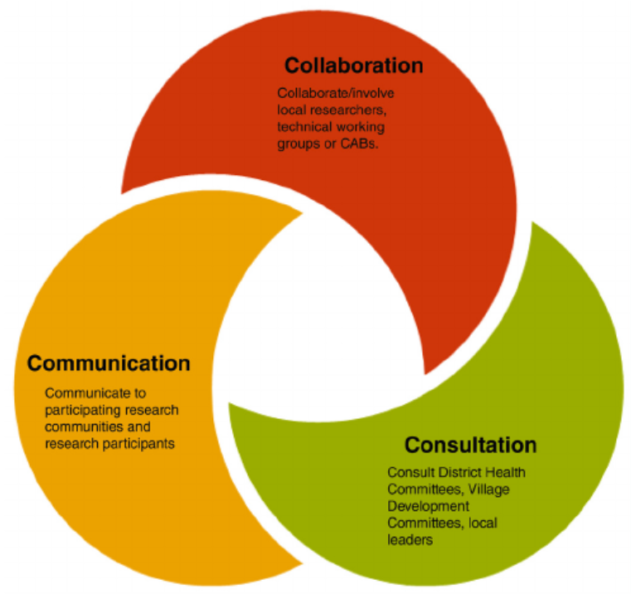
Figure 3: 3 C’s model of participatory community engagement
(Source: Nyirenda et al. 2018)
Based on Figure 3, to achieve success through genuine partnership and stakeholder engagement, I have planned to engage with community advisory boards (CAB). In CAB, there will be community groups and stakeholders including government, activists, service providers, health professionals, religious leaders and local people so that enhancing legitimacy while sharing responsibility in project design can be easier (Weinstein et al. 2023). I have also learnt to specify to maintain principles of Urban Community Projects such as facilitating a wider choice of nutritional meals while restoring dignity by empowering users to choose desired food items for themselves in the future. In terms of making a difference in future projects of tackling food poverty in UK society, I have decided to follow the core standards suggested by UNICEF by prioritising two-way communication in future. For that, systematic two-way communication can help develop consent of communication among the community with needs and other stakeholders like local organisations and government (UNICEF, 2023). As per my knowledge, not only the community with needs but also the other stakeholders can develop communication by sharing the purpose of the project and the requirements of each user. I can also ensure that the investors and users can share their feedback on social media platforms like Instagram and Facebook by sharing areas of improvement for making a difference in society.
Conclusion
From the above discussion, it can be concluded that the future project of Urban Community Projects to tackle food Poverty in the UK will engage more volunteers and local people to help a broad number of people. Moreover, the future project will also develop communication and collaboration among the stakeholders including the users by facilitating a feedback portal through social media. Community engagement will be ensured by taking advantage of Community Driven Development (CDD) with active consultation and policy implementation. Based on community mapping of poverty in the UK, I have decided to eliminate poverty. I have also focused on uprooting child poverty the most by facilitating nutritional meal boxes. Not only facilitating the choice of meals but also donating money and goods for making foods from scratch will be considered in future projects by Urban Community Projects. Based on the core standards of community engagement of UNICEF, I have planned to prioritise two-way communication by utilising social media platforms like Instagram and Facebook so that clear communication between investors and users can be clarified.
Action Plan
Number | Goals | Action | Timeframe
1 | - To implement traditional communication channels  - To increase user engagement | - To hire approximately 6 volunteers for traditional user engagement  - To engage with community advisory boards (CAB) to ensure user engagement in various community groups | Before 30th October, 2023
2 | - To increase stakeholders’ participation | - To ensure the implementation of policies for uprooting poverty  - To focus on strategic thinking about the engagement design, and development of a broad approach  - To prioritise scheduling a senior leadership discussion about stakeholder engagement  - To utilise sustainable outcomes of Community Driven Development (CDD) for achieving positive outcomes in uprooting poverty through a favourable policy environment, good governance and instructional strengthening | Within 30th November to 30th December, 2023
3 | - To ensure social engagement through social media platforms | - To facilitate a social media platform like Instagram and Facebook for users and other stakeholders to share areas of improvement in poverty elimination  - To reach out broad number of people living in poverty through social media  - To engage young children in making referrals by helping people living in poverty | By 20th February 2023
4 | - To ensure effective communication | - To facilitate two-way systematic communication as directed by UNICEF  - To develop consent of communication about the purpose or goals of the project among local people and users  - To create a citizen-based council to have agencies such as health, education, professional training and social services | Before 15th April, 2023
5 | - To make a difference by conducting community mapping | - To utilise community mapping to understand the most affected areas of the UK  - To eliminate poverty among the children groups in society | By 3oth August, 2023
Table 1: Action plan
(Source: Self-created)

Conclusion
Through this reflection, I have learnt the way to use various concepts for community engagement in terms of uprooting poverty from the UK society. I have also developed a detailed understanding of suitable principles, approaches, standards or models for this specific project of Urban Community Projects of tackling food poverty. I have also known the role of communication, collaboration and consultation in community engagement. The knowledge of engaging stakeholders including the users through social media will also help me in coordinating my future events in a better way.
In the future project in Urban Community Projects to tackle food poverty in the UK, the major focus will be utilising the traditional method of engaging people with needs while using social media platforms to attract investors and other stakeholders. It can also be concluded from the above discussion that 81% of children in the UK have to deal with poverty. Most of those children belong to lower-income families in the UK who live in poverty. In addition, Community Driven Development (CDD) will also be adopted by the future project in terms of achieving sustainable practices like a favourable policy environment, instructional strengthening and good governance. I have also suggested using community advisory boards (CAB) which can ensure user engagement in various community groups. It can be also concluded that the future project is focused on creating citizen-based councils to have agencies like health, education, professional training and social services. Lastly, the future project will shed light on ensuring the implementation of policies for uprooting poverty in the UK. It will also prioritise scheduling a senior leadership discussion focusing on the implementation of policies as well as stakeholder engagement.

References
BBC (2023). Mapping child poverty. Available at: http://news.bbc.co.uk/2/hi/uk_news/7642689.stm [Accessed on 25 September 2023]
Harithuddin, A.S.M., (2021). A first experience of using a failure report as a reflective tool in engineering education. International Journal of Emerging Technologies in Learning (Online), 16(18), p.23.https://doi.org/10.3991/ijet.v16i18.23159
Nyirenda, D., Gooding, K., Sambakunsi, R., Seyama, L., Mfutso-Bengo, J., Taylor, L.M., Gordon, S.B. and Parker, M., (2018). Strengthening ethical community engagement in contemporary Malawi. Wellcome open research, 3.https://www.researchgate.net/publication/327731298_Strengthening_ethical_community_engagement_in_contemporary_Malawi#pf4
Plante, C., (2019). Policy or window dressing? Exploring the impact of poverty reduction strategies on poverty among the Canadian provinces. Journal of International and Comparative Social Policy, 35(1), pp.112-136.https://osf.io/download/5af4e8cca5bbbc0012c60213/
Shackleton, R.T., Adriaens, T., Brundu, G., Dehnen-Schmutz, K., Estévez, R.A., Fried, J., Larson, B.M., Liu, S., Marchante, E., Marchante, H. and Moshobane, M.C., (2019). Stakeholder engagement in the study and management of invasive alien species. Journal of environmental management, 229, pp.88-101.https://doi.org/10.1016/j.jenvman.2018.04.044
UNICEF (2023). Minimum Quality Standards and Indicators for Community Engagement. Available at: https://www.unicef.org/mena/media/8401/file/19218_MinimumQuality-Report_v07_RC_002.pdf.pdf [Accessed on 25 September 2023]
Urban Community Projects, (2023, a). Tackling food poverty. Available at: https://www.urbancommunityprojects.org.uk/camden-mobile-food-bank [Accessed on 25 September 2023]
Weinstein, E.R., Herrera, C.M., Pla Serrano, L., Martí Kring, E. and Harkness, A., (2023). Promoting health equity in HIV prevention and treatment research: a practical guide to establishing, implementing, and sustaining community advisory boards. Therapeutic advances in infectious disease, 10, p.20499361231151508.https://journals.sagepub.com/doi/pdf/10.1177/20499361231151508
Zurstrassen, M., (2020). A review of the Myanmar national community driven development project in conflict-affected contexts.https://openknowledge.worldbank.org/bitstream/handle/10986/34141/A-Review-of-the-Myanmar-National-Community-Driven-Development-Project-in-Conflict-Affected-Contexts.pdf

