Managing the design and construction process
Modern and Traditional Construction
Date Completed: 8th January 2024

Word Count: 2258

Luke Hunt
Prepared for:
Rhodri Thomas

1.0 -Table of Contents
2.0 – Site Background 2
2.1 – Site Background 2
3.0 – Substructure analysis 3
3.1 – Foundation Requirements 3
3.2 – Required Excavation Works 7
4.0 – Super-Structure Analysis 8
4.1 – Design 8
4.2 – Structural Strength 8
4.3 – Stability 8
4.4 – Fire Safety 8
4.5 – Aesthetics 9
4.6 – Environmental Impact 9
4.7 - Sustainability 9
5.0 - References 10
6.0 – Appendices 11

2.0 – Site Background

2.1 – Site Background
The SA1 Swansea Innovation Matrix is a steel framed superstructure, located on the Swansea Docks. This development is part of the Trinity St David University, based in Swansea Bay, and will be functional for students in the following months. Due to the location and history of this building, careful consideration of foundations and materials are needed.
This case study will analyse and discuss the substructure and super-structure, going into detail on foundation requirements and the choices of materials used.
Below is a map of the area in which the super-structure sits. It is identified by the green rectangle on the image (Swansea Council, 2024).

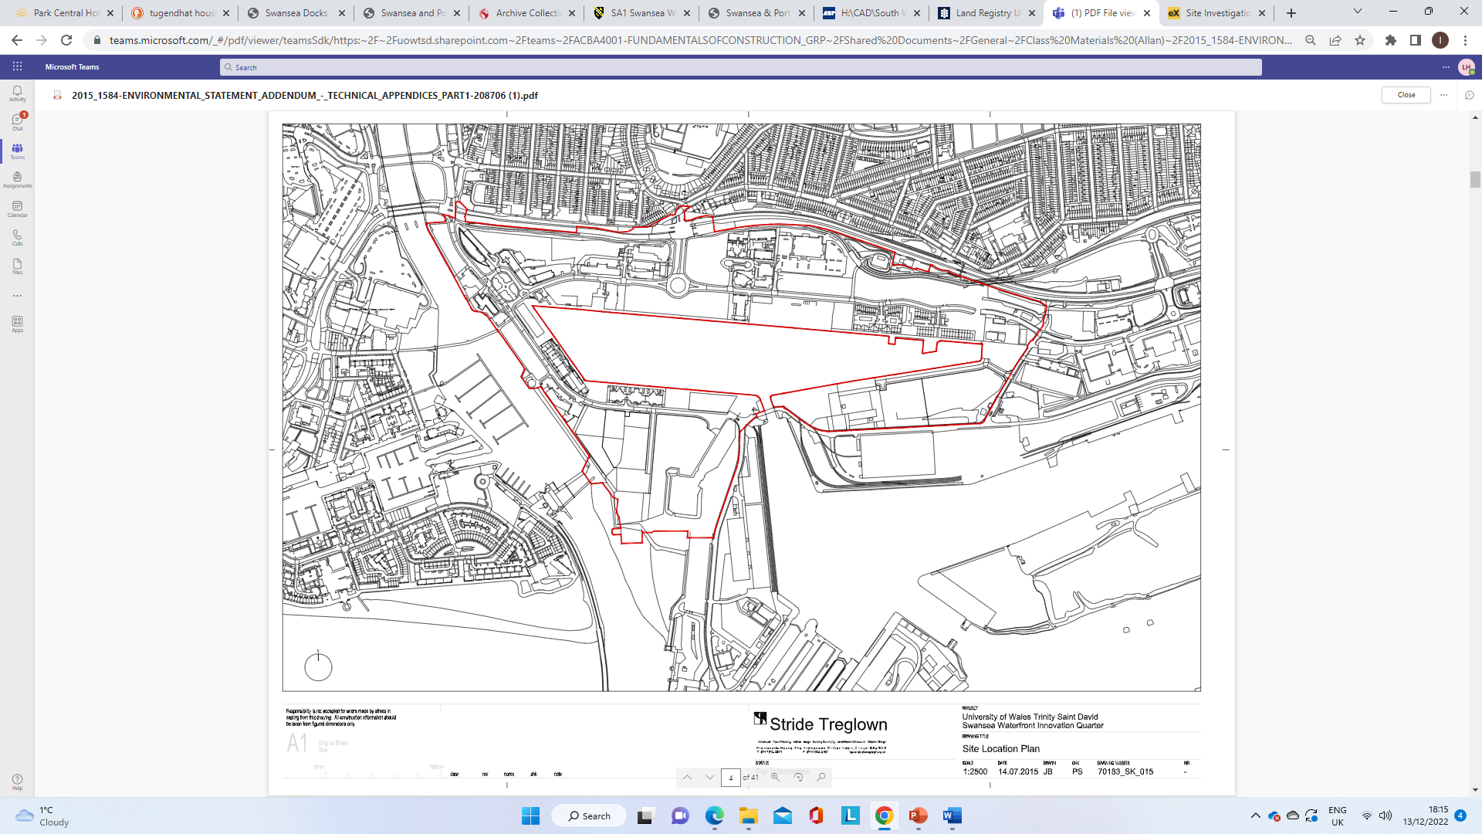

3.0 – Substructure analysis

3.1 – Foundation Requirements
The location and ground on which this superstructure is built has a vast historical background that includes pre-existing structures such as the Swansea docks remains, WW2 bombings, and was highly populated during the industrial revolution, thus leaving potential for ground contamination and unexploded bombs (Swansea & Port Talbot Docks , 2020). The area of this building is currently known as the SA1 Swansea Bay but was previously known as the Prince of Wales Docks. It was backfilled in the early 1970’s as preparation for new development to begin (SWANSEA AND PORT TALBOT DOCKS HISTORY, n.d.). With this in mind, it is crucial to identify a suitable foundation for the superstructure as there are many unknown factors involved. Below is an arial photograph of the site in the 1950’s.

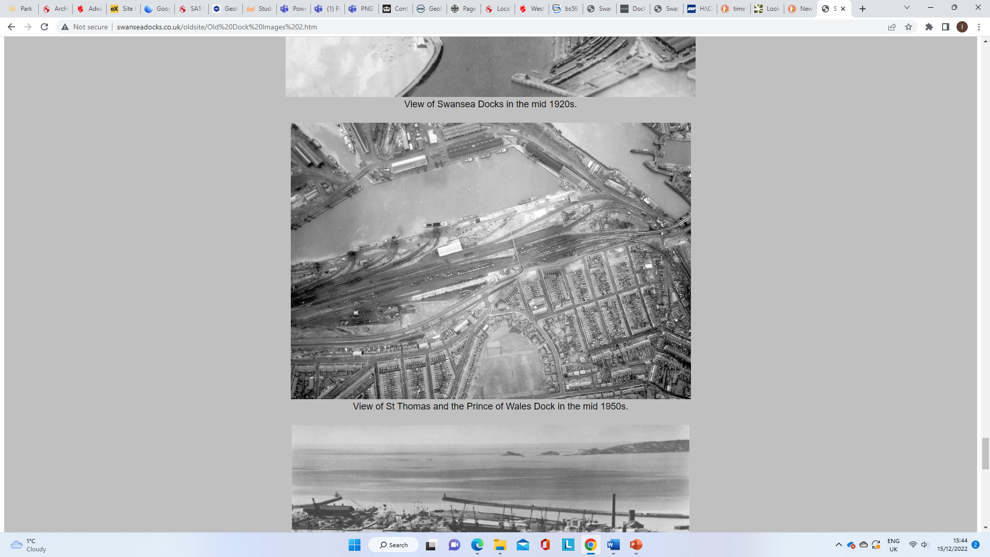
Arial Photograph of the Docks – 1950’s

Borehole logs are a good way of deciding on foundations as it gives an insight into the ground conditions of the local area. The data of the borehole logs give a good indication of the type of foundations that should be used on this building. Pile foundations are the clear choice of foundation for this building due to the various considerations mentioned above. They allow for the discovery of what may be underneath the site location and provide a stable foundation choice for the super-structure.
The British Geological Survey's publication of the borehole record below provides valuable context for understanding the kind of ground that were examined on the Innovation Matrix.
This borehole log details the 12 distinct tests that were conducted around the site. Every drilling test reveals variations not only in depth but also in the kind of ground at certain depths. As an illustration, borehole No. 1 has a total vertical depth of 22 metres. The ground was made up of small, rounded gravel at a depth of 4 metres, dirty sand at 8.50 metres, and coarse sand with stones at 9.50 metres. The overall vertical depth of Borehole No. 10 was 27.50 metres. 4.40 metres of sandstone gravel, 7.60 metres of gravel, and 5.50 metres of clay made up the remaining distance.
The consistency of the strata varies throughout these 12 borehole records. This suggests that the ground below is uneven and has varying depths. The strata becomes slightly more uniform at a depth of 30 metres, as demonstrated by boreholes No. 7, 8, and 11, which show coarse sand with some stone (British Geological Survey, 2020).

Below is the borehole log that was generated for the IQ building opposite to the Innovation Matrix. This will give a clear indication of what is to be expected the excavating and piling for the foundations.
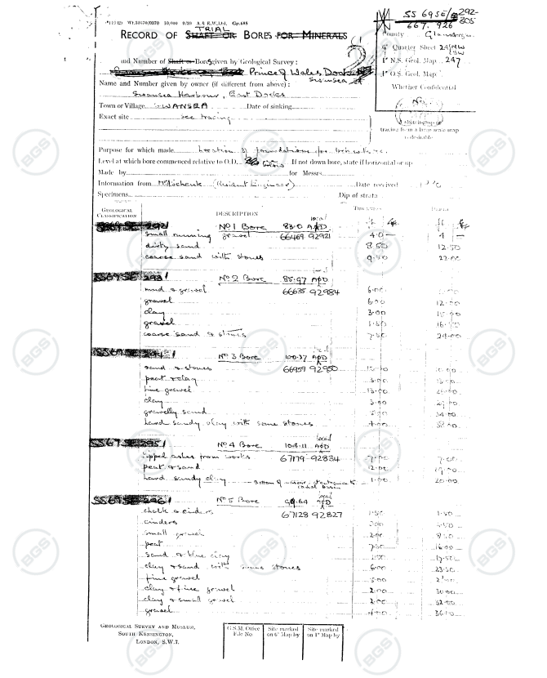

All the information above gives a detailed understanding of what is and may be in the ground for the site location.
However, there are other aspects the must come into consideration when identifying the right foundation type. Some of the factors on our case study include:
- The type of soil that the foundation will sit on – It must be able to hold the bearing weight of the foundations and the building above it.
- Structures adjacent to the project – Nearby structures and their foundations could be affected by the vibrations of any works being undertaken, but also the bearing load on the nearby ground.
- The type of site – Landfill sites, such as the Innovation Matrix, will have very uneven and inconsistent ground, making pile foundations a good choice as it can reach undisturbed ground.
- Size of the building – This building is a large superstructure which suggests that there will be a large volume of foundations present in the ground in order to bear the load. The volume of these foundations will vary as the data from the borehole logs suggest uneven ground conditions (Planning Portal, 2024).

The Drawing below shows how the pile foundations for the Innovation Matrix are placed and how the floor and walls are placed in accordance with the foundations (Swansea Council, 2023).
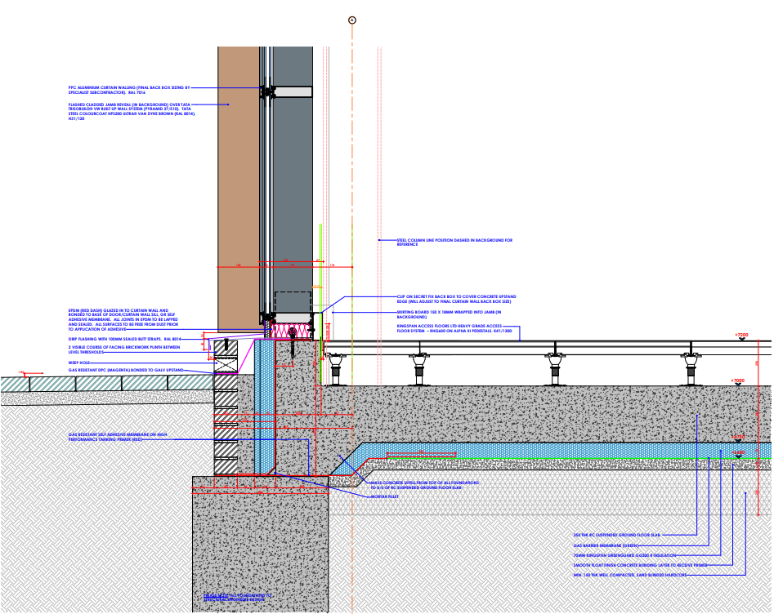

Below are two Elevations of the Innovation Matrix which give details on the size of the building – this will give the reader reference to the scale of the super structure (Swansea Council, 2023).
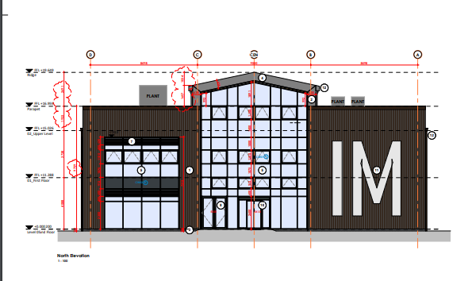

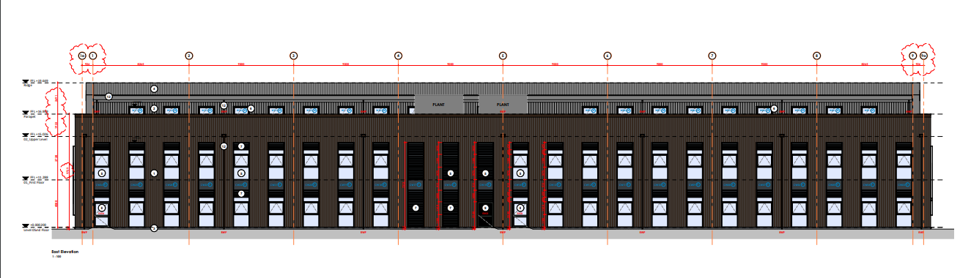

3.2 – Required Excavation Works

Excavation Works are some of the most crucial parts of any building project. This is because it provides the essential foundations for the superstructure that will be placed upon it. Without stable foundations and proper excavation works, the building will not be safe for use.
Some of the essential processes involved in excavation works for the Innovation Matrix include (LYNCH, 2023):
- Site Survey – This requires a survey of the area in order to plan how the excavation works will take place, identify the surface ground conditions and any hazards that may be on site.

- Marking out – Pegs and lines are then used to mark out areas that are to be excavated.

- Obtaining Permits – Any permits that are required, must be obtained prior to any excavation work proceeds.

- Equipment Set up – The necessary excavation equipment is brought on site and set up ready for excavation.

- Earthmoving – This is where excavation processes begin, and the surface layer of ground is removed from site.

- Site Grading – After the earthmoving process, grading then takes place which is the process that ensures the site location is level and ready for superstructure construction.

4.0 – Super-Structure Analysis

Found in the City and County of Swansea Planning Portal are a list of all the drawings, documents, and material breakdown for the project. The choice of materials used, will have determined the following sub-sections outcomes for the project. These sub-sections will identify and analyse the design, structural Strength, Stability, Fire Safety, Aesthetics, Environmental Impact and Sustainability of the development given these various factors. They will also break down any benefits and/or problems that come with the choices made.

4.1 – Design
As shown on page 7 of this document, the design of this building is considerably basic. It is a steel structure with an exterior cladding and some glazing throughout.
In terms of design, materials such as these are particularly good due to the quick erection period of the building and ease of fabrication.
Steel is an extremely good material that is durable, affordable, and sustainable, all of which are crucial factors that are needed for a job such as this. Steel can be used to span large distances, that other materials may not, yet remain stable and strong (GLW Engineering and Construction, 2017).
Due to the location of the building, cladding is a good choice for weather protection. It would shield against the salt, water and wind that prevails the waterfront (McCoy Mart, 2023). Although more expensive than other materials, this cladding will provide extra protection, preventing moisture from penetrating and damaging the interior. As there is a high concentration of salt in the air around, the building is likely to need more maintenance in order to keep the aesthetics of the cladding. However, this may not be too much of an issue if colour is taken into account.
Adjacent from the Innovation Matrix site, is the South Quay apartment blocks. This building is located in a very similar place to that of the Innovation Matrix but has been designed using render as an exterior. Appendix 1 (pg.14) shows the issues caused by the moisture and salt from the sea. This would suggest that the Innovation Matrix designs may have diverted from this route, due to the current aesthetical outcome of South Quay.

4.2 – Structural Strength
Structural Strength is the ability of multiple elements joining together to make up a structural system that can withstand and carry the loads place upon and/or within it (Archi Techtonics, n.d.). This requires a material, such as steel, to provide this whilst also conforming with the design. Steel can achieve this best as it can be formed in many shapes and sizes yet maintain is strength.
Giving a building such structural strength and stability will prevent any warping or cracking once build and will have limited expansion and contraction. This suggests that when the building settles, there should be, in theory, minimal cracks or warps.

4.3 – Stability
The stability of a building is its ability to transfer various loads throughout the structure down to the foundations. In terms of stability, steel has the greatest strength to weight ratio of all the materials used in the construction industry. This gives designers the ability to generate and manipulate the design without having to compromise too much. Even over long spans, steel can maintain its strength. Since the Innovation Matrix is a relatively long and tall structure, it would be best suited to being built with steel. It allows the building to have large open spaces, which is in keeping with contemporary building designs, yet continues to provide a strong, secure, and stable superstructure (Resources Construction, 2024).

4.4 – Fire Safety
Steel is a brilliant material for fire safety in a superstructure such as this, so long as all regulations and standards have been met in order to provide the steel with a good fire resistance, as can be found in Approved Document B (gov.uk, 2022). A building such as this, with fully regulated fireproofed steel can provide fire resistance for up to 30 mins, as stated by CPD (2023). Steel is non-combustible which enhances the buildings safety and the occupants within.
Cladding is very similar in that it can work well in terms of fire safety, as long as regulation standards are met. Due to the Grenfell disaster in 2019, regulations on fire safety have, especially with cladding, have come into force, making the industry aware that regulations must be followed. This has, over the past five years, become a big talking point within construction, and so the choice for fire rated cladding as a big step.

4.5 – Aesthetics
The Innovation Matrix is covered primarily in cladding. This material can be easily designed to match the colour desired for the building and so provides the client with a good opportunity to design the building to their specification without having to change the material in order to get the correct colour. Although an easy material choice, cladding isn’t the most aesthetically pleasing to admire, and so the colour is crucial in order to offset any potential cheap looks. Furthermore, the buildings in the immediate area surrounding the Innovation Matrix are built with brick exterior or render. This suggests that there could be a potential conflict in the designs of the buildings, and whether cladding would fit into the surrounding area.
The drawings on page 7 show the colour of cladding to be brown. Again, is this conflicting with the aesthetics of the other buildings and does it make the Innovation Matrix appear cheap?

4.6 – Environmental Impact
Although steel and other metals such as that used for cladding, generate high amounts of pollution in order to be produced, it can be recycled or reused, which makes it a much better material than that of concrete, for example. Steel is not renewable, like timber, however timber cannot be used to build superstructures as big as this and maintain its low cost and retain its strength. All materials have an environmental impact of some proportions, it is more about how the materials are produced, where they are produced, and how they are recycled or reused in the most efficient way possible (Springer Link, 2019).

4.7 - Sustainability
The materials used for the Innovation Matrix are extremely sustainable. Both the metal cladding exterior and the steel framed structure has the ability to be durable and provides the building structural stability (ArchiPro, 2020). Both of these materials can be recycled and reused, if ever necessary without creating too much of an impact on the environment. Furthermore, should any part of the building become damaged, or is in need of maintenance, it would be fairly cheap and easy to remedy any problems. Cladding is light and readily available, making it a good choice for the Innovation Matrix.

5.0 – Evaluation

This case study identifies the foundation requirements of the Innovation Matrix along with the choice of materials used for the project and why they were used. In terms of foundations, pile foundations remain to be the best option due to the inconsistent grounds below the site. The historical background and borehole logs provide evidence of this and suggest that the backfilled land may contain unknowns. Therefore, pile foundations make a great choice as they can pass through the inconsistent ground and set on more consistent, loadbearing strata.
The superstructure, made from steel frame, with metal cladding, shows that a building can be erected efficiently and at pace. Although the cladding provides good insulating properties and fire resistance, its aesthetics don’t match up with the surrounding buildings, which have brick exterior, making this part of the design choice questionable. It is clear however that this choice was made for the purpose of this building’s location. The cladding will provide a better resistance to the elements like the wind, salt and water, whilst the dark colour will hide the dirt that will eventually appear, thus making it a suitable choice for the Innovation Matrix.

6.0 - References
Archi Techtonics, n.d. Strength vs. Stability. [Online]
Available at: https://web.mit.edu/4.441/1_lectures/1_lecture1/1_lecture1.html
[Accessed 4th January 2024].
ArchiPro, 2020. Cladding and sustainability: what are the best options?. [Online]
Available at: https://archipro.co.nz/article/cladding-and-sustainability-what-are-the-best-options-archipro
[Accessed 4th January 2024].
British Geographical Survey, 2020. [Online]
Available at: http://scans.bgs.ac.uk/sobi_scans/boreholes/370200/images/10677848.html
[Accessed 3rd December 2022].
British Geological Survey, 2020. Borehole Logs. [Online]
Available at: https://api.bgs.ac.uk/sobi-scans/v1/borehole/scans/items/370200
[Accessed 4th January 2024].
CPD, 2023. CPD 3 2018: Steel and fire protection. [Online]
Available at: https://www.building.co.uk/cpd/cpd-3-2018-steel-and-fire-protection/5091899.article
[Accessed 4th January 2024].
GLW Engineering and Construction, 2017. The Advantages & Disadvantages Of Steel Frame Construction. [Online]
Available at: https://blog.glwengineering.co.uk/the-advantages-disadvantages-of-steel-frame-construction
[Accessed 4th January 2024].
gov.uk, 2022. Fire safety: Approved Document B. [Online]
Available at: https://www.gov.uk/government/publications/fire-safety-approved-document-b
[Accessed 4th January 2024].
LYNCH, D., 2023. What is Excavation Work? A Friendly Guide to Understanding. [Online]
Available at: https://essremodel.com/what-is-excavation-work/
[Accessed 4th January 2024].
McCoy Mart, 2023. The Pros and Cons of Cladding, Brick, and Rendering for Exterior Walls. [Online]
Available at: https://mccoymart.com/post/cladding-vs-brick-vs-rendering/
[Accessed 4th January 2024].
Planning Portal, 2024. Building Regulations: Foundations. [Online]
Available at: https://www.planningportal.co.uk/permission/common-projects/extensions/building-regulations-foundations
[Accessed 4th January 2024].
Resources Construction, 2024. How Stable Are Steel Frame Structures?. [Online]
Available at: https://constructionresourcesblog.com/how-stable-are-steel-frame-structures/
[Accessed 4th January 2024].
Springer Link, 2019. Environmental Impact of Steel Industry. [Online]
Available at: https://link.springer.com/referenceworkentry/10.1007/978-3-319-73645-7_101
[Accessed 4th January 2024].
Swansea & Port Talbot Docks , 2020. Retired Section Swansea Docks. [Online]
Available at: http://swanseadocks.co.uk/oldsite/Old%20Dock%20Images%202.htm
[Accessed 4th January 2024].
SWANSEA AND PORT TALBOT DOCKS HISTORY, n.d. Dry Docks at Swansea. [Online]
Available at: http://swanseadocks.co.uk/docksnewsite/drydocks.html
[Accessed 4th January 2024].
Swansea Council, 2023. Planning – Planning Application Documents. [Online]
Available at: https://property.swansea.gov.uk/online-applications/applicationDetails.do?activeTab=documents&keyVal=RS83QNEVL1900
[Accessed 4th January 2024].
Swansea Council, 2024. SA1 Swansea Waterfront. [Online]
Available at: https://www.swansea.gov.uk/saleorletsa1
[Accessed 4th January 2024].

7.0 – Appendices

Appendix 1:
Images showing South Quay when it was first built and being hit by the elements.



