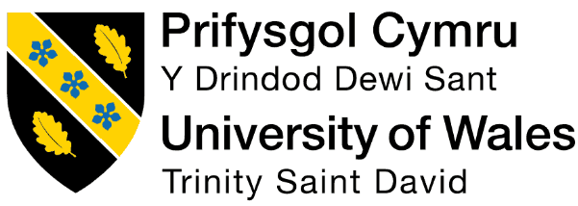

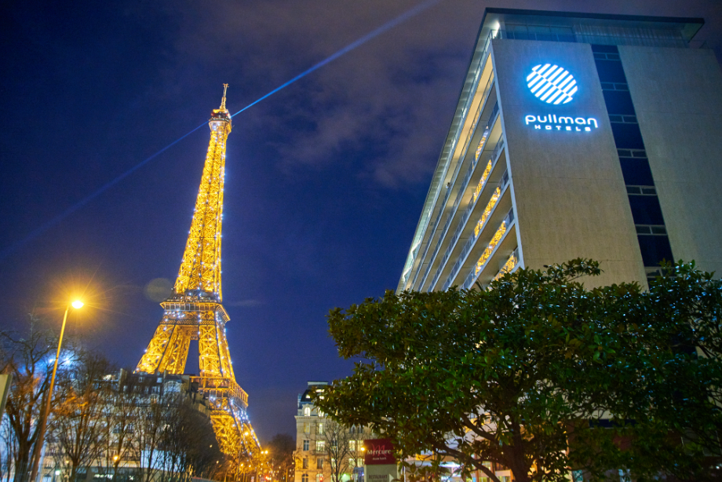  Cultural awareness |   Hotel handbook for the staff at Pullman Paris Tour Eiffel in France  Student name: Florin Matache  Student id:2126293  Module tutor :Rodrigo F. Aguilera  Module code :BMIH5003

Executive Summary
In this report, the country and cultural differences between the two countries such as France and the USA have been done by focusing on the cultural knowledge development for the staff at Pullman Paris Tour Eiffel. Hence, the way that the staff of this hotel could manage the USA guests regardless of their cultural differences has been described in this report. Cultural differences and understanding are important elements for the hospitality service, as they help to interact with the guests properly, resolve their requirements and thereby building a cross-cultural and empathetic relationship with them for the long-term future. In this way, the critical comparison between the two above-mentioned countries in light of the hotel staff has been done through Hofstede's cultural dimensions. Additionally, based on the analysis, a hotel handbook has been provided, which mentioned that the hotel staff should follow the individualistic, punctual and direct societal culture of the USA. Similarly, the recommendations for the hotel staff include cross-cultural training and diversity workforce maintenance for better outcomes as well.

Table of Contents
1. Introduction 3
2. Country-A analysis 3
3. Country-B analysis 4
4. Critical comparison between the two countries 4
5. Hotel Handbook 5
6. Summary 6
7. Recommendations 6
8. References 7

1. Introduction
The following report would be developed for the hotel staff of Pullman Paris Tour Eiffel for managing the guests from the international market. In this aspect, an analysis of the home country of the hotel and guests from another international country would be done. Additionally, relevant theoretical and model evaluation for comparing the cultural values of the two countries would be done, which help the hotel staff to provide a better guest experience. Furthermore, a hotel handbook related to do’s and don’ts as well as two justified recommendations would be provided for effective guest accommodation.

2. Country-A analysis
It has been observed that Pullman Paris Tour Eiffel is located in France at the foot of the Eiffel Tower and the Trocadero (Accor, 2023). The hotel is comprised of 430 rooms and ensured flexible places, which could attract the people of France and other countries for relaxation. Furthermore, it has been denoted that due to the effective geographic advantage of being close to the Eiffel Tower and the Trocadero, the hotel achieved high brand value in France (Pullman Paris Tour Eiffel, 2023). Additionally, the report from Europa (2023) stated that France consists of a wide variety of cultural diversity and flexibility, which helped the hotel for providing its luxurious and leisurely hospitality service to the guests.
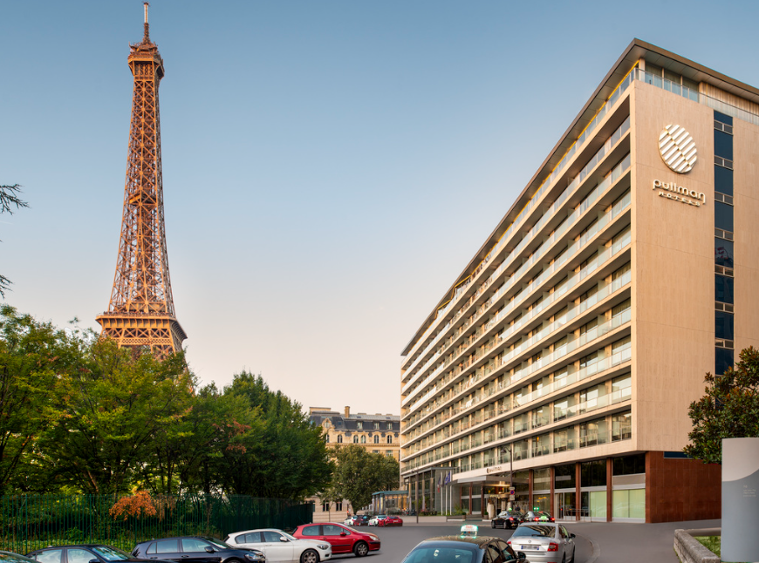
Figure 1: Location of Pullman Paris Tour Eiffel
(Source: Accor, 2023)

3. Country-B analysis
In this report, the cultural awareness of the following hotel staff would be done by focusing on the guests coming from the USA. Hence, an effective country analysis of the USA would be done for better understanding. According to Mendis (2023), the USA is considered a multicultural country with different backgrounds of people with different attitudes. The USA people consider individualism, equality, informality, punctuality and directness regarding their service preferences, which made them unique in the world (UCSF, 2023). Furthermore, social norms of the USA ensure the maintenance of privacy, race and need for personal spaces in comparison to other developed countries (Mendis, 2023). Considering this, the hotel staff of France need to maintain these key cultural traits of the USA people for providing them with better experiences.

4. Critical comparison between the two countries
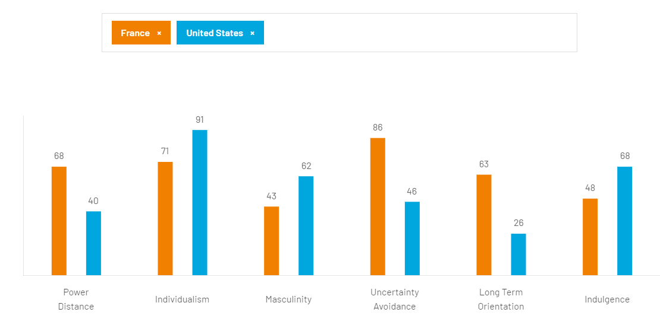
Figure 2: Cultural comparison between France and the USA through Hofstede’s model
(Source: Hofstede Insights, 2023)
The report from Hofstede Insights (2023) highlighted the significantly different cultural features of France and the USA, which need to be understood by the hotel staff at Pullman Paris Tour Eiffel. It has been observed that the power distance index in France is higher than in the USA. Similarly, the Individualism index of the country is lower than the USA as well. Considering this, it can be stated that the USA people might face difficulties while taking hospitality service at the hotel due to the authoritative and collectivist cultural characteristics of the country. Meanwhile, the study by Chauvin and Chassang (2022) reflected that the masculinity index of France is lower than that of the USA, which ensures following the social norms, relationship-oriented and quality of life maintenance by the French people, which is comparatively different from the USA citizen respectively.
Additionally, the culture of France follows high uncertainty avoidance while the UAI index of the USA is significantly low (Litvin, 2019). It indicates ease in the unpredictable situation by focusing on comfort and pragmaticism respectively (Hofstede Insights, 2023). Similarly, the long-term orientation index is high in France compared to the USA as well. Considering this, the short-term focus and lack of uncertain situation handling of the USA people would be challenging for the hotel staff at Pullman Paris Tour Eiffel, which needs proper strategies for providing high-quality guest satisfaction to the USA people.

5. Hotel Handbook
DO’s and DON’T’s for the hotel staff at Pullman Paris Tour Eiffel
Do’s  - Provide quality service timely  - Build an empathetic relationship with the guests  - Be friendly and professional for maintaining informality and directness  - Acknowledge the fault and apologise  - Provide equal preferences compared to other guests  - Consider the privacy and safety of the guests  - Provide eye contact while talking for maintaining perfect body language  - Deliver the high-quality room service | Don’ts  - Do not create chaos regarding any issues  - Avoid any personal questions of the guests  - Do not practice racial and other types of discrimination  - Do not skip the communication  - Do not neglect the complaints of the guests

Table 1: Hotel Handbook for Pullman Paris Tour Eiffel’s staff
Considering the above handbook, it can be stated that the hotel staff of Pullman Paris Tour Eiffel should focus on the cultural norms and preferences of the USA guests while staying in their hotel. In this aspect, the hotel staff should practice the above-mentioned Do’s while attending to the USA guests, which would help in interacting with them and thereby engaging them with the hotel service. In this way, better guest engagement with the hotel could be developed through a cross-cultural environment generation.

6. Summary
At the end of the study, it can be stated that cultural differences between the two countries could affect the hotel service and in this aspect, the staff of the hotel need to practice effective cross-cultural strategies for interacting with guests from different cultures. In this report, the cultural understanding of the staff of a French hotel namely Pullman Paris Tour Eiffel has been discussed with Hofstede's cultural dimension model for the USA guests, which is significantly different from the home country. In this way, a Do's and Don'ts handbook for the hotel staff has provided for better outcomes. Additionally, justified recommendations for the hotel staff have been provided at the end of the study for better guest engagement in that hotel as well.

7. Recommendations
- Better staff training and cross-cultural development programme: The management of Pullman Paris Tour Eiffel should provide better cross-cultural training and development programmes to the staff for improving their knowledge regarding different countries and their people. In this way, better guest experiences could be provided for better business outcomes (Menon, 2019).
- Diversity management in working teams: Additionally, the organisational culture of the hotel should implement diversity in their workforce by engaging staff from different cultures. In this way, better cross-cultural understanding for the hotel staff could be possible from the real-life experiences and it would be reflected in the guest handling from the target country.

8. References
Accor (2023) Pullman Paris eiffel tower, all.accor.com. Available at: https://all.accor.com/hotel/7229/index.en.shtml (Accessed: 23 May 2023).
Chauvin, B. and Chassang, I., (2022). “Cultural orientation and risk perception: Development of a scale operating in a French context.” Risk Analysis, 42(10), pp.2189-2213.
Europa (2023) Tolerance and cultural diversity discourses in France, European Website on Integration. Available at: https://ec.europa.eu/migrant-integration/library-document/tolerance-and-cultural-diversity-discourses-france_en (Accessed: 23 May 2023).
Hofstede Insights (2023) Country comparison tool, Hofstede Insights. Available at: https://www.hofstede-insights.com/country-comparison-tool?countries=france%2Cunited%2Bstates (Accessed: 24 May 2023).
Litvin, S.W., (2019). “Hofstede, cultural differences, and TripAdvisor hotel reviews.” International Journal of Tourism Research, 21(5), pp.712-717.
Mendis, D. (2023) American culture: Values, customs, & more in the USA, Shorelight. Available at: https://shorelight.com/student-stories/culture-of-usa/ (Accessed: 23 May 2023).
Menon, R. (2019) Impact of cross-cultural training practices in hospitality industry on the productivity of employees, LinkedIn. Available at: https://www.linkedin.com/pulse/impact-cross-cultural-training-practices-hospitality-industry-menon/ (Accessed: 24 May 2023).
Pullman Paris Tour Eiffel (2023) Pullman Paris tour Eiffel - H, Pullman Paris Tour Eiffel - Hôtel 4 étoiles - 15e arr. Available at: https://www.pullmanparistoureiffel.fr/en (Accessed: 23 May 2023).
UCSF (2023) U.S. culture, International Students and Scholars Office. Available at: https://isso.ucsf.edu/us-culture (Accessed: 23 May 2023).

